**Computing MACs, Hashes and HMACs for messages**

**SUBJECT NAME: CRYPTOGRAPHY AND NETWORK SECURITY**

**SUBJECT CODE: CS6008**

**MODULE: 8**

|  |  |
| --- | --- |
| **NAME** | BHUVANESHWAR S |
| **REG.NO** | 2019103513 |
| **DATE** | 11/06/2022 |

**AIM:**

To compute MACs, Hashes and HMACs for a given message.

**TOOLS INVOLVED:**

* JAVA
* CMD PROMPT
* VISUAL STUDIO CODE

**PROBLEM DESCRIPTION:**

1. **MESSAGE AUTHENTICATION CODE**

MAC algorithm is a symmetric key cryptographic technique to provide message authentication. For establishing MAC process, the sender and receiver share a symmetric key K. Essentially, a MAC is an encrypted checksum generated on the underlying message that is sent along with a message to ensure message authentication.

1. **HASHING**

Hashing is an algorithm performed on data such as a file or message to produce a number called a hash. The hash is used to verify that data is not modified, tampered with, or corrupted. In other words, you can verify the data has maintained integrity. A key point about a hash is that no matter how many times you execute the hashing algorithm against the data, the hash will always be the same if the data is the same.

1. **HMAC**

**Hash-Based Message Authentication Code (HMAC)** is a specific type of message authentication code (MAC) involving a cryptographic hash function and a secret cryptographic key. As with any MAC, it may be used to simultaneously verify both the data integrity and authenticity of a message.

HMAC can provide authentication using a shared secret instead of using digital signatures with asymmetric cryptography. It trades off the need for a complex public key infrastructure by delegating the key exchange to the communicating parties, who are responsible for establishing and using a trusted channel to agree on the key prior to communication.

**INPUT:**

Getting a input message from the user.

**OUTPUT:**

Computing MACs, Hashes and HMACs for a given messages.

**SCREENSHOT:**

1. **MAC**

**FILENAME: macGen.java**

import java.security.Key;

import java.security.SecureRandom;

import java.util.Scanner;

import javax.crypto.KeyGenerator;

import javax.crypto.Mac;

public class macGen {

    public static *void* main(String *args*[]) throws Exception {

        KeyGenerator keyGen = KeyGenerator.getInstance("DES");

        Scanner sc = new Scanner(System.in);

        SecureRandom secRandom = new SecureRandom();

        keyGen.init(secRandom);

        Key key = keyGen.generateKey();

        Mac mac = Mac.getInstance("HmacSHA256");

        mac.init(key);

        System.out.print("[+]\tEnter plain text :\t");

        String input = sc.nextLine();

        String msg = new String(input);

*byte*[] bytes = msg.getBytes();

*byte*[] macResult = mac.doFinal(bytes);

        System.out.println("Messafe Digest : ”);

        System.out.println(new String(macResult));

    }

}

**OUTPUT**

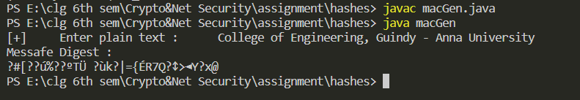

1. **HASHING USING SHA256**

**Sha256Gen.java**

import java.math.BigInteger;

import java.nio.charset.StandardCharsets;

import java.security.MessageDigest;

import java.security.NoSuchAlgorithmException;

import java.util.Scanner;

class sha256Gen {

    public static *byte*[] getSHA(String *input*) throws NoSuchAlgorithmException

    {

        MessageDigest md = MessageDigest.getInstance("SHA-256");

        return md.digest(*input*.getBytes(StandardCharsets.UTF_8));

    }

    public static String toHexString(*byte*[] *hash*)

    {

        BigInteger number = new BigInteger(1, *hash*);

        StringBuilder hexString = new StringBuilder(number.toString(16));

        while (hexString.length() < 64)

        {

            hexString.insert(0, '0');

        }

        return hexString.toString();

    }

    public static *void* main(String *args*[])

    {

        Scanner sc = new Scanner(System.in);

        try

        {

            System.out.println("[+] Enter message : ");

            String s1 = sc.nextLine();

            System.out.println("\n" + s1 + " - SHA256 : " + toHexString(getSHA(s1)));

        }

        catch (NoSuchAlgorithmException e) {

            System.out.println("Exception thrown for incorrect algorithm: " + e);

        }

    }

}

**OUTPUT:**

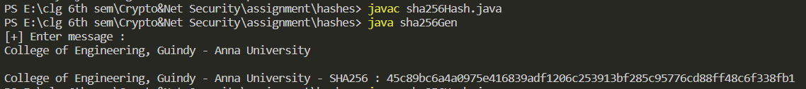

1. **HMAC**

**hmacGen.java**

import java.math.BigInteger;

import java.util.Base64;

import java.util.Scanner;

import javax.crypto.Mac;

import javax.crypto.spec.SecretKeySpec;

public class hmacGen{

  private static class HMAC {

    public static *byte*[] hmac256(String *secretKey*,String *message*){

      try{

        return hmac256(*secretKey*.getBytes("UTF-8"), *message*.getBytes("UTF-8"));

      }catch(Exception e){

        throw new RuntimeException("Failed to generate HMACSHA256 encrypt",e);

      }

    }

    public static *byte*[] hmac256(*byte*[] *secretKey*,*byte*[] *message*){

*byte*[] hmac256 = null;

      try{

        Mac mac = Mac.getInstance("HmacSHA256");

        SecretKeySpec sks = new SecretKeySpec(*secretKey*, "HmacSHA256");

        mac.init(sks);

        hmac256 = mac.doFinal(*message*);

        return hmac256;

      }catch(Exception e){

        throw new RuntimeException("Failed to generate HMACSHA256 encrypt ");

      }

    }

  }

  public static *void* main(String *args*[]){

    Scanner sc = new Scanner(System.in);

    System.out.println("[+] Enter message : ");

    String s1 = sc.nextLine();

*byte*[] hmacSha256 = HMAC.hmac256("secreT1_", s1);

    System.out.println(String.format("Hex: %032x", new BigInteger(1, hmacSha256)));

    String base64HmacSha256 = Base64.getEncoder().encodeToString(hmacSha256);

    System.out.println("Base64: " + base64HmacSha256);

  }

}

**OUTPUT**

