**Web Development Project**

**Team Members:**

Mirdhul J dev (18BCS0004)

Manibharathi S (18BCS0023)

Bhuvaneshwaran K (18BCS0034)

Project Topic:

**Cafe de Java**

**Description**

This project is to create a website for a Cafe which sells Coffee, Pastries. The website is going to be developed with the Standard technologies for Web development (HTML, CSS, and JavaScript).

The idea is to create a website with Catchy graphics, a menu section which displays the food items, a feedback form to get reviews, and also an email subscription to make customers notified about the ongoing interesting events, ideas, information related to the Cafe.

**Code & Screenshots**

**Main page**

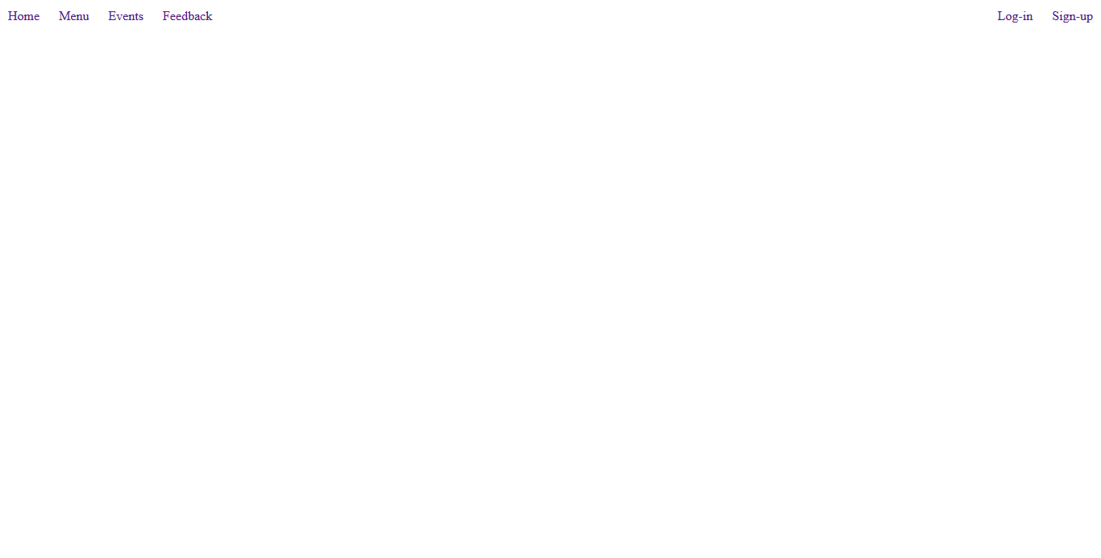

**Feed back section**

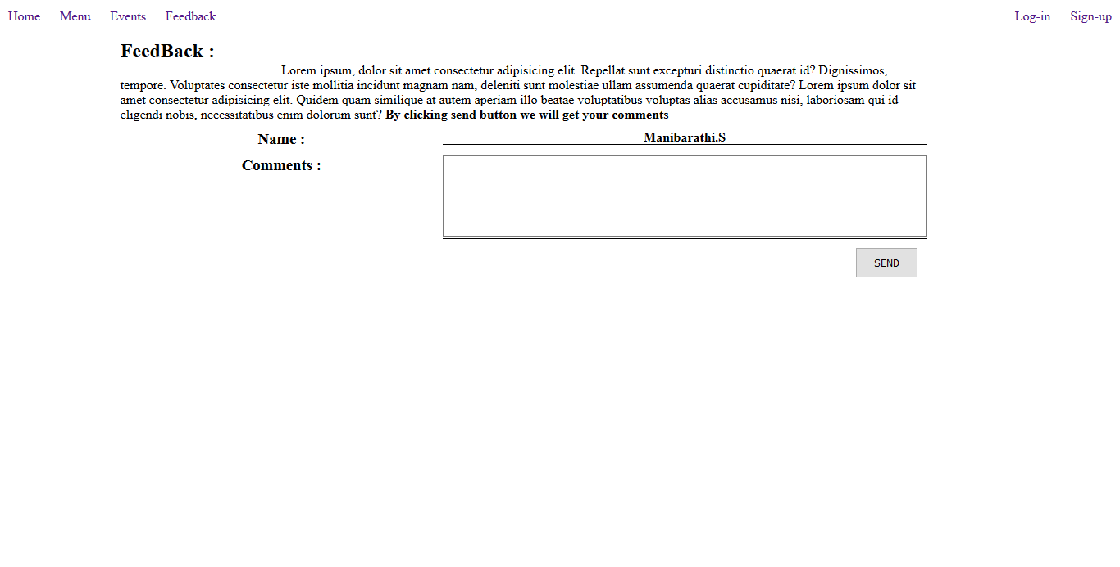

<!DOCTYPE html>

<html>

<head>

    <title>Cafe de java</title>

    <link rel="stylesheet" href="style.css">

    <script src="app.js"></script>

</head>

<body>

    <header>

        <div class="right">

            <li><a href="main.html">Home</a></li>

            <li><a href="#">Menu</a></li>

            <li><a href="#">Events</a></li>

            <li><a href="#FeedBack" onclick="TurnOnFeedBack()" >Feedback</a></li>

        </div>

        <div class="left">

            <li><a href="login.html">Log-in</a></li>

            <li><a href="signup.html">Sign-up</a></li>

        </div>

    </header>

    <!--FeedBack section Start------------------->

    <div class="feedback" id="FeedBack">

        <div class="row">

            <h2>FeedBack :</h2>

            <p style="text-indent: 20%;">Lorem ipsum, dolor sit amet consectetur adipisicing elit. Repellat sunt excepturi distinctio quaerat id? Dignissimos, tempore. Voluptates consectetur iste mollitia incidunt magnam nam, deleniti sunt molestiae ullam assumenda quaerat cupiditate?

               Lorem ipsum dolor sit amet consectetur adipisicing elit. Quidem quam similique at autem aperiam illo beatae voluptatibus voluptas alias accusamus nisi, laboriosam qui id eligendi nobis, necessitatibus enim dolorum sunt? <b>By clicking send button we will get your comments</b>

            </p>

        </div>

        <div class="row">

            <div class="col-1">

                <h3>Name :</h3>

            </div>

            <div class="col-2">

                <h4 id="UserName">

                    Manibarathi.S

                </h4>

            </div>

        </div>

        <div class="row">

            <div class="col-1">

                <h3>Comments :</h3>

            </div>

            <div class="col-2">

                <form action="#" id="commentForm" method="POST">

                <textarea name="UserFeedbck" id="Feedback" required></textarea>

               </form>

            </div>

        </div>

        <input type="submit" form="commentForm" value="SEND">

    </div>

</body>

</html>

**Sign up page**

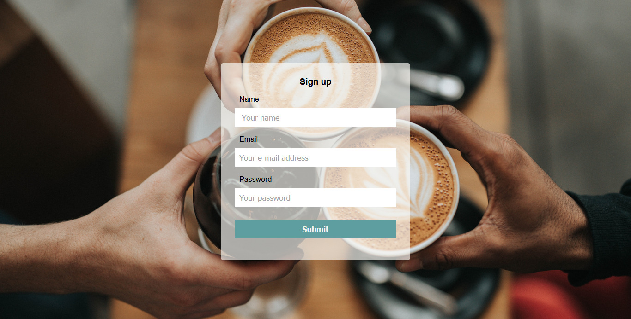

<!DOCTYPE html>

<html lang="en">

<head>

    <meta charset="UTF-8">

    <meta name="viewport" content="width=device-width, initial-scale=1.0">

    <title>Signup - Cafe de java</title>

    <link rel="stylesheet" href="style.css">

</head>

<body background="/images/bg06.jpg">

    <div >

        <div>

        </div>

        <div class='sign-up'>

                <center><h3>Sign up</h3></center>

            <br>

            <form action="">

                <label for="name">Name</label>

                <input type="text" name="name" id="" placeholder=" Your name"><br><br>

                <label for="name">Email</label>

                <input type="text" name="email" id=""placeholder="Your e-mail address"><br><br>

                <label for="name">Password</label>

                <input type="password" name="pass "placeholder="Your password"><br><br>

                <center>

                <button type="submit">Submit</button>

            </center>

            <br>

            </form>

        </div>

    </div>

</body>

</html>

**Login Page**

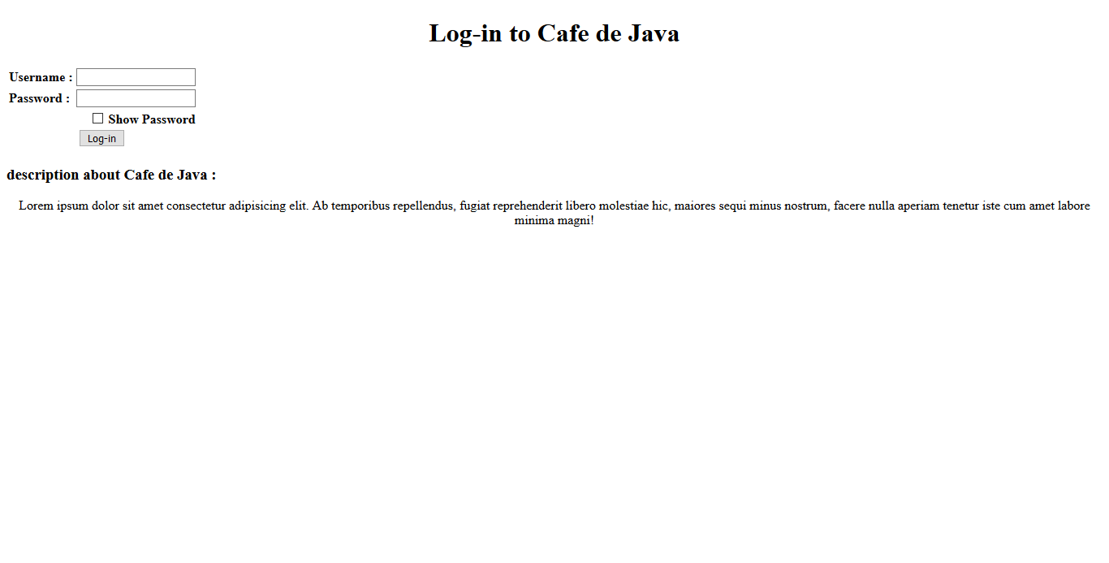

<!DOCTYPE html>

<head>

    <title>Log-in</title>

</head>

<body>

    <h1 style="text-align: center;">Log-in to Cafe de Java</h1>

    <table border="0">

        <form action="#" method="POST">

            <tr>

                <th><label for="UserName">Username :</label></td>

                <td><input type="text" id="UserName" required> <br></td>

            </tr>

            <tr>

                <th style="text-align: left;"><label for="Password" required>Password :</label></td>

                <td ><input type="password" id="Password" required> <br></td>

            </tr>

            <tr>

                <td style="text-align: right;" colspan="2"><input type="checkbox"> <b>Show Password</b> <br> </td>

            </tr>

            <tr>

                <td style="text-align: center;" colspan="2"><input type="submit" value="Log-in"></td>

            </tr>

        </form>

    </table>

    <h3>description about Cafe de Java :</h3>

    <p style="text-align: center;">

    Lorem ipsum dolor sit amet consectetur adipisicing elit. Ab temporibus repellendus, fugiat reprehenderit libero molestiae hic,

    maiores sequi minus nostrum, facere nulla aperiam tenetur iste cum amet labore minima magni!</p>

</body>

</html>