Flutter

Variables

Used to store data

String name = “”;

Data structures

List ,- collection of data

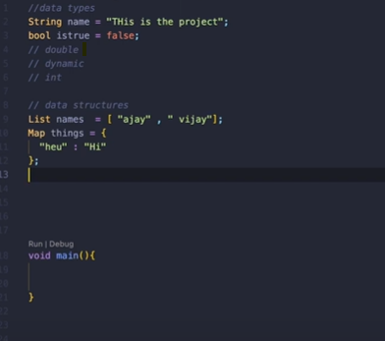Function