|  |
| --- |
| **EMPLOYEE PERFORMANCE ANALYSIS USING EXCEL** |

**NAME:BHUVANESHWARI.J**

**REGISTERNO:122202139**

**DEPARTMENT:B.COM(CS)**

**COLLEGE: ANNA ADHARSH**

**COLLEGE FOR WOMEN**

**P**

**R**

**O**

**J**

**E**

**C**

**T**

**T**

**I**

**T**

**L**

**E**

E

m

p

l

o

y

e

e

P

e

r

f

o

r

m

a

n

c

e

A

n

a

l

y

s

i

s

U

s

i

n

g

E

x

c

e

l

**AGENDA**

**1**

**.**

**P**

**r**

**o**

**b**

**l**

**e**

**m**

**S**

**t**

**a**

**t**

**e**

**m**

**e**

**n**

**t**

**2**

**.**

**P**

**r**

**o**

**j**

**e**

**c**

**t**

**O**

**v**

**e**

**r**

**v**

**i**

**e**

**w**

**3**

**.**

**E**

**n**

**d**

**U**

**s**

**e**

**r**

**s**

**4**

**.**

**O**

**u**

**r**

**S**

**o**

**l**

**u**

**t**

**i**

**o**

**n**

**a**

**n**

**d**

**P**

**r**

**o**

**p**

**o**

**s**

**i**

**t**

**i**

**o**

**n**

**5**

**.**

**M**

**o**

**d**

**e**

**l**

**l**

**i**

**n**

**g**

**A**

**p**

**p**

**r**

**o**

**a**

**c**

**h**

**6**

**.**

**R**

**e**

**s**

**u**

**l**

**t**

**s**

**a**

**n**

**d**

**D**

**i**

**s**

**c**

**u**

**s**

**s**

**i**

**o**

**n**

**7**

**.**

**C**

**o**

**n**

**c**

**l**

**u**

**s**

**i**

**o**

**n**



**PROBLEM STATEMENT**

The problem is to identify the Human Resources (HR) department of ABC Corporation aims to evaluate and improve employee performance across various departments. Currently, performance data is collected, but it is not systematically analysed to provide actionable insights. The HR team needs a comprehensive analysis of employee performance metrics to identify top performers, underperformers, and trends over time.

**PROJECT OVERVIEW**

* Analyze employee performance metrics to identify strengths, areas for improvement, and overall trends.
* Implement PivotTables to summarize and categorize performance data.
* Compare individual employee performance against benchmarks or targets.
* Analyze seasonal or project-specific performance variations. .
* Design dashboards for easy visualization of performance metrics.
* Share analysis results with management for decisionmaking.

**WHO ARE THE END USERS?**

* 1. Human Resources Team
  2. Managers
  3. Executives
  4. Training and Development Teams
  5. Compensation and Benefits Teams

* 1. Performance Review Committees

**OUR SOLUTION AND ITS VALUE**

**PROPOSITION**

* Flexibility to adapt the analysis to different roles, departments, or performance criteria, ensuring relevance and accuracy in evaluations
* Solution Data-driven analysis that support performance reviews, promotions, compensation decisions, and targeted training.
* Solutions The ability to analyze both current and historical performance data, with periodic updates to keep information.

* Value Proposition Saves time and reduces the risk of human error, ensuring consistent and reliable reporting across the organization.

**DATASET DESCRIPTION**

: Unique identifier for each employee in the

organizations

: The first name of the employee.

**LAST NAME : The last name of the employee.**

**BUSINESS UNIT :The specific business unit or department to which the employee belongs**

**EMPLOYEE TYPE : The type of employment the employee has**

**(Example: Full time, part time and contract)**

**GENDER CODE : A code representing the gender of the employee (Example: Male, Female and non binary)**

: The current rating or evaluation of

the employee's overall performance.

**MODELLING**

DATA SET: Kaggle, Employee dataset

FEATURE SELECTION: Conditional Formatting, Designing

DATA CLEANING Missing values, Irrelevant data, Correct Errors, Remove Unnecessary Columns and Rows

PIVOT TABLE: Employee ID, First Name, Performance Score.

CHART: Report of Employee Performance based on their Current Ratings is resented as Column Chart

**RESULTS**

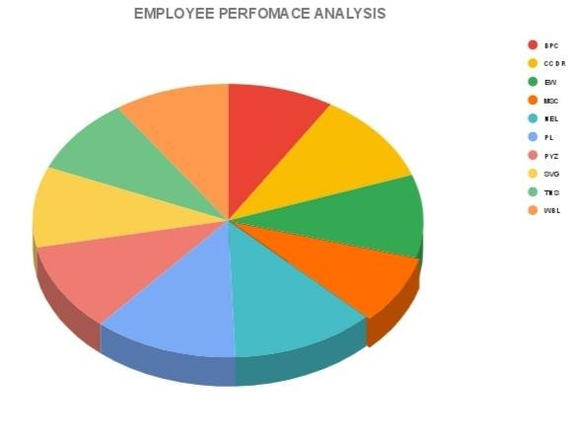

CONCLUSION

In conclusion, conducting an employee performance analysis using Excel provides a structured and efficient way to evaluate and track performance metrics. Excel's versatile functions and tools, such as pivot tables, charts, and conditional formatting, allow for clear data visualization and analysis, facilitating informed decision-making. By systematically analyzing performance data, management can identify trends, strengths, and areas for improvement, enabling targeted interventions and fostering a culture of continuous improvement. Regular updates and reviews of this data ensure that performance management remains dynamic and aligned with organizational goals.