

**TECHNICAL ANSWERS FOR REAL WORLD**

**FINAL PROJECT REPORT**

**COURSE CODE:** SWE1907

**TEAM MEMBERS**:

SAMHITHA PAVULURI – 19MIS1090

BHUVANESHWARI.K -19MIS1196

DEEPIKA G – 19MIS1159

**FACULTY:** Dr NAGARAJ

**PROJECT TITLE: SMART TECHNOLOGY BLIND PEOPLE**

**TABLE OF CONTENTS**

**1.PROBLEM STATEMENT** 3

**2.FEASIBILITY STUDY** 4

**3.SURVEY ANALYSIS** 4

**4.UML DIAGRAMS** 7

**USE CASE DIAGRAM** 7

**ACTIVITY DIAGRAM** 8

**CLASS DIAGRAM** 8

**SEQUENCE DIAGRAM** 9

**BLOCK DIAGRAM** 10

**5.FLOW CHART** 11

**CIRCUIT DIAGRAM** 12

**6.REQUIRED COMPONENTS** 12

**HARDWARE COMPONENTS** 12

**SOFTWARE COMPONENTS** 13

**7.COST TABLE** 13

**8.ARDUINO CODE** 14

**9.COMPONENT DESCRIPTION** 16

**10.APPLICATION AND ADVANTAGE** 21

**11.RESULT** 22

# **1.PROBLEM STATEMENT**

People who are visually impaired have severe vision problems that make it impossible for them to travel on their own. As a result, individuals must employ a variety of instruments and procedures to aid in their mobility. One of these methods is orientation and mobility training, which is provided by specialists who assist the blind and visually impaired. Based on their residual senses, enable them to walk independently and securely.

Recent developments in signal processing and sensor technology have led to the development of numerous methods for improving blind people's mobility. According to the literature, the mainly classified into two major aspects: input for sonar (infrared signals, etc.) ultrasonic transmissions). These devices work similarly to radar systems, which employ ultrasonic waves or sonar to identify obstacles such as stationary objects and moving things.

The time of the wave travel is used to calculate the separation between the subject and the obstructions. However, every system now in use alerts the blind to the existence of an item that is in front of or close to them at a set distance. The blind's ability to perceive space and recall details can be improved with more knowledge about the qualities of the thing.

**PROPOSED SYSTEM**

Blind stick is an innovative stick designed for visually disabled people for improved navigation. We here propose an advanced blind stick that allows visually challenged people to navigate with ease using advanced technology. The blind stick is integrated with ultrasonic sensor along with light and water sensing. Our proposed project first uses ultrasonic sensors to detect obstacles ahead using ultrasonic waves. On sensing obstacles the sensor passes this data to the microcontroller. The microcontroller then processes this data and calculates if the obstacle is close enough. If the obstacle is not that close the circuit does nothing. If the obstacle is close the microcontroller sends a signal to sound a buzzer. It also detects and sounds a different buzzer if it detects water and alerts the blind. One more feature is that it allows the blind to detect if there is light or darkness in the room.

For unused times, we make arduino asleep to save power and wake up it just by pushing a button. We used timer to control sensor, interrupt to control sleep / wakeup and eeprom for different Modes

# **2.FEASIBILITY STUDY**

**TECHNICAL FEASIBILITY**

The main objective i.e. detection of either a stationary or a moving obstacle is done with the help of Ultrasonic sensor.

Hence, we must need to know the working principle of ultrasonic sensor. We need to understand how ultrasonic waves are transmitted and regained back at receiver.

Step 1: We need to supply a short 10uS pulse to the trigger input to start the ranging, and then the module will send out an 8 cycle burst of ultrasound at 40 kHz and raise its echo.

Step 2: The Echo is a distance object that is pulse width and the range in proportion. The range can be calculated through the time interval between sending trigger signal and receiving echo signal.

Formula: uS / 58 = centimeters or uS / 148 =inch

Range = high level time * velocity (340M/S) / 2.

## **3.SURVEY ANALYSIS**

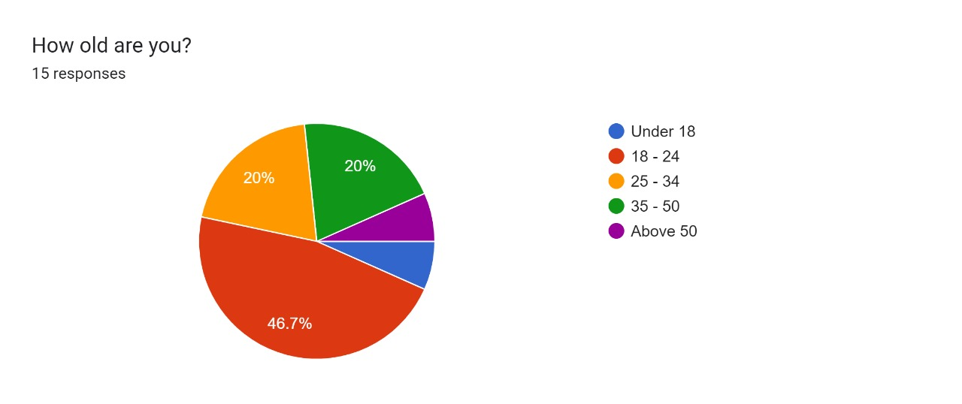

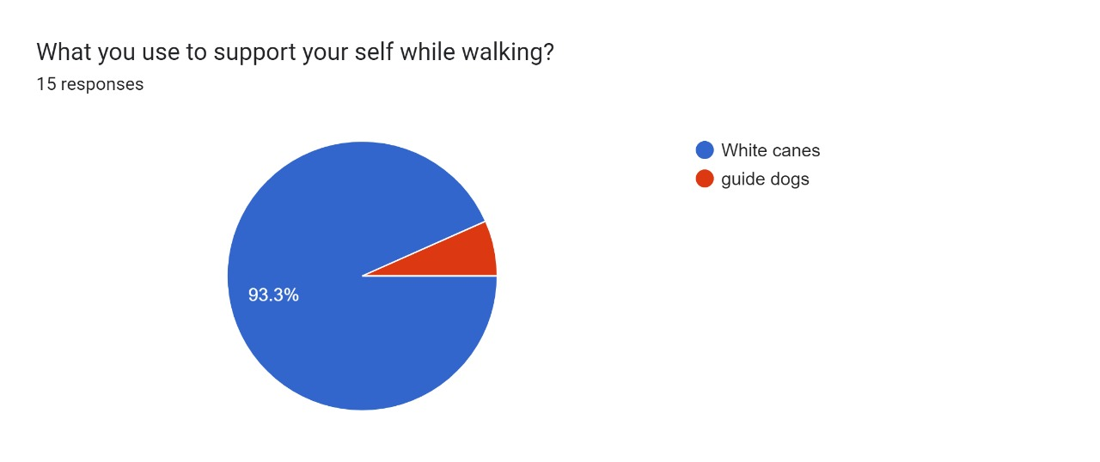

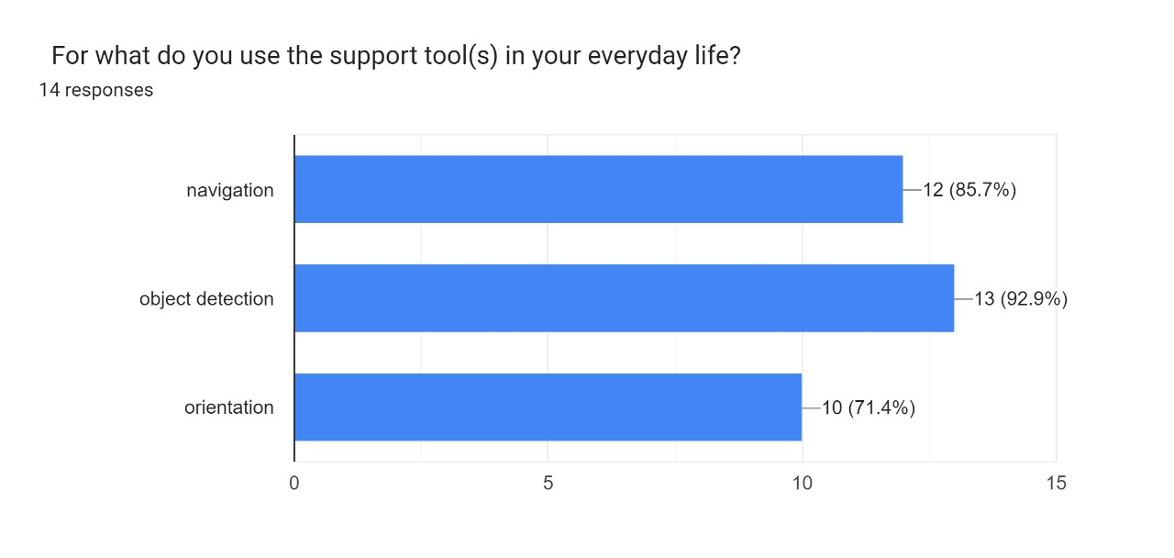

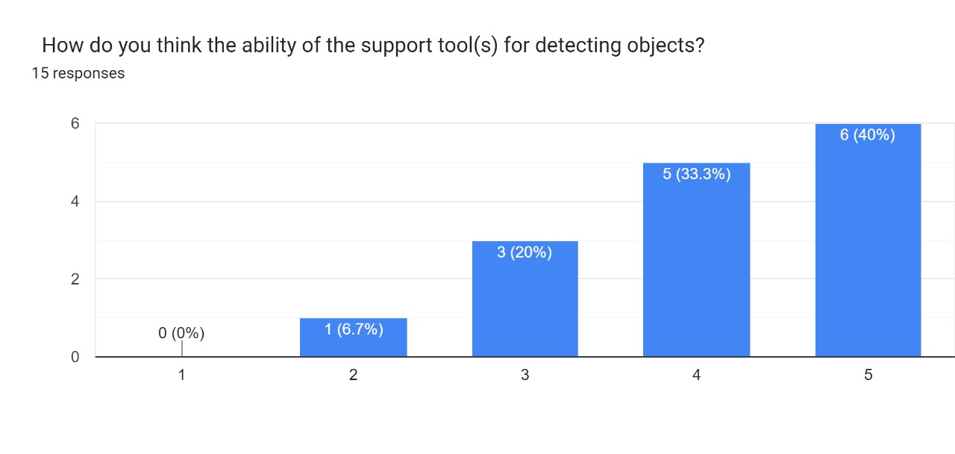

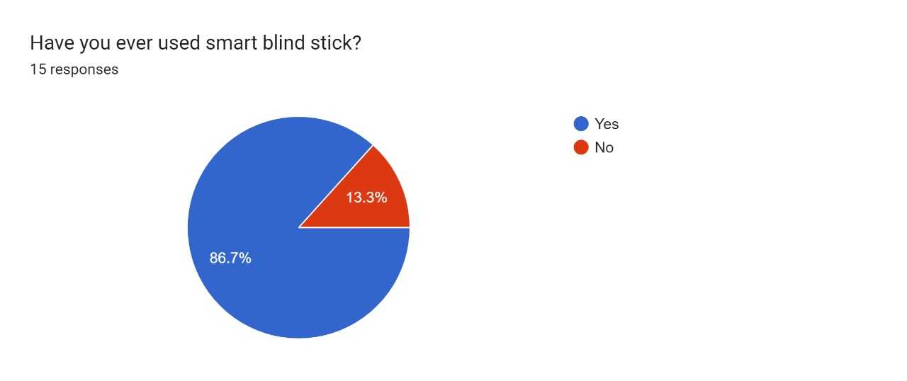

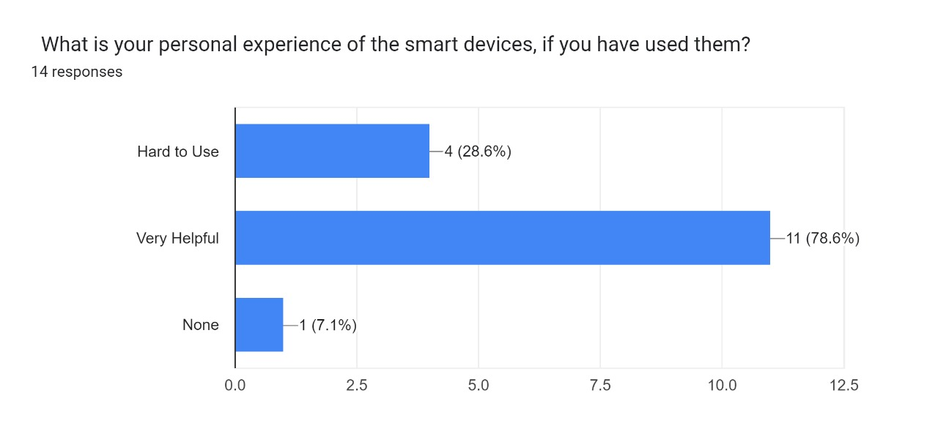

# **4.UML DIAGRAMS**

## **USE CASE DIAGRAM**

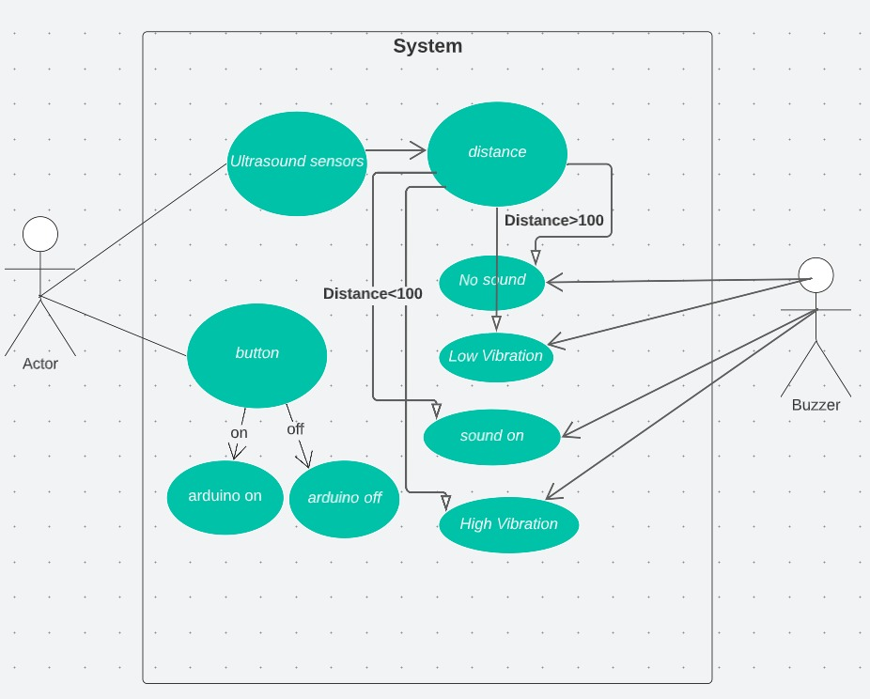

## **ACTIVITY DIAGRAM**

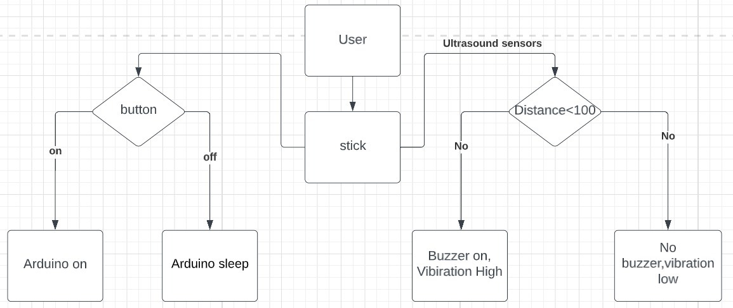

## **CLASS DIAGRAM**

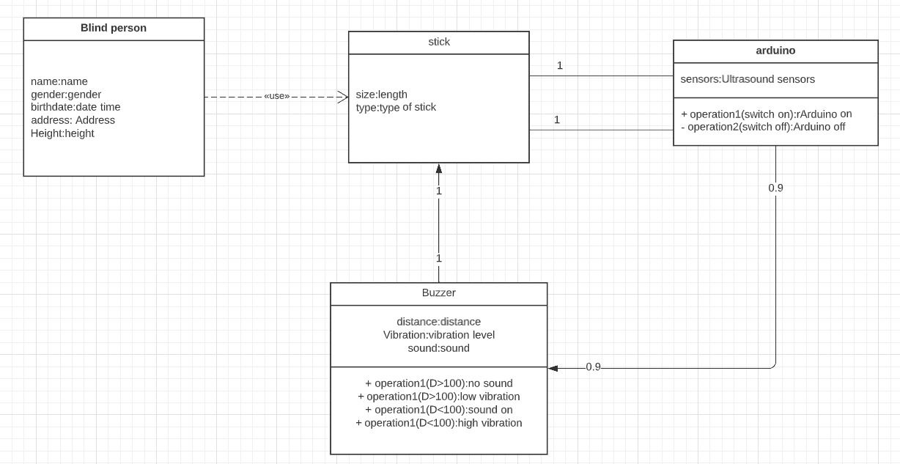

## **SEQUENCE DIAGRAM**

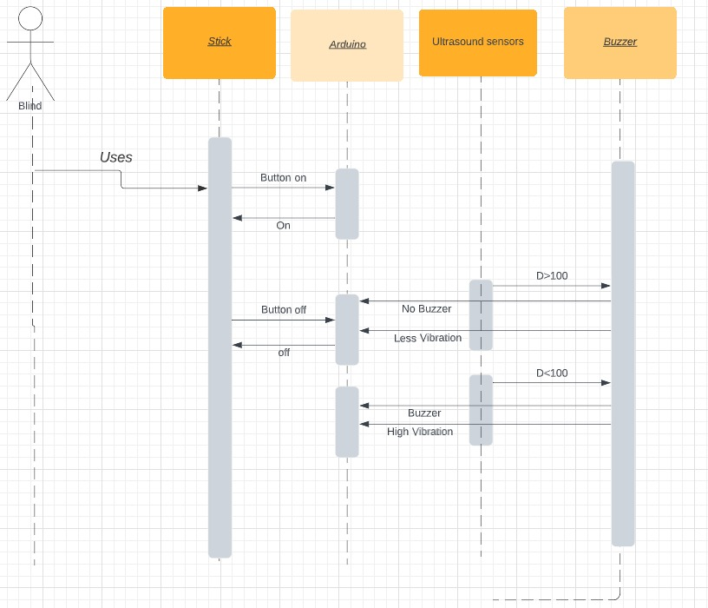

## **BLOCK DIAGRAM**

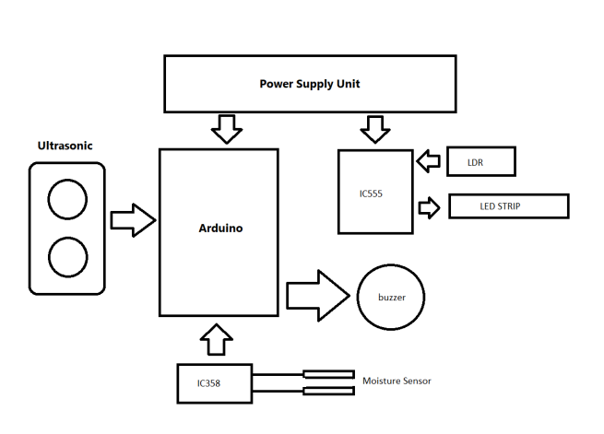

# **5.FLOW CHART**

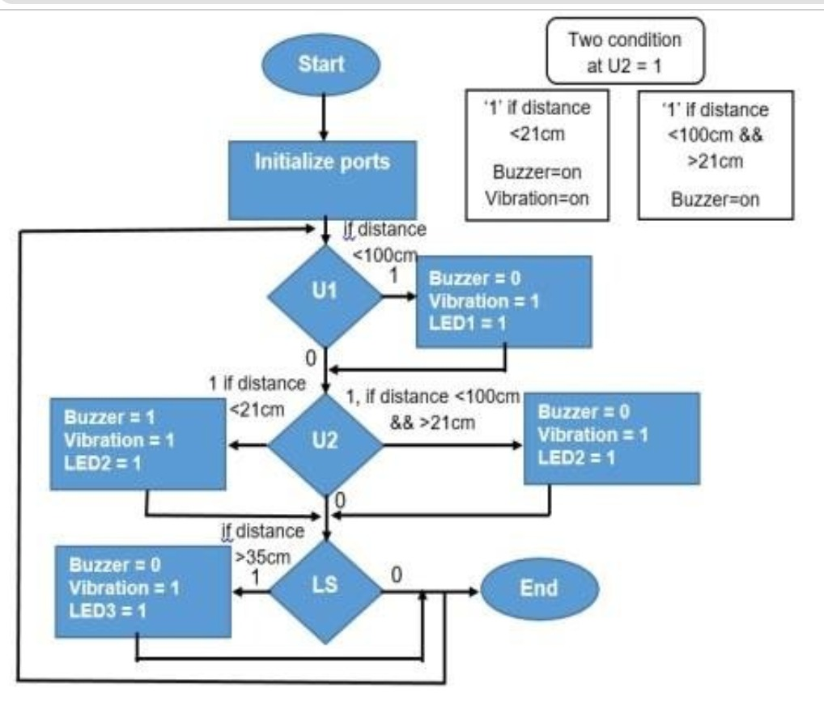

## **CIRCUIT DIAGRAM**

DISTANCE SENSING SYSTEM ON BREAD BOARD

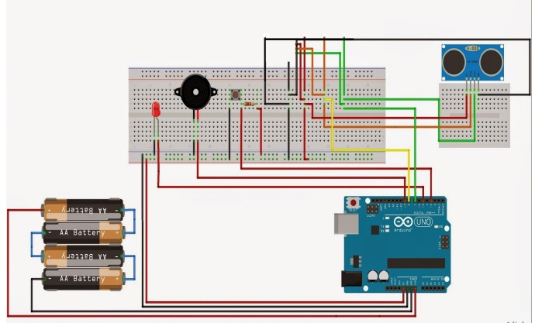

# **6.REQUIRED COMPONENTS**

## **HARDWARE COMPONENTS**

* BUZZER
* ULTRASONIC SENSOR
* MOISTURE SENSOR (Al PLATES)
* ARDUINO NANO
* LDR
* IC 555
* IC 358
* LEDs
* RESISTORS
* STICK
* 9V BATTERY
* VIBRATOR
* TAG CONNECTOR
* DC SOCKET
* DC PIN
* SWITCH
* POWER LED
* IC BASE

## **SOFTWARE COMPONENTS**

* ARDUINO 1.6.7
* TINKERCAD

# **7.COST TABLE**

|  |  |  |  |
| --- | --- | --- | --- |
| S.no | Components | Cost | Uses |
| 1. | Arduino Nano | 490 | It is used to build electronic projects |
| 2. | Buzzer | 15 | It is an audio signaling device, uses to make alert sounds |
| 3. | Ultrasonic Sensor | 120 | It is used to detect the objects |
| 4. | Moisture Sensor (AL plates) | 140 | It is used to detect the moisture of the soil or judge if there is water around the sensor |
| 5. | IC 555 | 10 | It is used for basic timing functions, such as turning a light on for a certain length of time, or to create a warning light that flashes on and off |
| 6. | LM 358 | 10 | It can be used as an transducer amplifer. |
| 7. | LDR | 10 | It is used to indicate the presence or absence of light, or to measure the light intensity |
| 8. | Resistors | 10 | It is used to control the flow of current |

|  |  |  |
| --- | --- | --- |
| S.no | Components | Cost |
| 9. | 9V Battery | 25 |
| 10. | Stick | 90 |
| 11. | 4 volt LEDs | 12 |
| 12. | Vibrator |  |
| 13. | Tag connector | 90 |
| 14. | DC Socket | 20 |
| 15. | DC Pin | 4 |
| 16. | Switch | 30 |
| 17. | Preset(2) | 20 |

# **8.ARDUINO CODE**

int triggerpin = 10; // connect trigger pin of ultrasonic to 10 pin of arduino nano

int echopin = 11; // connect echo pin of ultrasonic to 10 pin of arduino nano

int buzzer = 7;

int ws = 12;

int vibrator = 13;

void setup()

{

Serial.begin(9600);

pinMode(triggerpin, OUTPUT);

pinMode(echopin, INPUT);

pinMode(ws, INPUT);

pinMode(buzzer, OUTPUT);

pinMode(vibrator, OUTPUT);

}

void loop()

{

long duration, distance;

digitalWrite (triggerpin, LOW);

delayMicroseconds(2);

digitalWrite (triggerpin, HIGH);

delayMicroseconds(10);

duration = pulseIn(echopin, HIGH);

distance = duration/58.2;

Serial.println(distance);

delay(10);

if (digitalRead(ws)==LOW)

{

if (distance>100) // check distance

{

noTone (buzzer);

digitalWrite(vibrator,LOW);

}

else if (distance>100&&distance<50)

{

tone(buzzer, 100);

digitalWrite(vibrator, HIGH);

}

else

{

tone(buzzer, 250);

digitalWrite(vibrator, HIGH);

}

}

else

{

tone(buzzer, 500);

digitalWrite(vibrator, HIGH);

}

}

# **9.COMPONENT DESCRIPTION**

**ARDUINO:**

Arduino is an open-source platform used for building electronics projects. Arduino consists of both a physical programmable circuit board (often referred to as a microcontroller) and a piece of software, or IDE (Integrated Development Environment) that runs on your computer, used to write and upload computer code to the physical board. The Arduino platform has become quite popular with people just starting out with electronics, and for good reason. Unlike most previous programmable circuit boards, the Arduino does not separate piece of hardware (called a programmer) in order to load new code onto the board – you can simply use a USB cable. Additionally, the Arduino IDE uses a simplified version of C++, making it easier to learn to program. Finally, Arduino provides a standard form factor that breaks out the functions of the micro-controller into a more accessible package. The Uno is one of the more popular boards in the Arduino family and a great choice for beginners.

**WHAT’S ON THE BOARD**

**Power (USB / Barrel Jack)**

Every Arduino board needs a way to be connected to a power source. The Arduino UNO can be powered from a USB cable coming from your computer or a wall power supply (like this) that is terminated in a barrel jack. In the picture above the USB connection is labeled (1) and the barrel jack is labeled (2). The USB connection is also how you will load code onto your Arduino board. More on how to program with Arduino can be found in our Installing and Programming Arduino tutorial. NOTE: Do NOT use a power supply greater than 20 Volts as you will overpower (and thereby destroy) your Arduino. The recommended voltage for most Arduino models is between 6 and 12 Volts

**Pins (5V, 3.3V, GND, Analog, Digital, PWM, AREF)**

The pins on your Arduino are the places where you connect wires to construct a circuit (probably in conjuction with a breadboard and some wire. They usually have black plastic ‘headers’ that allow you to just plug a wire right into the board. The Arduino has several different kinds of pins, each of which is labeled on the board and used for different functions. GND (3): Short for ‘Ground’. There are several GND pins on the Arduino, any of which can be used to ground your circuit. 5V (4) & 3.3V (5): As you might guess, the 5V pin supplies 5 volts of power, and the 3.3V pin supplies 3.3 volts of power. Most of the simple components used with the Arduino run happily off of 5 or 3.3 volts. Analog (6): The area of pins under the ‘Analog In’ label (A0 through A5 on the UNO) are Analog In pins. These pins can read the signal from an analog sensor (like a temperature sensor) and convert it into a digital value that we can read. Digital (7): Across from the analog pins are the digital pins (0 through 13 on the UNO). These pins can be used for both digital input (like telling if a button is pushed) and digital output (like powering an LED). PWM (8): You may have noticed the tilde (~) next to some of the digital pins (3, 5, 6, 9, 10, and 11 on the UNO). These pins act as normal digital pins, but can also be used for something called PulseWidth Modulation (PWM). We have a tutorial on PWM, but for now, think of these pins as being able to simulate analog output (like fading an LED in and out). AREF (9): Stands for Analog Reference. Most of the time you can leave this pin alone. It is sometimes used to set an external reference voltage (between 0 and 5 Volts) as the upper limit for the analog input pin

**Reset Button**

Just like the original Nintendo, the Arduino has a reset button (10). Pushing it will temporarily connect the reset pin to ground and restart any code that is loaded on the Arduino. This can be very useful if your code doesn’t repeat, but you want to test it multiple times. Unlike the original Nintendo however, blowing on the Arduino doesn’t usually fix any problems.

**Power LED Indicator**

Just beneath and to the right of the word “UNO” on your circuit board, there’s a tiny LED next to the word ‘ON’ (11). This LED should light up whenever you plug your Arduino into a power source. If this light doesn’t turn on, there’s a good chance something is wrong. Time to re-check your circuit!

**Voltage Regulator**

The voltage regulator (14) is not actually something you can (or should) interact with on the Arduino. But it is potentially useful to know that it is there and what it’s for. The voltage regulator does exactly what it says – it controls the amount of voltage that is let into the Arduino board. Think of it as a kind of gatekeeper; it will turn away an extra voltage that might harm the circuit. Of course, it has its limits, so don’t hook up your Arduino to anything greater than 20 volts.

**ARDUINO SOFTWARE**

ARDUINO LANGUAGE

* C like syntax, but simplified
* Abstracts the pin naming to numbers
* Easy to learn, yet powerful
* Easy to reuse C-code from other projects
* Lots of libraries available
* Libraries can be written in C++

**ULTRASONIC SENSOR**

It is devices that use electrical–mechanical energy transformation to measure distance from the sensor to the target object. Ultrasonic waves are longitudinal mechanical waves which travel as a sequence of compressions and rarefactions along the direction of wave propagation through the medium. Apart from distance measurement, they are also used in ultrasonic material testing (to detect cracks, air bubbles, and other flaws in the products), Object detection, position detection, ultrasonic mouse, etc.

These sensors are categorized in two types according to their working phenomenon – piezoelectric sensors and electrostatic sensors. Here we are discussing the ultrasonic sensor using the piezoelectric principle. Piezoelectric ultrasonic sensors use a piezoelectric material to generate the ultrasonic waves.

**Ultrasonic (UV) Sensors or Ultrasound Sensors:**

Bats are wonderful creatures. Blind from the eyes and yet a vision so precise that could distinguish between a moth and a broken leaf even when flying at full speed. No doubt the vision is sharper than ours and is much beyond human capabilities of seeing, but is certainly not beyond our understanding. Ultrasonic ranging is the technique used by bats and many other creatures of the animal kingdom for navigational purposes. In a bid to imitate the ways of nature to obtain an edge over everything, we humans have not only understood it but have successfully imitated some of these manifestations and harnessed their potential to the greatest extent

**RESISTORS**

* A resistor may be defined as electronics components which are manufactured with a specified amount of resistance.
* A resistance conducts current in both directions. This means that a resistor can be connected in an electronic circuit without any concern for the lead polarization.
* In an electronic circuit, the purpose of resistor is twofold: firstly, it controls the flow of electric current. Secondly, it provides desired amount of voltage in electric circuit.

**Important resistor specification**

For all practical purpose, a resistor is almost completely defined with three specifications.

**Resistance Value, Percentage Tolerance and Wattage Rating**.

* Resistance value tells us about the opposition it offers to the flow of electrical current. Resistance is measured in ohms (Ω).
* Tolerance of a resistor is the permissible plus or minus deviation in resistance value. For example, the actual resistance value of a 100k, ±10% Resistor could be anywhere between 90k and 110k.Resistors with tight tolerance usually ±1% or better are referred as Precision Resistors. Metal film resistors are an example.
* Wattage rating is the maximum power in watts that the resistor can safely dissipate. The wattage rating of a resistor should be chosen that it is about twice the power that is likely to be dissipated when used in the circuit. Less common specifications include the voltage rating, the temperature co-efficient of resistance and voltage co-efficient of resistance.

**Resistor coding schemes**

* There are various coding and marking schemes used to express the major specifications of fixed resistors on the components itself.
* We are all familiar with the colour coding of resistors. Other marking schemes include the use of straight numerical value indication, certain numerical codes that can easily translated and numerical codes that can be understood only with help of the data sheet supplied by manufacturer. • The coding schemes used usually indicate the resistance value and the percentage tolerance of the resistors.
* Wattage rating is indicated only by the physical dimension. In some industrial type designations, wattage rating is also expressed by the code itself in addition to the resistance value and the percentage tolerance

**PRESETS**

For example to set the frequency of an alarm tone or the sensitivity of a light-sensitive circuit. A small screwdriver or similar tool is required to adjust presets.Presets are much cheaper than standard variable resistors so they are sometimes used in projects where a standard variable resistor would normally be used. Multiturn presets are used where very precise adjustments must be made. The screw must be turned many times (10+) to move the slider from one end of the track to the other, giving very fine control. These are miniature versions of the standard variable resistor. They are designed to be mounted directly onto the circuit board and adjusted only when the circuit is built

**BUZZER**

A buzzer connected to port P1.0 of the micro controller through a driver transistor (Q1). The buzzer requires 12 volts at a current of around 50ma, which can not provided by the micro controller. So the driver transistor is added. The buzzer is used to audible indication for valid ID and error situation and Alarm mode. As soon as pin of the micro controller goes high, the buzzer operates.

**10.APPLICATION AND ADVANTAGE**

**APPLICATION**

* To avoid Interference and the Blinds to Walk Carefully.
* It Can Be Used as Obstacle Avoidance System
* It acts automatically to prevent collisions if an eventuality arises. Does not depend on human action.

**ADVANTAGE**

* It does not require any inputs to be fed by the crew at the start of journey, thus human error is eliminated.
* The main advantage of our project is that it is compact and portable.
* Another great advantage of our project is, it is Easy to use.
* Cost is very little to construct the project.
* Maintaining and repairing cost is low.
* Use the locally available components.
* No human observation is needed for this project. It makes the project more reliable.
* Another greater advantage of our project it is computer interfacing.

# **11.RESULT**

In this project, we have built a guide stick to help blind people to understand whether there is an object around the stick or not. That can be useful for blinds to walk carefully.

By constructing this project, we have learned how to use timer and interrupt and understand their methods / implementations. We also recognized that how to make arduino sleep by using interrupt. Cell phones that we use have the same process to wake up. So it was very beneficial for us to understand how cell phones are listening buttons.

Furthermore, we examined the ultrasound sensors and researched their structure to understand how does that sensor measure distance by using ultra sound voice that beyond 20KHZ which a human cannot hear