Stored XSS into HTML context with nothing encoded
ABSTRACT
- This project demonstrates a Stored Cross-Site Scripting (XSS) vulnerability identified in a controlled lab environment provided by PortSwigger Web Security Academy.
- The goal of this project is to analyze how improper input validation allows attackers to inject malicious scripts into a web application.
- During testing, a payload was injected into the comment section, which was stored on the server and executed when the page was reloaded.
- The final result successfully triggered a JavaScript alert (alert(1)), proving the existence of a stored XSS vulnerability. This highlights the importance of secure coding practices in web applications.

DELIVERABLES
The following deliverables were achieved in this project:
- Identification of Stored XSS vulnerability
- Analysis of vulnerable input field (comment section)
- Successful execution of malicious payload
- Proof of Concept (PoC) with alert popup
- Screenshots showing attack steps and results
- Security recommendations to prevent such attacks

CODE / TOOLS USED
Tools Used:
- PortSwigger Lab Environment
Used to perform the Stored XSS attack in a safe, controlled lab
- Burp Suite (Proxy Browser – Chromium)
Used to access the lab and observe the request/response behaviour
Payload Used (Code):
<script>alert(1)</script>
Purpose:
- To check whether user input is stored without sanitization
- To verify execution of injected JavaScript

POC (PROOF OF CONCEPT)
Steps Performed:
- Opened the Stored XSS lab in PortSwigger Web Security Academy
- Navigated to the blog post page
- Entered the payload in the comment field: <script>alert(1)</script>
- Filled required fields (Name, Email, Website)
- Clicked on Post Comment
- Reloaded / revisited the blog page
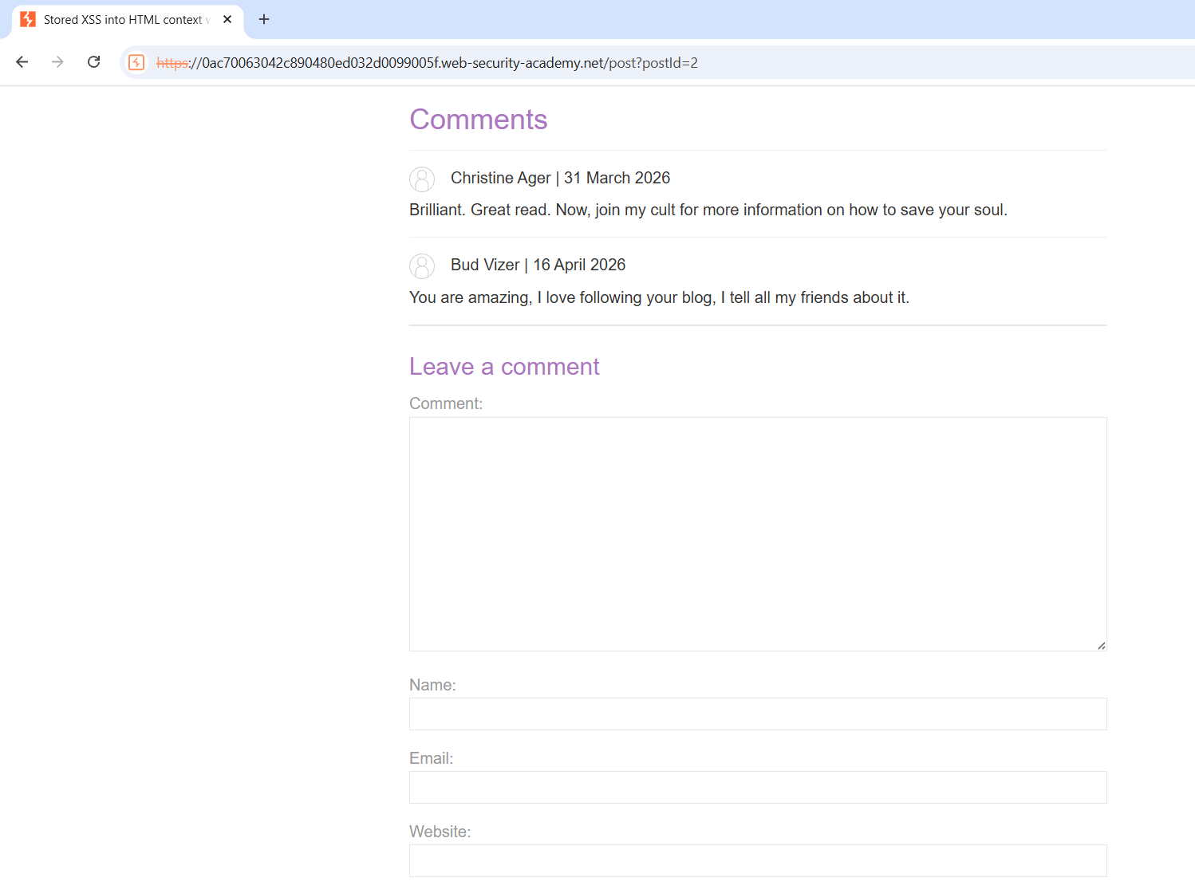
Malicious payload injected in comment field
User input submitted to the application
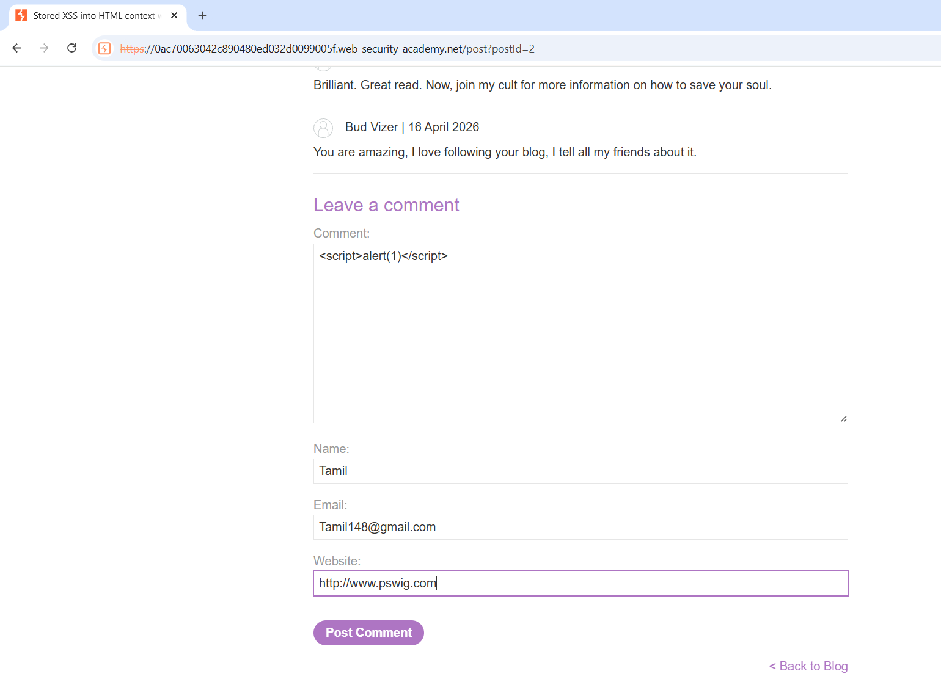
Stored XSS executed successfully (alert popup triggered)
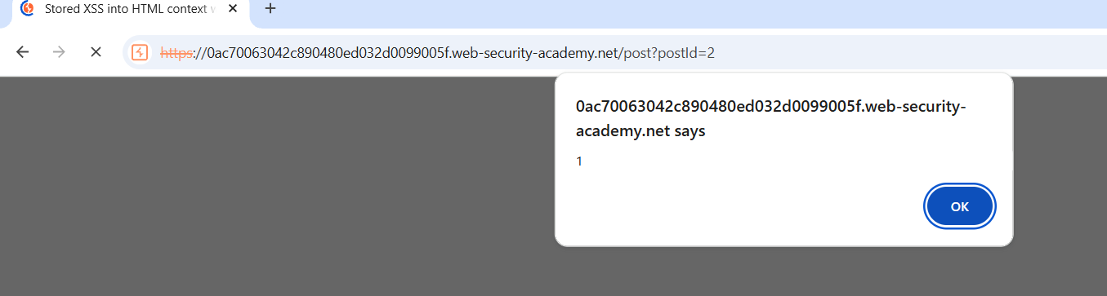

Result:
- The injected script was stored in the application
- When the page loaded, a popup appeared: alert(1)

Conclusion:
This confirms that the application is vulnerable to Stored XSS, as malicious scripts are stored and executed automatically for users viewing the page.
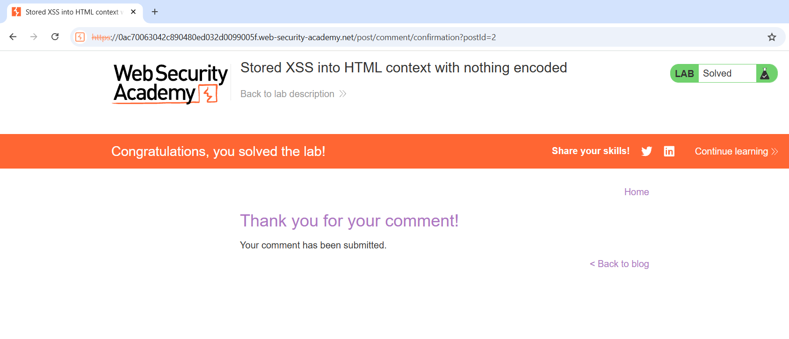

References
- PortSwigger Web Security Academy
https://portswigger.net/web-security
- Burp Suite Documentation
https://portswigger.net/burp
- OWASP
https://owasp.org
- OWASP Top 10 – Injection (A03:2021)
https://owasp.org/www-project-top-ten/

Impact
A successful Stored XSS attack can allow attackers to execute malicious JavaScript in a victim’s browser. This may lead to session hijacking, cookie theft, unauthorized actions, website defacement, phishing attacks, or redirection to malicious websites. Since the payload is permanently stored in the application, every user visiting the affected page can be impacted automatically.
Mitigation
The vulnerability can be prevented by implementing proper input validation and output encoding for all user-supplied data. Special characters should be sanitized before storing or displaying input in the browser. Additional security measures such as Content Security Policy (CSP), secure cookie settings (HTTP Only), and regular security testing can further reduce the risk of Stored XSS attacks.

