How can Myntra handle increasing cyber security threats in a cloud-based environment?
What challenges arise while protecting customer data from cyber attacks?
How can a security team identify and prevent potential threats effectively?
What measures should be taken to ensure data safety and maintain user trust?
- Identify the possible security issues in myntra
Unusual login
Unknown device login alert
Authorization request
Cross site scripting
Hacker goal :
User personal data steal
Name
Phone number
Payment details
- Identify the solution of those security issues
Unusual login :
Unknown device login alert :
- password reset
- Enable MFA
- Temporarily lock the account
- Revoke all active sessions
Authorization request :
- Implement role based access (admin-full access, user-limited access,guest- minimal access)
- Authentication + Authorization Separation
First: Verify identity (login)
Next: Check permission (authorization)
tools like Microsoft Entra ID
- Least Privilege Principle
Give only minimum required access
Avoid giving admin rights unnecessarily
- Multi-Factor Authentication (MFA)
Add extra security layer before granting access
- Secure API Authorization
- Use: Tokens (JWT)
- Logging & Monitoring
Track:
Who accessed what
When and from where
Use SIEM tools like Splunk
- Regular Access Review
Periodically check:
Who has access?
Remove unnecessary permissions

Cross site scripting :

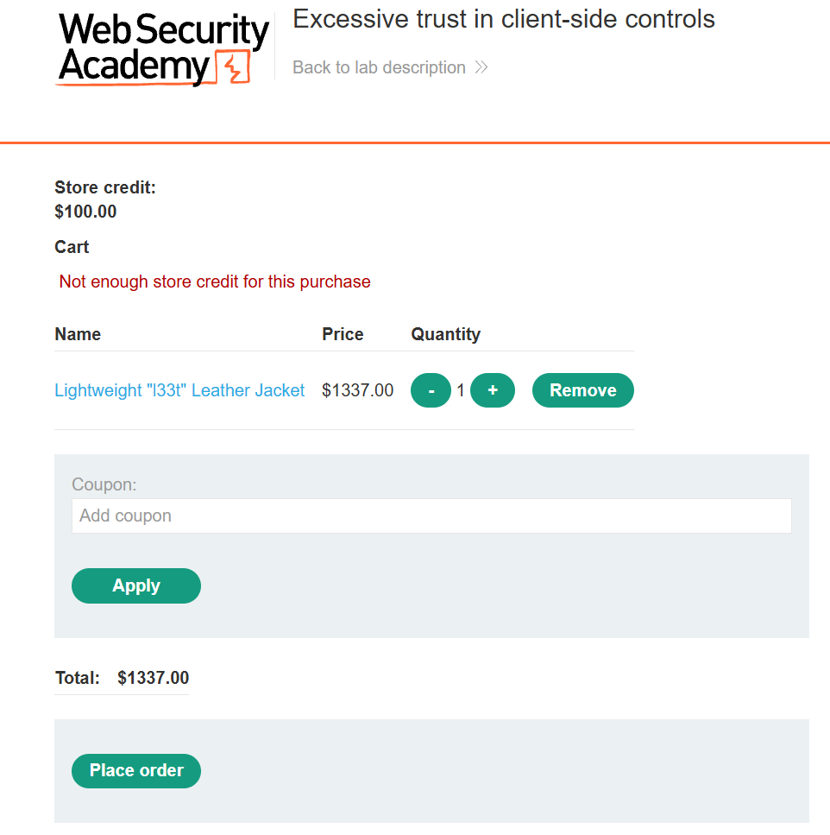
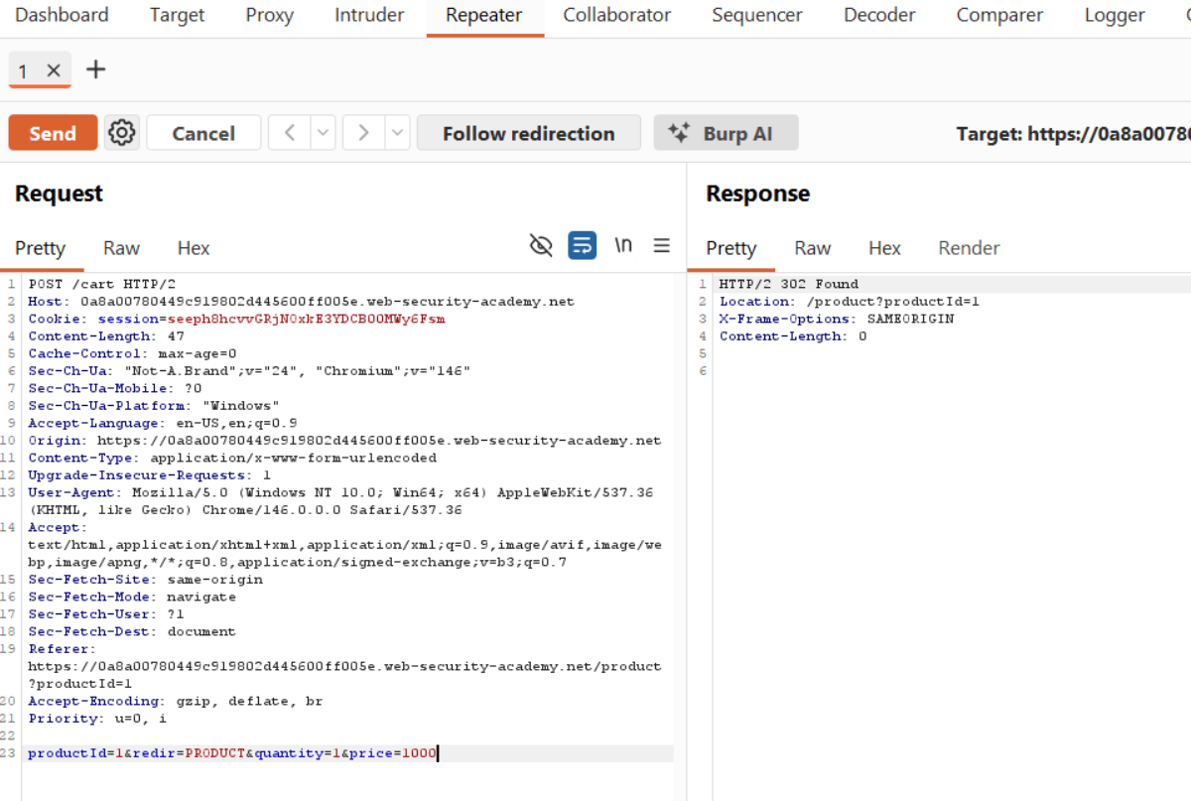
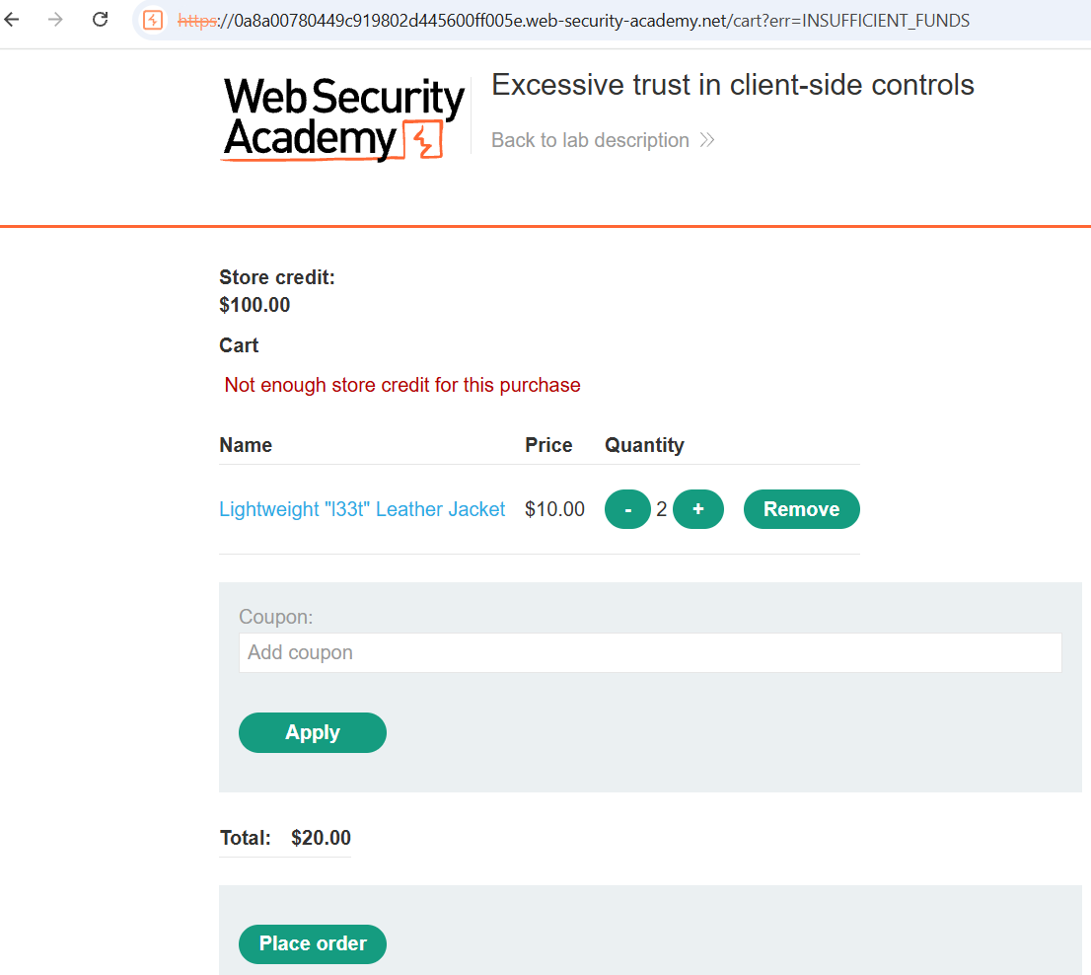
Client-side price manipulation (parameter tampering)
Price is sent from frontend → attacker modifies it → backend accepts it
Leads to financial loss and fraud
Security Solutions
1. Never Trust Client-Side Data
Do not accept price from request body
Always fetch price from server/database
Client sends: product_id
Server calculates: price from DB
Ignore any price field from client
2. Server-Side Validation
Validate:
Product ID exists
Price matches database value
Reject request if mismatch
3. Use Secure Session / Cart Handling
Store cart details (product + price) in server session
Do not rely on frontend/cart
4. Recalculate Total at Checkout
Always recompute:
Item price
Quantity
Total amount
Do not use client-submitted totals
5. Use Signed Tokens (Optional Advanced)
Use HMAC / JWT to sign cart data
If attacker modifies → signature breaks → reject request
Example framework: OAuth 2.0 (for secure token handling concepts)
6. Implement WAF & Monitoring
Detect tampering attempts using:
AWS WAF
Cloudflare
Alert on:
Price mismatch
Suspicious request modification
7. Logging & SIEM Monitoring
Log:
Original vs submitted values
User ID, IP, timestamp
Monitor using:
Splunk
Microsoft Sentinel
8. Security Testing
Perform regular testing:
Proxy testing (like attacker)
Business logic testing
Follow guidelines from OWASP

3.data flow

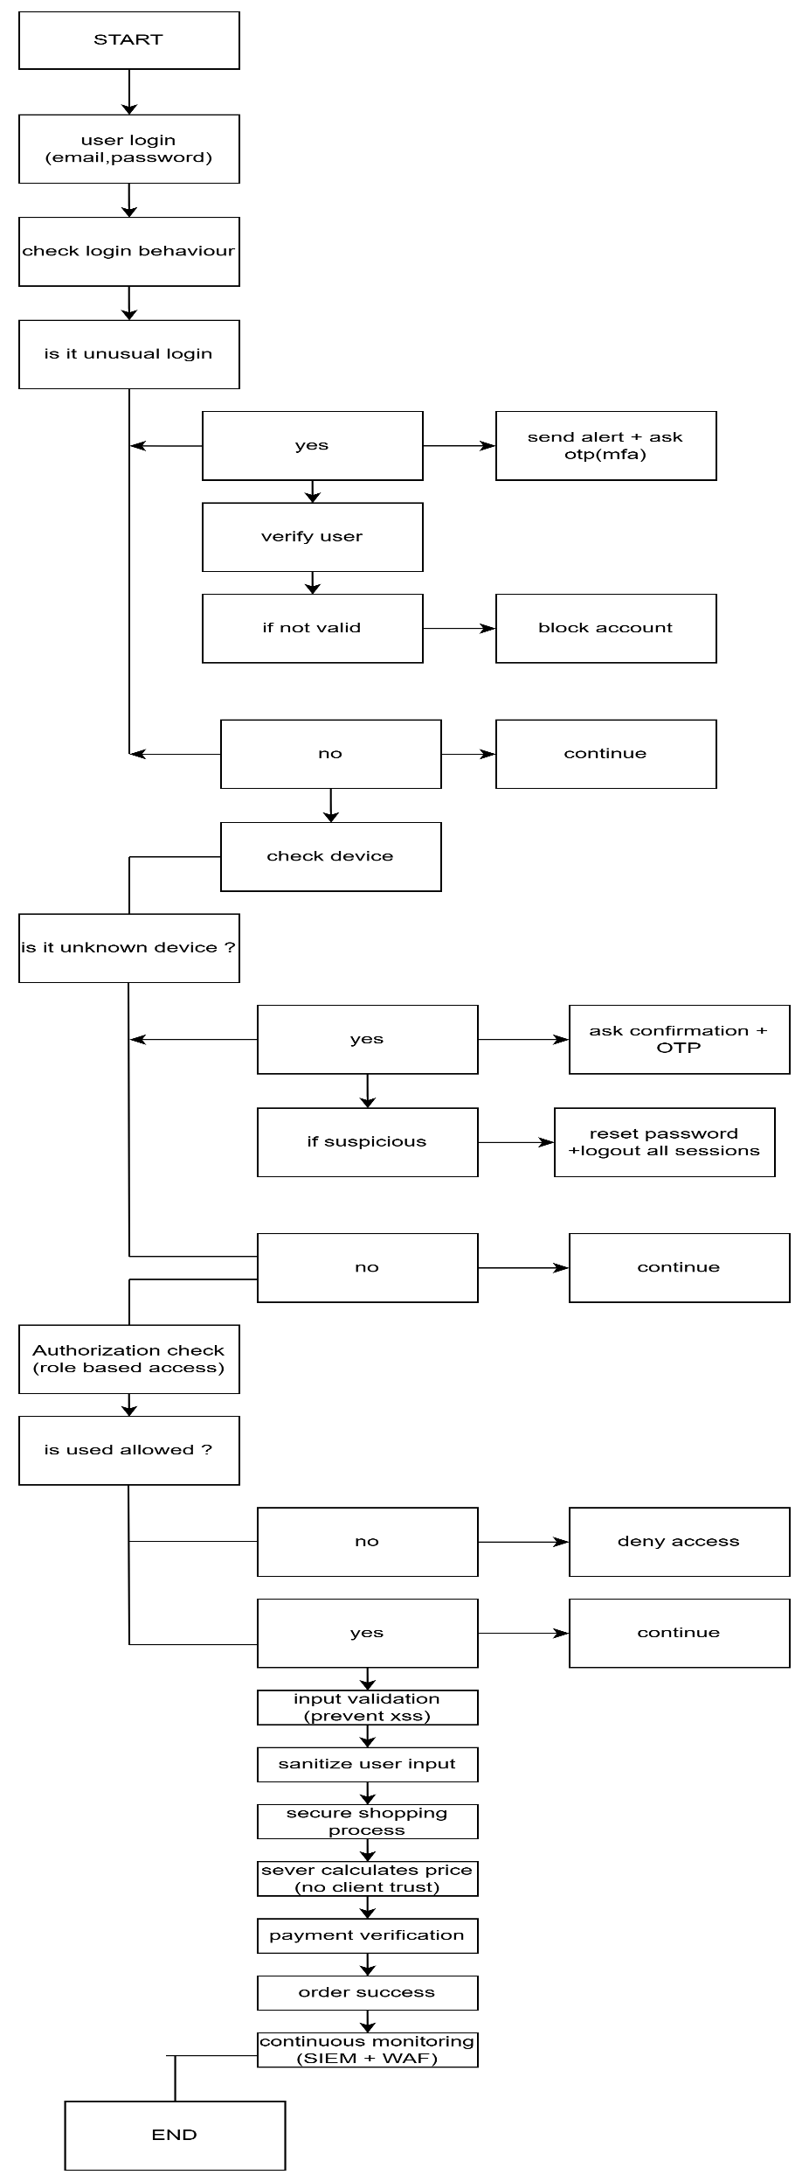

4.Draw the architecture for fixing it
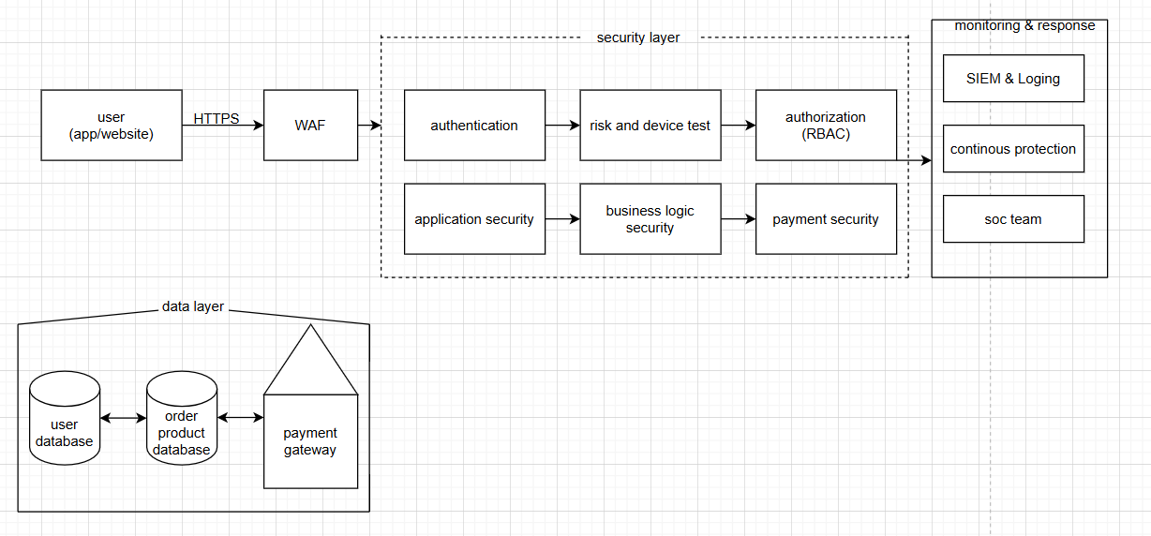

HTTPS – secure communication
MFA – extra security layer
RBAC – Role based access control
Input validation & XSS protection
Server – side price (validation – no client trust)
SIEM & logging – continuous monitoring
WAF – attack protection
Regular security testing – OWASP

