Phase 5:

Project Title: **SENTIMENT ANALYSIS FOR MARKETING**

Problem definition:



* **Sentiment Analysis**: Sentiment analysis, a branch of NLP, involves using algorithms to determine the sentiment or emotional tone behind a piece of text. In this context, customer feedback, which can be in the form of reviews, comments, or survey responses, is analyzed to classify sentiments as positive, negative, or neutral. This analysis provides a quantitative measure of how customers perceive a competitor's product.
* **Identifying Strengths and Weaknesses**: Through sentiment analysis, companies can identify specific aspects of a competitor's product that customers appreciate (strengths) and aspects that lead to dissatisfaction (weaknesses). Positive sentiments might indicate features customers love, excellent customer service, or overall satisfaction. Conversely, negative sentiments could highlight areas needing improvement such as product quality, customer support issues, or pricing concerns.
* **Competitive Benchmarking**: By comparing the sentiment analysis results of their competitor's products with their own, companies gain a clear benchmark. This benchmarking allows them to understand where they stand in the market in terms of customer satisfaction and what aspects of their own product they need to work on to be more competitive.
* **NLP Methods**: Various NLP techniques are employed for this analysis. These include tokenization (breaking down text into words or phrases), part-of-speech tagging (identifying the grammatical parts of each word), and named entity recognition (identifying entities such as product names). Additionally, advanced techniques like sentiment lexicons, machine learning algorithms (such as Naive Bayes, Support Vector Machines), and deep learning models (like Recurrent Neural Networks) are used to perform nuanced sentiment analysis.
* **Extracting Actionable Insights**: The ultimate goal of this sentiment analysis is to extract actionable insights. These insights can inform product development, marketing strategies, and customer service initiatives. For instance, if customers consistently praise a competitor's user-friendly interface, a company might invest in improving their own product's user experience. On the other hand, if customers express dissatisfaction with the competitor's customer support, the company might emphasize their superior customer service in their marketing campaigns.

**Design Thinking:**

1. Data Collection:

* Identify a dataset containing customer reviews and sentiments about competitor products.
* **Dataset Link:**[**https://www.kaggle.com/datasets/crowdflower/twitter-airline-sentiment**](https://www.kaggle.com/datasets/crowdflower/twitter-airline-sentiment)

1. Data Preprocessing:

Clean and preprocess the textual data to prepare it for analysis. This step involves tasks like removing special characters, converting text to lowercase, and handling missing or irrelevant data. Cleaning the data ensures that the subsequent analysis is based on accurate and consistent information.

1. Sentiment Analysis Techniques:

Employ different Natural Language Processing (NLP) techniques for sentiment analysis:

1. Bag of Words: Represent the text data as a bag of words, disregarding grammar and word order. This method simplifies the text into a collection of words, enabling sentiment analysis based on word frequency.
2. Word Embeddings: Use pre-trained word embeddings like Word2Vec or GloVe to represent words as high-dimensional vectors. This captures semantic relationships between words and enhances the analysis's understanding of context.
3. Transformer Models: Utilize transformer-based models like BERT or GPT to capture complex contextual information. These models excel in understanding the context of words in a sentence, leading to more accurate sentiment analysis results.
4. Feature Extraction:

* Extract features and sentiments from the preprocessed text data. Features can include specific keywords, phrases, or aspects mentioned in the reviews. Sentiments are derived through the chosen sentiment analysis techniques, categorizing reviews as positive, negative, or neutral based on the content's emotional tone.

1. Visualization:

* Create visualizations to depict the sentiment distribution and analyze trends within the dataset. Visual representations such as bar charts, pie charts, or heatmaps can illustrate the proportion of positive, negative, and neutral sentiments. Time-based visualizations or word clouds can also reveal trends and common themes within the reviews.

1. Insights Generation:

* Gather feedback by testing the model with dataset and

integrate them to the marketing systems.

* Translate the sentiment analysis results into actionable

insights for marketing strategies.

* Continuously assess the performance and identify the areas

for improvement based on customer feedback.

FLOW CHART:

Data Collection

Data Preprocessing

Sentiment analysis techniques

Feature Extraction

Insights Generation

Visualization

METHODOLOGY

Data Preprocessing**:**

We start by importing the necessary libraries for data cleaning and tokenization, such as NLTK and spaCy. We then load the airline tweets dataset and perform some initial data exploration. We can also remove any irrelevant or noisy data such as tweets that contain links or mentions of other Twitter users. After that, we perform text cleaning by removing stop words, special characters, and other noise from the text data. Finally, we tokenize the text data and convert it into numerical format for feature extraction.

Feature Extraction:

We can extract features from the tokenized text data using techniques such as Word2Vec or GloVe. These methods convert the text data into fixed-length vectors that can be fed into the RNN model. We can also use techniques such as tf-idf or bag-of-words to represent the text data.

Model Building:

We can build a Recurrent Neural Network (RNN) model to classify the sentiment of the airline tweets. We can use architectures such as Long Short-Term Memory (LSTM) or Gated Recurrent Units (GRU) to model the sequence of the text data. We can also use techniques such as dropout and batch normalization to regularize the model and prevent overfitting.

ModelTraining**:**

We can train the RNN model on the preprocessed and feature-extracted data. We can use techniques such as cross-validation to evaluate the model’s performance. We can also use techniques such as early stopping to prevent the model from overfitting the training data.

Model Testing:

We can test the trained model on new, unseen data to evaluate its performance. We can use metrics such as accuracy, precision, recall, and F1 score to evaluate the model’s performance on the test data. We can also use techniques such as confusion matrix and ROC curve to analyze the model’s performance in more detail.

DATA SET:

Link to the Kaggle project site: <https://www.kaggle.com/crowdflower/twitter-airline-sentiment>

**STEP – 1:**

**Import the libraries, load dataset, print shape of data, data description:**

import pandas as pd

import numpy as np

import seaborn as sns

import matplotlib.pyplot as plt

%matplotlib inline

import re, string, unicodedata

from bs4 import BeautifulSoup

!pip install contractions

import nltk

import contractions

nltk.download('wordnet')

nltk.download('punkt')

from nltk.tokenize import word_tokenize

from nltk.stem import LancasterStemmer, WordNetLemmatizer

from sklearn.feature_extraction.text import CountVectorizer, TfidfVectorizer

from sklearn import metrics

from sklearn.ensemble import RandomForestClassifier

from sklearn.model_selection import train_test_split

from sklearn.model_selection import cross_val_score

from sklearn.model_selection import GridSearchCV

from sklearn.metrics import accuracy_score,confusion_matrix,classification_report

from mlxtend.plotting import plot_confusion_matrix

from imblearn.over_sampling import SMOTE

*#from google.colab import drive*

*#drive.mount('/content/drive/')*

import os

for dirname, _, filenames **in** os.walk('/kaggle/input'):

for filename **in** filenames:

print(os.path.join(dirname, filename))

LOAD DATASET**:**

*#Tweet= pandas.read_csv("../input/Tweets.csv")*

*#Tweet.head()*

project_path = '/kaggle/input/twitter-airline-sentiment/'

*# Load the dataset*

tweet_data = pd.read_csv(project_path + 'Tweets.csv',header=0)

tweet_data.head()

SHAPE OF DATA:

*# There are 14640 rows and 15 columns in the tweet data*

Print(tweet_data.shape)

(14640, 15)

tweet_data.info()

<class 'pandas.core.frame.DataFrame'>

RangeIndex: 14640 entries, 0 to 14639

Data columns (total 15 columns):

# Column Non-Null Count Dtype

--- ------ -------------- -----

0 tweet_id 14640 non-null int64

1 airline_sentiment 14640 non-null object

2 airline_sentiment_confidence 14640 non-null float64

3 negativereason 9178 non-null object

4 negativereason_confidence 10522 non-null float64

5 airline 14640 non-null object

6 airline_sentiment_gold 40 non-null object

7 name 14640 non-null object

8 negativereason_gold 32 non-null object

9 retweet_count 14640 non-null int64

10 text 14640 non-null object

11 tweet_coord 1019 non-null object

12 tweet_created 14640 non-null object

13 tweet_location 9907 non-null object

14 user_timezone 9820 non-null object

dtypes: float64(2), int64(2), object(11)

memory usage: 1.7+ MB

tweet_data.dtypes

tweet_id int64

airline_sentiment object

Tweet_location object

user_timezone object

dtype: object

**EXPLOROTARY DATA ANALYSIS EDA:**

**Sentiment Analysis for each Airline**

g = sns.FacetGrid(tweet_data, col="airline", col_wrap=3, height=5, aspect =0.7)

g = g.map(sns.countplot, "airline_sentiment",order =tweet_data.airline_sentiment.value_counts().index, palette='plasma')

plt.show()

*# Here we can see that United Airlines, US Airways, American Airlines has the most number of negative review*

*# Virgin America has the least number of negative reviews*

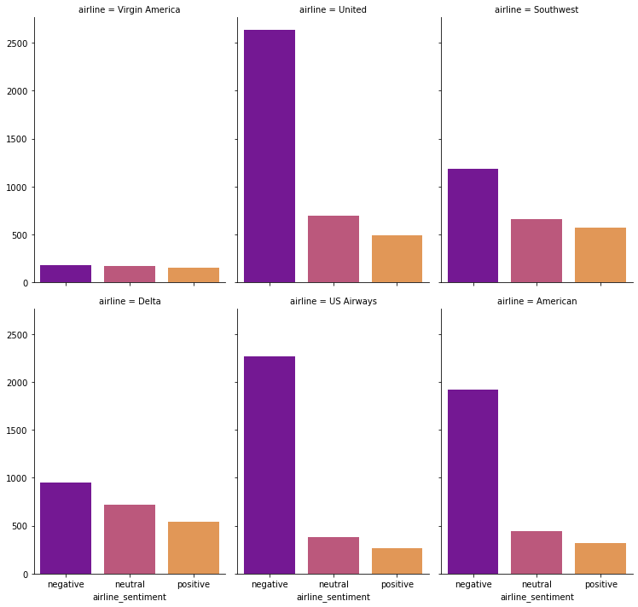

**Most Common negative review reasons**

*# Check the most common negative reason*

y = tweet_data['negativereason']

print(y.value_counts())

plt.figure(figsize=(25,5))

g = sns.countplot(y)

*# Customer service and late flight seems to be the main reason why customers are giving bad feedback*

Customer Service Issue 2898

Late Flight 1655

Can't Tell 1190

Cancelled Flight 839

Lost Luggage 718

Bad Flight 580

Flight Booking Problems 529

Flight Attendant Complaints 479

longlines 178

Damaged Luggage 74

Name: negativereason, dtype: int64

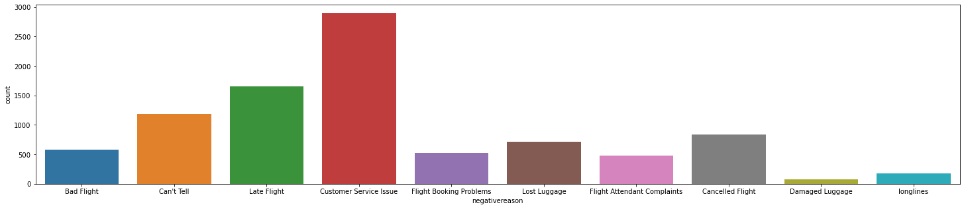

**STEP – 2:**

**Understand of data-columns:**

a. Drop all other colmns except “text” and “airline_sentiment”.

b. Check the shape of data.

c. Print first 5 rows of data.

tweet_data.columns

Index(['tweet_id', 'airline_sentiment', 'airline_sentiment_confidence',

'negativereason', 'negativereason_confidence', 'airline',

'airline_sentiment_gold', 'name', 'negativereason_gold',

'retweet_count', 'text', 'tweet_coord', 'tweet_created',

'tweet_location', 'user_timezone'],

dtype='object')

**Drop Irrelevant columns**

*# Let us now remove irrelevant columns*

tweet_data_relevant = tweet_data.drop(['tweet_id', 'airline_sentiment_confidence',

'negativereason', 'negativereason_confidence', 'airline',

'airline_sentiment_gold', 'name', 'negativereason_gold',

'retweet_count','tweet_coord', 'tweet_created',

'tweet_location', 'user_timezone'], axis =1)

**Shape of Data**

*# There are 14568 rows and 2 columns (This is result of keeping relevant rows and duplicate data cleanup)*

tweet_data_relevant.shape

(14568, 2)

**Printing first 5 rows of data**

tweet_data_relevant.head(5)

print(tweet_data_relevant.airline_sentiment.value_counts())

negative 9140

neutral 3083

positive 2345

Name: airline_sentiment, dtype: int64

**Is the data balanced**

y = tweet_data_relevant['airline_sentiment']

print(y.value_counts())

plt.figure(figsize=(20,5))

g = sns.countplot(y)

*# No, Here we can see that the data is not balanced, There are lot of negative sentiments*

negative 9140

neutral 3083

positive 2345

Name: airline_sentiment, dtype: int64

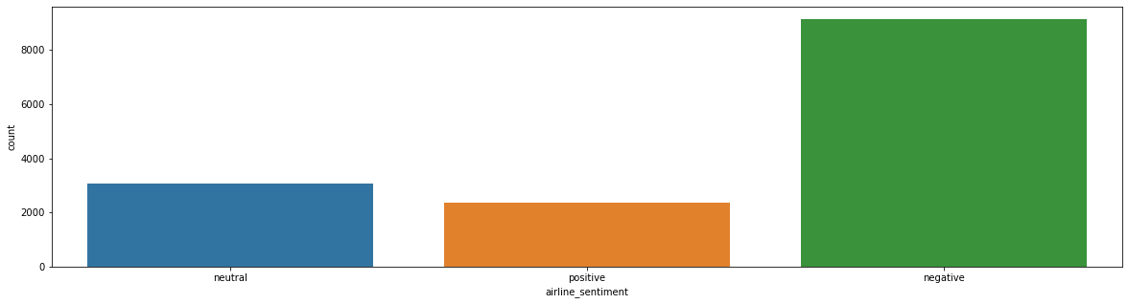

**STEP 3:**

**Text pre-processing: Data preparation.**

**Html tag removal:**

def perform_html_cleanup( raw_review ):

*# 1. Remove HTML*

review_text = BeautifulSoup(raw_review).get_text()

return review_text

**Replace Contraction**

def replace_contractions(raw_review):

*#Replace contractions in raw_review*

return contractions.fix(raw_review)

**Tokenization**

def perform_tokenization( raw_review ):

*# 2. Perform Tokenization*

word_tokens = word_tokenize(raw_review) *# Tokenization*

return word_tokens

**Removal of Numbers**

def remove_numbers(list_of_words):

pattern = '[0-9]'

list = [re.sub(pattern, '', i) for i **in** list_of_words]

return list

**Remove special characters and punctuations**

def remove_special_character_punctuation(list_of_words):

pattern = '[^A-Za-z0-9]+'

list = [re.sub(pattern, '', i) for i **in** list_of_words]

return list

def remove_punctuation(words):

*"""Remove punctuation from list of tokenized words"""*

new_words = [] *# Create empty list to store pre-processed words.*

for word **in** words:

new_word = re.sub(r'[^\w\s]', '', word)

if new_word != '':

new_words.append(new_word) *# Append processed words to new list.*

return new_words

**Conversion to Lower case**

def to_lowercase(words):

*"""Convert all characters to lowercase from list of tokenized words"""*

new_words = [] *# Create empty list to store pre-processed words.*

for word **in** words:

new_word = word.lower() *# Converting to lowercase*

new_words.append(new_word) *# Append processed words to new list.*

return new_words

**Remove empty String**

def remove_empty_string(words):

return list(filter(None, words))

**Stemming**

def stem_words(words):

*"""Stem words in list of tokenized words"""*

stemmer = LancasterStemmer()

stems = [] *# Create empty list to store pre-processed words.*

for word **in** words:

stem = stemmer.stem(word)

stems.append(stem) *# Append processed words to new list.*

return stems

**Lemmatization**

def lemmatize_verbs(words):

*"""Lemmatize verbs in list of tokenized words"""*

lemmatizer = WordNetLemmatizer()

lemmas = [] *# Create empty list to store pre-processed words.*

for word **in** words:

lemma = lemmatizer.lemmatize(word, pos='v')

lemmas.append(lemma) *# Append processed words to new list.*

return lemmas

**Complete Pre-preocessing**

def perform_cleanup(raw_review):

clean_review = perform_html_cleanup(raw_review)

clean_review = replace_contractions(clean_review)

clean_review = perform_tokenization(clean_review)

clean_review = remove_numbers(clean_review)

clean_review = remove_special_character_punctuation(clean_review)

clean_review = remove_punctuation(clean_review)

clean_review = to_lowercase(clean_review)

clean_review = remove_empty_string(clean_review)

*#clean_review = stem_words(clean_review)*

clean_review = lemmatize_verbs(clean_review)

return clean_review

print(tweet_data_relevant.head())

clean_reviews = []

for i, row **in** tweet_data_relevant.iterrows():

words = tweet_data_relevant.at[i, 'text']

words = perform_cleanup(words)

tweet_data_relevant.at[i,'text'] = " ".join( words )

clean_reviews.append( tweet_data_relevant.at[i, 'text'] )

tweet_data_relevant.head()

**Print first 5 rows of data after pre-processing**

tweet_data_relevant.head(5)

**STEP – 4**

**Vectorization:**

a. Use CountVectorizer.

b. Use TfidfVectorizer

**CountVectorizer**

print ("Creating the bag of words...**\n**")

*# Initialize the "CountVectorizer" object, which is scikit-learn's*

*# bag of words tool.*

count_vectorizer = CountVectorizer(analyzer = "word", \

tokenizer = None, \

preprocessor = None, \

stop_words = None, \

max_features = 5000)

*# fit_transform() does two functions: First, it fits the model*

*# and learns the vocabulary; second, it transforms our training data*

*# into feature vectors. The input to fit_transform should be a list of*

*# strings.*

count_vectorizer_data_features = count_vectorizer.fit_transform(clean_reviews)

*# Numpy arrays are easy to work with, so convert the result to an*

*# array*

count_vectorizer_data_features = count_vectorizer_data_features.toarray()

print (count_vectorizer_data_features.shape)

print(count_vectorizer_data_features)

(14568, 5000)

[[0 0 0 ... 0 0 0]

[0 0 0 ... 0 0 0]

[0 0 0 ... 0 0 0]

...

[0 0 0 ... 0 0 0]

[0 0 0 ... 0 0 0]

[0 0 0 ... 0 0 0]]

**Stop words**

count_vectorizer_stop_words = count_vectorizer.get_stop_words()

print (count_vectorizer_stop_words)

*# There are no stop words since we are doing sentiment analysis*

**Sum up the counts of each vocabulary word**

*# Sum up the counts of each vocabulary word*

dist = np.sum(count_vectorizer_data_features, axis=0)

*# For each, print the vocabulary word and the number of times it*

*# appears in the training set*

for tag, count **in** zip(count_vectorizer_vocab, dist):

print (count, tag)

**STEP - 5**

**Fit and evaluate model using both type of vectorization.**

**RandomForest Classifier on CountVectorizer**

tweet_data_relevant.head()

y = tweet_data_relevant['airline_sentiment']

print(y.value_counts())

plt.figure(figsize=(20,5))

g = sns.countplot(y)

*# No, Here we can see that the data is not balanced, There are lot of negative sentiments*

negative 9140

neutral 3083

positive 2345

Name: airline_sentiment, dtype: int64



**Dividing Data to Train and Test**

x = count_vectorizer_data_features *# Predictor feature columns*

y = tweet_data_relevant['airline_sentiment'] *# Predicted class*

x_train, x_test, y_train, y_test = train_test_split(x, y, test_size=0.3, random_state=1) *# 1 is just any random seed number*

print(x_train.shape)

print(y_train.shape)

print(x_test.shape)

print(y_test.shape)

(10197, 5000)

(10197,)

(4371, 5000)

(4371,)

**Applying SMOTE since the data is not balanced**

smt = SMOTE(random_state=0)

X_train_SMOTE, y_train_SMOTE = smt.fit_sample(x_train, y_train)

print(X_train_SMOTE.shape)

print(y_train_SMOTE.shape)

(19266, 5000)

(19266,)

y_train_SMOTE

0 negative

1 negative

2 positive

3 negative

4 negative

...

19261 positive

19262 positive

19263 positive

19264 positive

19265 positive

Name: airline_sentiment, Length: 19266, dtype: object

**Checking if data is balanced after applying SMOTE**

after_smote_airline_sentiment=pd.DataFrame(y_train_SMOTE, columns=['airline_sentiment'])

y = after_smote_airline_sentiment['airline_sentiment']

print(y.value_counts())

plt.figure(figsize=(20,5))

g = sns.countplot(y)

*# Here we can see that after applying smote, the data is balanced*

positive 6422

neutral 6422

negative 6422

Name: airline_sentiment, dtype: int64

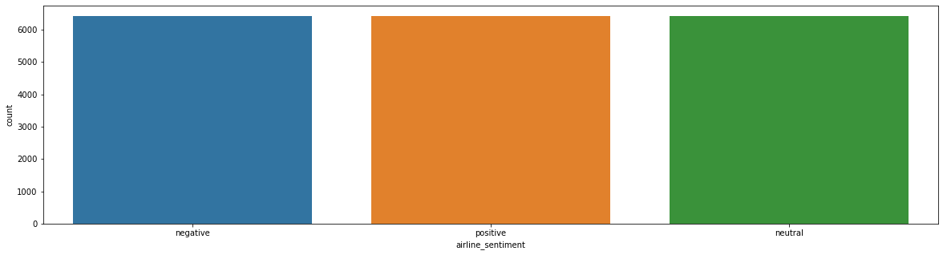

**Dividing Test data to Test and Validation Data**

*# Dividing the test data into test and validation set in 50-50 ratio*

x_validation, x_test_main, y_validation, y_test_main = train_test_split(x_test, y_test, test_size=0.50, random_state=1)

print(x_validation.shape)

print(x_test_main.shape)

print(y_validation.shape)

print(y_test_main.shape)

*# There are 2185 samples for validation and 2186 samples for testing*

(2185, 5000)

(2186, 5000)

(2185,)

(2186,)

**Initialize RandomForestClassifier**

*# Initialize a Random Forest classifier with 100 trees*

randomforestclassifier = RandomForestClassifier(bootstrap=True, ccp_alpha=0.0, class_weight=None,

criterion='gini', max_depth=None, max_features='auto',

max_leaf_nodes=None, max_samples=None,

min_impurity_decrease=0.0, min_impurity_split=None,

min_samples_leaf=1, min_samples_split=2,

min_weight_fraction_leaf=0.0, n_estimators=100,

n_jobs=None, oob_score=False, random_state=1, verbose=0,

warm_start=False)

*# Fit the forest to the training set, using the bag of words as*

*# features and the sentiment labels as the response variable*

print ("Training the random forest...")

randomforestclassifier = randomforestclassifier.fit( X_train_SMOTE, y_train_SMOTE)

randomforestclassifier.score(X_train_SMOTE, y_train_SMOTE)

0.9391674452403197

**Evaluate score by cross-validation**

print (np.mean(cross_val_score(randomforestclassifier,X_train_SMOTE, y_train_SMOTE,cv=10)))

0.8023050588429925

*# Make class predictions for the Validation set*

y_validation_predict= randomforestclassifier.predict(x_validation)

**Training and Validation Accuracy**

print("Trainig accuracy",randomforestclassifier.score(X_train_SMOTE,y_train_SMOTE))

print()

print("Validation accuracy",randomforestclassifier.score(x_validation, y_validation))

print()

Trainig accuracy 0.9391674452403197

Validation accuracy 0.765675057208238

**Classification Report (Validation Set)**

print(metrics.classification_report(y_validation,y_validation_predict))

precision recall f1-score support

negative 0.82 0.89 0.85 1331

neutral 0.61 0.52 0.56 467

positive 0.73 0.62 0.67 387

accuracy 0.77 2185

macro avg 0.72 0.68 0.69 2185

weighted avg 0.76 0.77 0.76 2185

**Confusion Matrix (Validation Set)**

cm=confusion_matrix(y_validation_predict , y_validation)

plt.figure()

plot_confusion_matrix(cm,figsize=(12,8), hide_ticks=True,cmap=plt.cm.Reds)

plt.xticks(range(2), ['Negative', 'Neutral', 'Positive'], fontsize=16,color='black')

plt.yticks(range(2), ['Negative', 'Neutral', 'Positive'], fontsize=16)

plt.show()

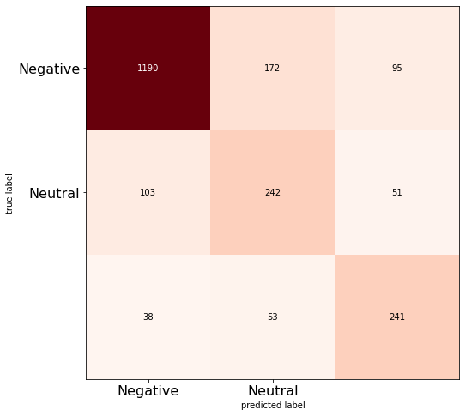

Random Forest Classifier on TfidfVectorizer

Dividing Data into train and Test

x_tf_idf = tfidf_vectorizer_data_features *# Predictor feature columns*

y_tf_idf = tweet_data_relevant['airline_sentiment'] *# Predicted class*

x_train_tf_idf, x_test_tf_idf, y_train_tf_idf, y_test_tf_idf = train_test_split(x_tf_idf, y_tf_idf, test_size=0.3, random_state=1) *# 1 is just any random seed number*

print(x_train_tf_idf.shape)

print(y_train_tf_idf.shape)

print(x_test_tf_idf.shape)

print(y_test_tf_idf.shape)

(10197, 5000)

(10197,)

(4371, 5000)

(4371,)

y = tweet_data_relevant['airline_sentiment']

print(y.value_counts())

plt.figure(figsize=(20,5))

g = sns.countplot(y)

*# No, Here we can see that the data is not balanced, There are lot of negative sentiments*

negative 9140

neutral 3083

positive 2345

Name: airline_sentiment, dtype: int64



**Applying SMOTE since the data is not balanced**

tf_idf_smt = SMOTE(random_state=0)

X_train_tf_idf_SMOTE, y_train_tf_idf_SMOTE = smt.fit_sample(x_train_tf_idf, y_train_tf_idf)

print(X_train_tf_idf_SMOTE.shape)

print(y_train_tf_idf_SMOTE.shape)

(19266, 5000)

(19266,)

after_smote_airline_sentiment_tf_idf=pd.DataFrame(y_train_tf_idf_SMOTE, columns=['airline_sentiment'])

y = after_smote_airline_sentiment_tf_idf['airline_sentiment']

print(y.value_counts())

plt.figure(figsize=(20,5))

g = sns.countplot(y)

*# Here we can see that after smote , the data is balanced*

positive 6422

neutral 6422

negative 6422

Name: airline_sentiment, dtype: int64



*# Dividing the test data into test and validation set in 50-50 ratio*

x_validation_tf_idf, x_test_main_tf_idf, y_validation_tf_idf, y_test_main_tf_idf = train_test_split(x_test_tf_idf, y_test_tf_idf, test_size=0.50, random_state=1)

print(x_validation_tf_idf.shape)

print(x_test_main_tf_idf.shape)

print(y_validation_tf_idf.shape)

print(y_test_main_tf_idf.shape)

*# There are 2185 samples for validation and 2186 samples for testing*

(2185, 5000)

(2186, 5000)

(2185,)

(2186,)

**Training and Validation Accuracy**

print("Trainig accuracy",randomforestclassifier_tf_idf.score(X_train_tf_idf_SMOTE,y_train_tf_idf_SMOTE))

print()

print("Validation accuracy",randomforestclassifier_tf_idf.score(x_validation_tf_idf, y_validation_tf_idf))

print()

**Classification Report (Test Set)**

*# Make class predictions for the test set*

y_test_predict_tf_idf= randomforestclassifier_tf_idf.predict(x_test_main_tf_idf)

print(metrics.classification_report(y_test_main_tf_idf,y_test_predict_tf_idf))

precision recall f1-score support

negative 0.82 0.92 0.86 1387

neutral 0.64 0.48 0.55 465

positive 0.72 0.59 0.65 334

accuracy 0.78 2186

macro avg 0.73 0.66 0.69 2186

weighted avg 0.76 0.78 0.76 2186

**Confusion Matrix** (Test Set)

cm=confusion_matrix(y_validation_predict_tf_idf , y_validation_tf_idf)

plt.figure()

plot_confusion_matrix(cm,figsize=(12,8), hide_ticks=True,cmap=plt.cm.Reds)

plt.xticks(range(2), ['Negative', 'Neutral', 'Positive'], fontsize=16,color='black')

plt.yticks(range(2), ['Negative', 'Neutral', 'Positive'], fontsize=16)

plt.show()

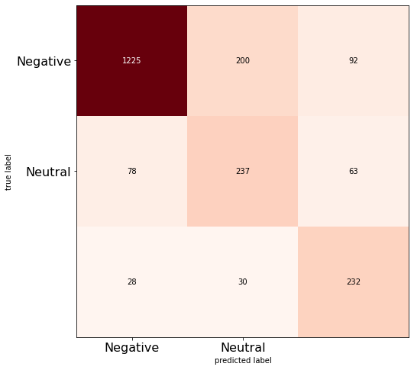

**Test Accuracy**

print("Test accuracy",randomforestclassifier_tf_idf.score(x_test_main_tf_idf, y_test_main_tf_idf))

print()

**Classification Report (Test Set)**

*# Make class predictions for the test set*

y_test_predict_tf_idf= randomforestclassifier_tf_idf.predict(x_test_main_tf_idf)

print(metrics.classification_report(y_test_main_tf_idf,y_test_predict_tf_idf))

**Confusion Matrix (Test Set)**

cm=confusion_matrix(y_test_predict_tf_idf , y_test_main_tf_idf)

plt.figure()

plot_confusion_matrix(cm,figsize=(12,8), hide_ticks=True,cmap=plt.cm.Reds)

plt.xticks(range(2), ['Negative', 'Neutral', 'Positive'], fontsize=16,color='black')

plt.yticks(range(2), ['Negative', 'Neutral', 'Positive'], fontsize=16)

plt.show()

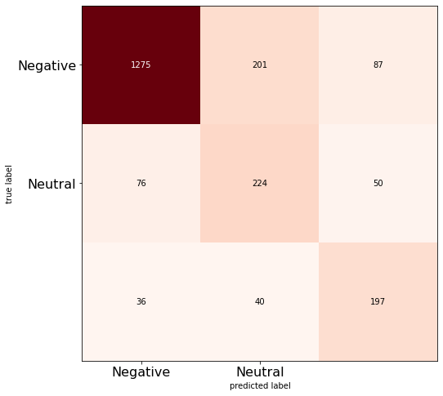

**STEP 6**

**Pre-processing steps in NLP**

*# Pre-processing steps in NLP*

*# 1. HTML tag cleanup*

*# - It returns all the text in a document or beneath a tag, as a single Unicode string:*

*# 2. Contraction*

*# - Contractions are shortened version of words or syllables.*

*# - In case of English contractions are often created by removing one of the vowels from the word.*

*# - Examples would be, do not to don’t and I would to I’d. Converting each contraction to its expanded, original form helps with text standardization.*

*# 3. Tokenization*

*# - Tokenization is a step which splits longer strings of text into smaller pieces, or tokens.*

*# - Larger chunks of text can be tokenized into sentences, sentences can be tokenized into words, etc.*

*# - Further processing is generally performed after a piece of text has been appropriately tokenized.*

*# - Tokenization is also referred to as text segmentation or lexical analysis.*

*# - Sometimes segmentation is used to refer to the breakdown of a large chunk of text into pieces larger than words (e.g. paragraphs or sentences),*

*# while tokenization is reserved for the breakdown process which results exclusively in words.*

*# 4. Removing numbers*

*# - Remove numbers from list of tokenized words*

*# 5. Remove special characters*

*# - Remove special characters from list of tokenized words*

*# 6. Remove punctuation*

*# - Remove punctuation from list of tokenized words*

*# 7. Convert text to lower case*

*# - converting all text to the same case*

*# 8. Remove empty strings*

*# - Remove empty string from list of tokenized words*

*# 9. Stemming*

*# - Converting the words into their base word or stem word ( Ex - tastefully, tasty, these words are converted to stem word called 'tasti').*

*# This reduces the vector dimension because we dont consider all similar words*

*# 10.Lemmatization*

*# - Lemmatization, unlike Stemming, reduces the inflected words properly ensuring that the root word belongs to the language.*

*# In Lemmatization root word is called Lemma. A lemma (plural lemmas or lemmata) is the canonical form, dictionary form, or citation form of a set of words.*

**Techniques for Encoding**

*# Steps to do after text pre-processing:*

*#Techniques for Encoding - These are the popular techniques that are used for encoding:*

*# o Bag of words (CountVectorization)*

*# In BoW we construct a dictionary that contains set of all unique words from our text review dataset.*

*# The frequency of the word is counted here. If there are d unique words in our dictionary then for every sentence or review the vector will be of length d*

*# and count of word from review is stored at its particular location in vector. The vector will be highly sparse in such case.*

*# o Tf-idf (TfIdfVectorization) (Term Frequency - Inverse Document Frequency)*

*# Term Frequency - Inverse Document Frequency it makes sure that less importance is given to most frequent words and also considers less frequent words.*

*# Term Frequency is number of times a particular word(W) occurs in a review divided by totall number of words (Wr) in review. The term frequency value ranges from 0 to 1.*

*# Inverse Document Frequency is calculated as log(Total Number of Docs(N) / Number of Docs which contains particular word(n)). Here Docs referred as Reviews.*

*# TF-IDF is TF * IDF that is (W/Wr)*LOG(N/n)*

**Performance of Classification Model**

**RandomForestClassifier on CountVectorizer**

print("Trainig accuracy",randomforestclassifier.score(X_train_SMOTE,y_train_SMOTE))

print()

print("Testing accuracy",randomforestclassifier.score(x_test_main, y_test_main))

print()

y_test_predict= randomforestclassifier.predict(x_test_main)

print(metrics.classification_report(y_test_main,y_test_predict))

cm=confusion_matrix(y_test_predict , y_test_main)

plt.figure()

plot_confusion_matrix(cm,figsize=(12,8), hide_ticks=True,cmap=plt.cm.Reds)

plt.xticks(range(2), ['Negative', 'Neutral', 'Positive'], fontsize=16,color='black')

plt.yticks(range(2), ['Negative', 'Neutral', 'Positive'], fontsize=16)

plt.show()

precision recall f1-score support

negative 0.81 0.90 0.85 1387

neutral 0.62 0.48 0.54 465

positive 0.64 0.57 0.60 334

accuracy 0.76 2186

macro avg 0.69 0.65 0.67 2186

weighted avg 0.75 0.76 0.75 2186

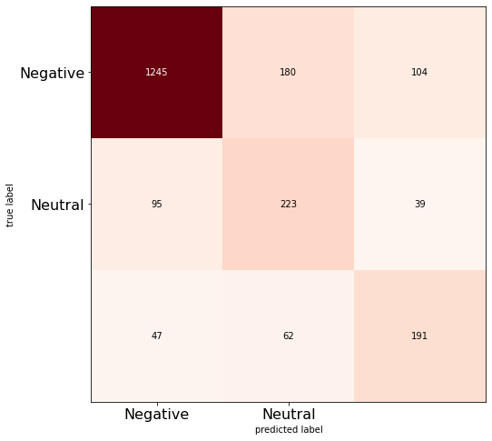

**RandomForestClassifier on TfidfVectorizer**

print("Trainig accuracy",randomforestclassifier_tf_idf.score(X_train_tf_idf_SMOTE,y_train_tf_idf_SMOTE))

print()

print("Test accuracy",randomforestclassifier_tf_idf.score(x_test_main_tf_idf, y_test_main_tf_idf))

print()

*# Make class predictions for the test set*

y_test_predict_tf_idf= randomforestclassifier_tf_idf.predict(x_test_main_tf_idf)

print(metrics.classification_report(y_test_main_tf_idf,y_test_predict_tf_idf))

cm=confusion_matrix(y_test_predict_tf_idf , y_test_main_tf_idf)

plt.figure()

plot_confusion_matrix(cm,figsize=(12,8), hide_ticks=True,cmap=plt.cm.Reds)

plt.xticks(range(2), ['Negative', 'Neutral', 'Positive'], fontsize=16,color='black')

plt.yticks(range(2), ['Negative', 'Neutral', 'Positive'], fontsize=16)

plt.show()



Accuracy=[]

Model=[]

Accuracy.append(randomforestclassifier.score(x_test_main, y_test_main))

Accuracy.append(randomforestclassifier_tf_idf.score(x_test_main_tf_idf, y_test_main_tf_idf))

Model.append("RandomForestClassifier on CountVectorizer")

Model.append("RandomForestClassifier on TfidfVectorizer")

index=[0,1]

plt.bar(index,Accuracy,color='rgbyk')

plt.xticks(index,Model,rotation=45)

plt.ylabel('Accuracy')

plt.xlabel('Model')

plt.title('Classifier Accuracies')

xlocs, xlabs = plt.xticks()

for i, v **in** enumerate(Accuracy):

plt.text(xlocs[i] - 0.25, v + 0.01, str(v))

*# The RandomForestClassfier on TfidfVectorizer is having better accuracy*

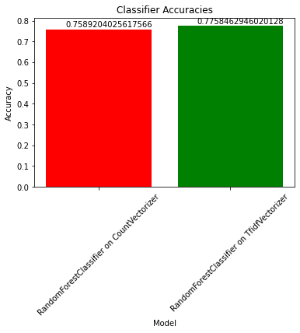

CONCLUSION:

In summary, the sentiment analysis of marketing initiatives has proven to be a pivotal tool for comprehending consumer perceptions and behaviors. Through the exploration of sentiment polarity and context, this project revealed invaluable insights into how customers respond to various campaigns, aiding in the refinement of strategies. The nuanced understanding obtained from sentiment analysis not only helps in gauging customer satisfaction but also guides targeted content creation, ultimately fostering stronger connections between brands and their audience. The continuous integration of sentiment analysis in marketing practices stands as a fundamental approach for companies aiming to adapt swiftly, optimize engagement, and maintain a customer-centric approach in the ever-evolving market landscape.