**Project Documentation**

**1.Introduction:**

FitFlex: Your Personal Fitness Companion is a modern fitness application designed to help individuals take control of their health and wellness journey. It combines personalized workout plans, nutrition tracking, and progress monitoring into one easy-to-use platform.

* **Project Title:** FitFlex
* **Team ID:NM2025TMID44289**
* **Team Leader:** Bhuvaneswari A& bhuvaneswarivel376@gmail.com
* **Team Members:**
* **Priyadharshini R& ravidharshini67@gmail.com**
* **Maheshwari N& maheshwarin5154@gmail.com**
* **Nithyasri s& sivanithyasri2007@gmail.com**
* **Lavanya P& lavanyarasammal@gmail.com**

**2. Project Overview**

* **Purpose:**  
  FitFlex is a fitness and wellness management platform designed to help users track workouts, set goals, monitor diet plans, and connect with trainers.
* **Features:**
  + Personalized workout and diet plans
  + Progress tracking with graphs
  + Trainer–student live chat & video sessions
  + Community support & challenges
  + Admin panel for trainer and user management

**3. Architecture**

* **Frontend:** React.js with Bootstrap & Material UI
* **Backend:** Node.js with Express.js
* **Database:** MongoDB (stores user profiles, workout logs, trainer details, chats)

**4. Setup Instructions**

* **Prerequisites:**
  + Node.js
  + MongoDB
  + Git
  + React.js
  + Express.js
  + Visual Studio Code
* **Installation Steps:**
* # Clone the repository
* git clone <repo-link>
* # Install client dependencies
* cd client
* npm install
* # Install server dependencies
* cd ../server
* npm install

**5. Folder Structure**

**FitFlex/**

**│── README.md # Project overview**

**│── package.json # Root dependencies & scripts (if monorepo)**

**│── .gitignore # Ignore files**

**│── docs/ # Documentation files**

**│**

**├── frontend/ # React App (UI)**

**│ │── package.json**

**│ │── public/ # Static assets**

**│ │ ├── index.html**

**│ │ ├── favicon.ico**

**│ │ └── assets/ # Logos, icons, images**

**│ │**

**│ └── src/ # Source code**

**│ ├── index.js # Entry point**

**│ ├── App.js # Root component**

**│ ├── assets/ # App-specific assets**

**│ │ ├── images/**

**│ │ └── icons/**

**│ │**

**│ ├── components/ # Shared UI components**

**│ │ ├── Navbar.js**

**│ │ ├── Footer.js**

**│ │ ├── Button.js**

**│ │ └── Card.js**

**│ │**

**│ ├── features/ # Main modules**

**│ │ ├── auth/ # Authentication**

**│ │ ├── workouts/ # Workout plans**

**│ │ ├── nutrition/ # Meal & diet tracking**

**│ │ └── progress/ # Progress tracking**

**│ │**

**│ ├── pages/ # Route-based pages**

**│ │ ├── Home.js**

**│ │ ├── Dashboard.js**

**│ │ ├── Profile.js**

**│ │ └── Settings.js**

**│ │**

**│ ├── context/ # Global state**

**│ ├── hooks/ # Custom hooks**

**│ ├── services/ # API requests**

**│ ├── utils/ # Helper functions**

**│ ├── styles/ # CSS / Tailwind**

**│ └── tests/ # Frontend tests**

**│**

**├── backend/ # Node.js +**

**6. Running the Application**

* **Frontend:**
* cd client
* npm start
* **Backend:**
* cd server
* npm start
* **Access:** Visit <http://localhost:3000>

**7.styling:**

* **Frameworks/Libraries: Bootstrap or Tailwind CSS**
* **Custom CSS: Stored in styles/ folder**
* **Icons: React Icons**

**8. Authentication**

* JWT-based authentication for secure login
* Role-based access (Admin, Trainer, User)

**9. User Interface**

* Landing Page
* User Dashboard (Workouts, Diet, Progress)
* Trainer Dashboard
* Admin Panel
* Chat & Video Call Integration

**10. Testing**

* Manual testing during development
* Tools: Postman, Chrome Dev Tools

**11. Screenshots or Demo**

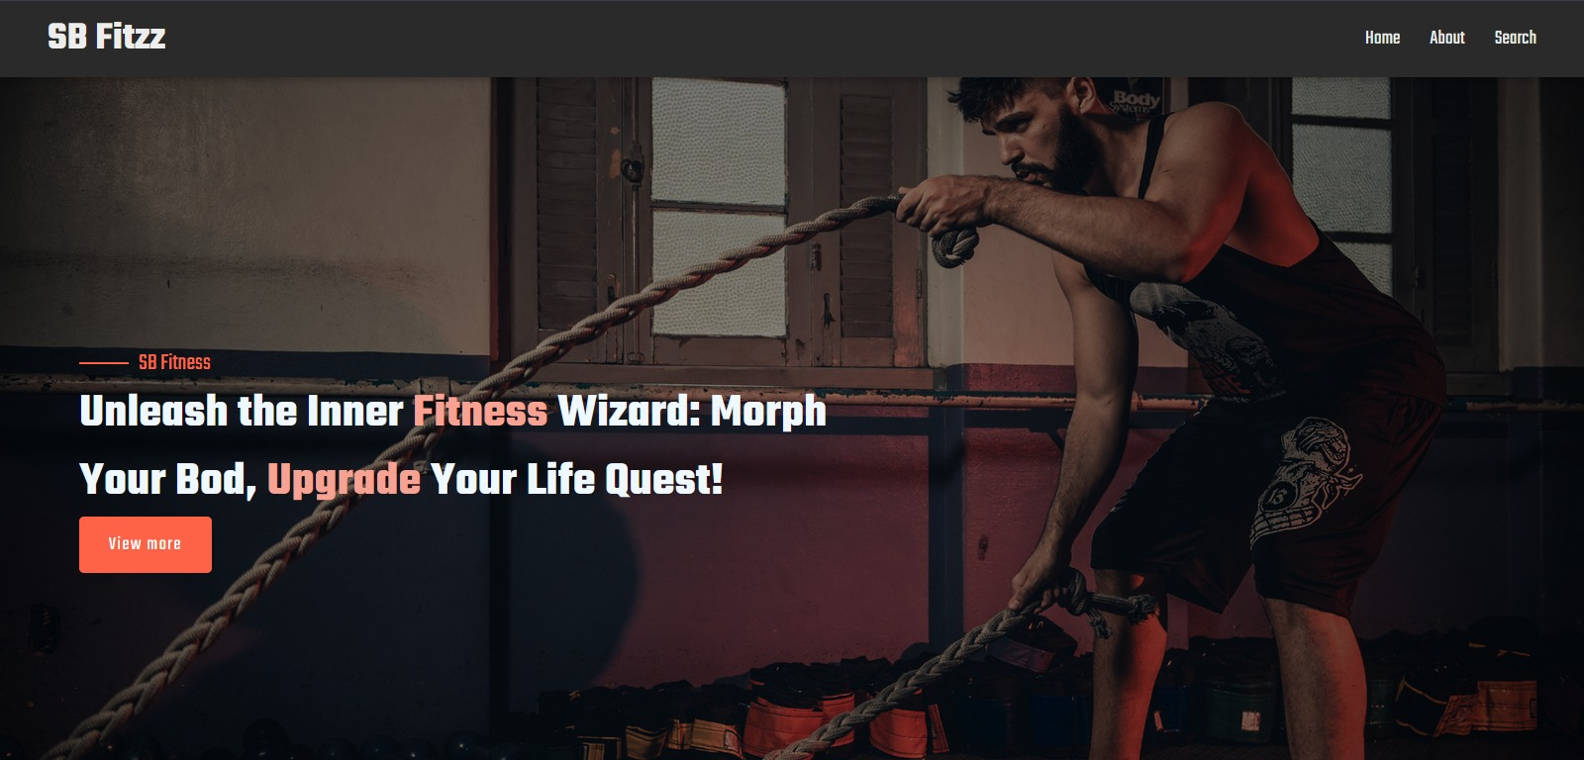

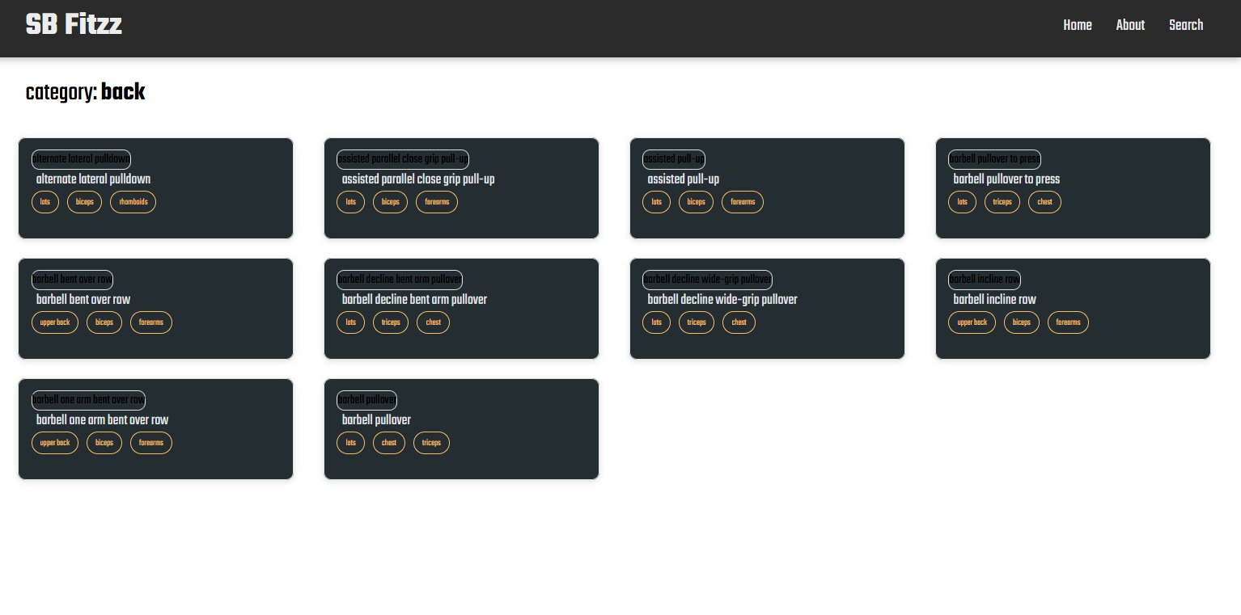

**12. Known Issues**

* Limited offline support
* Video calls may lag on low internet speeds

**13. Future Enhancements**

* AI-based personalized fitness recommendations
* Integration with smart wearables (Fitbit, Apple Watch)
* Group fitness challenges with leaderboards