**1)**

<!DOCTYPE html>

<html>

    <head>

        <style>

            .image{

                border:8px solid lightcoral;

                border-radius: 8px;

                padding:30px;

            }

            .image1{

            border:8px dashed lightcoral;

                border-radius: 8px;

                padding:30px;

            }

            .image2{

                border:8px dotted lightcoral;

                border-radius: 8px;

                padding:30px;

            }

            .image3{

            border:8px double lightcoral;

                border-radius: 8px;

                padding:30px;

            }

            .image4{

                border:8px groove lightcoral;

                border-radius: 8px;

                padding:30px;

            }

            .image5{

            border:8px hidden lightcoral;

                border-radius: 8px;

                padding:30px;

            }

            .image6{

                border:8px outset lightcoral;

                border-radius: 8px;

                padding:30px;

            }

            .image7{

            border:8px inherit lightcoral;

                border-radius: 8px;

                padding:30px;

            }

            .image8{

            border:8px inset lightcoral;

                border-radius: 8px;

                padding:30px;

            }

            .image9{

                border:8px rigid lightcoral;

                border-radius: 8px;

                padding:30px;

            }

            .image10{

            border:8px unset lightcoral;

                border-radius: 8px;

                padding:30px;

            }

        </style>

    </head>

    <body>

        <img class="image" src="./download.jfif" alt="solid" width="300" height="300">

        <img class="image1" src="./download.jfif" alt="dashed" width="300" height="300">

        <img class="image2" src="./download.jfif" alt="dotted" width="300" height="300">

        <img class="image3" src="./download.jfif" alt="double" width="300" height="300">

        <img class="image4" src="./download.jfif" alt="groove" width="300" height="300">

        <img class="image5" src="./download.jfif" alt="hidden" width="300" height="300">

        <img class="image6" src="./download.jfif" alt="outset" width="300" height="300">

        <img class="image7" src="./download.jfif" alt="inherit" width="300" height="300">

        <img class="image8" src="./download.jfif" alt="inset" width="300" height="300">

        <img class="image9" src="./download.jfif" alt="rigid" width="300" height="300">

        <img class="image10" src="./download.jfif" alt="unset" width="300" height="300">

    </body>

</html>

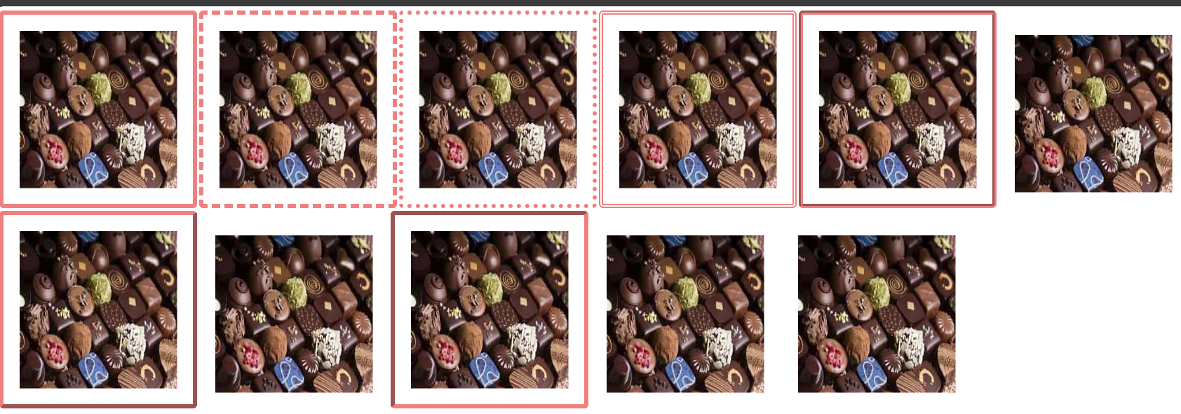

**2)**

<html>

<head>

<style>

  .image1{

        position:absolute;

        top:10px;

        left:40px;

        z-index:1;

        }

        .image2{

        position:absolute;

        top:10px;

        left:60px;

        z-index:2;

        }

        .image3{

        position:absolute;

        top:10px;

        left:84px;

        z-index:3;

        }

        .image4{

        position:absolute;

        top:10px;

        left:110px;

        z-index:4;

        }

        .image5{

        position:absolute;

        top:10px;

        left:130px;

        z-index:5;

        }

        .image6{

        position:absolute;

        top:10px;

        left:150px;

        z-index:6;

        }

         .image7{

        position:absolute;

        top:10px;

        left:170px;

        z-index:7;

        }

        .image8{

        position:absolute;

        top:10px;

        left:190px;

        z-index:8;

        }

        .image9{

        position:absolute;

        top:10px;

        left:210px;

        z-index:9;

        }

        .image10{

        position:absolute;

        top:10px;

        left:230px;

        z-index:10;

        }

        .image11{

        position:absolute;

        top:10px;

        left:250px;

        z-index:11;

        }

        .image12{

        position:absolute;

        top:10px;

        left:270px;

        z-index:12;

        }

        .image13{

        position:absolute;

        top:10px;

        left:290px;

        z-index:13;

        }

        </style>

      </head>

     <body style="background-color:lightcyan">

     <img class="image1" src="./ace.png"/>

     <img class="image2" src="./two.png"/>

     <img class="image3" src="./three.png"/>

     <img class="image4" src="./four.png"/>

     <img class="image5" src="./five.png"/>

     <img class="image6" src="./six.png"/>

     <img class="image7" src="./seven.png"/>

     <img class="image8" src="./eight.png"/>

     <img class="image9" src="./nine.png"/>

     <img class="image10" src="./ten.png"/>

     <img class="image11" src="./joker.png"/>

     <img class="image12" src="./queen.png"/>

     <img class="image13" src="./king.png"/>

     </body>

     </html>

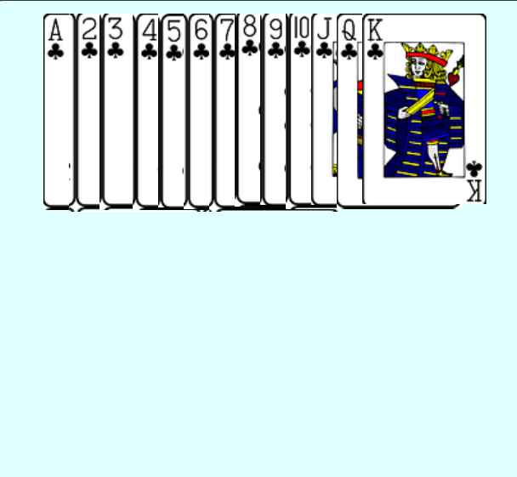

**3)**

<html>

<head>

<style>

    .block0{

        background-color:red;

        top:100px;

        position:absolute;

        width:100px;}

    .block{

        background-color:black;

        top:120px;

        position:absolute;

        width:120px;}

        .block1{

        background-color:red;

        top:140px;

        position:absolute;

        width:140px;}

        .block2{

        background-color:black;

        top:160px;

        position:absolute;

        width:160px;}

        .block3{

        background-color:red;

        top:180px;

        position:absolute;

        width:180px;}

        .block4{

        background-color:black;

        top:200px;

        position:absolute;

        width:200px;}

        </style>

      </head>

     <body>

        <h1>CSS Position property to place multiple contents in a stair case format.</h1>

        <div class="block0" style="height:40px;"></div>

        <div class="block" style="height:40px;"></div>

<div class="block1" style="height:40px;"></div>

<div class="block2" style="height:40px;"> </div>

<div class="block3" style="height:61px;"> </div>

<div class="block4" style="height:40px;"> </div>

</body>

</html>



**4)**

<!DOCTYPE html>

<html lang="en">

<head>

    <meta charset="UTF-8">

    <meta name="viewport" content="width=device-width, initial-scale=1.0">

    <link rel="stylesheet" href="style.css">

    <title>Font Family</title>

</head>

<body>

<p>

    <span class="line1">Bhuvanika :)</span><br><br>

    <span class="line2">Bhuvanika :)</span><br><br>

    <span class="line3">Bhuvanika :)</span><br><br>

    <span class="line4">Bhuvanika :)</span><br><br>

    <span class="line5">Bhuvanika :)</span><br>

</p>

</body>

</html>

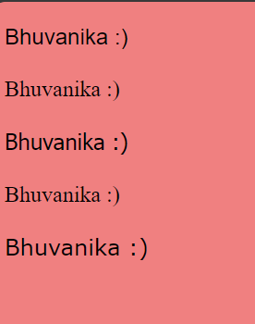

**5)**

<html>

<head>

   <title>Technical Symposium</title>

   <style>

     body{

            font-family:'Times New Roman', Times, serif;

          background-color:lightpink;

          }

      </style>

</head>

<body>

   <form action="#" method="post">

   <h2> Technical Symposium</h2>

   <label for="name">Name</label>

   <input type="text" id="name" name="name" required>

   <br>

   <br>

   <label for="email">Email</label>

   <input type="email" id="email" name="email" required><br>

   <br>

    <label for="institution">Institution</label>

   <input type="text" id="institution" name="institution" required><br>

   <br>

   <label for="date">Date</label>

   <input type="date" id="date" name="date" required><br>

   <br>

   <label for="event">Event</label>

  <select id="event" name="event"><br>

  <option value="PaperPresentation">PaperPresentation</option>

  <option value="ProjectPresentation">ProjectPresentation</option>

  <option value="workshop">Workshop</option>

  <option value="Hackathon">Hackathon</option>

  </select><br><br><br>

  <input type="submit" value="Register"><br>

   </form>

  </body>

 </html>

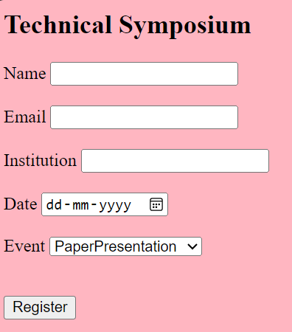

**6)**

<html>

<head>

<title>About me</title>

<style>

  body{

       font-family:'Times New Roman', Times, serif;

       background-color:lightpink;

       font-size: small;

       }

       .img{

           float:left;

           margin-right:20px;

           }

    </style>

    <body>

    <img class="img" src="./choco.jpeg" alt="chocolate" width="400" height="400">

    <h1>Chocolate or cocoa is a food made from roasted and ground cacao seed kernels that is available as a liquid, solid, or paste, either on its own or as a flavoring agent in other foods. Cacao has been consumed in some form since at least the Olmec civilization (19th–11th century BCE),[1][2] and later Mesoamerican civilizations also consumed chocolate beverages before being introduced to Europe in the 16th century.[3]

        The seeds of the cacao tree have an intense bitter taste and must be fermented to develop the flavor. After fermentation, the seeds are dried, cleaned, and roasted. The shell is removed to produce cocoa nibs, which are then ground to cocoa mass, unadulterated chocolate in rough form. Once the cocoa mass is liquefied by heating, it is called chocolate liquor. The liquor may also be cooled and processed into its two components: cocoa solids and cocoa butter. Baking chocolate, also called bitter chocolate, contains cocoa solids and cocoa butter in varying proportions without any added sugar. Powdered baking cocoa, which contains more fiber than cocoa butter, can be processed with alkali to produce Dutch cocoa. Much of the chocolate consumed today is in the form of sweet chocolate, a combination of cocoa solids, cocoa butter, or added vegetable oils and sugar. Milk chocolate is sweet chocolate that additionally contains milk powder or condensed milk. White chocolate contains cocoa butter, sugar, and milk, but no cocoa solids.

        Chocolate is one of the most popular food types and flavors in the world, and many foodstuffs involving chocolate exist, particularly desserts, including cakes, pudding, mousse, chocolate brownies, and chocolate chip cookies. Many candies are filled with or coated with sweetened chocolate. Chocolate bars, either made of solid chocolate or other ingredients coated in chocolate, are eaten as snacks. Gifts of chocolate molded into different shapes (such as eggs, hearts, and coins) are traditional on certain Western holidays, including Christmas, Easter, Valentine's Day, and Hanukkah. Chocolate is also used in cold and hot beverages, such as chocolate milk and hot chocolate, and in some alcoholic drinks, such as creme de cacao.

        Although cocoa originated in the Americas, West African countries, particularly Côte d'Ivoire and Ghana, are the leading producers of cocoa in the 21st century, accounting for some 60% of the world cocoa supply.</h1>

    <div></div>

    </body>

    </html>

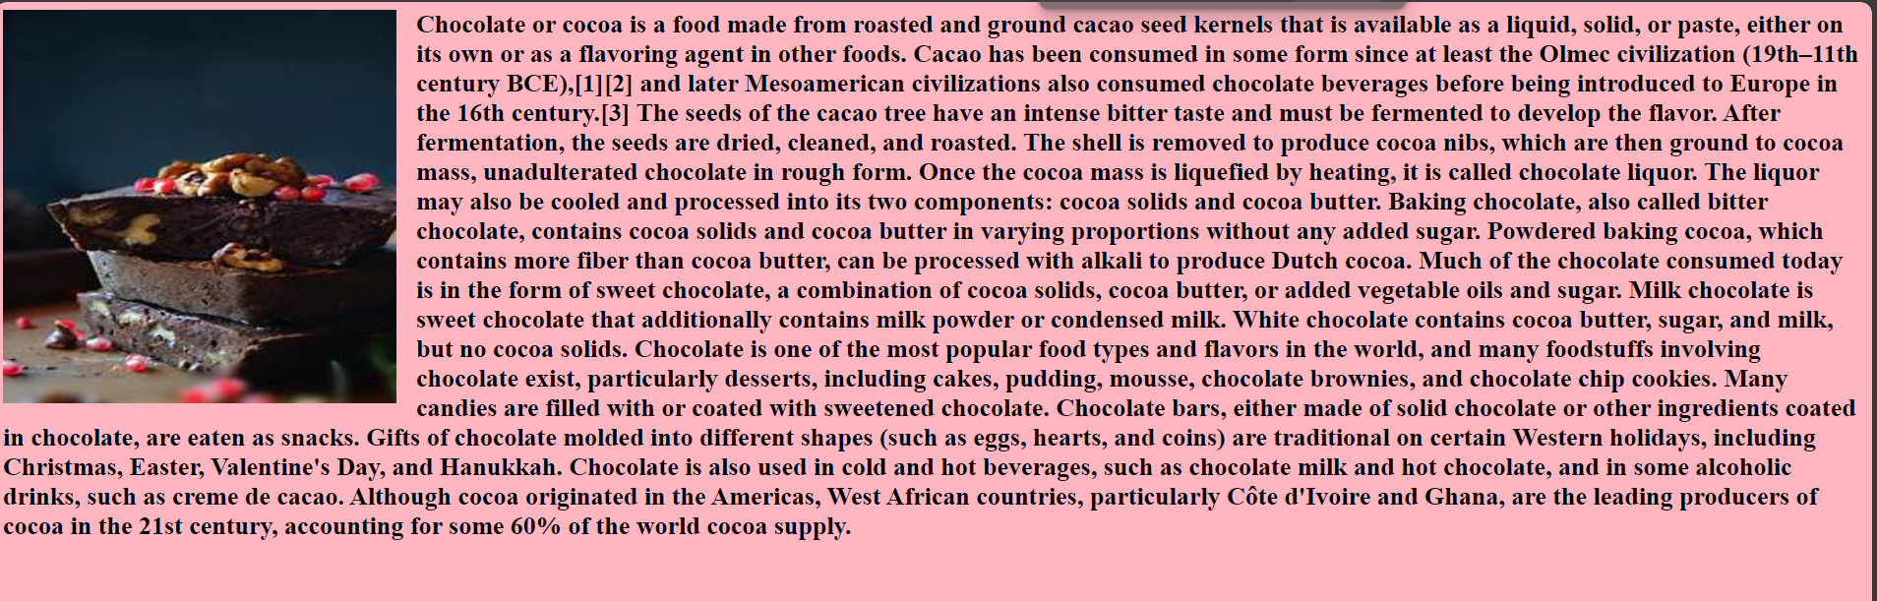

**7)**

<html>

<head>

<title>Rounded Corners</title>

<style>

    .rounded_element

    {

    background-color:#ff6347;

    padding:20px;

    width:300px;

    height:300px;

    border-radius:15px;

    }

    .rounded_image

    {

    background-image:url("./choco.jpeg");

    background-size:cover;

    padding:20px;

    width:300px;

    height:300px;

    border-radius:25px;

    }

</style>

<body>

<div class="rounded_element">"Chocolate or cocoa is a food made from roasted and ground cacao seed kernels that is available as a liquid, solid, or paste, either on its own or as a flavoring agent in other foods. Cacao has been consumed in some form since at least the Olmec civilization (19th–11th century BCE)and later Mesoamerican civilizations also consumed chocolate beverages before being introduced to Europe in the 16th century.The seeds of the cacao tree have an intense bitter taste and must be fermented to develop the flavor. After fermentation, the seeds are dried, cleaned, and roasted. The shell is removed to produce cocoa nibs, which are then ground to cocoa mass, unadulterated chocolate in rough form." </div>

<br>

<div class="rounded_image">"</div>

</body>

</html>

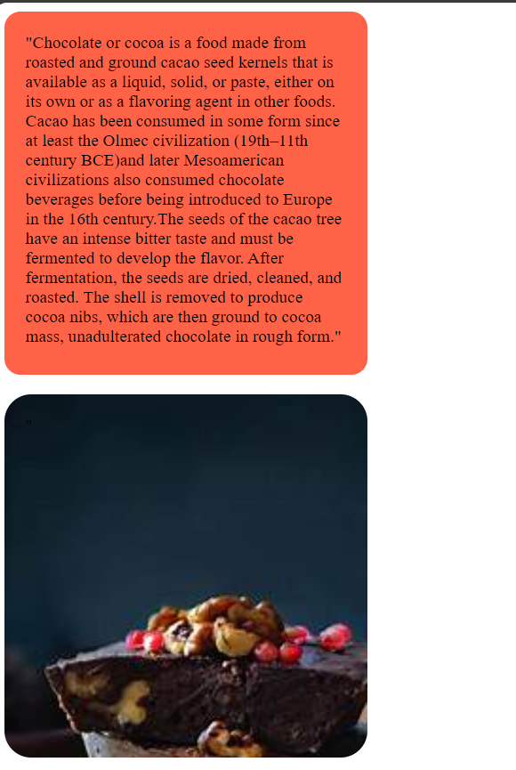

**8a)**

<html>

<head>

<style>

ul {

  padding: 0;

  overflow: hidden;

  background-color:darkred;

}

li {

  float: left;

}

li a {

  display: block;

  color: white;

  padding: 14px 16px;

  text-decoration: none;

}

</style>

</head>

<body>

<ul>

  <li><a  href="#home">Home</a></li>

  <li><a href="#events">Events</a></li>

  <li><a href="#contact">Contact</a></li>

  <li><a href="#about">About</a></li>

</ul>

</body>

</html>

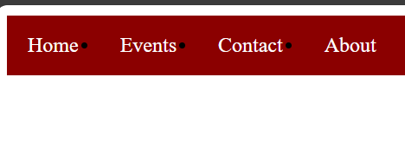

**8b)**

<!DOCTYPE html>

<html>

<head>

<style>

body {

  margin: 0;

}

ul {

  margin: 0;

  padding: 0;

  width: 20%;

  position: fixed;

  height: 150%;

  overflow: auto;

}

li a {

  display: block;

  color: #000;

  padding: 8px 16px;

  text-decoration: none;

}

li a {

  background-color: #04AA6D;

}

</style>

</head>

<body>

<ul>

  <li><a  href="#home">Home</a></li>

  <li><a href="#events">Events</a></li>

  <li><a href="#contact">Contact</a></li>

  <li><a href="#about">About</a></li>

</ul>

</body>

</html>

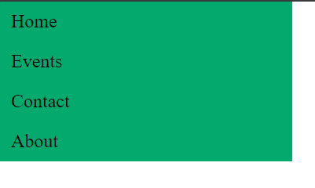

**Viva)**

<html>

<head>

<style>

  .image1{

        position:absolute;

        top:10px;

        left:40px;

        border:1px solid brown;

        z-index:1;

        }

        .image2{

        position:absolute;

        top:30px;

        left:180px;

        border:1px solid brown;

        z-index:2;

        }

        .image3{

        position:absolute;

        top:90px;

        left:120px;

        border:1px solid brown;

        z-index:3;

        }

        </style>

      </head>

     <body>

     <img class="image1" src=".\th (3).jfif"/>

     <img class="image2" src=".\th (2).jfif"/>

     <img class="image3" src=".\th (1).jfif"/>

     </body>

     </html>

