Individual Report: Agile Planning in Jira
Problem Statement #14: Corporate Mental Wellness & Counseling Platform (Team 14, Helping Hands Software)
Name: BHUVAN KUMAR P SRN: PES1UG24AM069 Unique Epic: KAN-4 Wellness Dashboard & Reports Date: 5 October 2026

1. My Epic
Epic KAN-4 "Wellness Dashboard & Reports" covers the part of the platform that shows wellness data, and gives each audience only the view it is entitled to. Employees see a trend of their own indicators (FR-004, UC-04). Therapists record session notes encrypted at rest (NFR-002, UC-06). Wellness Program Administrators see only aggregate reports, refused for groups of fewer than ten (NFR-002, UC-07). No other team member owns these requirements, so the Epic is unique to this report.
Definition of Done: every acceptance criterion passes, the code is reviewed, no corporate identifier appears on any dashboard or report, and encryption is verified by a storage dump test.

2. Jira Backlog with Epic and User Stories
The Epic holds seven user stories (KAN-5 to KAN-11), each written as "As a <role>, I want <goal>, so that <benefit>" with testable acceptance criteria in the Jira description. Five stories are planned into Sprint 1 and two remain in the product backlog.
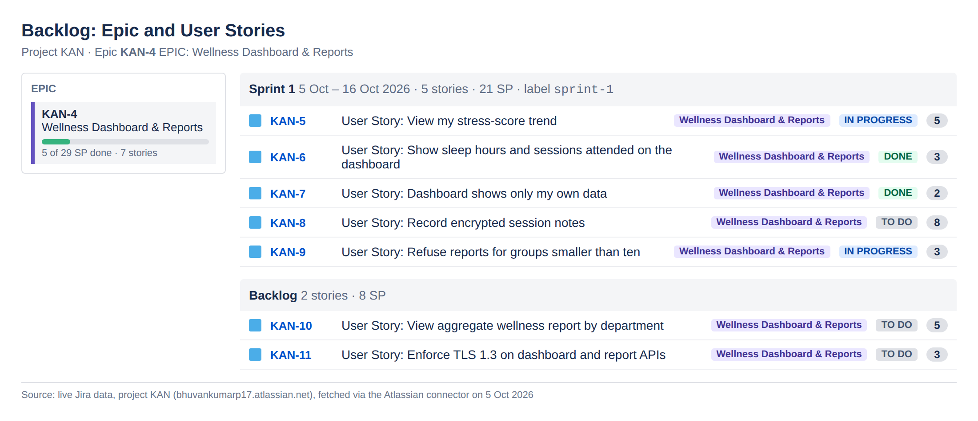
Figure 1: Backlog showing Epic KAN-4, the Sprint 1 stories and the remaining backlog

3. Story Point Assignments
Stories were estimated in story points on the Fibonacci scale (1, 2, 3, 5, 8, 13), comparing each story with a small reference story (KAN-7, 2 SP). The estimate reflects complexity, effort and risk together.
Key | User story | SP | Priority | Traces to | Sprint | Status
KAN-5 | View my stress-score trend | 5 | High | FR-004 | Sprint 1 | In Progress
KAN-6 | Show sleep hours and sessions attended on the dashboard | 3 | Medium | FR-004 | Sprint 1 | Done
KAN-7 | Dashboard shows only my own data | 2 | High | FR-004 | Sprint 1 | Done
KAN-8 | Record encrypted session notes | 8 | Highest | NFR-002 | Sprint 1 | To Do
KAN-9 | Refuse reports for groups smaller than ten | 3 | High | NFR-002 | Sprint 1 | In Progress
KAN-10 | View aggregate wellness report by department | 5 | Medium | NFR-002 | Backlog | To Do
KAN-11 | Enforce TLS 1.3 on dashboard and report APIs | 3 | Medium | NFR-002 | Backlog | To Do
 | Sprint 1 commitment | 21
 | Total epic estimate | 29

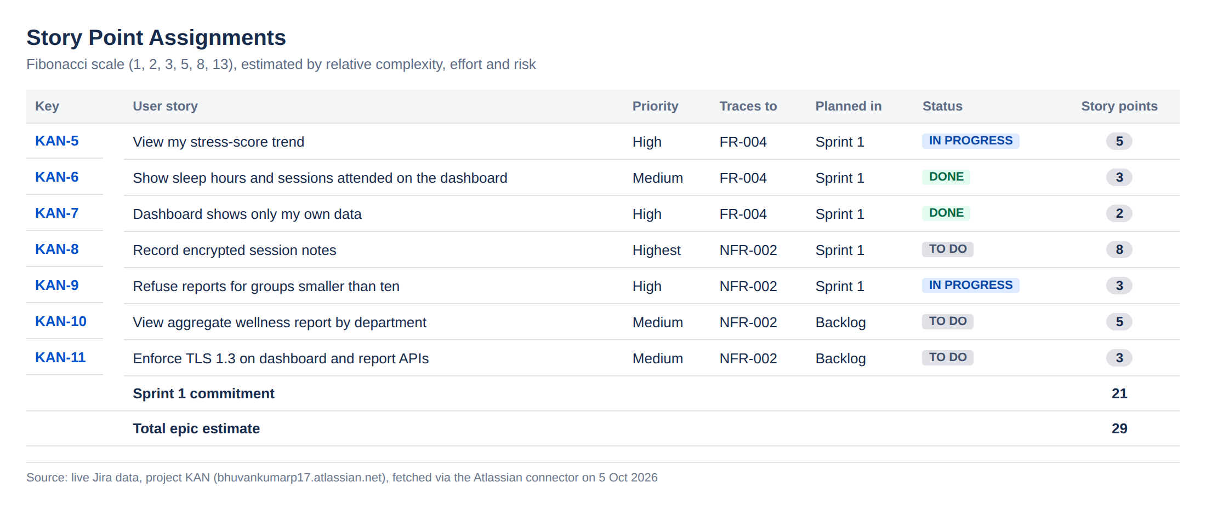
Figure 2: Story point assignments for Epic KAN-4

4. Sprint Board (Active Sprint View)
Sprint 1 runs from 5 to 16 October 2026 (10 working days) with the goal: "Employees can see their own wellness trend, and therapist notes are stored encrypted." It holds 21 story points. At the time of capture, two stories are Done, two are In Progress and one is To Do.
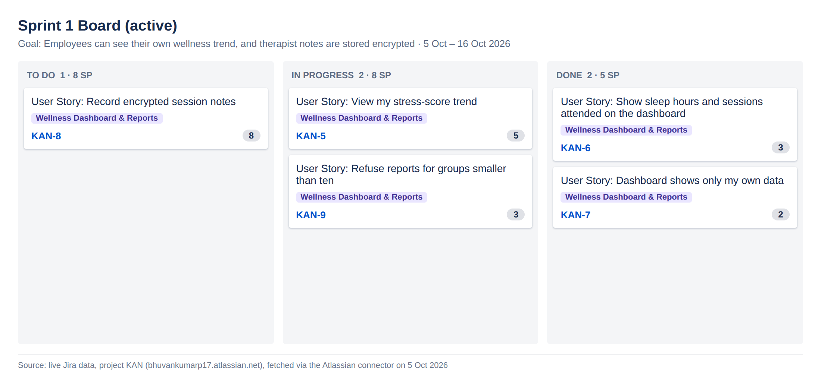
Figure 3: Sprint 1 board with To Do, In Progress and Done columns

5. Burndown Chart
The guideline burns 21 SP down to zero over ten working days, about 2.1 SP per day. On day 1, KAN-7 (2 SP) and KAN-6 (3 SP) were completed, leaving 16 SP. The actual line is below the guideline, so the sprint is ahead of plan. However, the riskiest story, KAN-8 (8 SP, encrypted notes), has not started yet. It must start early, or the line will flatten mid-sprint.
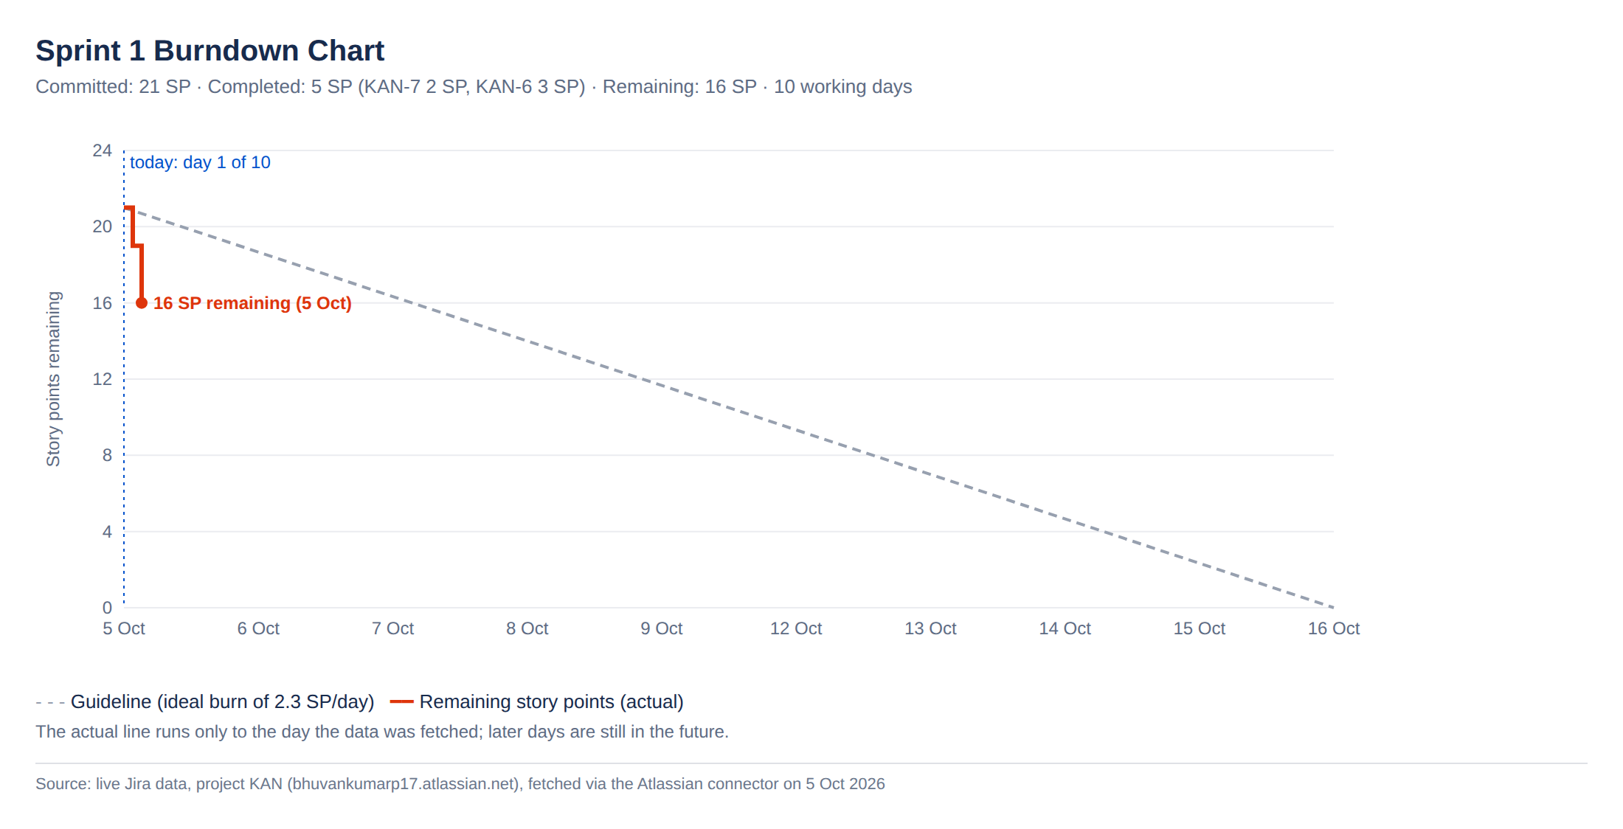
Figure 4: Sprint 1 burndown chart (remaining story points against the ideal guideline)

6. Reflection
Q1. How did you break your Epic into user stories?
I started from the Lab 1 requirements traced to my area (FR-004 and NFR-002) and the use cases UC-04, UC-06 and UC-07. I wrote one story per user-visible outcome rather than per technical layer, so each story delivers value on its own and can be demonstrated at sprint review. I split NFR-002 into three stories (encrypted notes, the group-size floor and TLS 1.3) because one combined story would have been too large to finish in a sprint and too vague to test.
Q2. How did you assign story points, and what was difficult?
I used relative estimation on the Fibonacci scale and anchored on the smallest well-understood story, KAN-7 (a pseudo-ID filter, 2 SP). Encrypted session notes got 8 SP because they involve key management, a storage dump test and log scrubbing, so the uncertainty is high. The hardest part was not estimating in hours: a story that looks quick to code, such as the group-size floor, still carries testing and privacy-review effort, so it got 3 SP rather than 1.
Q3. How did you decide what went into Sprint 1?
I ordered by value and risk. The employee trend (FR-004) is the core feature, and encrypted notes are a high-risk security requirement, so both went in early so problems would surface early. The group-size floor went in because the aggregate report depends on it. The department report and TLS hardening stayed in the backlog, which kept the commitment at 21 SP, a realistic load for one person over two weeks.
Q4. What does your burndown chart tell you?
The sprint is currently ahead of the guideline because two small stories closed on day 1. That early drop flatters progress: 13 of the remaining 16 SP sit in two stories, and one of them (8 SP) has not started. A burndown only drops when a story is fully Done, so large stories create flat stretches followed by cliffs. Next sprint I would split KAN-8 into smaller stories so the chart gives an earlier warning.
Q5. How did Jira help you manage the work?
Jira gave one place where the Epic, its stories, their estimates and their status are linked, so progress on the Epic is visible at a glance. Each story carries its traceability to Lab 1 requirements in its labels and description. The board made work in progress obvious, and the burndown turns daily status into a forecast. The limitation was setup: the project was created from the Kanban template, so sprints, the Story type and the Story Points field had to be enabled in project settings, and the template choice matters from day one.
Q6. What would you do differently next time?
I would create the project from the Scrum template so sprints and estimation are available from the start. I would agree the estimation baseline with the team before estimating, so points are comparable across members' Epics. I would split any story of 8 SP or more before sprint planning, and update the board daily so the burndown reflects reality.

