HTTP1

Our story begins in 1969, with a program called Advanced Research Projects Agency Network (ARPANET). ARPANET used packet switching and allowed multiple computers to communicate with each other on a single network. However, this was just a by-product. The original intention behind ARPANET was to design a time-sharing system that allowed research institutes to share their computer resources for effective utilization of processing power.

Before then, sometime during the 19th century, the seeds for the existence of the internet as we know it today had already been sown with the invention of electricity and the telegraph. With Morse sending the first telegraphic message in 1844 and the first cable being laid across Atlantic, the telegraph network infrastructure had spread its roots through continents and across oceans. In years to come, this would become the very foundation on which the internet was built. In 1973, Kahn and Cerf designed the TCP/IP protocol suite which was adopted by ARPANET a decade later, and from this point on, we witness the development of an interconnected network. The internet took a more recognizable form with the invention of the World Wide Web (that used HTTP as its underlying protocol) by Tim Berners-Lee and the Commercial Internet eXchange (CIX) that allowed a free exchange of TCP/IP traffic between ISPs.

Key Features of HTTP/1.0:

* The concept of headers both for requests (from the client machine) as well as responses (from servers) was introduced. The use of headers such as GET, POST, HEAD added extended flexibility, none of which was possible with the earlier version.
* Version information was now included.
* It allowed a single request/response for every TCP connection.
* Status codes were used to indicate successful requests and to indicate transmission errors.
* The content-type header made it possible to send files other than plain HTML, including scripts and media.
* It was no longer required for each connection to be terminated immediately after every request was served with a response; instead, with the keep-alive header, it was possible to have persistent connections. It allowed multiple requests/responses per TCP connection.
* The Upgrade header was used to indicate a preference from the client that made it possible to switch to a more preferred protocol if found appropriate by the server.
* HTTP/1.1 provided support for chunk transfers that allowed streaming of content dynamically as chunks and for additional headers to be sent after the message body. This enhancement was particularly useful in cases where values of a field remained unknown until the content had been produced. For example, when the content had to be digitally signed, it was not possible to do so before the entire content gets generated.
* Other features that reinforced its stability were introduced such as:
  + pipelining (the second request is sent before the response to the first is adequately served)
  + content negotiation (an exchange between client and server to determine the media type, it also provides the provision to serve different versions of a resource at the same URI)
  + cache control (used to specify caching policies in both requests and responses)

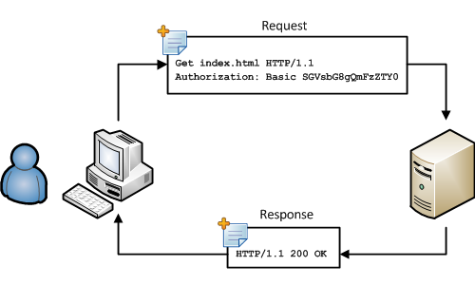

HTTP2

Key Features of HTTP/2:

* It introduces the concept of a server push where the server anticipates the resources that will be required by the client and pushes them prior to the client making requests. The client retains the authority to deny the server push; however, in most cases, this feature adds a lot of efficiency to the process.
* Introduces the concept of multiplexing that interleaves the requests and responses without head-of-line blocking and does so over a single TCP connection.
* It is a binary protocol i.e. only binary commands in the form of 0s and 1s are transmitted over the wire. The binary framing layer divides the message into frames that are segregated based on their type – Data or Header. This feature greatly increases efficiency in terms of security, compression and multiplexing.

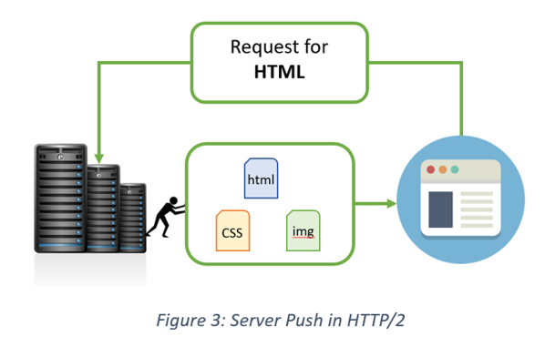

## HTTP/1.x vs HTTP/2: A Comparative Study

HTTP2 Vs. HTTP1 is not a debate at all. HTTP2 is much faster and more reliable than HTTP1. HTTP1 loads a single request for every TCP connection, while HTTP2 avoids network delay by using multiplexing.

HTTP is a network delay sensitive protocol in the sense that if there is less network delay, then the page loads faster. However, an impressive increase in network bandwidth only slightly improves page load time. This is key to understanding the differences in performance efficiencies between the different versions of HTTP. Back in the day when people used dial up modems web pages were simple and it was the actual data transfer between the server and the client that contributed towards the largest chunk of the page load time. Today the actual downloading of resources from server takes a negligible portion of the total page load time due to the tremendous increase in bandwidth availability. It is the time taken to establish the TCP connection and making requests that impacts performance. It was initially recommended to use only two connections per hostname but today most browsers use six connections per hostname. When we talk about http vs http2 in terms of performance it is important to note that a lot of performance optimizations adopted by HTTP/1.1 introduced complexities in terms of developmental efforts as well as network congestion that HTTP/2 attempts to address.

The table below points out the differentiating factors between http2 vs http1:

Header CompressionHeaders are sent on every request leading to a lot of duplicate data being sent uncompressed across the wire.Header compression is included by default in HTTP/2 using HPACK.Performance OptimizationProvides support for caching to deliver pages faster.Spriting, concatenating, inlining, domain sharding are some of the optimizations used as a workaround to the ‘six connections per host’ rule.Removes the need for unnecessary optimization hacks.Protocol TypeText based protocol that is in the readable form.It is a binary protocol (HTTP requests are sent in the form of 0s and 1s). Needs to be converted back from binary in order to read it.SecuritySSL is not required but recommended. Digest authentication used in HTTP1.1 is an improvement over HTTP1.0. HTTPS uses SSL/TLS for secure encrypted communication.Though security is still not mandatory, it is mostly encrypted (though it is not enforced) since almost all clients require traffic to be encrypted. It also has some minimum standards, such as minimum key size for encryption. TLS 1.2 etc.

Header CompressionHeaders are sent on every request leading to a lot of duplicate data being sent uncompressed across the wire.Header compression is included by default in HTTP/2 using HPACK.Performance OptimizationProvides support for caching to deliver pages faster.Spriting, concatenating, inlining, domain sharding are some of the optimizations used as a workaround to the ‘six connections per host’ rule.Removes the need for unnecessary optimization hacks.Protocol TypeText based protocol that is in the readable form.It is a binary protocol (HTTP requests are sent in the form of 0s and 1s). Needs to be converted back from binary in order to read it.SecuritySSL is not required but recommended. Digest authentication used in HTTP1.1 is an improvement over HTTP1.0. HTTPS uses SSL/TLS for secure encrypted communication.Though security is still not mandatory, it is mostly encrypted (though it is not enforced) since almost all clients require traffic to be encrypted. It also has some minimum standards, such as minimum key size for encryption. TLS 1.2 etc.