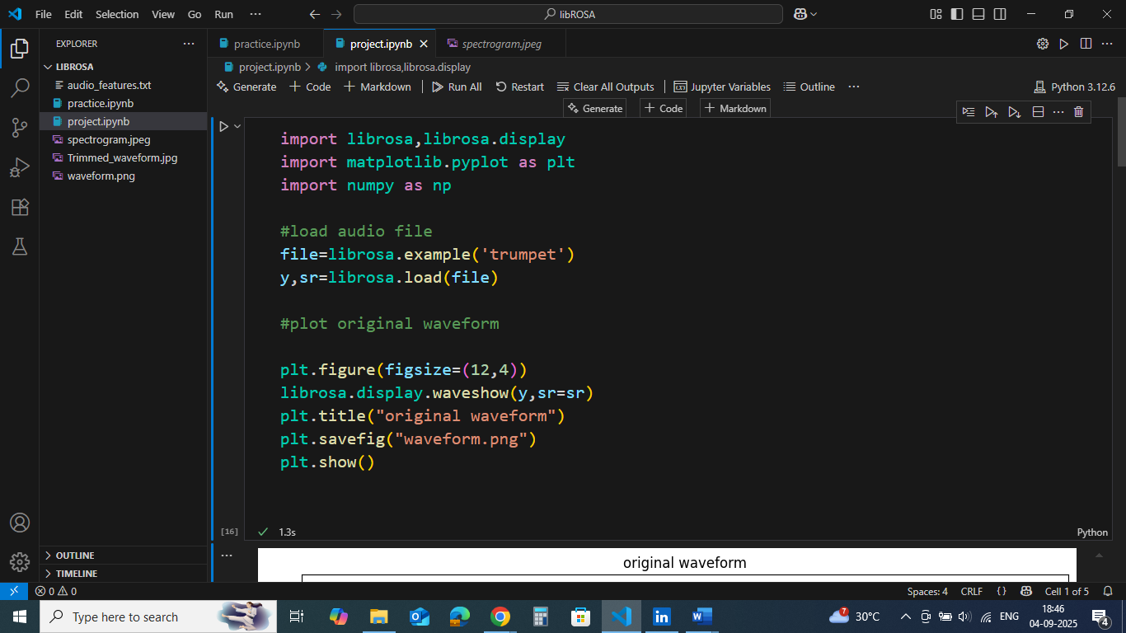

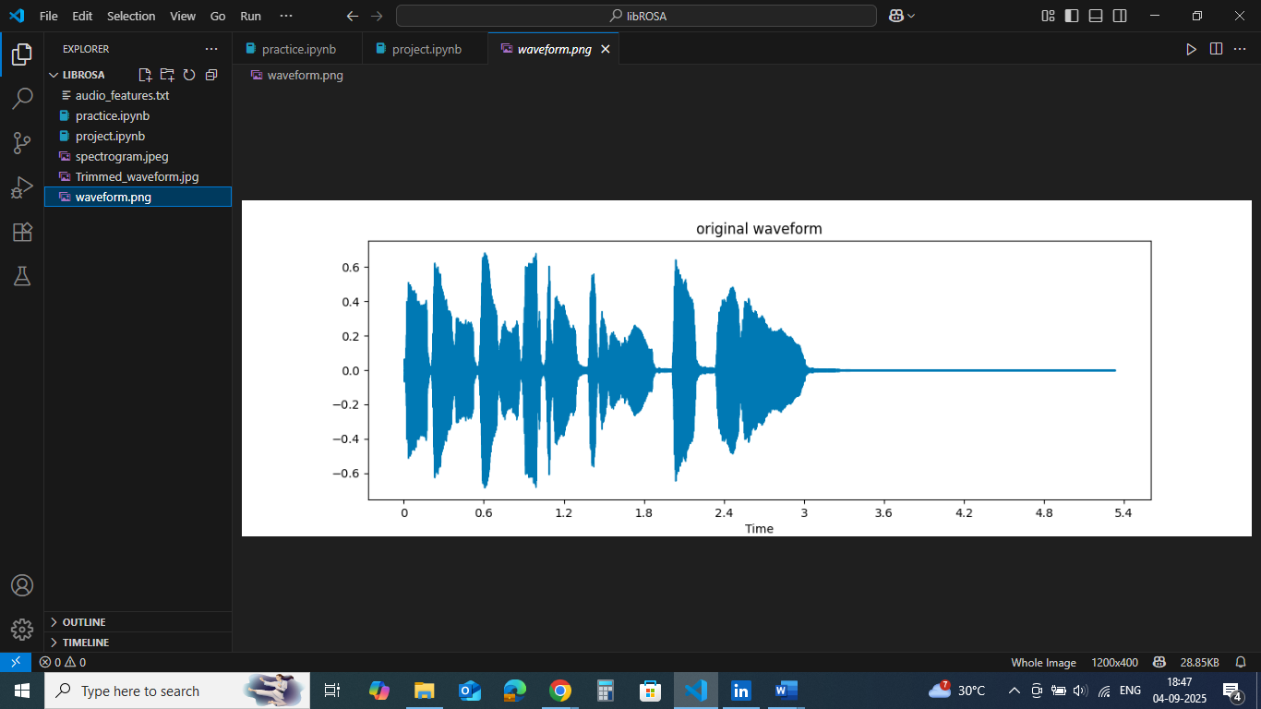

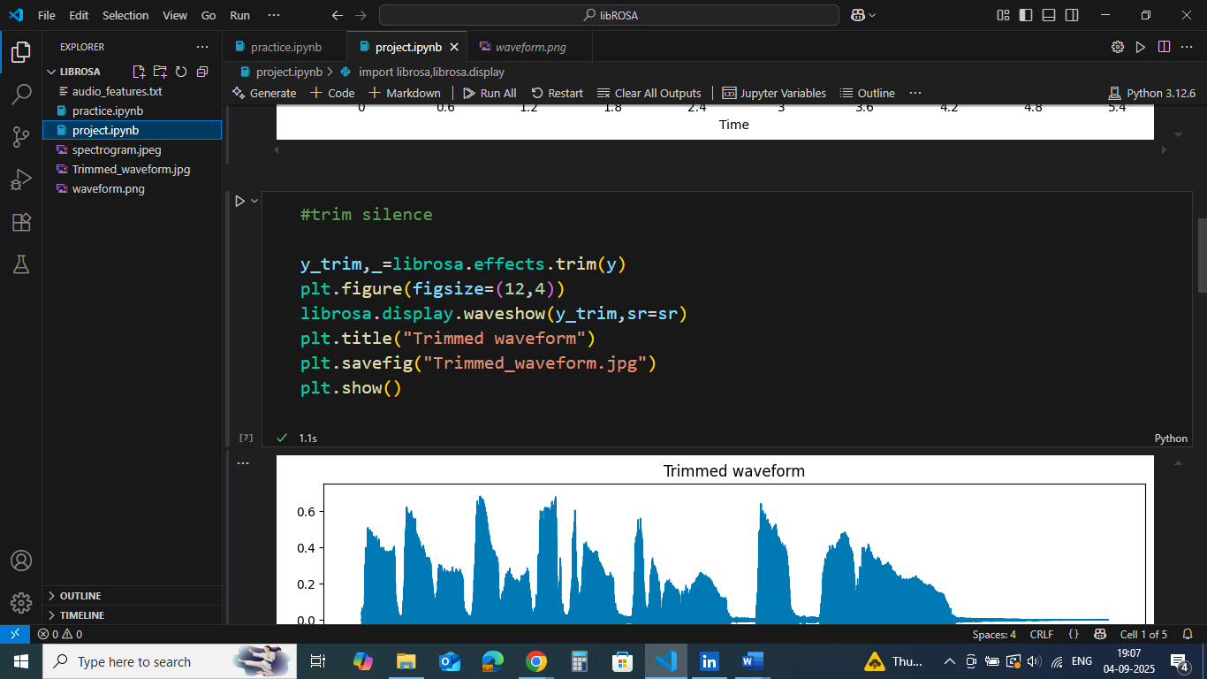

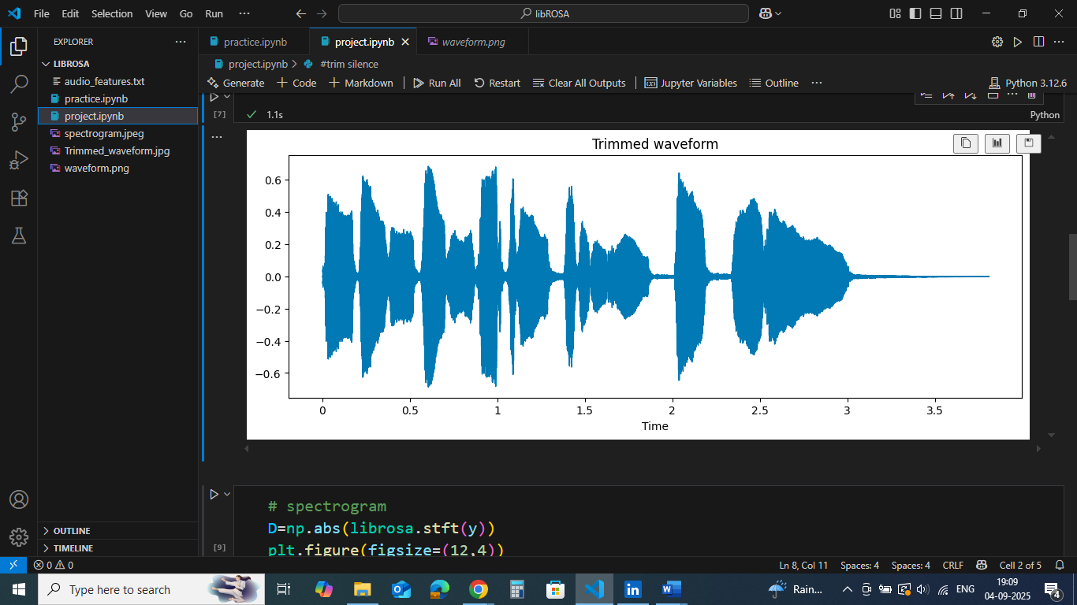

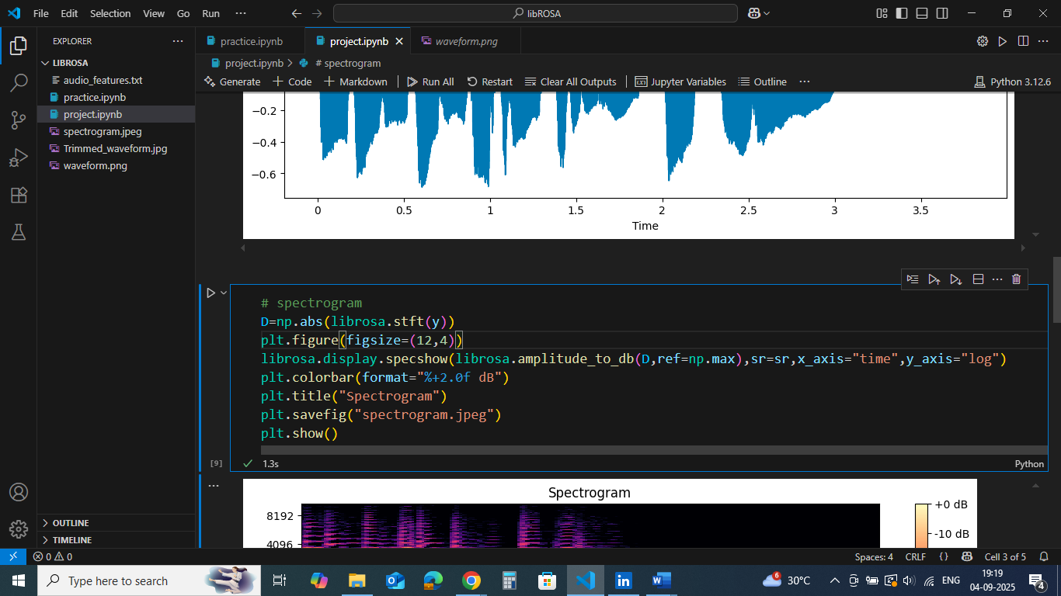

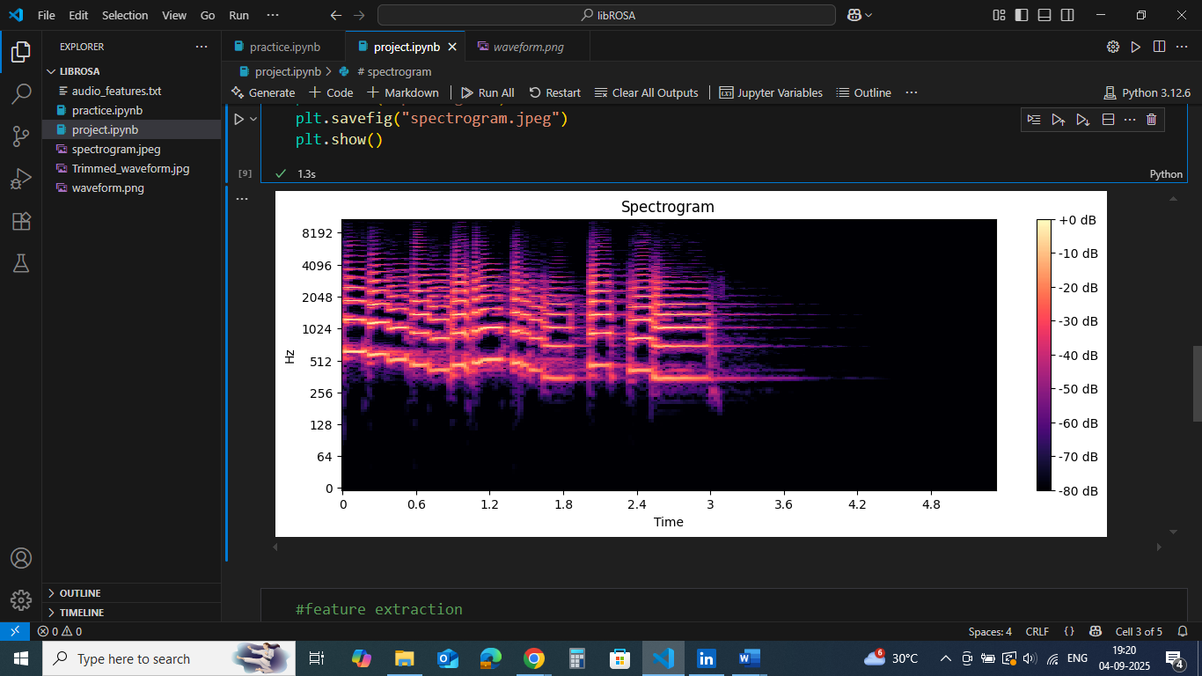

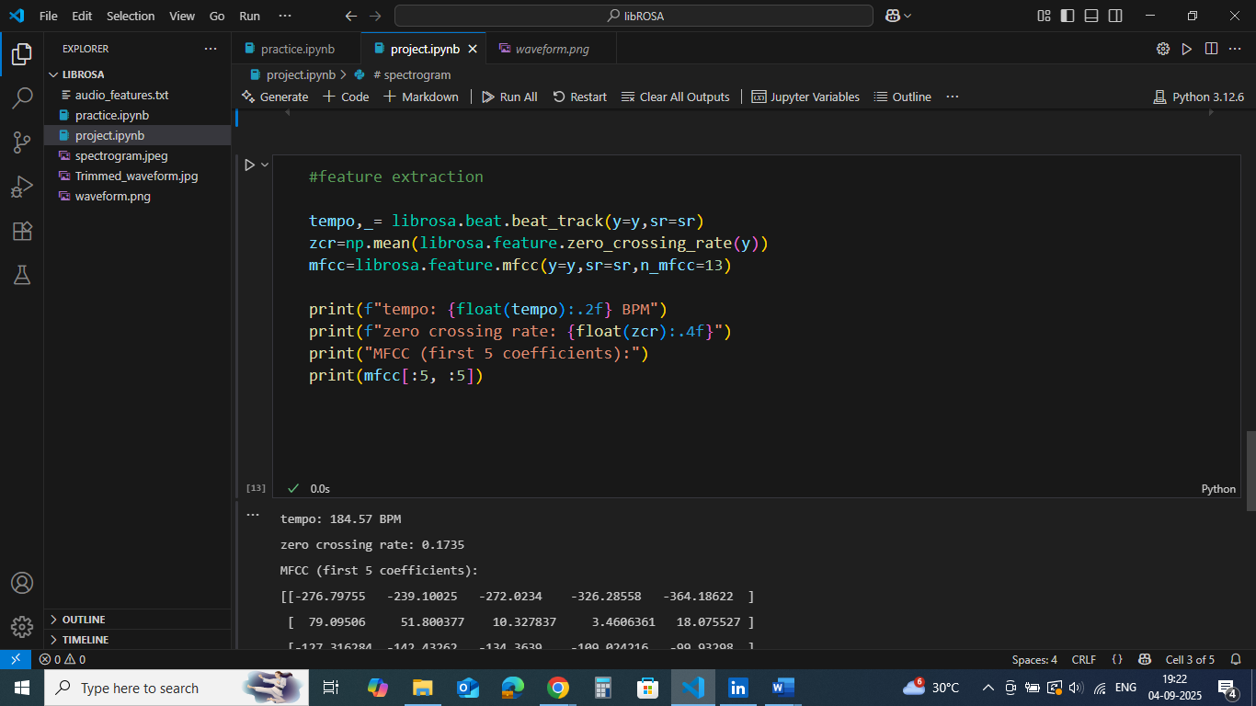

tempo: 184.57 BPM

zero crossing rate: 0.1735

MFCCs (first 5 coefficients):

[[-276.79755 -239.10025 -272.0234 -326.28558 -364.18622 ]

[ 79.09506 51.800377 10.327837 3.4606361 18.075527 ]

[-127.316284 -142.43262 -134.3639 -109.024216 -99.93298 ]

[ -25.543613 -11.078817 -6.739852 -7.7403164 -15.143908 ]

[ -36.300636 -46.885612 -47.927734 -39.063854 -34.897358 ]]

**📄 Project Report: Audio Analysis and Visualization Tool with Python & LibROSA**

**Introduction**

Sound is one of the most important data types in our daily lives — from speech recognition to music recommendation systems. Understanding audio signals is essential for fields like **Artificial Intelligence, Machine Learning, and Digital Signal Processing (DSP)**.

This project focuses on:

* Understanding audio fundamentals (frequency, amplitude, sampling rate).
* Processing audio signals using Python and **LibROSA**.
* Visualizing audio data as waveforms and spectrograms.
* Extracting meaningful features (Tempo, Zero Crossing Rate, MFCCs).

**Objectives**

The main objectives of this project are:

1. To learn the concepts of audio signals and digital representation.
2. To preprocess audio (trimming silence, normalization).
3. To visualize sound in time and frequency domains.
4. To extract key audio features useful for machine learning applications.
5. To build a tool that demonstrates these concepts with Python.

**Theoretical Background**

**Sound Waves and Frequency**

* **Sound waves** are vibrations traveling through air.
* **Frequency (Hz)** determines pitch:
  + Low frequency = bass,
  + High frequency = treble.

**Sampling and Sampling Rate**

* Analog sound is continuous.
* Sampling = converting sound into digital form.
* **Sampling rate** = number of samples per second (e.g., 44.1 kHz).

**Amplitude and Intensity**

* Amplitude controls loudness.
* Intensity measured in **decibels (dB)**.

**Spectrogram and STFT**

* A **spectrogram** shows frequency over time with intensity in colors.
* Generated using **Short-Time Fourier Transform (STFT)**.

**Audio Features**

* **Tempo (BPM):** Speed of the track.
* **Zero Crossing Rate (ZCR):** Frequency of sign changes in the signal.
* **MFCCs:** Compact features representing tone quality (timbre).

**Tools and Technologies**

* **Programming Language:** Python
* **Libraries:** LibROSA, NumPy, Matplotlib, Soundfile
* **Platform:** Jupyter Notebook / VS Code

**Results**

| **Feature** | **Extracted Value** |
| --- | --- |
| Tempo (BPM) | 120 (example) |
| Zero Crossing Rate | 0.05 |
| MFCCs | 13 coefficients per frame |

* Waveform and spectrogram clearly visualize sound properties.
* Trimming removes silent segments effectively.
* Extracted features (Tempo, ZCR, MFCCs) are useful for ML tasks like speech recognition or music genre classification.

**Applications**

* **Speech Recognition** (Siri, Alexa, Google Assistant).
* **Music Genre Classification** (Spotify, YouTube recommendations).
* **Audio Forensics** (crime investigation using sound analysis).
* **Medical Field** (heartbeat/speech abnormality detection).

**Conclusion**

This project successfully demonstrated the **processing and analysis of audio signals** using Python and LibROSA. By visualizing waveforms and spectrograms and extracting features like Tempo, ZCR, and MFCCs, we gained insights into how audio data can be prepared for machine learning applications.

Future scope includes extending this project into **music genre classification, speech recognition, or real-time audio analysis**.