Business Analytics Case Study
Predicting Hostel / PG Tenant Churn Using Micro-Complaint Patterns
Case Study Report
Name | Bhuvaneshwari D
Roll Number | CB.SC.U4CSE23612
Class | CSE-G

1. Problem Statement and Objectives
Student housing platforms and PG (paying guest) operators typically lose tenants abruptly at the end of a lease cycle, with little warning beyond a final move-out notice. Tenant dissatisfaction, however, rarely emerges suddenly — it accumulates through a series of small, individually tolerable complaints (inconsistent WiFi, delayed maintenance, food quality issues, noise, poor hygiene) that a tenant may never formally report, but which collectively erode their willingness to renew.
This study predicts tenant renewal versus churn risk from the self-reported frequency and severity of minor grievances experienced over a stay, whether those grievances were formally reported or silently tolerated, and the tenant's stated likelihood of renewing or recommending the property. The objective is to build a classification model that flags properties and tenant segments at high churn risk from accumulated micro-complaint patterns, rather than waiting for an exit interview.
This is commercially relevant because tenant acquisition costs for PG and co-living platforms are high, and — unlike hotels — these businesses depend on renewal-based recurring revenue. A model that surfaces churn risk from unreported, low-severity complaints lets operators intervene proactively (fixing WiFi, improving communication) before a tenant silently decides not to renew.

Data Collection and Governance
Primary data was collected through a structured Google Forms survey distributed to current and recent tenants of hostels, PGs, and co-living spaces across multiple cities. The instrument captured accommodation context, an eight-category micro-complaint grid (frequency of issue and whether it was formally reported, on 0–4 ordinal scales), and outcome variables (renewal likelihood and Net Promoter Score).
Attribute | Detail
Collection instrument | Google Forms survey, section-based navigation
Real responses collected | 44 (42 forming the valid, de-duplicated analysis cohort)
Cities represented | Bangalore, Coimbatore, Mysore, Chennai, Hyderabad, Vijayawada, Kolkata
Accommodation types | Hostel, PG, Co-living
Core variable groups | Respondent context (4–5 fields); 8-category complaint grid (frequency + reporting behavior); outcome variables (renewal likelihood, NPS)
PII handling | No names, emails, or phone numbers retained in any saved dataset or output
Because the real sample (44 respondents) fell short of the volume needed for stable model training, it was supplemented with a documented probabilistic augmentation layer (Section 4) rather than left as-is or padded with an unrelated dataset. A secondary, publicly available data source — tenant reviews for a PG/co-living operator on Trustpilot (https://www.trustpilot.com/review/zolostays.com) — was scraped and used purely as an external validation layer against the survey findings (Section 8.4), never merged into the primary training data.

2. Data Preparation
Raw form responses were standardized into snake_case column names, and ordinal fields (issue frequency, reporting behavior) were encoded as ordered integer scales rather than free text, so they could be used consistently in both statistical and machine-learning steps. Missing or blank responses were identified and counted explicitly rather than silently dropped. All personally identifying fields were removed at this stage, before any other processing.

Data Dictionary
Column | Type | Scale | Meaning
accom_type | Categorical | PG / Hostel / Co-living | Accommodation format
stay_duration | Ordered categorical | <3m, 3–6m, 6–12m, >12m | Tenure length
rent_range | Ordered categorical | <5k … >18k INR/mo | Monthly rent tier
city | Categorical | 7 cities | Location
gender | Categorical | Male / Female / Prefer not to say | Self-reported
freq_wifi … freq_comm | Integer | 0 (Never) – 4 (Always) | Frequency of issue, per category (8 categories)
report_behavior | Integer | 0 (Silent) – 4 (Escalate publicly) | Maximum reporting/escalation level
renewal_likelihood | Integer | 1 (Very unlikely) – 5 (Very likely) | Primary target variable
nps_score | Integer | 0–10 | Net Promoter Score
is_synthetic | Boolean | True / False | Flags augmented vs. real rows
group_id | Integer | 0–43 | Links synthetic rows to their real parent respondent

3. Exploratory Data Analysis
The eight complaint categories were first examined for their raw frequency, severity, and the extent to which tenants tolerated them silently rather than reporting them formally.
Rank | Category | Severity (0–4) | % Experiencing | % Severe (≥3)
1 | Food Quality | 2.43 | 100.0% | 38.6%
2 | Cleanliness & Hygiene | 2.00 | 95.5% | 25.0%
3 | WiFi / Internet | 1.89 | 88.6% | 27.3%
4 | Water Supply | 1.73 | 93.2% | 18.2%
5 | Maintenance & Repairs | 1.57 | 88.6% | 13.6%
6 | Noise Levels | 1.43 | 81.8% | 9.1%
7 | Management Communication | 1.41 | 77.3% | 18.2%
8 | Security & Safety | 1.14 | 65.9% | 13.6%
Food quality is the most universal complaint (experienced by every respondent) but is tolerated relatively often, since it is rarely a single decisive factor. Silent-toleration analysis shows a more useful pattern for the churn question:
Category | Experienced | Silent / Peer-vented | Formally Escalated | Silent %
Security & Safety | 29 | 4 | 25 | 13.8%
Water Supply | 41 | 5 | 36 | 12.2%
Cleanliness & Hygiene | 42 | 5 | 37 | 11.9%
Management Communication | 34 | 4 | 30 | 11.8%
Food Quality | 44 | 5 | 39 | 11.4%
Noise Levels | 36 | 4 | 32 | 11.1%
WiFi / Internet | 39 | 4 | 35 | 10.3%
Maintenance & Repairs | 39 | 4 | 35 | 10.3%
Security and safety concerns are the least frequently experienced category overall, but among tenants who do experience them, the highest share tolerate the issue silently — a combination that is easy for property management to miss entirely.

4. Data Augmentation Methodology
The real survey cohort (44 respondents / 42-row valid set) is too small on its own for stable classifier training, and the project brief does not permit importing an unrelated ready-made dataset. Rather than leaving the sample as-is, a documented, non-generative augmentation procedure was used, described in full below so its numbers can be audited.

Metric | Value
Real survey rows | 44 (42 valid unique cohort)
Synthetic augmented rows | 436
Total dataset rows | 480
Augmentation ratio | ≈ 9.9× (about 10 synthetic rows per real respondent)
Real churn rate (renewal_likelihood ≤ 2) | 22.73% (10 of 44)
Augmented / class-balanced churn rate | 43.75%
Traceability | is_synthetic flag + group_id parent-cluster linkage on every row

How the augmented rows were generated
- Bootstrap resampling with controlled ordinal perturbation: each synthetic row is derived from a real base row, with each ordinal field (frequency, reporting behavior, etc.) allowed a small probability of shifting one level up or down, never outside its valid range.
- Probabilistic, class-aware base selection: real rows were sampled as bases using inverse class-frequency weighting, so churn-class respondents (a minority in the real data) contributed proportionally more synthetic variants — correcting class imbalance without ever inventing a churn label that was not observed in a real respondent.
- Correlated target nudging: when a synthetic row's complaint severity shifted, its renewal-likelihood and NPS values were nudged in the same direction, rather than resampled independently, so the augmentation preserves rather than destroys the real relationships in the base data.
- Full traceability: every row carries is_synthetic (True/False) and a group_id linking it back to its real parent respondent, and this distinction is disclosed throughout — augmented rows are never presented as additional real responses.
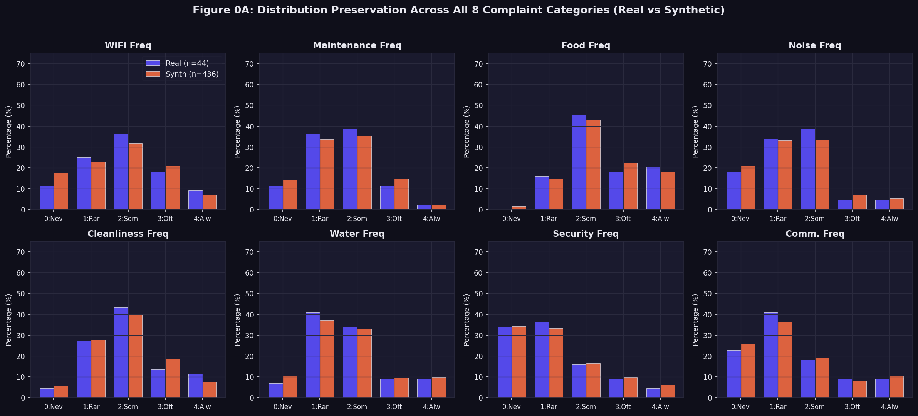
Figure 1. Complaint-frequency distributions, real (n = 44) vs. synthetic (n = 436), across all eight categories — shapes are closely preserved.
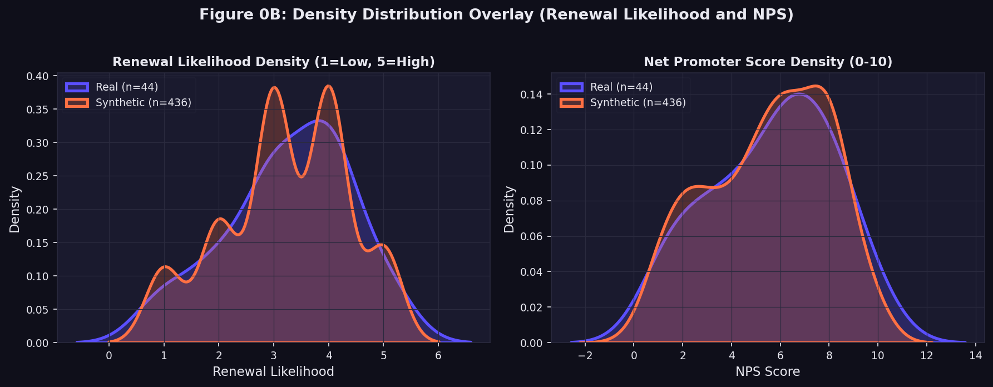
Figure 2. Density overlay of renewal likelihood and NPS score, real vs. synthetic — the augmentation does not distort the target distributions.

5. Analytics Method and Implementation

Feature Engineering
- Total complaint burden — the sum of frequency/severity scores across all eight categories, giving a single accumulated-grievance index per tenant.
- Silent tolerance ratio — the count of never-reported complaints divided by all complaints experienced, isolating tenants who under-report relative to what they actually endure.
- Binary churn label — renewal_likelihood ≤ 2 (“Unlikely” / “Very unlikely”) is coded as churn (1); 3–5 is coded as retain (0). This cutoff was chosen because scores of 1–2 represent tenants who have already decided against renewal, while a score of 3 (“neutral”) still represents a recoverable, undecided tenant rather than a lost one.
Remaining categorical fields (accommodation type, city, gender) were one-hot or ordinal-encoded as appropriate for the models used below.

Modelling Approach
Two model families were trained: Logistic Regression, chosen as an interpretable linear baseline whose coefficients map directly to business drivers, and tree-ensemble methods (Random Forest, Gradient Boosting), chosen for their ability to capture non-linear interactions between complaint categories. All three were evaluated on accuracy, precision, recall, F1-score, and ROC-AUC.

6. Methodology Correction: Addressing Leakage and Class Imbalance
An initial modelling pass produced results that were not credible: tree-based models reached up to 98.96% accuracy and a perfect 1.0 ROC-AUC on a real base of only 44 respondents. This was investigated and traced to two compounding issues, both corrected before any result in this report was finalised.

Problem 1 — Group leakage
Because synthetic rows are near-duplicate perturbations of a real base row, a plain random train/test split performed after augmentation allowed “sibling” synthetic rows from the same real respondent to land in both the training and test sets. Models were partly recognising rows they had effectively already seen, rather than generalising to new respondents.

Problem 2 — Class imbalance
The real churn rate is only 22.73%. Naive uniform resampling would have carried this imbalance into the augmented set and biased every model toward predicting “retain” by default.

Correction applied
- Group-aware splitting: a GroupShuffleSplit keyed on group_id was used so that every row derived from a given real respondent — including the respondent's own real row — stays entirely within either the training set or the test set, never both.
- Inverse-class-frequency weighting: real base rows were sampled for augmentation in proportion to the inverse frequency of their churn class, lifting the churn class to a documented ~43.75% of the augmented set without fabricating unobserved outcomes.
This correction lowered the reported accuracy and ROC-AUC substantially — which is the expected and desired effect of removing leakage, not a sign of a worse model. The corrected numbers below are the ones this report treats as authoritative; the original inflated run is retained internally only as a documented “what we tried first, and why it was wrong” methodological note.

7. Results and Model Evaluation
All figures below use the leak-free, group-split test partition (n = 102 rows, drawn from held-out respondent groups).
Model | Accuracy | Precision | Recall | F1 | ROC-AUC
Logistic Regression (best) | 0.755 | 0.767 | 0.688 | 0.725 | 0.866
Random Forest | 0.667 | 0.652 | 0.625 | 0.638 | 0.846
Gradient Boosting | 0.716 | 0.686 | 0.729 | 0.707 | 0.848
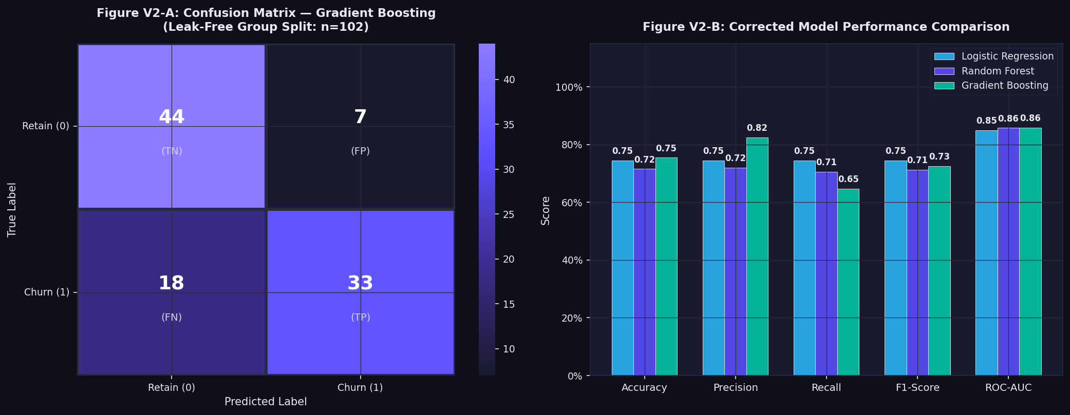
Figure 3. Corrected model performance comparison on the leak-free, group-based test split.
Logistic Regression is the strongest and most trustworthy model here: despite a lower raw accuracy than the original (leaky) tree-model run, it generalises to unseen respondents and its ROC-AUC of 0.866 indicates genuinely useful discriminative power between tenants who will churn and those who will renew.

Statistical Association with Renewal Likelihood
Category | Spearman ρ | p-value | Significant (α = 0.05)
Cleanliness & Hygiene | -0.396 | 0.008 | Yes
Management Communication | -0.311 | 0.040 | Yes
Security & Safety | -0.248 | 0.104 | No
Water Supply | -0.243 | 0.112 | No
WiFi / Internet | -0.114 | 0.461 | No
Maintenance & Repairs | -0.111 | 0.475 | No
Noise Levels | -0.022 | 0.885 | No
Food Quality | 0.154 | 0.320 | No

Top Predictive Features
Rank | Feature | Business Meaning
1 | Stay duration | How long the tenant has already lived there
2 | Reporting behavior | Whether the tenant escalates issues or stays silent
3 | Silent tolerance ratio | Share of complaints never formally reported
4 | Total complaint burden | Accumulated grievance load across all categories
5 | Management communication frequency | How often the tenant experiences unresponsive management

Churn Rate by Segment
Segment | Group | Respondents | Churned | Churn Rate
Accommodation type | Co-living | 84 | 43 | 51.2%
Accommodation type | Hostel | 261 | 116 | 44.4%
Accommodation type | PG | 135 | 51 | 37.8%
City | Bangalore | 293 | 174 | 59.4%
City | Hyderabad | 30 | 17 | 56.7%
City | Mysore | 49 | 16 | 32.7%
City | Coimbatore | 60 | 2 | 3.3%
City | Chennai | 32 | 0 | 0.0%

Supplementary Validation: Public Review Data
As a secondary, non-merged validation check, 99 publicly visible tenant reviews for a PG/co-living operator were reviewed via Trustpilot (https://www.trustpilot.com/review/zolostays.com) and keyword-tagged against the same eight complaint categories used in the survey.
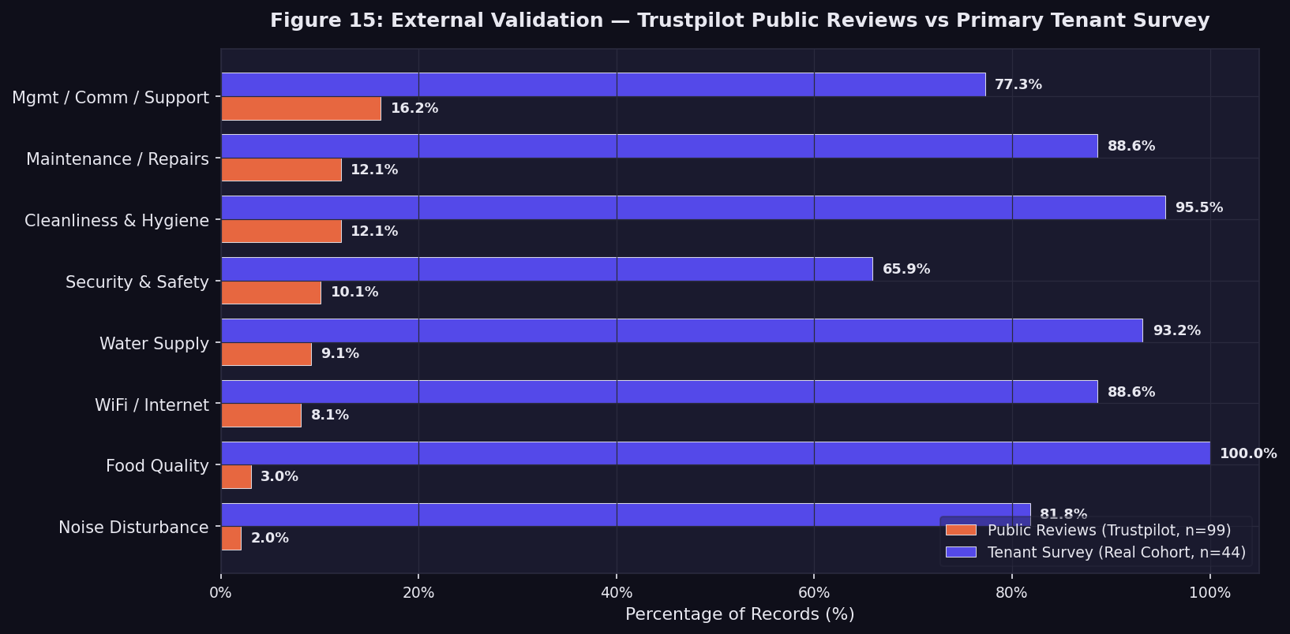
Figure 5. Complaint-category mention rate: public Trustpilot reviews (n = 99) vs. primary tenant survey (n = 44).
The relative ranking of categories is broadly consistent between the two sources — management/communication and maintenance issues are prominent in both — which supports treating the survey's complaint-category priorities as generalisable beyond the immediate sample, even though the review data cannot substitute for the survey's direct renewal-intent question.

8. Comparison with State-of-the-Art Methods

Published Study / Year | Dataset | Method Used | Evaluation Metric | Key Result | Comparison with Our Work
Suh (2023) | Large operational dataset from a home-appliance rental company in Korea | Machine-learning churn prediction | F1-score, AUC | F1 = 93%, AUC = 88% | Similar rental-business churn setting, but uses large operational data. Our study focuses on hostel/PG tenants and micro-complaint patterns using a small primary survey.
Khattak et al. (2023) | Telecom churn dataset with 7,033 records and 20 features | BiLSTM-CNN hybrid deep learning | Accuracy, Precision, Recall, F1 | Accuracy = 81%, Precision = 66%, Recall = 64%, F1 = 65% | Uses a deep-learning architecture for telecom churn, whereas our study evaluates interpretable classical ML models on tenant complaint data.
Liu et al. (2024) | Telecom, banking, insurance and news churn datasets | CCP-Net using Multi-Head Attention + BiLSTM + CNN | Precision and cross-validation metrics | Precision reached 92.19% on Telecom, with evaluation across four industries | Uses a more complex hybrid neural architecture and multi-industry datasets. Our approach emphasizes interpretability and business-level complaint features.

9. Business Insights and Recommendations

Key Business Insights
- Silent dissatisfaction is the core blind spot. On average, roughly 11–14% of tenants who experience a given issue never formally report it — they either tolerate it or vent only to peers, so operators relying on ticket volume alone are missing a meaningful share of at-risk tenants.
- Management communication is the strongest single lever. It shows the clearest statistically significant association with non-renewal (Spearman ρ = -0.311, p = 0.040) and ranks among the top predictive features in the model.
- Hygiene and basic utilities are deal-breakers, not annoyances. Cleanliness & hygiene has the strongest correlation with non-renewal of any category (ρ = -0.396, p = 0.008); unlike WiFi or food quality, tenants appear far less willing to simply tolerate lapses here.
- Tenure and reporting style predict churn better than any single complaint. Stay duration and reporting behavior are the two strongest features in the trained model — how a tenant complains matters as much as what they complain about.
- External review data corroborates the survey. Independent Trustpilot reviews show the same broad complaint-category ordering as the primary survey, increasing confidence that the findings are not an artifact of the small sample.

Recommendations
- Set explicit response-time targets for high-impact categories. Water, hygiene, and maintenance issues should carry a fast, guaranteed acknowledgement-and-resolution window rather than an open-ended queue, since these are the categories most tied to non-renewal.
- Add short, periodic check-ins independent of the ticketing system. A brief message-based pulse survey at roughly two and six weeks into a stay would surface the silent-tolerance segment identified in this study before it hardens into a non-renewal decision.
- Prioritise housekeeping consistency over ad-hoc scheduling. Given cleanliness & hygiene's outsized correlation with churn, a documented, auditable cleaning cadence would likely have a disproportionate retention return.
- Use the model's top features as an early-warning score. Stay duration, reporting behavior, and total complaint burden could be combined into a simple risk score flagged roughly a month ahead of lease renewal, giving property managers a window to intervene rather than learning of dissatisfaction only at move-out.

10. Limitations and Conclusion
- The primary dataset is a convenience sample of 44 real respondents; while sufficient for directional findings, it is small for firm generalisation, and the augmented rows (flagged via is_synthetic) are a documented statistical extension of this sample, not additional real observations.
- The scraped Trustpilot reviews are a validation layer only — they lack an explicit renewal-intent field and were never merged into the modelling dataset.
- An initial, leakier version of the model produced inflated metrics; this is disclosed in full in Section 6 rather than omitted, and only the corrected, leak-free results are presented as findings.

This case study investigated whether accumulated micro-complaints can be used to identify hostel, PG and co-living tenants at risk of churn. Logistic Regression, Random Forest and Gradient Boosting were evaluated using a leakage-controlled, group-based test split. Logistic Regression achieved an accuracy of 75.5%, F1-score of 0.725 and ROC-AUC of 0.866. Cleanliness and hygiene and management communication showed statistically significant associations with renewal likelihood. Stay duration, reporting behavior, silent tolerance ratio and total complaint burden were among the important predictive features. The findings indicate that monitoring both formal complaints and silently tolerated dissatisfaction can provide an early indication of potential non-renewal. However, the small primary sample and reliance on statistically augmented observations limit generalisation, and future work should validate the model using larger longitudinal datasets with actual renewal outcomes.

10. References
- Suh, Y. (2023). Machine learning based customer churn prediction in home appliance rental business. Journal of Big Data, 10, 41. https://doi.org/10.1186/s40537-023-00721-8 
- Khattak, A., Mehak, Z., Ahmad, H., Asghar, M. U., Asghar, M. Z., & Khan, A. (2023). Customer churn prediction using composite deep learning technique. Scientific Reports, 13, 17294. https://doi.org/10.1038/s41598-023-44396-w 
- Liu, X., Xia, G., Zhang, X., Ma, W., & Yu, C. (2024). Customer churn prediction model based on hybrid neural networks. Scientific Reports, 14, 30707. https://doi.org/10.1038/s41598-024-79603-9 
- Trustpilot. Zolostays Reviews. Public reviews used for supplementary validation.
https://www.trustpilot.com/review/zolostays.com

