- Design an application that contains Phone Contacts in vertical linear manner. Selected contact appears at the top of the list with a large italicized font and a blue background.
Solution:
- Activity.xml file
<?xml version="1.0" encoding="utf-8"?>
<androidx.constraintlayout.widget.ConstraintLayout xmlns:android="http://schemas.android.com/apk/res/android"
xmlns:app="http://schemas.android.com/apk/res-auto"
xmlns:tools="http://schemas.android.com/tools"
android:layout_width="match_parent"
android:layout_height="match_parent"
tools:context=".MainActivity">
<TextView
android:id="@+id/pc"
android:layout_width="142dp"
android:layout_height="49dp"
android:capitalize="words"
android:text="@string/phone"
app:layout_constraintBottom_toBottomOf="parent"
app:layout_constraintEnd_toEndOf="parent"
app:layout_constraintHorizontal_bias="0.099"
app:layout_constraintStart_toStartOf="parent"
app:layout_constraintTop_toTopOf="parent"
app:layout_constraintVertical_bias="0.103" />
<ListView
android:id="@+id/listview"
android:layout_width="321dp"
android:layout_height="510dp"
app:layout_constraintBottom_toBottomOf="parent"
app:layout_constraintEnd_toEndOf="parent"
app:layout_constraintHorizontal_bias="0.633"
app:layout_constraintStart_toStartOf="parent"
app:layout_constraintTop_toTopOf="parent"
app:layout_constraintVertical_bias="0.814" />
</androidx.constraintlayout.widget.ConstraintLayout>

- String.xml file in values
<resources>
<string name="app_name">First Lab Program</string>
<string name="phone">Selected Phone Contacts will Display Here</string>
<string-array name="li_contact">
<item>Dr M A Jayaram 1234567899</item>
<item>Dr Prashanth G K 9980933552</item>
<item>Mr H K Virupakshaiah 234567887</item>
<item>Dr Bharathi P T 9980933552</item>
<item>Mr H S Vijayakumar 9980933552</item>
<item>Mr T M Kirankumar 9980933552</item>
<item>Mr Bhanu Prakash C 9980933552</item>
<item>Mr C N Ramesh 9980933552</item>
</string-array>
</resources>
- Main java file
- package com.example.firstlabprogram;

- import androidx.appcompat.app.AppCompatActivity;

- import android.graphics.Typeface;
- import android.os.Bundle;
- import android.view.View;
- import android.widget.ArrayAdapter;
- import android.widget.AdapterView;
- import android.widget.ListView;
- import android.widget.TextView;

- public class MainActivity extends AppCompatActivity {
- ListView lv;
- TextView tv;
- String [] li;

- @Override
- protected void onCreate(Bundle savedInstanceState) {
- super.onCreate(savedInstanceState);
- setContentView(R.layout.activity_main);
- // my codeing
- li=getResources().getStringArray(R.array.li_contact);
- lv=(ListView) findViewById(R.id.listview);
- tv=(TextView) findViewById(R.id.pc);

- final ArrayAdapter<String> adapter=new ArrayAdapter<String>(this,android.R.layout.simple_list_item_1,android.R.id.text1,li);
- lv.setAdapter(adapter);

- lv.setOnItemClickListener(new AdapterView.OnItemClickListener() {
- @Override
- public void onItemClick(AdapterView<?> adapterView, View view, int i, long l) {
- String value=adapter.getItem(i);
- tv.setText(value);
- tv.setTypeface(null, Typeface.ITALIC);

- }
- });

- }
- }

Output: -

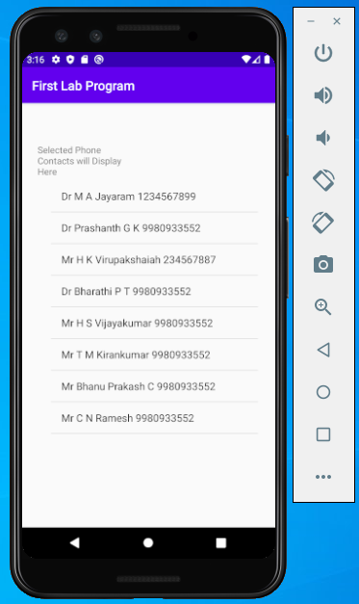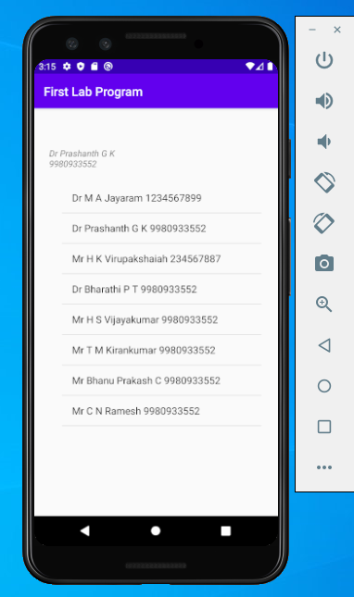

- Create an application that uses Layout Managers and Event Listeners.
Activity.xml file
<?xml version="1.0" encoding="utf-8"?>
<androidx.constraintlayout.widget.ConstraintLayout xmlns:android="http://schemas.android.com/apk/res/android"
xmlns:app="http://schemas.android.com/apk/res-auto"
xmlns:tools="http://schemas.android.com/tools"
android:id="@+id/Form_one"
android:layout_width="match_parent"
android:layout_height="match_parent"
android:background="#41939E"
tools:context=".MainActivity">
<TextView
android:id="@+id/txt_view"
android:layout_width="254dp"
android:layout_height="44dp"
android:text="@string/EV"
android:textSize="24sp"
app:layout_constraintBottom_toBottomOf="parent"
app:layout_constraintHorizontal_bias="0.191"
app:layout_constraintLeft_toLeftOf="parent"
app:layout_constraintRight_toRightOf="parent"
app:layout_constraintTop_toTopOf="parent"
app:layout_constraintVertical_bias="0.088" />
<TextView
android:id="@+id/txt_disp"
android:layout_width="360dp"
android:layout_height="52dp"
android:layout_marginTop="52dp"
android:text="@string/Display_Name"
android:textSize="30sp"
app:layout_constraintBottom_toTopOf="@+id/Butt_Convert"
app:layout_constraintEnd_toEndOf="parent"
app:layout_constraintHorizontal_bias="0.313"
app:layout_constraintStart_toStartOf="parent"
app:layout_constraintTop_toBottomOf="@+id/txt_view"
app:layout_constraintVertical_bias="0.011" />
<Button
android:id="@+id/Butt_Convert"
android:layout_width="200dp"
android:layout_height="49dp"
android:layout_marginBottom="384dp"
android:text="@string/butt_valu1"
app:layout_constraintBottom_toBottomOf="parent"
app:layout_constraintEnd_toEndOf="parent"
app:layout_constraintHorizontal_bias="0.142"
app:layout_constraintStart_toStartOf="parent" />
<TextView
android:id="@+id/txt_Dept"
android:layout_width="346dp"
android:layout_height="51dp"
android:layout_marginTop="56dp"
android:text="@string/Dept"
android:textSize="30sp"
app:layout_constraintEnd_toEndOf="parent"
app:layout_constraintHorizontal_bias="0.246"
app:layout_constraintStart_toStartOf="parent"
app:layout_constraintTop_toBottomOf="@+id/Butt_Convert" />
<Spinner
android:id="@+id/Disp_Spinner"
android:layout_width="322dp"
android:layout_height="43dp"
android:layout_marginStart="8dp"
android:layout_marginLeft="8dp"
android:layout_marginTop="64dp"
android:layout_marginEnd="8dp"
android:layout_marginRight="8dp"
android:prompt="@string/Spinner_value"
android:spinnerMode="dropdown"
app:layout_constraintBottom_toBottomOf="parent"
app:layout_constraintEnd_toEndOf="parent"
app:layout_constraintHorizontal_bias="0.109"
app:layout_constraintStart_toStartOf="parent"
app:layout_constraintTop_toBottomOf="@+id/txt_Dept"
app:layout_constraintVertical_bias="0.0" />
</androidx.constraintlayout.widget.ConstraintLayout>

String.xml file
<resources>
<string name="app_name">Second Lab Program</string>
<string name="EV">Event Listereners</string>
<string name="Display_Name">SIT, MCA</string>
<string name="butt_valu1">Convert to Italic</string>
<string name="Dept">Department</string>
<string name="Spinner_value">Select the Department</string>
<string-array name="depts">
<item>Select the Your Department</item>
<item>MCA</item>
<item>MBA</item>
<item>BE</item>
</string-array>
</resources>

mainActivity.class file
package com.example.secondlab;
import androidx.appcompat.app.AppCompatActivity;
import android.graphics.Typeface;
import android.opengl.EGLExt;
import android.os.Bundle;
import android.view.View;
import android.widget.ArrayAdapter;
import android.widget.AdapterView;
import android.widget.AdapterView.OnItemSelectedListener;
import android.widget.Button;
import android.widget.Spinner;
import android.widget.TextView;
import android.widget.Toast;
public class MainActivity extends AppCompatActivity {
Button btn_convet;
TextView txtview;
String[] dept;
@Override
protected void onCreate(Bundle savedInstanceState) {
super.onCreate(savedInstanceState);
setContentView(R.layout.activity_main);
btn_convet=(Button)findViewById(R.id.Butt_Convert);
dept=getResources().getStringArray(R.array.depts);
Spinner s1=(Spinner)findViewById(R.id.Disp_Spinner);
ArrayAdapter<String> adapter=new ArrayAdapter<String>(this,android.R.layout.simple_dropdown_item_1line,dept);
s1.setAdapter(adapter);
s1.setOnItemSelectedListener(new OnItemSelectedListener() {
@Override
public void onItemSelected(AdapterView<?> adapterView, View view, int i, long l) {
int index=adapterView.getSelectedItemPosition();
if(index>0){
Toast.makeText(getBaseContext(),"You Have Selected " + dept[index], Toast.LENGTH_SHORT).show();
}
}
@Override
public void onNothingSelected(AdapterView<?> adapterView) {
}
});
btn_convet.setOnClickListener(new View.OnClickListener() {
@Override
public void onClick(View view) {
txtview=(TextView)findViewById(R.id.txt_disp);
txtview.setTypeface(null, Typeface.ITALIC);
}
});
}
}

OUTPUT:

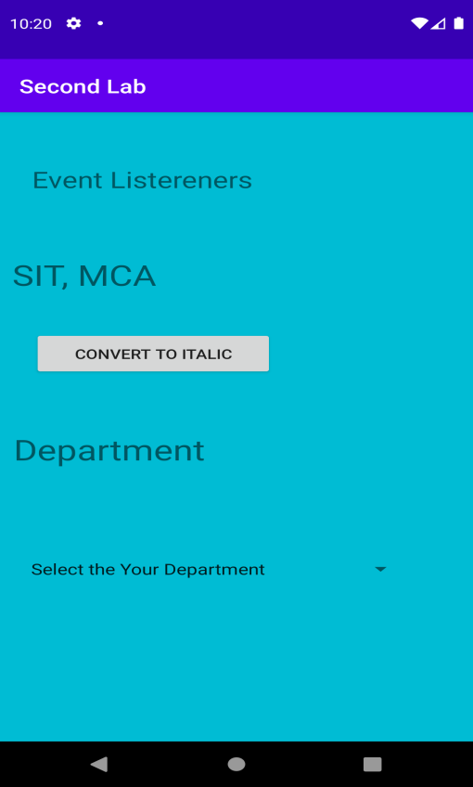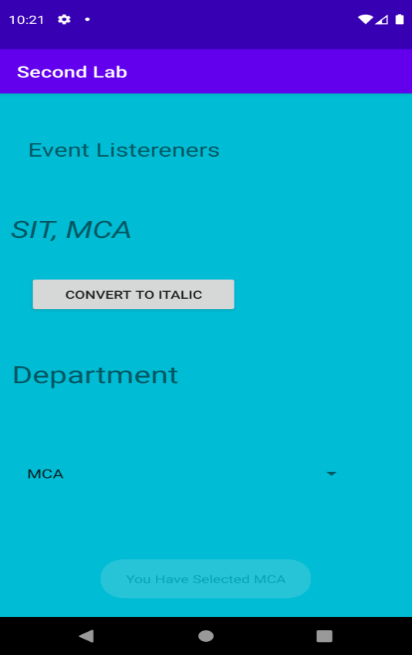

- Develop a standard calculator application to perform basic calculations like addition, subtraction, multiplication and division.

Solution:
Activity Xml File
<?xml version="1.0" encoding="utf-8"?>
<androidx.constraintlayout.widget.ConstraintLayout xmlns:android="http://schemas.android.com/apk/res/android"
xmlns:app="http://schemas.android.com/apk/res-auto"
xmlns:tools="http://schemas.android.com/tools"
android:layout_width="match_parent"
android:layout_height="match_parent"
android:background="#00BFA5"
tools:context=".MainActivity">
<TextView
android:id="@+id/txt_Num-"
android:layout_width="149dp"
android:layout_height="35dp"
android:layout_marginStart="24dp"
android:layout_marginLeft="24dp"
android:layout_marginTop="188dp"
android:text="@string/second_num"
app:layout_constraintEnd_toStartOf="@+id/Edit_num-2"
app:layout_constraintStart_toStartOf="parent"
app:layout_constraintTop_toTopOf="parent" />
<TextView
android:id="@+id/Txt_Num-1"
android:layout_width="162dp"
android:layout_height="41dp"
android:layout_marginStart="24dp"
android:layout_marginLeft="24dp"
android:layout_marginTop="84dp"
android:text="@string/fn"
android:textSize="18sp"
app:layout_constraintEnd_toStartOf="@+id/Edit_First_num"
app:layout_constraintHorizontal_bias="0.0"
app:layout_constraintStart_toStartOf="parent"
app:layout_constraintTop_toTopOf="parent" />

<EditText
android:id="@+id/Edit_First_num"
android:layout_width="182dp"
android:layout_height="40dp"
android:layout_marginEnd="8dp"
android:layout_marginRight="8dp"
android:ems="10"
android:inputType="numberDecimal"
app:layout_constraintBottom_toBottomOf="parent"
app:layout_constraintEnd_toEndOf="parent"
app:layout_constraintHorizontal_bias="0.93"
app:layout_constraintStart_toStartOf="parent"
app:layout_constraintTop_toTopOf="parent"
app:layout_constraintVertical_bias="0.121" />
<EditText
android:id="@+id/Edit_num-2"
android:layout_width="wrap_content"
android:layout_height="wrap_content"
android:layout_marginEnd="12dp"
android:layout_marginRight="12dp"
android:ems="10"
android:inputType="numberDecimal"
app:layout_constraintBottom_toBottomOf="parent"
app:layout_constraintEnd_toEndOf="parent"
app:layout_constraintTop_toTopOf="parent"
app:layout_constraintVertical_bias="0.274" />
<TextView
android:id="@+id/txt_Result"
android:layout_width="248dp"
android:layout_height="47dp"
android:hint="Result Displayed Here"
android:text="@string/Result"
android:textSize="18sp"
app:layout_constraintBottom_toBottomOf="parent"
app:layout_constraintEnd_toEndOf="parent"
app:layout_constraintHorizontal_bias="0.2"
app:layout_constraintStart_toStartOf="parent"
app:layout_constraintTop_toTopOf="parent"
app:layout_constraintVertical_bias="0.433" />
<Button
android:id="@+id/Btt_Add"
android:layout_width="wrap_content"
android:layout_height="wrap_content"
android:layout_marginStart="32dp"
android:layout_marginLeft="32dp"
android:layout_marginTop="412dp"
android:onClick="add"
android:text="Add"
app:layout_constraintStart_toStartOf="parent"
app:layout_constraintTop_toTopOf="parent" />
<Button
android:id="@+id/Btt_Sub"
android:layout_width="wrap_content"
android:layout_height="wrap_content"
android:layout_marginTop="412dp"
android:layout_marginEnd="28dp"
android:layout_marginRight="28dp"
android:onClick="sub"
android:text="Subtraction"
app:layout_constraintEnd_toStartOf="@+id/Btt_Mul"
app:layout_constraintTop_toTopOf="parent" />
<Button
android:id="@+id/Btt_Mul"
android:layout_width="wrap_content"
android:layout_height="wrap_content"
android:layout_marginTop="412dp"
android:layout_marginEnd="28dp"
android:layout_marginRight="28dp"
android:onClick="mul"
android:text="Mul"
app:layout_constraintEnd_toEndOf="parent"
app:layout_constraintTop_toTopOf="parent" />
<Button
android:id="@+id/Btt_Div"
android:layout_width="wrap_content"
android:layout_height="wrap_content"
android:layout_marginStart="24dp"
android:layout_marginLeft="24dp"
android:onClick="div"
android:text="Division"
app:layout_constraintBottom_toBottomOf="parent"
app:layout_constraintEnd_toStartOf="@+id/Btt_Clr"
app:layout_constraintHorizontal_bias="0.38"
app:layout_constraintStart_toStartOf="parent"
app:layout_constraintTop_toTopOf="parent"
app:layout_constraintVertical_bias="0.812" />
<Button
android:id="@+id/Btt_Clr"
android:layout_width="wrap_content"
android:layout_height="wrap_content"
android:layout_marginEnd="136dp"
android:layout_marginRight="136dp"
android:onClick="clear_data"
android:text="Clear"
app:layout_constraintBottom_toBottomOf="parent"
app:layout_constraintEnd_toEndOf="parent"
app:layout_constraintTop_toTopOf="parent"
app:layout_constraintVertical_bias="0.812" />
</androidx.constraintlayout.widget.ConstraintLayout>

String File
<resources>
<string name="app_name">Simple Calculator</string>
<string name="fn">Enter First Number</string>
<string name="second_num">Enter Second Number</string>
<string name="Result">Result Will be Displayed Here</string>
</resources>

Java File
package com.example.thirdlab;
import androidx.appcompat.app.AppCompatActivity;
import android.os.Bundle;
import android.widget.EditText;
import android.widget.TextView;
import android.view.View;
import android.widget.Toast;
import org.w3c.dom.Text;
import java.io.IOException;
import java.text.DecimalFormat;
public class MainActivity extends AppCompatActivity {
@Override
protected void onCreate(Bundle savedInstanceState) {
super.onCreate(savedInstanceState);
setContentView(R.layout.activity_main);
}
public void add(View v){
Float num1,num2,sum;
EditText t1=(EditText)findViewById(R.id.Edit_First_num);
EditText t2=(EditText)findViewById(R.id.Edit_num_2);
TextView t3=(TextView)findViewById(R.id.txt_Result);
t3.setText("Result");
if(t1.length()==0 || t2.length()==0)
Toast.makeText(this, "Enter the values for number1 or Number 2", Toast.LENGTH_SHORT).show();
else {
try {
num1 = Float.parseFloat(t1.getText().toString());
num2 = Float.parseFloat(t2.getText().toString());
sum = num1 + num2;
t3.setText("Result :" + Float.toString(sum));
}
catch (NumberFormatException e){
Toast toast=Toast.makeText(getApplicationContext(),"Enter Number only",Toast.LENGTH_LONG);
toast.show();
}
}
}
public void sub(View v){
Float num1,num2,sum;
EditText t1=(EditText)findViewById(R.id.Edit_First_num);
EditText t2=(EditText)findViewById(R.id.Edit_num_2);
TextView t3=(TextView)findViewById(R.id.txt_Result);
t3.setText("Result");
if(t1.length()==0 || t2.length()==0)
Toast.makeText(this, "Enter the values for number1 or Number 2", Toast.LENGTH_SHORT).show();
else {
try {
num1 = Float.parseFloat(t1.getText().toString());
num2 = Float.parseFloat(t2.getText().toString());
sum = num1 - num2;
t3.setText("Result :" + Float.toString(sum));
}
catch (NumberFormatException e){
Toast toast=Toast.makeText(getApplicationContext(),"Enter Nmber only",Toast.LENGTH_LONG);
toast.show();
}
}
}
public void mul(View v){
Float num1,num2,sum;
EditText t1=(EditText)findViewById(R.id.Edit_First_num);
EditText t2=(EditText)findViewById(R.id.Edit_num_2);
TextView t3=(TextView)findViewById(R.id.txt_Result);
t3.setText("Result");
if(t1.length()==0 || t2.length()==0)
Toast.makeText(this, "Enter the values for number1 or Number 2", Toast.LENGTH_SHORT).show();
else {
try {
num1 = Float.parseFloat(t1.getText().toString());
num2 = Float.parseFloat(t2.getText().toString());
sum = num1 * num2;
t3.setText("Result :" + Float.toString(sum));
}
catch (NumberFormatException e){
Toast toast=Toast.makeText(getApplicationContext(),"Enter Nmber only",Toast.LENGTH_LONG);
toast.show();
}
}
}
public void div(View v){
Float num1,num2,sum;
EditText t1=(EditText)findViewById(R.id.Edit_First_num);
EditText t2=(EditText)findViewById(R.id.Edit_num_2);
TextView t3=(TextView)findViewById(R.id.txt_Result);
t3.setText("Result");
if(t1.length()==0 || t2.length()==0)
Toast.makeText(this, "Enter the values for number1 or Number 2", Toast.LENGTH_SHORT).show();
else {
try {
num1 = Float.parseFloat(t1.getText().toString());
num2 = Float.parseFloat(t2.getText().toString());
if(num2!=0) {
sum = num1 / num2;
t3.setText("Result :" + Float.toString(sum));
}
else
Toast.makeText(this, "Enter the Second Number Other Than Zero", Toast.LENGTH_SHORT).show();
}
catch (NumberFormatException e){
Toast toast=Toast.makeText(getApplicationContext(),"Enter Nmber only",Toast.LENGTH_LONG);
toast.show();
}
}
}
public void clear_data(View v){
Float num1,num2,sum;
EditText t1=(EditText)findViewById(R.id.Edit_First_num);
EditText t2=(EditText)findViewById(R.id.Edit_num_2);
TextView t3=(TextView)findViewById(R.id.txt_Result);
t1.setText("");
t1.setSelection(0);
t2.setText("");
t3.setText("Result");
}
}

OUTPUT:

