- Devise an application that draws basic graphical primitives (rectangle, circle) on the screen.

Solution:
Activity Xml File
<?xml version="1.0" encoding="utf-8"?>
<androidx.constraintlayout.widget.ConstraintLayout xmlns:android="http://schemas.android.com/apk/res/android"
xmlns:app="http://schemas.android.com/apk/res-auto"
xmlns:tools="http://schemas.android.com/tools"
android:id="@+id/cc"
android:layout_width="match_parent"
android:layout_height="match_parent"
android:background="#7A7878"
tools:context=".MainActivity">
<ImageView
android:id="@+id/ivg"
android:layout_width="324dp"
android:layout_height="160dp"
android:contentDescription="@string/todo"
android:saveEnabled="true"
app:layout_constraintBottom_toTopOf="@+id/btt_rec"
app:layout_constraintEnd_toEndOf="parent"
app:layout_constraintHorizontal_bias="0.37"
app:layout_constraintStart_toStartOf="parent"
app:layout_constraintTop_toTopOf="parent"
app:layout_constraintVertical_bias="0.517"
tools:srcCompat="@tools:sample/avatars" />
<Button
android:id="@+id/btt_rec"
android:layout_width="wrap_content"
android:layout_height="wrap_content"
android:text="@string/rec"
app:layout_constraintBottom_toBottomOf="parent"
app:layout_constraintEnd_toEndOf="parent"
app:layout_constraintHorizontal_bias="0.051"
app:layout_constraintStart_toStartOf="parent"
app:layout_constraintTop_toTopOf="parent"
app:layout_constraintVertical_bias="0.579" />
<Button
android:id="@+id/Btt_Circle"
android:layout_width="116dp"
android:layout_height="56dp"
android:text="@string/cir"
app:layout_constraintBottom_toBottomOf="parent"
app:layout_constraintEnd_toEndOf="parent"
app:layout_constraintHorizontal_bias="0.464"
app:layout_constraintStart_toStartOf="parent"
app:layout_constraintTop_toTopOf="parent"
app:layout_constraintVertical_bias="0.585" />
<Button
android:id="@+id/btt_line"
android:layout_width="116dp"
android:layout_height="62dp"
android:text="@string/SL"
app:layout_constraintBottom_toBottomOf="parent"
app:layout_constraintEnd_toEndOf="parent"
app:layout_constraintHorizontal_bias="0.945"
app:layout_constraintStart_toStartOf="parent"
app:layout_constraintTop_toTopOf="parent"
app:layout_constraintVertical_bias="0.591" />
<Button
android:id="@+id/butt_reset"
android:layout_width="139dp"
android:layout_height="59dp"
android:onClick="pgk"
android:text="@string/CLN"
app:layout_constraintBottom_toBottomOf="parent"
app:layout_constraintEnd_toEndOf="parent"
app:layout_constraintStart_toStartOf="parent"
app:layout_constraintTop_toTopOf="parent"
app:layout_constraintVertical_bias="0.748" />
<Button
android:id="@+id/butt_square"
android:layout_width="109dp"
android:layout_height="62dp"
android:text="@string/Button_square"
app:layout_constraintBottom_toBottomOf="parent"
app:layout_constraintEnd_toEndOf="parent"
app:layout_constraintHorizontal_bias="0.033"
app:layout_constraintStart_toStartOf="parent"
app:layout_constraintTop_toTopOf="parent"
app:layout_constraintVertical_bias="0.751" />
<Button
android:id="@+id/Button_Eixt"
android:layout_width="115dp"
android:layout_height="66dp"
android:text="@string/exit"
app:layout_constraintBottom_toBottomOf="parent"
app:layout_constraintEnd_toEndOf="parent"
app:layout_constraintHorizontal_bias="0.979"
app:layout_constraintStart_toStartOf="parent"
app:layout_constraintTop_toTopOf="parent"
app:layout_constraintVertical_bias="0.766" />
<TextView
android:id="@+id/txtview"
android:layout_width="331dp"
android:layout_height="51dp"
android:foregroundGravity="center"
android:gravity="center"
android:text="@string/namedisp"
android:textColor="@android:color/holo_orange_dark"
android:textSize="30sp"
app:layout_constraintBottom_toBottomOf="parent"
app:layout_constraintEnd_toEndOf="parent"
app:layout_constraintHorizontal_bias="0.355"
app:layout_constraintStart_toStartOf="parent"
app:layout_constraintTop_toTopOf="parent"
app:layout_constraintVertical_bias="0.036" />
</androidx.constraintlayout.widget.ConstraintLayout>

String File
<resources>
<string name="app_name">Drawing Shapes</string>
<string name="CLN">Clear The Image</string>
<string name="SL">Straight Line</string>
<string name="rec">Rectangle</string>
<string name="cir">Circle</string>
<string name="todo">TODO</string>
<string name="Button_square">Square</string>
<string name="exit">exit</string>
<string name="namedisp">Drawing the Shapes</string>
</resources>

Java File

package com.example.mca_lab_4;
import android.widget.ImageView;
import android.graphics.Bitmap;
import android.graphics.Canvas;
import android.graphics.Color;
import android.graphics.Paint;
import android.graphics.Rect;
import android.view.View;
import android.widget.Button;
import android.app.Activity;
import android.widget.Toast;
import android.graphics.drawable.BitmapDrawable;
//import android.support.v4.app.AppCompatActivity;
import android.os.Bundle;
public class MainActivity extends Activity {
ImageView iv;
Button button, button1, button2, button4, button5,button6;
Bitmap bitmap;
Canvas canvas;
Paint paint;
int sp = 55;
Rect rect;
int CanvasRadius;
int CanvasPadding = 7;
int height, width;
@Override
protected void onCreate(Bundle savedInstanceState) {
super.onCreate(savedInstanceState);
setContentView(R.layout.activity_main);
iv = (ImageView) findViewById(R.id.ivg);
button = (Button) findViewById(R.id.btt_rec);
button1 = (Button) findViewById(R.id.Btt_Circle);
button2 = (Button) findViewById(R.id.btt_line);
button4 = (Button) findViewById(R.id.butt_square);
button5 = (Button) findViewById(R.id.Button_Eixt);
button6=(Button)findViewById(R.id.butt_reset);
}
public void Draw_pgk (View view){
bitmap = Bitmap.createBitmap(400, 250, Bitmap.Config.RGB_565);
canvas = new Canvas(bitmap);
canvas.drawColor(Color.CYAN);
paint = new Paint();
paint.setStyle(Paint.Style.FILL_AND_STROKE);
paint.setColor(Color.BLUE);
paint.setAntiAlias(true);// smoothen the edges
if (view == button) {
rect = new Rect(55, 55, 350, 200);
canvas.drawRect(rect, paint);
iv.setImageBitmap(bitmap);
Toast toast = Toast.makeText(getApplicationContext(), "Recangle Image Drawn", Toast.LENGTH_LONG);
toast.show();
}
if (view == button1) {
CanvasRadius = Math.min(canvas.getWidth(), canvas.getHeight() / 2);
canvas.drawCircle(canvas.getWidth() / 2,
canvas.getHeight() / 2,
CanvasRadius - CanvasPadding,
paint
);
iv.setImageBitmap(bitmap);
Toast toast = Toast.makeText(getApplicationContext(), "Circle Image Drawn", Toast.LENGTH_LONG);
toast.show();
}
if (view == button2) {
canvas.drawLine(200, 55, 200, 300, paint);
iv.setImageBitmap(bitmap);
Toast toast = Toast.makeText(getApplicationContext(), "Straight Line Drawn", Toast.LENGTH_LONG);
toast.show();
}
if (view == button4) {
rect = new Rect(55, 55, 200, 200);
canvas.drawRect(rect, paint);
iv.setImageBitmap(bitmap);
Toast toast = Toast.makeText(getApplicationContext(), "Square Drawn", Toast.LENGTH_LONG);
toast.show();
}
if (view == button5) {
finish();
}
if(view==button6){
iv.setImageDrawable(null);
}
}
}

*Note :- 1. Select the Draw_pgk() in the onclick event for all the buttons

OUTPUT:
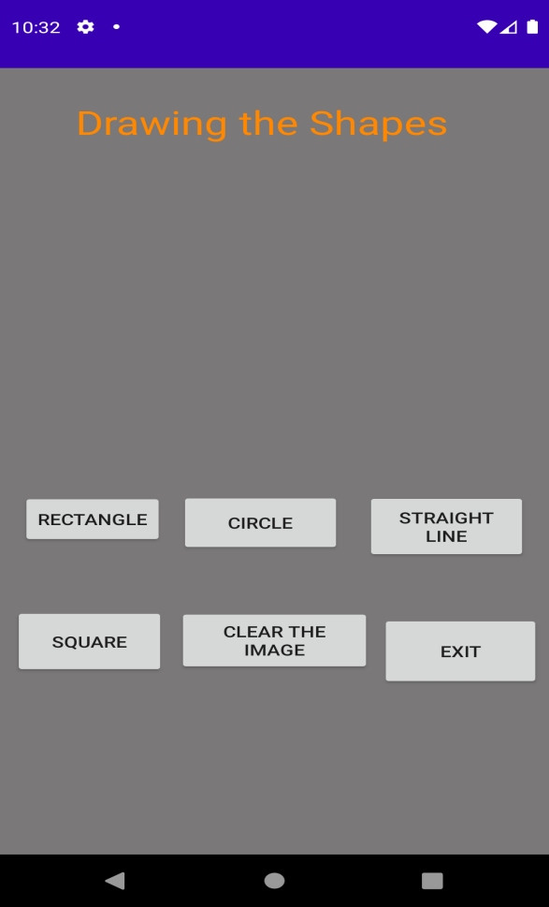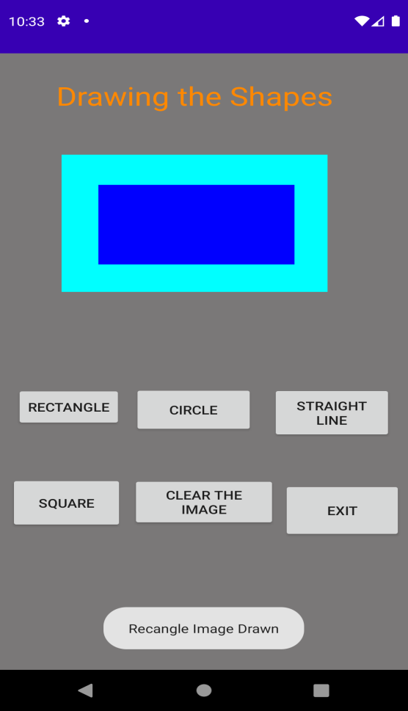
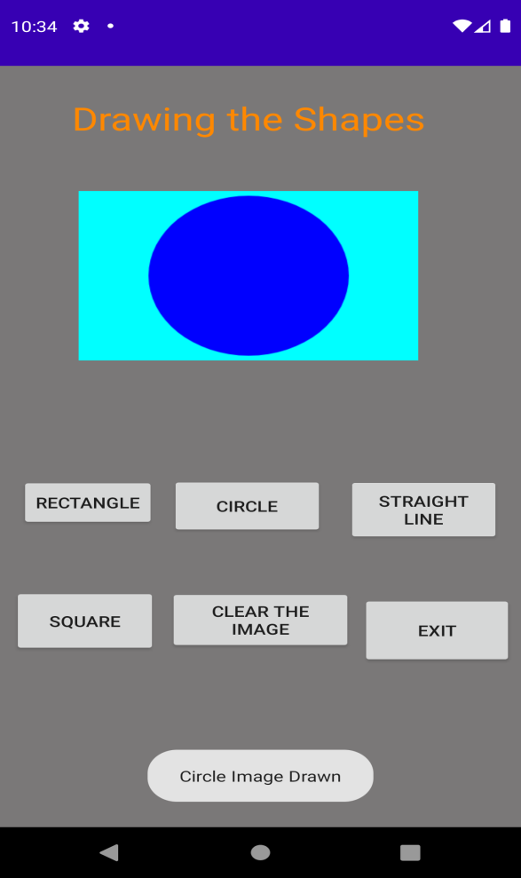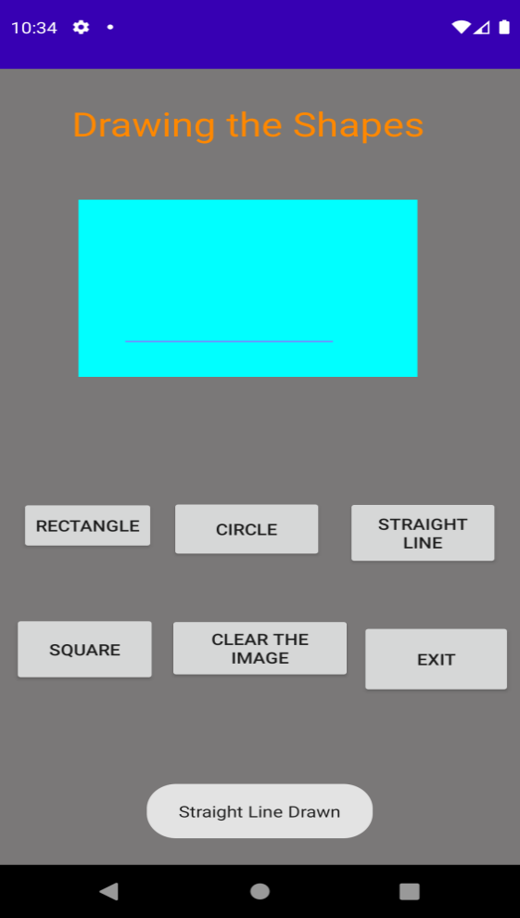
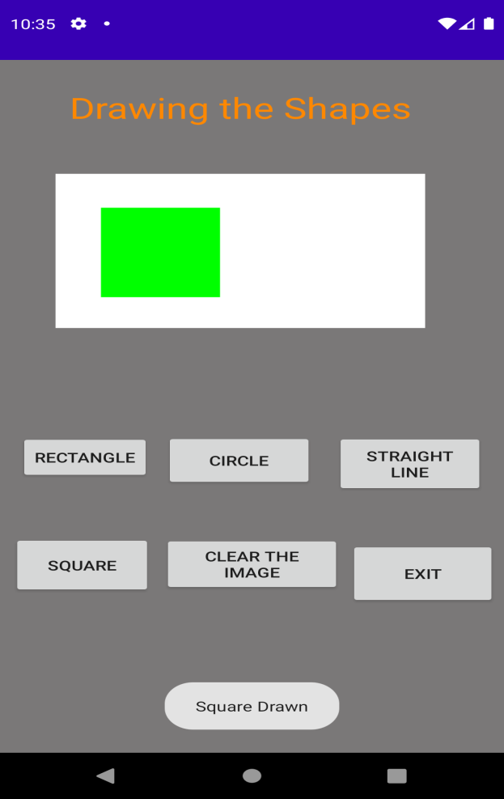

- Build a mobile application that create, save, update and delete data in a database.

Activity File
<?xml version="1.0" encoding="utf-8"?>
<androidx.constraintlayout.widget.ConstraintLayout xmlns:android="http://schemas.android.com/apk/res/android"
xmlns:app="http://schemas.android.com/apk/res-auto"
xmlns:tools="http://schemas.android.com/tools"
android:id="@+id/database"
android:layout_width="match_parent"
android:layout_height="match_parent"
android:background="#00BFA5"
tools:context=".MainActivity">
<TextView
android:id="@+id/txt_name"
android:layout_width="126dp"
android:layout_height="34dp"
android:layout_marginLeft="28dp"
android:layout_marginTop="8dp"
android:layout_marginEnd="248dp"
android:layout_marginRight="248dp"
android:text="@string/Name"
android:textSize="18sp"
app:layout_constraintBottom_toBottomOf="parent"
app:layout_constraintEnd_toEndOf="parent"
app:layout_constraintLeft_toLeftOf="parent"
app:layout_constraintTop_toTopOf="parent"
app:layout_constraintVertical_bias="0.085" />
<EditText
android:id="@+id/ed_name"
android:layout_width="184dp"
android:layout_height="43dp"
android:autofillHints="@string/eyn"
android:ems="10"
android:hint="@string/eyn"
android:inputType="textPersonName"
android:textSize="18sp"
app:layout_constraintBottom_toBottomOf="parent"
app:layout_constraintEnd_toEndOf="parent"
app:layout_constraintHorizontal_bias="0.812"
app:layout_constraintStart_toStartOf="parent"
app:layout_constraintTop_toTopOf="parent"
app:layout_constraintVertical_bias="0.098" />
<TextView
android:id="@+id/txt_surname"
android:layout_width="85dp"
android:layout_height="41dp"
android:text="@string/surname"
android:textSize="18sp"
app:layout_constraintBottom_toBottomOf="parent"
app:layout_constraintEnd_toEndOf="parent"
app:layout_constraintHorizontal_bias="0.11"
app:layout_constraintStart_toStartOf="parent"
app:layout_constraintTop_toTopOf="parent"
app:layout_constraintVertical_bias="0.168" />
<EditText
android:id="@+id/ed_surname"
android:layout_width="196dp"
android:layout_height="40dp"
android:autofillHints="@string/Surname"
android:ems="10"
android:hint="@string/Surname"
android:inputType="textPersonName"
android:textSize="18sp"
app:layout_constraintBottom_toBottomOf="parent"
app:layout_constraintEnd_toEndOf="parent"
app:layout_constraintHorizontal_bias="0.851"
app:layout_constraintStart_toStartOf="parent"
app:layout_constraintTop_toTopOf="parent"
app:layout_constraintVertical_bias="0.183" />
<EditText
android:id="@+id/ed_id"
android:layout_width="209dp"
android:layout_height="42dp"
android:autofillHints="@string/Id"
android:ems="10"
android:hint="@string/Id"
android:inputType="textPersonName"
android:textSize="18sp"
app:layout_constraintBottom_toBottomOf="parent"
app:layout_constraintEnd_toEndOf="parent"
app:layout_constraintHorizontal_bias="0.905"
app:layout_constraintStart_toStartOf="parent"
app:layout_constraintTop_toTopOf="parent"
app:layout_constraintVertical_bias="0.267" />
<TextView
android:id="@+id/txt_id"
android:layout_width="83dp"
android:layout_height="36dp"
android:text="@string/Did"
android:textSize="18sp"
app:layout_constraintBottom_toBottomOf="parent"
app:layout_constraintEnd_toEndOf="parent"
app:layout_constraintHorizontal_bias="0.115"
app:layout_constraintStart_toStartOf="parent"
app:layout_constraintTop_toTopOf="parent"
app:layout_constraintVertical_bias="0.264" />
<Button
android:id="@+id/btt_add"
android:layout_width="wrap_content"
android:layout_height="wrap_content"
android:text="@string/AddData"
app:layout_constraintBottom_toBottomOf="parent"
app:layout_constraintEnd_toEndOf="parent"
app:layout_constraintHorizontal_bias="0.112"
app:layout_constraintStart_toStartOf="parent"
app:layout_constraintTop_toTopOf="parent"
app:layout_constraintVertical_bias="0.411" />
<Button
android:id="@+id/btt_view"
android:layout_width="86dp"
android:layout_height="41dp"
android:text="@string/ViewAll"
app:layout_constraintBottom_toBottomOf="parent"
app:layout_constraintEnd_toEndOf="parent"
app:layout_constraintHorizontal_bias="0.129"
app:layout_constraintStart_toStartOf="parent"
app:layout_constraintTop_toTopOf="parent"
app:layout_constraintVertical_bias="0.527" />
<Button
android:id="@+id/btt_update"
android:layout_width="93dp"
android:layout_height="45dp"
android:text="@string/Update"
app:layout_constraintBottom_toBottomOf="parent"
app:layout_constraintEnd_toEndOf="parent"
app:layout_constraintStart_toStartOf="parent"
app:layout_constraintTop_toTopOf="parent"
app:layout_constraintVertical_bias="0.413" />
<Button
android:id="@+id/btt_delete"
android:layout_width="75dp"
android:layout_height="46dp"
android:text="@string/Delete"
app:layout_constraintBottom_toBottomOf="parent"
app:layout_constraintEnd_toEndOf="parent"
app:layout_constraintHorizontal_bias="0.869"
app:layout_constraintStart_toStartOf="parent"
app:layout_constraintTop_toTopOf="parent"
app:layout_constraintVertical_bias="0.41" />
<Button
android:id="@+id/Button_exit"
android:layout_width="wrap_content"
android:layout_height="wrap_content"
android:text="@string/exit"
app:layout_constraintBottom_toBottomOf="parent"
app:layout_constraintEnd_toEndOf="parent"
app:layout_constraintHorizontal_bias="0.492"
app:layout_constraintStart_toStartOf="parent"
app:layout_constraintTop_toTopOf="parent"
app:layout_constraintVertical_bias="0.532" />
</androidx.constraintlayout.widget.ConstraintLayout>

String file
<resources>
<string name="app_name">Data Base Lab SQL Lite</string>
<string name="eyn">Enter your Name</string>
<string name="AddData">Add Data</string>
<string name="ViewAll">View all</string>
<string name="Update">Update</string>
<string name="Delete">Delete</string>
<string name="Name">Name:</string>
<string name="Surname">Enter your Surname</string>
<string name="Id">Id</string>
<string name="Did">ID</string>
<string name="surname">Surname</string>
<string name="exit">Clear</string>
</resources>

Java file( 3 files)
- Customer model
package com.example.pgk_database_sql;
public class CustomerModel {
public String id;
public String name;
public String Sname;
public CustomerModel() {
}
public CustomerModel(String id, String name, String Sname) {
this.id = id;
this.name = name;
this.Sname = Sname;
}
@Override
public String toString() {
return "CustomerModel{" +
"id='" + id + '\'' +
", name='" + name + '\'' +
", Sname='" + Sname + '\'' +
'}';
}
public String getId() {
return id;
}
public void setId(String id) {
this.id = id;
}
public String getName() {
return name;
}
public void setName(String name) {
this.name = name;
}
public String getSname() {
return Sname;
}
public void setSname(String Sname) {
this.Sname = Sname;
}
}

- DB Helper
package com.example.pgk_database_sql;
import android.content.ContentValues;
import android.content.Context;
import android.database.Cursor;
import android.database.sqlite.SQLiteDatabase;
import android.database.sqlite.SQLiteOpenHelper;
import androidx.annotation.Nullable;
import android.content.Context;
import android.widget.Toast;
import org.w3c.dom.Text;
public class DBHelper extends SQLiteOpenHelper {
public static final String Database_Name="student.db";
public static final String Table_name="student_table";
public static final String Col_1="Id";
public static final String Col_2="Name";
public static final String Col_3="Surname";
public DBHelper(@Nullable Context context) {
super(context, Database_Name, null, 1);
}
@Override
public void onCreate(SQLiteDatabase db) {
String query=("Create Table "+Table_name+"( Id Integer Primary key Autoincrement ,Name Text,Surname Text)");
db.execSQL(query);
}
@Override
public void onUpgrade(SQLiteDatabase db, int oldVersion, int newVersion) {
db.execSQL(" Drop Table If Exists "+Table_name);
onCreate(db);
}
public boolean insertData(String id, String Name,String Surname)
{
SQLiteDatabase db=this.getWritableDatabase();
ContentValues contentValues=new ContentValues();
if(id.length()==0 || Name.length()==0 || Surname.length()==0)
return false;
else {
contentValues.put(Col_1, id);
contentValues.put(Col_2, Name);
contentValues.put(Col_3, Surname);
long result = db.insert(Table_name, null, contentValues);
if (result == 1)
return false;
else
return true;
}
}
public Cursor getAllData()
{
SQLiteDatabase db=this.getWritableDatabase();
Cursor res=db.rawQuery(" select * from "+Table_name,null);
return res;
}
public boolean updateData(String id,String name,String surname)
{
int i;
SQLiteDatabase db=this.getWritableDatabase();
if(name.isEmpty() || surname.isEmpty() || id.isEmpty())
return false;
ContentValues contentValues=new ContentValues();
contentValues.put(Col_1,id);
contentValues.put(Col_2,name);
contentValues.put(Col_3,surname);
i=db.update(Table_name,contentValues,"Id=?",new String[]{id});
if(i>0)
return true;
else
return false;
}
public Integer DeleteData(String id)
{
SQLiteDatabase db=this.getWritableDatabase();
return db.delete(Table_name,"ID=?",new String[]{id});
}
}

- Main activity
package com.example.pgk_database_sql;
import androidx.appcompat.app.AppCompatActivity;
import android.database.Cursor;
import android.os.Bundle;
import android.view.View;
import android.widget.Adapter;
import android.widget.ArrayAdapter;
import android.widget.Button;
import android.widget.EditText;
import android.widget.ListView;
import android.widget.Toast;
import android.app.AlertDialog;
import java.util.ArrayList;
import java.util.List;
public class MainActivity extends AppCompatActivity {
DBHelper mydb;
EditText ename, esurname, eid;
Button btt_add, btt_view, btt_delete, btt_update,bclear;
@Override
protected void onCreate(Bundle savedInstanceState) {
super.onCreate(savedInstanceState);
setContentView(R.layout.activity_main);
mydb = new DBHelper(this);
ename = (EditText) findViewById(R.id.ed_name);
esurname = (EditText) findViewById(R.id.ed_surname);
eid = (EditText) findViewById(R.id.ed_id);
btt_add = (Button) findViewById(R.id.btt_add);
btt_delete = (Button) findViewById(R.id.btt_delete);
btt_update = (Button) findViewById(R.id.btt_update);
btt_view = (Button) findViewById(R.id.btt_view);
bclear=(Button)findViewById(R.id.Button_exit);
AddData();
viewAllData();
UpdateData();
DeleteData();
Cleardata();
}
private void Cleardata() {
bclear.setOnClickListener(new View.OnClickListener() {
@Override
public void onClick(View v) {
ename.setText("");
eid.setText("");
esurname.setText("");
ename.setCursorVisible(true);
}
});
}
public void AddData() {
btt_add.setOnClickListener(new View.OnClickListener() {
@Override
public void onClick(View v) {
boolean isInserted = mydb.insertData(eid.getText().toString(), ename.getText().toString(), esurname.getText().toString());
System.out.println(isInserted);
if (isInserted == true)
Toast.makeText(MainActivity.this, "Data Inserted", Toast.LENGTH_SHORT).show();
else
Toast.makeText(MainActivity.this, "Data Not Inserted", Toast.LENGTH_SHORT).show();
}
});
}
public void DeleteData() {
btt_delete.setOnClickListener(new View.OnClickListener() {
@Override
public void onClick(View v) {
Integer dr = mydb.DeleteData(eid.getText().toString());
if (dr > 0)
Toast.makeText(MainActivity.this, "Record Deleted", Toast.LENGTH_SHORT).show();
else
Toast.makeText(MainActivity.this, "Record not found", Toast.LENGTH_SHORT).show();
}
});
}
public void UpdateData() {
btt_update.setOnClickListener(new View.OnClickListener() {
@Override
public void onClick(View v) {
boolean ud = mydb.updateData(eid.getText().toString(), ename.getText().toString(), esurname.getText().toString());
if (ud == true)
Toast.makeText(MainActivity.this, "Record Updated", Toast.LENGTH_SHORT).show();
else
Toast.makeText(MainActivity.this, "Data not updated", Toast.LENGTH_SHORT).show();
}
});
}
public void viewAllData() {
btt_view.setOnClickListener(new View.OnClickListener() {
@Override
public void onClick(View v) {
Cursor res = mydb.getAllData();
if (res.getCount() == 0)
Toast.makeText(MainActivity.this, "No record", Toast.LENGTH_SHORT).show();
else {
StringBuffer buffer = new StringBuffer();
while (res.moveToNext()) {
buffer.append("Id:" + res.getString(0) + "\t");
buffer.append("Name:" + res.getString(1) + "\t");
buffer.append("Surname:" + res.getString(2) + "\t");
buffer.append("\n");
}
showMessage("Data from Database", buffer.toString());
}
}
});
}
public void showMessage(String title, String Message) {
AlertDialog.Builder builder = new AlertDialog.Builder(this);
builder.setCancelable(true);
builder.setTitle(title);
builder.setMessage(Message);
builder.show();
}
}
OUTPUT:

- Devise an application that implements Multi-threading.

Soln:
XML file

<?xml version="1.0" encoding="utf-8"?>
<LinearLayout xmlns:android="http://schemas.android.com/apk/res/android"
xmlns:app="http://schemas.android.com/apk/res-auto"
xmlns:tools="http://schemas.android.com/tools"
android:layout_width="match_parent"
android:layout_height="match_parent"
android:orientation="vertical"
tools:context=".MainActivity">
<TextView
android:layout_width="389dp"
android:layout_height="65dp"
android:gravity="center"
android:text="@string/DT"
android:textColor="@android:color/holo_orange_dark"
android:textSize="25sp"
app:layout_constraintBottom_toBottomOf="parent"
app:layout_constraintLeft_toLeftOf="parent"
app:layout_constraintRight_toRightOf="parent"
app:layout_constraintTop_toTopOf="parent" />
<ImageView
android:id="@+id/imageView"
android:layout_width="250dp"
android:layout_height="250dp"
android:layout_gravity="center"
android:layout_margin="50dp" />
<Button
android:id="@+id/button"
android:layout_width="wrap_content"
android:layout_height="wrap_content"
android:layout_gravity="center"
android:layout_margin="10dp"
android:text="Load Image 1"
app:backgroundTint="#EA5E8E" />
<Button
android:id="@+id/button2"
android:layout_width="wrap_content"
android:layout_height="wrap_content"
android:layout_gravity="center"
android:layout_margin="10dp"
android:text="Load image 2"
app:backgroundTint="#EA5E8E" />
</LinearLayout>

Java files

package com.example.mad_sixth;
import androidx.appcompat.app.AppCompatActivity;
import android.os.Bundle;
import android.view.View;
import android.widget.Button;
import android.widget.ImageView;
public class MainActivity extends AppCompatActivity {
ImageView img;
Button bt1, bt2;
int count=0;
@Override
protected void onCreate(Bundle savedInstanceState) {
super.onCreate(savedInstanceState);
setContentView(R.layout.activity_main);
bt1 = (Button)findViewById(R.id.button);
bt2= (Button) findViewById(R.id.button2);
img = (ImageView)findViewById(R.id.imageView);
bt1.setOnClickListener(new View.OnClickListener(){
@Override
public void onClick(View v) {
new Thread(new Runnable(){
@Override
public void run(){
img.post(new Runnable(){
@Override
public void run(){
if(count==0) {
img.setImageResource(R.drawable.india);
count=count+1;
}
else {
img.setImageResource(R.drawable.kar_1);
count=count-1;
}
}
});
}
}).start();
}
});
bt2.setOnClickListener(new View.OnClickListener(){
@Override
public void onClick(View v)
{
new Thread(new Runnable(){
@Override
public void run(){
img.post(new Runnable(){
@Override
public void run() {
img.setImageResource(R.drawable.swamy);
}
});
}
}).start();
}
});
}
}

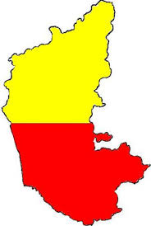

Place three images in the drawable folder

Output:

