**RAJESWARI RAJENDIRAN**

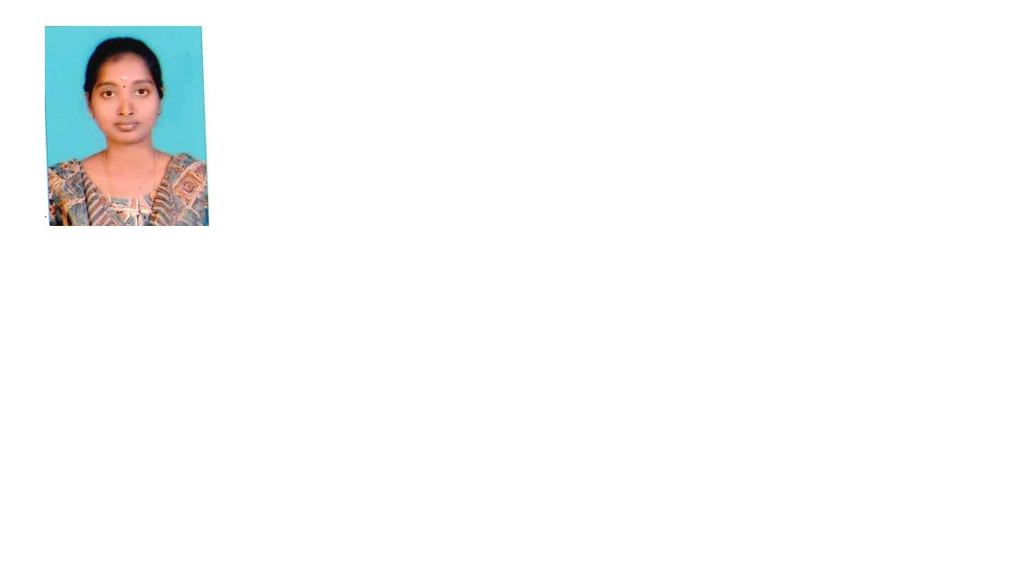

No 2/220, Pasumpon Devar Street, Periyar Salai, Palavakkam, Chennai, Tamil Nadu 600041

*Ph:* ***+91******860 846 5766***

*E Mail:* [*rajitext@gmail.com*](mailto:rajitext@gmail.com)

**PROFESSIONAL SUMMARY**

Experienced as Garment Merchandiser with 6 years of experience in Textile/ Garments Industry. Excellent reputation for resolving problems, improving customer satisfaction, and driving overall operational improvements. Consistently saved costs while increasing profits.

**EDUCATION**

**June/2009 to May/2013** **B.Tech Textile Technology**

Jaya Engineering College – Chennai

**ACADEMIC PROJECT**

**Functional Finishes on Polyester/Cotton Fabric**

The objective of this project is to finish the garment with water repellent and UV protective finishes on front and back of the garment.

**WORK HISTORY**

**Jun/2013 to Nov/2016** Garment Junior Merchandiser

**Gokul Knitt Fabs Garments** — Tirupur, Tamil Nadu

**Nov/2016 to Till Now** Garment Merchandiser

**Jay Jay Mills** — Tirupur, Tamil Nadu

**SKILLS**

* Garment tagging
* Garment and texture knowledge
* Quality control and Testing

**BUYER HANDLNG**

* MEMOS
* JANSEN TEXTILE
* CARREFOUR
* CASTRO
* VEITR
* FRONTLINE
* COOP
* THE CHILDRENS PLACE

**ROLES AND RESPONSIBILITIES**

* Process and follow up accessories accurately with suppliers and workers.
* Reporting, about stock release; stock return and new arrivals to warehouse and store.
* Forecast order quantities based on stock level and sales information. Review buyer PO sheet and proceed to next level.
* Handling yarn and fabric programming based on projection. Worked in printing and fabrics process.
* Preparing, samples and perform sample testing and reporting.
* Working, with sales coordinators to identify new opportunities and improvements.
* Identifying, and resolving merchandising, purchase order in a timely fashion Coordinating, with merchandiser to develop seasonal products.
* Assisted Senior Merchandiser in managing activities from product development to handing over files to the production team.
* Maintained accurate records of customers and their orders.
* Interacting and following up with the buying, house to understand products requirement and provide the information to them as required.
* Checking, Photo Samples, Counter Samples; Fit Samples, Size Set, PP Samples etc.
* Handle independent buyers account and fulfill various merchandising activities with responsibility.
* Approval of Fabric; Print/ Embroidery strike Offs; Lab Dips; etc.
* Maintained and monitored stock levels and movements.

**SEMINARS/ WORKSHOPS/ TRAININGS**

* Lakshmi Saraswathi Mills, Arani, Tamil Nadu.
* Undergone Implant Training in RK Industries, Tambaram.
* Futura Polyester, Arani, Tamil Nadu.
* Textile Testing, Mylapore, Chennai
* Participation in workshop on CAAM — CAD

**PERSONAL DATA**

* 1. Date of birth : 31 Jan 1991
  2. Gender : Female
  3. Marital status : Single

Nationality : Indian

Language known : English, Tamil

* 1. Permanent Address : No 62, West Street, Sadaiyampattu Village,
     + - 1. Somandargudi Post, Kallakurichi Taluk,
  2. Villupuram Dist. Pin Code: 606 213

**DECLARATION**

I hereby declare that all the above-mentioned are true to the best of my knowledge and belief.

Place: Chennai **RAJESWARI RAJENDIRAN**

Date: