Software Architecture and Design Specification
Collaborative Study Material & Quiz Platform (CSMQP)
Version | 1.0
Authors | Bhuvan M S, Bhuvi Dange, Bhuvi Bagga, Bheema Varshini
Date | 16-09-2026
Status | Draft

1. Introduction

1.1 Purpose
This document specifies the proposed architecture and detailed design for CSMQP, based on the approved scope and requirements in the project SRS.

1.2 Scope
The design covers user registration and authentication, study-material management, question-bank management, quiz creation and attempts, performance analytics, and administration. External university LMS integration remains outside the initial release.

1.3 Audience
Developers, QA engineers, instructors, students, administrators, security reviewers, and assessment evaluators.

1.4 Definitions
CSMQP – Collaborative Study Material & Quiz Platform; MERN – MongoDB, Express.js, React.js, Node.js; JWT – JSON Web Token; CRUD – Create, Read, Update, Delete; MCQ – Multiple Choice Question; TLS – Transport Layer Security.

2. Document Overview
This specification translates the SRS into a proposed component structure, data responsibilities, security controls, interfaces, sequence flows, and requirement traceability. Where the SRS leaves an implementation choice open, the choice below is explicitly marked as proposed.

3. Architecture

3.1 Goals and Constraints
- Support the mandatory MERN technology stack.
- Provide role-based access for Student, Instructor, and Administrator.
- Meet the SRS performance targets: up to 500 concurrent users, page load ≤2 seconds at the 95th percentile, and quiz grading ≤1 second under normal conditions.
- Maintain at least 99.5% uptime excluding scheduled maintenance.
- Protect credentials, session tokens, and user-owned academic data.
- Respect the 15 MB upload limit and avoid storing financial/payment data.

3.2 Stakeholders and Concerns
Stakeholder | Primary concerns
Student | Simple access to materials, quizzes, results, and personal analytics.
Instructor | Material upload, question-bank management, quiz authoring, publishing, and class analytics.
Administrator | User management and content moderation.
Developer / QA | Modularity, testability, traceability, and maintainability.
Security reviewer | Credential protection, authorization, input validation, and TLS.

3.3 Component (UML) Diagram
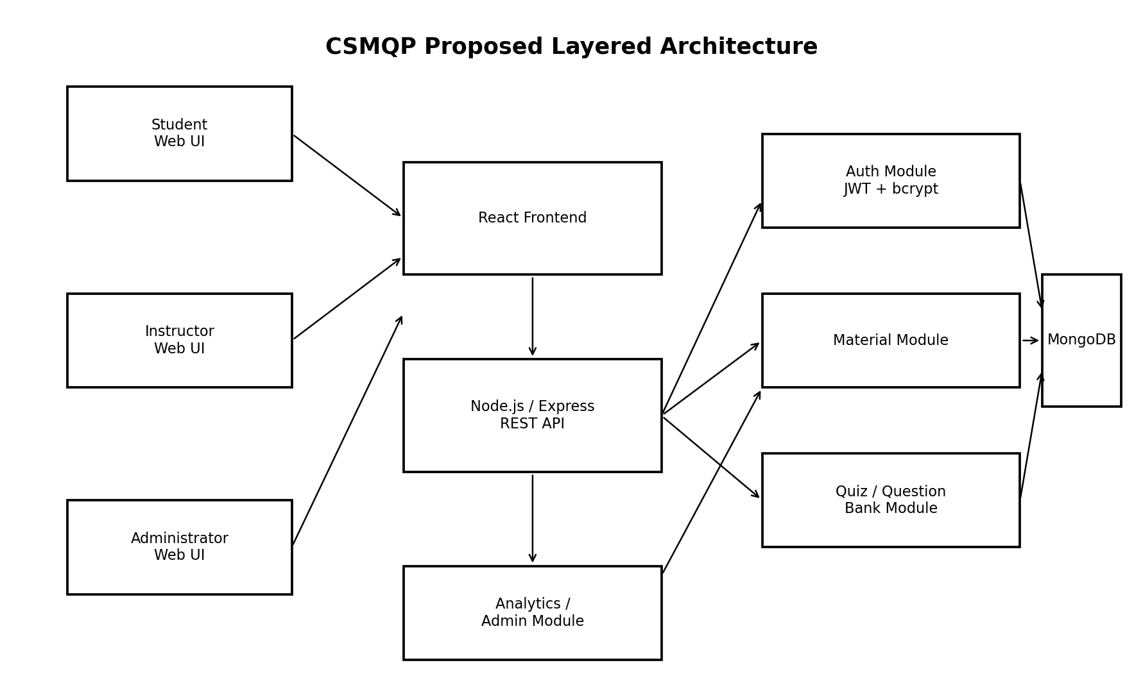
Figure 1. Proposed CSMQP component architecture.

3.4 Component Descriptions
Component | Responsibility
React Frontend | Responsive UI for Student, Instructor, and Administrator workflows.
Node.js / Express REST API | Receives requests, applies middleware, validates input, and routes operations.
Auth Module | Registration, login, bcrypt/equivalent password hashing, JWT creation and validation, role checks.
Material Module | Upload, 15 MB validation, categorization, search, viewing/download, and material metadata.
Question Bank Module | Create, edit, delete, tag, and retrieve MCQ/True-False questions.
Quiz Module | Create, configure, publish, attempt, submit, score, and return quiz results.
Analytics Module | Calculate student dashboards and instructor class-level statistics.
Admin Module | Manage user accounts and moderate reported materials/questions.
MongoDB | Persist users, materials metadata, questions, quizzes, attempts, results, and analytics source records.

3.5 Chosen Architecture Pattern and Rationale
Proposed pattern: layered modular web architecture. The presentation layer is the React client; the application/API layer is Node.js/Express; domain modules implement authentication, materials, questions, quizzes, analytics, and administration; MongoDB provides persistence. This separation follows the SRS interfaces and makes individual modules independently testable. A microservices split is not required for the initial release because the SRS describes a self-contained platform and does not require independently deployed services.

3.6 Technology Stack and Data Stores
Area | Technology / design
Frontend | React.js responsive web client.
Backend | Node.js with Express.js RESTful APIs.
Database | MongoDB accessed through Mongoose ODM.
Authentication | JWT for stateless sessions; bcrypt or equivalent for password hashing.
Transport security | TLS 1.2 or higher for client-server communication.
Deployment | Self-hosted or cloud-hosted, as allowed by the SRS.

3.7 Proposed Data Model
Collection / entity | Key fields
User | userId, email, passwordHash, role, status
Material | materialId, ownerId, name, format, size, subject, topic, storageReference, status
Question | questionId, instructorId, type, text, options, correctAnswer, subject, topic, difficulty, status
Quiz | quizId, instructorId, title, questionIds, timeLimit, published, eligibility
QuizAttempt | attemptId, quizId, studentId, answers, startTime, submitTime, score
Analytics | derived from quiz-attempt records; student and class aggregates

3.8 Risks and Mitigations
Risk | Mitigation
Unauthorized access | JWT validation plus role-based authorization middleware on protected routes.
Credential disclosure | Salted password hashing; never persist plaintext passwords.
Malicious input | Server-side validation and sanitization against XSS, CSRF, and NoSQL injection.
Oversized uploads | Reject files above 15 MB before persistence.
Performance degradation | Load testing at 500 concurrent users; optimize API/database queries and pagination where required.
Availability failure | Operational monitoring and deployment redundancy appropriate to the hosting environment.

3.9 Traceability to Requirements
SRS requirements | Primary design module
CSMQP-F-001..003; CSMQP-SR-001..003 | Auth Module
CSMQP-F-010..013 | Material Module
CSMQP-F-020..023 | Question Bank Module
CSMQP-F-030..035 | Quiz Module
CSMQP-F-040..042 | Analytics Module
CSMQP-F-050..051 | Admin Module
CSMQP-NF-001..005 | Frontend / API / Database / Infrastructure
CSMQP-SR-004..005 | API middleware / Transport security

3.10 Security Architecture
Threat / concern | Control
Credential disclosure | bcrypt/equivalent hashing; no plaintext passwords.
Token theft or tampering | Signed JWTs with defined expiry; reject expired/tampered tokens.
Privilege escalation | Role-based authorization; student write attempts against instructor-owned resources return 403.
Injection and script attacks | Sanitize and validate all user input; security test suite covers XSS, CSRF, and NoSQL injection.
Network interception | TLS 1.2+ for all client-server communication.

4. Design

4.1 Design Overview
The design uses a responsive React client and a RESTful Express API. Authentication and authorization are implemented as reusable middleware and services. Feature modules encapsulate their business rules and persistence access. MongoDB stores the system's primary application records.

4.2 UML Sequence Diagram – Authentication
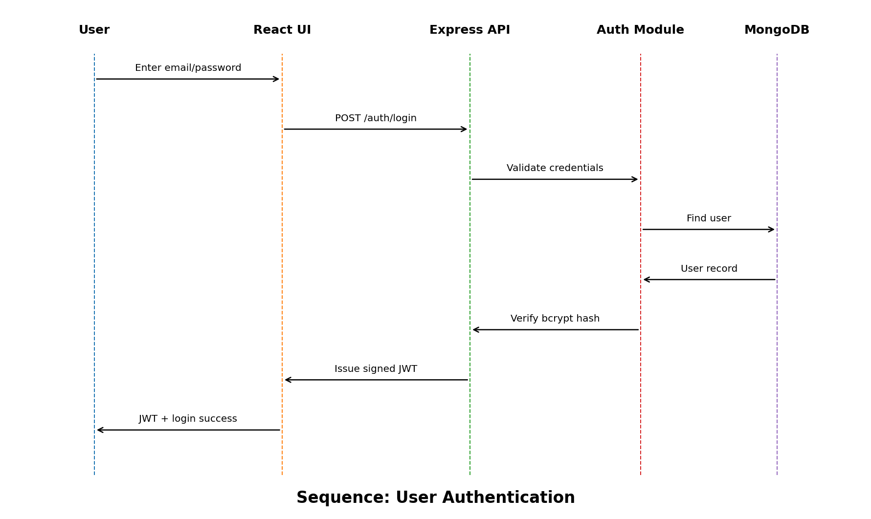
Figure 2. Proposed login sequence derived from CSMQP-F-001..003 and CSMQP-SR-001..002.

4.3 UML Sequence Diagram – Quiz Attempt
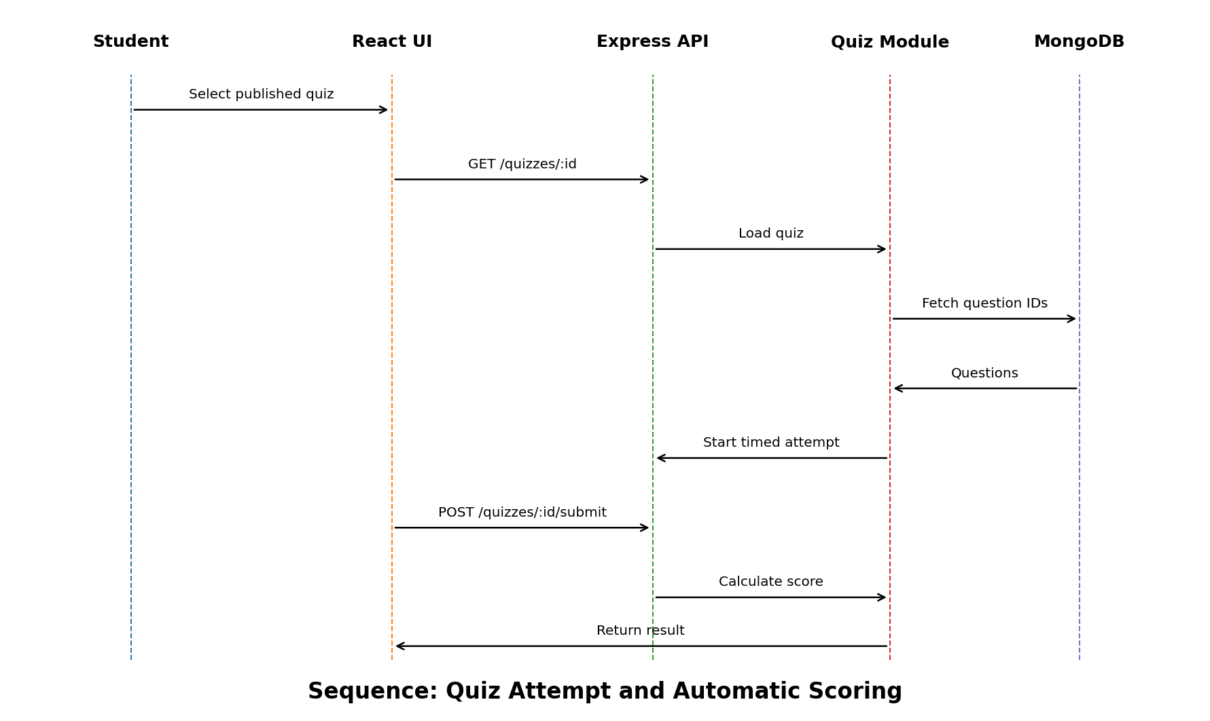
Figure 3. Proposed quiz-attempt sequence derived from CSMQP-F-030..035.

4.4 API Design
The SRS specifies RESTful APIs but does not prescribe endpoint names. The following endpoint names are therefore proposed design details.
Component | Method / endpoint | Purpose | Key responses
Auth | POST /api/auth/register | Register a user. | 201 success; 400 invalid/duplicate data.
Auth | POST /api/auth/login | Authenticate and issue JWT. | 200 token; 401 invalid credentials.
Materials | POST /api/materials | Instructor upload with format and size validation. | 201 created; 400 invalid file; 403 unauthorized.
Materials | GET /api/materials?query= | Search available materials by name/keyword. | 200 matching materials.
Quiz | POST /api/quizzes | Create a quiz from selected question IDs. | 201 created; 403 unauthorized.
Quiz | POST /api/quizzes/{id}/submit | Submit attempt and calculate score. | 200 result; 400 invalid/late submission.
Analytics | GET /api/analytics/student | Return student's dashboard data. | 200 analytics; 401 unauthorized.

4.5 Error Handling, Logging and Monitoring
- Use standardized HTTP status codes and consistent JSON error responses.
- Do not log passwords, JWT secrets, or other sensitive authentication material.
- Record sufficient audit information for administrative actions and important security events.
- Monitor request latency, error rates, authentication failures, quiz grading latency, and service availability.
- Return user-friendly errors while avoiding disclosure of internal implementation details.

4.6 UX Design
The UI should remain responsive across desktop, tablet, and mobile browsers and provide clear navigation among Study Materials, Quizzes, Question Bank, and Analytics. Success and error feedback should be explicit. The target browser set is the latest versions of Chrome, Firefox, Safari, and Edge.

4.7 Open Issues and Next Steps
- Finalize password-policy details, which are marked TBD in the SRS.
- Select and document the charting library for performance dashboards, currently TBD in the SRS.
- Finalize file-storage implementation details for uploaded study materials.
- Define deployment topology and backup/restore procedures.
- Define the exact API contract and OpenAPI/Swagger specification before implementation.

5. Appendices

5.1 Glossary
ATM-related terms are not applicable to CSMQP. Key terms: CSMQP, MERN, JWT, CRUD, MCQ, API, TLS, XSS, CSRF, NoSQL injection, RTM.

5.2 References
Primary reference: CSMQP Software Requirements Specification, Version 1.0, dated 04-09-2026.

5.3 Tools
PlantUML or draw.io may be used to reproduce the UML diagrams; Swagger/OpenAPI may be used to formalize the API design.

