DSuC Lab Assignment.

- Write a program to perform various operations in the Array: Insertion, Deletion, Display.

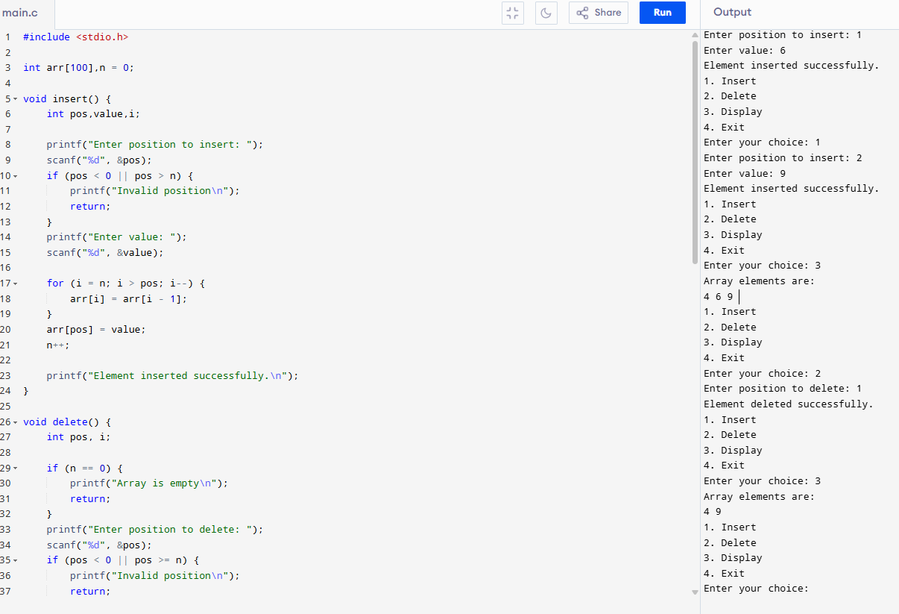

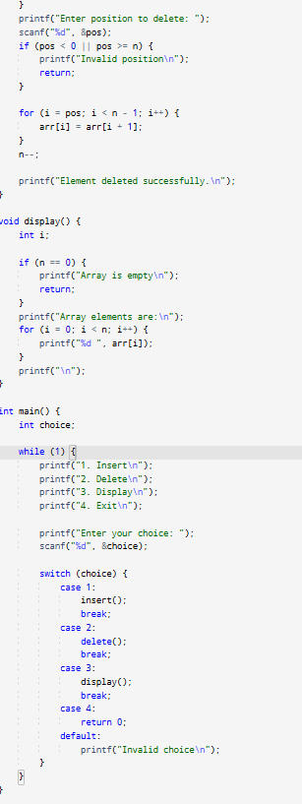

- Write a program to find the arithmetic operations on matrices: Sum, Subtraction & Product of 2 matrices & Transpose of a matrix.

- Sum of Matrices.

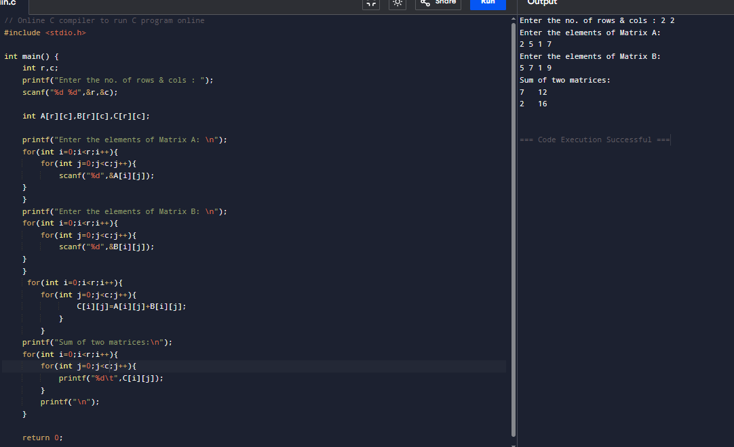

- Subtraction of Matrices.

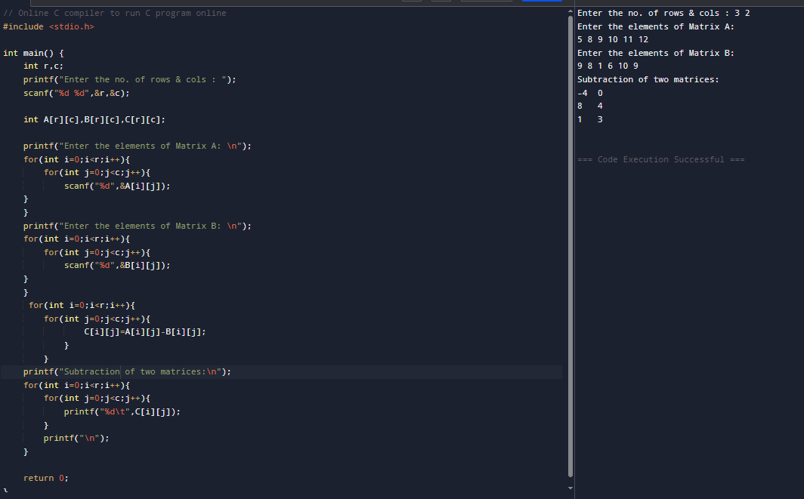

- Product of Matrices.

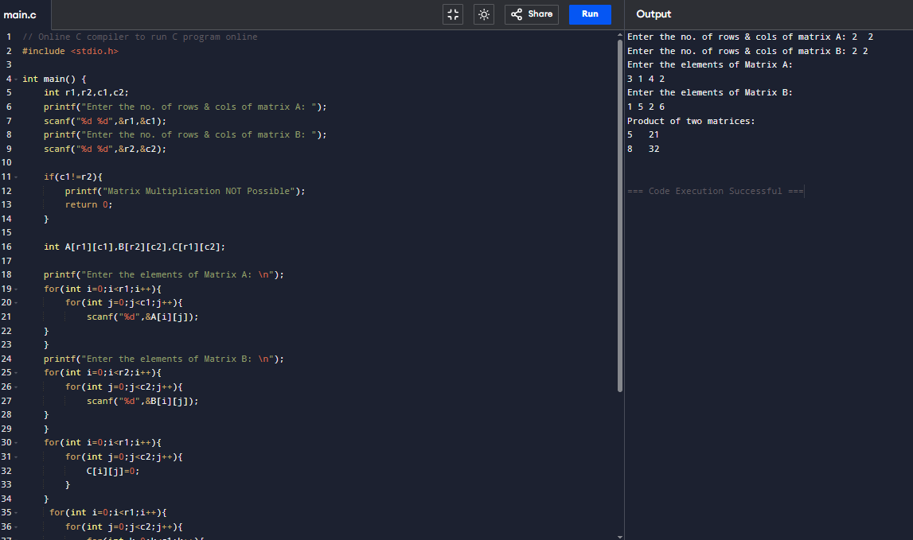

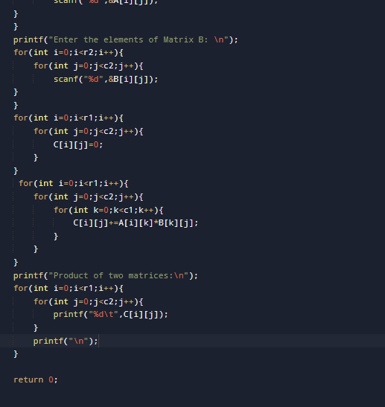

- Transpose of Matrix.

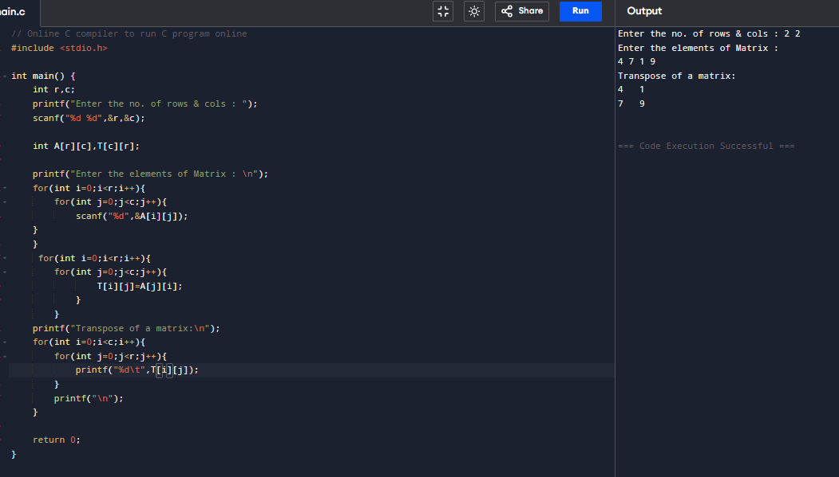

- Write a Program to sort the list using: Bubble Sort, Quick Sort, Insertion sort, Merge Sort, Heap Sort.

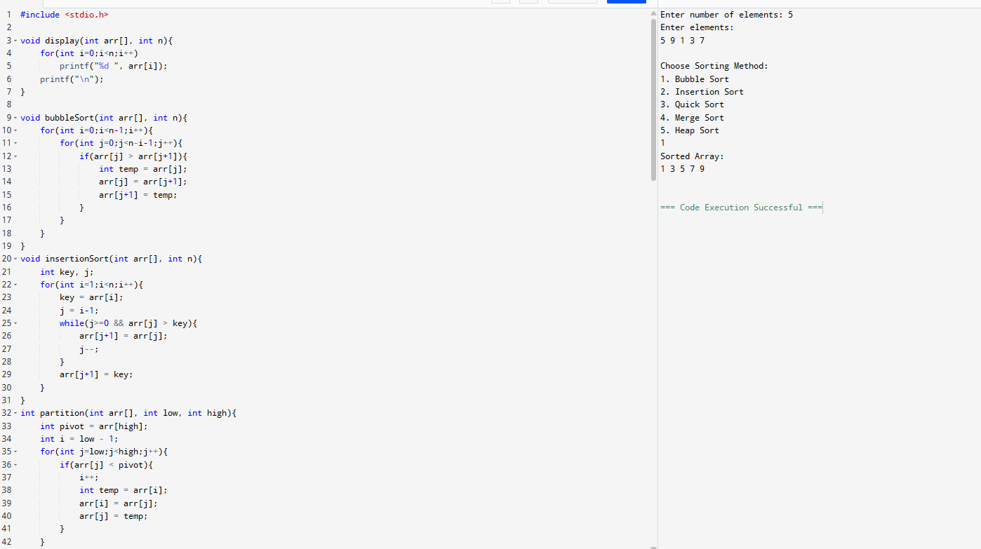

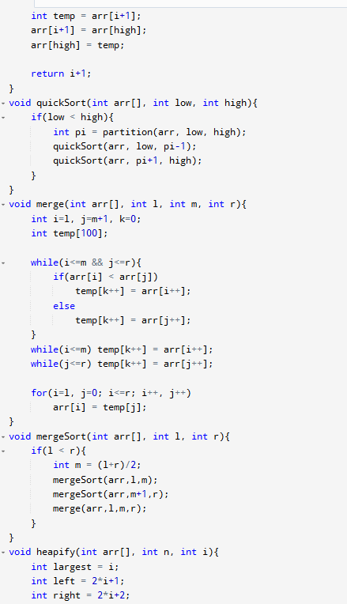

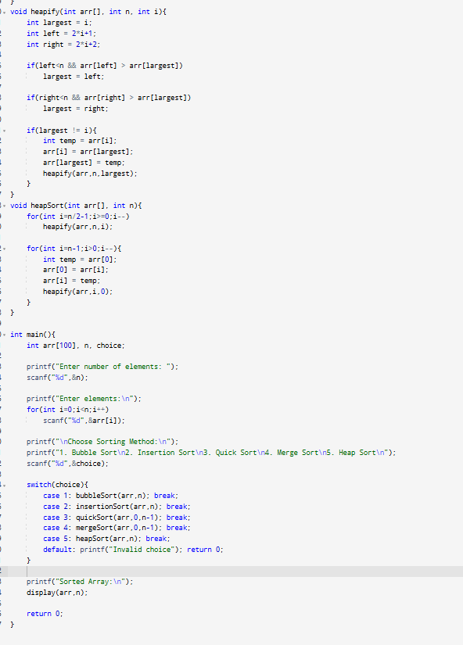

- Write a program to search the element using: Linear Search & Binary Search.

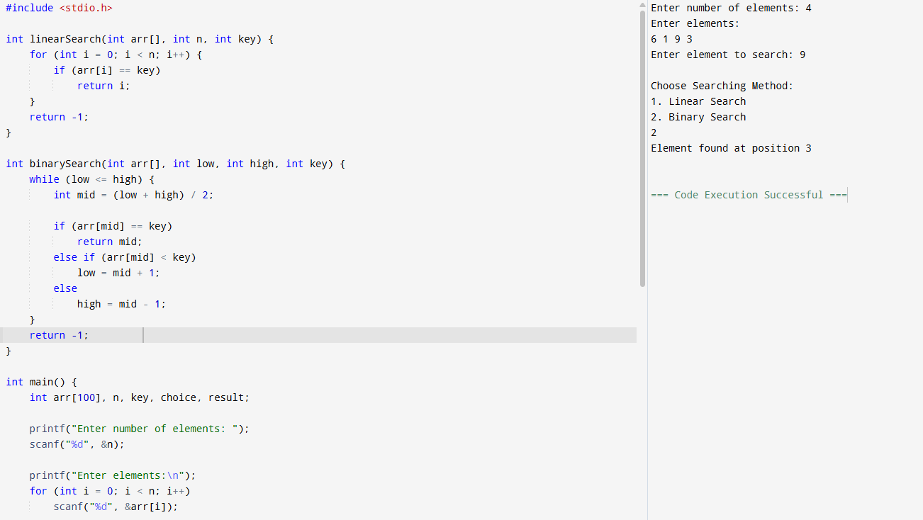

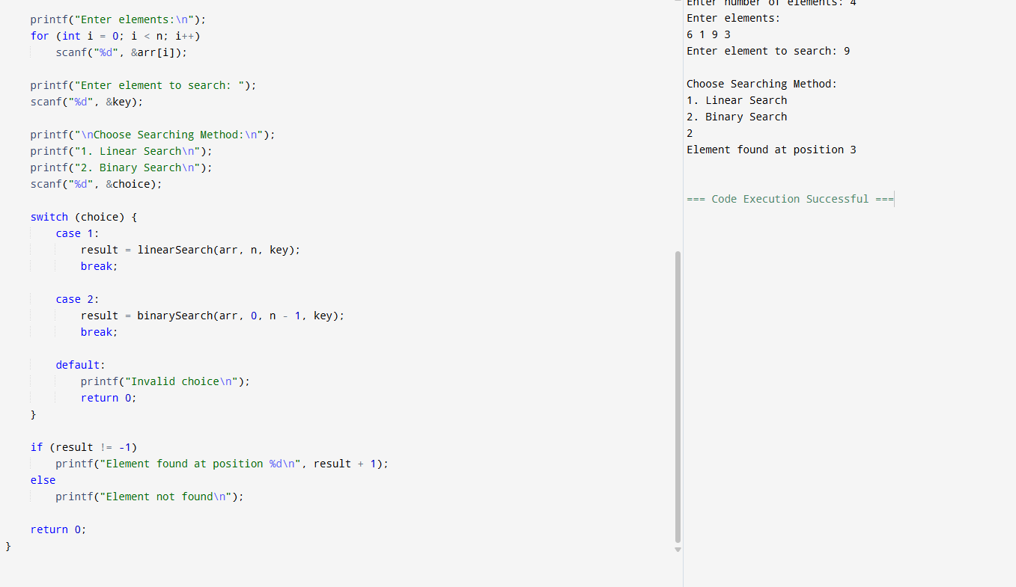

- Write a program to perform all operations: For the Stack using an Array, For the Queue using an Array & For the Circular Queue using an Array.

- For the Stack using an Array.

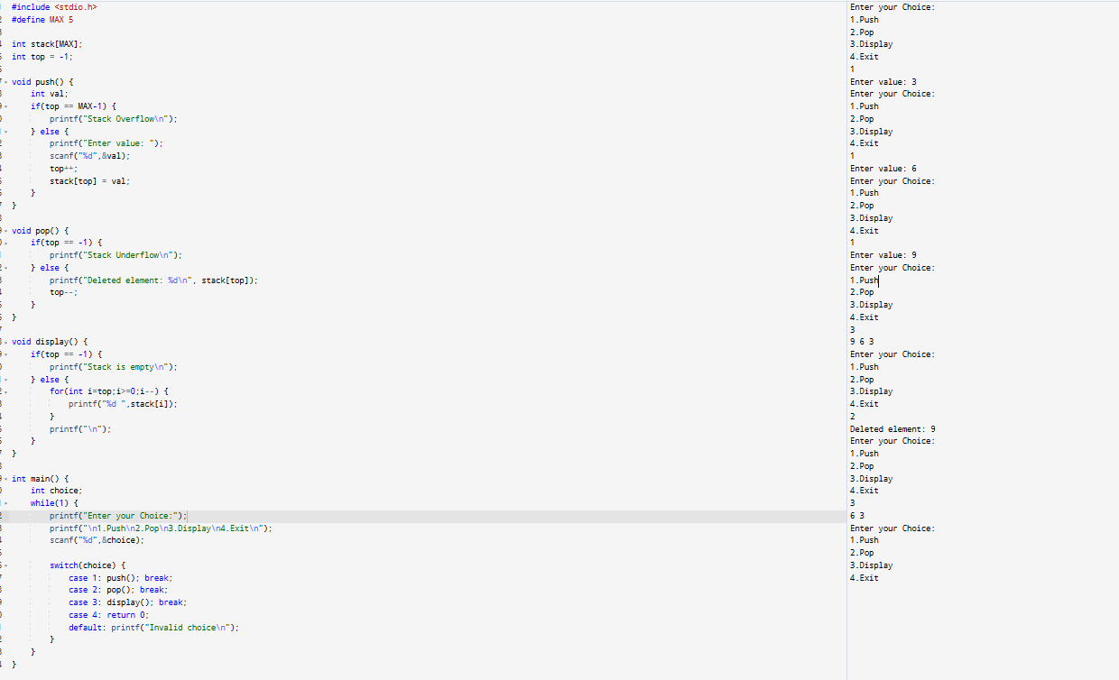

- For the Queue using an Array.

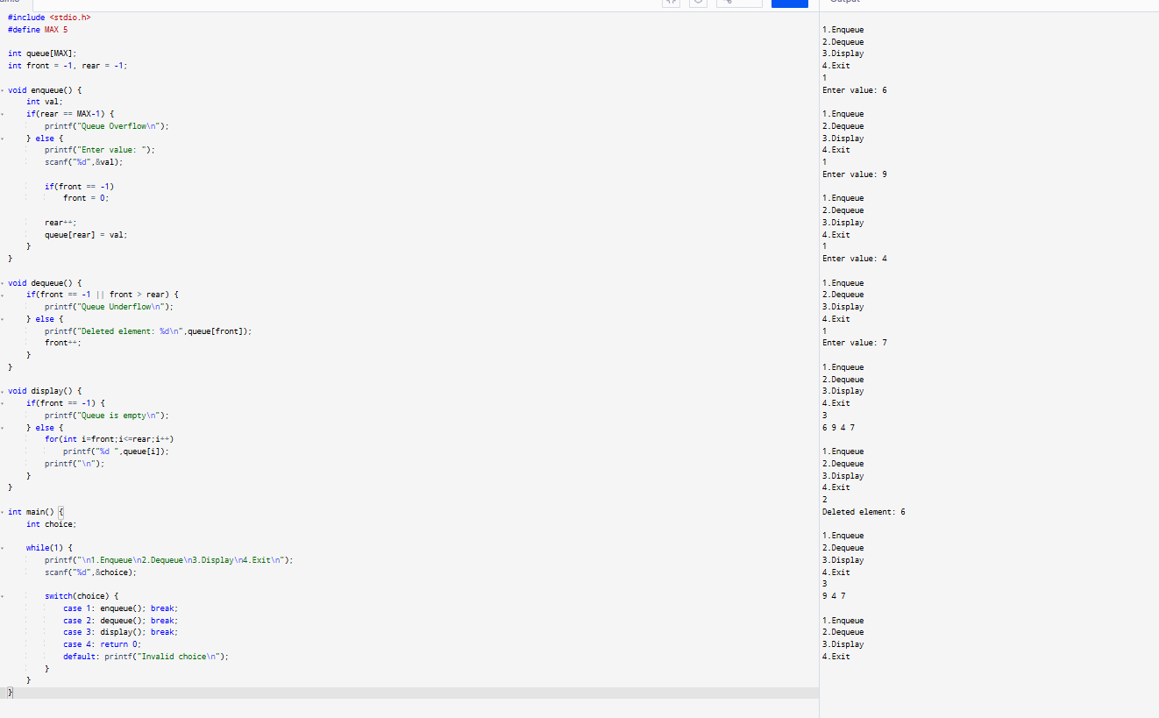

- For the Circular Queue using an Array.

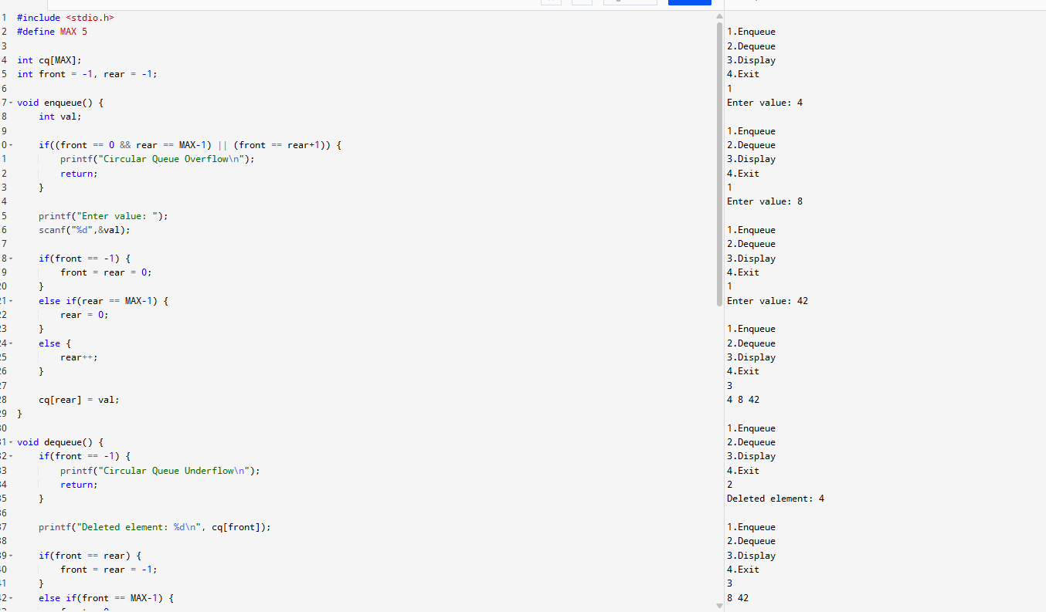

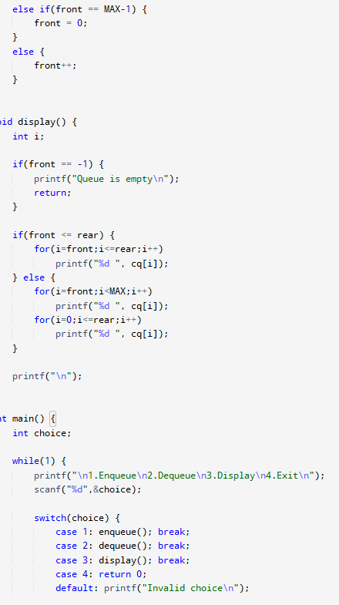

- Write a program to evaluate the Postfix Notation.

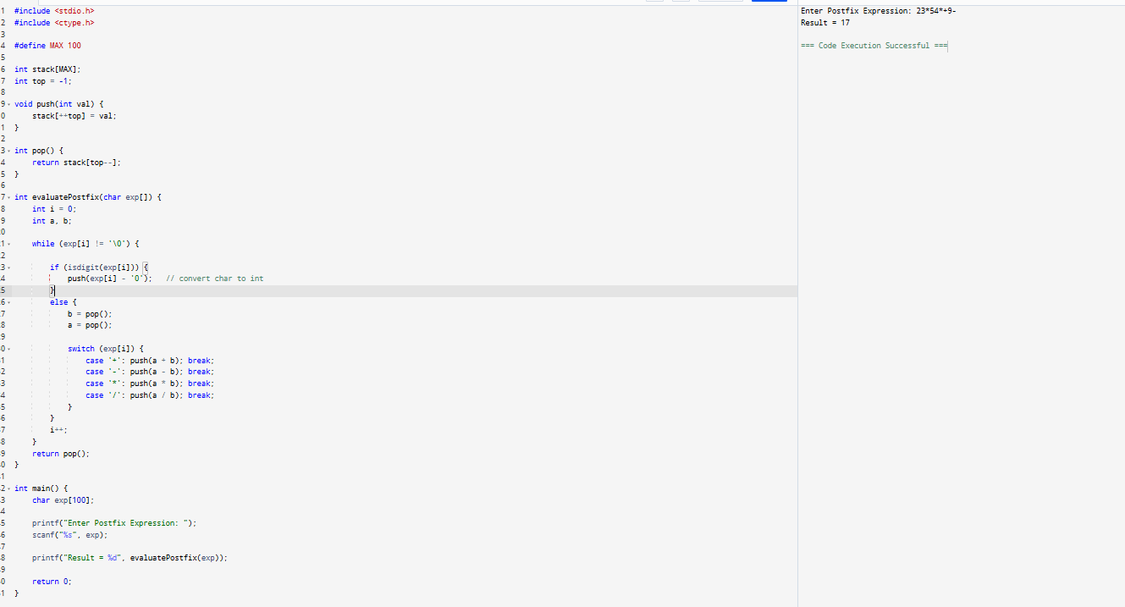

- Write a program to convert infix notation into Postfix Notation.

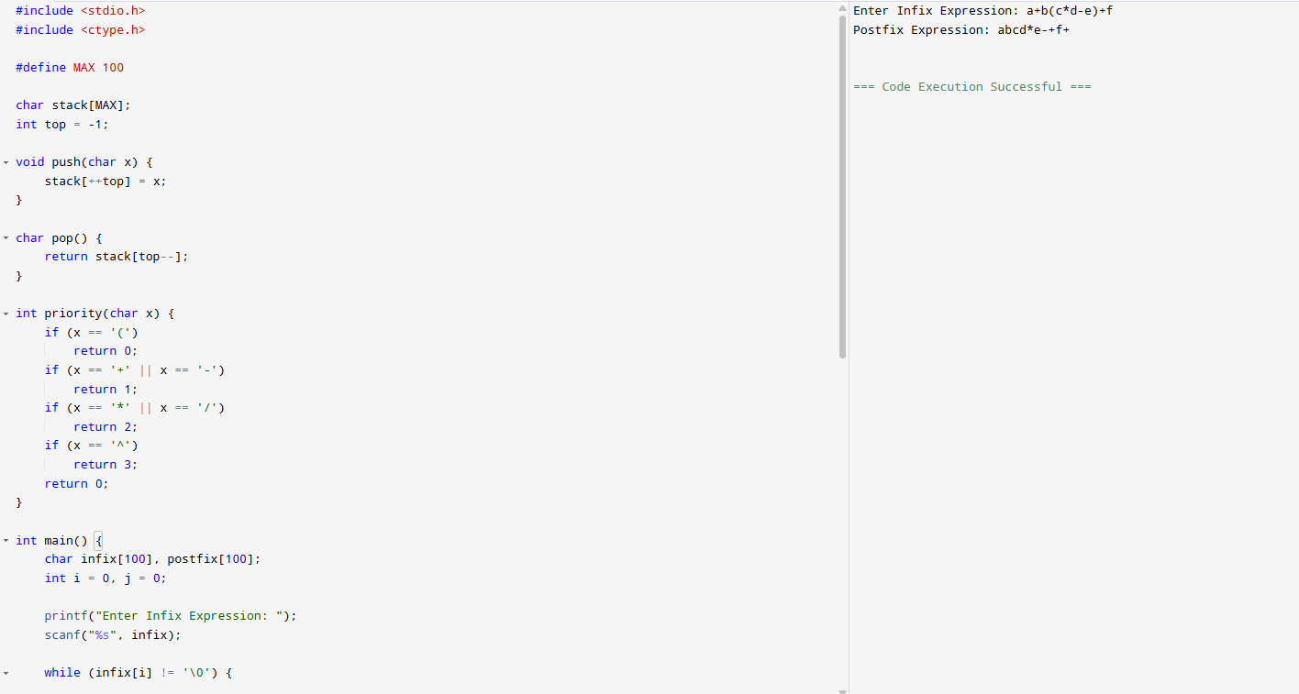

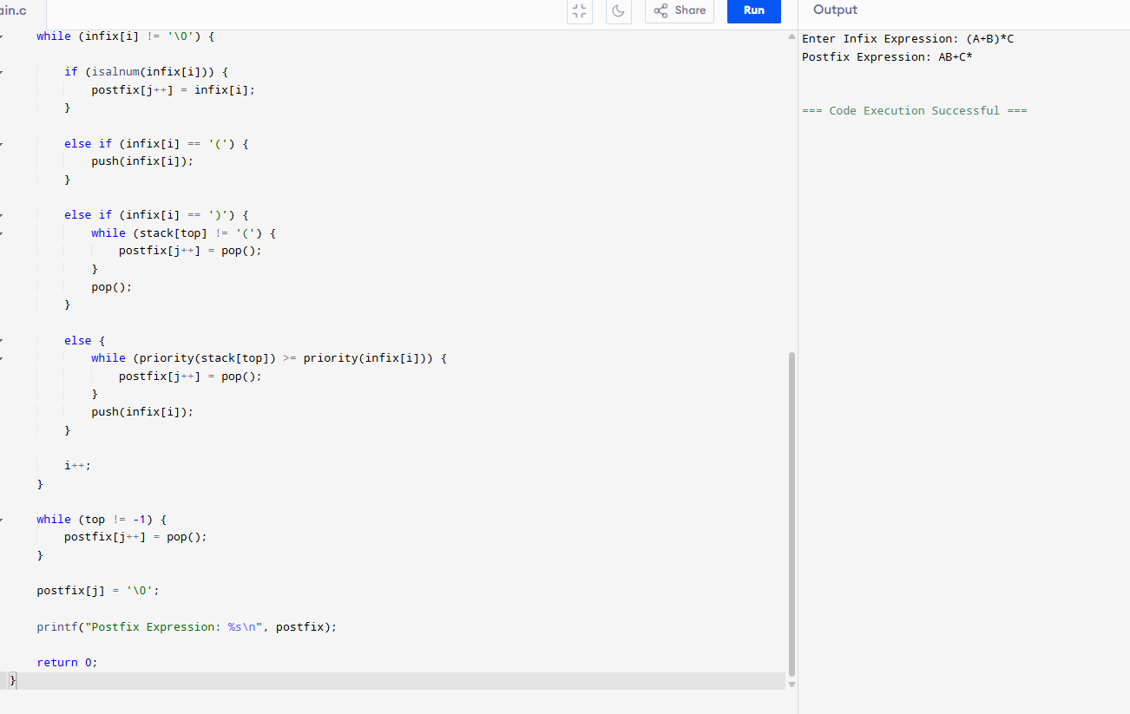

8. Write a program to perform the operations of the linked list: Insertion, Deletion & Display.

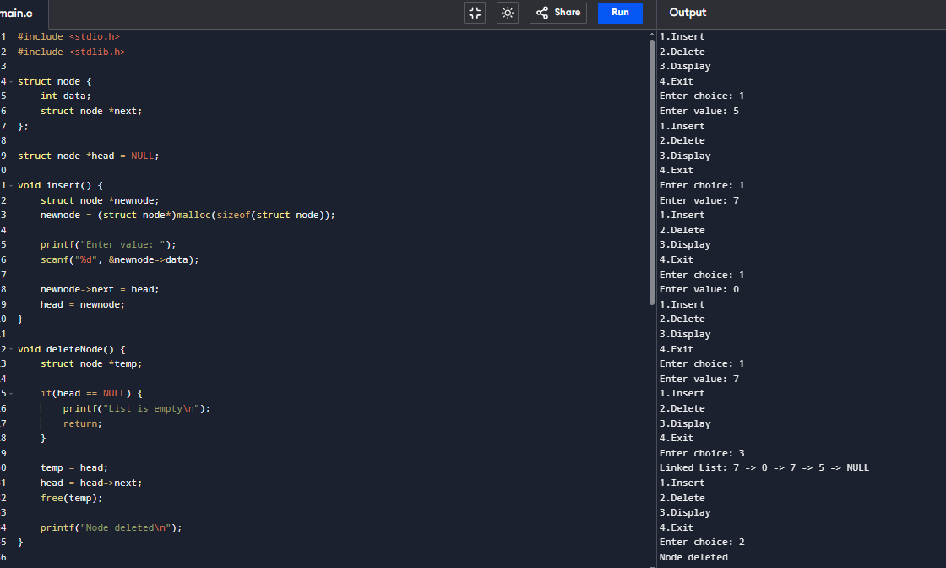

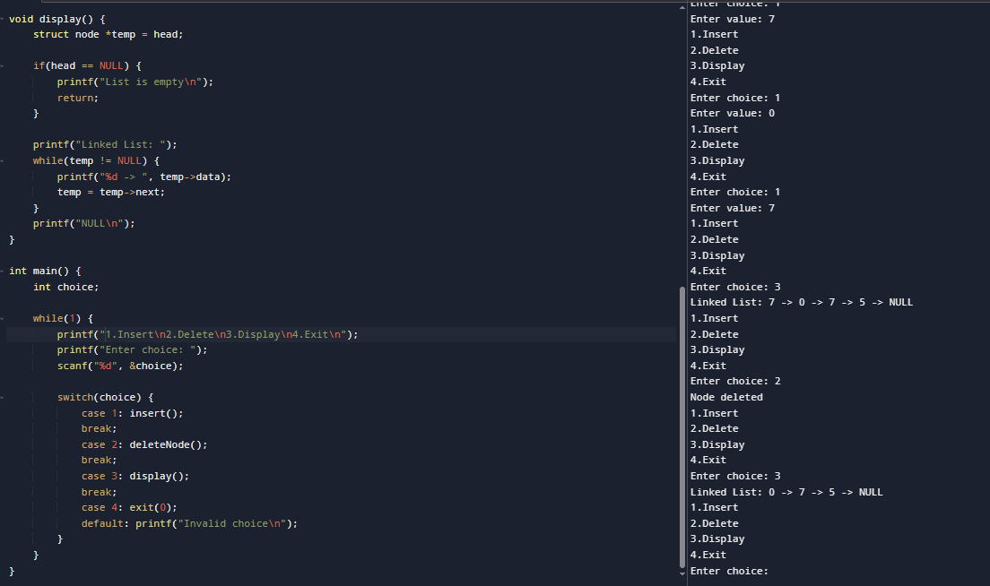

9. Write a program to perform the operations of the Circular linked list: Insertion, Deletion & Display.

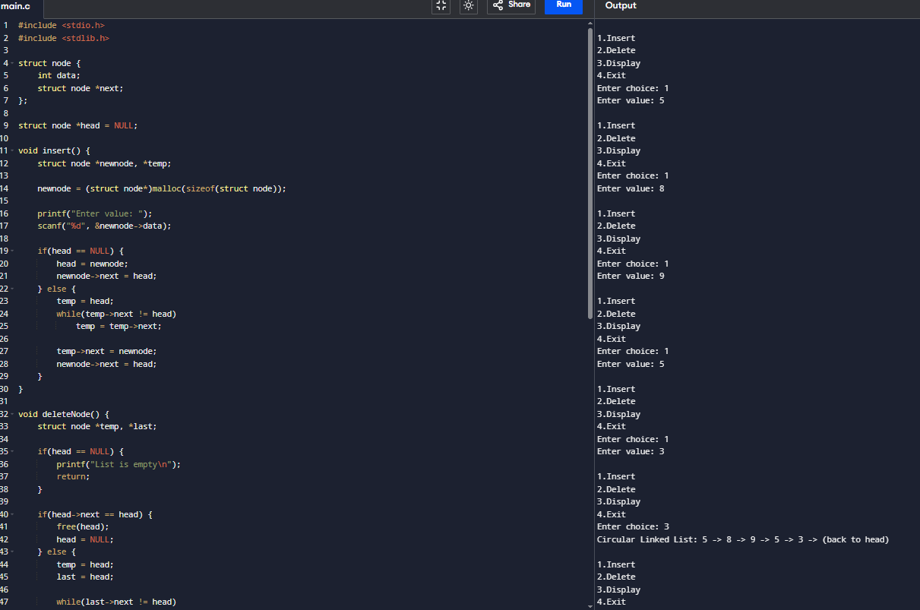

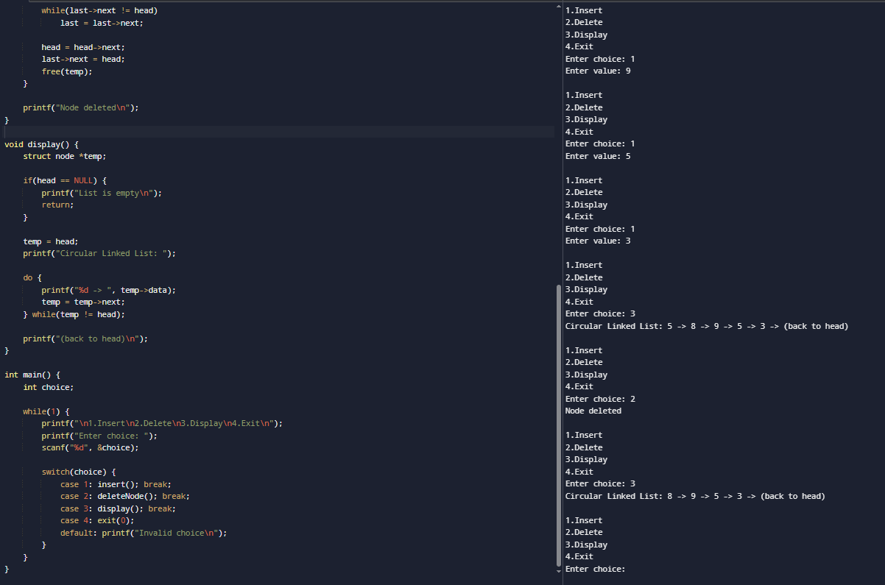

10. Write a program to perform all operations: For Stack using Linked List, For Queue using Linked List & For Circular Queue using Linked List.

- For Stack using Linked List.

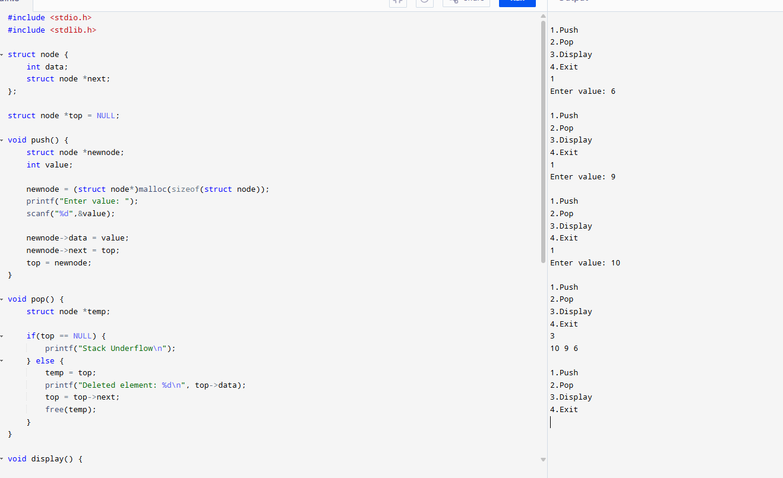

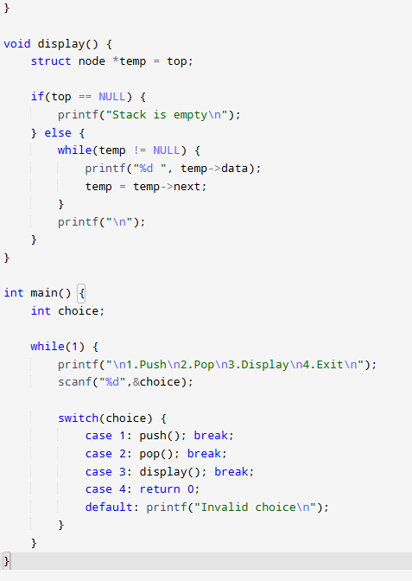

- For Queue using Linked List.

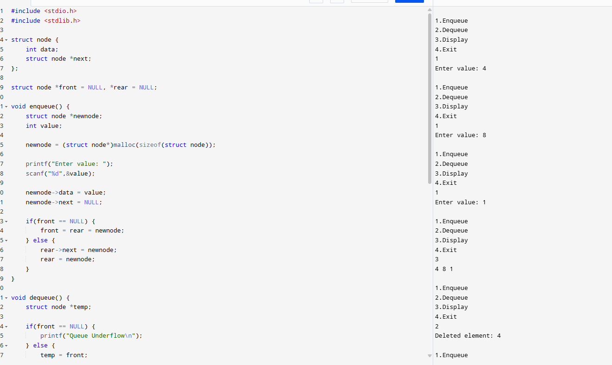

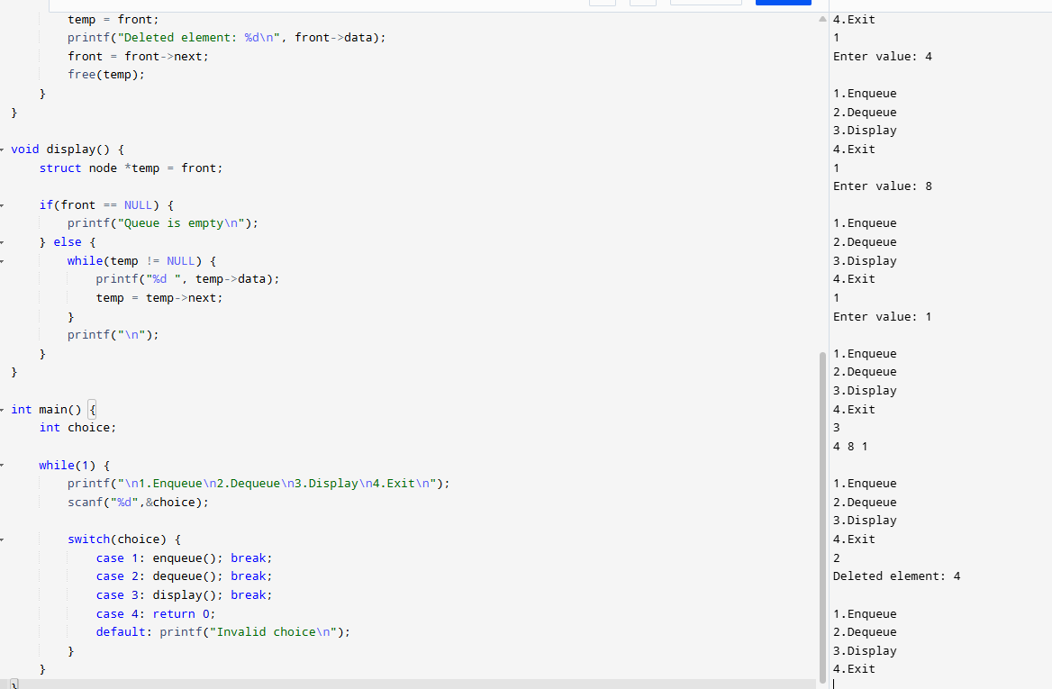

- For Circular Queue using Linked List.
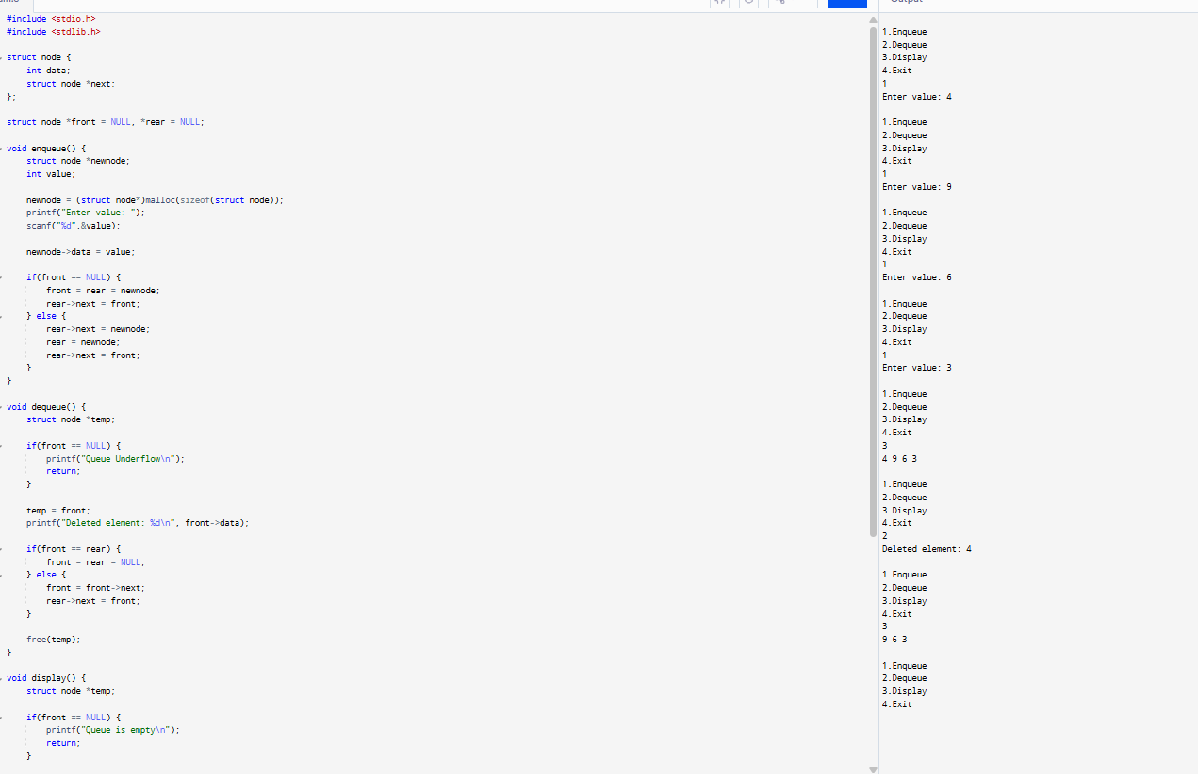

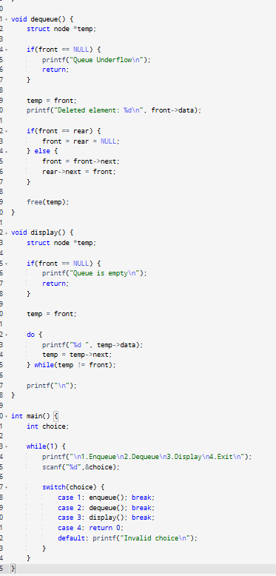
11. Write a program to perform concatenation of two linked lists.

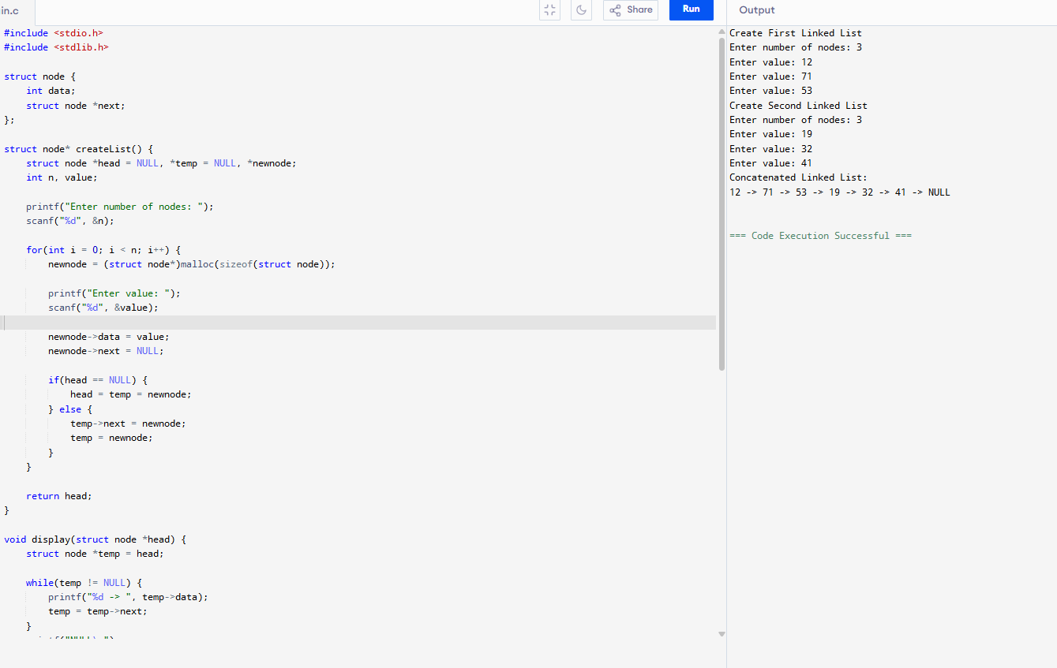

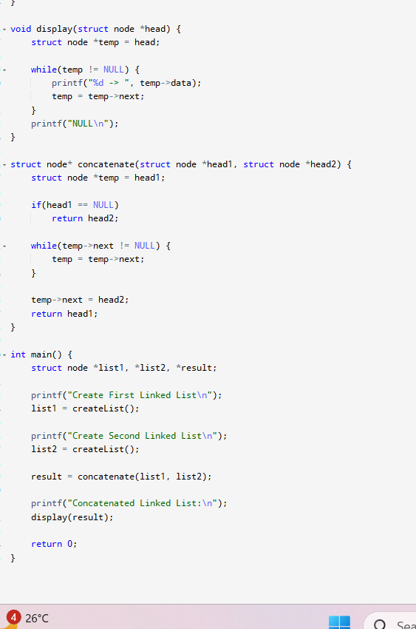
12. Write a program to perform the operations of the Double linked list: Insertion, Deletion & Display.

