Beyond Idempotency: End-to-End Exactly-Once Effects and Ambiguity Recovery for LLM Agent Tool Execution in Distributed Systems
Bhuvin Gowda
Independent researcher, Fremont, California, USA
Corresponding author: bhuvingowda@gmail.com | Telephone: +1-612-756-6014

Abstract
Large language model (LLM) agents increasingly invoke side-effecting tools through distributed gateways and services, where timeouts and crashes can make a successful external effect indistinguishable from a failed request. We study exactly-once externally observable effects under at-least-once invocation. Six protection placements are evaluated across an agent, tool gateway, orchestrator, and downstream service, including a reconciliation protocol for ambiguous post-effect failures. Across 3,340 experiments representing 33.4 million logical operations, durable protection eliminated observed duplicate effects in representative ambiguous-failure cells where the unprotected baseline produced approximately 10% duplicates. Under post-effect crashes, end-to-end protection without reconciliation left about 10% of operations unresolved, whereas lookup-based reconciliation reduced unresolved outcomes to zero. Under retry fanout 10, protected execution held downstream amplification near one while the baseline reached 10-11 calls. The results show that duplicate suppression and ambiguity recovery are distinct distributed-systems guarantees.
Keywords: LLM agents; distributed systems; idempotency; exactly-once effects; fault tolerance; reconciliation

1 Introduction
Tool-using LLM agents extend language models from text generation to action. They can create orders, reserve inventory, charge payments, send notifications, provision infrastructure, and invoke arbitrary APIs. Contemporary agent protocols and frameworks make these calls look like ordinary structured request-response interactions [11, 12, 14]. The distributed system underneath them, however, cannot assume that a tool call is atomic. A downstream effect may commit while the response is delayed, lost, or interrupted by a crash. From the agent's perspective, the same observable timeout can therefore mean either 'nothing happened' or 'the effect happened but the result was lost'.
This ambiguity is a classical distributed-systems problem in a new execution path. Exactly-once interaction has long required durable state and recovery across client, network, and server failures [4], and long-lived distributed workflows commonly avoid global transactions in favor of local transactions, compensation, idempotency, and explicit recovery [1, 2, 5, 6]. Agentic systems add another retry-capable layer: logical identity can be generated by the agent, deduplication can be enforced by a gateway or orchestrator, and the actual side effect can be protected by the downstream service. The guarantee obtained by composing these layers is not obvious.
Recent work on LLM tool reliability has introduced verify-before-retry, idempotency keys, structured safety constraints, and empirical studies of tool-call consistency [8-10]. These advances establish that tool-use reliability is a practical concern, but they do not fully characterize the guarantee boundary created by placing retry protection at different layers of a distributed service path. In particular, preventing a second side effect is not the same as recovering the result of a side effect whose commit status is unknown.
This paper therefore asks when layer-local idempotency is sufficient, when end-to-end logical operation identity is required, and when downstream queryability is necessary for safe recovery. We use the term exactly-once effect deliberately: the system may execute multiple physical attempts, but each logical operation should produce at most one externally observable committed effect. We do not claim literal exactly-once execution or a universal guarantee for arbitrary non-idempotent external APIs.
The empirical study comprises 3,340 experiments and 33.4 million measured logical operations across six architecture variants, eleven failure scenarios, four workloads, multiple failure probabilities, concurrency levels up to 100, and duplicate/retry fanout up to 10. The primary finding is a separation of guarantees. Durable layer-local mechanisms can eliminate duplicate effects in several ambiguous-failure conditions, but they can still leave operations unresolved. Explicit downstream lookup and reconciliation recover those ambiguous outcomes without reissuing the external effect.
The contributions are fourfold: (1) a formal distinction between logical operations, physical attempts, and external effects for agent tool execution; (2) a cross-layer taxonomy of protection placement from agent identity through downstream idempotency; (3) an explicit UNKNOWN-to-RECONCILING recovery protocol whose safety depends on downstream operation identity and queryability; and (4) a large fault-injection evaluation that quantifies duplicate safety, ambiguity recovery, retry amplification, and performance cost.

2 Background and related work

2.1 Distributed transaction and retry semantics
Distributed systems have long separated atomic database transactions from multi-service workflows. Sagas decompose long-lived transactions into local steps with compensating actions [1], while later work emphasized that large-scale service architectures often cannot rely on globally serializable distributed transactions [2]. Gray and Reuter's transaction-processing foundations and modern distributed-systems treatments likewise distinguish atomic local state from failures that occur across process and network boundaries [3, 5].
Exactly-once request-response semantics are particularly difficult because a crash can occur after the server performs an operation but before the client learns the outcome. Ivaki et al. showed that durable client/server state is needed to recover such interactions [4]. Production microservice practice uses related techniques such as durable idempotency records, transactional outboxes, and idempotent consumers [6]. Our study differs by isolating the placement of protection across an agent-to-service path and by measuring both effect safety and unresolved ambiguity.

2.2 Tool-using LLM agents
Tool use has become a core capability of autonomous LLM systems. Surveys describe agents that select and invoke external APIs, computational tools, code environments, and enterprise services [11, 12]. The Model Context Protocol (MCP) provides a standardized tool interface and, in its 2026 revision, emphasizes a stateless request-response protocol core that is intended to improve scalability and reliability [14]. These interfaces increase interoperability but do not, by themselves, define transaction semantics for consequential side effects.
Mansoor et al. study non-atomic LLM tool failures and combine postcondition verification, verify-before-retry logic, and idempotency keys [8]. Doshi et al. address safe tool use through enforceable constraints and MCP capabilities [9], while Yagubyan measures reproducibility in multi-step structured tool-calling pipelines [10]. Agent evaluation surveys identify robustness, safety, cost-efficiency, and fine-grained evaluation as open problems [13]. Our work complements these studies by treating tool execution as a distributed transaction-boundary problem and explicitly separating duplicate suppression from ambiguity resolution.

2.3 Fault-tolerant cloud and serverless execution
Fault tolerance is also central to cloud and serverless execution. Histrio, for example, provides actor-based state and exactly-once processing within a controlled serverless programming model [7]. Cloud scheduling work studies resilience and resource management under failures [15]. Our setting is different: the external side effect may occur in a separately administered service with only partial cooperation. This makes downstream capability (no identity, idempotent execution, or idempotent-plus-queryable execution) a first-class experimental factor.

3 Problem formulation and design

3.1 Logical operation and correctness properties
A logical tool operation is O = <id, tool, args>. The operation_id is stable across retries, while each physical invocation receives a distinct attempt_id. A canonical request fingerprint is computed from the tool name and normalized arguments. Reuse of an operation identifier with a different fingerprint is rejected as an identity conflict.
For a logical operation O, let Effects(O) denote the number of committed externally observable effects and Attempts(O) the number of physical attempts. The central safety property is Effects(O) <= 1. A successful exactly-once effect has Effects(O) = 1 even when Attempts(O) > 1. Additional properties are stable replay of completed outcomes, identity integrity, retry transparency, and eventual completion under recoverable failures. The protocol is not intended to guarantee successful completion when the downstream effect boundary cannot expose the information required for safe recovery.

3.2 Protection variants
Table 1 Protection variants evaluated in the study
Variant | Placement | Semantics
V0 | Naive retry | No stable protection; retries may repeat the external effect.
V1 | Agent identity | Stable logical operation identity for correlation; no durable enforcement at the effect boundary.
V2 | Gateway durable dedupe | Durable gateway ledger suppresses duplicate execution/replays known outcomes; ambiguity can remain.
V3 | Downstream idempotency | The downstream service atomically maps operation_id to one business effect.
V4 | End-to-end protection | Stable identity across layers, durable ledger/ownership, request-integrity checks, downstream support and replay; no explicit reconciliation.
V5 | End-to-end + reconciliation | V4 plus C2 lookup and UNKNOWN-to-RECONCILING recovery for ambiguous effect-time failures.
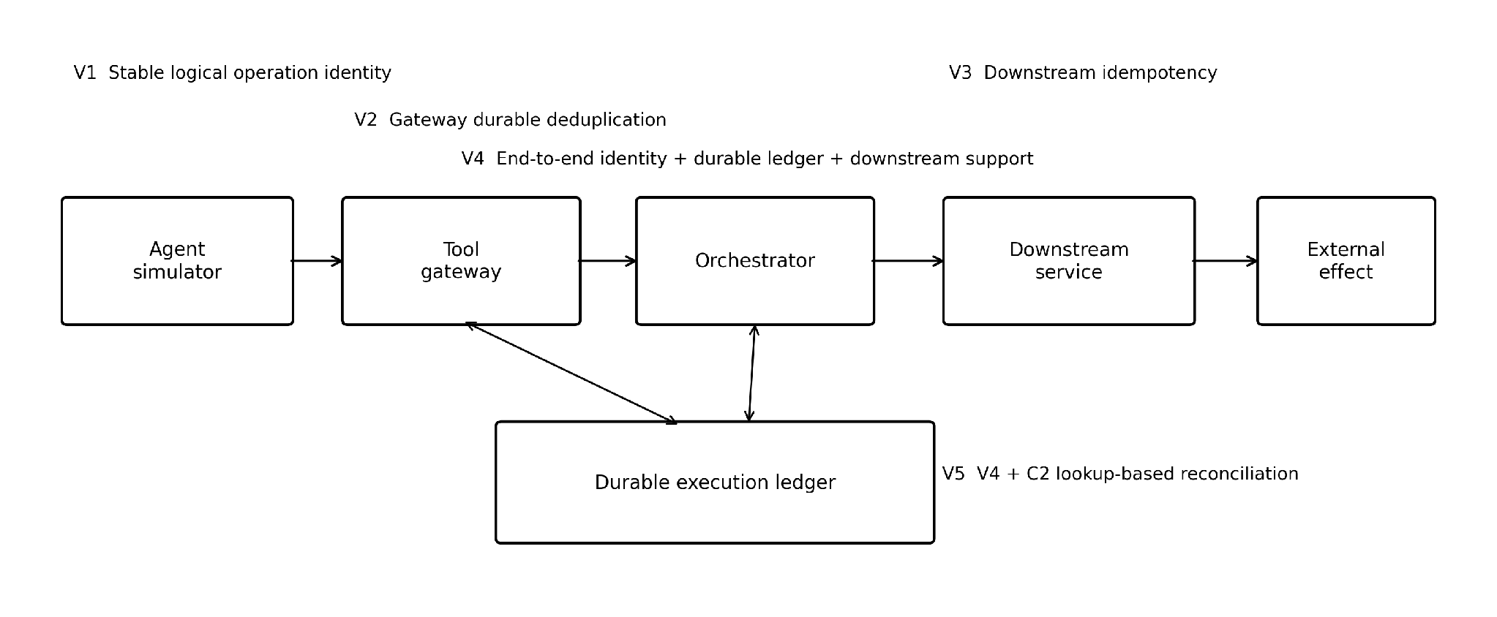
Fig. 1 Cross-layer execution path and protection placement

3.3 Downstream capability model
We model three downstream capability classes. C0 is unprotected: it accepts an ordinary request but does not deduplicate by logical operation identity and cannot query a prior effect. C1 supports idempotent execution: an operation_id is accepted and atomically associated with at most one business effect. C2 extends C1 with lookup_by_operation_id, allowing an upstream recovery procedure to determine whether an ambiguous operation already committed. This distinction is central: C1 can protect the effect boundary, whereas C2 additionally makes post-effect uncertainty observable.

3.4 Durable execution ledger and recovery
Protected variants use a durable execution ledger with states RECEIVED, CLAIMED, EXECUTING, UNKNOWN, RECONCILING, EFFECT_CONFIRMED, COMPLETED, RETRYABLE_FAILURE, and FAILED_FINAL. Ownership is lease-based to prevent concurrent workers from executing the same protected logical operation. A known safe pre-effect failure can transition to RETRYABLE_FAILURE and be reclaimed. An expired or crashed execution that may have crossed the effect boundary transitions to UNKNOWN rather than being blindly retried.
V5 handles UNKNOWN by entering RECONCILING and querying the C2 downstream service using operation_id. If the effect exists, the ledger records EFFECT_CONFIRMED and COMPLETED without reissuing the side effect. If the effect is confirmed absent, the operation becomes retryable. If the outcome remains indeterminate, it stays UNKNOWN. V4 intentionally lacks this step, exposing the difference between conservative duplicate safety and explicit ambiguity recovery.
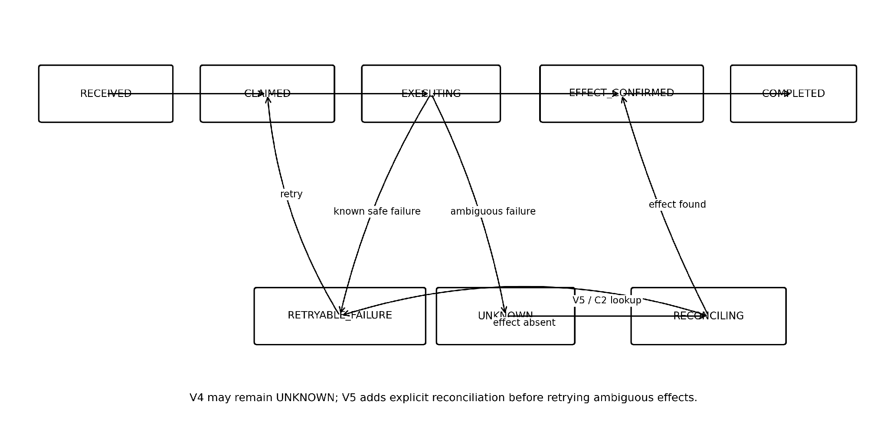
Fig. 2 Simplified protected-operation state machine and V5 reconciliation path

4 Experimental methodology

4.1 Testbed and workloads
The testbed uses a deterministic Python agent simulator, a Java 21/Spring Boot tool gateway and orchestrator, four Spring Boot downstream services, and PostgreSQL 16 for the ledger and business state. Docker Desktop on Apple M4 hardware provided the execution environment. A deterministic simulator was chosen instead of a live language model for the primary study so that system-level failure semantics, retry decisions, and workload traces could be reproduced exactly across variants. The research question concerns distributed execution after a tool has been selected; model reasoning quality is therefore held constant rather than treated as an experimental variable.
Four side-effecting workloads are implemented: create_order (primary), charge_payment, reserve_inventory, and send_notification. Ground-truth effects are recorded in an observer schema that runtime service identities cannot read. Analysis accesses this observer only after execution. Phase-6 auditing found zero forbidden observer reads, zero illegal ledger-state transitions, and zero ownership-overlap violations.

4.2 Failure model
Table 2 Failure scenarios used in the final Phase-6 matrix
ID | Failure scenario
F0 | No injected failure
F1 | Request loss before execution
F2 | Timeout before downstream dispatch
F3 | Response loss after a successful effect
F4 | Delayed response causing retry
F5 | Sequential duplicate invocation
F6 | Concurrent duplicate invocation
F7 | Gateway crash before downstream call
F8 | Orchestrator crash after downstream effect and before durable effect confirmation
F9 | Crash after effect confirmation and before final result persistence
F11 | Retry storm / duplicate fanout

4.3 Experimental matrix
Table 3 Phase-6 experiment groups
Group | Failures | Variants | Factors | Runs
A Baseline | F0 | V0-V5 | C=1,10,50,100 | 240
B Ambiguous | F3,F4,F8,F9 | V0-V5 | p=1,5,10,20%; C=10,50 | 1,920
C Duplicate pressure | F5,F6,F11 | V0-V5 | fanout=2,5,10; C=50 | 540
D Capability | F3,F8 | V2-V5 | C0/C1/C2 valid combinations; p=10%; C=50 | 220
E Safe controls | F1,F2,F7 | V0-V5 | p=10%; C=50 | 180
F Generalization | F3,F8 | V0,V2,V4,V5 | payment, inventory, notification; p=10%; C=50 | 240
The complete matrix contains 3,340 experiments and 33.4 million measured logical operations. Each planned cell uses ten independent seeds where applicable. Ambiguous-failure probabilities are 1%, 5%, 10%, and 20%; concurrency is 10 or 50 for the core ambiguity group. Baseline concurrency extends to 100, and duplicate/retry pressure uses fanout 2, 5, and 10. Warm-up operations are tagged and excluded from measured metrics.

4.4 Metrics and analysis
Reliability metrics are Duplicate Effect Rate (DER), Exactly-Once Effect Rate (EOER), Lost Effect Rate (LER), Recovery Success Rate (RSR), and Unresolved Ambiguity Rate (UAR). Retry Amplification Factor (RAF) is the number of measured physical agent attempts per logical operation, while Downstream Amplification Factor (DAF) is the number of downstream business invocations per logical operation. Retry Replay Rate (RRR) measures replayed measured retry attempts over measured retry requests. Performance metrics are P50, P95, and P99 end-to-end latency and throughput.
Reliability is observed at logical-operation granularity, while seeded runs are treated as the experimental replication level to avoid pseudo-replication. Planned categorical/reliability comparisons use run-level differences with confidence intervals and appropriate exact/chi-square reasoning where counts are relevant; continuous performance comparisons use non-parametric tests when appropriate. The Phase-7 comparison registry applies Holm correction to families of related tests and reports effect sizes alongside adjusted p-values. Valid latency/throughput outliers are retained in the primary analysis rather than automatically excluded.

4.5 Reproducibility and integrity controls
All 3,340 final experiments passed artifact validation. Metrics were independently recomputed from raw artifacts with zero unexplained discrepancies. The run corpus contains no missing experiments or metric NaNs. One infrastructure retry occurred without any scientific configuration change. Source/configuration SHA-256 manifests, environment metadata, stage audits, and analysis scripts were preserved. A validator-only RRR discrepancy discovered during F6 analysis was corrected by aligning the validator with the measured-event definition already used by summary generation; the underlying run artifacts remained valid.

5 Results

5.1 RQ1: How effectively do placement strategies prevent duplicate effects?
The unprotected baseline was directly exposed to duplicate side effects under ambiguous failures. At F3 with 10% injected response loss and concurrency 50, V0 mean DER was 9.956%. V2, V4, and V5 each had DER=0. The absolute V0-to-protected difference was -9.956 percentage points (95% CI approximately -10.079 to -9.833 percentage points; Holm-adjusted p<0.001). Under F8 at the same probability and concurrency, V0 mean DER was 9.892%, again compared with DER=0 for V2, V4, and V5 (adjusted p<0.001).
These results reject a monotonic 'stronger variant always has lower DER' hypothesis. Gateway durable deduplication (V2) already prevents duplicate effects in the representative cells, so DER alone cannot distinguish V2 from V4/V5. The stronger protocols contribute additional recovery semantics rather than additional duplicate suppression in these conditions.
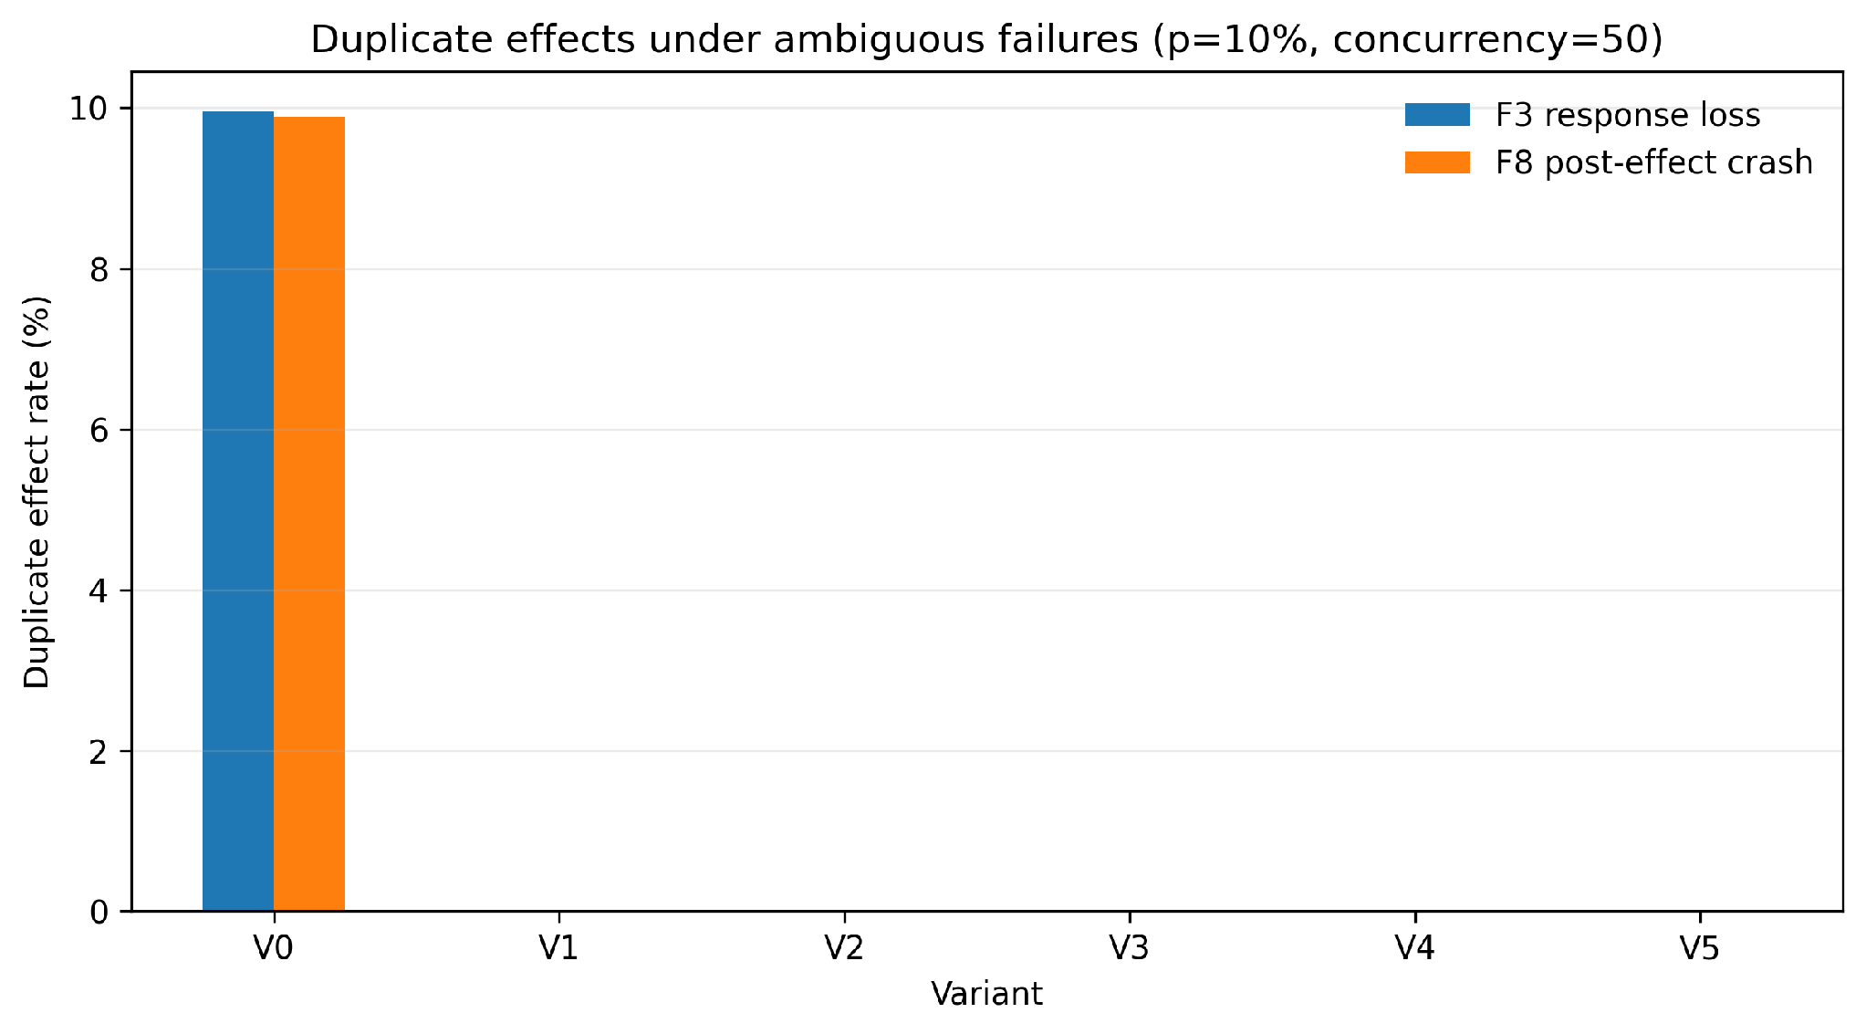
Fig. 3 Mean duplicate-effect rate for F3 and F8 at 10% failure probability and concurrency 50

5.2 RQ2: How does protection placement change the guarantee?
The capability experiments show that effect safety and recoverability depend on different downstream properties. For V2 and V4 under F8, changing C0/C1/C2 did not materially reduce UAR in the planned capability comparisons: unresolved outcomes remained near 10% because these variants do not perform explicit C2 reconciliation. By contrast, V5 with C1 had RSR=0, while V5 with C2 recovered 9.882% of operations on average (absolute difference 9.882 percentage points; 95% CI 9.672-10.092; adjusted p<0.001).
Thus idempotent execution and queryability provide different guarantees. C1 can prevent a repeated logical operation from producing a second business effect. C2 additionally allows a coordinator to discover that the first attempt already committed. Upstream durable state cannot manufacture this information when the external API is C0 (non-idempotent and non-queryable); after a response-lost post-effect failure, a safe coordinator may be forced to remain uncertain.
Table 4 Selected downstream-capability results at F8
Variant / condition | Capability | Primary outcome
V2, F8 | C0 | UAR 9.939%
V2, F8 | C1 | UAR 10.101%
V2, F8 | C2 | UAR 9.991%
V4, F8 | C1 | UAR 10.045%
V4, F8 | C2 | UAR 9.922%
V5, F8 | C1 | RSR 0%
V5, F8 | C2 | RSR 9.882%

5.3 RQ3: Resilience to ambiguity and retry pressure
F8 creates the critical post-effect ambiguity window. At 10% probability and concurrency 50, V4 mean UAR was 10.001%, while V5 UAR was 0 (absolute difference -10.001 percentage points; 95% CI approximately -10.219 to -9.783; adjusted p<0.001). V5 converts the affected population into reconciled outcomes rather than duplicate effects. Across F8 probabilities, V4 UAR tracks the injected ambiguity rate, while V5 with C2 maintains near-zero unresolved outcomes and records reconciliation instead.
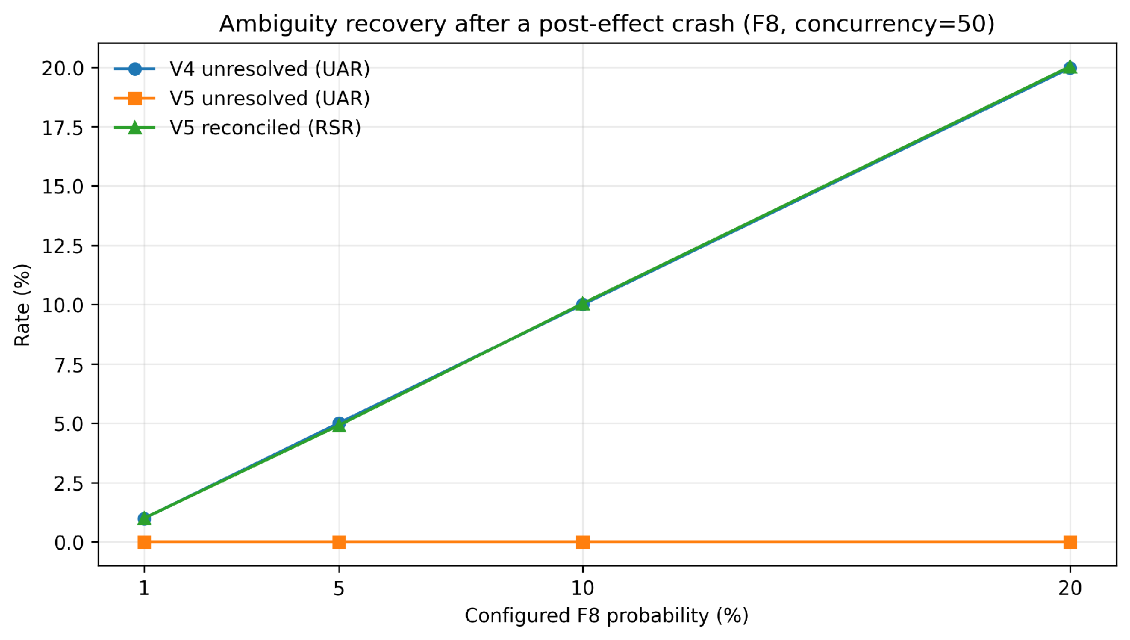
Fig. 4 V4 unresolved ambiguity versus V5 reconciliation under F8, using only group-B ambiguity runs
The benefit is specific to true uncertainty about whether the external effect committed. Under F9, where effect confirmation is already durable and only final result persistence is interrupted, V4 and V5 both have UAR=0 in the planned 10%/C50 comparison. This explains why the preregistered recovery hypothesis is only partially supported: reconciliation adds information where the system has lost knowledge of the effect boundary, not after every post-effect failure.
Retry pressure further separates internal attempts from external effect pressure. At F6 fanout 10, V0 has DAF=10 and DER=1, while V5 has DAF=0.99976 and DER=0; the DAF reduction is approximately 90.0% (adjusted p<0.001). At F11 fanout 10, V0 has DAF=11 and DER=1, while V5 has DAF=1 and DER=0, a 90.9% reduction in downstream amplification (adjusted p<0.001). RAF still rises with fanout, demonstrating that protected execution can absorb retry pressure before it reaches the side-effect boundary.
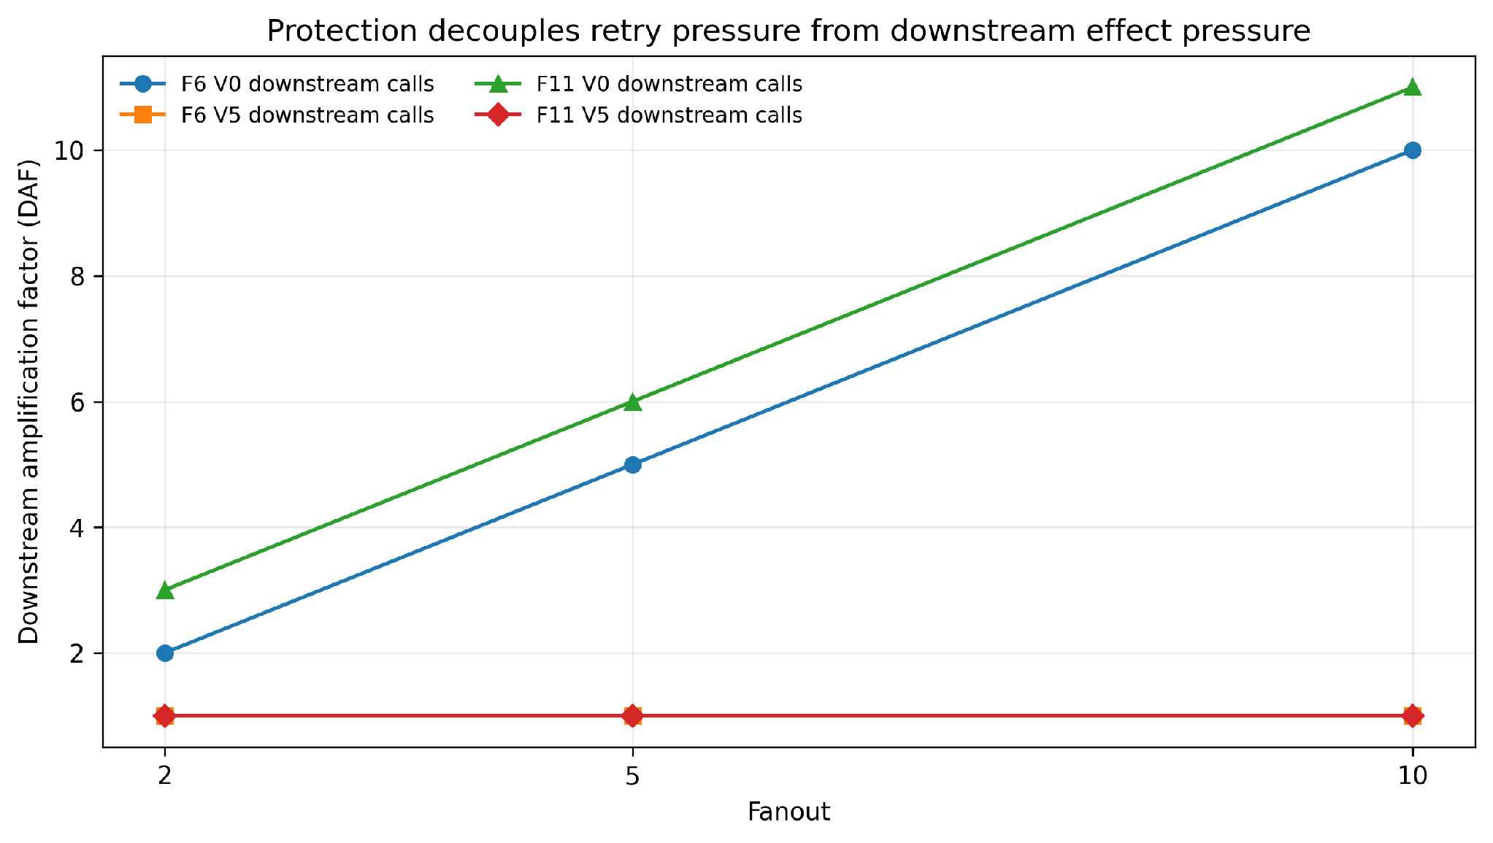
Fig. 5 Downstream amplification under concurrent duplicate and retry-storm pressure

5.4 RQ4: Reliability cost
Baseline results do not show a consistent monotonic latency penalty as protection becomes stronger. At concurrency 50, mean P95 latency was 47.113 ms for V0, 53.849 ms for V2, 44.878 ms for V3, 50.077 ms for V4, and 46.848 ms for V5. The V0-to-V5 difference was -0.266 ms (-0.56%) with a confidence interval spanning zero and Holm-adjusted p=0.562. At concurrency 100, mean P95 was 110.886 ms for V0 and 121.804 ms for V5 (+9.85%), but the adjusted comparison was also not statistically decisive (p=0.562).
Throughput likewise varies by architecture and concurrency. V2/V4/V5 introduce durable coordination and may reduce throughput relative to V0 in some baseline cells, but the measured tail-latency cost is not uniformly increasing with semantic strength. We therefore characterize the performance-cost hypothesis as mixed rather than asserting either 'negligible overhead' or a universal penalty.
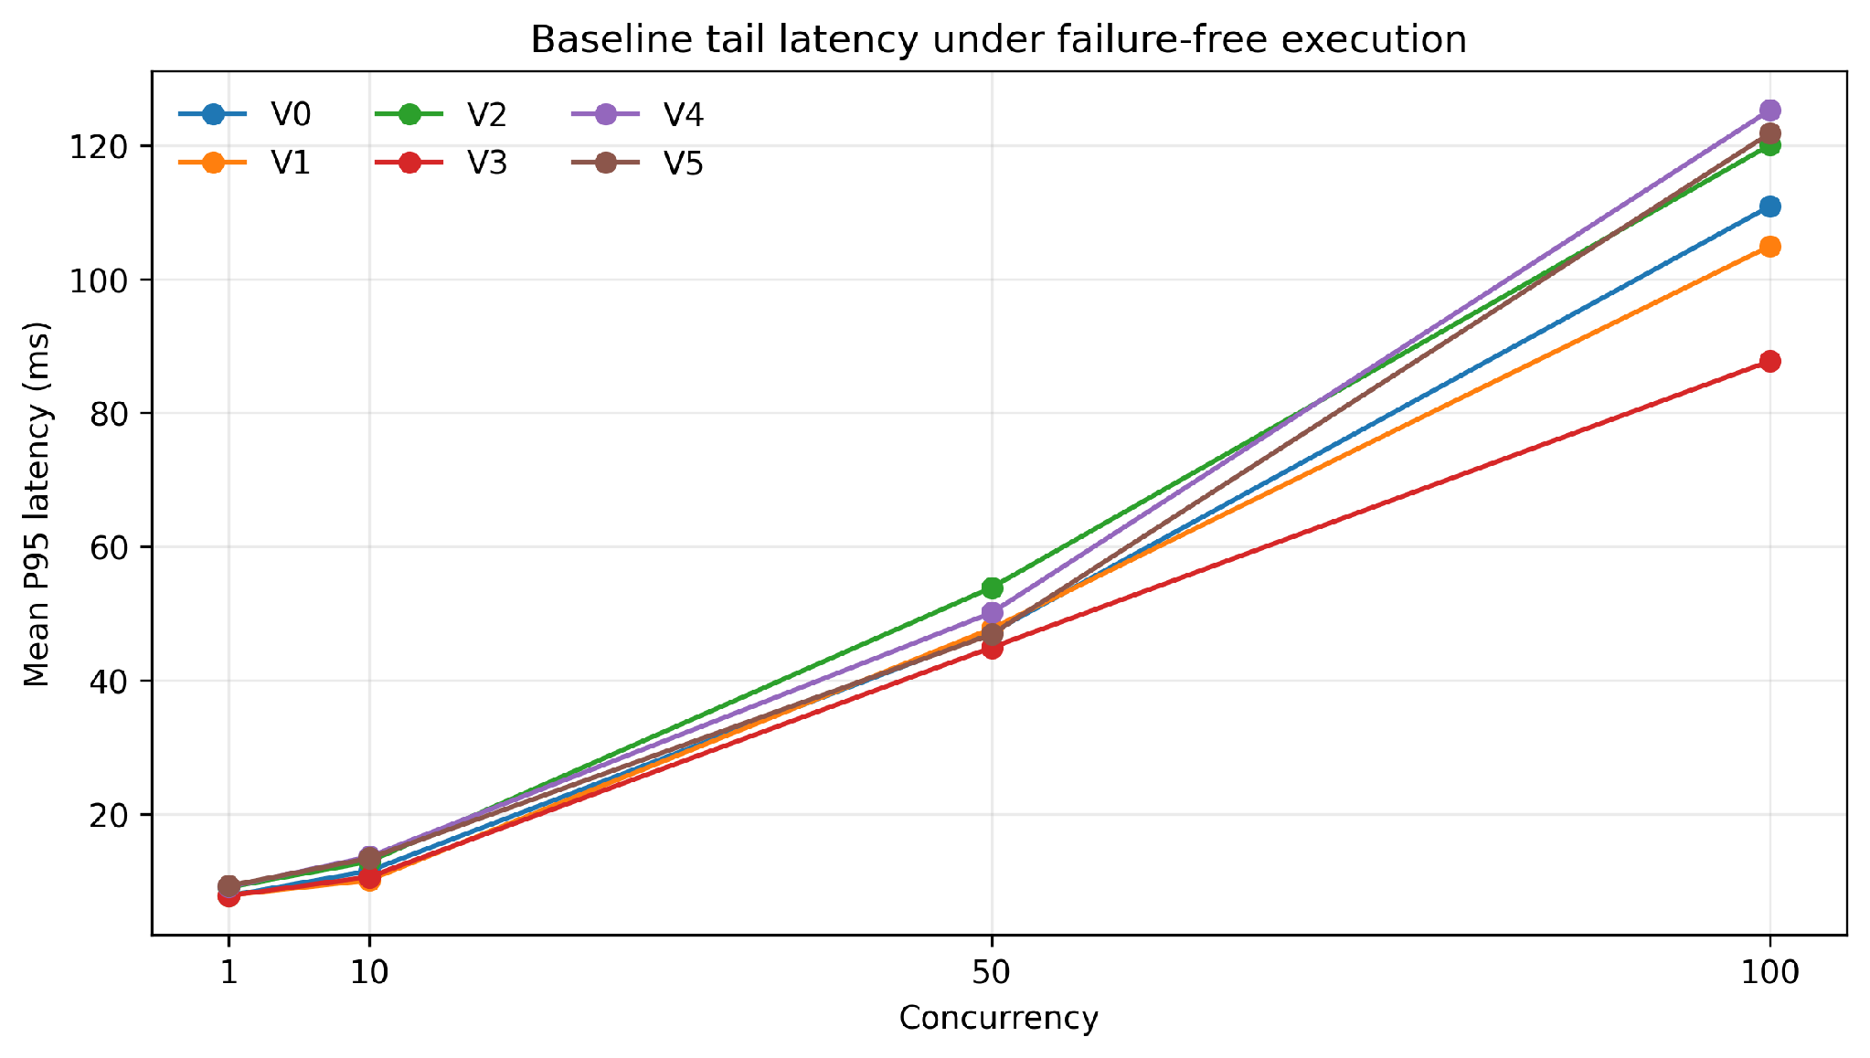
Fig. 6 Mean P95 latency under failure-free execution
Table 5 Mean baseline P95 latency (ms) in representative concurrency levels
Concurrency | Variant | Mean P95 (ms)
50 | V0 | 47.113
50 | V2 | 53.849
50 | V3 | 44.878
50 | V4 | 50.077
50 | V5 | 46.848
100 | V0 | 110.886
100 | V2 | 120.039
100 | V3 | 87.721
100 | V4 | 125.254
100 | V5 | 121.804

5.5 Workload generalization
The same qualitative safety/recovery pattern was evaluated for payment, inventory reservation, and notification workloads, in addition to the primary order workload. Across the 240 generalization runs, protected variants retained zero duplicate-effect behavior in the intended protected configurations, while V5/C2 reconciled ambiguous post-effect failures without requiring the observer. These results support mechanism-level generalization across four simulated side-effect types, but they do not establish universal behavior for arbitrary production APIs or external providers.

6 Discussion

6.1 Duplicate safety is not ambiguity recovery
The central result is that duplicate suppression and ambiguity recovery should be treated as separate distributed-systems guarantees. V2, V4, and V5 can all reach DER=0 in the representative F3/F8 cells, yet their knowledge of the operation outcome differs. A gateway ledger may stop a duplicate from reaching the downstream service while still being unable to determine whether an earlier side effect committed. Consequently, DER alone is an incomplete correctness metric for side-effecting agent tools.
This distinction also reframes idempotency. The data do not support the claim that 'idempotency is insufficient to prevent duplicates'; in fact, idempotency at a suitable boundary can be sufficient for effect safety. The stronger statement supported by the experiments is that idempotency alone does not necessarily resolve post-effect uncertainty. Queryability by stable logical identity supplies the missing evidence needed for safe recovery.

6.2 Where exactly-once effects can and cannot be claimed
The protocol makes no claim of literal exactly-once execution. Physical attempts can be repeated, as shown by RAF values under fanout, while the externally visible effect remains bounded. Exactly-once effects also depend on assumptions: stable operation identity, request immutability, a durable ledger, atomic downstream deduplication for C1/C2, eventual recovery, and accurate C2 lookup. If the effect is performed by an arbitrary C0 API that neither deduplicates nor exposes prior execution by logical identity, an upstream coordinator cannot always distinguish 'committed but response lost' from 'never committed'.
This limitation is important for agent infrastructure. Reliability should be negotiated as a tool contract rather than inferred from an RPC interface. A tool that advertises idempotent execution can support safe retry at the effect boundary; a tool that additionally exposes lookup by operation identity can support reconciliation. Tool protocols such as MCP standardize invocation, but production deployments may benefit from explicit execution-semantics metadata or conventions for operation identity and recovery.

6.3 Architectural implications for agentic systems
Three practical implications follow. First, assign a stable logical operation identifier before the first side-effecting call and preserve it across agent and infrastructure retries. Second, enforce request integrity so an identifier cannot be reused for a different canonical request. Third, treat an expired in-flight operation that may have crossed the effect boundary as UNKNOWN rather than blindly retrying it. If the downstream service is queryable, reconcile before retrying; if it is not, expose the uncertainty rather than manufacturing a false success or risking a duplicate effect.
The retry-amplification results further suggest that systems should measure both RAF and DAF. A high retry count is not necessarily dangerous if retries terminate at a durable protection layer. Conversely, seemingly modest agent retry behavior can become expensive or unsafe when every attempt reaches a non-idempotent downstream service.

6.4 Interpretation of preregistered hypotheses
Table 6 Evidence direction for the planned hypotheses
Hypothesis | Evidence | Interpretation
H1 | Consistent | Layer-local protection reduces DER relative to V0 but can retain cross-layer ambiguity.
H2 | Not consistent as written | V2, V4, and V5 all reach DER=0 in representative F3/F8 cells; stronger variants are distinguished by recovery, not DER.
H3 | Mixed | V5 strongly improves F8 ambiguity recovery, but V4 and V5 are indistinguishable on UAR under F9.
H4 | Mixed | No consistent monotonic P95 penalty across variants/concurrency.
H5 | Consistent | Protected variants bound DAF near one under high fanout while V0 scales downstream calls with retry pressure.

7 Threats to validity

7.1 Construct validity
The study defines correctness in terms of externally observable effects and durable observer records. This deliberately excludes semantic correctness of the business action itself and language-model reasoning quality. RSR, UAR, RAF, DAF, and RRR depend on explicit event definitions; these metrics were independently recomputed for all final runs. A validator-only RRR inconsistency found during analysis was corrected without altering raw scientific artifacts.

7.2 Internal validity
Fault injection is deterministic and seed-controlled, and matched traces are reused across variants where hook reachability permits. Runtime users cannot read observer ground truth. Phase-5 hardening added single-runner locking after a background process was found capable of resetting experimental state; Phase 6 then used checkpointed, single-instance execution. All final runs passed artifact and state-machine audits, with zero ownership overlaps. Infrastructure failures were separated from scientific outcomes; one infrastructure retry was recorded and rerun without changing its configuration.

7.3 External validity
The implementation uses one distributed testbed on Docker Desktop/Apple M4, one relational database, Java/Spring services, and simulated workloads. The four workloads exercise distinct side-effect types but do not cover arbitrary APIs, databases, cloud runtimes, long-running autonomous agents, or Byzantine faults. The primary agent is deterministic rather than a live LLM. This choice improves reproducibility and isolates transaction semantics but means the study does not measure model-induced variation in tool selection or arguments. Future work should combine the protocol with live agents, heterogeneous external APIs, and multi-region failure modes.

7.4 Statistical conclusion validity
Ten seeded replications are used for planned cells. Reliability effects are large and stable in the headline comparisons, but performance measurements show substantial host-level variation: 542 latency/throughput candidates were flagged as potential outliers and retained. Multiple-comparison correction reduces the risk of overinterpreting isolated p-values. The performance conclusions are therefore intentionally conservative and should not be generalized as hardware-independent cost bounds.

8 Conclusion
Side-effecting LLM tool calls inherit the classical ambiguity of distributed request-response systems: the external operation can succeed even when the agent observes failure. Across 3,340 experiments and 33.4 million logical operations, we find that durable layer-local protection can be sufficient to suppress duplicate effects, but duplicate safety does not imply knowledge of the outcome. Under a post-effect crash, end-to-end protection without reconciliation leaves approximately the injected failure population unresolved, while C2 lookup-based reconciliation converts that uncertainty into completed outcomes without reissuing the effect. Under high retry fanout, protected variants keep downstream amplification near one even as agent attempts increase. These results motivate an execution contract for agent tools that separates stable logical identity, idempotent effect enforcement, and queryable recovery. Exactly-once effects are achievable within those explicit assumptions; arbitrary non-idempotent, non-queryable APIs remain outside that guarantee boundary.

References
[1] Garcia-Molina, H., Salem, K.: Sagas. In: Proceedings of the 1987 ACM SIGMOD International Conference on Management of Data, pp. 249-259 (1987). https://doi.org/10.1145/38713.38742
[2] Helland, P.: Life beyond distributed transactions: an apostate's opinion. In: CIDR 2007, pp. 132-141 (2007).
[3] Gray, J., Reuter, A.: Transaction Processing: Concepts and Techniques. Morgan Kaufmann, San Francisco (1992).
[4] Ivaki, N., Barbosa, R., Araujo, F.: A middleware for exactly-once semantics in request-response interactions. In: 18th IEEE Pacific Rim International Symposium on Dependable Computing, pp. 157-166 (2012). https://doi.org/10.1109/PRDC.2012.23
[5] Kleppmann, M.: Designing Data-Intensive Applications. O'Reilly Media, Sebastopol (2017).
[6] Richardson, C.: Microservices Patterns: With Examples in Java. Manning, Shelter Island (2018).
[7] De Martini, L., Buttiglieri, G.N., Margara, A.: Histrio: Actor-based programming and correctness guarantees for serverless environments. Inf. Syst. 140, 102724 (2026). https://doi.org/10.1016/j.is.2026.102724
[8] Mansoor, I.K., Phadke, A., Rana, P.: Verified tool calls improve LLM agent reliability under non-atomic failures. arXiv:2608.02645 (2026). https://doi.org/10.48550/arXiv.2608.02645
[9] Doshi, A., Hong, Y., Xu, C., Kang, E., Kapravelos, A., Kastner, C.: Towards verifiably safe tool use for LLM agents. In: Proceedings of the IEEE/ACM 48th International Conference on Software Engineering (ICSE-NIER), pp. 201-205 (2026). https://doi.org/10.1145/3786582.3786839
[10] Yagubyan, A.: How consistent are LLM agents? Measuring behavioral reproducibility in multi-step tool-calling pipelines. arXiv:2605.28840 (2026). https://doi.org/10.48550/arXiv.2605.28840
[11] Xu, W., Huang, C., Gao, S., et al.: LLM-based agents for tool learning: a survey. Data Sci. Eng. 10, 533-563 (2025). https://doi.org/10.1007/s41019-025-00296-9
[12] Hussain, M., et al.: From language to action: a review of large language models as autonomous agents and tool users. Artif. Intell. Rev. (2026). https://doi.org/10.1007/s10462-025-11471-9
[13] Yehudai, A., Eden, L., Li, A., Uziel, G., Zhao, Y., Bar-Haim, R., Cohan, A., Shmueli-Scheuer, M.: A survey on evaluation of LLM-based agents. In: Findings of the Association for Computational Linguistics: ACL 2026, pp. 26690-26714 (2026).
[14] Model Context Protocol: The 2026-07-28 specification (2026). https://blog.modelcontextprotocol.io/posts/2026-07-28/. Accessed 6 September 2026.
[15] Hagras, T., El-Sayed, G.A.: A fault-tolerant and load-balancing scheduler for independent tasks on cloud-based virtual machines. Cluster Comput. 29, 61 (2026). https://doi.org/10.1007/s10586-025-05857-1

Statements and Declarations

Funding
The author declares that no funds, grants, or other support were received during the preparation of this manuscript.

Competing interests
The author declares no relevant financial or non-financial interests to disclose.

Author contributions
Bhuvin Gowda: conceptualization, methodology, software architecture, experimental design, investigation, data analysis, visualization, and writing - original draft and review.

Data availability
The complete experimental corpus comprises approximately 72 GB of raw run artifacts. A compact reproducibility bundle containing the experiment manifest, run-level dataset, analysis tables, audit summaries, environment metadata, source/configuration hashes, and analysis scripts is available from the corresponding author on reasonable request. The final submission should replace this statement with a persistent public repository link if the artifacts are deposited before publication.

Code availability
Source code associated with this study is publicly available at https://github.com/bhuvingowda89/paper-agentic-concurrency-model. A source SHA-256 manifest was preserved with the reproducibility bundle.

Ethics approval
Not applicable. The study uses simulated software workloads and does not involve human participants, personal data, or animals.

