Compound Service-Level Degradation and Diagnosis in Large Language Model Inference Systems
Bhuvin Gowda Mysore Basavaraju
Independent Researcher, Fremont, California, United States
Corresponding author: Bhuvin Gowda Mysore Basavaraju; 38890 Moore Dr, Fremont, California 94536, USA; bhuvingowda@gmail.com; Tel: +1-612-756-6014
ORCID: 0009-0003-1492-2049
Abstract
Introduction: Large language model inference is increasingly operated as a software service whose latency depends on prompt processing, autoregressive decode, offered load, application dependencies, and observability. Concurrent degradation can violate multiple service-level objectives while producing symptoms that do not necessarily compose from isolated faults. Methods: We introduce SLOScope, a reproducible benchmark with frozen intervention ground truth, matched controls, repeated run-level experiments, multi-source telemetry, and provenance-checked analysis. The study comprises 104 source-domain runs, 66 zero-shot model-holdout runs, systematic offline telemetry degradations, and a 48-run live telemetry-cost campaign. Results: INPUT+LOAD and OUTPUT+LOAD show statistically supported multivariate non-additivity, whereas three other retained pairs do not. Single-fault-trained logistic root-cause analysis recovers 57.5% of compound cause sets versus 97.5% with mixed training. Temporal features improve source-domain exact recovery to 82.5% but fall to 20.0% after zero-shot transfer from Qwen2.5-0.5B to Qwen2.5-1.5B. Removing host telemetry preserves the pre-specified diagnosis-quality screen and reduces optional telemetry storage by 14–17%, but the live +5% latency non-regression criterion is not established. Conclusion: Reliable diagnosis evaluation should separate interaction from severity, complete cause-set recovery from single-fault accuracy, in-domain performance from configuration transfer, and offline telemetry ablation from measured operational cost.
Keywords: large language model inference; software systems; performance diagnosis; root-cause analysis; observability; reproducible benchmarking

Practitioner Points
- Evaluate compound incidents with complete cause-set metrics; top-1 accuracy can hide a missed concurrent cause.
- Revalidate temporal diagnosis features after model or runtime changes; strong in-domain accuracy may not transfer.
- Treat telemetry reduction as an operational saving only after measuring collection/storage cost and service impact.

Introduction
LLM inference has become a continuously operated service workload rather than a purely offline model-execution task. Modern serving systems batch requests, schedule prompt processing and token generation, manage large key-value caches, stream partial results, and often sit behind application gateways that call additional services. Prior systems work has shown that prefill and decode have distinct resource and latency characteristics^{1–3}. Production-oriented observability systems have correspondingly begun to focus on fine-grained latency decomposition and inference-specific diagnosis^{4–6}. These advances create a practical question that is still easy to underestimate: what happens when more than one degradation mechanism is active at the same time?
Consider a request with a longer prompt arriving during a high-load interval. Its time to first token (TTFT) may reflect both extra prefill work and scheduling pressure. A long generation under load may interact differently because the decode stage competes with other active requests over a longer interval. A downstream delay can increase total latency without necessarily changing model-side work, yet the observable end-to-end signature can overlap with model-side effects. An incident responder rarely receives the experimental labels “long prompt,” “load,” or “dependency delay.” Instead, the responder observes a mixture of request timing, trace spans, system measurements, runtime metrics, and potentially incomplete telemetry.
Most evaluation methodologies simplify this problem in one of two ways. LLM-serving studies frequently optimize or benchmark latency, goodput, batching, or scheduling under workload variation^{1–3}. RCA studies frequently evaluate localization algorithms over injected faults and multi-source telemetry^{7–11}. Recent work has begun to connect RCA directly to LLM inference^{5,6,12}. However, four methodological issues remain especially important for compound degradation. First, simultaneous mechanisms can interact, so a compound signature may not equal the sum of isolated signatures. Second, a model trained on single faults may identify one visible cause while missing a concurrent cause. Third, a diagnostic feature that works well on one model configuration may move substantially under a model-size change. Fourth, a rich telemetry configuration can appear diagnostically useful without establishing whether its acquisition cost is justified.
SLOScope addresses these issues with a controlled, run-level experimental methodology. Rather than treating request rows as independent replicates, the benchmark freezes mechanism definitions, matched controls, randomized repetition blocks, telemetry contracts, and statistical families before formal analysis. It records the active mechanism set as experimental ground truth and keeps this ground truth separate from observed symptoms. It then follows the evidence through five questions: isolated identifiability, compound interaction, multi-label diagnosis and model transfer, robustness to degraded observability, and telemetry quality/cost.
The study deliberately preserves negative results. Several plausible hypotheses fail. A hand-designed mechanism-evidence ranker does not outperform the strongest temporal baseline in-domain. Its temporal-plus-contradiction hypothesis is not supported. Under model holdout, mechanism-oriented evidence does not outperform the pre-specified statistical baseline. Reduced host telemetry saves storage and preserves offline diagnosis quality, but the live latency experiment does not establish the frozen $+5\%$ non-regression bound. We treat these outcomes as scientific constraints, not as results to be redefined away.

Practice relevance.
The immediate subject is large language model inference, but the engineering problem is the design and operation of an inference-serving software system whose behavior depends jointly on workload, runtime configuration, application dependencies, and observability. Empirical studies of production machine-learning inference serving, controlled resiliency benchmarking, and distributed tracing show that runtime behavior under faults, workload changes, and observability constraints is a recurring software-engineering concern^{13–15}. SLOScope complements that work with a controlled benchmark for concurrent degradation, complete cause-set diagnosis, model-holdout transfer, degraded telemetry, and measured telemetry cost. The reusable outcome is not a model-specific optimization but an experimental contract for evaluating diagnosis and observability in AI-enabled runtime systems.

Contributions.
This paper makes five contributions.
- A reproducible compound-degradation benchmark methodology. SLOScope provides controlled INPUT, OUTPUT, LOAD, and DOWNSTREAM mechanisms; matched controls; frozen run-level ground truth; request/trace/system telemetry; campaign provenance; validation; and publication indices on a commodity llama.cpp/Metal stack.
- A matched interaction analysis and multivariate compound metric. We combine factorial contrasts with Compound Signature Divergence (CSD), a standardized multivariate deviation from additive composition. The data show strong non-additivity for INPUT+LOAD and OUTPUT+LOAD but not for all compound pairs.
- A multi-label diagnosis study of compositional failure. Single-fault-trained RCA loses complete-cause recovery on compound observations. The main error is secondary-cause under-attribution, especially missed INPUT evidence. Mixed training largely closes the gap, demonstrating that diagnosis of a compound cannot be inferred from single-fault performance alone.
- A transfer and observability study. We evaluate zero-shot transfer from Qwen2.5-0.5B to Qwen2.5-1.5B while holding runtime, hardware, instrumentation, and mechanism semantics fixed, then degrade telemetry offline through missingness, sampling, noise, delay, and channel removal. The strongest in-domain temporal model is also the least portable across the model shift.
- A quality/cost frontier grounded in live measurement. We distinguish analysis-only feature ablations from real collection/storage reductions and measure four telemetry configurations in a final matched live campaign. Removing host telemetry saves 14–17% of optional telemetry storage while passing the pre-specified quality screen, but the service-performance guard remains statistically unresolved.
The resulting contribution is not a claim that one RCA algorithm solves LLM incidents. Instead, SLOScope provides a disciplined way to ask when degradation signatures compose, when diagnosis composes, what survives configuration change, and what evidence is worth collecting.

Background and motivation

Software engineering for inference-serving systems
LLM inference is commonly discussed as a model-serving or systems-performance problem, but operational inference is also an AI-enabled software-engineering problem. The delivered service includes request admission, application gateways, dependencies, runtime libraries, model execution, instrumentation, and automated diagnosis. Reliability failures can therefore emerge at boundaries between learned and conventional software components rather than inside the model alone. Prior work on engineering ML systems has emphasized that quality assurance and empirical validation need to account for properties introduced by data- and model-dependent behavior¹⁶. In parallel, software-performance research has long used controlled load tests, runtime measurements, and multivariate characterization to expose performance antipatterns and scalability bottlenecks¹⁷. SLOScope brings these concerns together around compound degradation: it treats the inference service as a software system whose non-functional behavior must be measured under repeatable interventions, whose diagnoses must be evaluated as software-maintenance decisions, and whose telemetry has an explicit operational cost.
This framing also motivates several choices that differ from an ML benchmark. Model output quality is not the dependent variable; the study evaluates service behavior and diagnostic correctness. Training/test splits are defined over repeated system runs rather than token-level examples. Healthy controls and false alarms are reported alongside fault recovery. Finally, negative hypotheses remain visible because the objective is to characterize the limits of a diagnosis methodology, not to optimize a leaderboard after observing the test set.

Serving stages and observable SLOs
Autoregressive LLM inference has at least two performance regimes that matter to interactive serving. During prefill, the model processes the input sequence and produces the first output token. During decode, it generates later tokens iteratively. Systems such as vLLM, DistServe, and Sarathi-Serve show why these stages should not be collapsed into one latency number: they differ in parallelism, batching behavior, memory pressure, and sensitivity to interference^{1–3}. Accordingly, user-facing SLOs often distinguish TTFT from later token-generation latency or end-to-end latency.
In an application service, model execution is only part of the request path. A gateway may perform admission, routing, dependency calls, streaming, and response aggregation. Under concurrent load, queueing or scheduling can dominate an otherwise short inference request. A benchmark that aims to study diagnosis therefore needs to represent both model-stage mechanisms and application-stage mechanisms while preserving a common request identity across them.

Why compound degradation is not just “more latency”
A compound observation can be severe without being non-additive. Suppose two isolated mechanisms each add latency but do so independently; the combined request can violate several SLOs while still being well predicted by the sum of the two isolated effects. Conversely, a compound can show interaction even if only one absolute threshold is crossed. This distinction motivates two complementary notions in this paper:
- SLO severity: which pre-specified service objectives are crossed;
- signature interaction: whether the observed multivariate behavior departs from the matched additive prediction.
Treating these notions as equivalent risks converting any severe compound into evidence of interaction.

Why single-fault RCA may fail compositionally
Multi-label diagnosis is different from ordinary single-class classification. When INPUT and LOAD are both active, predicting LOAD alone is not “almost correct” operationally if the responder must mitigate both mechanisms. The failure is especially important when one mechanism dominates the measured signature and masks a weaker concurrent mechanism. This motivates exact cause-set recovery, complete cause recall, partial recall, over-attribution, under-attribution, and pair-specific error analysis rather than only aggregate accuracy or top-1 localization.

Why robustness and telemetry cost belong in the same study
Observability systems are not free. Trace collection, host polling, runtime scraping, storage, and downstream feature computation all have costs. At the same time, removing telemetry can reduce false alarms in one setting while erasing causal evidence in another. A purely offline feature-ablation study does not establish acquisition cost, and a purely storage-oriented study does not establish diagnostic quality. SLOScope therefore separates three questions: (1) how diagnosis changes when telemetry is degraded, (2) which channel removals preserve a pre-frozen quality screen, and (3) whether the same reduction yields measurable storage savings without violating a live performance guard.

Materials and Methods

Research questions, hypotheses, and evidence discipline

Research questions
The study is organized around five research questions.
How do isolated degradation mechanisms affect observable LLM-serving behavior, and which direct evidence separates the experimental intervention from its downstream SLO effect?
When two mechanisms are active simultaneously, which performance dimensions depart from additive expectations, and is compound SLO severity equivalent to multivariate signature interaction?
How accurately can a multi-label RCA method recover complete cause sets under compound degradation, and how well do learned diagnostic relationships transfer across a model-size holdout?
How does compound diagnosis change when telemetry is missing, sampled, noisy, delayed, or removed by channel?
Which telemetry reductions preserve diagnosis quality, what storage savings do they produce, and can live service non-regression be established under a pre-specified guard?

Frozen hypotheses
Five hypotheses were frozen before the corresponding confirmatory analyses. Table 1 reports their final status. Importantly, a failed hypothesis remains failed; later analysis does not weaken its definition.
Table 1. Frozen hypotheses and final outcomes. "Supported for specific pairs" for H1 is intentionally narrower than a universal compound-interaction claim.
H | Pre-specified hypothesis | Final status
H1 | Compound signatures can be non-additive. | Supported for specific pairs (INPUT+LOAD and OUTPUT+LOAD), not universally.
H2 | Single-fault-trained RCA loses complete-cause recall on compound mechanisms. | Supported.
H3 | Temporal evolution plus contradiction evidence improves cause-set diagnosis in the interpretable MESR design. | Not supported.
H4 | Mechanism-oriented evidence transfers better than statistical signatures under model holdout. | Not supported.
H5 | Reduced telemetry preserves most RCA quality at lower cost without violating the frozen service-performance guard. | Not supported.
Note: RCA, root-cause analysis; MESR, Mechanism-Evidence Set Ranker. Hypothesis wording and decision rules were frozen before the corresponding confirmatory analyses.

Evidence discipline
Three rules reduce the risk of accidental overclaiming.
Run-level inference. Requests are observations within a run, not independent experimental replicates. Source-domain confirmatory tests operate on eight repetition blocks; model-holdout and telemetry-cost tests operate on six repetition blocks. Request rows are used to compute run-level summaries.
Ground truth is experimental, not inferred. Active mechanism sets come from frozen condition contracts. Telemetry never defines the truth label. This prevents circular evaluation in which an observed symptom becomes both the feature and the label.
Primary families are pre-specified. Paired isolated tests use Holm correction within the four-mechanism family; factorial interaction tests use Holm correction over the 15 pre-defined metric-level contrasts; CSD uses an exact sign-flip family over five compound pairs; H2, H3, H4, and H5 use their frozen decision rules. Exploratory or descriptive analyses are labeled as such.

SLOScope design

Architecture
Figure 1 summarizes the benchmark. A deterministic workload generator sends requests to an instrumented gateway. The gateway coordinates a synthetic dependency and a llama.cpp inference server. Request identity is preserved across measured request rows and gateway/dependency/llama trace spans. The artifact pipeline writes immutable run directories containing configuration, ground truth, request outcomes, traces, telemetry, validation results, manifests, and provenance hashes.
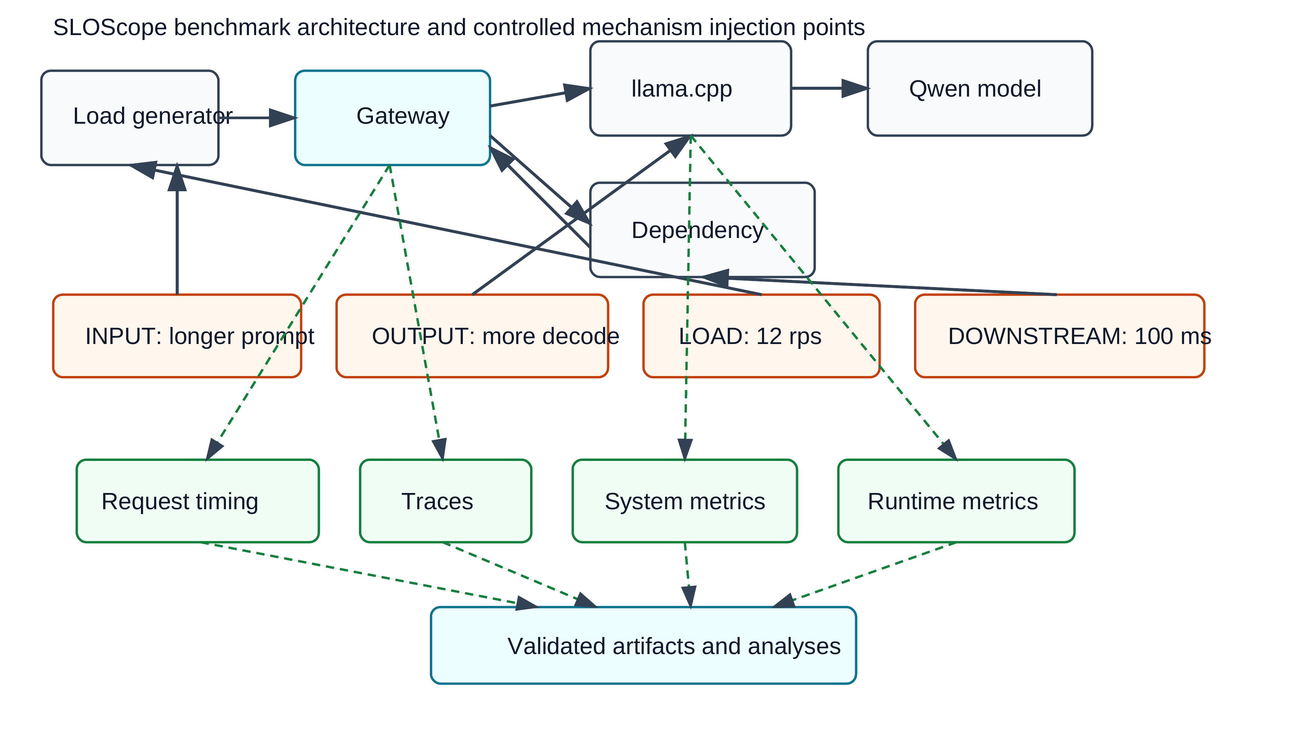
Figure 1. SLOScope architecture. Experimental interventions are separated from telemetry channels and validated artifacts. INPUT and OUTPUT affect model-side work, LOAD affects arrival pressure, and DOWNSTREAM affects a synthetic application dependency.

Mechanism taxonomy
Table 2 defines the four primary mechanisms. The terms INPUT, OUTPUT, LOAD, and DOWNSTREAM refer to interventions, not inferred diagnoses. INPUT uses a medium synthetic prompt with an observed median of 267 prompt tokens. OUTPUT uses a continuation workload requesting 32 output tokens, matched to an OUTPUT_CONTROL that requests 16. LOAD uses 12 requests/s offered load. DOWNSTREAM configures a synthetic dependency delay of 100 ms and verifies the delay through an independent control path.
Table 2. Primary SLOScope mechanisms. "Direct evidence" denotes an observed channel that can verify the intervention more directly than end-to-end latency; formal queue-depth evidence was unavailable for LOAD.
Mechanism | Operational definition | Direct evidence | Primary stage | Compound partners
INPUT | Synthetic medium-input prompt (median 267 observed prompt tokens). | Prompt-token count and prefill-related timing. | Prefill / TTFT | LOAD; DOWNSTREAM
OUTPUT | Continuation workload requesting 32 output tokens; matched control requests 16. | Output-token count and decode timing. | Decode | LOAD; DOWNSTREAM
LOAD | 12 requests/s offered load. | Arrival schedule and scheduler slip; queue-depth metric unavailable. | Queue / contention | INPUT; OUTPUT; DOWNSTREAM
DOWNSTREAM | Synthetic dependency delay configured to 100 ms. | Independently verified dependency duration. | Gateway / dependency | INPUT; OUTPUT; LOAD
Note: TTFT, time to first token. LOAD queue depth was not reconstructed from latency because the formal runtime queue metric was unavailable.
A CPU-contention mechanism was implemented and calibrated but deferred from the primary publication campaign because 20–50% nominal contention did not produce a useful monotonic degradation regime on the Metal configuration. Retaining a weak intervention for combinatorial completeness would have reduced interpretability; we therefore report the calibration decision rather than hiding it.

Telemetry and artifacts
The benchmark collects four conceptually different evidence classes.
- Request timing: scheduled and actual arrival, first token, completion, TTFT, total latency, post-first-token duration, scheduler slip, prompt/output token counts, dependency timing, and outcomes.
- Traces: gateway, dependency, and llama spans linked by request identity.
- System telemetry: host-level CPU measurements used by some RCA feature tiers and the cost study.
- Runtime telemetry: llama.cpp metric scraping. The formal source runs did not contain usable long-form queue-depth fields, so queue depth is explicitly reported as unavailable rather than reconstructed from latency.
Each run includes a manifest with hashes and validation outputs. Formal campaigns additionally generate repetition ledgers, campaign ledgers, integrity reports, and publication-run indices. Pilot runs and superseded campaigns are excluded by construction from publication analyses.

Gateway timing reconciliation
During the first formal campaign attempt, one successful request had a transient race: the streaming client observed completion before the gateway had published its timing snapshot. All trace spans existed, revealing a collection-order race rather than missing execution evidence. The corrected collector marks missing timing IDs during request execution and performs bounded reconciliation only after the measured workload completes, before artifact writing and validation. This preserves scheduling semantics because reconciliation is outside the workload window. The original campaign was superseded, the fix was tested, and the 104-run publication campaign was restarted under a new campaign identity. In the final source campaign, three natural timing races in later phases were resolved by the same mechanism with zero unresolved cases.

Experimental methodology

Runtime, hardware, and models
The source domain uses llama.cpp 0.5.0 (build 11146, commit 7fe450e19) on Darwin arm64/Metal. The server runs with two parallel slots, context size 2048, metrics enabled, and prompt caching disabled. The source model is Qwen2.5-0.5B-Instruct GGUF Q4_K_M and the model-holdout target is Qwen2.5-1.5B-Instruct GGUF Q4_K_M¹⁸. The target campaign holds the runtime, hardware, server flags, measurement stack, and mechanism settings constant; the intended system change is model identity/size.
The choice of commodity hardware is deliberate. The paper does not claim that a Mac/Metal stack represents datacenter GPU serving. Instead, it asks whether compound-degradation methods can be made reproducible without proprietary infrastructure, while later quantifying exactly where external validity is limited.

Calibration and frozen SLOs
Formal source SLO thresholds were set before the publication campaign using 16 dedicated control runs: eight BASELINE and eight OUTPUT_CONTROL. Each calibration run used the final protocol of five warm-ups and 40 measured requests. One-sided future-run prediction limits produced three counted thresholds: TTFT p95 $=0.065129$ s, total-latency p95 $=0.267794$ s, and post-first-token-duration p95 $=0.201624$ s. Throughput remains diagnostic because offered load differs by condition.
Absolute SLO crossings are used cautiously. The target-model campaign does not reuse the source thresholds as universal service objectives. Doing so would confound a model-size change with an SLO violation. For source-domain interaction analyses, matched factorial contrasts are primary whenever a matched control exists.

Formal campaigns
Table 3 summarizes the three formal datasets. The source campaign contains 13 conditions and eight repetitions (104 runs). Each run uses five warm-up requests followed by 40 measured requests and a five-second cooldown. Conditions are randomized within repetition blocks using a frozen seed. The campaign covers BASELINE, OUTPUT_CONTROL, four isolated mechanisms, five primary compounds, and two additional matched output-control cells needed for factorial analysis. INPUT+OUTPUT is intentionally absent because the accepted INPUT and OUTPUT references use different prompt families and were not cleanly matched for a four-cell factorial design.
Table 3. Formal campaign summary. The Phase-7F cost campaign measures telemetry overhead and is not an RCA training/evaluation dataset.
Campaign | Model | Runs | Measured requests | Role
Phase6-V2 | Qwen2.5-0.5B Q4_K_M | 104 | 4160 | Source factorial, SLO, CSD, and RCA dataset.
Phase7D target | Qwen2.5-1.5B Q4_K_M | 66 | 2640 | Zero-shot model-holdout RCA dataset.
Phase7F cost | Qwen2.5-0.5B Q4_K_M | 48 | 1920 | Live telemetry storage/performance measurement only.
Note: RCA, root-cause analysis; SLO, service-level objective; CSD, Compound Signature Divergence. The cost campaign is excluded from RCA training and evaluation.
The target campaign contains 11 RCA-transfer conditions and six repetitions (66 runs); it omits the extra factorial-only output-control cells because the purpose is zero-shot RCA transfer rather than re-estimating CSD. A pilot confirmed that the exact source mechanism settings were operationally viable on Qwen2.5-1.5B before formal execution. The final telemetry-cost campaign contains 48 runs: four telemetry configurations $×$ two workload regimes $×$ six repetitions. Cost runs are never used as RCA training or test observations.
All 104 source publication runs, 66 target publication runs, and 48 cost runs passed their respective integrity audits. The source campaign contains 4160 measured successes; the target contains 2640; the cost campaign contains 1920. No publication campaign contains an invalid primary run or alternate attempt.

Run-level performance metrics
For successful measured requests, the primary timing definitions are
$$\begin{matrix}TTFT & =t_{first token}−t_{arrival}, \\ L_{total} & =t_{completion}−t_{arrival}, \\ L_{decode} & =t_{completion}−t_{first token}.\end{matrix}$$
Run-level analyses use medians and p95 values from the 40 measured requests. Successful requests per second and scheduler slip provide load-sensitive diagnostics. Direct mechanism evidence includes observed prompt/output token counts and dependency duration. Queue depth would have been useful direct evidence for LOAD, but the required llama.cpp runtime rows were absent from the final artifacts; we do not infer them from TTFT.

Factorial interaction analysis
For a compound with factors $A$ and $B$, each repetition contains matched cells $A0B0$, $A1B0$, $A0B1$, and $A1B1$. For metric $Y$, the additive interaction contrast is
$$I_{r}=Y_{A1B1,r}−Y_{A1B0,r}−Y_{A0B1,r}+Y_{A0B0,r}.$$
Positive values mean the compound exceeds the additive prediction for a degradation metric; negative values mean it falls below. For each of five retained factorial families and three counted timing metrics, we report the mean run-level interaction, Student-$t$ interval, one-sample test, effect size, and Holm adjustment over all 15 contrasts.

Compound Signature Divergence
Metric-level contrasts can disagree across dimensions. CSD therefore treats the interaction as a vector. For feature $j$ and repetition $r$,
$$\begin{matrix}Δ_{rj} & =X_{A1B1,rj}−X_{A1B0,rj}−X_{A0B1,rj}+X_{A0B0,rj}, \\ Z_{rj} & =Δ_{rj}/s_{j},\end{matrix}$$
where $s_{j}$ is the pooled within-cell standard deviation for the factorial family. The primary feature set has eight observable performance features: p95 and median TTFT, total latency, and post-first-token duration, plus scheduler-slip p95 and successful requests/s. The compound statistic is
$$CSD=\sqrt{\frac{1}{d}\sum_{j=1}^{d}{{\overset{‾}{Z}}_{j}^{2}}}.$$
Because a norm is always nonnegative, significance is not inferred from repetition-level norms. Instead, the primary test enumerates all $2^{8}=256$ sign flips of repetition-level standardized interaction vectors and applies Holm correction across the five compounds. A 10,000-resample bootstrap reports descriptive uncertainty, and robust-scale plus leave-one-feature-out analyses test sensitivity.

RCA feature tiers and protocols
RCA uses the cause universe {INPUT, OUTPUT, LOAD, DOWNSTREAM}. Predictions are sets, not single labels. Feature tiers are:
- F0: SLO state and normalized violation margins;
- F1: run-level performance features;
- F2: F1 plus host CPU, dependency timing, and validated trace-span summaries;
- F2T: F2 plus temporal features derived from the ordered 40-request sequence (early/late summaries and normalized slopes);
- F3: F2 plus observed prompt/output token counts, treated as evidence-rich sensitivity because those features directly expose INPUT/OUTPUT workload differences.
The primary learned baseline is deterministic one-vs-rest logistic regression with L2 regularization, $C=1$, balanced classes, and threshold 0.5. Source evaluation uses leave-one-repetition-out folds. Under P1, training includes controls and single mechanisms but excludes compounds; the held-out compound observations test compositional generalization. Under P2, training includes source compounds from the seven training repetitions and evaluates the held-out repetition.
Metrics include exact set accuracy, Jaccard, micro/macro F1, complete cause recall, partial cause recall, over-attribution, under-attribution, control false-alarm rate, and pair-specific recovery. H2 compares P1 with P2 using fold-level complete cause recall and an exact sign-flip test.

Interpretable mechanism-evidence ranker
We also evaluate a pre-specified interpretable ranker (MESR, reported as D4-FULL). It groups evidence into general signature ($S$), mechanism anchors ($M$), temporal evidence ($T$), and contradiction evidence ($X$). Feature-level evidence is standardized using source training distributions, correlated fields are aggregated into semantic channels, group scores are normalized against cause-absent training distributions, and each cause receives a thresholded margin. Candidate sets include the empty set, all singletons, and all two-cause combinations; set scoring rewards supported causes and penalizes omitted positive-margin causes.
The method is scientifically useful even though it does not win. A corrected compliance phase was required because an initial implementation combined raw rather than group-normalized evidence. The corrected version is the only authoritative MESR result. The study explicitly forbids further same-dataset redesign after that correction.

Cross-model transfer
Zero-shot transfer trains all preprocessing and model parameters on source controls/singles only. Target rows never participate in imputation, scaling, logistic coefficients, MESR evidence distributions, or thresholds. Target evaluation includes 12 controls, 24 singles, and 30 compound observations. H4 compares D4-FULL with M2/F2 on six target repetition blocks using exact $2^{6}=64$ sign flips. M2/F2T is mandatory secondary reporting because it is the strongest in-domain baseline.
A secondary control-normalization experiment uses only unlabeled target control observations—the baseline control and the output-family control—to align feature location and scale. It is frozen before target outcomes and never replaces the pure zero-shot result.

Degraded telemetry and live telemetry cost
Robustness evaluation is offline and never retrains the diagnosis methods. It applies five independent degradation families to test observations: random feature missingness (10/25/50%), temporal sample reduction (75/50/25% retained), additive Gaussian noise (10/25/50% of source training SD), temporal misalignment (1/3/5 request shifts), and whole-channel removal. Ten deterministic realizations are used for stochastic severities. A quality-screening rule is frozen at at least 90% of clean compound exact recovery with no more than a 0.10 absolute increase in control false alarms.
The final live cost campaign distinguishes real acquisition/storage changes from analysis-only feature removals. Four configurations retain request telemetry and traces: FULL, NO_HOST, NO_RUNTIME, and LIGHT (no host or runtime polling). The primary H5 candidate is NO_HOST because host-channel removal passed the quality screen in both source and target analyses. The live service guard requires the upper bound of the paired 95% CI for relative total-latency-p95 change to be no more than $+5\%$ under both BASELINE and LOAD_MEDIUM.

Results

RQ1: isolated mechanisms and control stability

Isolated effects are strong and mechanism-specific
Table 4 and Figure 2 summarize the primary matched effects. INPUT raises TTFT p95 by 45.6 ms (95% CI 43.8–47.4 ms; Holm-adjusted $p=2.77×{10}^{−10}$). OUTPUT raises post-first-token-duration p95 by 223.9 ms (205.7–242.1 ms; $p=1.45×{10}^{−8}$). LOAD raises TTFT p95 by 1.084 s (1.045–1.123 s; $p=1.94×{10}^{−10}$), and DOWNSTREAM raises total-latency p95 by 104.1 ms (99.4–108.8 ms; $p=5.04×{10}^{−10}$).
Table 4. Primary isolated mechanism effects from repetition-matched controls (n=8 paired run differences per mechanism).
Mechanism | Primary metric | Mean delta (s) | 95% CI (s) | Holm-adjusted p
INPUT | TTFT p95 | 0.0456 | [0.0438, 0.0474] | 2.77×10^-10
OUTPUT | Decode duration p95 | 0.2239 | [0.2057, 0.2421] | 1.45×10^-8
LOAD | TTFT p95 | 1.0841 | [1.0452, 1.1230] | 1.94×10^-10
DOWNSTREAM | Total latency p95 | 0.1041 | [0.0994, 0.1088] | 5.04×10^-10
Note: CI, confidence interval; TTFT, time to first token. Reported p values are Holm-adjusted within the four-mechanism confirmatory family.
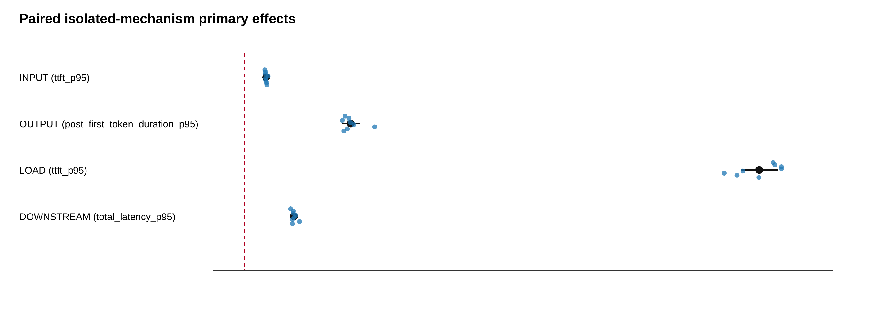
Figure 2. Run-level paired isolated-mechanism effects. Statistical inference is performed over eight repetition blocks, not over individual requests.
These effects align with available direct evidence. INPUT runs observe a median of 267 server prompt tokens. OUTPUT runs observe a median of 32 server output tokens. DOWNSTREAM runs observe a median dependency duration of approximately 103.5 ms. LOAD lacks the desired queue-depth confirmation because the final runtime metric artifacts contain no usable requests_processing/requests_deferred rows. The LOAD result is therefore an observed timing effect under a known experimental load intervention, not a claim about directly measured queue depth.

Output-control drift changes how absolute thresholds should be read
The source BASELINE transported reasonably from dedicated calibration to the formal campaign: mean TTFT p95 shifted by 1.52%, total latency p95 by 6.15%, and decode-duration p95 by 8.53%; none of the eight formal BASELINE runs crossed a counted SLO. OUTPUT_CONTROL behaved differently. Relative to calibration, its formal mean total-latency p95 shifted by 15.64% and decode-duration p95 by 20.44%. Seven of eight formal OUTPUT_CONTROL runs crossed at least one counted threshold (four total-latency crossings and seven decode crossings), despite zero crossings in the eight calibration OUTPUT_CONTROL runs.
This observation is important for construct validity. The frozen SLO thresholds remain unchanged; recalibrating them after observing the campaign would be post hoc. Instead, OUTPUT mechanism claims rely primarily on contemporaneous matched controls. Absolute SLO crossing remains descriptive evidence. More generally, a benchmark can have internally valid interventions while a calibration-derived “healthy envelope” drifts across time or workload family. That control-transportability problem is itself relevant to operational diagnosis.

RQ1 answer.
The four interventions produce reproducible, stage-consistent run-level effects. However, direct evidence quality differs by mechanism, and control drift shows why identifiability should be expressed as a combination of experimental intervention, matched effect, and observable evidence rather than only as threshold crossing.

RQ2: compound interaction and signature non-additivity

Metric-level interactions are selective
Across five factorial families and three timing metrics, 15 pre-defined interaction contrasts are tested. Five have confidence intervals entirely above zero (SUPER_ADDITIVE_EVIDENCE), one is below zero (SUB_ADDITIVE_EVIDENCE), and nine remain uncertain after inspection of their intervals. Holm-supported interactions are concentrated in the two load-containing workload-size compounds:
- INPUT+LOAD: TTFT, total latency, and decode duration;
- OUTPUT+LOAD: TTFT and total latency.
INPUT+DOWNSTREAM has a small negative TTFT interaction, but its Holm-adjusted value does not support a confirmatory interaction claim. OUTPUT+DOWNSTREAM and LOAD+DOWNSTREAM do not show supported interaction on the counted timing metrics.
This pattern already rejects a simple narrative that “compound faults are super-additive.” Some pairs interact strongly; others are approximately explained by isolated components at the resolution of this experiment.

CSD captures multivariate departure from additivity
Table 5 and Figure 3 summarize CSD. INPUT+LOAD has CSD=51.58 with bootstrap interval 50.80–52.46 and Holm-adjusted $p=0.0390625$. OUTPUT+LOAD has CSD=30.81 with interval 29.67–31.88 and the same adjusted $p$. INPUT+DOWNSTREAM (0.71), OUTPUT+DOWNSTREAM (0.79), and LOAD+DOWNSTREAM (0.95) are not supported after multiplicity correction.
Table 5. Compound Signature Divergence (CSD) and source-domain compound-SLO frequency. CSD support uses the frozen exact sign-flip test with Holm adjustment across five compound families.
Compound | CSD | 95% bootstrap interval | Holm p | Compound-SLO runs
INPUT_LOAD | 51.58 | [50.80, 52.46] | 0.0391 | 8/8
INPUT_DOWNSTREAM | 0.71 | [0.39, 1.50] | 0.3047 | 8/8
OUTPUT_LOAD | 30.81 | [29.67, 31.88] | 0.0391 | 8/8
OUTPUT_DOWNSTREAM | 0.79 | [0.60, 1.39] | 0.3047 | 8/8
LOAD_DOWNSTREAM | 0.95 | [0.73, 1.94] | 0.3047 | 8/8
Note: CSD, Compound Signature Divergence; SLO, service-level objective. Compound-SLO runs reports repetitions in which the compound condition violated the frozen source SLO set.
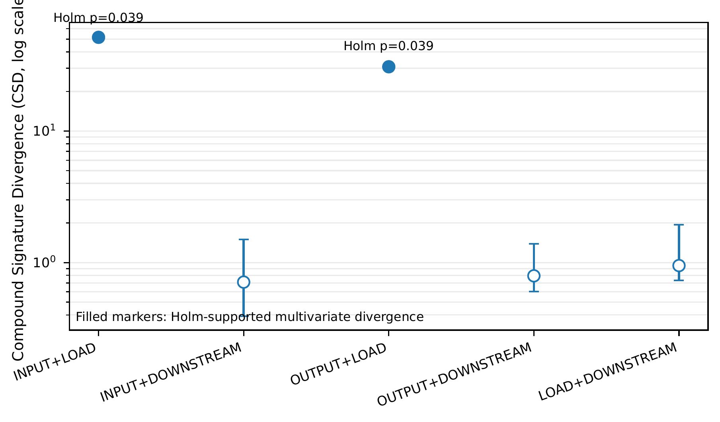
Figure 3. Primary CSD for the five retained compound families. Only INPUT+LOAD and OUTPUT+LOAD pass the frozen exact sign-flip test after Holm correction.
The magnitude is a standardized RMS interaction norm, not an application severity scale. Large values for the load pairs arise because the compound residual is large relative to within-cell variability across several observable dimensions. Robust-scale sensitivity preserves the ordering qualitatively, and leave-one-feature-out analysis does not remove the supported divergence of INPUT+LOAD or OUTPUT+LOAD.

SLO severity and non-additivity are different
All five retained compound conditions have compound-SLO violations in all eight source repetitions, yet only two show supported multivariate CSD. This is one of the central empirical distinctions in the paper. A compound can be severe because two additive degradations are simultaneously present. Conversely, interaction analysis asks whether the joint signature deviates from the matched expectation. Operational severity and mechanism interaction should therefore be reported separately.

H1 and RQ2.
H1 is supported for specific compound pairs, not universally. The evidence is strongest for interactions involving LOAD with INPUT or OUTPUT. RQ2 therefore yields a qualified result: compound mechanisms can be non-additive, but the property depends on the pair and metric rather than following automatically from multiple SLO violations.

RQ3: compound diagnosis

Single-fault training leaves a complete-cause gap
The first RCA question is intentionally compositional: if a method learns only controls and isolated mechanisms, can it recover both causes when two mechanisms are active? Under P1 single-fault training, the primary M2/F2 logistic baseline achieves 57.5% compound exact-set recovery, Jaccard 0.7875, and complete cause recall 0.575. It has zero over-attribution on compound observations but under-attributes 42.5% of them. This error profile is operationally significant: the method is conservative, yet frequently incomplete.
Under P2 mixed training, the same feature/model family reaches 97.5% compound exact recovery, 1.0 complete cause recall, and 0.9917 compound Jaccard. The fold-level P2–P1 complete-recall differences are 0.6 for one repetition and 0.4 for each of the remaining seven, for a mean improvement of 0.425 (95% CI 0.3659–0.4841). The exact sign-flip value is $p=0.0078125$. H2 is therefore supported within this experimental scope. Figure 4 visualizes the repetition-level gap between single-fault and mixed-training compound diagnosis.
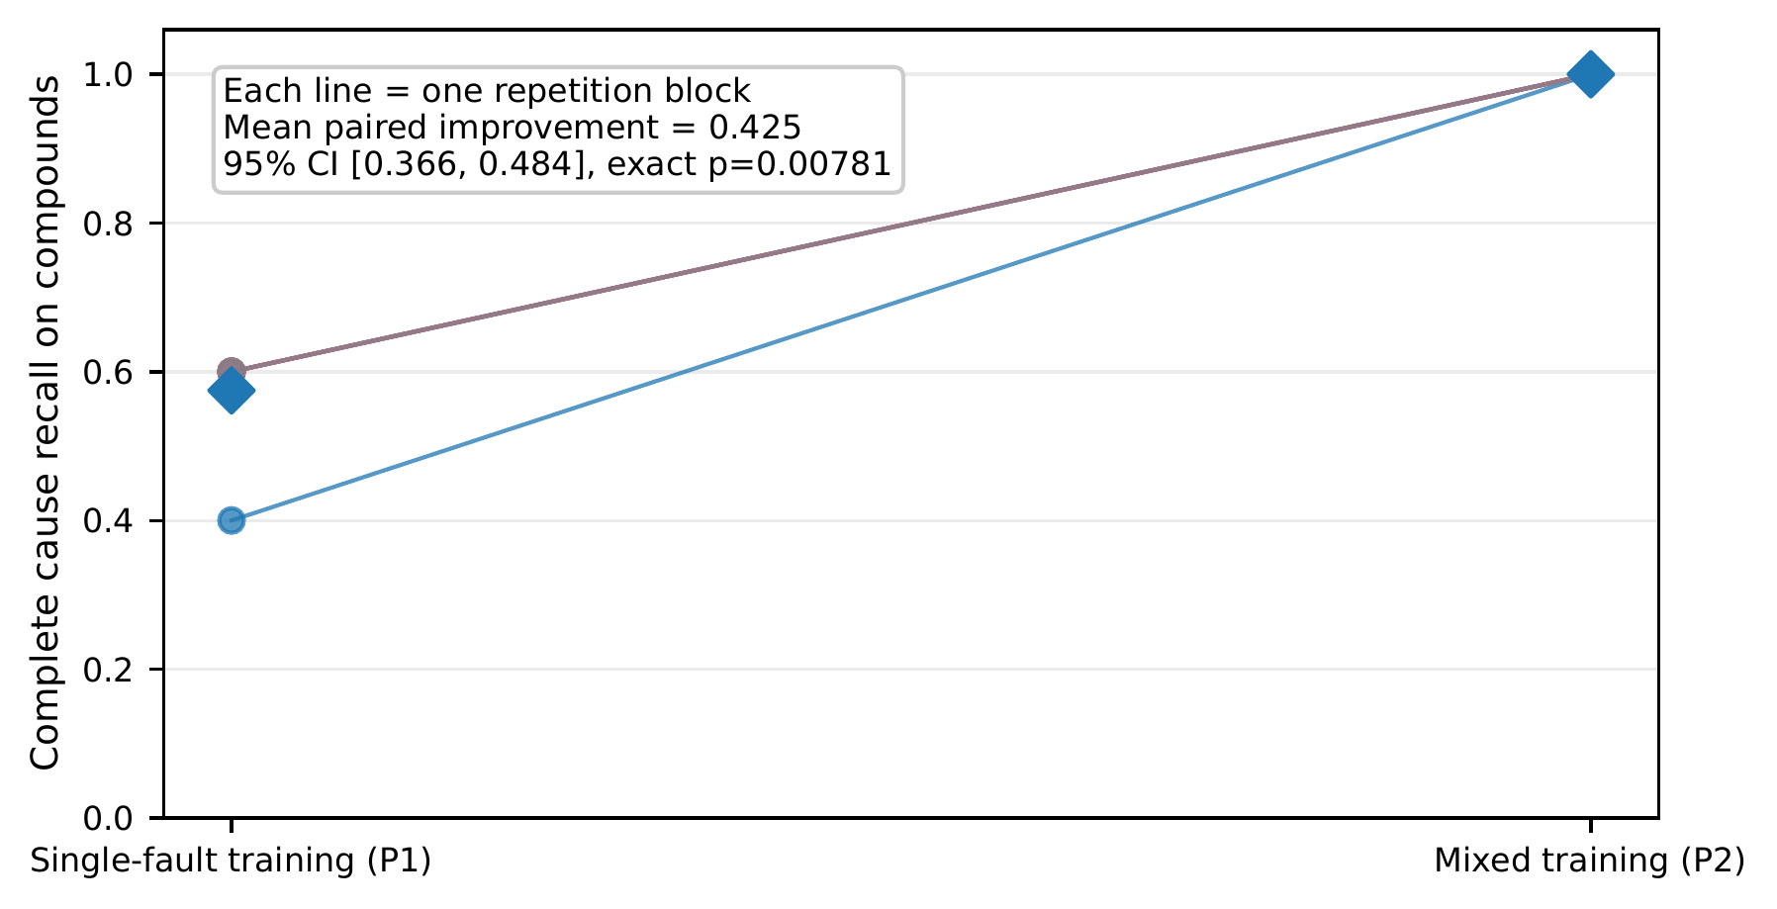
Figure 4. Single-fault versus mixed-training compound diagnosis. The primary inferential comparison is fold-level complete cause recall; compound runs are not treated as independent inferential replicates.

The gap is highly pair-specific
Aggregate accuracy hides a structured failure. Under P1 M2/F2, both INPUT-containing pairs have 0/8 exact recovery. OUTPUT–LOAD has 7/8 exact recovery; OUTPUT–DOWNSTREAM and LOAD–DOWNSTREAM each have 8/8. Top-1 cause coverage is still 1.0 across compound pairs, meaning the method usually sees a true cause; it often misses the second one. The dominant error taxonomy contains 16 MISS_INPUT + SINGLE_ONLY_PREDICTION cases and one analogous MISS_OUTPUT case.
This result sharpens the meaning of the single-to-compound gap. It is not random confusion across all four labels. Rather, strong LOAD or DOWNSTREAM evidence can dominate the compound signature while INPUT disappears from the predicted set. The same phenomenon later persists across the model holdout.

Temporal features help in-domain
Adding temporal evolution features changes the in-domain result substantially. M2/F2T reaches 82.5% source compound exact recovery compared with 57.5% for M2/F2. These features summarize how request timing evolves across the 40-request run (early/late medians and normalized slopes), allowing the classifier to exploit patterns that a static run summary cannot represent.
This positive result is deliberately not interpreted as a universally better model. The cross-model experiment in the next section shows that the same temporal representation is highly configuration-sensitive.

Interpretable evidence ranking does not close the gap
The corrected D4-FULL method reaches 60.0% source compound exact recovery, complete cause recall 0.600, and Jaccard 0.7542. It recovers OUTPUT+LOAD, OUTPUT+DOWNSTREAM, and LOAD+DOWNSTREAM perfectly, but still has 0/8 exact recovery for INPUT+LOAD and INPUT+DOWNSTREAM. INPUT recall on compound observations remains zero.
The pre-specified H3 comparison asks whether adding temporal and contradiction evidence to signature+mechanism evidence improves exact cause-set recovery. Corrected D4-SM and D4-FULL both achieve 60.0%; the fold-level difference is zero and the exact test does not support H3. An evidence-rich F3 sensitivity variant reaches 80.0%, consistent with the intuition that directly observed prompt/output-token evidence is highly diagnostic, but F3 is not treated as the primary fair method because those fields reveal workload mechanisms much more directly than the other feature tiers.
The negative MESR result matters methodologically. After correcting a specification-compliance bug, we stopped redesigning the method on the same 104-run dataset. This avoids turning the benchmark into a tuning set for a hand-crafted algorithm.

RQ3 diagnosis answer.
Compound cause-set recovery is substantially harder than single-fault localization, and the difficulty is pair-specific. Mixed training largely solves the observed source-domain combinations, but single-fault-trained methods frequently miss a concurrent INPUT mechanism. Temporal summaries can help strongly in-domain; an interpretable evidence ranker is competitive with the static baseline but does not solve the compositional problem.

RQ3: cross-model generalization

Zero-shot model-holdout design
The target experiment changes Qwen2.5-0.5B to Qwen2.5-1.5B while preserving llama.cpp version/build, server flags, hardware, mechanism definitions, request counts, and instrumentation. All RCA preprocessing and learned parameters are fit on source controls/singles only. The target pilot is excluded from training. No target fault label is used for scaling, imputation, thresholding, or method selection.
This design does not test cross-runtime or cross-hardware transfer. It isolates one practically meaningful axis: whether diagnostic relationships survive a three-fold change in model parameter scale within the same model family and serving stack.

The strongest in-domain model is the least portable
Table 6 and Figure 5 summarize the authoritative scikit-learn reproduction. M2/F2 moves from 57.5% source compound exact recovery to 60.0% target. D4-FULL remains 60.0% in both domains. In contrast, M2/F2T falls from 82.5% to 20.0%, retaining only 24.2% of its source exact accuracy. D4-FULL-F3 falls from 80.0% to 60.0%.
Table 6. Source and zero-shot target compound diagnosis. Target CFA is the false-alarm rate on 12 target control runs. Retention is target/source compound exact recovery.
Method | Source exact | Target exact | Target CFA | Retention
M2/F2 | 0.575 | 0.600 | 0.917 | 1.043
M2/F2T | 0.825 | 0.200 | 0.667 | 0.242
D4-FULL | 0.600 | 0.600 | 0.583 | 1.000
D4-FULL-F3 | 0.800 | 0.600 | 0.500 | 0.750
Note: CFA, control false-alarm rate. D4-FULL-F3 is an evidence-rich sensitivity condition rather than the primary fair comparison.
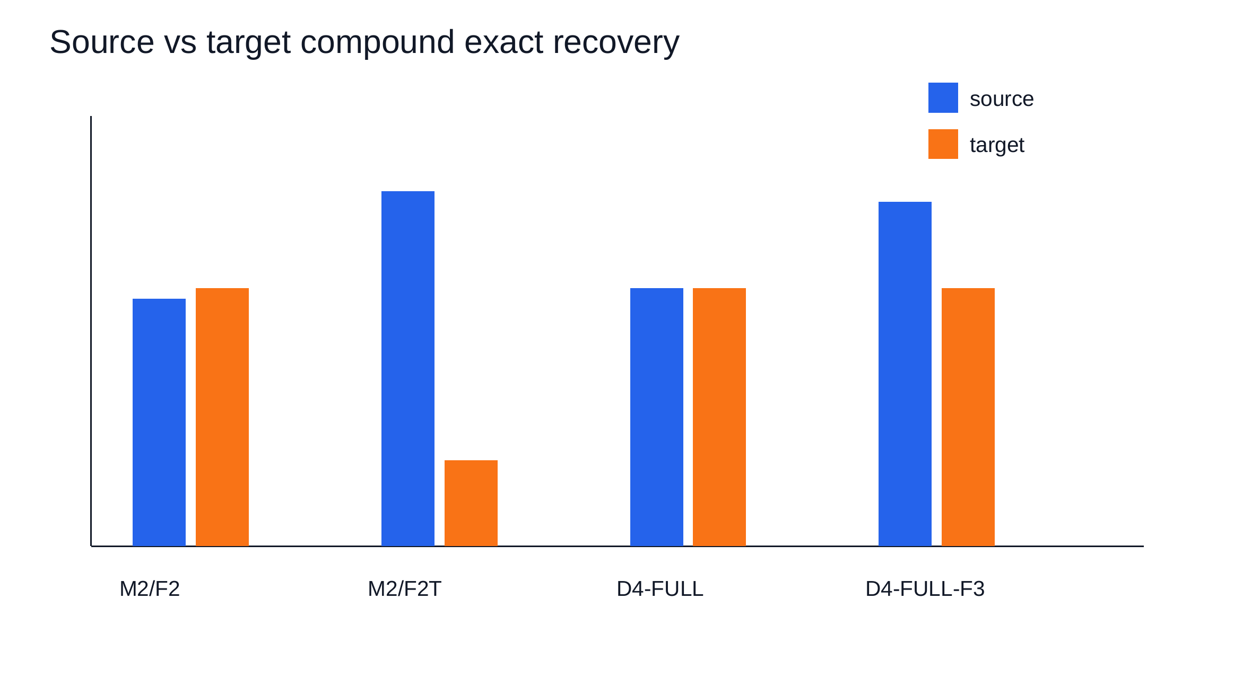
Figure 5. Source-domain and zero-shot target compound exact recovery. The temporal baseline (M2/F2T) is strongest in-domain but experiences the largest transfer degradation.
The primary H4 comparison is D4-FULL versus M2/F2. Their target compound exact accuracy is identical in every one of the six repetition blocks, giving six differences of zero and exact $p=1.0$. H4 is not supported. A secondary comparison shows D4-FULL exceeding M2/F2T by 0.4 in every target repetition (exact $p=0.03125$), but this does not rescue H4 because the hypothesis was defined against M2/F2, not against a post hoc weaker target baseline.

Feature shift is large in the temporal/performance representation
Several F2T features move by multiple source standard deviations: total-latency early median by approximately 3.96 SD, TTFT early median by 3.72, prefill-proxy early median by 3.53, total-latency median by 3.27, and total-latency p95 by 3.20. Figure 6 visualizes the largest shifts.
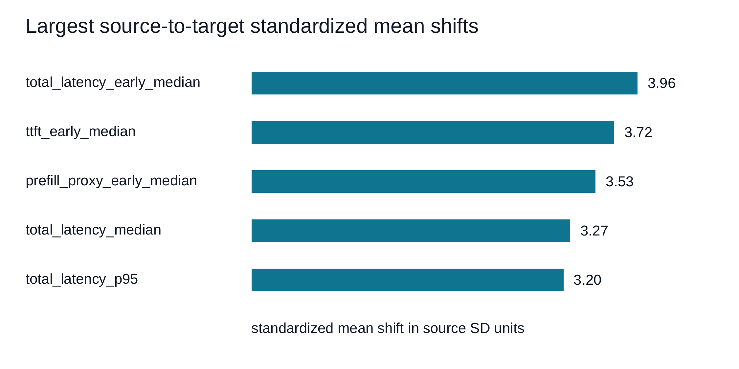
Figure 6. Largest source-to-target standardized mean shifts among common diagnostic features. These distribution changes are consistent with, but do not causally prove, the temporal baseline's transfer failure.
It is tempting to conclude that these shifts cause the classifier failure, but the experiment does not identify a causal chain from feature shift to decision error. The defensible interpretation is narrower: the strongest in-domain method relies on a representation whose distribution changes substantially under the model holdout, and its zero-shot performance degrades at the same time.

Control false alarms reveal a second transfer problem
Compound accuracy alone paints an incomplete picture. On the 12 target controls, M2/F2 raises false alarms on 11, M2/F2T on 8, D4-FULL on 7, and D4-FULL-F3 on 6. Thus, methods that preserve 60% compound exact recovery are not necessarily calibrated for a changed healthy distribution. A pre-frozen control-normalization attempt does not solve the problem: target compound exact recovery falls to 20.0% for M2/F2 and 23.3% for M2/F2T.
Pair-specific results also preserve the source-domain INPUT problem. M2/F2 and D4-FULL both recover 0/6 INPUT+LOAD and 0/6 INPUT+DOWNSTREAM target runs. M2/F2T obtains INPUT recall 1.0 but still 0/6 exact recovery on both INPUT compounds because it adds extra causes. This distinction again motivates set metrics rather than per-label recall alone.

H4 and generalization answer.
H4 is not supported. Mechanism-oriented D4-FULL is more stable than M2/F2T but does not outperform the primary statistical M2/F2 baseline. Generalization is therefore mixed: some diagnostic structure transfers, temporal features can be highly model-sensitive, and target control calibration remains a major limitation.

RQ4: robustness to degraded observability

Robustness protocol
The robustness study perturbs test telemetry only; it never retrains a degradation-aware model. Random feature missingness uses 10 deterministic realizations per severity. Temporal sampling reconstructs F2T features from reduced ordered request sequences. Noise magnitude is defined relative to source training SD even on the target domain, preserving the zero-shot contract. Delay shifts temporal streams without wraparound. Whole-channel loss removes pre-defined evidence groups rather than searching arbitrary subsets.
This design measures resilience of already-trained diagnosis pipelines. It does not answer whether robustness-aware training could recover the lost performance.

Fifty-percent missingness separates clean accuracy from robustness
Table 7 reports the 50% missingness snapshot and Figure 7 shows the broader curve. On the source domain, M2/F2 falls from 0.575 clean exact recovery to 0.283, M2/F2T from 0.825 to 0.453, and D4-FULL from 0.600 to 0.535. On the target, the corresponding values are 0.217, 0.207, and 0.513.
Table 7. Compound diagnosis at 50% random feature missingness. Retention is relative to each method/domain clean exact recovery.
Domain | Method | Compound exact | Retention | Control false alarm
Source | M2/F2 | 0.283 | 0.491 | 0.644
Source | M2/F2T | 0.453 | 0.548 | 0.394
Source | D4-FULL | 0.535 | 0.892 | 0.638
Target | M2/F2 | 0.217 | 0.361 | 0.683
Target | M2/F2T | 0.207 | 1.033 | 0.758
Target | D4-FULL | 0.513 | 0.856 | 0.633
Note: Retention is degraded compound exact recovery divided by the corresponding clean exact recovery. Values above 1 can occur when a degradation realization reduces false positives or changes a decision boundary favorably by chance.
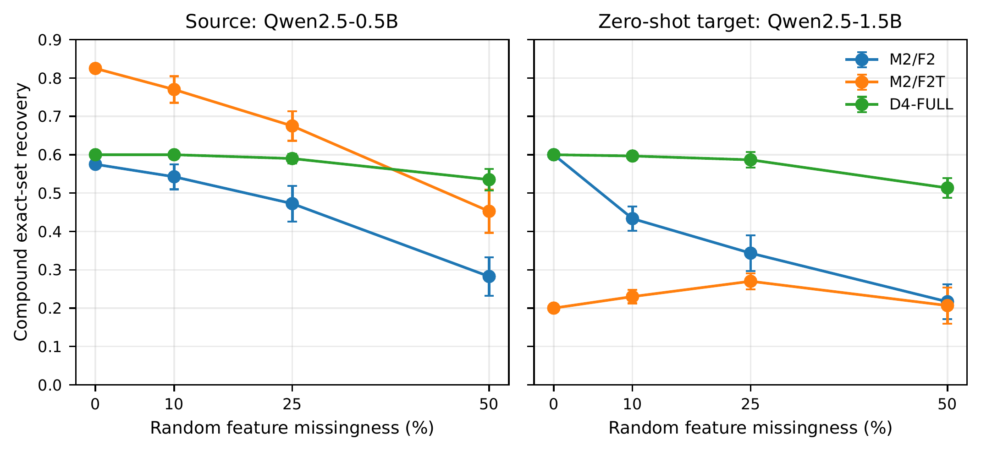
Figure 7. Compound exact recovery under random feature missingness. Degradation simulations perturb test telemetry without retraining.
The main insight is not that D4-FULL has the highest clean accuracy; it does not. Instead, its robustness profile is comparatively stable across the model shift. For M2/F2T, target-minus-source robustness-AUC differences are -0.421 under missingness, -0.699 under noise, -0.419 under temporal sampling, and -0.317 under delay. For D4-FULL, the corresponding differences are approximately -0.008, -0.041, -0.013, and 0.000. These AUC contrasts are descriptive and are not used as a new superiority test.

Whole-channel loss exposes semantic dependencies
Whole-channel ablations show that the consequences of missing observability depend on the method. Dependency and trace removal can strongly affect methods that use explicit downstream evidence. The interpretable ranker is especially sensitive to loss of mechanism-anchor evidence, which is consistent with its design. Conversely, host CPU and some derived feature channels can often be removed while passing the pre-frozen quality screen.
The INPUT failure requires special care. Clean M2/F2 and D4-FULL already have zero exact recovery on INPUT+LOAD and INPUT+DOWNSTREAM in both domains. A degraded-telemetry simulation should not be credited with “causing” those failures. We therefore report incremental recall loss relative to the clean method/domain baseline and label persistent INPUT errors as pre-existing.

Quality screening for the cost phase
The H5 quality component uses a conservative screen: at least 90% of clean compound exact recovery and no more than a 0.10 absolute increase in control false-alarm rate. Multiple pre-defined channel removals pass this screen. In particular, removing host CPU telemetry (C1) passes for M2/F2 in both source and target domains. This configuration becomes the pre-specified primary candidate for live cost measurement.

RQ4 answer.
Robustness is method- and domain-dependent. High clean accuracy does not imply robustness, and the temporal baseline’s model sensitivity persists under several telemetry degradations. The interpretable method is less accurate in the clean source domain but comparatively stable across the model shift and high missingness. These are separate system properties and should not be collapsed into one “best method” label.

RQ5: telemetry quality/cost frontier

Why live cost measurement is necessary
Several Phase-7E ablations remove derived features rather than a collection channel. Dropping median latency, p95 latency, throughput summaries, or temporal evolution does not eliminate the request timing needed to compute them. Treating such ablations as instrumentation savings would overstate the cost result. The final cost campaign therefore manipulates only actual telemetry collection toggles supported by the measurement stack while retaining request telemetry and traces in every primary configuration.
The four configurations are FULL, NO_HOST, NO_RUNTIME, and LIGHT (host and runtime polling both disabled). The live campaign uses the source 0.5B model under BASELINE and LOAD_MEDIUM, six matched repetitions per workload, five warm-ups, and 40 measured requests. The primary cost measure is optional telemetry bytes per measured request on disk.

Storage savings are direct and repeatable
Table 8 and Figure 8 show the frontier. FULL consumes 603.04 optional telemetry bytes/request on average, NO_HOST 508.26, NO_RUNTIME 545.16, and LIGHT 448.32. Relative to FULL, the aggregate reductions are 15.7%, 9.6%, and 25.7%, respectively.
Table 8. Frozen telemetry quality/storage frontier. Quality values are mapped from the authoritative Phase-7E analysis; storage is measured live in Phase 7F.
Config | Source exact | Target exact | Optional B/req | Reduction | Pareto dominated
T0_FULL | 0.575 | 0.600 | 603.04 | 0.0% | yes
T1_NO_HOST | 0.600 | 0.600 | 508.26 | 15.7% | yes
T2_NO_RUNTIME | 0.575 | 0.600 | 545.16 | 9.6% | yes
T3_LIGHT | 0.600 | 0.600 | 448.32 | 25.7% | no
Note: Optional B/req is optional telemetry bytes per measured request. Quality values are mapped from Phase 7E; Phase 7F cost runs are not RCA observations.
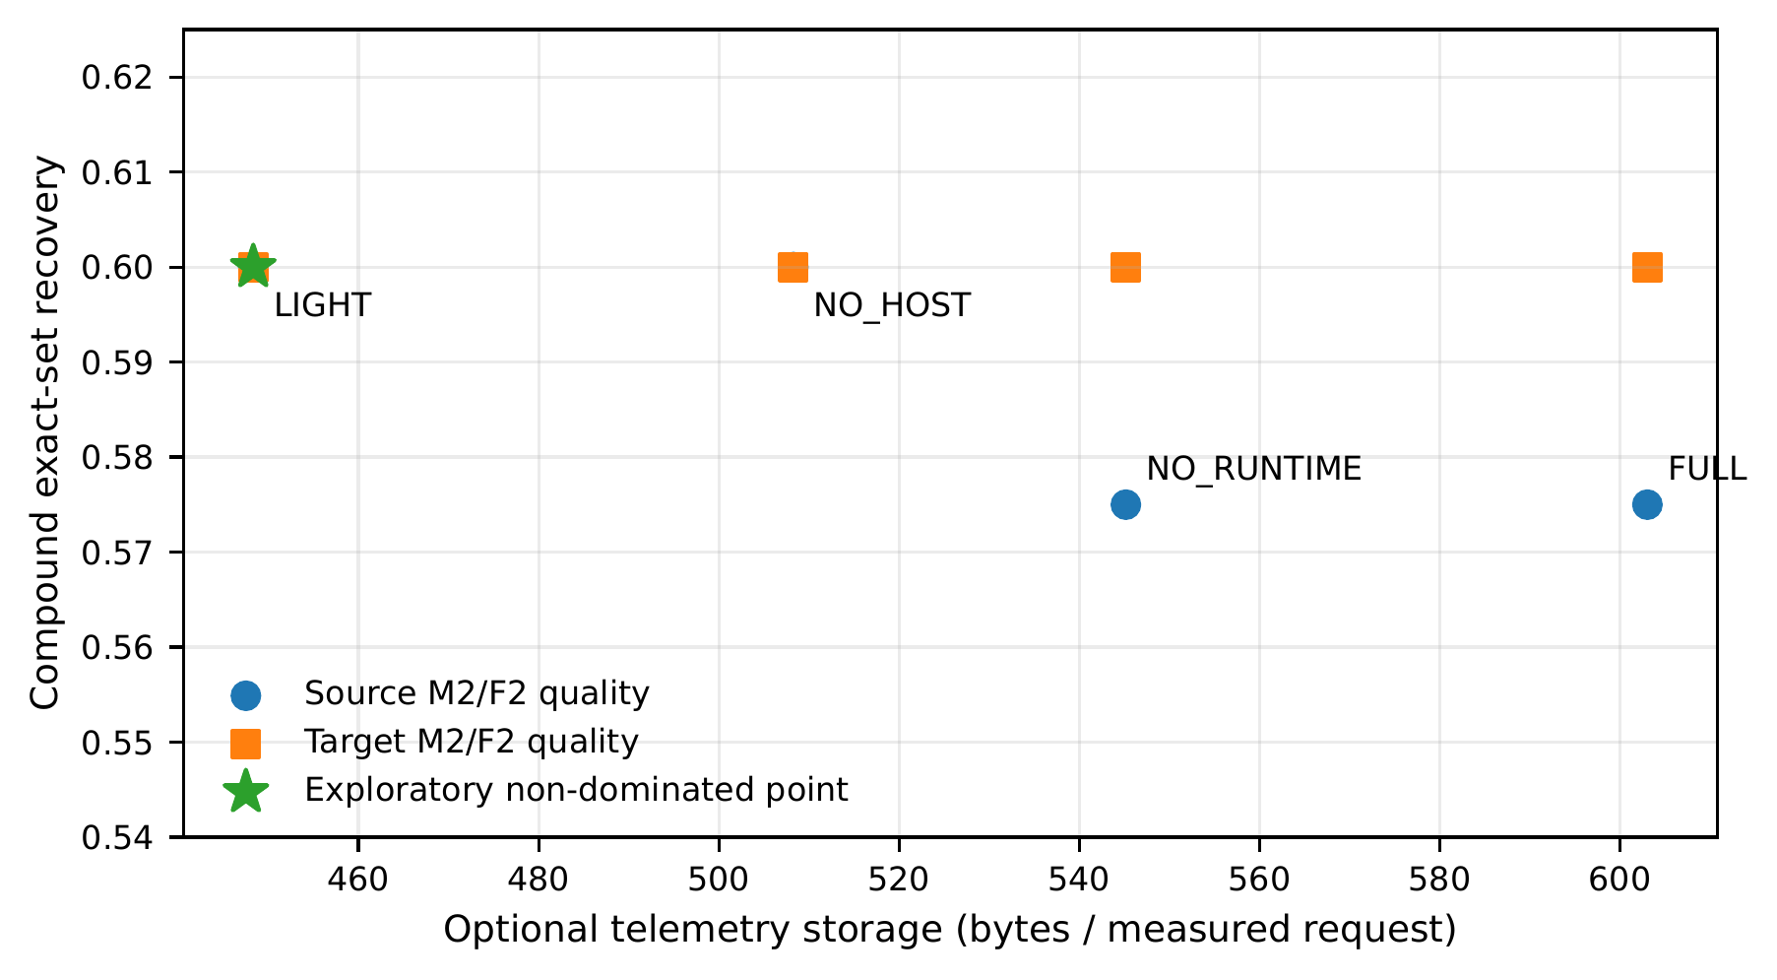
Figure 8. Quality/storage frontier for the frozen telemetry configurations. T3_LIGHT is the only non-dominated point under the exploratory Pareto definition, but H5 remains tied to the pre-specified NO_HOST comparison.
The primary H5 comparison uses NO_HOST. In matched blocks, storage reduction is positive in all 12 comparisons. Under BASELINE, the mean reduction is 17.26% (median 17.07%, range 17.00–17.80%) and saves 108.08 bytes/request on average. Under LOAD_MEDIUM, the mean reduction is 14.05% (median 14.00%, range 13.87–14.27%) and saves 81.48 bytes/request.

Diagnosis quality is preserved under the frozen screen
For source M2/F2, compound exact recovery is 0.575 with FULL and 0.600 under the corresponding NO_HOST quality ablation; source control false alarms move from 0.6875 to 0.625. On the target, exact recovery is 0.600 for both and control false alarms move from 0.9167 to 0.5833. These values satisfy the pre-frozen quality screen.
The correct interpretation is quality preservation, not “removing host telemetry improves RCA.” The observed differences are small-sample outcomes and no hypothesis tests claim a diagnostic benefit from removing data.

The service non-regression guard is not established
H5 also requires live evidence that the primary reduction does not exceed the pre-specified $+5\%$ latency guard. For NO_HOST versus FULL, BASELINE total-latency-p95 relative change has mean -2.52% with 95% CI [-10.83%, +5.79%]. LOAD_MEDIUM has mean -0.45% with CI [-8.02%, +7.13%]. Both upper bounds exceed +5%; criterion D therefore fails.
This is a statistical non-conclusion about non-regression, not evidence that NO_HOST slows the service. The point estimates are slightly negative, but the experiment does not make the interval narrow enough to satisfy the frozen guard. H5 is consequently not supported.
An offline target projection estimates that host telemetry accounts for 804,979 bytes across the 66 target runs, or 304.92 bytes/request and 40.90% of optional target telemetry storage. This is storage accounting only; no target live cost experiment was run. Trace files contribute roughly 289–290 bytes/request in the source/target formal campaigns, but because tracing instrumentation was not disabled in the live cost study, file size is not presented as the total runtime cost of tracing.

RQ5 answer.
Telemetry reduction can preserve the tested RCA quality while materially reducing storage. However, the final pre-specified claim requires both quality/cost evidence and a live service non-regression result. The latter is not established, so H5 remains negative. The quality/storage frontier is useful even without a positive H5 verdict.

Discussion

Compound SLO severity is not compound interaction
The most important conceptual separation in the study is between severity and interaction. Every retained compound repeatedly crosses multiple source SLOs, but only INPUT+LOAD and OUTPUT+LOAD show supported multivariate non-additivity. Operational dashboards that count violated SLOs can therefore identify severe incidents without revealing whether the underlying mechanisms interact. For benchmarking, matched factorial cells are needed to make that distinction.

Single-fault competence does not imply compositional competence
A classifier can achieve high per-cause or top-1 behavior and still fail the operator’s actual task: identify all concurrently active causes. The source P1 baseline usually ranks at least one true cause first, but complete recovery collapses specifically on INPUT-containing compounds. This suggests that future LLM-serving RCA evaluations should report exact sets, complete cause recall, and pair-level confusion rather than only single-root metrics.

Temporal evidence is powerful and fragile
Temporal features produce the strongest source-domain single-fault-trained result (82.5%), yet the exact same source-trained model falls to 20.0% on the larger target model. The result is more informative than either number alone. It shows a tension between exploiting a detailed configuration-specific signature and learning a representation that survives a system change. The large temporal feature shifts are consistent with this tension. Future work should treat temporal invariance, not only temporal richness, as a design objective.

Interpretability, accuracy, transfer, and robustness are different axes
The corrected MESR ranker is not the best source-domain method. Nevertheless, its source-to-target exact recovery is stable (0.600 to 0.600) and its robustness AUC changes little under several telemetry degradations. The statistical F2 baseline also transfers in absolute compound accuracy, while F2T does not. These outcomes caution against reporting one scalar leaderboard as if it summarized operational diagnostic quality. A practical evaluator should separately measure clean accuracy, false alarms, transfer, degradation robustness, evidence interpretability, and telemetry cost.

Control behavior deserves first-class status
Two control phenomena materially affect interpretation. First, OUTPUT_CONTROL drifts between calibration and the formal source campaign, making matched controls essential for OUTPUT-related effects. Second, target controls trigger high false-alarm rates for all zero-shot RCA methods. A model can therefore preserve compound exact accuracy while becoming operationally noisy after configuration change. Future domain adaptation should be evaluated against both fault recovery and healthy-control calibration.

Negative hypotheses improve the result boundary
H3, H4, and H5 fail under their frozen definitions. These failures narrow, rather than weaken, the paper’s empirical message. H3 shows that a plausible semantic combination rule is insufficient to recover hidden INPUT evidence. H4 shows that mechanism-oriented stability does not automatically imply superiority over a simpler statistical representation. H5 shows that offline quality preservation plus storage savings is insufficient to assert operational non-regression. In each case, preserving the negative outcome prevents the benchmark from becoming a post hoc optimization exercise.

Implications for software-engineering research
The results suggest several methodological implications for empirical studies of AI-enabled software systems. First, benchmark design should model composition explicitly. Reporting accuracy over isolated faults is insufficient when deployed incidents may contain multiple concurrent causes; the label space, metrics, and test protocol should allow complete cause sets. Second, benchmark controls need a transportability check. The OUTPUT_CONTROL drift in this study shows that a pre-campaign healthy envelope can remain procedurally valid while becoming a weak absolute reference later. Matched controls and explicit false-alarm reporting therefore belong in the experimental design rather than being treated as cleanup analyses.
Third, representation quality should be evaluated across configuration changes, not only within cross-validation folds. F2T is the strongest source-domain single-fault-trained model yet the weakest primary zero-shot model after the model-size change. This is a concrete example of why a feature representation can be predictive without being portable. For software-engineering research on AI systems, configuration holdouts should complement random or repetition-based splits whenever the intended tool is expected to survive model, runtime, or deployment evolution.
Fourth, observability studies should distinguish three different objects: diagnostic information, data volume, and runtime overhead. Phase 7E shows that a feature or channel can be removed without materially changing diagnostic quality. Phase 7F then shows that this does not automatically establish service non-regression. Offline ablation and live instrumentation cost answer different research questions and should be evaluated separately. Recent adaptive tracing work similarly emphasizes the joint need to preserve diagnostic value while reducing trace volume and operational overhead¹⁹.

Implications for practitioners
For practitioners, the results support five conservative guidelines.
- Test concurrent causes explicitly. Do not extrapolate multi-cause incident behavior from isolated-fault accuracy. A model that localizes one visible cause can still miss a concurrent mechanism.
- Keep healthy controls close to the deployment context. Preserve matched control observations near the time and workload family of interest, especially when calibration-derived SLO envelopes can drift.
- Validate temporal features after configuration changes. Temporal summaries can be highly informative in-domain but should be revalidated after model/runtime changes before automated RCA decisions depend on them.
- Track false alarms as a transfer metric. Target compound accuracy alone can look stable while healthy-control behavior degrades sharply. Operational deployment requires both fault recovery and control calibration.
- Measure telemetry cost at the collection boundary. Distinguish a downstream feature ablation from a real telemetry reduction. Measure what is actually disabled, the bytes or polling operations removed, and whether service behavior stays within a pre-defined operational guard.
These guidelines intentionally avoid prescribing one universal RCA model. The study instead indicates which evidence contracts should accompany an automated diagnostic system: complete cause-set evaluation, matched controls, configuration-holdout testing, degraded-observability testing, and measured collection cost.

Threats to validity

Construct validity
The four interventions are controlled abstractions of production degradation, not a complete incident taxonomy. INPUT and OUTPUT are workload mechanisms; LOAD is offered arrival pressure; DOWNSTREAM is synthetic service latency. Real incidents may arise from kernel regressions, memory pressure, network congestion, distributed collectives, storage, failures, retries, cache behavior, or combinations not represented here. CPU contention was calibrated but excluded from the primary campaign because it failed to produce a useful monotonic regime on this Metal setup.
The LOAD intervention is experimentally known but lacks direct queue-depth telemetry in the formal artifacts. We therefore avoid claims that specifically require observed queue length. Scheduler slip and latency are effects, not substitutes for a missing queue gauge.
CSD is a study-defined multivariate interaction statistic. Its interpretation depends on the frozen performance feature set and within-cell scaling. Sensitivity checks with robust scaling and leave-one-feature-out analysis reduce, but do not eliminate, this construct dependence. CSD should be interpreted as standardized departure from additive signature composition, not as a universal incident-severity score.
Source SLO thresholds are calibrated from dedicated pre-campaign controls. The formal output-family control drift shows that a frozen healthy envelope can become less transportable even without an invalid run. The paper therefore prioritizes matched effect analysis over post hoc threshold adjustment and does not apply source SLOs as target-model objectives.

Internal validity
Experiments run on a single physical commodity host. Background activity, thermal state, operating-system scheduling, and Metal runtime behavior can affect latency. We mitigate these risks through deterministic run protocols, block randomization, repeated runs, warm-ups, cooldowns, stable runtime/model provenance, and full campaign validation, but cannot eliminate host-level variability.
Instrumentation is part of the measured system. The gateway, trace collection, metrics polling, and artifact finalization may influence behavior. The final cost campaign directly measures some telemetry configurations but does not disable trace instrumentation, so it cannot quantify the full runtime overhead of tracing. Its trace analysis is storage context only.
One gateway timing race was discovered during an earlier formal attempt. The affected campaign was superseded, the root cause was identified, the collector was corrected, regression tests were added, and the publication campaign was restarted with new provenance. Post-workload reconciliation later resolved a small number of naturally occurring timing publication races without altering the measured workload window.

External validity
The source environment is llama.cpp 0.5.0 on Darwin arm64/Metal with Qwen2.5 0.5B and 1.5B Q4_K_M models. Results should not be generalized directly to CUDA datacenter GPUs, vLLM/SGLang runtimes, distributed tensor/pipeline parallelism, mixture-of-experts models, much larger models, or proprietary production stacks. The target experiment improves model-size validity within one family but is not a cross-runtime or cross-hardware study.
Only five pairwise compounds are retained. INPUT+OUTPUT is excluded because the accepted INPUT and OUTPUT references do not form a clean matched prompt-family factorial. Three- and four-way combinations are outside the study. The workload is synthetic and reproducible rather than production-trace-derived.

Statistical conclusion validity
The source campaign has eight repetitions per condition; target and cost campaigns have six. Exact sign-flip tests therefore have coarse minimum attainable two-sided values (0.0078125 for eight folds and 0.03125 for six). Confidence intervals can remain wide, as illustrated by the failed H5 service guard despite benign point estimates. We pre-specify comparison families and use Holm correction where multiple confirmatory contrasts are tested, but the study still contains many descriptive analyses that should not be read as additional hypothesis tests.
Random telemetry-degradation simulations use 10 realization seeds per severity. Those realizations quantify simulation sensitivity, not new system-run replication. Their intervals should not be conflated with repeated physical executions.

RCA validity
The dataset is small by machine-learning standards (104 source runs) because the inferential unit is the run, not each request. Flexible nonlinear models and broad hyperparameter search are intentionally excluded to limit overfitting. The F3 tier contains direct prompt/output-token evidence and is therefore reported only as an evidence-rich sensitivity/upper bound. Mixed P2 training approaches ceiling performance partly because the same compound families appear in training repetitions; the scientifically harder result is P1 single-to-compound generalization.
High target control false-alarm rates show that zero-shot transfer is not operationally calibrated even when compound exact accuracy is retained. The study’s control-normalization experiment is deliberately simple and unsuccessful; stronger domain-adaptation methods are future work, not hidden tuning.

Related Work

Large language model serving performance and service-level objectives
Practice-oriented evidence shows that inference serving, monitoring, latency, deployment architecture, and quality assurance are recurring engineering concerns in real-world machine-learning systems¹³. At the systems level, large language model serving has extensively studied throughput, memory efficiency, latency constraints, and phase-aware scheduling. vLLM introduces PagedAttention to improve KV-cache utilization and batching efficiency¹. DistServe separates prefill and decode placement to optimize goodput under TTFT and token-latency constraints². Sarathi-Serve uses chunked prefill and stall-free scheduling to manage the throughput–latency tradeoff³. These systems motivate SLOScope’s separation of prefill/TTFT and decode behavior, but their primary objective is serving efficiency rather than controlled multi-cause diagnosis.
LatencyPrism targets non-intrusive latency decomposition and SLO-oriented anomaly analysis across heterogeneous inference environments⁴. StriaTrace is a production-oriented tracing and diagnosis system for online LLM inference, reducing tracing overhead while localizing a broad set of observed abnormalities⁵. TELLER reconstructs cross-layer request context from traces and logs and performs operator-level inference RCA⁶. These systems are closer to SLOScope’s observability motivation, but address different questions: SLOScope focuses on matched compound interventions, additive versus non-additive signatures, complete cause-set recovery, model-holdout transfer, degraded telemetry, and a controlled quality/cost frontier.

RCA benchmarks and microservice diagnosis
Microservice RCA provides a rich methodological foundation. SPE has recently examined explainable cascading-failure diagnosis from logs in microservice systems²⁰, illustrating the practical value of identifying not only a visible symptom but also the failure path that produced it. MicroRCA correlates performance anomalies with resource utilization over an attributed service graph⁷. Nezha integrates metrics, logs, and traces into event-graph patterns for interpretable fine-grained localization⁸. BARO combines online change-point detection with robust statistical RCA⁹. TORAI studies multi-source RCA when service-call graphs contain blind spots¹¹. RCAEval contributes datasets, failure cases, multi-source telemetry, and reproducible baselines for more standardized comparison¹⁰.
The closest bridge to LLM workloads is Beyond Microservices, which evaluates a broad set of existing RCA methods on GPU-driven LLM inference failures and finds that traditional RCA behavior does not transfer uniformly to the LLM setting¹². SLOScope is complementary rather than a replacement benchmark: it uses fewer primary mechanism families but adds pairwise compound ground truth, matched factorial interaction analysis, multi-label cause-set metrics, explicit single-to-compound training protocols, model-size holdout, telemetry degradation, and live storage-cost measurement.

Observability cost and software-performance experimentation
The observability-cost question is also connected to practice-oriented runtime studies outside large language model serving. Distributed-tracing pipelines have been used to recover workload-dependent interaction structure and improve deployment decisions in microservice systems¹⁵, while controlled benchmark tooling has been used to quantify the performance impact of resiliency patterns across workloads and failure rates¹⁴. These studies reinforce the value of measuring runtime behavior under explicit, reproducible interventions rather than inferring practical consequences from static analysis alone. The observability-cost question is also connected to software-engineering work outside LLM serving. LMAT adaptively changes host-level tracing granularity based on learned system behavior and reports substantial trace-volume reduction while preserving anomaly/RCA capability in its evaluated environments¹⁹. Its goal is online adaptive tracing; SLOScope instead freezes telemetry configurations and asks whether a quality-preserving reduction also yields measurable storage savings without violating a pre-specified service guard. The two studies therefore share the principle that observability should be evaluated as a quality/cost tradeoff rather than as a free source of features.
More broadly, automated software-performance testing has used controlled workload execution and multivariate runtime characterization to expose scalability antipatterns and identify influential services¹⁷. SLOScope inherits this empirical-software-engineering perspective but changes the unit of analysis: the object is an AI inference service with distinct prefill/decode stages, multi-source telemetry, multi-label causes, and a configuration-transfer problem. This distinction matters because a representation that is predictive for one model can shift by several source standard deviations after a model-size change even when the surrounding runtime and hardware are fixed.

Positioning and novelty boundary
We therefore do not claim novelty from “LLM + telemetry + RCA” alone. Recent systems already cover that intersection^{5,6,12}. The contribution is the combined experimental methodology: controlled compound mechanisms with matched controls, a multivariate non-additivity test, complete cause-set diagnosis under single-fault training, zero-shot model transfer with source-only preprocessing, systematic degraded-observability evaluation, and a live telemetry quality/cost follow-through. This boundary is narrower but more defensible than a priority claim such as “first LLM RCA system.”
For a software-engineering audience, the reusable contribution is therefore the evaluation contract rather than one model-specific diagnosis rule. The contract makes concurrent causes explicit, preserves intervention ground truth separately from observed symptoms, tests control calibration, evaluates configuration transfer, and follows offline observability ablations with live cost measurement. These elements can be reused for other AI-enabled services where reliability depends on interactions among learned components, runtime software, application dependencies, and instrumentation.

Reproducibility and Artifact Availability
The artifact is organized to separate analysis reproduction from expensive inference reproduction. Publication-run indices identify the authoritative source and target observations; manifests and hashes protect against accidental mixing with pilots, superseded campaigns, or provisional analyses. Corrected analyses supersede their historical versions without deleting them, and a blacklist prevents provisional Phase-7D.2 classifier results from being treated as authoritative.
The release plan provides three reproduction levels. Level 1 regenerates manuscript-facing statistics, tables, and figures from processed publication artifacts without running inference. Level 2 executes a small local smoke test. Level 3 documents full campaign reproduction. A data dictionary defines request, trace, telemetry, condition, ground-truth, CSD, and RCA fields. The result registry maps manuscript-facing numbers back to authoritative analysis artifacts, and an automated audit verifies those bindings before manuscript release.
This structure is intended to make the benchmark reusable even for researchers who do not have the original Mac/Metal environment. The most reusable components are the mechanism taxonomy, frozen campaign/validation pattern, matched compound-factorial protocol, CSD implementation, multi-label RCA evaluation contracts, telemetry degradation harness, and quality/cost methodology.

Conclusion
SLOScope studies compound SLO degradation as an experimental systems problem rather than assuming that isolated-fault behavior composes. Four controlled mechanisms produce clear isolated effects, but compound interaction is selective: INPUT+LOAD and OUTPUT+LOAD show statistically supported multivariate non-additivity while three other retained pairs do not. Single-fault-trained multi-label RCA exhibits a significant complete-cause gap, dominated by missed INPUT evidence. Temporal features substantially improve source-domain diagnosis yet transfer poorly to a larger model, showing that diagnostic richness and portability can be in tension. An interpretable mechanism-evidence method is comparatively stable but does not outperform the primary statistical baseline, so its hypothesis remains negative. Under degraded telemetry, clean accuracy and robustness diverge further. Finally, live cost measurements demonstrate real storage savings from reduced telemetry, but the pre-specified service non-regression condition is not established and H5 remains unsupported.
The broader lesson is that LLM-serving RCA should be evaluated across at least four axes: compound interaction, complete cause-set recovery, configuration transfer, and observability cost. A method that looks strong on only one axis can fail on another. By releasing a reproducible benchmark methodology, interaction analysis, RCA protocols, robustness harness, and provenance-oriented artifact, SLOScope aims to make those tradeoffs measurable rather than implicit.

Author Contributions
B.G.M.B. conceived and designed the study, developed the system architecture and experimental methodology, implemented and validated the experimental framework, conducted the experiments, analyzed and interpreted the results, prepared the figures and tables, and wrote and revised the manuscript. B.G.M.B. approved the final version of the manuscript and is accountable for all aspects of the work.

Funding
No funds, grants, or other support were received during the preparation of this manuscript.

Conflict of Interest
The author declares no relevant financial or non-financial interests to disclose.

Data Availability Statement
The data, scripts, frozen configurations, processed publication indices, and provenance records supporting the findings are included in the reproducibility artifact accompanying this submission. The final publication artifact will be deposited in an appropriate public archival repository before publication, and the persistent DOI or URL will be added to the final record. The analysis package supports regeneration of manuscript-facing statistics, tables, and figures without rerunning the full inference campaigns.

Figure Legends
Figure 1. SLOScope architecture. Experimental interventions are separated from telemetry channels and validated artifacts. INPUT and OUTPUT affect model-side work, LOAD affects arrival pressure, and DOWNSTREAM affects a synthetic application dependency.
Figure 2. Primary isolated mechanism effects from repetition-matched controls.
Figure 3. Compound Signature Divergence across the five retained compound pairs; statistical support is limited to the pre-specified multiplicity-corrected comparisons.
Figure 4. Single-fault versus mixed-training compound diagnosis. The primary inferential comparison is fold-level complete cause recall; compound runs are not treated as independent inferential replicates.
Figure 5. Source-domain and zero-shot target compound exact recovery for the frozen diagnosis methods.
Figure 6. Largest standardized source-to-target feature shifts for the common transfer feature space.
Figure 7. Compound exact recovery under random feature missingness in source and zero-shot target domains.
Figure 8. Quality/storage frontier for the frozen telemetry configurations. LIGHT is the only non-dominated point under the exploratory Pareto definition, while the confirmatory telemetry hypothesis remains tied to the pre-specified NO_HOST comparison.
1. Kwon W, Li Z, Zhuang S, et al. Efficient memory management for large language model serving with PagedAttention. In: Proceedings of the 29th ACM Symposium on Operating Systems Principles (SOSP).; 2023:611-626. doi:10.1145/3600006.3613165
2. Zhong Y, Liu S, Chen J, et al. DistServe: Disaggregating prefill and decoding for goodput-optimized large language model serving. In: 18th USENIX Symposium on Operating Systems Design and Implementation (OSDI). USENIX Association; 2024:193-210.
3. Agrawal A, Kedia N, Panwar A, et al. Taming throughput-latency tradeoff in LLM inference with sarathi-serve. In: 18th USENIX Symposium on Operating Systems Design and Implementation (OSDI). USENIX Association; 2024:117-134.
4. Yin D, Ren J, Sun X, et al. LatencyPrism: Online non-intrusive latency sculpting for SLO-guaranteed LLM inference. Published online 2026. https://arxiv.org/abs/2601.09258
5. Wu H, Chen Y, Qian K, et al. StriaTrace: Efficient tracing and diagnosis for online LLM inference (operational systems). In: 20th USENIX Symposium on Operating Systems Design and Implementation (OSDI). USENIX Association; 2026:627-645.
6. Xu R, Li J, Chen P, Xie Z. TELLER: Non-intrusive cross-layer root-cause analysis for LLM inference. In: Proceedings of the 41st IEEE/ACM International Conference on Automated Software Engineering (ASE).; 2026. doi:10.1145/3832783.3837440
7. Wu L, Tordsson J, Elmroth E, Kao O. MicroRCA: Root cause localization of performance issues in microservices. In: IEEE/IFIP Network Operations and Management Symposium (NOMS).; 2020. doi:10.1109/NOMS47738.2020.9110353
8. Yu G, Chen P, Li Y, Chen H, Li X, Zheng Z. Nezha: Interpretable fine-grained root causes analysis for microservices on multi-modal observability data. In: Proceedings of the 31st ACM Joint European Software Engineering Conference and Symposium on the Foundations of Software Engineering (ESEC/FSE).; 2023:553-565. doi:10.1145/3611643.3616249
9. Pham L, Ha H, Zhang H. BARO: Robust root cause analysis for microservices via multivariate bayesian online change point detection. Proceedings of the ACM on Software Engineering. 2024;1(FSE):2214-2237. doi:10.1145/3660805
10. Pham L, Zhang H, Ha H, Salim F, Zhang X. RCAEval: A benchmark for root cause analysis of microservice systems with telemetry data. In: Companion Proceedings of the ACM Web Conference.; 2025:777-780. doi:10.1145/3701716.3715290
11. Pham L, Ha H, Zhang X, Zhang H. TORAI: Multi-source root cause analysis for blind spots in microservice service call graph. Proceedings of the ACM on Software Engineering. 2026;3(FSE). doi:10.1145/3808137
12. Scheinert D, Acker A, Wittkopp T, et al. Beyond microservices: Testing web-scale RCA methods on GPU-driven LLM workloads. In: Companion of the 17th ACM/SPEC International Conference on Performance Engineering (ICPE Companion).; 2026:163-172. doi:10.1145/3777911.3800637
13. Muiruri D, Lwakatare LE, Nurminen JK, Mikkonen T. Perspectives on machine learning inference serving in real-world settings. Software: Practice and Experience. 2026;56(6):734-757. doi:10.1002/spe.70069
14. Aderaldo CM, Costa TM, Vasconcelos DM, Mendonça NC, Cámara J, Garlan D. A declarative approach and benchmark tool for controlled evaluation of microservice resiliency patterns. Software: Practice and Experience. 2025;55(1):170-192. doi:10.1002/spe.3368
15. Colarusso C, Caro AD, Falco I, Goglia L, Zimeo E. A distributed tracing pipeline for improving locality awareness of microservices applications. Software: Practice and Experience. 2024;54(6):1118-1140. doi:10.1002/spe.3317
16. Giray G. A software engineering perspective on engineering machine learning systems: State of the art and challenges. Journal of Systems and Software. 2021;180:111031. doi:10.1016/j.jss.2021.111031
17. Avritzer A, Britto R, Trubiani C, et al. Scalability testing automation using multivariate characterization and detection of software performance antipatterns. Journal of Systems and Software. 2022;193:111446. doi:10.1016/j.jss.2022.111446
18. Yang A, Yang B, Zhang B, et al. Qwen2.5 technical report. Published online 2024. https://arxiv.org/abs/2412.15115
19. Darvishi K, Noferesti M, Sehgal Y, Ezzati-Jivan N. LMAT: An adaptive tracing approach based on efficient system behavior analysis using language models. Journal of Systems and Software. 2026;238:112890. doi:10.1016/j.jss.2026.112890
20. Soldani J, Forti S, Roveroni L, Brogi A. Explaining microservices’ cascading failures from their logs. Software: Practice and Experience. 2025;55(5):809-828. doi:10.1002/spe.3400

