Chapter 1

Interpretation of Topographical Maps

Class 10 - Total Geography Morning Star

Discover more
topographical maps
Topographical Maps
Textbook
Topographic map
Atlas
Topographical maps
Contemporary India 2
topographical map
Contemporary India Part - 2 Textbook in Geography for Class - 10 - 1068
Online study platform

Short Answer questions

Question 1
What is a 'map'?
Answer
A map is defined as a representation of the earth's surface or a part of it, showing natural or man-made features, drawn to scale on a flat surface.

Question 2
State the essential features of a map.
Answer
The essential features of a map are:
- Title
- Scale
- Direction
- Grid System
- Conventional Signs
- Key or Legend

Question 3
What do you mean by the 'key' of a map?
Answer
Key of a map explains the meaning of the symbols that are used in the map. It is also known as legend.

Question 4
Name the categories into which maps have been classified?
Answer
On the basis of size, maps can be classified into two categories:
- Large scale maps (Cadastral maps and Topographical maps)
- Small scale maps (Atlas maps and Wall maps)
On the basis of content and purpose, maps can be classified into three types-
- Physical maps
- Political maps
- Thematic maps

Question 5
What are the topographical maps?
Answer
A topographical map shows the surface of the earth in detail. These maps are drawn on a number of sheets where each sheet depicts the details of only one particular part of the whole area. these sheets are joined to give a complete picture of the entire area.
Topographical maps show physical features like valleys, hills, peaks etc., as well as man-made features like roads, railways, canals etc.

Question 6
What is the National Grid Reference (NGR)?
Answer
Grid lines are imaginary lines drawn on a survey map in red colour. The origin of the Grid is a point south-west of the map. The 'National Grid Reference' is used for indicating the correct position of a particular feature on the map.

Structured Questions
Discover more
Atlas
Topographical Maps
Topographical maps
Textbook
topographical maps
topographical map
Topographic map
Contemporary India Part - 2 Textbook in Geography for Class - 10 - 1068
Contemporary India 2
ICSE study materials

Question 1
Give the four-figure grid reference of the following from the given map extract:
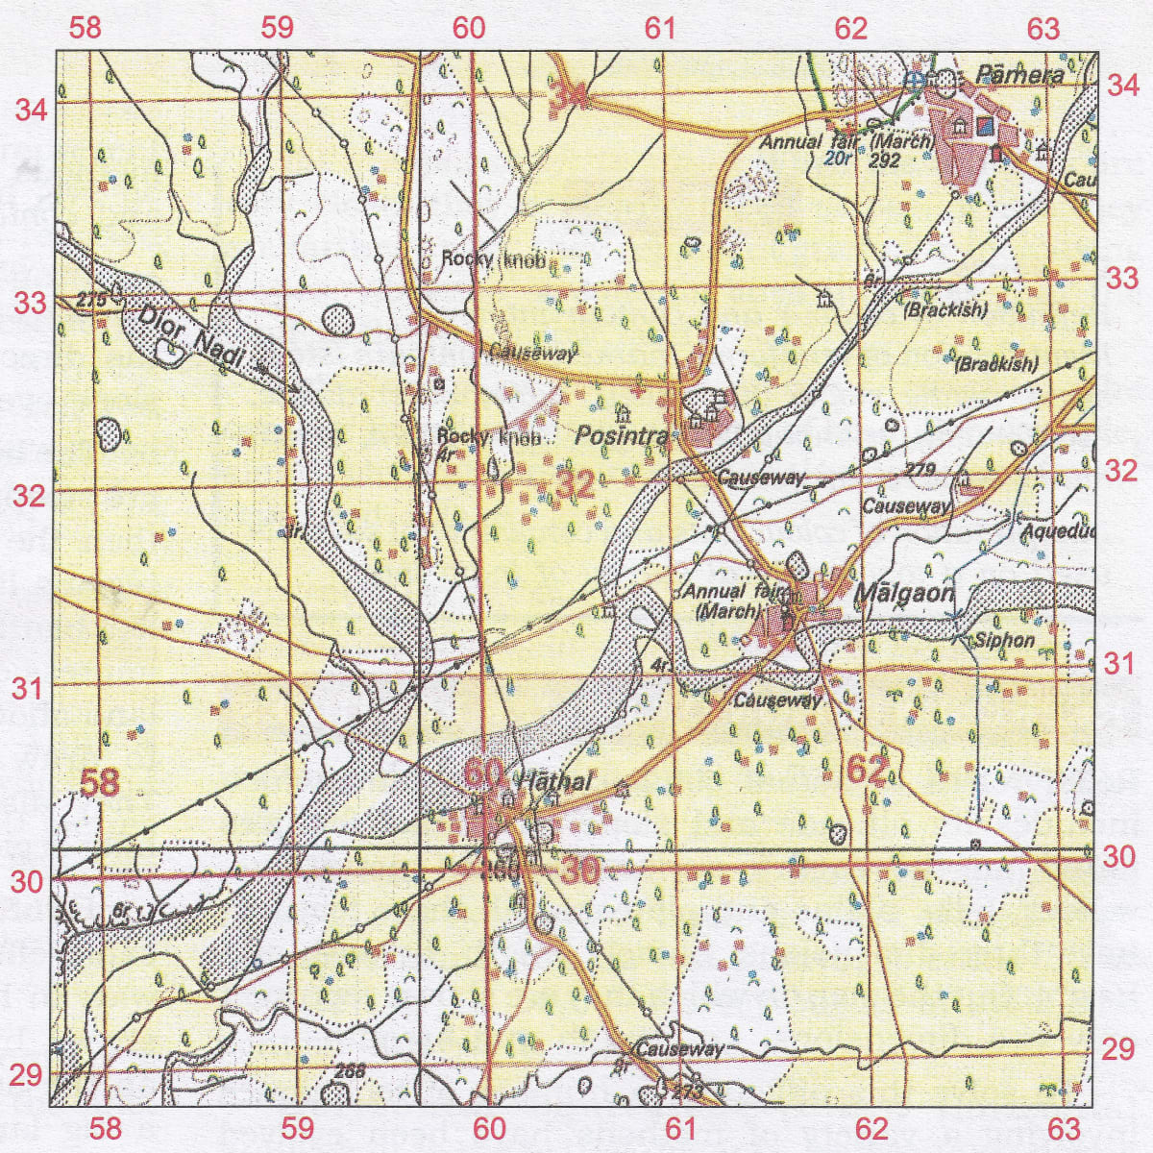
(a) Two settlements having a Post office.
(b) Two settlements having a dispensary.
(c) The Siphon.
(d) The confluence of the main river and Dior Nadi.
(e) The area of Brackish water.
(f) The Annual Fair grounds west of Malgaon.
Answer
(a) 6131, 6233
(b) 6234, 6032
(c) 6231
(d) 5930
(e) 6232
(f) 6131

Question 2
Give the six-figure grid reference of the following from the given map extract:
(a) Police Station.
(b) 4r near the rocky knob.
(c) Post office at Malgaon.
(d) The Surveyed tree at Posintra.
(e) Dispensary north of Posintra
(f) Hospital near Pamera
Answer
(a) 625338
(b) 598321
(c) 615312
(d) 600320
(e) 608324
(f) 622340

