**MINISTRY CATEGORY-** *MINISTRY OF ELECTRONICS AND INFORMATION TECHNOLOGY (MEITY)*

**PROBLEM STATEMENT-** *CREATE AN APP THAT CAN RUN ON A WINDOWS/LINUX BASED* **PROBLEM CODE-** #MTY17 *DESKTOP TO AID THE DISABLED PERSONS TO PERFORM DAY TO DAY TASKS*

**TEAM LEADER NAME-** *BHUVNESH KUMAR***COLLEGE CODE-***1-3330347904*

**IDEA OF APPROACH**

**OVERVIEW**

The app provides a whole new way for disabled people to perform day to day task over Linux operated PC just with the help of their voice. All the person has to do is just a registration with one time help of a non-disabled person and then the app allows the person to do day to day task like writing a word file, browsing, launching other applications, etc. with the help of voice commands. It also has a narrator which can read out loud a pdf/word file and can also navigate the person about the commands being implemented by the computer.

**SECURITY**

The app also comes with fingerprint-secured service. It allows the person to login to the computer with the registered fingerprint which makes it more secure and reliable.

**HOW THE SERVICE WORKS?**

As the computer starts, the app starts running as a service in the background. The Database of the application contains commands set and links to the scripts corresponding to the set, when any of the command set matches to the intermediate text of the command given by the user, corresponding script will get executed. Say, the command either “Play Music” or “Open Music” is given by the user, the corresponding script of the command set (say, music.py) will get executed which will play the music. In case no command set matches, user is asked for a clearer command.

**TECHNOLOGY STACK**

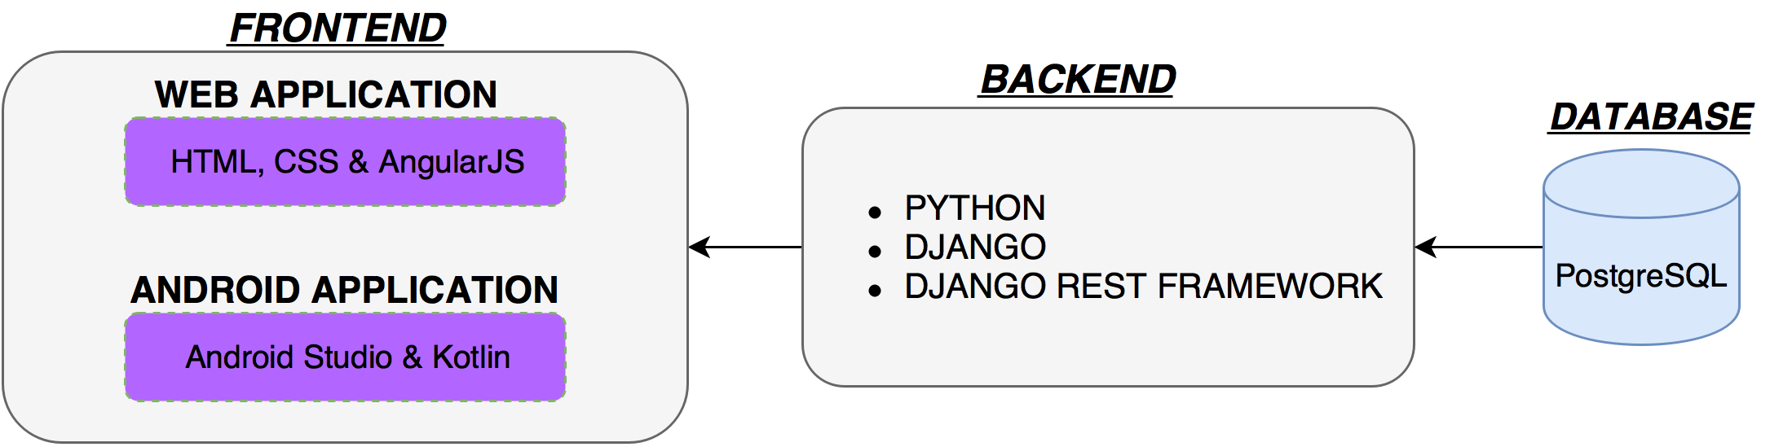

**USE CASE**

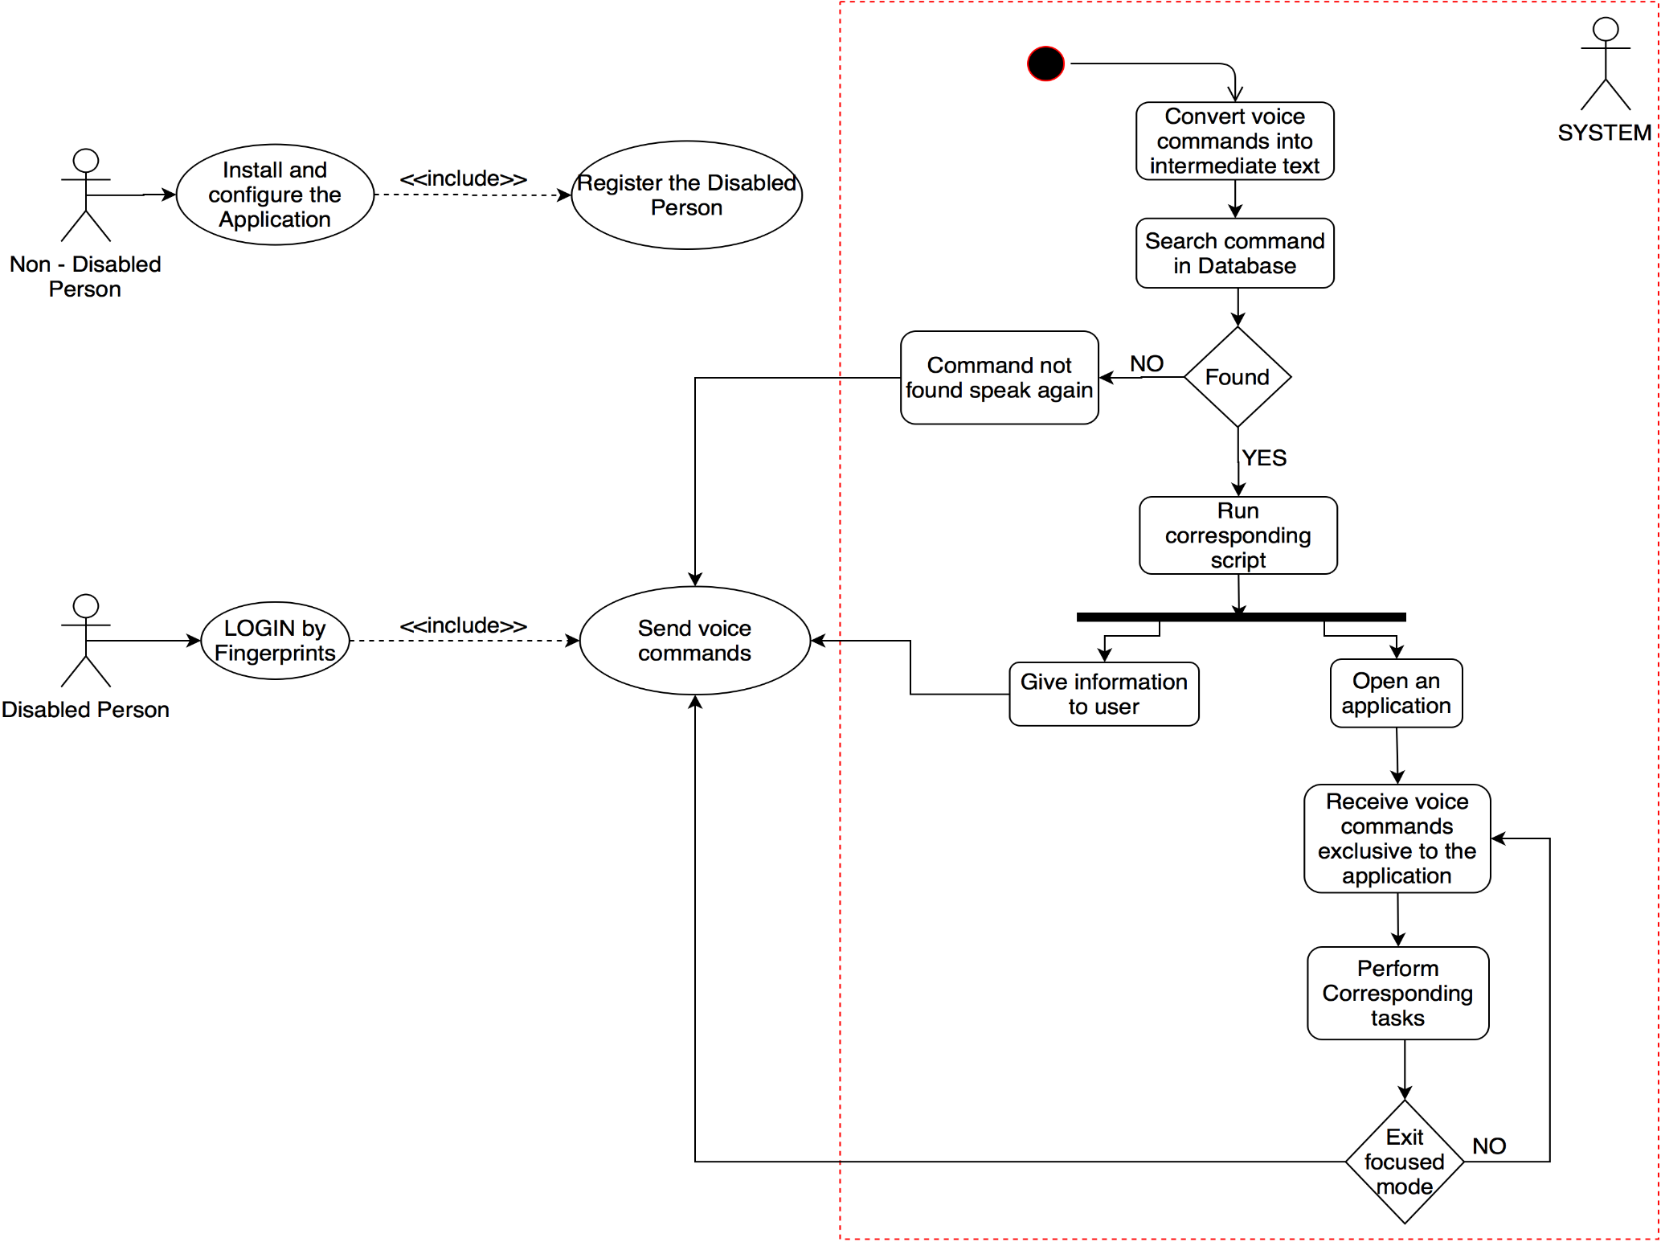

**DEPENDENCIES**

* **OpenCV Library** (for Image and fingerprint recognition)
* **Fingerprint scanner**
* **Web Cam**

**ACTIVITY DIAGRAM**

