chapter sixteen

Solubility and Complex Ion Equilibria

**// Chapter Index**

16.1 Solubility Equilibria and the Solubility Product

Relative Solubilities

Common Ion Effect

pH and Solubility

16.2 Precipitation and Qualitative Analysis

Selective Precipitation

Qualitative Analysis

16.3 Equilibria Involving

Complex Ions

Complex Ions and Solubility

**//Image**

Stalactites and stalagmites in the Drapery Room at Mammoth Cave in Kentucky. These formations are created when carbonate minerals dissolve in groundwater acidiﬁed by carbon dioxide and then solidify when the water evaporates.

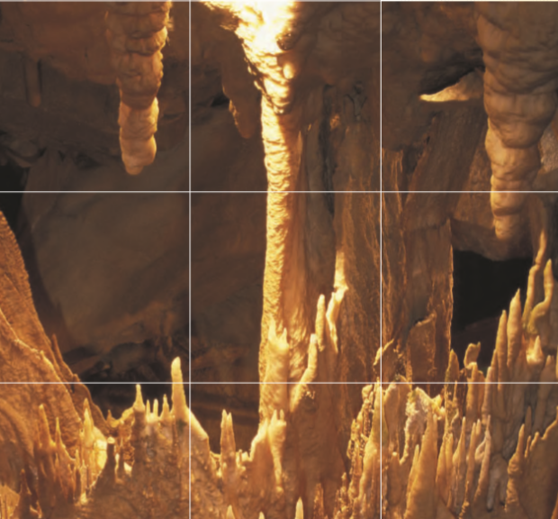

Most of the chemistry of the natural world occurs in aqueous solution. We have already introduced one very signiﬁcant class of aqueous equilibria, acid–base reactions. In this chapter we consider more applications of aqueous equilibria, those involving the solubility of salts and those involving the formation of complex ions.

The interplay of acid–base, solubility, and complex ion equilibria is often important in natural processes, such as the weathering of minerals, the uptake of nutrients by plants,and tooth decay. For example, limestone (CaCo3) will dissolve in water made acidic by dissolved carbon dioxide:

**//Chemical Reaction**

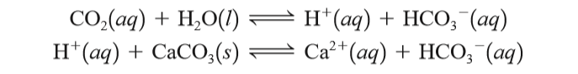

This two-step process and its reverse account for the formation of limestone caves and the stalactites and stalagmites found therein. In the forward direction of the process, the acidic water (containing carbon dioxide) dissolves the underground limestone deposits,thereby forming a cavern. The reverse process occurs as the water drips from the ceiling of the cave, and the carbon dioxide is lost to the air. This causes solid calcium carbonate to form, producing stalactites on the ceiling and stalagmites where the drops hit the cave ﬂoor.

In this chapter we will discuss the formation of solids from an aqueous

solution and the resulting equilibria. We will also show how selective precipitation and the formation of complex ions can be used to do qualitative analysis.

**//Heading**

16.1 Solubility Equilibria and the Solubility Product

Solubility is a very important phenomenon. The fact that substances such as sugar and table salt dissolve in water allows us to ﬂavor foods easily. The fact that calcium sulfate is less soluble in hot water than in cold water causes it to coat tubes in boilers, reducing thermal efﬁciency. Tooth decay involves solubility: When food lodges between the teeth, acids form that dissolve tooth enamel, which contains a mineral called hydroxyapatite, Ca5(P04)3OH. Tooth decay can be reduced by treating teeth with ﬂuoride (see Chemical Connections, p. 748). Fluoride replaces the hydroxide in hydroxyapatite to produce the corresponding ﬂuorapatite, Ca5(P04)3F and calcium ﬂuoride, CaF2, both of which are less soluble in acids than the original enamel. Another important consequence of solubility involves the use of a suspension of barium sulfate to improve the clarity of X rays of the gastrointestinal tract. The very low solubility of barium sulfate, which contains the toxic ion Ba2+, makes ingestion of the compound safe.

**//Quotes**

Adding F- to drinking water is controversial.

For simplicity, we will ignore the effects of ion associations in these solutions.

In this section we consider the equilibria associated with solids dissolving to form aqueous solutions. We will assume that when a typical ionic solid dissolves in water, it dissociates completely into separate hydrated cations and anions. For example, calcium ﬂuoride dissolves in water as follows:

**//Chemical Reaction**

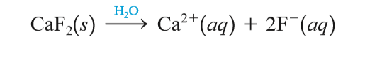

When the solid salt is ﬁrst added to the water, no Ca2+ and F- ions are present. However, as the dissolution proceeds, the concentrations of Ca2+and F- increase, making it more and more likely that these ions will collide and re-form the solid phase. Thus two competing processes are occurring—the dissolution reaction and its reverse:

**//Chemical Reaction**



Ultimately, dynamic equilibrium is reached:

**//Chemical Reaction**



At this point no more solid dissolves (the solution is said to be saturated). We can write an equilibrium expression for this process according to the law of mass action:

**//Chemical Reaction**



**//Image**



**An X ray of the lower gastrointestinal tract using barium sulfate.**

where [Ca2+] and [F-] are expressed in mol/L. The constant Ksp is called the solubility product constant or simply the solubility product for the equilibrium expression. Since CaF2 is a pure solid, it is not included in the equilibrium expression. The fact that the amount of excess solid present does not affect the position of the solubility equilibrium might seem strange at ﬁrst; more solid means more surface area exposed to the solvent, which would seem to result in greater solubility. This is not the case, however. When the ions in solution re-form the solid, they do so on the surface of the solid. Thus doubling the surface area of the solid not only doubles the rate of dissolving, but also doubles the rate of re-formation of the solid. The amount of excess solid present therefore has no effect on the equilibrium position. Similarly, although either increasing the surface area by grinding up the solid or stirring the solution speeds up the attainment of equilibrium, neither procedure changes the amount of solid dissolved at equilibrium. Neither the amount of excess solid nor the size of the particles present will shift the position of the solubility equilibrium.

**//Quotes**

Pure liquids and pure solids are never included in an equilibrium expression.

It is very important to distinguish between the solubility of a given solid and its solubility product. The solubility product is an equilibrium constant and has only one value for a given solid at a given temperature. Solubility, on the other hand, is an equilibrium position. In pure water at a speciﬁc temperature a given salt has a particular solubility. On the other hand, if a common ion is present in the solution, the solubility varies according to the concentration of the common ion. However, in all cases the product of the ion concentrations must satisfy the Ksp expression. The Ksp values at 25C0for many common ionic solids are listed in Table 16.1. The units are customarily omitted. Solving solubility equilibria problems requires many of the same procedures we have used to deal with acid–base equilibria, as illustrated in Examples 16.1 and 16.2.

//Quotes

K sp is an equilibrium constant; solubility is an equilibrium position.

**//Example 16.1**

Calculating Ksp from Solubility I

Copper(I) bromide has a measured solubility of 2.0 104 mol/L at 25C. Calculate its Ksp value.

**//Solution**

In this experiment the solid was placed in contact with water. Thus, before any reaction occurred, the system contained solid CuBr and H2O. The process that occurs is the dissolving of CuBr to form the separated Cu+ and Br- ions:

**//Chemical Reaction**



**//Tables 16.1**

Ksp Values at 250C for Common Ionic Solid

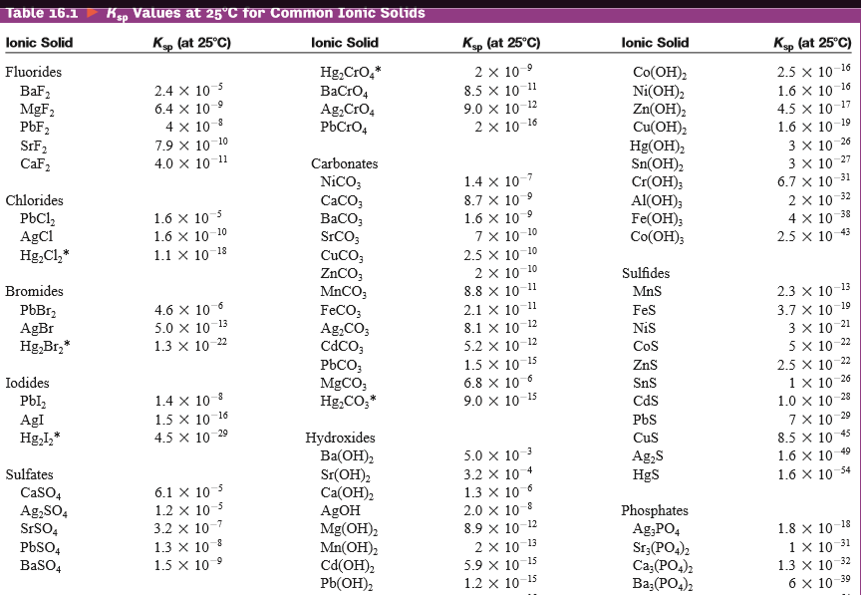



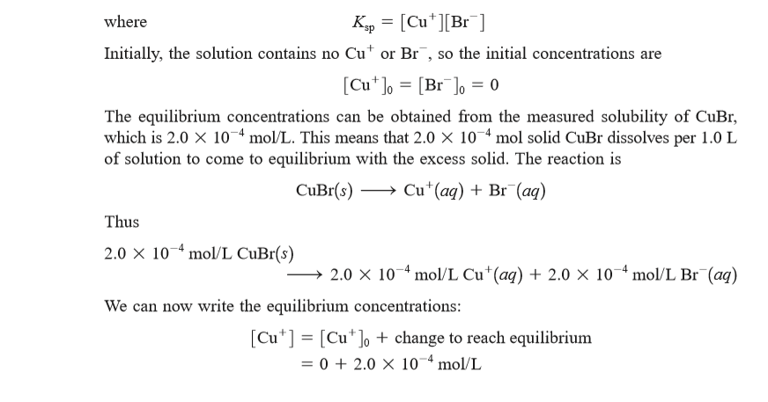

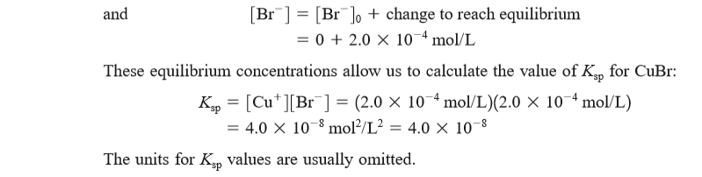

**// Example 16.2**

Calculating Ksp from Solubility II

Calculate the Ksp value for bismuth sulﬁde (Bi2S3), which has a solubility of 1.0 x 10-15 mol/L at 250C.

**//Solution**

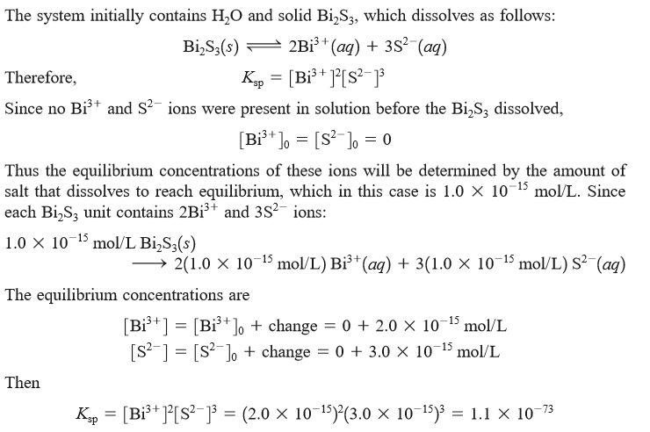

**//Image**

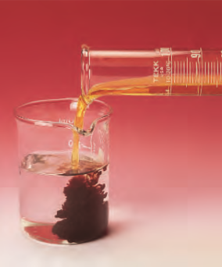

Precipitation of bismuth sulﬁde.

**//Quotes**

Sulﬁde is a very basic anion and really exists in water as HS.We will not consider this complication.

Solubilities must be expressed in mol/L in Ksp calculations.

We have seen that the experimentally determined solubility of an ionic solid can be used to calculate its Ksp value.* The reverse is also possible: The solubility of an ionic solid can be calculated if its Ksp value is known.

*This calculation assumes that all the dissolved solid is present as separated ions. In some cases, such as CaSO4, large numbers of ion pairs exist in solution, so this method yields an incorrect value for Ksp.

**//chemical connections**

The Chemistry of Teeth

If dental chemistry continues to progress at the present rate, tooth decay may soon be a thing of the past. Cavities are holes that develop in tooth enamel, which is composed of the mineral hydroxyapatite, Ca5(PO4)3OH. Recent research has shown that there is constant dissolving and re-forming of the tooth mineral in the saliva at the tooth’s surface. Demineralization (dissolving of tooth enamel) is mainly caused by weak acids in the saliva created by bacteria as they metabolize carbohydrates in food. (The solubility of Ca5(PO4)3OH in acidic saliva should come as no surprise to you if you understand how pH affects the solubility of a salt with basic anions.)

In the ﬁrst stages of tooth decay, parts of the tooth surface become porous and spongy and develop swisscheese-like holes that, if untreated, eventually turn into cavities (see photo). However, recent results indicate that if the affected tooth is bathed in a solution containing appropriate amounts of Ca2+, PO43-, and F-, it remineralizes. Because the F- replaces OH+ in the tooth mineral (Ca5(PO4)3OH is changed to Ca5(PO4)3F), the remineralized area is more resistant to future decay, since ﬂuoride is a weaker base than hydroxide ion. In addition, it has been shown that the presence of Sr2+ in the remineralizing ﬂuid signiﬁcantly increases resistance to decay. If these results hold up under further study, the work of dentists will change dramatically. Dentists will be much more involved in preventing damage to teeth than in repairing damage that has already occurred. One can picture the routine use of a remineralization rinse that will repair problem areas before they become cavities. Dental drills could join leeches as a medical anachronism.

**//Image**

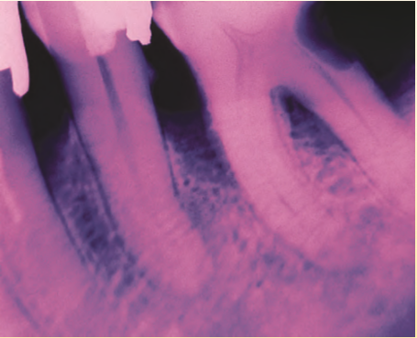

X-ray photo showing decay (dark area) on the molar (right).

**//Example 16.3**

Calculating Solubility from Ksp

The Ksp value for copper(II) iodate, Cu(IO3)2, is 1.4 x 10-7 at 250C. Calculate its solubility at 250C.

**// Solution**

The system initially contains H2O and solid Cu(IO3)2, which dissolves according to the following equilibrium:

**//Chemical Reaction**

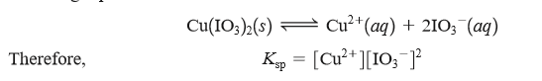

To ﬁnd the solubility of Cu(IO3)2, we must ﬁnd the equilibrium concentrations of the Cu2+and IO3- ions. We do this in the usual way by specifying the initial concentrations (before any solid has dissolved) and then deﬁning the change required to reach equilibrium. Since in this case we do not know the solubility, we will assume that x mol/L of the solid dissolves to reach equilibrium. The 1:2 stoichiometry of the salt means that

**//Chemical Reaction**



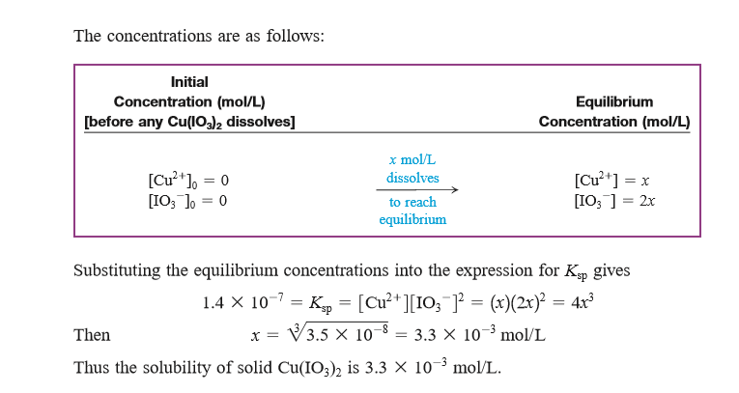

Relative Solubilities

A salt’s Ksp value gives us information about its solubility. However, we must be careful in using Ksp values to predict the relative solubilities of a group of salts. There are two possible cases:

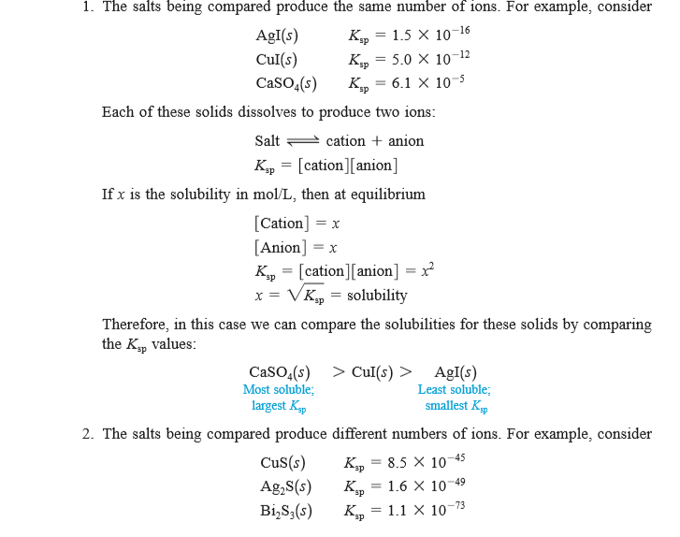

//Table