StartupHub — Phase 0 Findings
Positioning · Landscape Sweep · Competitive Deep Dive | Compiled 18 October 2026

Read this before writing a single slide. It compresses Phase 0 into what is defensible, what is not, and what to do next. Every claim is cited to the source register (76 sources: 44 government primary, 32 competitive).
1. The five findings that change the project
Finding 1 — India digitised innovation ACCOUNTABILITY, not innovation OPERATIONS
Every mandated system is a periodic compliance ledger keyed on events and snapshots. Not one is a system of record keyed on a venture through time.

System | Unit of record | What it demands
IIC | the activity/event | 16+/yr, each a form with 4 social links, 3-way participant counts, expenditure, video URL, 2 photos, a document upload
YUKTI-NIR | the innovation snapshot | Three static buckets: Idea/PoC (TRL 1-4), Innovation/Prototype (TRL 5-9), Business/Startup
NIRF-Innovation | the spreadsheet row | ~11 screens PER DISCIPLINE; per startup: name, DPIIT no, amount, funder, year, achievement level, investment type
AISHE | the institution-year aggregate | Binary NIRF participation status — plus the AISHE code everything else keys off
DPIIT | the recognition certificate | No institution-facing dashboard exists at all

Nothing in the stack can answer: "how many of our incubatees are still alive?"

This is not a feature gap inside an existing product. It is a category error in how innovation policy was digitised. → Decision Log D-004
Finding 2 — The sharpest proof in the entire project
The IIC portal has a menu item called "IPR/TTO Centres". It registers a technology-transfer office's EXISTENCE and FLOOR AREA. The portal then has NO FIELD ANYWHERE to record a single patent.

Body | What it demands | Source
IIC | Registers the TTO centre — no patent field exists | GOV-022
NIRF Innovation | "Patents Commercialized & Technology Transferred" and "Income from Technology Transferred (in Rupees)" | GOV-028
ARIIA | "Patent Application No", "Year of Patent Application", "Current Status", "IP / Patented Technology" per innovation | GOV-032
KAPILA (MoE) | 2,746 institutes registered; 11,768 patents reimbursed; HEI patent filings 15,383 (FY23) → 33,675 (FY25) = +119% | GOV-007
MeitY playbook | IP due diligence: ownership clarity, freedom to operate, defensibility; ownership vs 2-year university tech-transfer licence | GOV-038
IIT Madras | 431 patents filed in FY25-26; IP Management Cell + Technology Transfer Office | COMP-027

The patent data exists in the institution, exists nowhere in the ecosystem stack, and is re-entered by hand every year. AND ZERO OF ELEVEN DIRECT COMPETITORS HAVE ANY IPR MODULE.

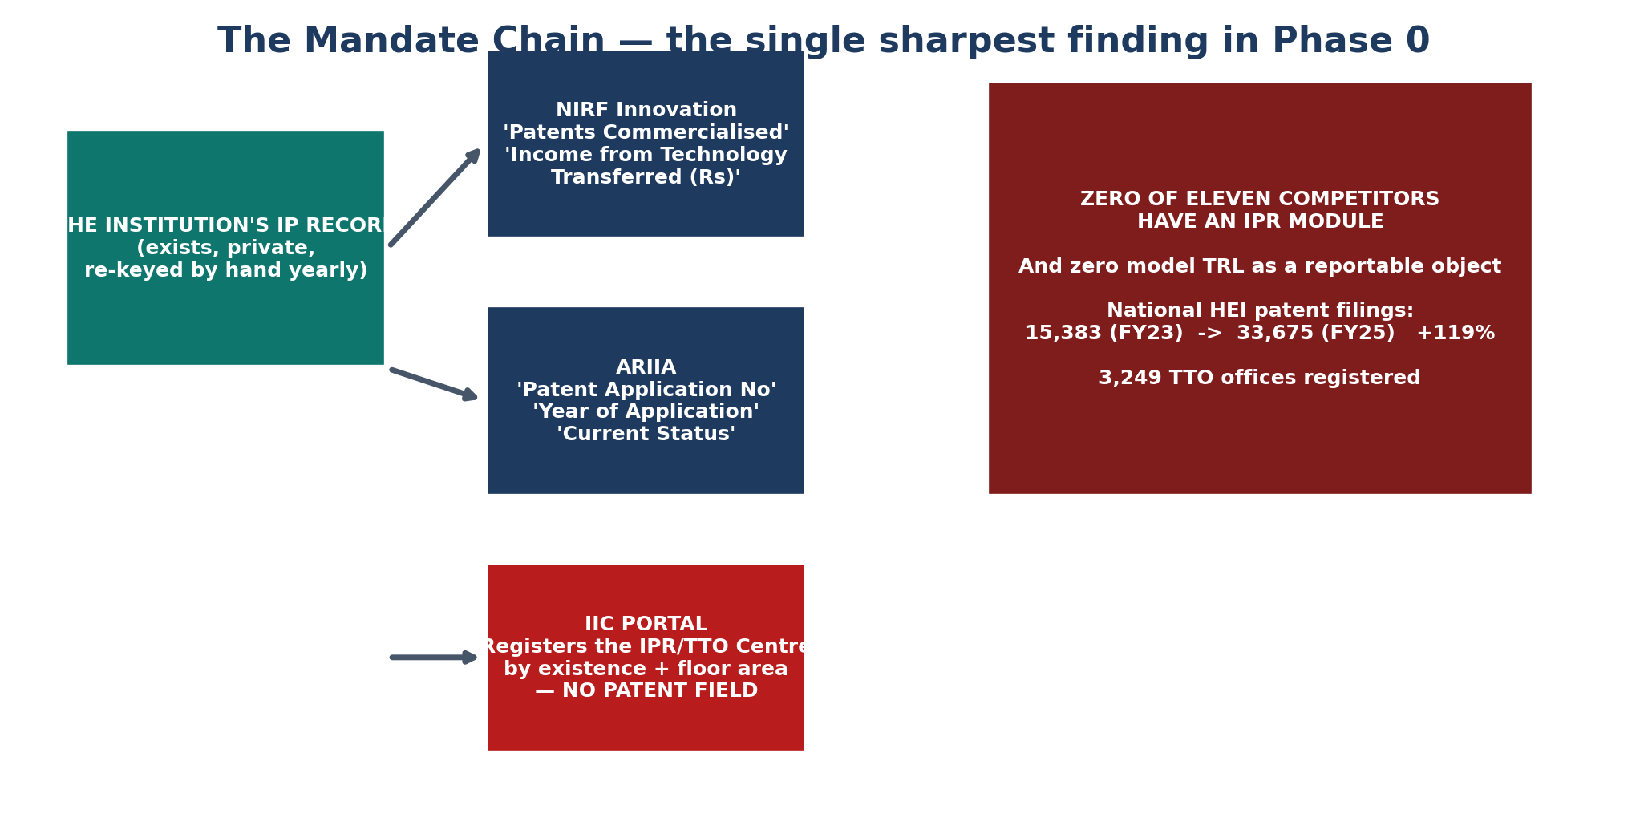
The mandate chain — what institutions must report, and what no system holds
Finding 3 — The market is not empty, and the price is Rs 75,000 not Rs 1.2 lakh
todo.md carries an assumed Rs 1.2 lakh/year with NO source. It sits ABOVE the cheapest credible Indian incumbent.

Product | Price / year | Note
NestLens Orbit Launch | Rs 75,000 | India-native, published INR, every feature. THE COMPETITIVE ANCHOR.
IncubatX Foundation | Rs 1,20,000 | Founded 2026, zero verifiable customers, demo data on live dashboard
Founderhood Starter −15% (university) | Rs 1,82,070 | THE CREDIBLE GLOBAL PRICE OBJECTION
Incubatee year one | Rs 3,95,200 | Highest verified Indian price point
AcceleratorApp core | Rs 5,39,000 | ISO 27001 certified. Yale, MIT Design X, Max Planck. Zero Indian institutions.
Elsevier Pure, min Indian deployment | Rs 44,60,000 | + Rs 43.5 lakh mandatory onboarding. Does NOT manage startups.

Rs 75,000/yr is a COMPETITIVE anchor, not a pricing decision. We have asked zero institutions what they would pay. → Decision Log D-006, Open Question OQ-03
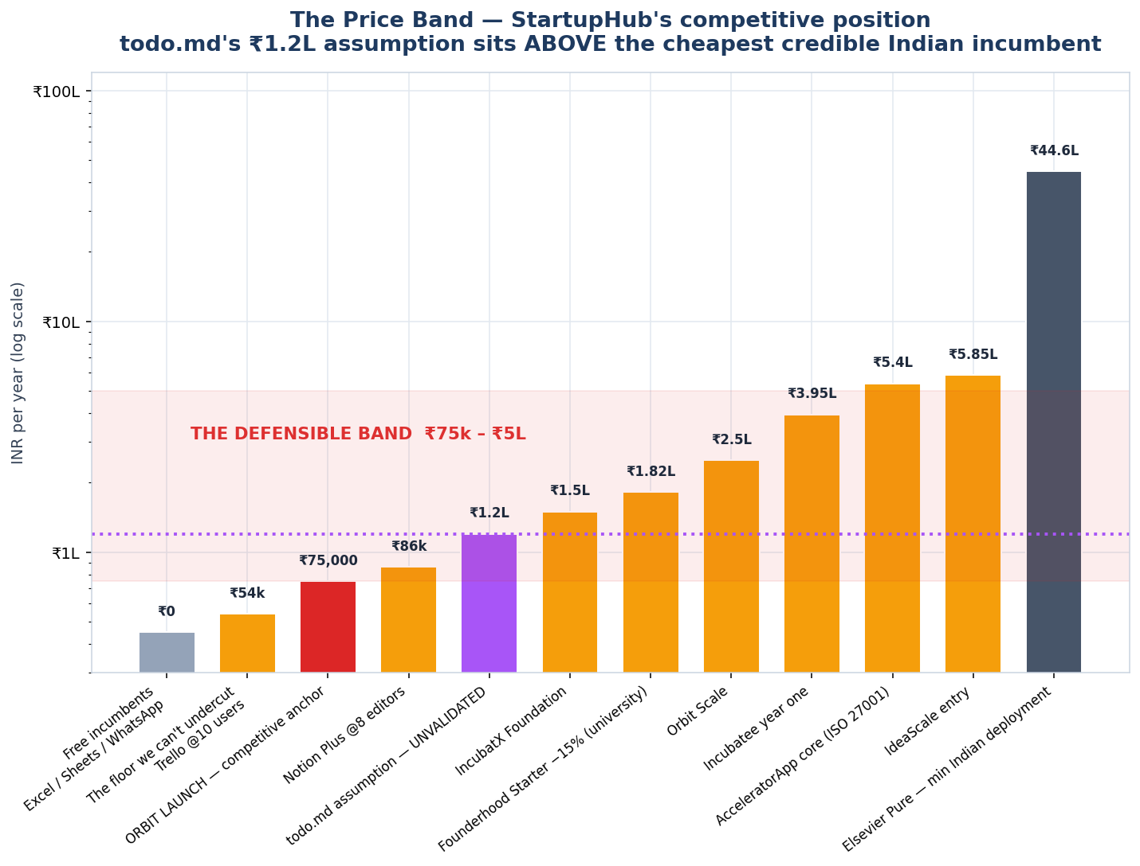
The price band
Finding 4 — Three capabilities are contested by literally nobody
Capability | Competitors with it | Why India makes it mandatory
IPR / patent lifecycle management | 0 of 11 | ARIIA fields, IIC IPR Cells, MeitY diligence, 3,249 TTO offices, +119% filing growth
TRL as a first-class, reportable object | 0 of 11 | YUKTI-NIR bands every submission by TRL; ARIIA asks for TRL Stage; MeitY uses TRL as the investment benchmark
YUKTI-NIR / IIC / ARIIA submission workflow | 0 of 11 | A government workflow. Verified YUKTI-NIR entries AUTO-POOL into ARIIA Section 4 ranking

This is a mandate-shaped hole, not a feature gap. → Decision Log D-005

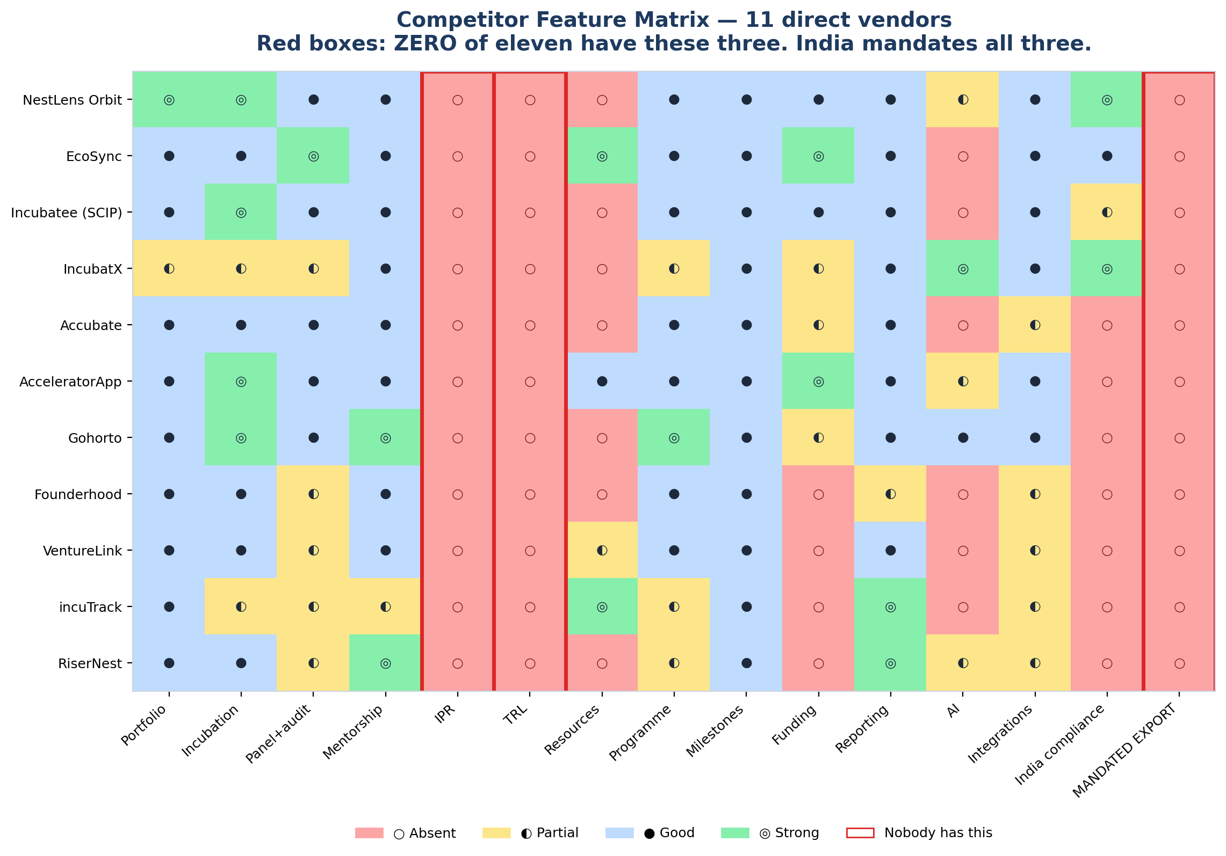
Competitor feature matrix — the three red columns are empty across all eleven vendors
Finding 5 — The real competitor is free, and it is WhatsApp
"IISc Students — Join this Whatsapp group for updates." India's most research-intensive institution routes student coordination through WhatsApp.

Alternative | Real India cost | What it structurally cannot do
Excel / Google Sheets | Rs 0 (bundled) | No permissions, no audit trail, no relational integrity, no workflow, manual consolidation
WhatsApp + Google Drive | Rs 0 | No structure, no permissions, no audit trail, no reporting. THIS IS THE OPERATIONAL DATABASE.
Notion / Superhuman Docs / Airtable | Rs 26k–1.73L at IIC scale | AUDIT LOGS GATED BEHIND ENTERPRISE. Notion records events only "starting from the time of upgrade" — no retroactive history.
Trello / ClickUp / Monday / Asana | Rs 54k–1.19L at 10 users | No domain model, no intake workflow, no IPR. Audit logs Enterprise-only.
Campus ERP | Rs 500–2,000 per student per year | ZERO Indian campus ERP vendors have a startup-incubation module

We cannot win by being cheaper. We can only win by being the ONLY thing that produces a compliant submission — and by having the retroactive audit trail that free and cheap tools structurally cannot provide. → Decision Log D-008

2. The positioning, stated precisely
NOT a platform for startups. NOT a directory. NOT another IIC portal. NOT an "AI-powered ecosystem platform" — IncubatX already claims that and ships demo data on its dashboard.
StartupHub is a SYSTEM OF RECORD for the venture — keyed on the entity and its state over time — that produces the mandated submissions as a by-product.

The institution enters a startup ONCE. That single record then generates:
Submission | Why it matters | Competitor coverage
IIC activity pack (evidence attached) | Star rating is a headline institution attribute | 0 of 11
YUKTI-NIR entry with correct TRL + verifier workflow | AUTO-POOLS into ARIIA Section 4 ranking ★ | 0 of 11
NIRF Innovation rows across all disciplines | 5 marks hinge on one countable | 0 of 11
ARIIA submission | 100+ indicators, 5 categories | 0 of 11
DST / BIRAC / MeitY utilisation report | Audited, PFMS-registered | 1 partial
IPR docket — disclosure → filing → deadlines → annuity → royalty | Nobody has it; India mandates it | 0 of 11

★ The YUKTI-NIR → ARIIA auto-pool is the single most powerful business-model insight in Phase 0. A product that makes an institution look better in a national ranking is selling into a budget line that ALREADY EXISTS. → Decision Log D-007

3. Where StartupHub must NOT compete
Honest scoping is more useful than optimism.
Territory | Who owns it | Why we refuse
Real estate, labs, desks, key control | incuTrack (20 years, work orders, key control, insurance, kitchen incubators) and EcoSync (5 pricing tiers, deposits, Razorpay) | Capital-intensive, peripheral to the wedge, and the most likely source of a free defensive feature
Grant disbursement depth | AcceleratorApp's Funding module and EcoSync | Cover with scheme MATCHING, not a general ledger
Community / social feed | RiserNest and Circle (Rs 89–199/mo) | They do it better and cheaper than we can
Generic LMS | Disco, Circle, LoftOS | Not our business
Big logo walls | AcceleratorApp (Yale, MIT, Max Planck) and Accubate (TCS, KPMG, Hero) | We cannot out-muscle either on brand

And the under-rated threat: LoftOS. A no-code portal builder WITH an accelerator template. A university IT team could build its own incubation portal for $29–349/month and OWN IT OUTRIGHT. Case study: RWTH Aachen University (Collaeb).

Implication: the moat cannot be "we have features a builder doesn't". It must be the things a builder structurally cannot produce — mandated-portal schemas, IPR docket logic, TRL-to-scheme mapping, and a compliance output the institution can hand to a government body.

4. What we know we do NOT know
ID | Unknown | Blocks | How to settle it
OQ-01 | The current official count of IICs is unverifiable | This is the single most important denominator in the project - the closest proxy for 'how many Indian institutions have a functioning innovation struc | Authenticated access to iic.mic.gov.in/institute-list; manual read of the MIC Brochure 2025 graphic; written query to MIC (mic-mhrd@gov.in); or an RTI.
OQ-02 | AICTE total approved institutions and the engineering-college-specific count | Engineering colleges are a named segment in todo.md Phase 4. Sizing them requires the true count. | AICTE Centralized Support System login, or the annual approved-institution list.
OQ-03 | Willingness to pay - completely unvalidated | Phases 7, 8, 16, 17 and 18 all depend on it. A financial model built on Rs 1.2L is currently an assertion, not a model. | Phase 3 interviews (10-15 institutions) using the VALUE framing - 'if this problem disappeared tomorrow, what would that save you?' - not 'would you pay Rs 1.2

ID | Other significant unknowns
OQ-04 | No public API exists for IIC, YUKTI, NIRF, AISHE or MAARG → assume NO API, design export/import (Phase 22)
OQ-10 | The IIC star-rating formula is NOT publicly documented — the official page returns "Coming Soon". FEATURE RISK.
OQ-11 | BHASKAR may be overhauled into a "National Startup Master Data" registry. Tier 4 — trade press, not a notification.
OQ-13 | Procurement mechanics (GeM, DRE, data localisation) may be the hardest constraint in the business.

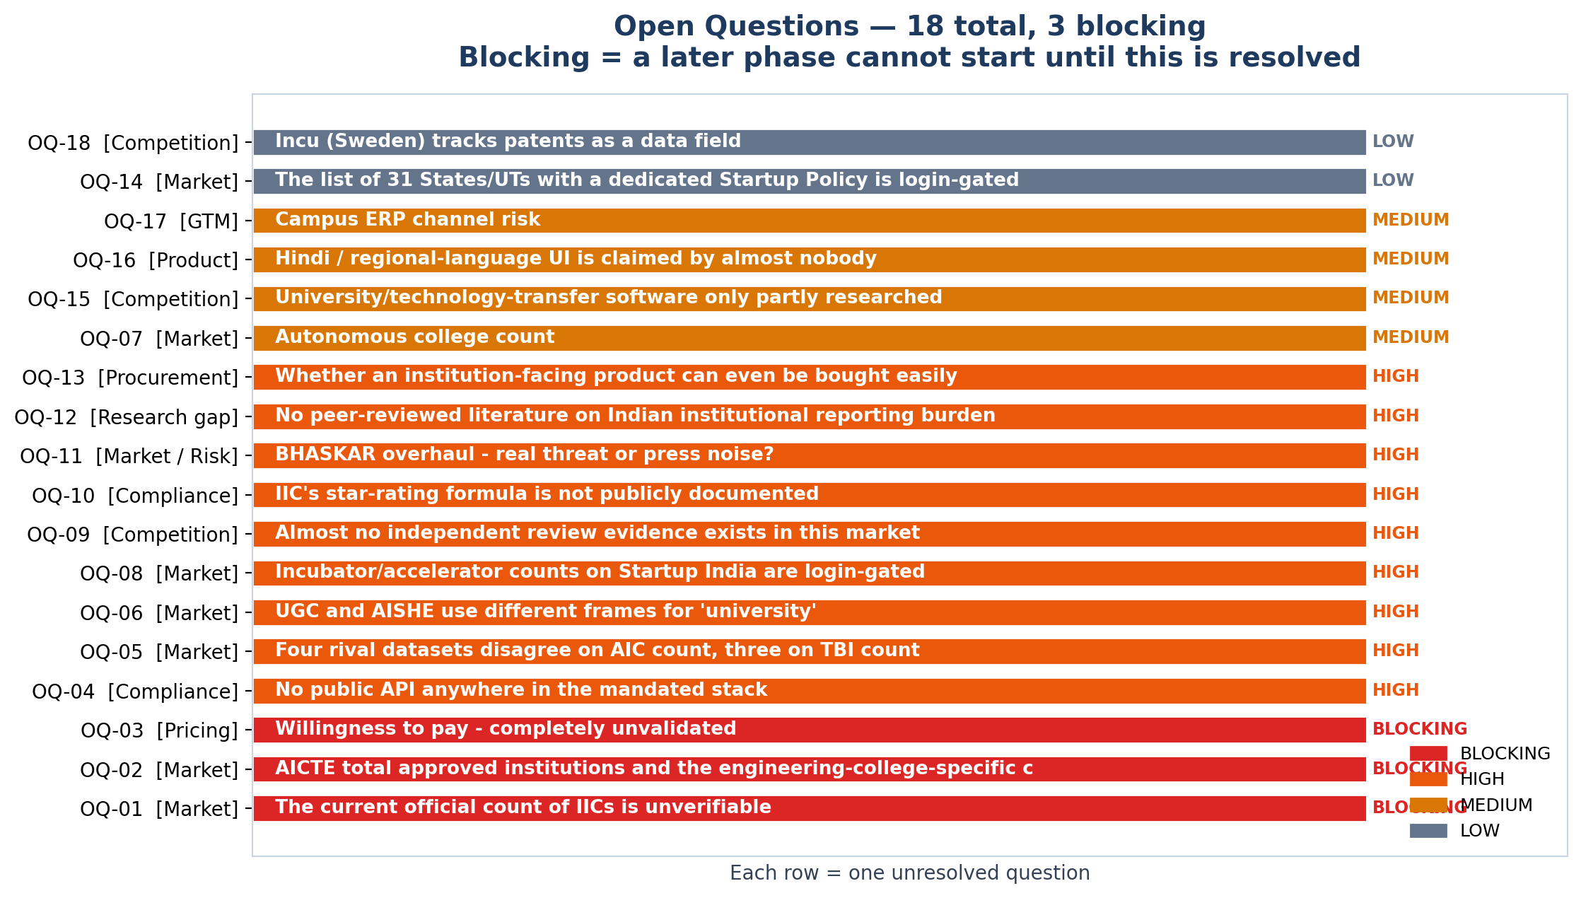
All 18 open questions
5. Three verified weaknesses we can attack directly
These are quotable, citable, and true — not spin.
EcoSync has already conceded it cannot pass enterprise procurement
"We do not hold SOC 2 or ISO 27001 certification, and we would rather tell you that here than have you find out in a security questionnaire. We do not publish an uptime SLA. We are a small team in India building this for incubators in India, and our first incubator is still our reference customer rather than our hundredth." — ecosync.network

EcoSync is arguably the best-placed competitor operationally — and it has pre-emptively answered "no" to the two questions a university IT committee asks first.
Gohorto's trust badges rest on three reviews
It claims a "G2 High Performer 2026" badge and a "5.0/5 on Capterra" rating — built on 3 GetApp reviews, one flagged vendor-referred. Its own comparison pages score itself 4.8 and every rival 2.1–3.6. Its scale claims are unverifiable and its timeline implausible.
Orbit publishes two conflicting price lists on its own domain
Institutional tiers say Rs 75,000/yr. The NestLens overview page says "Orbit OS Rs 29,999/month (Rs 2,99,999/year)". A buyer hits both within one click. In a procurement-comparison conversation where that surfaces, StartupHub wins on transparency — and transparency is cheap to compete on.
No competitor can prove a large Indian institution runs on their software. Six of eleven have ZERO third-party reviews; the two with real reference bases (AcceleratorApp, Accubate) have ZERO Indian institutions. For StartupHub, ONE published, verifiable Indian university case study with named referees is worth more than any feature on the comparison table. It takes months — start early.

6. What to do next
Immediate (this week)
- Resolve OQ-01 — the IIC count. Query MIC (mic-mhrd@gov.in) or read the MIC Brochure 2025 graphic to resolve the IIC count. GATES TAM/SAM.
- Extract the NIRF PDF corpus into 01_Evidence_Vault/Datasets/. Factly proved it is extractable and monetised it (6,817 rows, 204 institutions). That cohort is our most reachable segment and the seed of a potential data asset.
- Start the reference-customer clock. Six of eleven competitors have no reference institution. A named case study takes months to produce and is worth more than features.
Phase 1 (Problem Research)
- Six of twelve problem areas are currently INFERRED or ASSUMED. Only IPR tracking has 9 independent primary citations.
- Commission a time-and-motion study across ~20 IIC institutions. No one has published this (OQ-12). It is the difference between saying "institutions have this problem" and "7 of 10 lose X hours per month to it."
Phase 2–3 (Customer Research + Interviews)
- Start with PERFORMANCE MONITORING (weakest evidence, strongest structural claim) and the IPR WORKFLOW (best-documented, never observed). Full interview priority order is in 03_Problem_Evidence.
- Use the VALUE framing, never the price framing: "If this problem disappeared tomorrow, what would that save you?"
Phase 21 (MVP) — the scope consequence
todo.md Phase 0's proposed V1 is NO LONGER VIABLE AS WRITTEN.

Ten modules — dashboard, registry, idea management, incubation, mentor, IPR, resource, program, performance, reports — is what IncubatX, Orbit and EcoSync already sell. If that is V1, StartupHub is a worse version of three funded competitors.
The V1 must be narrower and deeper on the mandate: one venture record · the TRL engine · the IPR docket · the generated submissions. Four things. Everything else in Phase 21's list is table stakes.
7. The uncomfortable summary
Phase 0 did not find a BIGGER opportunity. It found a much SHARPER and much SMALLER one.

Not "the innovation ecosystem needs a platform." Eleven vendors already sell that, from Rs 75,000/yr.
Instead:
Indian institutions are legally required to file patent-level data three times a year to three different government bodies, in a national system that has no field for recording a patent — and eleven vendors are competing on AI and grant ledgers instead.
That is the gap. It is narrow, it is real, it is documented entirely in primary government sources, and NOBODY is competing for it.

