StartupHub — Segment Census
How big is each segment, really? | Compiled 18 October 2026

⚠ The three biggest figures a pitch will want — how many institutions have an IIC, how many incubators exist, and what institutions will pay — are respectively UNVERIFIABLE, NOT PUBLISHED BY ANYONE, and COMPLETELY UNVALIDATED. Nothing below should be presented externally without its date and source.

Segment sizes span THREE orders of magnitude. This is why Phase 0 deliberately did not freeze a beachhead customer.
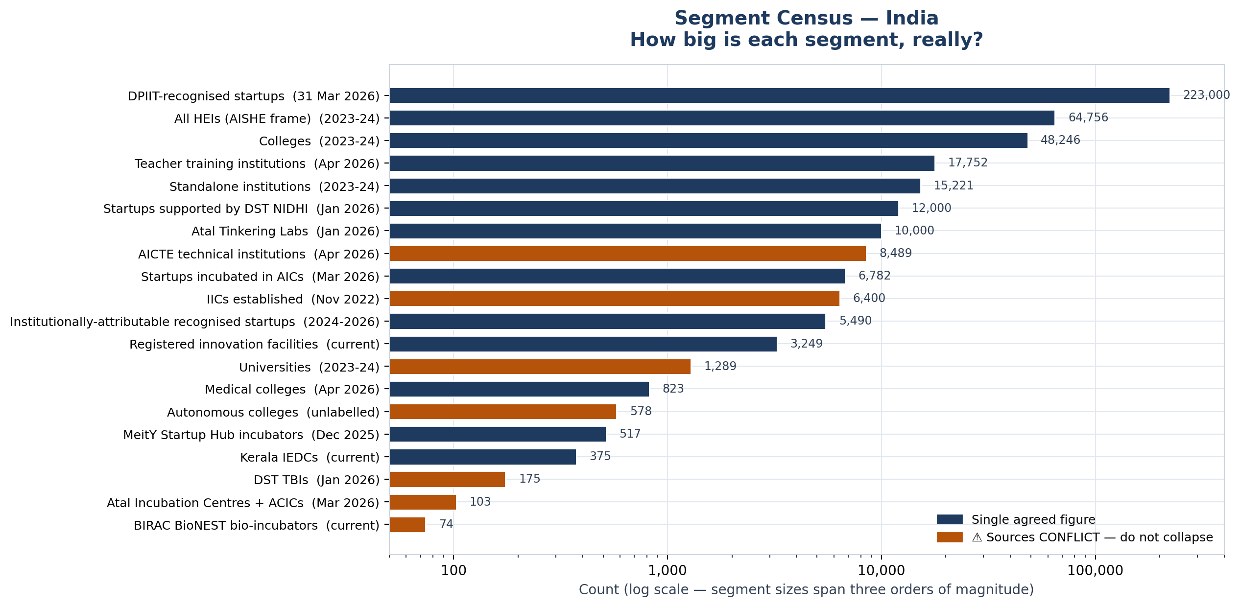
Segment census (log scale)
All denominators
Segment | Count | As of | Source | Rel. | Conflict | Notes
All HEIs (AISHE frame) | 64,756 | 2023-24 | GOV-001 | HIGH |  | Latest published AISHE edition. 2024-25 still in error-rectification.
Colleges | 48,246 | 2023-24 | GOV-002 | HIGH |  | 70.0% private unaided, 12.9% private aided, 17.1% government. 4,787 (10.3%) exclusively for women.
Standalone institutions | 15,221 | 2023-24 | GOV-002 | HIGH |  | Only 77.4% responded — the weakest category.
Universities | 1,289 | 2023-24 | GOV-002 | HIGH | YES | UGC's different frame says 1,153. Do not mix. See OQ-06.
Autonomous colleges | 578 | unlabelled | GOV-005 | MEDIUM | YES | Dashboard vintage unlabelled; exceeds published AISHE 2023-24 totals. See OQ-07.
AICTE technical institutions | 8,489 | Apr 2026 | GOV-004 | MEDIUM | YES | PRS Tier 2 compilation. AICTE dashboard returned HTTP 404. Engineering-college-only count UNVERIFIED. See OQ-02.
Medical colleges | 823 | Apr 2026 | GOV-004 | MEDIUM |  | NMC.
Teacher training institutions | 17,752 | Apr 2026 | GOV-004 | MEDIUM |  | NCTE.
IICs established | 6,400 | Nov 2022 | GOV-006 | HIGH | YES | LAST OFFICIAL PIB COUNT — four years stale. Current figure UNVERIFIED. See OQ-01 — BLOCKING.
Atal Incubation Centres + ACICs | 103 | Mar 2026 | GOV-008 | HIGH | YES | 83 AIC + 20 ACIC across 28 S/UTs. AIM site says 72; AIC page says 69. Incubated 6,782 startups.
Atal Tinkering Labs | 10,000 | Jan 2026 | GOV-009 | HIGH |  | Across 733 districts; 1.1 crore+ students.
DST TBIs | 175 | Jan 2026 | GOV-010 | HIGH | YES | '175+' PIB; DST page says 'more than 160'; ISTI says 164. Name the source whenever citing.
MeitY Startup Hub incubators | 517 | Dec 2025 | GOV-012 | HIGH |  | Closest official national incubator count. Also 329+ labs, 6,148+ startups.
BIRAC BioNEST bio-incubators | 74 | current | GOV-011 | HIGH | YES | Same page's table footer reads 'Showing 1 to 10 of 75'.
DPIIT-recognised startups | 223,000 | 31 Mar 2026 | GOV-013 | HIGH |  | 23.36 lakh+ direct jobs; 1.07 lakh (48%) women-led. 55,200+ recognised in FY2025-26.
Startups incubated in AICs | 6,782 | Mar 2026 | GOV-008 | HIGH |  | >2,000 women-led / socially inclusive.
Startups supported by DST NIDHI | 12,000 | Jan 2026 | GOV-010 | HIGH |  | 1,30,000+ jobs; 1,100+ IP.
Kerala IEDCs | 375 | current | GOV-042 | HIGH |  | Across colleges and universities. Most developed institution-facing state programme.
Institutionally-attributable recognised startups | 5,490 | 2024-2026 | GOV-030 | MEDIUM |  | Deduplicated distinct ventures across 204 institutions (from 6,817 rows). Most reachable cohort. Tier 3 source.
Registered innovation facilities | 3,249 | current | GOV-007 | HIGH |  | Plus 5,157 pre-incubation and 3,083 incubation facilities.

DPIIT-recognised startups by State (31 March 2026)
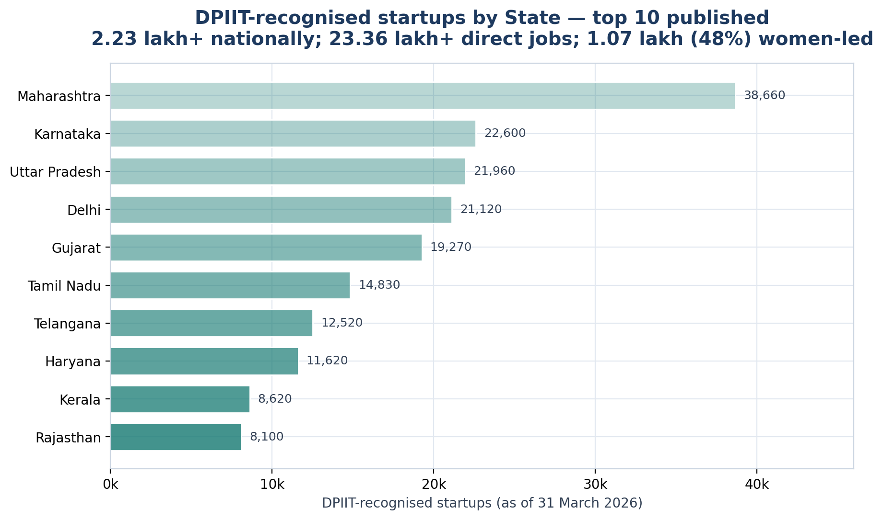
Top 10 published
State / UT | Startups | Direct jobs
Maharashtra | 38,660 | 413,900
Karnataka | 22,600 | 246,000
Uttar Pradesh | 21,960 | 211,580
Delhi | 21,120 | 236,640
Gujarat | 19,270 | 214,800
Tamil Nadu | 14,830 | 152,900
Telangana | 12,520 | 136,570
Haryana | 11,620 | 139,600
Kerala | 8,620 | 74,130
Rajasthan | 8,100 | 83,100

Where the reporting burden is concentrated
Obligation | Scale | Source
IIC council meetings | Min 2/yr with signed resolutions, quarterly plans, minutes, photographs — AND THEY GATE EVERYTHING ELSE | GOV-019
IIC activities | 16+/yr, each a full evidence submission (4 social links, 3-way counts, expenditure, video, 2 photos, document) | GOV-020/021
YUKTI-NIR | Every innovation/startup, TRL-banded, institute-verified, FLOWS INTO ARIIA | GOV-023/024
NIRF Innovation | ~11 screens PER DISCIPLINE; per startup: name, DPIIT no, amount, funder, year, achievement level, investment type | GOV-028
ARIIA | 100+ indicators across 5 categories, incl. patent-level fields | GOV-032
NIDHI / DST / BIRAC | Grant utilisation, audited certificates, PFMS/CGA registration, unspent-balance refund | GOV-010
AISHE | Binary NIRF status — plus the AISHE code everything else keys off | GOV-032

And the hard gate, verbatim from the portal manual: "If it is in red cross then you cannot add any activity under 'Manage Activity' section." A governance artefact gates the reporting form.

