Software Requirements Specification

For

Research Paper Tracking and Recommendation Tool
VERSION 1.0
Prepared by

Group Name: TEAM 7

Haritha | SE23UMCS046
Gayathri | SE23UMCS047
Prasamita | SE23UMCS048
Yasaswini | SE23UCSE180
Swaroopa  Bhuvaneshwari  Shahzeb  Jagrat | SE23UMCS066  SE23UMCS052  SE23UCSE197  SE23UARI050

Instructor: Prof. Avinash
Course: Software Engineering
Lab Section: AI/ ICSE batch
Date: 13th March 2026
Contents
Contents ii
Revisions ii
1 Introduction 1
1.1 Document Purpose 1
1.2 Product Scope 1
1.3 Intended Audience and Document Overview 2
1.4 Definitions, Acronyms and Abbreviations 2
1.5 Document Conventions 2
1.6 References and Acknowledgments 3
2 Overall Description 3
2.1 Product Overview 3
2.2 Product Functionality 5
2.3 Design and Implementation Constraints 6
2.4 Assumptions and Dependencies 6
3 Specific Requirements 7
3.1 External Interface Requirements 7
3.2 Functional Requirements 8
3.3 Use Case Model 10
4 Other Non-functional Requirements 19
4.1 Performance Requirements 19
4.2 Safety and Security Requirements 20
4.3 Software Quality Attributes 21
5 Other Requirements 21
Appendix A – Data Dictionary 22
Appendix B - Group Log 24

Revisions
Version | Primary Author(s) | Description of Version | Date Completed
Version 1.0 | Haritha, Yasaswini, Prasamita, Gayathri, Swaroopa, Bhuwaneshwari, Jagrat, Shahzeb | Initial version of the Software Requirements Specification (SRS) document for the Research Paper Tracking and Recommendation Tool. | 16/03/2026

Introduction
The Research Paper Tracking and Recommendation Tool is a web-based system designed to help students and researchers efficiently manage and organize academic research papers. The system allows users to search, store, track, and manage research papers within a personal workspace while also providing recommendations for related papers based on user interests. This helps users streamline their research process and easily discover relevant academic content.
This section introduces the overall purpose of the document and provides an overview of the project. It also explains the scope of the system, the intended audience of the document, key definitions and abbreviations, and references used throughout the Software Requirements Specification (SRS).

Document Purpose
This document presents the Software Requirements Specification (SRS) for the Research Paper Tracking and Recommendation Tool (Version 1.0). The purpose of this document is to clearly describe the functional and non-functional requirements of the system and provide a structured understanding of how the software should behave.
The SRS acts as a reference for the development team, instructor, and other stakeholders involved in the project. It outlines the expected system features, external interfaces, system constraints, and performance requirements. By documenting these requirements in a structured format, the SRS helps ensure that the system is developed according to the intended objectives and that all stakeholders share a common understanding of the system's functionality.

Product Scope
The Research Paper Tracking and Recommendation Tool is designed to support students and researchers in organizing and managing academic research papers efficiently. Researchers often work with a large number of papers, making it difficult to track reading progress, organize notes, and discover related research. This system aims to simplify that process by providing a centralized platform where users can manage their research papers in an organized workspace.
The system enables users to search for research papers, save them to a personal workspace, track their reading status, and store notes related to each paper. In addition, the tool includes a recommendation feature that suggests relevant papers based on user activity and interests. By providing these capabilities, the system helps improve research productivity, reduces the effort required to manage academic resources, and supports users in discovering new research relevant to their work.

Intended Audience and Document Overview
This document is intended for several types of readers involved in the development and evaluation of the system.
- Developers will use this document to understand the system requirements and guide the implementation of the software.
- The project instructor or client will review this document to verify that the system requirements align with the project objectives.
- Testers may use this document to design test cases and validate whether the implemented system meets the specified requirements.
- End users, such as students and researchers, may refer to this document to understand the system’s capabilities and expected behaviour.
The remainder of this document is organized as follows. Section 2 provides an overall description of the system, including its major functionalities and constraints. Section 3 describes the detailed functional requirements and use case model. Section 4 outlines the non-functional requirements such as performance, security, and quality attributes. Additional supporting information is included in the appendices.

Definitions, Acronyms and Abbreviations
Term | Definition
API | Application Programming Interface used for communication between software components
DB | Database used to store system data
SRS | Software Requirements Specification
UI | User Interface that allows users to interact with the system
User | A student or researcher using the research paper tracking system
Recommendation System | A component that suggests relevant research papers based on user activity.
Metadata | Information about a research paper such as title, authors, publication year, and abstract.
Recommendation Engine | A system component that analyses research papers and user activity to generate suggestions for relevant papers.
Workspace | The personal area of the system where users store and manage saved research papers and related notes.

Document Conventions
This document follows the IEEE Software Requirements Specification format provided in the course template. The document uses structured numbering for sections and subsections to maintain clarity and consistency.
The main formatting conventions used in this document include:
- Standard text written in Arial font (size 11 or 12).
- Section and subsection headings formatted according to the template structure.
- Functional requirements labelled using identifiers such as F1, F2, F3, etc.
- Non-functional requirements labelled with identifiers such as P1, P2, where applicable.
These conventions help maintain consistency throughout the document and make the requirements easier to understand and reference during system development.

References and Acknowledgments
The development of this document was guided by several sources related to software engineering and research management systems. The following references were used while preparing this SRS:
- IEEE Software Requirements Specification (SRS) documentation guidelines
- Course materials from the Software Engineering course
- Research platforms such as Google Scholar and Semantic Scholar for understanding research paper organization and discovery systems
These resources helped inform the structure and requirements described in this document.

Overall Description

Product Overview
The Research Paper Tracking and Recommendation Tool is designed as a standalone web-based system that assists students and researchers in organizing and managing academic research papers. Researchers often work with a large number of papers collected from different sources, which makes it difficult to track reading progress, manage notes, and identify related work. This system provides a centralized environment where users can store and manage their research papers while keeping track of their research activities.
The system interacts with users through a web interface and communicates with a backend server responsible for storing data and generating recommendations. Users can search for papers, save them to their workspace, track their reading status, and receive recommendations for related research papers. The system also maintains a database where information about users, research papers, and notes is stored. The recommendation component analyzes user activity and suggests relevant papers to support the research process.
The system integrates advanced artificial intelligence techniques to assist researchers in understanding and exploring academic literature more effectively. In addition to basic research paper management, the platform provides AI-powered features such as automatic paper summarization, research gap detection, literature review generation, and semantic paper recommendations. The system also supports visualization of research relationships through a research map that displays connections between related papers. These capabilities help users quickly understand complex research areas, identify emerging topics, and discover unexplored research opportunities.
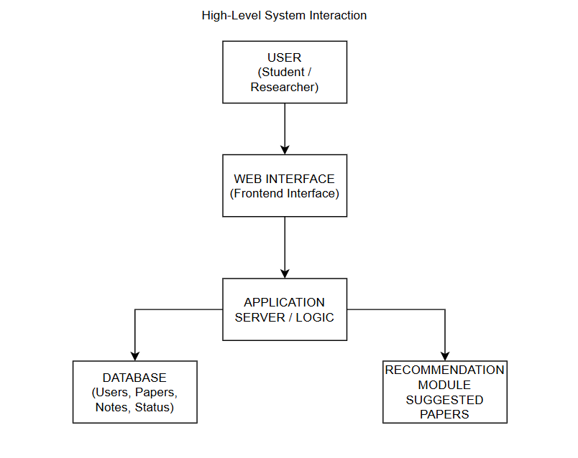
This diagram illustrates how the user interacts with the system through the web interface, which communicates with the application server. The server processes user requests, stores information in the database, and retrieves recommendations from the recommendation module. The recommendation system may use content-based filtering or similarity analysis on paper metadata such as keywords, abstracts, and research topics.
The system integrates several artificial intelligence components to enhance the research workflow. Uploaded research papers are processed using vector embeddings to represent document content in a semantic form. These embeddings enable efficient semantic search and recommendation of related research papers. The system also uses Large Language Models (LLMs) to generate summaries of research papers and to support a conversational interface that allows users to ask questions about uploaded documents. A Retrieval-Augmented Generation (RAG) architecture is used to retrieve relevant sections of the document and generate accurate responses to user queries.
The AI components of the system use techniques such as natural language processing, semantic embeddings, topic modelling, and graph-based analysis to extract knowledge from research papers.

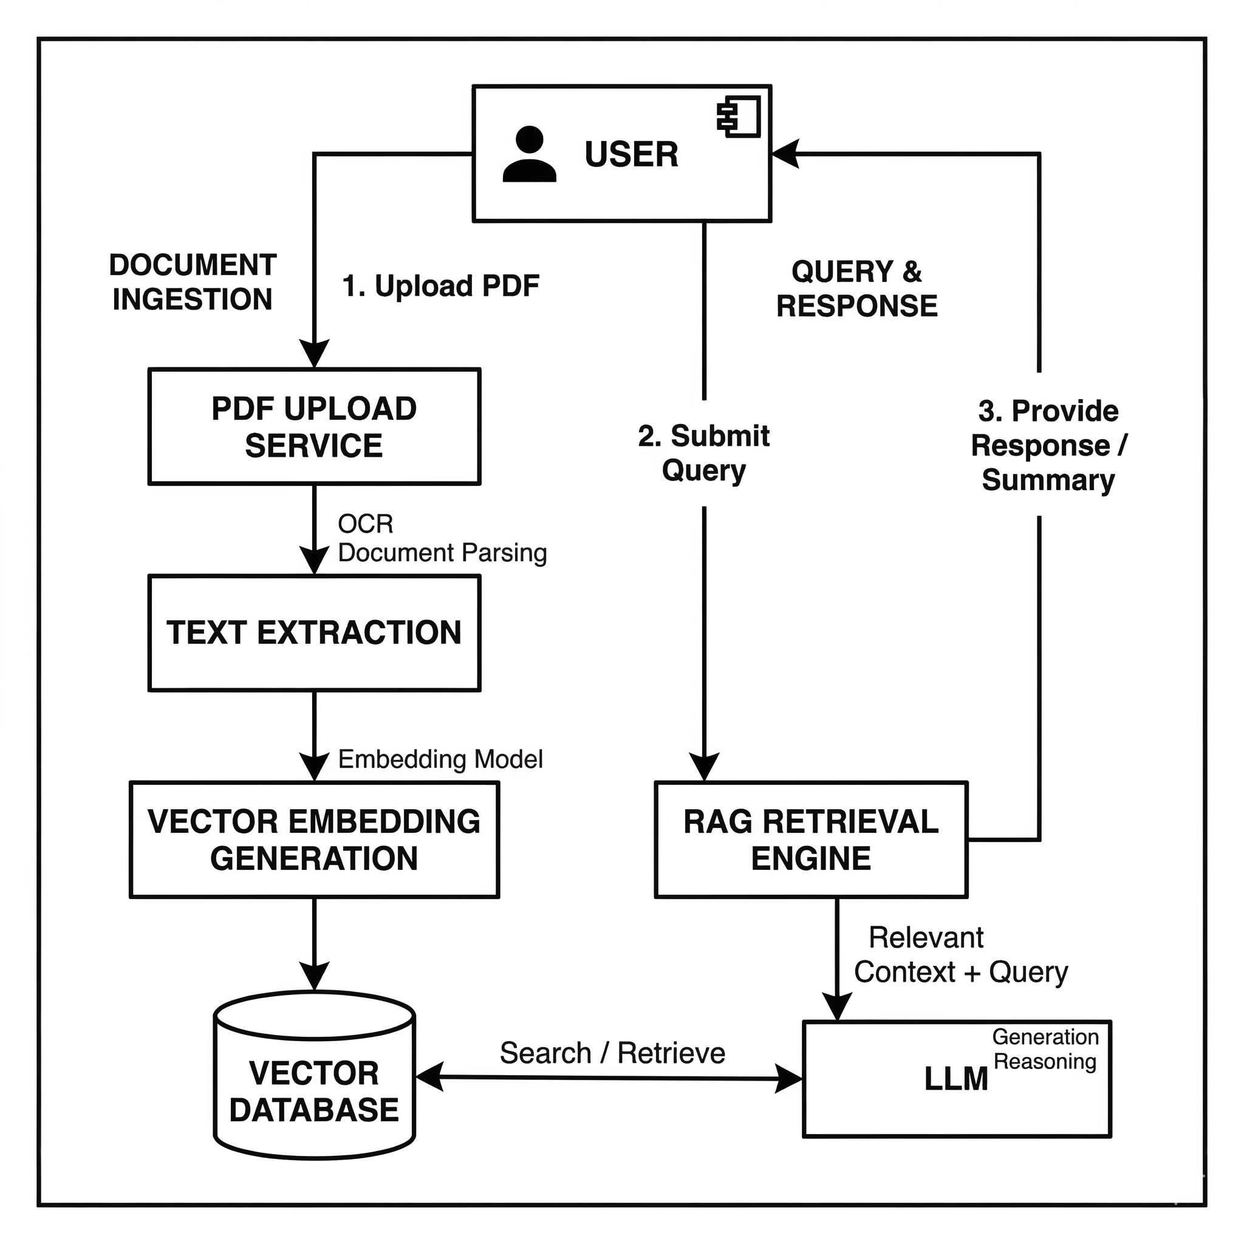

Product Functionality
The system provides several core functionalities to support the research workflow of students and researchers.

The system provides the following major functionalities:
• User registration and authentication
• Searching for research papers using keywords or topics
• Uploading research papers in PDF format
• Viewing detailed information about research papers
• Adding research papers to a personal workspace
• Tracking the reading status of research papers
• Creating and managing notes associated with research papers

AI-based research assistance features include:
• Automatic generation of research paper summaries using large language models
• Chat-based interaction with research papers to answer user questions
• Detection of potential research gaps within a topic area
• Generation of literature review summaries based on multiple research papers
• Recommendation of semantically related research papers using vector embeddings
• Visualization of research relationships through a research map or citation graph
• Identification of similar research papers using semantic similarity analysis
These capabilities transform the system from a simple paper management tool into an intelligent research discovery platform. These functions provide users with a structured environment for managing academic research and discovering new papers related to their interests.

Design and Implementation Constraints
The development of the system is subject to several design and implementation constraints that must be considered during the development process.
First, the system will be implemented as a web-based application, which means users must access the system through a web browser. The development will rely on common web technologies such as HTML, CSS, and JavaScript for the user interface and backend technologies for server-side processing and database management.
Second, the design of the system must follow the COMET (Concurrent Object Modeling and Architectural Design Method) methodology as required by the course. COMET provides a structured approach for designing concurrent and distributed systems and will guide the architectural design of the software.
In addition, the system design must be documented using UML (Unified Modeling Language) diagrams such as class diagrams, sequence diagrams, and use case diagrams. UML provides a standard way of visualizing the design of software systems and helps improve communication between developers and stakeholders.
The system will also rely on a database for storing user data, research papers, and notes. Performance limitations such as server resources, storage capacity, and network connectivity may affect the scalability and response time of the system.
References:
- Gomaa, H. Designing Concurrent, Distributed, and Real-Time Applications with UML and COMET.
- Object Management Group (OMG). Unified Modeling Language (UML) Specification.

Assumptions and Dependencies
The development of the Research Paper Tracking and Recommendation Tool is based on several assumptions and dependencies that may influence the system design and implementation.
- Users will have access to a computer or device with a stable internet connection and a modern web browser.
- The system assumes that research paper metadata (such as titles, authors, and abstracts) will be available from external sources or datasets.
- Users are assumed to have basic familiarity with using web-based applications.
- The recommendation module depends on user activity and stored research paper information to generate meaningful suggestions.
- The system depends on the availability of a backend server and database infrastructure for storing and retrieving system data.
If any of these assumptions change, modifications to the system design or implementation may be required.

Specific Requirements

External Interface Requirements

User Interfaces
The system provides a web-based user interface that allows students and researchers to interact with the Research Paper Tracking and Recommendation Tool through a standard web browser. The interface is designed to be simple, intuitive, and easy to navigate so that users can efficiently manage their research papers and related information.
The main user interface components include:
- Login and Registration Interface – Allows users to create an account and securely access the system using their credentials.
- Dashboard / Workspace – Provides an overview of the user’s saved research papers, reading progress, and recent activities.
- Paper Search Interface – Enables users to search for research papers using keywords, titles, or research topics.
- Paper Details View – Displays detailed information about a selected research paper, including title, authors, abstract, and publication details.
- Notes Interface – Allows users to add, edit, and manage personal notes associated with specific research papers.
- Recommendation Panel – Displays suggested research papers based on user activity and previously saved papers.
Users interact with the system primarily through menus, buttons, search fields, and interactive panels provided in the web interface.

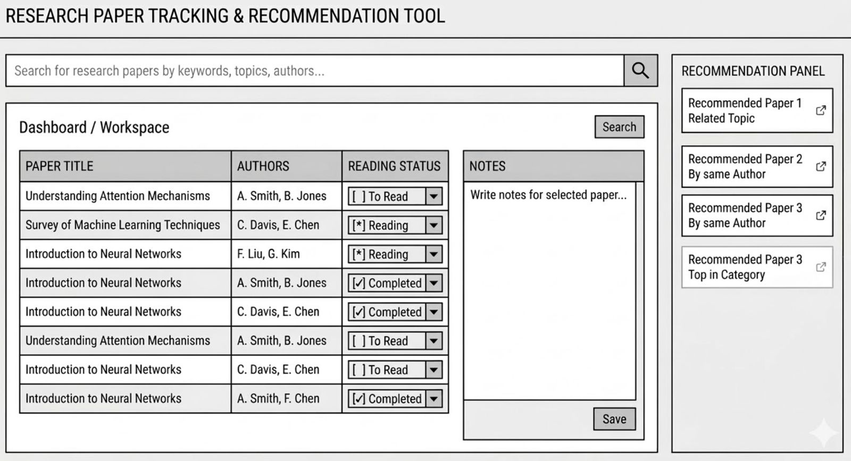

Hardware Interfaces
The Research Paper Tracking and Recommendation Tool interacts with standard computing devices used by students and researchers. The system does not require specialized hardware and can operate on commonly available devices.
The primary hardware interfaces include:
- Desktop Computers and Laptops – Used by users to access the system through a web browser.
- Input Devices – Such as keyboards, mice, or touchpads for interacting with the user interface.
- Mobile Devices (Optional Access) – Users may also access the web application through mobile browsers.
- Server Hardware – Hosts the application and stores the database containing user accounts, research papers, and notes.
The system primarily receives user input through these devices and processes requests through the server infrastructure.

Software Interfaces
The system interacts with several software components that support its functionality.
- Web Browser Interface – The application is accessed through modern web browsers such as Google Chrome, Microsoft Edge, or Mozilla Firefox.
- Database Management System (DBMS) – Stores user information, research paper data, reading status, and notes.
- Recommendation Module – Processes stored user activity and research paper information to generate paper recommendations.
- External Research Paper Sources (Optional) – The system may retrieve research paper metadata from external academic databases or APIs.
These software interfaces enable the system to store, process, and retrieve information required for managing research papers and generating recommendations.

Functional Requirements
Functional requirements describe the specific actions and services that the system must perform. These requirements define the expected behaviour of the Research Paper Tracking and Recommendation Tool.

F1: User Registration
The system shall allow new users to create an account by providing required information such as name, email address, and password.

F2: User Authentication
The system shall allow registered users to log into the system using valid credentials and securely access their personal workspace.

F3: Search Research Papers
The system shall allow users to search for research papers using keywords, titles, or research topics.

F4: View Paper Details
The system shall allow users to view detailed information about a selected research paper, including title, authors, abstract, and publication details.

F5: Add Paper to Workspace
The system shall allow users to save selected research papers to their personal workspace for future reference.

F6: Track Reading Status
The system shall allow users to update and track the reading status of research papers (e.g., To Read, Reading, Completed).

F7: Create Notes
The system shall allow users to create notes associated with specific research papers.

F8: Edit or Delete Notes
The system shall allow users to modify or delete notes that were previously created.

F9: Manage Workspace
The system shall allow users to organize, update, or remove research papers from their workspace.

F10: Generate Paper Recommendations
The system shall generate recommendations for research papers based on the user’s reading history or saved papers.

F11: View Recommended Papers
The system shall allow users to view a list of recommended research papers within the recommendation panel.

F12: Logout
The system shall allow users to securely log out of the system.

F13 – Upload Research Paper (PDF)
The system shall allow users to upload research papers in PDF format to their personal workspace for storage and processing.

F14 – Extract and Process Paper Content
The system shall extract textual content from uploaded PDF research papers and prepare it for further processing by the AI components of the system.

F15 – Generate AI Summary
The system shall generate a concise summary of the uploaded research paper using a Large Language Model (LLM).

F16 – Generate Vector Embeddings
The system shall convert the extracted research paper content into vector embeddings to enable semantic search and document similarity analysis.

F17 – Chat with Research Paper
The system shall allow users to ask questions about an uploaded research paper and receive responses generated using a Retrieval-Augmented Generation (RAG) model.

F18 – Retrieve Relevant Document Sections
The system shall retrieve relevant sections of a research paper based on semantic similarity between the user’s question and the stored vector embeddings.

F19 – AI-Based Paper Recommendation
The system shall recommend research papers by comparing vector embeddings of documents and identifying semantically similar research papers.

F20 – Detect Research Gaps
The system shall analyse uploaded or retrieved research papers and identify potential research gaps within a given topic area using natural language processing techniques.

F21 – Generate Literature Review
The system shall automatically generate a structured literature review summary based on a collection of related research papers.

F22 – Generate Research Map Visualization
The system shall visualize relationships between research papers using a graph-based research map that represents similarity or citation relationships between papers.

F23 – Detect Similar Research Papers
The system shall compute semantic similarity between research papers and present a ranked list of related papers.

Use Case Model

The Use Case Model describes how users interact with the system to perform different tasks. The primary actor in the system is the User (Student or Researcher) who interacts with the system to search, manage, and track research papers.
The main use cases of the system include:
- Register account
- Login to the system
- Search research papers
- Upload Research Paper
- Generate Paper Summary
- View paper details
- Chat with Research Paper
- Add paper to workspace
- Manage notes
- Track reading progress
- View recommended papers
- Detect Research Gaps
- Generate Literature Review
- View Research Map
- View Similar Papers

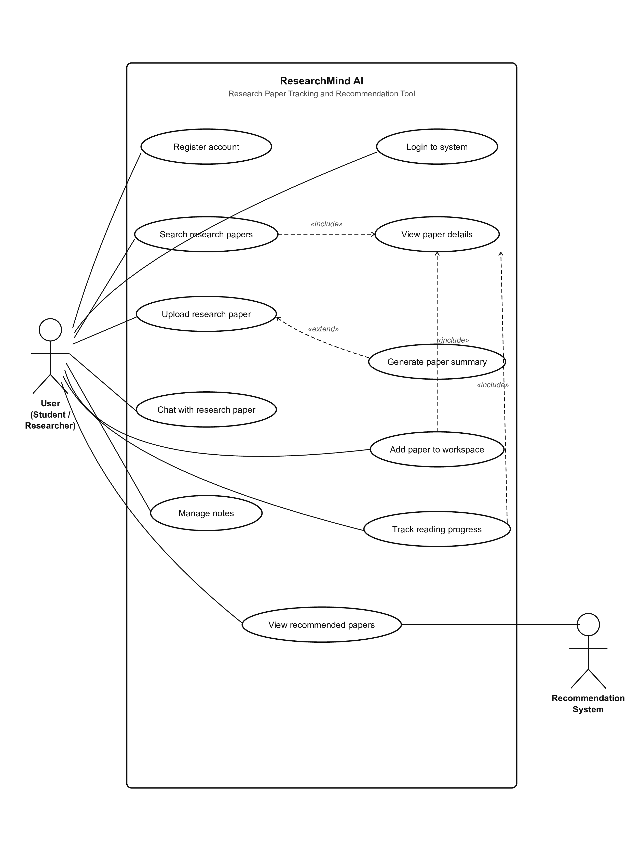
A Use Case Diagram will illustrate the interactions between the user and the system functionalities.

Use Case U1 User Login
Authors: Yasaswini
Purpose:
The purpose of this use case is to allow registered users to securely access the system and their personal research workspace.
Requirements Traceability:
F2 – User Authentication
Priority:
High
Preconditions:
The user must have an existing registered account.
Post Conditions:
The user is successfully authenticated and redirected to the system dashboard.
Actors:
User (Student or Researcher)
Extends:
None
Flow of Events
1. Basic Flow
- The user opens the system login page.
- The user enters their registered email and password.
- The system verifies the entered credentials.
- If the credentials are valid, the system grants access and displays the user dashboard.
2. Alternative Flow
- If the user enters incorrect login credentials, the system displays an error message and prompts the user to try again.
3. Exceptions
- If the system database is unavailable, the login request cannot be processed and the user is notified.
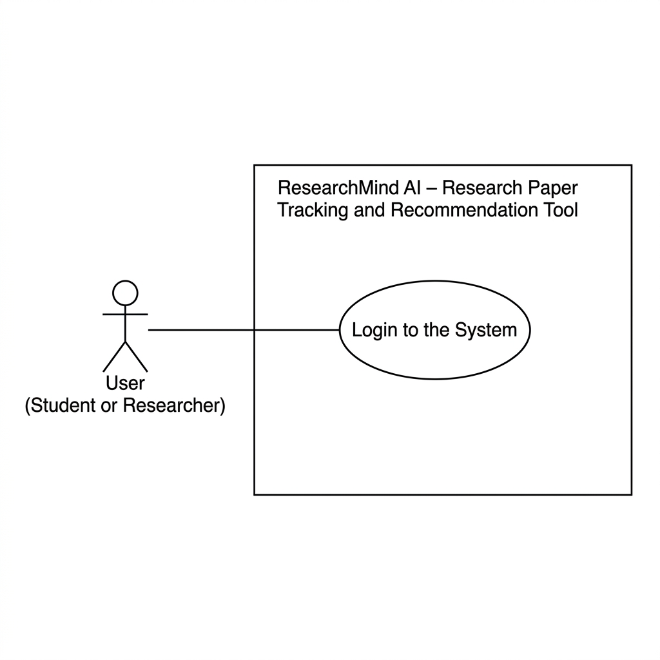
Includes:
None
Notes / Issues:
Future versions may include multi-factor authentication for improved security.

Use Case U2 Search Research Papers
Authors: Prasamita
Purpose:
To allow users to search for research papers based on keywords, titles, or topics.
Requirements Traceability:
F3 – Search Research Papers
Priority:
High
Preconditions:
The user must be logged into the system.
Post Conditions:
A list of relevant research papers is displayed to the user.
Actors:
User (Student or Researcher)
Flow of Events
1. Basic Flow
- The user enters a keyword or topic in the search field.
- The system processes the search request.
- The system retrieves relevant research papers from the database or external sources.
- The search results are displayed to the user.
2. Alternative Flow
- If no matching papers are found, the system displays a message indicating that no results were found.
3. Exceptions
- If the search service fails, the system notifies the user that the search could not be completed.
Includes:
None
Notes / Issues:
Future improvements may include advanced search filters such as publication year, author name, or research field.
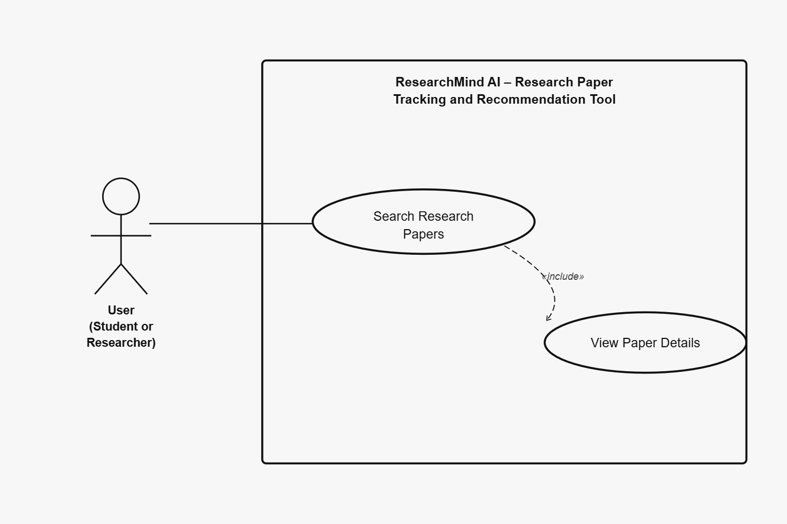

Use Case U3 – Add Paper to Workspace
Author: Bhuvaneshwari
Purpose:
This use case allows users to save selected research papers into their personal workspace so they can easily access and manage them later.
Requirements Traceability:
F5 – Add Paper to Workspace
Priority:
High
Preconditions:
The user must be logged into the system and must have searched or viewed a research paper.
Post Conditions:
The selected research paper is added to the user’s workspace.
Actors:
User (Student / Researcher)
Extends:
None
Flow of Events
1. Basic Flow
- The user searches for or views a research paper.
- The system displays the paper details.
- The user selects the option to add the paper to their workspace.
- The system stores the paper in the user’s workspace.
- The system confirms that the paper has been successfully added.
2. Alternative Flow
- If the paper already exists in the workspace, the system informs the user that the paper has already been saved.
3. Exceptions
- If the system fails to save the paper due to a database error, an error message is displayed.
Includes:
None
Notes / Issues:
Future versions may allow users to organize saved papers into folders.

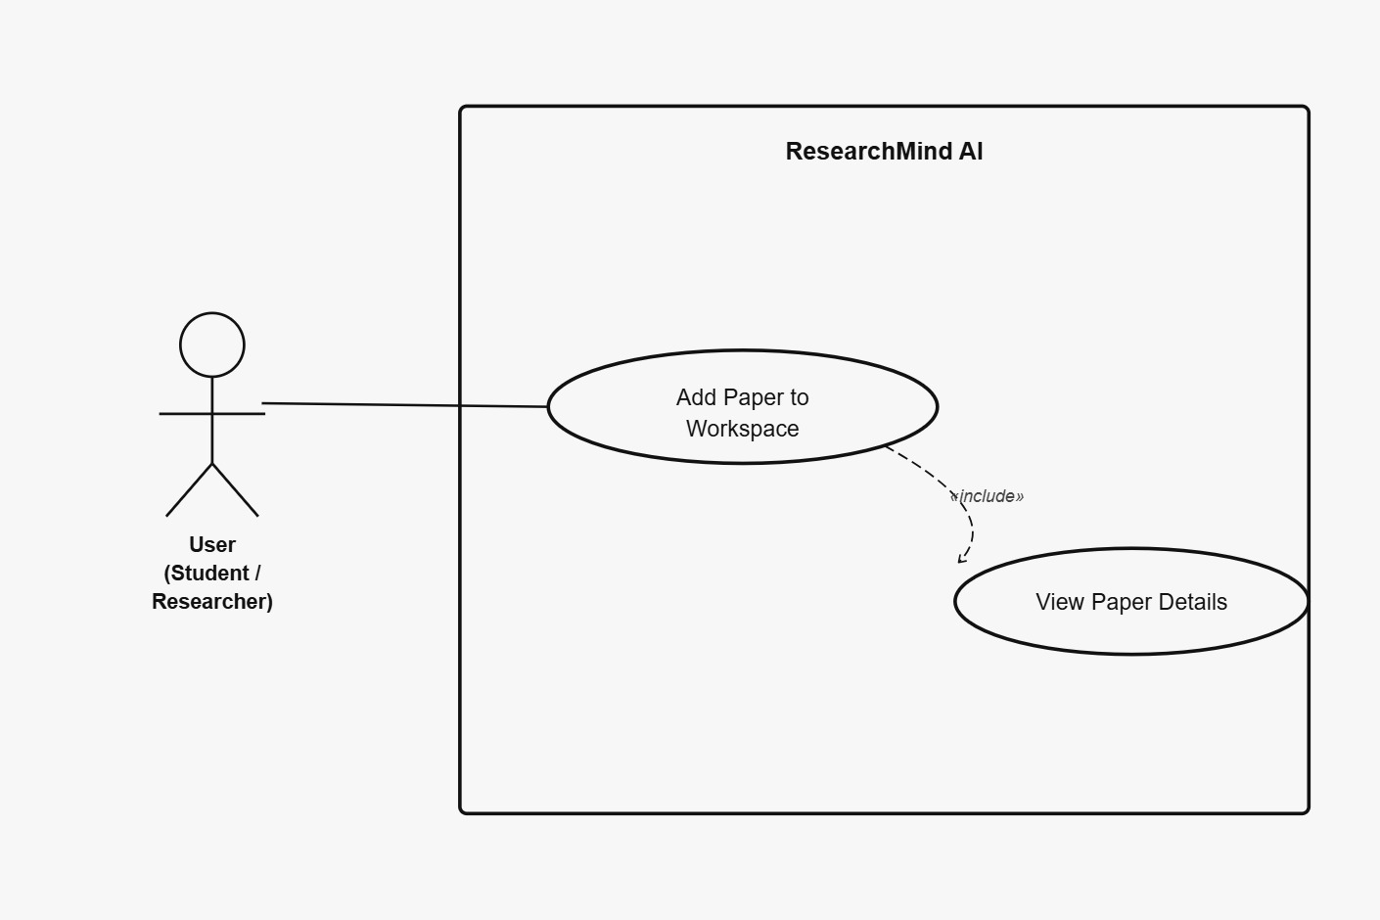

Use Case U4 – View Recommended Papers
Authors: Swaroopa
Purpose:
To provide users with recommendations for research papers based on their previously viewed or saved papers.
Requirements Traceability:
F10 – Generate Paper Recommendations
Priority:
Medium
Preconditions:
The user must be logged into the system and must have activity history within the workspace.
Post Conditions:
A list of recommended research papers is displayed to the user.
Actors:
User (Student / Researcher)
Recommendation System
Flow of Events
1. Basic Flow
- The user accesses the recommendation section of the system.
- The system analyses the user’s saved papers and activity history.
- The recommendation module identifies related research papers.
- The system displays the recommended papers to the user.
2. Alternative Flow
- If there is insufficient user activity, the system displays general recommended papers.
3. Exceptions
- If the recommendation service fails, the system notifies the user that recommendations are temporarily unavailable.
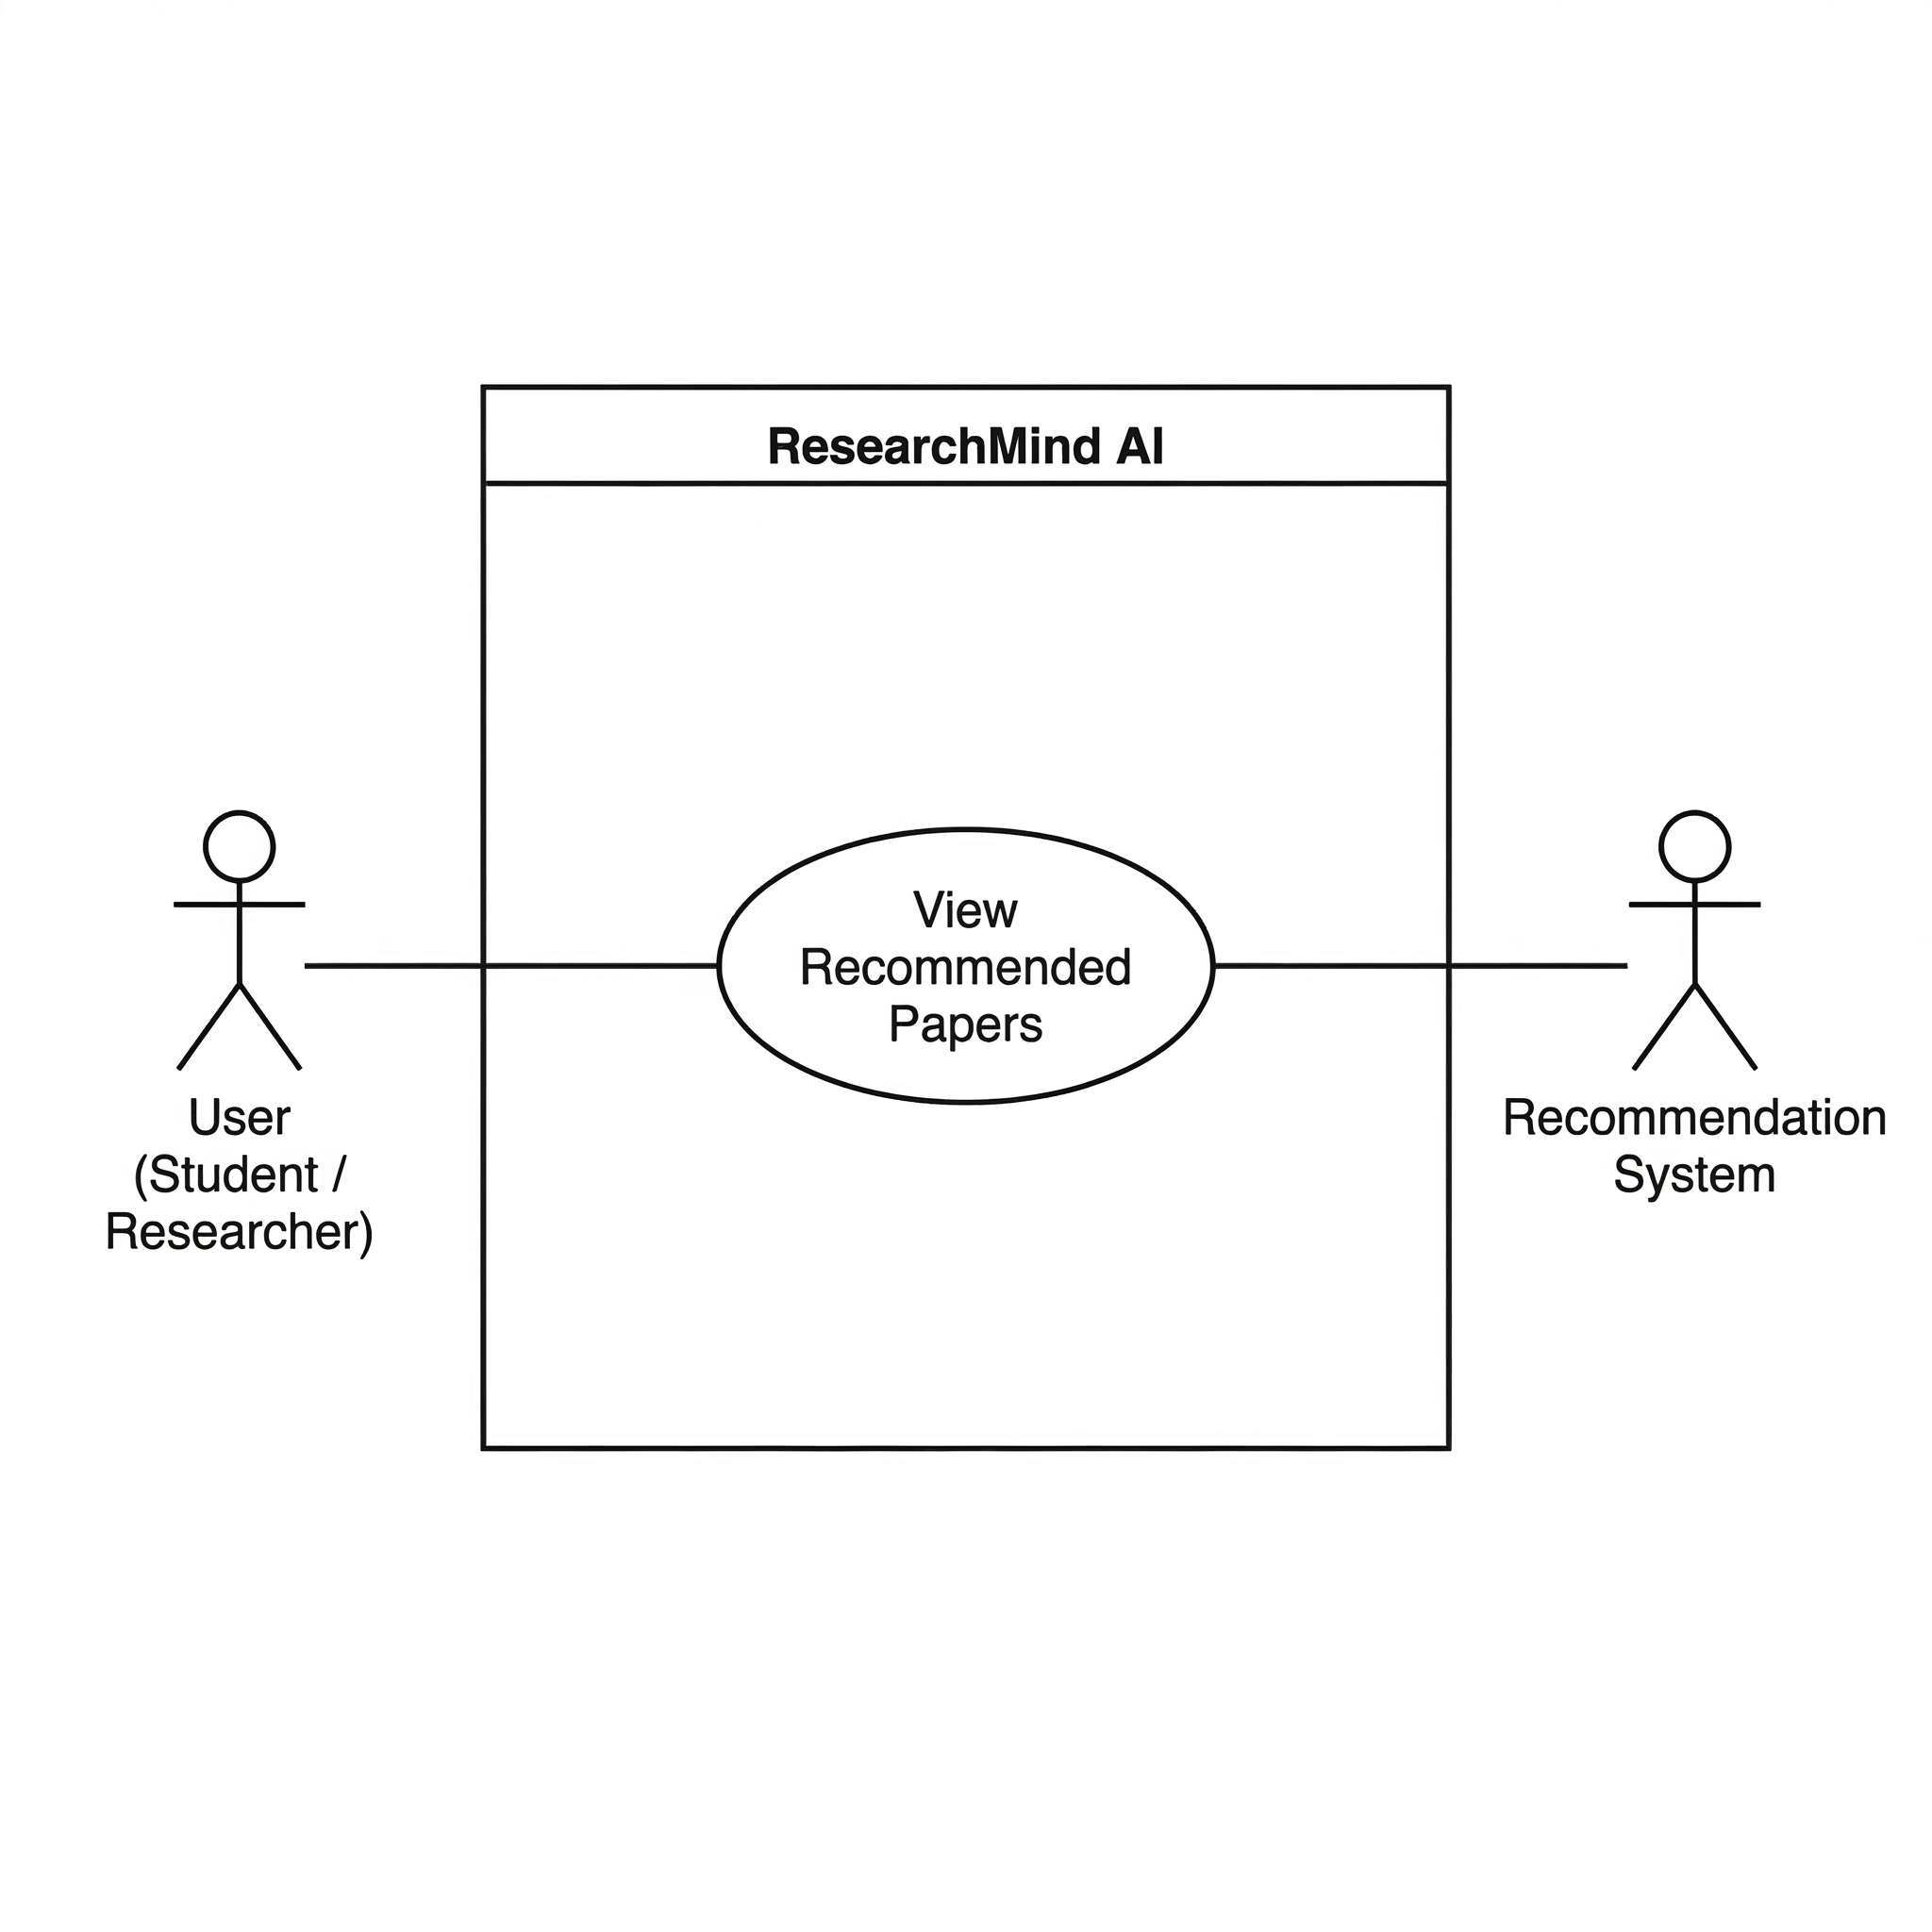
Includes:
None
Notes / Issues:
Future versions may include personalized recommendation algorithms.

Use Case U5 – Register Account
Author: Gayathri
Purpose:
This use case allows new users to create an account in the system so that they can access the platform’s research management features.
Requirements Traceability:
F1 – User Registration
Priority:
High
Preconditions:
The user must not already have an account in the system.
Post Conditions:
A new user account is successfully created and stored in the system database.
Actors:
User (Student / Researcher)
Extends:
None
- Flow of Events
1. Basic Flow
- The user opens the registration page.
- The user enters required information such as name, email, and password.
- The system validates the entered information.
- The system creates a new user account.
- The system confirms successful registration.
2. Alternative Flow
- If the email address is already registered, the system displays an error message.
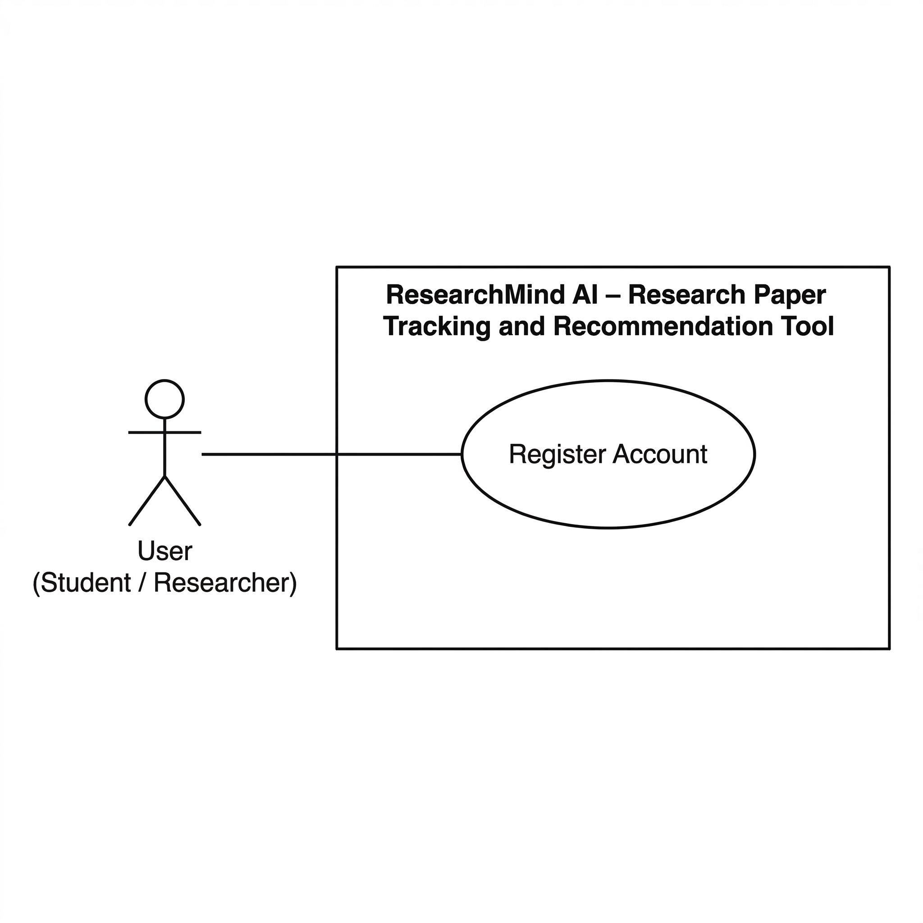
3. Exceptions
- If the system fails to store the account information, registration cannot be completed.
Includes:
None
Notes / Issues:
Future versions may include email verification.

Use Case U6 – Upload Research Paper
Author: Jagrat
Purpose:
This use case allows users to upload research papers in PDF format to their workspace so they can analyse and interact with the document.
Requirements Traceability:
F13 – Upload Research Paper
Priority:
High
Preconditions:
The user must be logged into the system.
Post Conditions:
The uploaded research paper is stored in the system and prepared for further processing.
Actors:
User (Student / Researcher)
- Flow of Events
1. Basic Flow
- The user selects the option to upload a research paper.
- The user selects a PDF file from their device.
- The system uploads and stores the file.
- The system extracts the text from the document for further processing.
2. Alternative Flow
- If the uploaded file is not in PDF format, the system displays an error message.
3. Exceptions
- If the upload fails due to network issues, the system notifies the user.
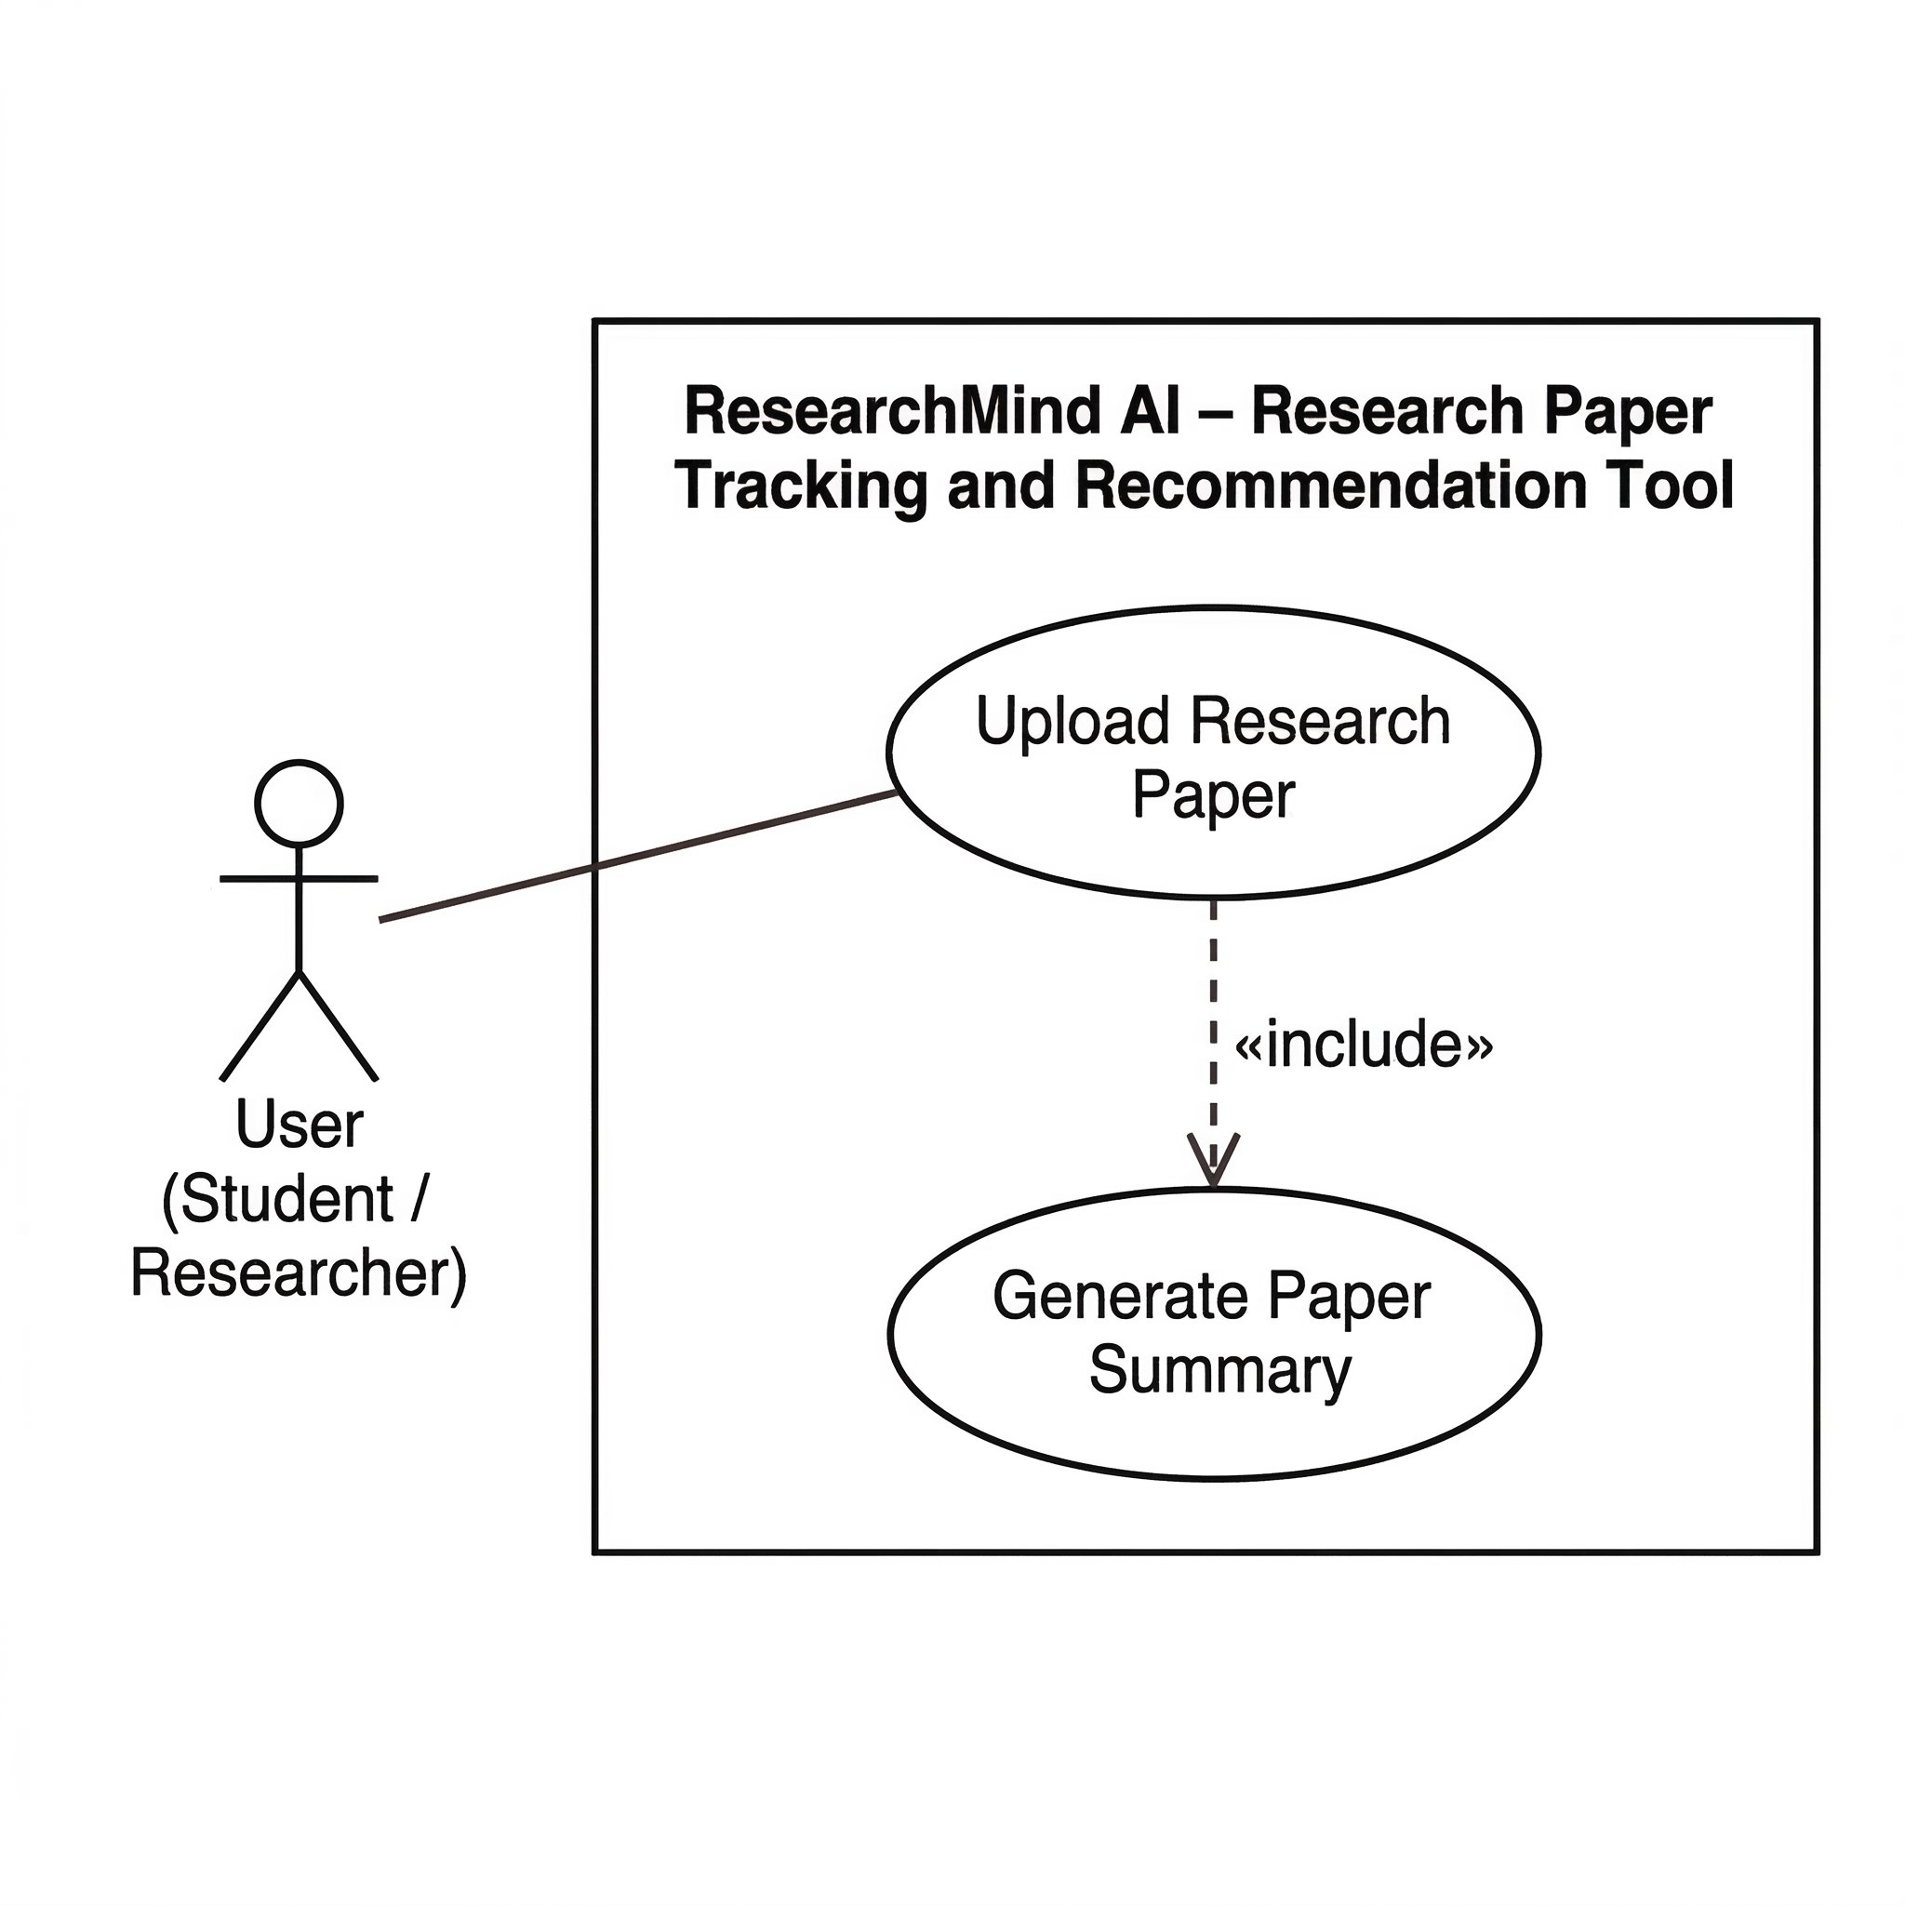
Includes:
Generate Paper Summary

Use Case U7 – Generate Paper Summary
Author: Haritha
Purpose:
To automatically generate a concise summary of an uploaded research paper using an AI language model.
Requirements Traceability:
F14 – Generate Research Paper Summary
Priority:
Medium
Preconditions:
The research paper must be uploaded and processed by the system.
Post Conditions:
A summarized version of the research paper is displayed to the user.
Actors:
User (Student / Researcher)
- Flow of Events
1. Basic Flow
- The user selects the option to generate a summary for an uploaded paper.
- The system processes the paper content.
- The AI model generates a concise summary of the document.
- The summary is displayed to the user.
2. Alternative Flow
- The user may regenerate the summary if needed.
3. Exceptions
- If the AI service fails, the system displays an error message.
Includes:
None

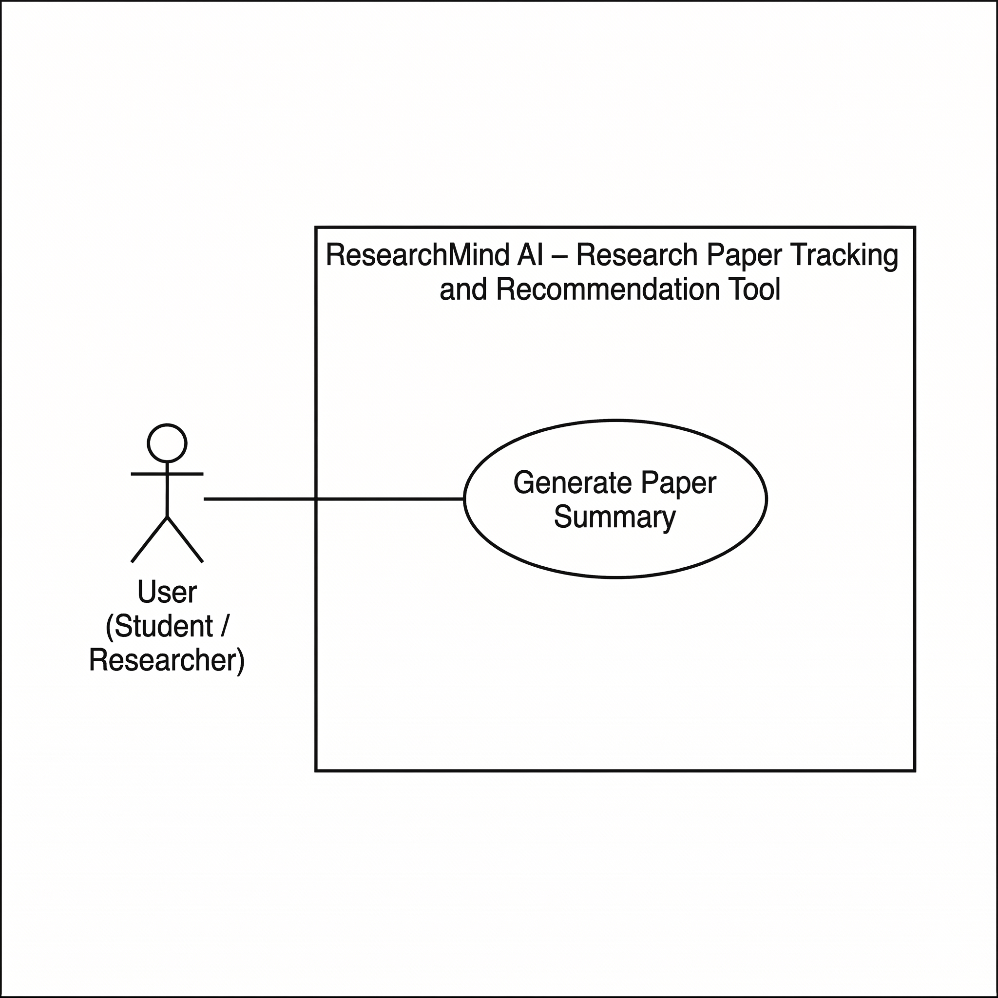

Use Case U8 – Chat with Research Paper
Author: Shahzeb
Purpose:
To allow users to ask questions about a research paper and receive answers generated by the system.
Requirements Traceability:
F17 – Chat with Research Paper
Priority:
Medium
Preconditions:
The research paper must be uploaded and processed by the system.
Post Conditions:
The system generates a response to the user’s question based on the content of the research paper.
Actors:
User (Student / Researcher)
- Flow of Events
1. Basic Flow
- The user opens a research paper.
- The user enters a question related to the document.
- The system retrieves relevant sections of the paper.
- The AI model generates an answer.
- The system displays the response to the user.
2. Alternative Flow
- The user may ask additional follow-up questions.
3. Exceptions
- If the AI service is unavailable, the system displays a message indicating that the request cannot be processed.
Includes:
View Paper Details

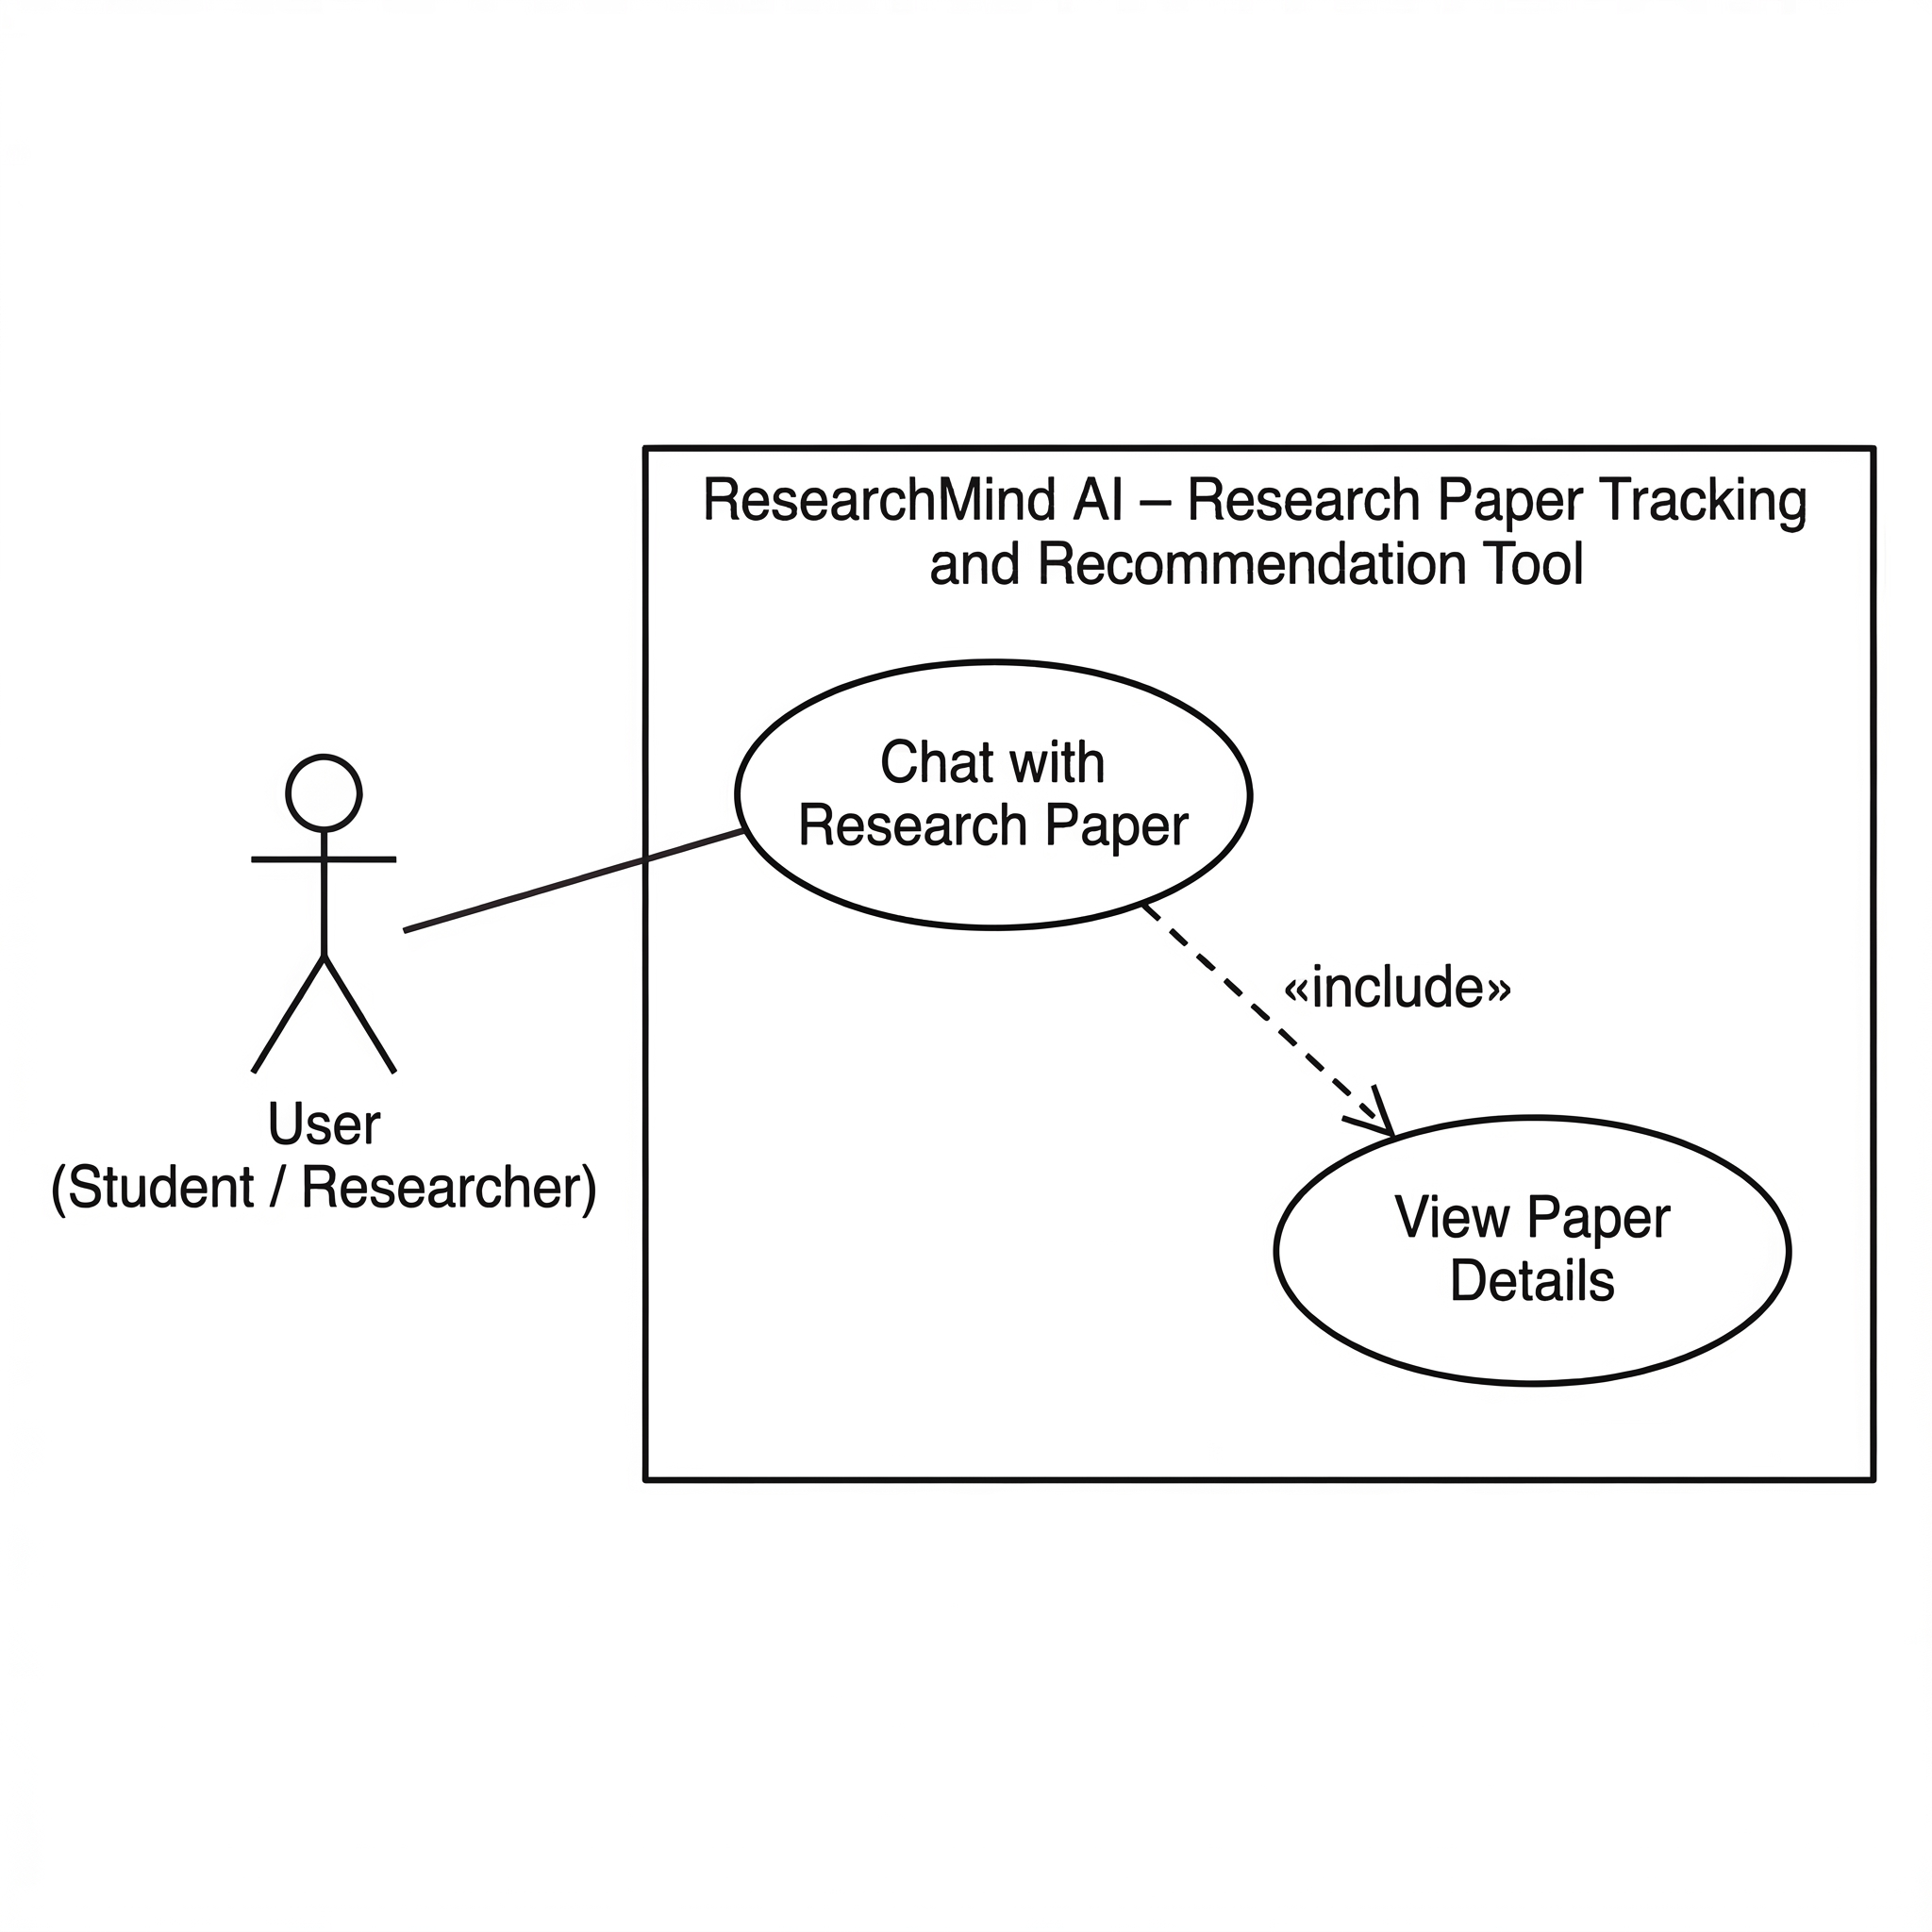

Other Non-functional Requirements

Performance Requirements
Performance requirements describe how efficiently the system should operate under normal usage conditions. Since the Research Paper Tracking and Recommendation Tool is a web-based application, the system must provide responsive interactions for users performing research tasks such as searching papers, viewing results, and managing their workspace.
The following performance requirements are defined:
P1 – Login Response Time
The system shall authenticate a user and display the dashboard within 3 seconds under normal network conditions.
P2 – Search Response Time
The system shall return search results for research papers within 5 seconds after the user submits a search query.
P3 – Workspace Update Performance
When a user adds a research paper to their workspace, the system shall update and store the information in the database within 2 seconds.
P4 – Recommendation Generation
The system shall generate and display recommended research papers within 5 seconds after the user accesses the recommendation panel.
P5 – Concurrent Users
The system should support multiple concurrent users accessing the platform without significant degradation in performance.
P6 – AI Processing Time
The system shall generate AI summaries or responses to user queries within 10 seconds under normal system conditions.
P7 – AI Analysis Performance
The system shall perform AI-based analysis tasks such as research gap detection, literature review generation, and research map construction within a reasonable processing time under normal operating conditions.

These performance requirements ensure that the system remains responsive and usable for researchers who frequently interact with research data.

Safety and Security Requirements
The system must ensure that user data and research information are protected from unauthorized access, modification, or loss. Although the system does not control physical devices, security and data protection remain important considerations.

The following security requirements are defined:
S1 – User Authentication
The system shall require users to authenticate using valid login credentials before accessing their workspace or personal data.
S2 – Data Protection
The system shall securely store user data, including saved papers and notes, in a database to prevent unauthorized modification or deletion.
S3 – Secure Communication
All communication between the user’s web browser and the system server should occur through secure communication protocols such as HTTPS.
S4 – Access Control
Users shall only be able to access and modify research papers, notes, and workspace information associated with their own accounts.
S5 – Data Backup
The system should maintain periodic backups of the database to prevent loss of research data due to system failures.
These measures help maintain the confidentiality, integrity, and availability of user data within the system.
.

Software Quality Attributes
Software quality attributes describe the characteristics that ensure the system is reliable, maintainable, and easy to use. The following quality attributes are considered important for the Research Paper Tracking and Recommendation Tool.

Reliability
The system must operate consistently and provide accurate results when users perform research tasks.
- The system should maintain stable operation during normal usage without unexpected crashes.
- The database must reliably store research papers, user notes, and reading status information.
- In the event of a system failure, previously saved user data should not be lost.
Ensuring reliability is important because users depend on the system to manage and track important research materials.

Usability
The system should provide an intuitive and user-friendly interface that allows students and researchers to easily navigate and perform research tasks.
- The interface should be simple and clearly organized so that users can quickly find features such as search, workspace, and notes.
- Navigation menus, buttons, and search fields should be easy to understand and operate.
- Users should be able to perform common actions such as searching papers or saving notes with minimal steps.
Improving usability helps ensure that users can efficiently manage research papers without needing extensive training.

Maintainability
The system should be designed in a way that allows developers to easily update or modify the software in the future.
- The system architecture should follow modular design principles so that individual components can be updated independently.
- Clear documentation and UML diagrams should be maintained to assist future developers in understanding the system design.
- New features, such as improved recommendation algorithms or additional research data sources, should be able to be integrated without major changes to the system.
Maintaining a modular and well-documented design will help ensure that the system can evolve as new requirements emerge.

Scalability
The system should be designed to support growth in the number of users, uploaded research papers, and AI processing requests without significant degradation in performance.
To achieve scalability, the system should follow a modular architecture where different components such as the application server, AI processing services, and vector database can be scaled independently. For example, AI-related tasks such as document summarization, embedding generation, and question answering may require additional computational resources when system usage increases.
The system should also support efficient storage and retrieval of research paper embeddings within the vector database to ensure that recommendation and semantic search operations remain responsive as the dataset grows. In addition, the system architecture should allow deployment on scalable cloud infrastructure so that additional processing or storage resources can be allocated when necessary.
Designing the system with scalability in mind will help ensure that the platform can handle an increasing number of users and research papers while maintaining acceptable system performance.

Other Requirements
This section describes additional requirements that are not explicitly covered in previous sections of this Software Requirements Specification but are relevant to the development and operation of the Research Paper Tracking and Recommendation Tool.

Database Requirements
The system requires a database to store and manage information related to users, research papers, notes, and reading progress. The database should support efficient storage and retrieval of data to ensure smooth system operation.
The database will store the following types of information:
- User account information such as username, email, and encrypted password
- Research paper metadata including title, authors, abstract, and publication details
- User workspace data such as saved papers and reading status
- Notes created by users for individual research papers
The database system should ensure data consistency, integrity, and efficient querying to support search and recommendation functionalities.

Scalability Considerations
The system should be designed in a way that allows it to support an increasing number of users and research papers over time. As more users interact with the platform, the system architecture should be able to handle additional data storage and processing requirements without significant performance degradation.
Future improvements may include optimization of search algorithms and recommendation models to support larger datasets.

Future Enhancement Possibilities
The current version of the system focuses on basic research paper tracking and recommendation features. However, the design should allow future enhancements such as:
- Integration with external academic databases or APIs
- Advanced filtering and sorting of research papers
- Improved recommendation algorithms based on user research interests
- Collaboration features that allow users to share research papers or notes
Designing the system with these potential enhancements in mind will help ensure long-term adaptability and usefulness.

Appendix A – Data Dictionary

The data dictionary describes the main data elements used in the Research Paper Tracking and Recommendation Tool. It provides details about system variables, their descriptions, possible values, and the operations in which they are used. This helps developers and stakeholders clearly understand how data is stored and used within the system.

Data Element | Description | Type | Related Operations
AI_Response | Answer generated by the AI system in response to a user query about a research paper | Text | Chat with research paper
AI_Summary | Automatically generated summary of a research paper created using a Large Language Model | Text | Summary generation
Authors | Names of the researchers who wrote the research paper | String | Paper search, paper details display
Citation_Graph | Graph structure representing relationships between research papers | Graph | Research map visualization
Email | Email address associated with a user account | String | User registration, login
Extracted_Text | Text extracted from an uploaded PDF document for further AI processing | Text | Embedding generation, summarization
Literature_Review | AI-generated summary of research papers within a topic | Text | Literature review generation
Notes | User-created notes related to a research paper | Text | Notes creation, editing
Paper_Embedding | Vector representation of research paper content used for semantic search and recommendations | Vector | Semantic search, recommendation
Paper_ID | Unique identifier assigned to each research paper | Integer | Paper search, storage
Paper_Title | Title of the research paper | String | Paper search, paper details display
Reading_Status | Indicates the user's reading progress on a research paper | Enum (To Read, Reading, Completed) | Paper tracking
Recommendation_List | List of research papers suggested to the user based on semantic similarity | List | Recommendation system
Research_Gap | Identified missing or underexplored research areas | Text | Research gap detection
Similarity_Score | Numerical score representing similarity between papers | Float | Paper similarity analysis
Topic_Cluster | Group of papers related to the same research topic | List | Topic clustering
Uploaded_PDF | Research paper file uploaded by the user | File | Upload paper
User_ID | Unique identifier assigned to each user | Integer | User management
User_Query | Question asked by the user about a research paper in the chat interface | Text | Chat with research paper
Username | Name used to identify a user account in the system | String | User registration, login

This data dictionary provides a structured overview of how important data elements are used throughout the system.

Appendix B - Group Log
The group log records the meetings and activities conducted by the team during the preparation of the Software Requirements Specification document. It helps demonstrate the collaborative effort involved in analyzing the project requirements and producing the final document.

Date | Participants | Activity Description
08/03/2026 | All group members | Initial discussion about the project idea and system objectives
09/03/2026 | All group members | Brainstormed system features and identified core functionalities
10/03/2026 | All Group members | Created initial UML diagrams including use case and class diagrams
11/03/2026 | All group members | Drafted the first sections of the SRS document
13/03/2026 | All group members | Reviewed and refined the functional requirements and system descriptions
16/03/2026 | All group members | Finalized the SRS document and prepared it for submission

These meetings helped ensure that the team collaboratively developed the system requirements and maintained consistency across the document.

