1. Write a HTML code to create a table like below:

|  |  |  |
| --- | --- | --- |
| Cell1 | Cell2 | Cell3 |
| Cell4 | Cell5 | Cell6 |
| Cell7 | | |

* 1. Copy the above table and put the image into cell7 and write its description on cell5. Also use “**alt, width, height**” property.

1. Write a HTML code to generate the form as below:

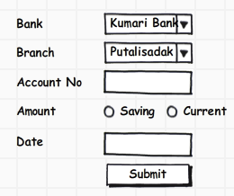

* 1. Account No cannot be empty: If empty the page should not be submit. Validate using Java script.

1. Write a HTML code to create a frame like below:

|  |  |
| --- | --- |
| A | |
| B | C |