<DEPARTMENT OF ELECTRICAL & COMPUTER ENGINEERING>
<ABES ENGINEERING COLLEGE, GHAZIABAD>
SOFTWARE REQUIREMENTS
SPECIFICATION (SRS)
Project Title: LogiCraft - Centralized Logistics & Fleet Management Platform
Standard Academic Compliance: IEEE Std 830-1998
————————————————————————————
SUBMITTED BY:  1. Bhuwan Sharma (Roll No: 2400320230031)  Degree: Bachelor of Technology (B.Tech)  Academic Year: 2024 - 20278 | UNDER THE GUIDANCE OF:  Prof. Abhi Gurjar  <Designation / Title>  Department of Electrical & Engg.  Status: 3rd Year Project Specification  Date of Submission: <DD-MM-YYYY>

Document Revision & Approval History
Version | Date | Description / Major Changes | Prepared By | Reviewed By
0.1 | 28-Sep-2026 | Initial Draft & Scope Definition | Bhuwan | Abhi Gurjar
1.0 | 30-Sep-2026 | Final 3rd Year SRS Baseline & Technical Architecture Baseline | Bhuwan | HOD / Committee

Guidance Note: This Software Requirements Specification document conforms to the IEEE 830-1998 standard recommended practice. All sections are strictly designed for 3rd-year university lab evaluation, project reviews, and system design baselines.

1. Introduction
1.1 Purpose
The purpose of this Software Requirements Specification (SRS) document is to provide a complete, clear, and unambiguous definition of the functionality, external interfaces, performance targets, data models, security controls, and architectural constraints of the proposed system: 'LogiCraft - Centralized Logistics & Fleet Management Platform'. This specification serves as the primary reference for student developers, project evaluators, academic supervisors, and prospective logistics users during the 3rd-year engineering curriculum.
1.2 Scope of the System
LogiCraft is designed to solve fragmented logistics operations, disconnected vehicle/fleet tracking, warehouse inventory blind spots, shipment-status inconsistency, and manual dispatch logging by delivering an end-to-end centralized logistics and fleet-management platform.
- In-Scope Capabilities: Centralized dashboard with operational KPIs and exception feeds; fleet and driver management; shipment lifecycle management and tracking IDs; warehouse and SKU inventory management; live GPS/telemetry visualization; ML-based shipment delay-risk prediction; PostgreSQL-backed operational data management; JWT authentication, RBAC, CORS, and audit logging.
- Out-of-Scope Boundaries: Physical fabrication of custom GPS/OBD-II hardware (standard software API/simulated telemetry is used); direct enterprise ERP/accounting integration such as SAP/Oracle Financials; real-time commercial payment-gateway processing (mock transaction modes may be used for transit/ticketing scenarios).
- Expected Benefits: Targeted 60% reduction in operational turnaround time for dispatchers; elimination of manual spreadsheet duplication; auditable state transitions across supply-chain entities; centralized access to fleet, shipment, warehouse, and tracking information; and improved operational visibility through analytics and map-based monitoring.
1.3 Definitions, Acronyms, and Abbreviations
Category | Term / Acronym | Definition / Standard Context
Standard | SRS | Software Requirements Specification (IEEE Std 830-1998 format).
Architecture | API | Application Programming Interface for JSON/REST data interchange.
Backend | Spring Boot | Java enterprise framework providing REST APIs, dependency injection, security integration, and application services.
ORM / JPA | Spring Data JPA | Object-Relational Mapping layer connecting Java entities and PostgreSQL tables.
Database | PostgreSQL | Open-source relational database management system used for the operational data tier.
Migrations | Flyway | Version-controlled database schema migration engine.
Security | JWT / RBAC | JSON Web Token for stateless authorization and Role-Based Access Control.
ML Engine | FastAPI / Scikit-Learn | Python microservice serving the trained RandomForest shipment-delay classifier.
Frontend | Vite / React | Modern frontend build tooling and component-based UI rendering.
Mapping | Google Maps API | Geospatial libraries used to render interactive tracking maps.
1.4 References
- IEEE Std 830-1998: IEEE Recommended Practice for Software Requirements Specifications.
- Software Engineering (10th Edition): Ian Sommerville, Pearson Education.
- Relevant Research Papers & APIs: Spring Boot Reference Documentation (v3.2.x); PostgreSQL 15 Documentation and pg_trgm extension documentation; Scikit-Learn User Guide for supervised learning and model serialization; MapLibre GL JS documentation; FastAPI documentation; and relevant REST/JWT security guidance. Project implementation source and migration scripts are maintained in the LogiCraft project repository.
1.5 Document Overview
The remainder of this SRS is partitioned into: Section 2 for product perspective, architecture, user personas, operating context, folder structure, dataset specifications, and implementation constraints; Section 3 for functional requirements; Section 4 for UI, hardware, software, and communication interfaces; Section 5 for non-functional requirements; Section 6 for deployment commands, systematic testing, logical tests, UML/DFD/ERD/sequence models, and future advancements; and Section 7 for academic review and sign-off.
2. Overall Description
2.1 Product Perspective
LogiCraft is a self-contained multi-tier platform comprising a Vite/React presentation layer, a Java Spring Boot REST API and business-logic tier, a Python FastAPI machine-learning sidecar, and a PostgreSQL persistence tier. The frontend communicates with Spring Boot through authenticated JSON/REST requests; Spring Boot accesses PostgreSQL through Spring Data JPA/JDBC and calls the FastAPI sidecar for shipment delay-risk prediction.
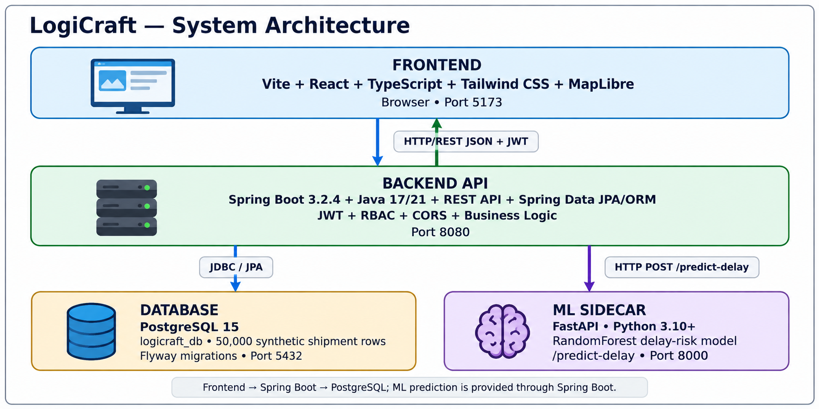
Figure 1. Clean system architecture of LogiCraft.

Backend Directory Folder Structure (Maven Package Standard)

backend/logicraft/
├── pom.xml
└── src/
├── main/
│ ├── java/com/logicraft/
│ │ ├── App.java
│ │ ├── auth/ # AuthController, AuthService, JWT filter/provider, User entity/repository
│ │ ├── fleet/ # Vehicle/Driver entities, repositories, controllers
│ │ ├── shipment/ # Shipment entity/repository/controllers, ML DTOs and client
│ │ ├── transport/ # Trip entity/repository/controller
│ │ ├── warehouse/ # Warehouse entity/repository/controller
│ │ ├── common/ # Metrics and cross-cutting logic/ exception handling
│ │ └── config/ # SecurityConfig, CORS, password encoder
│ └── resources/
│ ├── application.yml
│ └── db/migration/
│ ├── V1__init_schema.sql
│ ├── V2__operational_schema_and_seed.sql
│ ├── V4__frontend_contract_reconciliation.sql
│ ├── V5__seed_50k_shipments.sql
│ └── V6__seed_tracking_and_fleet.sql

PostgreSQL Operational Dataset Specifications

Dataset size: exactly 50,000 synthetic operational shipment rows generated through PostgreSQL/Flyway migration scripts.
Data quality requirements: unique tracking/reference identifiers, valid foreign-key relationships, operational status values, non-negative quantities/costs, and timestamps suitable for tracking and analytics. The dataset is synthetic and intended for development, testing, performance evaluation, and academic demonstration.

Frontend ↔ Backend Connection and Data Flow

1. The React frontend sends asynchronous HTTP requests using fetch/Axios to Spring Boot endpoints such as /api/v1/shipments.
2. Spring Security validates the request origin through CORS and validates the Authorization: Bearer <JWT_TOKEN> header through JwtAuthenticationFilter.
3. Controllers invoke the service/repository layer; Spring Data JPA maps Java entities to PostgreSQL tables and returns JSON responses using Jackson.
4. For delay-risk prediction, the frontend calls /api/v1/shipments/predict-risk; Spring Boot's MlPredictionClient forwards the request to FastAPI at /predict-delay and returns the risk result to the frontend.
5. The frontend renders returned shipment, fleet, warehouse, tracking, metric, and ML results in the dashboard, tables, and map views.
2.2 User Classes and Characteristics
The target software accommodates distinct user personas with varying access hierarchies:
User Role / Persona | Technical Proficiency | Core Responsibilities & Rights
System Administrator | High (DevOps / DB Management) | Complete system access: RBAC role assignments, system configuration, audit-log monitoring, and database management.
Fleet Manager / Supervisor | Intermediate | Manages vehicle registries, driver duty rosters, maintenance schedules, and fleet telemetry.
Dispatcher / Operations | Intermediate | Creates shipments, triggers ML delay predictions, assigns vehicles/trips, and manages dispatch updates.
Warehouse Lead | Intermediate | Monitors SKU stock, records inbound receiving, authorizes outbound dispatch, and adjusts bin locations.
Driver / Field Staff | Basic | Receives trip assignments, updates location state, and flags route exceptions.
Customer / Guest | Basic | Read-only public shipment tracking by reference ID without administrative privileges.
2.3 Operating Environment
The application operates as a browser-based client backed by Java/Python services and a PostgreSQL database. The following environment is the baseline for development and academic evaluation:
- Client Requirements: Modern web browser (Chrome >= v110, Firefox >= v108, Edge, Safari); minimum desktop display resolution 1366x768; responsive layouts supported for smaller screens.
- Server Runtime Environment: Linux (Ubuntu 22.04 LTS / Fedora 38+) or Windows Server; OpenJDK 17 LTS or 21 LTS; Python 3.10+ for ML sidecar; Node.js 18+ for frontend tooling.
- Database Storage Tier: PostgreSQL 15 with postgresql-contrib/pg_trgm extension installed; database name baseline: logicraft.
2.4 Design and Implementation Constraints
- Academic/Implementation Constraint: The project is designed for local development or low-cost/free-tier deployment where available; all core services can run locally for evaluation.
- Security Compliance: Passwords are stored only as BCrypt hashes; plain-text credentials are prohibited; JWT authorization is stateless; CORS is explicitly configured for permitted frontend origins.
- Modularity Standards: Modular REST service architecture with Controller → Service → Repository separation, Spring Data JPA ORM, versioned Flyway migrations, and isolated ML microservice integration.
2.5 Assumptions and Dependencies
- Assumptions: Continuous network connectivity between frontend, Spring Boot backend, FastAPI ML service, and PostgreSQL during normal operation; synthetic operational data is acceptable for academic testing; external map/tile availability is assumed for map rendering.
- Dependencies: PostgreSQL 15 and pg_trgm; Java/OpenJDK; Maven; Node.js/npm; Python/venv and ML packages; MapLibre/Mapbox-compatible map tiles; FastAPI and the serialized ML(i.e. RandomForest) model.
3. System Features and Functional Requirements
Requirements are categorized by functional subsystem modules with unique requirement identifiers (FR-x.x):
3.1 Module 1: Authentication and Access Governance
Req ID | Feature Description | Input / Validation Rule | Priority
FR-1.1 | User Credential Registration | Username, email, password >=8 chars with required character variety; store password only as BCrypt hash. | High
FR-1.2 | Secure JWT Authentication | Validate submitted credentials against BCrypt hash and issue signed JWT for authenticated API access. | High
FR-1.3 | Role-Based Access Control | Protect endpoints according to roles such as SUPER_ADMIN, FLEET_MANAGER and DISPATCHER. | High
FR-1.4 | CORS Protection | Allow requests only from configured frontend origins such as http://localhost:5173 and http://localhost:3000. | Medium
3.2 Module 2: Core Processing & Business Operations
Req ID | Feature Description | Input / Validation Rule | Priority
FR-2.1 | 50,000-Row Shipment Ingestion & Search | Paginated shipment retrieval with PageRequest and 13 operational columns; support reference/origin/destination search. | High
FR-2.2 | Fast Trigram Text Search | Use PostgreSQL pg_trgm GIN indexing for fast text search over shipment reference, origin, and destination. | High
FR-2.3 | ML Shipment Delay-Risk Prediction | Forward shipment parameters to FastAPI RandomForest model and return delay_risk (HIGH/LOW) with risk_score. | High
FR-2.4 | Vehicle & Driver Registry | CRUD management of vehicles, drivers, vehicle status, duty rosters, and maintenance information. | High
FR-2.5 | Live Map Telemetry Monitoring | Display active trips with latitude, longitude, speed, and ETA using MapLibre-based maps/ Google Maps API. | Medium
FR-2.6 | Warehouse Inventory Tracking | Display SKU stock, reserved quantities, reorder points, inbound/outbound movements, and stock adjustments. | Medium
3.3 Module 3: Reporting, Visualization & Administrative Control
Req ID | Feature Description | Input / Validation Rule | Priority
FR-3.1 | Dashboard Summary Metrics | Aggregate active fleet counts, on-time delivery rate, open exceptions, shipment counts, and operational summaries. | Medium
FR-3.2 | Operational CSV/XLSX Export | Generate exportable summaries of filtered shipment and inventory records. | Low
FR-3.3 | Immutable Audit Logging | Record actor, action type, IP address, timestamp, and relevant state changes in write-only audit records. | High
4. External Interface Requirements
4.1 User Interfaces (UI)
The interface is structured as a responsive single-page application with a persistent sidebar, top search/action header, KPI cards, interactive map, operational logs, and dispatch tables. Forms provide immediate success/error feedback, and navigation updates workspace views without full-page reloads.
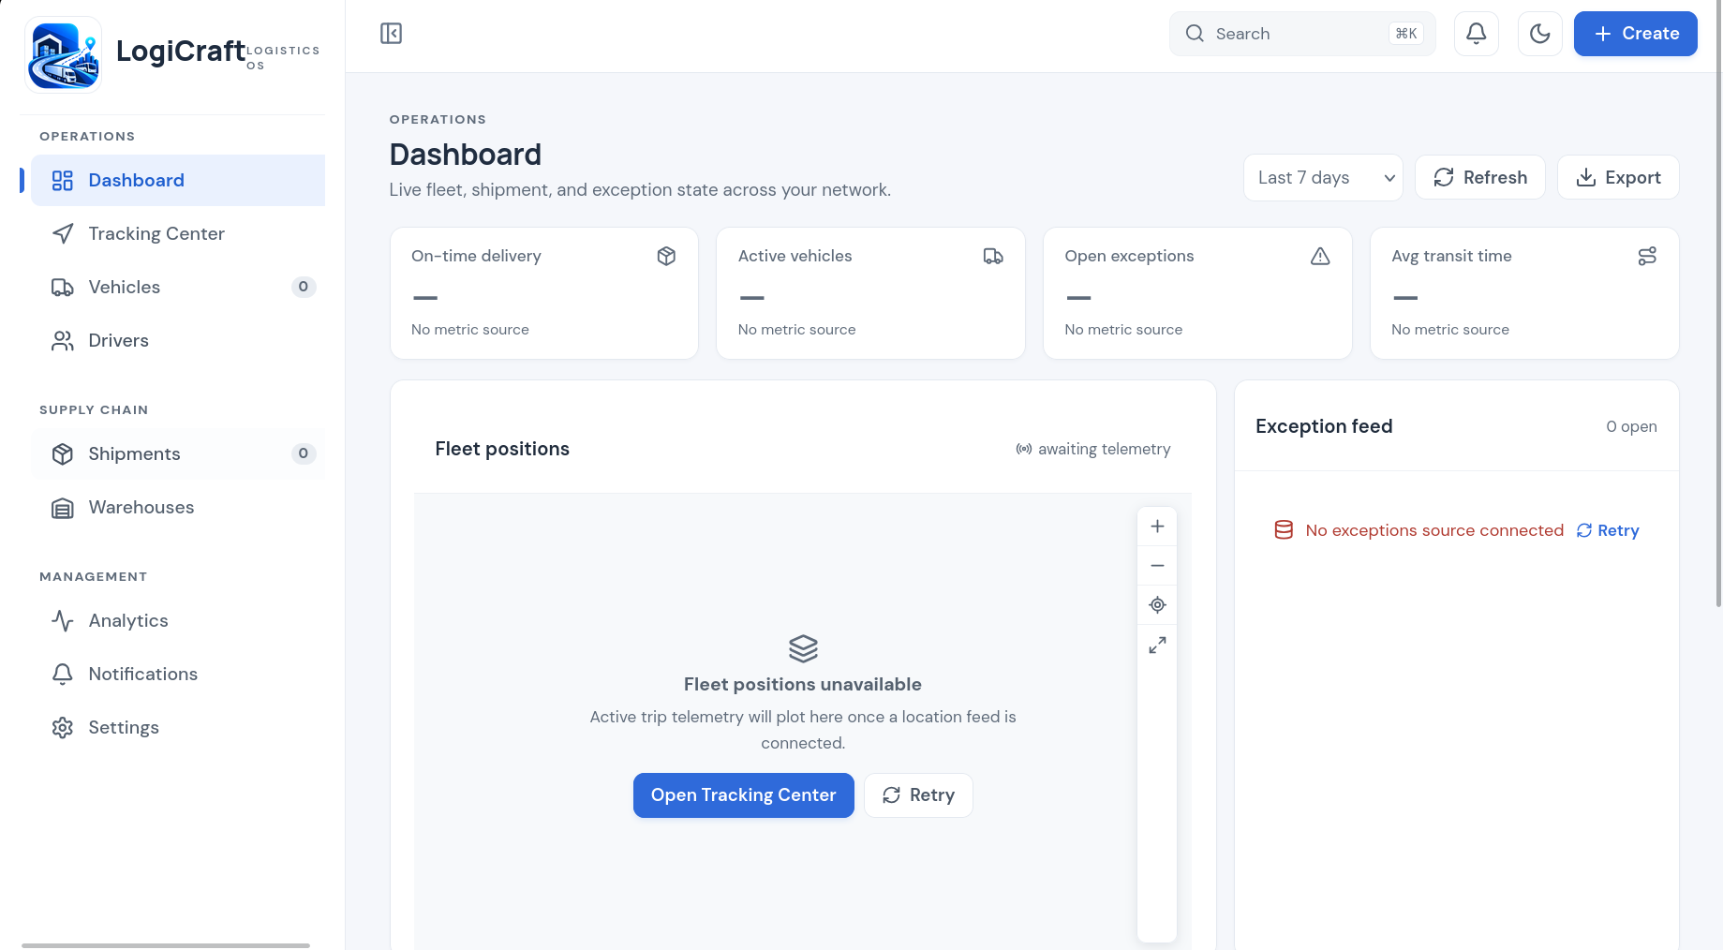
Figure 2. Clean LogiCraft dashboard wireframe.

4.2 Hardware Interfaces
Specification of physical interaction points: Standard keyboard, mouse/touchpad, display (>=720p), and server storage/network interfaces. GPS/telemetry hardware is simulated through software/API ingestion in the academic implementation.
- Standard Deployment: Standard input/output peripherals (Keyboard, Mouse, Display >= 720p).
- Embedded / IoT Variants (future): OBD-II/GPS devices may publish telemetry through MQTT/WebSockets; custom hardware fabrication is outside the current scope.
4.3 Software Interfaces
- Relational Database Connector: Spring Data JPA/Hibernate ORM and JDBC connect the Spring Boot backend to PostgreSQL on TCP port 5432.
- ML/Mapping Utilities: Spring RestClient connects to the FastAPI ML sidecar on port 8000; MapLibre/Mapbox/Google Maps API-compatible tiles provide interactive map rendering.
4.4 Communication Interfaces
- Web Traffic Protocol: HTTP/1.1 for local development and HTTPS over TCP/IP for deployment; Spring Boot API baseline port 8080.
- Data Serialization: UTF-8 encoded application/json payloads; frontend-facing fields use camelCase while PostgreSQL columns use snake_case.
5. Non-Functional Requirements (NFRs)
Attribute | Target Metric / Standard | Verification & Testing Method
5.1 Performance | API response target < 350 ms for paginated queries over 50,000 shipment rows; initial page load target < 2.0 s. | JMeter/load testing, Spring Actuator timing, browser performance tools.
5.2 Security | Zero plain-text passwords; BCrypt password hashing; parameterized/JPA queries; stateless JWT; CORS enforcement. | OWASP ZAP scan, authentication tests, code audit, negative-input testing.
5.3 Reliability | Target service uptime >= 98% during evaluation; transaction rollback on runtime exceptions; recoverable service startup. | Exception injection, Flyway validation, restart/recovery tests.
5.4 Portability | Cross-browser support for Chrome, Firefox, Safari, Edge; responsive desktop/tablet layouts. | Developer Tools responsive-mode verification and browser testing.
6. System Design and Analysis Models
University evaluation and project review require standard graphical analysis models illustrating the static structure, information flow, user interactions, and dynamic behavior of LogiCraft. The following subsections additionally document deployment commands, systematic testing, logical/business-rule tests, and future advancements.
Diagram Type | Objective & Scope | Deliverable Format
Use Case Diagram | Maps Administrator, Fleet Manager, Dispatcher, Warehouse Lead, Driver, and Customer/Guest actors to authentication, shipment, tracking, warehouse, audit, and public-tracking functions. | Clean UML-style PNG embedded in this document.
Data Flow Diagram (DFD) | Shows Level 0 information flow between users/GPS/ML/database and the LogiCraft platform; modular Level 1 flows cover authentication, shipment management, and ML prediction. | Clean DFD diagram embedded in this document.
Entity-Relationship Diagram (ERD) | Shows core relational entities, primary/foreign keys, and cardinalities for workspaces, users, shipments, trips, refresh tokens, and vehicles. | Crow's Foot-style relational diagram embedded in this document.
Sequence Diagram | Shows authentication and shipment ML-risk prediction message flow between Client UI, Spring Boot, PostgreSQL, and FastAPI. | UML sequence diagram embedded in this document.

6.1 Deployment & Execution Commands

# Frontend — Vercel
npm install
npm run build
vercel --prod

# Backend — Render
mvn clean package -DskipTests
java -jar target/*.jar

# ML Service — Render
pip install -r requirements.txt
uvicorn app:app --host 0.0.0.0 --port $PORT

# Database — Render PostgreSQL
Create PostgreSQL → Copy DATABASE_URL → Configure Spring Boot

# Production Configuration
Frontend → Vercel
↓
Spring Boot API
(Render)
↓ ↓
PostgreSQL FastAPI ML
(Render) (Render)

# Configure the following environment variables:
DATABASE_URL
JWT_SECRET
ML_SERVICE_URL
CORS_ALLOWED_ORIGINS
VITE_API_BASE_URL
# Deployment Verification
curl https://<BACKEND_URL>/api/v1/metrics/summary
curl https://<ML_SERVICE_URL>/docs

6.2 Testing Strategy — Unit, Systematic & Logical Testing

Testing is performed at both individual-file/unit level and full-application/systematic level.
1. Unit and Integration Testing:
• Single-file tests: mvn test -Dtest=UserRepositoryTest; mvn test -Dtest=ShipmentControllerTest.
• Full application suite: mvn test.
• Backend integration checks validate repository queries, controller responses, authentication, authorization, and database constraints.
2. Systematic Website Testing:
• Login page: valid/invalid credentials, validation messages, JWT generation/storage, redirect to dashboard.
• All buttons: verify Quick Action, create, edit, delete, filter, pagination, export, modal close, and navigation actions.
• Images/assets: verify logo and image assets load correctly without broken paths and remain visually clear.
• Navigation: test every sidebar route (/vehicles, /shipments, /tracking, /warehouses, /analytics, etc.) and verify workspace updates without full-page reload.
• Data tables: test pagination, search, sorting/filtering, empty states, and 50,000-row data retrieval.
• Maps: verify map rendering, vehicle pins, route/telemetry display, ETA, and exception states.
• Access control: verify unauthorized users cannot access protected endpoints or restricted UI actions.
3. Logical / Business-Rule Testing:
• ML rule validation: high-risk consignments are checked against the model output and expected risk-score behavior.
• Database integrity: invalid workspace_id or foreign-key references must fail and roll back the transaction.
• Inventory rule: stock adjustments that would produce negative inventory are rejected.
• Status validation: shipment transitions must remain within supported lifecycle states.
• API contract validation: frontend camelCase JSON fields must correctly map to backend entities/database snake_case fields.
Expected outcome: all critical functions, UI controls, API endpoints, database constraints, authentication flows, and business rules behave according to the SRS with no blocking defects before evaluation/deployment.

6.3 System Design and Analysis Diagrams

Level 1 DFD — Modular Breakdown

1.0 Authentication: User credentials → BCrypt verification → JWT token → authenticated session.
2.0 Shipment Management: Search parameters → PostgreSQL pg_trgm/GIN query → paginated shipment JSON.
3.0 ML Delay Prediction: Consignment attributes → FastAPI RandomForest classifier → delay_risk and risk_score.
4.0 Fleet/Tracking: Vehicle and trip state → telemetry records → map/dashboard status.
5.0 Warehouse: SKU movements → inventory validation → updated stock and audit records.

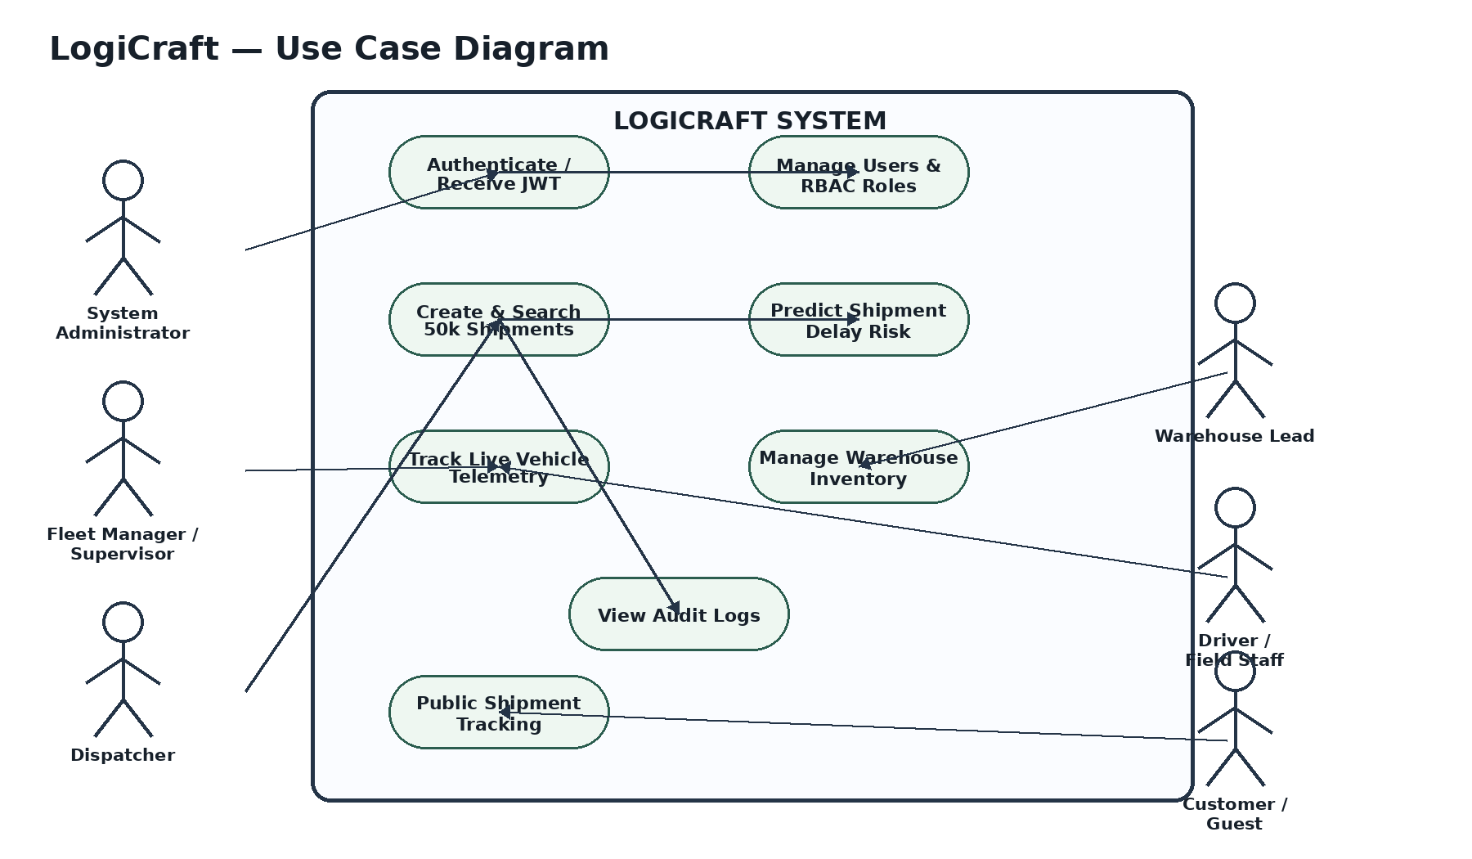
Figure 3. LogiCraft use case model.

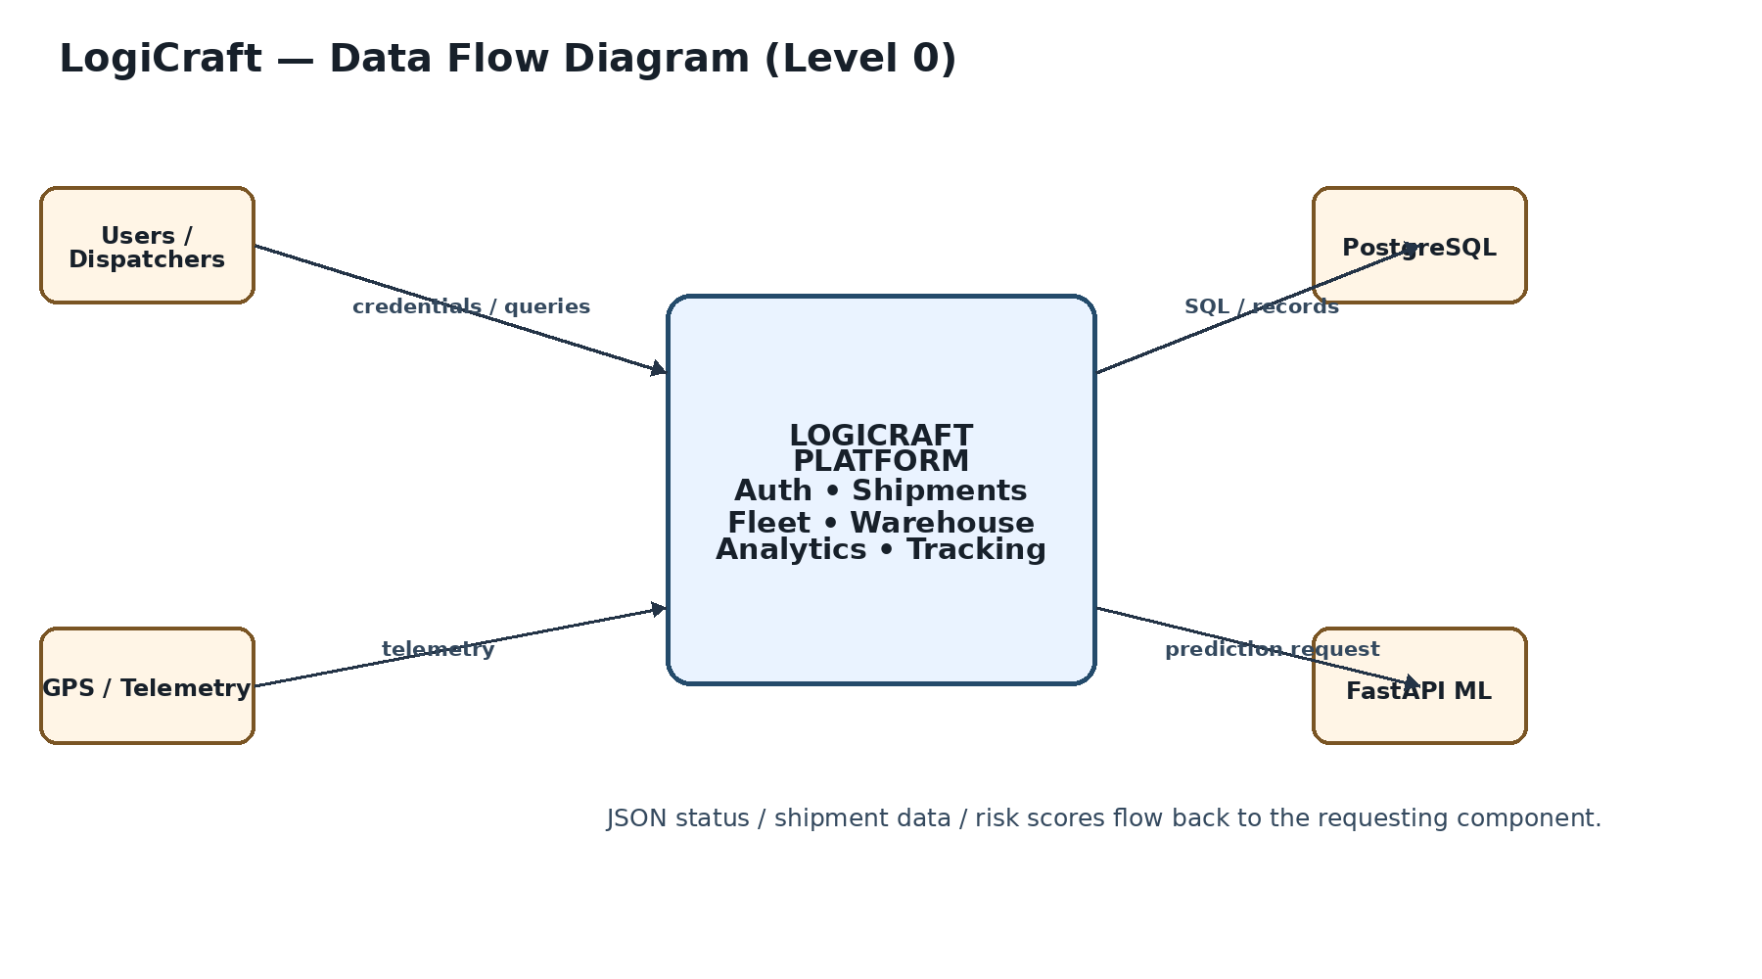
Figure 4. LogiCraft context-level data flow diagram.

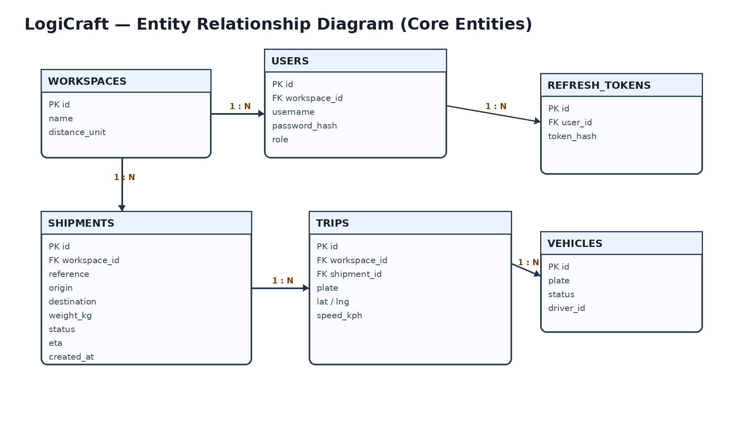
Figure 5. Core LogiCraft entity-relationship model.

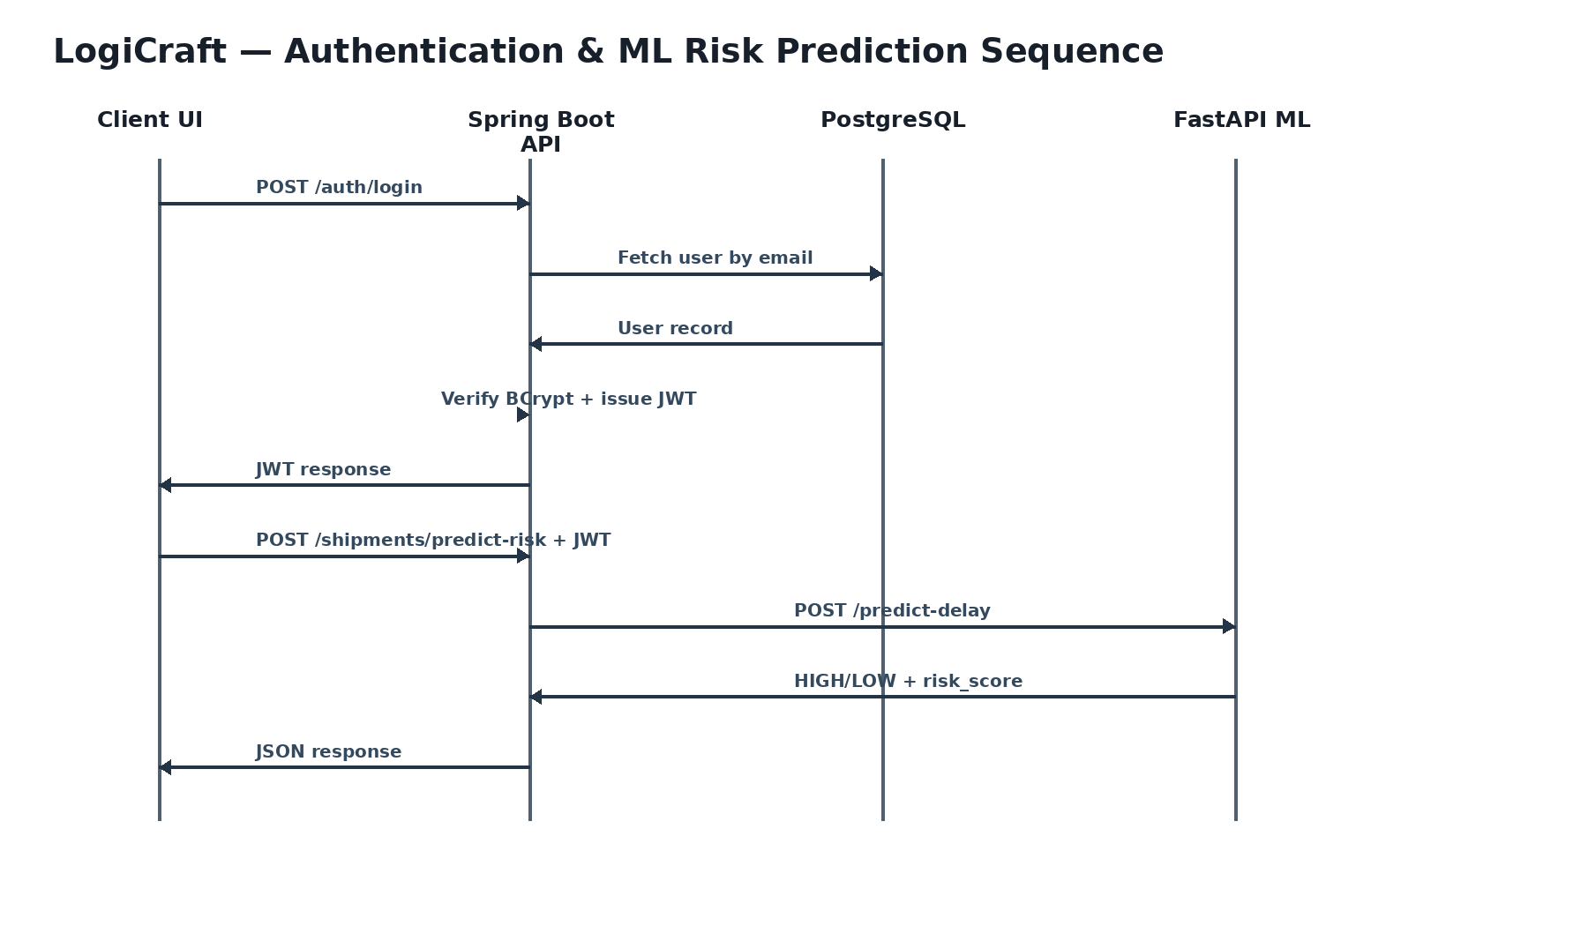
Figure 6. Authentication and ML shipment-risk prediction sequence.

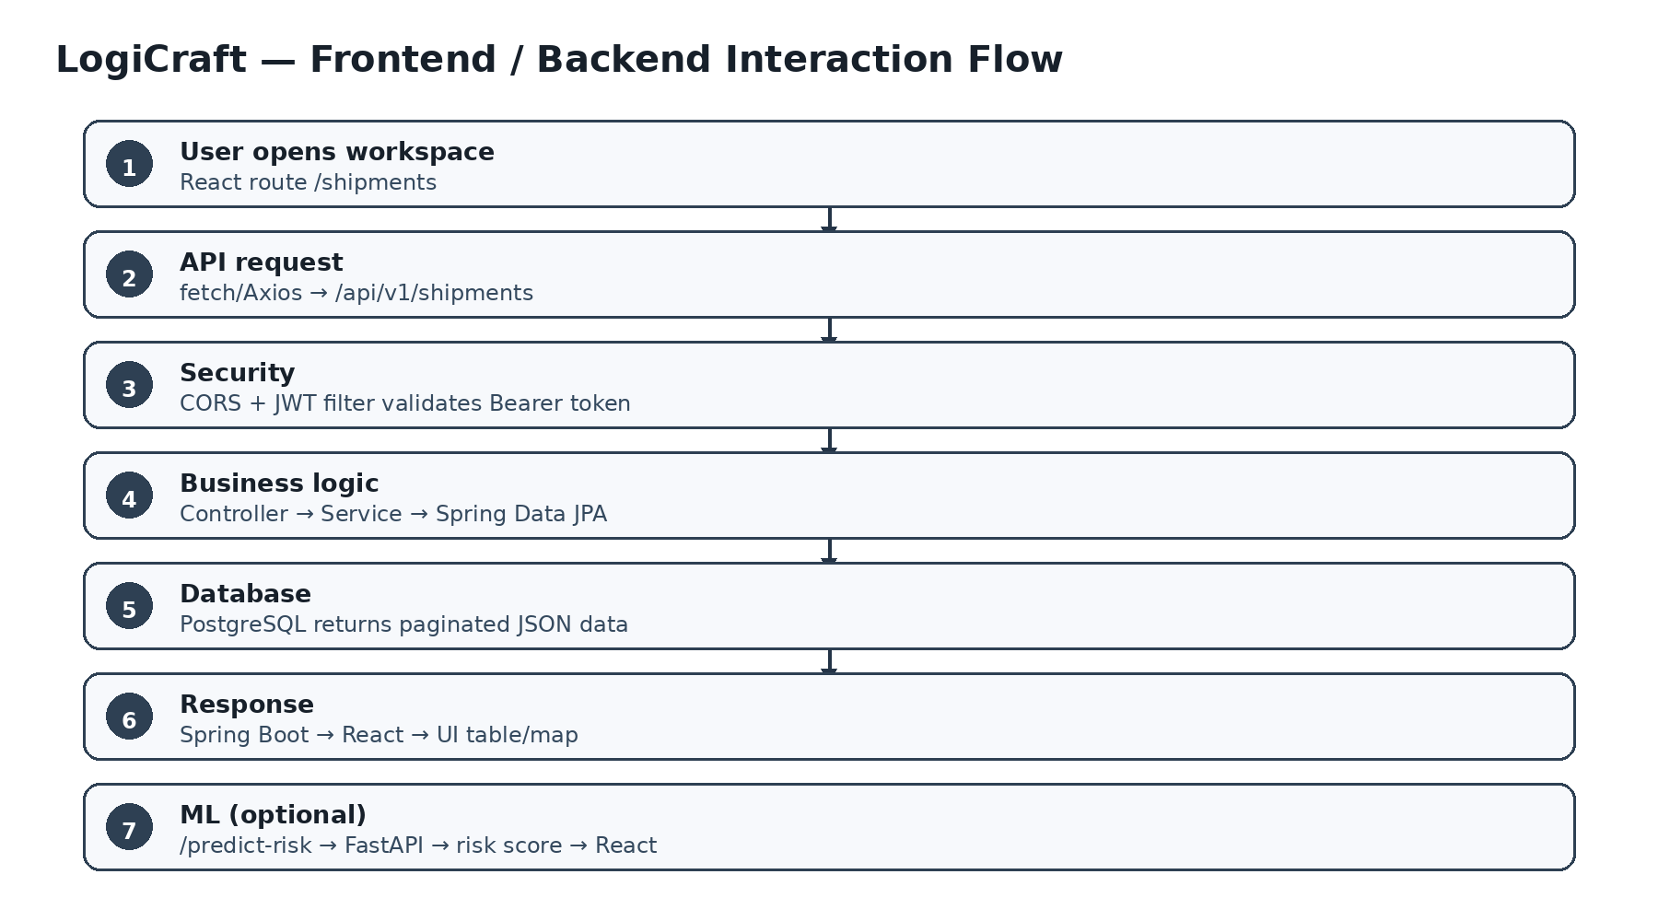
Figure 7. Frontend-to-backend communication and ML proxy flow.

6.4 Future Advancements in the Project

1. Predictive Vehicle Maintenance: Train time-series models on engine temperature, oil pressure, mileage, and diagnostic telemetry to predict component failures.
2. Driver Mobile Application (PWA / React Native): Provide offline-first trip updates, digital proof-of-delivery signatures, barcode scanning, and synchronization.

3. IoT OBD-II Telematics Ingestion: Stream vehicle diagnostic codes and GPS coordinates through MQTT/WebSockets into scalable message queues such as Redis.

4. Multi-Tenant SaaS Expansion & Billing: Add organization isolation, subscription plans, automated billing, and localized multi-currency freight-rate calculations.

7. Academic Review & Sign-Off
This Software Requirements Specification document has been submitted and reviewed by the academic supervisory panel:
Project Coordinator / Guide | Internal Examiner | Head of Department (HOD)
Signature: __________________  Date: __________________ | Signature: __________________  Date: __________________ | Signature: __________________  Date: __________________

