Final Project Report
  - Generative AI RAG Document Q&A Chatbot
Course: CSE 434 / CSE 534 — Generative AI
Team Member: Bhuwan Jung Thapa (THAPABJ)

Project focus. This report is about the PDF problem I kept running into as a student: too many course files, spread across too many semesters, and no reliable way to ask questions across all of them without losing track or getting hallucinated answers.

1. Introduction & Problem Definition
The problem I wanted to solve came from my own semester experience. Many student like me takes multiple courses across multiple semesters, and every course can have many PDFs: the syllabus, weekly lecture PDFs, assignment files, project requirement PDFs, exam updates, presentation guidelines, and other announcements. I have personally downloaded the same file more than once because I could not find the last downloaded copy when I needed it.
Using a normal chatbot, such as ChatGPT or Gemini, also became a hurdle. There are upload limits, so I cannot just put every course PDF from a semester into one session. Long sessions also make the answer quality feel less reliable: answers can become unnecessarily long, the model may mix up documents, and the chance of hallucination goes up when the conversation gets bigger. For course policies and deadlines, a wrong answer is not a small mistake.
My goal was to build a local document Q&A system where I can upload all course PDFs into one local dataset, keep them there for later, and ask questions whenever I need. The system should retrieve the source text, answer only from that source, cite the file and page, and refuse when the answer is not supported. In simple terms, I wanted a course-document assistant that stays useful even when the dataset grows and the session gets long.
The project connects to course topics through Retrieval-Augmented Generation, prompt engineering, evaluation, and fine-tuning. I first tried OpenAI API access, but usage limits became a problem. I then moved to Gemini 2.5 Lite during testing, and for the final local test, the project was configured to use a Gemini Lite preview model.

2. Dataset
The indexed corpus contains 4 course PDFs, 26 extracted pages, and 39 persisted chunks. The documents are user-uploaded files stored in the project data folder: CSE 434 / CSE 534 Syllabus, Final Project Presentation Guideline, Midterm Project Check Requirement, and Project Requirement.
Document | Chunks | Role in corpus
CSE_434___CSE_534_Syllabus.pdf | 22 | Course policies, grading, staff, schedule, and assignments
Final_Project_Presentation_Guideline.pdf | 4 | Final presentation timing, slide count, required slide topics
Midterm_Project_Check_Requirement.pdf | 7 | Midterm report goals, rubric, graduate expectations
Project_Requirement.pdf | 6 | Team size, timeline, project examples, graduate requirements

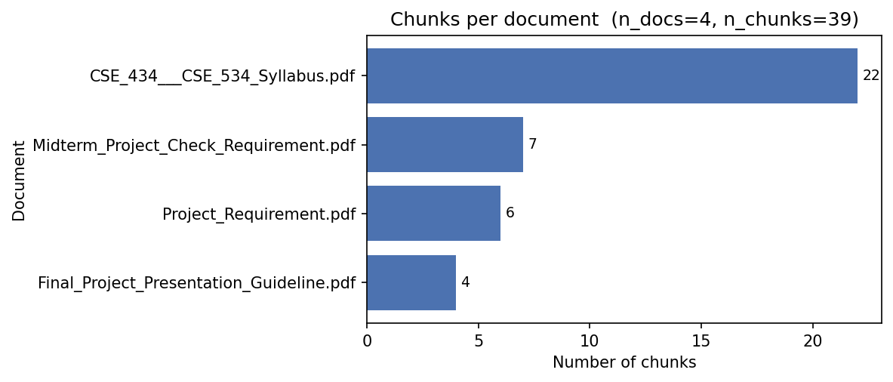
Figure 1. Chunk count by source document, generated from the indexed corpus.
Preprocessing follows the final implementation rather than a hypothetical dataset plan: pypdf extracts text page by page, whitespace is normalized, headings are used to split logical sections when possible, long sections are recursively split to 800 characters with 150 characters of overlap, and chunks below 250 characters are merged backward.
The evaluation set is eval/sample_eval_questions.csv with 25 gold questions, each containing a question, gold answer, expected document, and optional page. The LoRA experiment generated 117 document-grounded QA pairs from the indexed chunks, split into 99 training examples and 18 held-out examples.
Ethically, the project avoids web scraping and uses only user-uploaded course PDFs. Most processing, indexing, retrieval, and logging run locally. The main privacy constraint is that final generation may call Gemini or OpenAI with the retrieved context, so the app should be used only with documents the user is allowed to send to the selected API provider.

3. Methods / System Design
The system has two synchronized flows. Ingestion converts PDFs into searchable evidence; query time embeds the user question, retrieves the most relevant chunks, checks confidence, and only then sends the context to the LLM. The same embedding model is used for chunks and questions, which keeps both sides in one vector space.
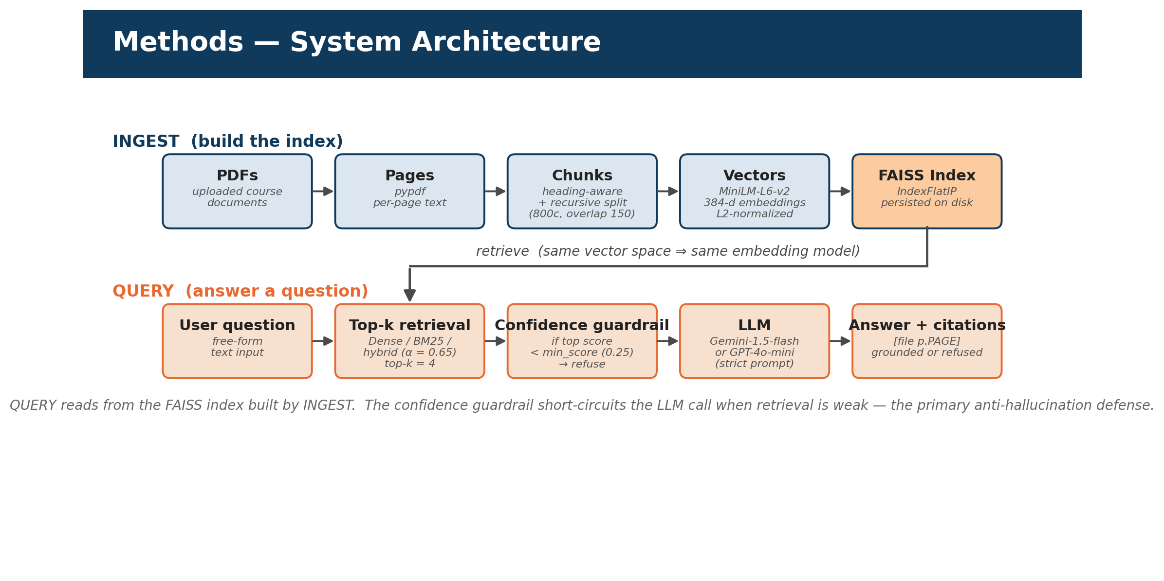
Figure 2. Final RAG architecture: ingestion writes the FAISS index; query-time retrieval reads from it.
The embedding model is sentence-transformers/all-MiniLM-L6-v2, producing 384-dimensional L2-normalized vectors. FAISS IndexFlatIP performs exact inner-product search, which is appropriate for the small corpus and avoids approximate-nearest-neighbor recall tradeoffs. The app also supports BM25 and hybrid search; in hybrid mode, final_score = alpha * dense_score + (1 - alpha) * BM25_score, with alpha set to 0.65.

3. Methods / System Design (continued)
The answer prompt is intentionally strict: answer only from the supplied context, cite the source as [filename p.PAGE], and return a fixed refusal sentence if the documents do not support the answer. A confidence guardrail runs before generation; if the top retrieved score is below 0.25, the LLM is not called, and the system returns the refusal directly.
Component | Final setting | Reason
Chunk size / overlap / min chunk | 800 / 150 / 250 chars | Balances context continuity with retrieval precision
Embedding model | all-MiniLM-L6-v2, 384d | Small, fast, free baseline for local use
Index | FAISS IndexFlatIP | Exact search is sufficient at 39 chunks
Retrieval | Hybrid FAISS + BM25, alpha=0.65 | Combines semantic paraphrase and exact course terms
Top-k / min_score | 4 / 0.25 | Limits context size and refuses weak retrieval
LLM layer | Gemini Lite preview model or GPT-4o-mini | Provider selected at runtime; OpenAI was limited, so Gemini Lite preview was used for final testing
LoRA setup | FLAN-T5-small, r=8, alpha=16, dropout=0.05 | Parameter-efficient style adaptation
LoRA training | 3 epochs, batch=2, lr=5e-4 | Saved adapter keeps base model frozen

Evaluation uses two passes. The full pipeline pass records predicted answer, retrieved documents, page ranges, top score, Hit@k, grounded_or_not, token overlap, semantic similarity, BERTScore, and label. A retrieval-only pass checks ranks up to k=10, so the report can separate retrieval ranking from answer generation.
For the graduate-level part, I added a LoRA experiment to see whether a small model could learn the answer style I wanted: use the given context, stay grounded, and include citations. I still kept RAG as the main system because the documents can change at any time when a user uploads new PDFs. I did not run full QLoRA on my local Mac, but I plan to continue this part in Google Colab using a T4 GPU, where 4-bit QLoRA training is more realistic.

4. Final Results
Metric | Value | Interpretation
Evaluation questions | 25 | All rows labeled
Overall retrieval source hit | 96% | 24 of 25 saved evaluation rows matched the expected source
Correctness rate | 52% | 13 Correct / 25 labeled
Partially correct | 11 | Largest remaining error type
Unsupported refusals | 1 | Appropriate silence when support is missing
Hallucination rate | 0% | 0 hallucinated labels
Grounded-by-guardrail rate | 96% | 24 grounded / 25 questions
Semantic similarity mean | 0.612 | Predicted vs. gold answer
BERTScore F1 mean | 0.769 | Mean precision 0.711, recall 0.838
Calibration ECE | 0.139 | Lower is better

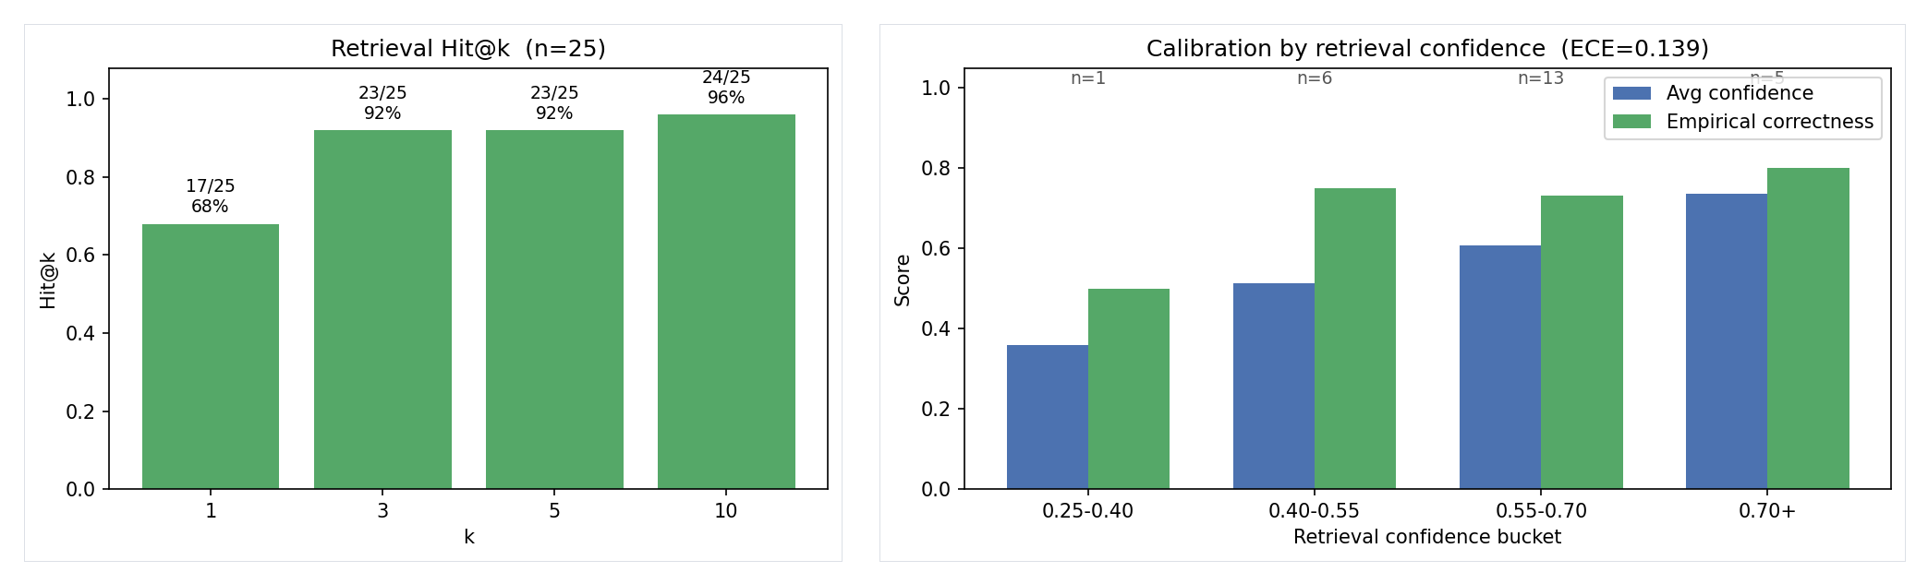
Figure 3. Retrieval rank sweep and confidence calibration from the saved evaluation run.
The separate retrieval-only rank sweep is more diagnostic than a single score: Hit@1 is 68% (17/25), Hit@3 is 92% (23/25), Hit@5 is 92% (23/25), and Hit@10 is 96% (24/25). The correct evidence is usually retrieved, but not always ranked first.

4. Final Results (continued)
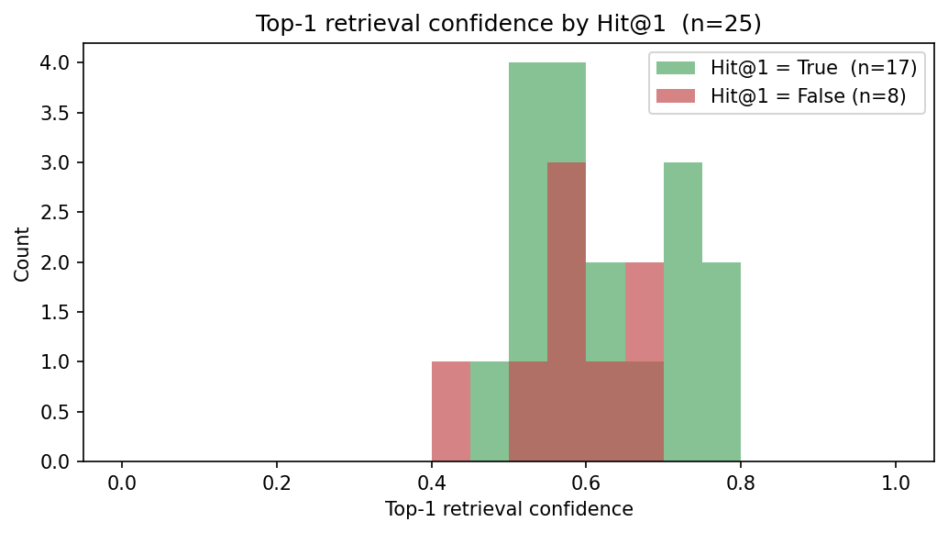
Figure 4. Top-1 retrieval confidence split by Hit@1.
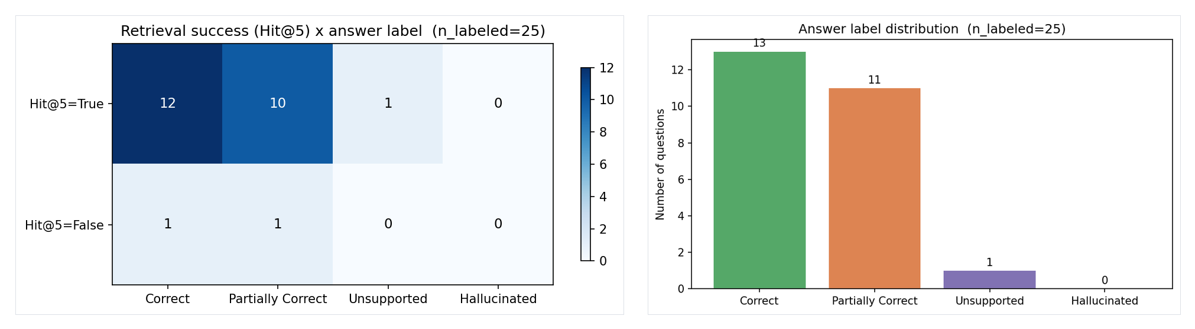
Figure 5. Hit@5 by answer label and the final label distribution.
LoRA/QLoRA result | Value | Meaning
Train / eval examples | 99 / 18 | Generated from indexed chunks
Base model | google/flan-t5-small | Small seq2seq model for local experiment
Training loss metric | eval_loss = 0.332 | After 3 epochs
Adapter evaluation | mean Jaccard = 0.677 | 10 generated eval rows
QLoRA readiness | false | bitsandbytes=false, CUDA=false

The LoRA adapter result is useful as a style-adaptation experiment: it learns the context-answer-citation pattern in a small number of trainable weights. It does not replace the RAG pipeline, because the adapter cannot automatically know newly uploaded PDFs unless their evidence is still retrieved and supplied as context.

LoRA Adapter Test
After the midterm report, I added a LoRA / QLoRA experiment to compare the original FLAN-T5 model against the same FLAN-T5 model with my trained LoRA adapter attached. For the test, I gave both models the same question and the same retrieved course-document context, then compared whether the adapted model followed the grounded answer-and-citation style better than the base model.
Question / case | Base model answer | LoRA adapter answer
Course project late-submission question | Base FLAN-T5 answered only: No. | The LoRA adapter answered with the retrieved syllabus text and citation, including: No late submission is permitted for course project-related deadlines.
Held-out syllabus evaluation question | Base FLAN-T5 gave a short fragment: The assignment is adapted for the assignment. | The LoRA adapter copied the relevant context much more completely and stayed closer to the expected answer.

This did not mean the LoRA model became a full chatbot by itself. The important result was that fine-tuning helped the small model follow the context-and-citation style better than the base model. The main chatbot still needs RAG because new PDFs can be uploaded at any time.

5. Qualitative Examples and Comparative Interpretation
Label | Question | Actual saved output snippet | Scores
Correct | What is the late assignment policy? | Late assignments are accepted up to three days after the due date with a penalty of 10% per day... [CSE_434___CSE_534_Syllabus.pdf p.2-7] | top=0.695; sem=0.765; BERT=0.783
Correct with source conflict | How long is Final Project Presentation time? | The Final Project Presentation time is 8 minutes... while the Project Requirement document states 10-12 minutes... | top=0.757; sem=0.824; BERT=0.779
Unsupported | How many points is Assignment 1 worth? | I could not find a supported answer in the uploaded documents. | top=0.561; grounded=False
Partially Correct | When is the midterm exam? | The course does not include a midterm exam [CSE_434___CSE_534_Syllabus.pdf p.1]. | top=0.579; sem=0.580; BERT=0.773

These cases show the main behavior pattern. The guardrail prevents unsupported invention, and citations make correct answers auditable. The remaining errors are mostly partially correct answers, where retrieval found relevant material but generation resolved ambiguous evidence poorly or paraphrased the gold answer too loosely.
The presentation deck frames the comparison qualitatively: with RAG, answers are cited and can be refused, but without RAG, a raw LLM has no reliable course-document source and may invent specifics. Similarly with LoRA, the model can learn the answer style but remains limited unless the retrieved context is still provided. No separate saved numeric raw-LLM baseline was present, so the report treats that comparison as qualitative rather than as an additional benchmark.

6. Short Reflection, Limitations & Future Work

Reflection
The main lesson is that retrieval quality and refusal behavior mattered more than simply upgrading the generator. Strict prompting plus a pre-LLM confidence threshold produced a 0% hallucination label rate in the saved evaluation. The project also changed since the midterm by adding hybrid retrieval, BERTScore, calibration/ECE, live report figures (live chart updated based on manual evaluation), and the LoRA/QLoRA tab.

Limitations
- The evaluation set has only 25 questions because each row needs a gold answer and a manual label.
- Most remaining errors are partially correct, not hallucinated; better generation checking or reranking is needed.
- pypdf extraction fails on scanned or unusual-layout PDFs unless OCR is added before ingestion.
- The default MiniLM embedding model is fast but can under-rank technical or long-context evidence.

Future Work
- Add OCR fallback for scanned documents.
- Add a cross-encoder reranker after FAISS/BM25 so the correct chunk is more often ranked first.
- Expand the evaluation set with more human-written questions and independent raters.
- Cache evaluation answers by question and retrieved chunk ids to reduce repeated API cost.
- Compare the LoRA adapter and RAG answers with a larger held-out set using semantic similarity and human judgments.

