1.class Solution {
public boolean halvesAreAlike(String s) {
String vowels = "aeiouAEIOU";
int mid = s.length() / 2;
int countA = 0, countB = 0;

for (int i = 0; i < mid; i++) {
if (vowels.indexOf(s.charAt(i)) != -1) countA++;
if (vowels.indexOf(s.charAt(i + mid)) != -1) countB++;
}

return countA == countB;
}
}
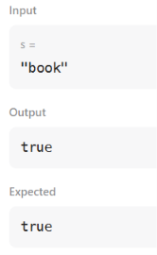
2. import sys
from collections import Counter

def solve():
input_data = sys.stdin.read().split()
if not input_data:
return

T = int(input_data[0])
results = []

for i in range(1, T + 1):
s = input_data[i]
n = len(s)

half_len = n // 2
first_half = s[:half_len]
second_half = s[n - half_len:]

if Counter(first_half) == Counter(second_half):
results.append("YES")
else:
results.append("NO")

print("\n".join(results))

if __name__ == "__main__":
solve()
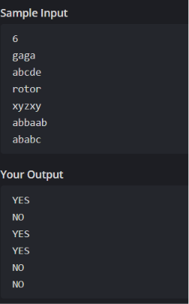
3. import java.io.*;
import java.math.*;
import java.security.*;
import java.text.*;
import java.util.*;
import java.util.concurrent.*;
import java.util.function.*;
import java.util.regex.*;
import java.util.stream.*;
import static java.util.stream.Collectors.joining;
import static java.util.stream.Collectors.toList;

class Result {
public static List<Integer> compareTriplets(List<Integer> a, List<Integer> b) {
int aliceScore = 0;
int bobScore = 0;

for (int i = 0; i < 3; i++) {
if (a.get(i) > b.get(i)) {
aliceScore++;
} else if (a.get(i) < b.get(i)) {
bobScore++;
}
}

List<Integer> result = new ArrayList<>();
result.add(aliceScore);
result.add(bobScore);
return result;
}
}
public class Solution {
public static void main(String[] args) throws IOException {
BufferedReader bufferedReader = new BufferedReader(new InputStreamReader(System.in));
BufferedWriter bufferedWriter = new BufferedWriter(new FileWriter(System.getenv("OUTPUT_PATH")));

List<Integer> a = Stream.of(bufferedReader.readLine().replaceAll("\\s+$", "").split(" "))
.map(Integer::parseInt)
.collect(toList());

List<Integer> b = Stream.of(bufferedReader.readLine().replaceAll("\\s+$", "").split(" "))
.map(Integer::parseInt)
.collect(toList());

List<Integer> result = Result.compareTriplets(a, b);

bufferedWriter.write(
result.stream()
.map(Object::toString)
.collect(joining(" "))
+ "\n"
);

bufferedReader.close();
bufferedWriter.close();
}
}
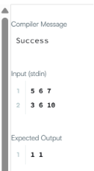
4. import java.util.HashSet;

class Solution {
public boolean containsDuplicate(int[] nums) {

HashSet<Integer> set = new HashSet<>();

for (int num : nums) {
if (set.contains(num)) {
return true;
}

set.add(num);
}

return false;
}
}
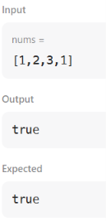
5.import java.io.*;
import java.math.*;
import java.security.*;
import java.text.*;
import java.util.*;
import java.util.concurrent.*;
import java.util.function.*;
import java.util.regex.*;
import java.util.stream.*;
import static java.util.stream.Collectors.joining;
import static java.util.stream.Collectors.toList;

class Result {

public static String timeConversion(String s) {

int hour = Integer.parseInt(s.substring(0, 2));
String ampm = s.substring(8, 10);

if (ampm.equals("AM")) {
if (hour == 12) {
hour = 0;
}
} else {
if (hour != 12) {
hour += 12;
}
}

return String.format("%02d", hour) + s.substring(2, 8);
}
}
public class Solution {
public static void main(String[] args) throws IOException {
BufferedReader bufferedReader = new BufferedReader(new InputStreamReader(System.in));
BufferedWriter bufferedWriter = new BufferedWriter(new FileWriter(System.getenv("OUTPUT_PATH")));

String s = bufferedReader.readLine();

String result = Result.timeConversion(s);

bufferedWriter.write(result);
bufferedWriter.newLine();

bufferedReader.close();
bufferedWriter.close();
}
}

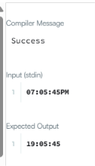
6. class Solution{
public void moveZeroes(int[] nums){
int j=0;
for (int i=0; i<nums.length; i++){
if(nums[i]!=0){
nums[j]=nums[i];
j++;
}
}
while (j<nums.length){
nums[j]=0;
j++;
}
}
}
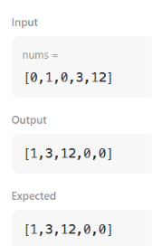
7. import java.io.*;
import java.math.*;
import java.security.*;
import java.text.*;
import java.util.*;
import java.util.concurrent.*;
import java.util.function.*;
import java.util.regex.*;
import java.util.stream.*;
import static java.util.stream.Collectors.joining;
import static java.util.stream.Collectors.toList;

class Result {

public static int diagonalDifference(List<List<Integer>> arr) {

int n = arr.size();

int leftSum = 0;
int rightSum = 0;

for (int i = 0; i < n; i++) {
leftSum += arr.get(i).get(i);
rightSum += arr.get(i).get(n - 1 - i);
}

return Math.abs(leftSum - rightSum);
}
}

public class Solution {
public static void main(String[] args) throws IOException {
BufferedReader bufferedReader = new BufferedReader(new InputStreamReader(System.in));
BufferedWriter bufferedWriter = new BufferedWriter(new FileWriter(System.getenv("OUTPUT_PATH")));

int n = Integer.parseInt(bufferedReader.readLine().trim());

List<List<Integer>> arr = new ArrayList<>();

IntStream.range(0, n).forEach(i -> {
try {
arr.add(
Stream.of(bufferedReader.readLine().replaceAll("\\s+$", "").split(" "))
.map(Integer::parseInt)
.collect(toList())
);
} catch (IOException ex) {
throw new RuntimeException(ex);
}
});

int result = Result.diagonalDifference(arr);

bufferedWriter.write(String.valueOf(result));
bufferedWriter.newLine();

bufferedReader.close();
bufferedWriter.close();
}
}

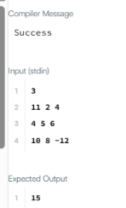
8. class Solution {
public int[][] transpose(int[][] matrix) {

int rows = matrix.length;
int cols = matrix[0].length;

int[][] result = new int[cols][rows];

for (int i = 0; i < rows; i++) {
for (int j = 0; j < cols; j++) {
result[j][i] = matrix[i][j];
}
}

return result;
}
}

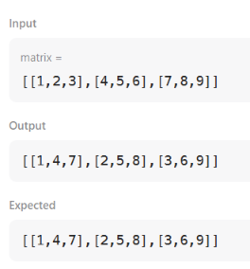
9. class Solution {
public int[][] matrixBlockSum(int[][] mat, int k) {

int m = mat.length;
int n = mat[0].length;

int[][] answer = new int[m][n];

for (int i = 0; i < m; i++) {
for (int j = 0; j < n; j++) {

int sum = 0;

int startRow = Math.max(0, i - k);
int endRow = Math.min(m - 1, i + k);

int startCol = Math.max(0, j - k);
int endCol = Math.min(n - 1, j + k);

for (int r = startRow; r <= endRow; r++) {
for (int c = startCol; c <= endCol; c++) {
sum += mat[r][c];
}
}

answer[i][j] = sum;
}
}

return answer;
}
}
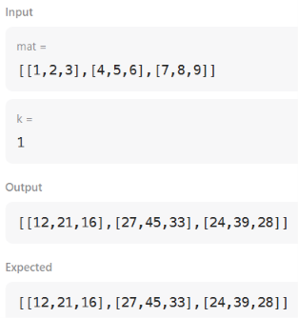
10import java.io.*;
import java.math.*;
import java.security.*;
import java.text.*;
import java.util.*;
import java.util.concurrent.*;
import java.util.function.*;
import java.util.regex.*;
import java.util.stream.*;
import static java.util.stream.Collectors.joining;
import static java.util.stream.Collectors.toList;

class Result {

public static void matrixRotation(List<List<Integer>> matrix, int r) {

int m = matrix.size();
int n = matrix.get(0).size();

int layers = Math.min(m, n) / 2;

for (int layer = 0; layer < layers; layer++) {

List<Integer> values = new ArrayList<>();

// Top row
for (int j = layer; j < n - layer; j++) {
values.add(matrix.get(layer).get(j));
}

// Right column
for (int i = layer + 1; i < m - layer; i++) {
values.add(matrix.get(i).get(n - layer - 1));
}

// Bottom row
for (int j = n - layer - 2; j >= layer; j--) {
values.add(matrix.get(m - layer - 1).get(j));
}

// Left column
for (int i = m - layer - 2; i > layer; i--) {
values.add(matrix.get(i).get(layer));
}

// Rotate anti-clockwise
int size = values.size();
int shift = r % size;

List<Integer> rotated = new ArrayList<>();

for (int i = shift; i < size; i++) {
rotated.add(values.get(i));
}

for (int i = 0; i < shift; i++) {
rotated.add(values.get(i));
}

// Put rotated values back
int index = 0;

// Top row
for (int j = layer; j < n - layer; j++) {
matrix.get(layer).set(j, rotated.get(index++));
}

// Right column
for (int i = layer + 1; i < m - layer; i++) {
matrix.get(i).set(n - layer - 1, rotated.get(index++));
}

// Bottom row
for (int j = n - layer - 2; j >= layer; j--) {
matrix.get(m - layer - 1).set(j, rotated.get(index++));
}

// Left column
for (int i = m - layer - 2; i > layer; i--) {
matrix.get(i).set(layer, rotated.get(index++));
}
}

// Print result
for (List<Integer> row : matrix) {
System.out.println(
row.stream()
.map(String::valueOf)
.collect(Collectors.joining(" "))
);
}
}
}
public class Solution {
public static void main(String[] args) throws IOException {
BufferedReader bufferedReader = new BufferedReader(new InputStreamReader(System.in));

String[] firstMultipleInput = bufferedReader.readLine().replaceAll("\\s+$", "").split(" ");

int m = Integer.parseInt(firstMultipleInput[0]);

int n = Integer.parseInt(firstMultipleInput[1]);

int r = Integer.parseInt(firstMultipleInput[2]);

List<List<Integer>> matrix = new ArrayList<>();

IntStream.range(0, m).forEach(i -> {
try {
matrix.add(
Stream.of(bufferedReader.readLine().replaceAll("\\s+$", "").split(" "))
.map(Integer::parseInt)
.collect(toList())
);
} catch (IOException ex) {
throw new RuntimeException(ex);
}
});

Result.matrixRotation(matrix, r);

bufferedReader.close();
}
}

