1. import java.io.*;
import java.util.*;

class Result {

public static long stringSimilarity(String s) {

int n = s.length();
long sum = 0;

for (int i = 0; i < n; i++) {

int j = 0;

while (i + j < n && s.charAt(j) == s.charAt(i + j)) {
j++;
}

sum += j;
}

return sum;
}
}

public class Solution {

public static void main(String[] args) throws IOException {

BufferedReader br =
new BufferedReader(new InputStreamReader(System.in));

int t = Integer.parseInt(br.readLine());

while (t-- > 0) {

String s = br.readLine().trim();

System.out.println(Result.stringSimilarity(s));
}

br.close();
}
}
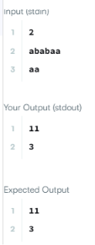
2. class Solution {
public boolean repeatedSubstringPattern(String s) {

int n = s.length();

for (int len = 1; len <= n / 2; len++) {

if (n % len != 0) {
continue;
}

String sub = s.substring(0, len);

boolean valid = true;

for (int i = len; i < n; i += len) {

if (!s.substring(i, i + len).equals(sub)) {
valid = false;
break;
}
}

if (valid) {
return true;
}
}

return false;
}
}
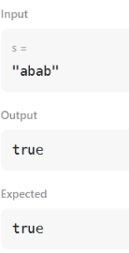
3. import java.io.*;
import java.math.*;
import java.security.*;
import java.text.*;
import java.util.*;
import java.util.concurrent.*;
import java.util.function.*;
import java.util.regex.*;
import java.util.stream.*;
import static java.util.stream.Collectors.joining;
import static java.util.stream.Collectors.toList;

class Result {

public static String twoStrings(String s1, String s2) {

HashSet<Character> set = new HashSet<>();

// Store characters of s1
for (char c : s1.toCharArray()) {
set.add(c);
}

// Check characters of s2
for (char c : s2.toCharArray()) {
if (set.contains(c)) {
return "YES";
}
}

return "NO";
}
}
public class Solution {
public static void main(String[] args) throws IOException {
BufferedReader bufferedReader = new BufferedReader(new InputStreamReader(System.in));
BufferedWriter bufferedWriter = new BufferedWriter(new FileWriter(System.getenv("OUTPUT_PATH")));

int q = Integer.parseInt(bufferedReader.readLine().trim());

IntStream.range(0, q).forEach(qItr -> {
try {
String s1 = bufferedReader.readLine();

String s2 = bufferedReader.readLine();

String result = Result.twoStrings(s1, s2);

bufferedWriter.write(result);
bufferedWriter.newLine();
} catch (IOException ex) {
throw new RuntimeException(ex);
}
});

bufferedReader.close();
bufferedWriter.close();
}
}

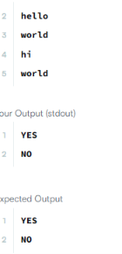
4. class Solution {
public boolean rotateString(String s, String goal) {

if (s.length() != goal.length()) {
return false;
}

String combined = s + s;

return combined.contains(goal);
}
}

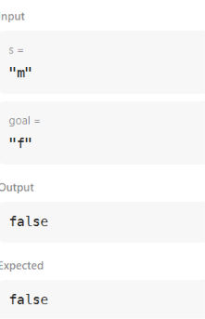
5.import java.io.*;
import java.math.*;
import java.security.*;
import java.text.*;
import java.util.*;
import java.util.concurrent.*;
import java.util.function.*;
import java.util.regex.*;
import java.util.stream.*;
import static java.util.stream.Collectors.joining;
import static java.util.stream.Collectors.toList;

class Result {

public static int marsExploration(String s) {

int count = 0;
String pattern = "SOS";

for (int i = 0; i < s.length(); i++) {

if (s.charAt(i) != pattern.charAt(i % 3)) {
count++;
}
}

return count;
}
}
public class Solution {
public static void main(String[] args) throws IOException {
BufferedReader bufferedReader = new BufferedReader(new InputStreamReader(System.in));
BufferedWriter bufferedWriter = new BufferedWriter(new FileWriter(System.getenv("OUTPUT_PATH")));

String s = bufferedReader.readLine();

int result = Result.marsExploration(s);

bufferedWriter.write(String.valueOf(result));
bufferedWriter.newLine();

bufferedReader.close();
bufferedWriter.close();
}
}

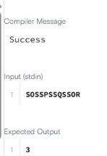

6. import java.util.*;

class Solution {
public List<Integer> findAnagrams(String s, String p) {
List<Integer> result = new ArrayList<>();

if (s.length() < p.length()) {
return result;
}

int[] pCount = new int[26];
int[] window = new int[26];

// Count characters in p
for (char c : p.toCharArray()) {
pCount[c - 'a']++;
}

int k = p.length();

// First window
for (int i = 0; i < k; i++) {
window[s.charAt(i) - 'a']++;
}

// Check first window
if (Arrays.equals(pCount, window)) {
result.add(0);
}

// Slide the window
for (int i = k; i < s.length(); i++) {

// Add new character
window[s.charAt(i) - 'a']++;

// Remove old character
window[s.charAt(i - k) - 'a']--;

// Check if anagram
if (Arrays.equals(pCount, window)) {
result.add(i - k + 1);
}
}

return result;
}
}
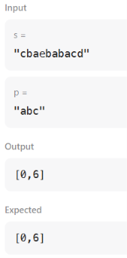
7. import java.util.*;

public class Solution {

public static int palindromeIndex(String s) {

int left = 0;
int right = s.length() - 1;

while (left < right) {

if (s.charAt(left) != s.charAt(right)) {

// Remove left character
if (isPalindrome(s, left + 1, right)) {
return left;
}

// Remove right character
if (isPalindrome(s, left, right - 1)) {
return right;
}

return -1;
}

left++;
right--;
}

return -1;
}

public static boolean isPalindrome(String s, int left, int right) {

while (left < right) {

if (s.charAt(left) != s.charAt(right)) {
return false;
}

left++;
right--;
}

return true;
}

public static void main(String[] args) {

Scanner sc = new Scanner(System.in);

int q = sc.nextInt();

while (q > 0) {

String s = sc.next();

System.out.println(palindromeIndex(s));

q--;
}

sc.close();
}
}
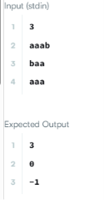
8. class Solution {
public int strStr(String haystack, String needle) {

int n = haystack.length();
int m = needle.length();

for (int i = 0; i <= n - m; i++) {

int j = 0;

while (j < m && haystack.charAt(i + j) == needle.charAt(j)) {
j++;
}

if (j == m) {
return i;
}
}

return -1;
}
}
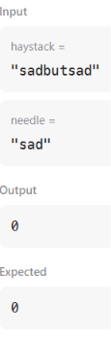
9. class Solution {

public String longestPalindrome(String s) {

if (s.length() < 2) {
return s;
}

int start = 0;
int end = 0;

for (int i = 0; i < s.length(); i++) {

// Odd length palindrome
int len1 = expand(s, i, i);

// Even length palindrome
int len2 = expand(s, i, i + 1);

int len = Math.max(len1, len2);

if (len > end - start + 1) {

start = i - (len - 1) / 2;
end = i + len / 2;
}
}

return s.substring(start, end + 1);
}

public int expand(String s, int left, int right) {

while (left >= 0 && right < s.length()
&& s.charAt(left) == s.charAt(right)) {

left--;
right++;
}

return right - left - 1;
}
}
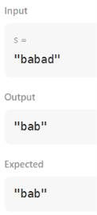
10. import java.io.*;
import java.util.*;

class Result {

public static List<Integer> circularPalindromes(String s) {

int n = s.length();

// Double the string to handle rotations
String str = s + s;

// Build transformed string for Manacher's algorithm
StringBuilder t = new StringBuilder();

t.append('#');

for (int i = 0; i < str.length(); i++) {
t.append(str.charAt(i));
t.append('#');
}

int m = t.length();

int[] p = new int[m];

int center = 0;
int right = 0;

// Manacher's algorithm
for (int i = 0; i < m; i++) {

int mirror = 2 * center - i;

if (i < right) {
p[i] = Math.min(right - i, p[mirror]);
}

while (i - p[i] - 1 >= 0 &&
i + p[i] + 1 < m &&
t.charAt(i - p[i] - 1)
== t.charAt(i + p[i] + 1)) {

p[i]++;
}

if (i + p[i] > right) {
center = i;
right = i + p[i];
}
}

List<Integer> answer = new ArrayList<>();

// Check every rotation
for (int start = 0; start < n; start++) {

int max = 1;

/*
* Odd length palindromes.
*
* Character i is at position 2*i+1
* in transformed string.
*/
for (int i = start; i < start + n; i++) {

int radius = p[2 * i + 1] / 2;

// Cannot go outside this rotation
int left = i - start;
int rightSide = start + n - 1 - i;

radius = Math.min(radius,
Math.min(left, rightSide));

int length = 2 * radius + 1;

max = Math.max(max, length);
}

/*
* Even length palindromes.
*
* Center is between i-1 and i.
*/
for (int i = start + 1; i < start + n; i++) {

int radius = p[2 * i] / 2;

int left = i - start;
int rightSide = start + n - i;

radius = Math.min(radius,
Math.min(left, rightSide));

int length = 2 * radius;

max = Math.max(max, length);
}

answer.add(max);
}

return answer;
}
}

public class Solution {

public static void main(String[] args) throws Exception {

BufferedReader br =
new BufferedReader(
new InputStreamReader(System.in));

int n = Integer.parseInt(br.readLine().trim());

String s = br.readLine().trim();

List<Integer> result =
Result.circularPalindromes(s);

StringBuilder output = new StringBuilder();

for (int x : result) {
output.append(x).append('\n');
}

System.out.print(output);
}
}
