1. public class Solution {
public int maxSubArray(int[] nums) {
int maxSum = nums[0];
int currentSum = nums[0];

for (int i = 1; i < nums.length; i++) {
currentSum = Math.max(nums[i], currentSum + nums[i]);
maxSum = Math.max(maxSum, currentSum);
}

return maxSum;
}
}
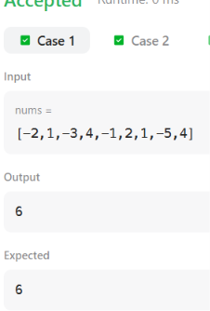
2. import java.io.*;
import java.math.*;
import java.security.*;
import java.text.*;
import java.util.*;
import java.util.concurrent.*;
import java.util.function.*;
import java.util.regex.*;
import java.util.stream.*;
import static java.util.stream.Collectors.joining;
import static java.util.stream.Collectors.toList;

class Result {

public static int birthday(List<Integer> s, int d, int m) {

int count = 0;

for (int i = 0; i <= s.size() - m; i++) {

int sum = 0;

for (int j = i; j < i + m; j++) {
sum += s.get(j);
}

if (sum == d) {
count++;
}
}

return count;
}
}

public class Solution {
public static void main(String[] args) throws IOException {
BufferedReader bufferedReader = new BufferedReader(new InputStreamReader(System.in));
BufferedWriter bufferedWriter = new BufferedWriter(new FileWriter(System.getenv("OUTPUT_PATH")));

int n = Integer.parseInt(bufferedReader.readLine().trim());

List<Integer> s = Stream.of(bufferedReader.readLine().replaceAll("\\s+$", "").split(" "))
.map(Integer::parseInt)
.collect(toList());

String[] firstMultipleInput = bufferedReader.readLine().replaceAll("\\s+$", "").split(" ");

int d = Integer.parseInt(firstMultipleInput[0]);

int m = Integer.parseInt(firstMultipleInput[1]);

int result = Result.birthday(s, d, m);

bufferedWriter.write(String.valueOf(result));
bufferedWriter.newLine();

bufferedReader.close();
bufferedWriter.close();
}
}

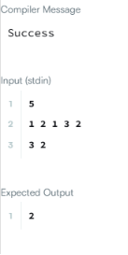

3. import java.io.*;
import java.math.*;
import java.security.*;
import java.text.*;
import java.util.*;
import java.util.concurrent.*;
import java.util.function.*;
import java.util.regex.*;
import java.util.stream.*;
import static java.util.stream.Collectors.joining;
import static java.util.stream.Collectors.toList;

class Result {

public static List<Integer> maxSubarray(List<Integer> arr) {

int currentSum = arr.get(0);
int maxSubarray = arr.get(0);

int maxSubsequence = arr.get(0);

for (int i = 1; i < arr.size(); i++) {

int num = arr.get(i);

// Maximum subarray sum - Kadane's Algorithm
currentSum = Math.max(num, currentSum + num);
maxSubarray = Math.max(maxSubarray, currentSum);

// Maximum subsequence sum
if (num > 0) {
maxSubsequence += num;
} else {
maxSubsequence = Math.max(maxSubsequence, num);
}
}

// If there is at least one positive number,
// maxSubsequence should contain only positive numbers.
boolean hasPositive = false;

for (int num : arr) {
if (num > 0) {
hasPositive = true;
break;
}
}

if (hasPositive) {
maxSubsequence = 0;

for (int num : arr) {
if (num > 0) {
maxSubsequence += num;
}
}
}

return Arrays.asList(maxSubarray, maxSubsequence);
}
}
public class Solution {
public static void main(String[] args) throws IOException {
BufferedReader bufferedReader = new BufferedReader(new InputStreamReader(System.in));
BufferedWriter bufferedWriter = new BufferedWriter(new FileWriter(System.getenv("OUTPUT_PATH")));

int t = Integer.parseInt(bufferedReader.readLine().trim());

IntStream.range(0, t).forEach(tItr -> {
try {
int n = Integer.parseInt(bufferedReader.readLine().trim());

List<Integer> arr = Stream.of(bufferedReader.readLine().replaceAll("\\s+$", "").split(" "))
.map(Integer::parseInt)
.collect(toList());

List<Integer> result = Result.maxSubarray(arr);

bufferedWriter.write(
result.stream()
.map(Object::toString)
.collect(joining(" "))
+ "\n"
);
} catch (IOException ex) {
throw new RuntimeException(ex);
}
});

bufferedReader.close();
bufferedWriter.close();
}
}

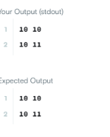
4. class Solution {
public int maxSubarraySumCircular(int[] nums) {

int total = 0;

int currentMax = 0;
int maxSum = nums[0];

int currentMin = 0;
int minSum = nums[0];

for (int num : nums) {

// Maximum normal subarray
currentMax = Math.max(num, currentMax + num);
maxSum = Math.max(maxSum, currentMax);

// Minimum subarray
currentMin = Math.min(num, currentMin + num);
minSum = Math.min(minSum, currentMin);

total += num;
}

// If all elements are negative
if (maxSum < 0) {
return maxSum;
}

// Maximum circular sum
return Math.max(maxSum, total - minSum);
}
}
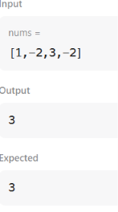
5. class Solution {
public int myAtoi(String s) {

int i = 0;
int n = s.length();

// 1. Skip leading spaces
while (i < n && s.charAt(i) == ' ') {
i++;
}

// 2. Check sign
int sign = 1;

if (i < n && s.charAt(i) == '-') {
sign = -1;
i++;
} else if (i < n && s.charAt(i) == '+') {
i++;
}

// 3. Read digits
int result = 0;

while (i < n && Character.isDigit(s.charAt(i))) {

int digit = s.charAt(i) - '0';

// 4. Check overflow
if (result > (Integer.MAX_VALUE - digit) / 10) {
if (sign == 1) {
return Integer.MAX_VALUE;
} else {
return Integer.MIN_VALUE;
}
}

result = result * 10 + digit;
i++;
}

return result * sign;
}
}
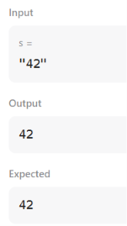
6. import java.io.*;
import java.math.*;
import java.security.*;
import java.text.*;
import java.util.*;
import java.util.concurrent.*;
import java.util.function.*;
import java.util.regex.*;
import java.util.stream.*;
import static java.util.stream.Collectors.joining;
import static java.util.stream.Collectors.toList;

class Result {

public static int alternatingCharacters(String s) {

int deletions = 0;

for (int i = 1; i < s.length(); i++) {

if (s.charAt(i) == s.charAt(i - 1)) {
deletions++;
}
}

return deletions;
}
}

public class Solution {
public static void main(String[] args) throws IOException {
BufferedReader bufferedReader = new BufferedReader(new InputStreamReader(System.in));
BufferedWriter bufferedWriter = new BufferedWriter(new FileWriter(System.getenv("OUTPUT_PATH")));

int q = Integer.parseInt(bufferedReader.readLine().trim());

IntStream.range(0, q).forEach(qItr -> {
try {
String s = bufferedReader.readLine();

int result = Result.alternatingCharacters(s);

bufferedWriter.write(String.valueOf(result));
bufferedWriter.newLine();
} catch (IOException ex) {
throw new RuntimeException(ex);
}
});

bufferedReader.close();
bufferedWriter.close();
}
}

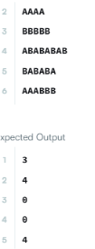
7. class Solution {
public int lengthOfLongestSubstring(String s) {

HashSet<Character> set = new HashSet<>();

int left = 0;
int maxLength = 0;

for (int right = 0; right < s.length(); right++) {

while (set.contains(s.charAt(right))) {
set.remove(s.charAt(left));
left++;
}

set.add(s.charAt(right));

maxLength = Math.max(maxLength, right - left + 1);
}

return maxLength;
}
}
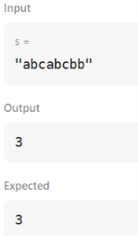
8. class Solution {
public List<String> findAndReplacePattern(String[] words, String pattern) {

List<String> answer = new ArrayList<>();

for (String word : words) {

if (matches(word, pattern)) {
answer.add(word);
}
}

return answer;
}

public boolean matches(String word, String pattern) {

HashMap<Character, Character> map = new HashMap<>();
HashMap<Character, Character> reverse = new HashMap<>();

for (int i = 0; i < word.length(); i++) {

char w = word.charAt(i);
char p = pattern.charAt(i);

// pattern -> word
if (map.containsKey(p) && map.get(p) != w) {
return false;
}

// word -> pattern
if (reverse.containsKey(w) && reverse.get(w) != p) {
return false;
}

map.put(p, w);
reverse.put(w, p);
}

return true;
}
}
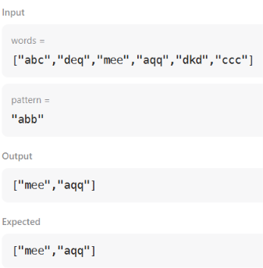
9. class Solution {
public List<String> stringMatching(String[] words) {

List<String> answer = new ArrayList<>();

for (int i = 0; i < words.length; i++) {

for (int j = 0; j < words.length; j++) {

if (i != j && words[j].contains(words[i])) {
answer.add(words[i]);
break;
}
}
}

return answer;
}
}
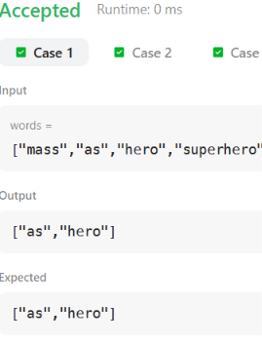
10. import java.util.ArrayList;

public class GFG {

// Function to search for all occurrences of 'pat' in 'txt' using Naive Approach
static ArrayList<Integer> search(String pat, String txt)
{
// Length of the pattern
int m = pat.length();

// Length of the text
int n = txt.length();

ArrayList<Integer> ans = new ArrayList<>();

// Slide the pattern over text one by one
for (int i = 0; i <= n - m; i++)
{
int j;

// Check for pattern match at index i
for (j = 0; j < m; j++)
{
if (txt.charAt(i + j) != pat.charAt(j))
break;
}

// If pattern matches, store index
if (j == m)
ans.add(i);
}

return ans;
}

public static void main(String[] args)
{
String txt = "aabaacaadaabaaba";
String pat = "aaba";

ArrayList<Integer> res = search(pat, txt);

for (int it : res)
{
System.out.print(it + " ");
}
}
}
