MICRO PROJECT REPORT
ADVANCED DATABASE SYSTEMS
SEATSURE: CONCURRENCY-SAFE CAMPUS EVENT REGISTRATION WITH AUTO-PROMOTING WAITLISTS
Submitted by:
Bhavya Sharma
[University Roll No.]
In partial fulfilment for the award of the degree of
BACHELOR OF TECHNOLOGY
In
COMPUTER SCIENCE AND ENGINEERING (AI AND FUTURE TECHNOLOGIES)
Under the guidance of
[Guide's Name]
[Designation]

Alliance School of Advanced Computing
Alliance University, Bengaluru
October-2026

COMPUTER SCIENCE AND ENGINEERING
ALLIANCE SCHOOL OF ADVANCED COMPUTING
CERTIFICATE
This is to certify that the report on Advanced Database Systems for the micro project titled “SeatSure: Concurrency-Safe Campus Event Registration with Auto-Promoting Waitlists” is submitted by Bhavya Sharma [Uni. Roll No. [University Roll No.]] in partial fulfilment of the requirements for the award of the degree of Bachelor of Technology (Computer Science and Engineering – AI and Future Technologies) of Alliance University. It is a bonafide record of work carried out under my supervision and guidance during the academic year 2026–27. The work presented in this report is original and has not formed the basis for the award of any other degree to the candidate or to anybody else.
……………………………
[Guide's Name]
[Designation]

COMPUTER SCIENCE AND ENGINEERING
ALLIANCE SCHOOL OF ADVANCED COMPUTING
DECLARATION
I hereby declare that the report titled SeatSure: Concurrency-Safe Campus Event Registration with Auto-Promoting Waitlists (Advanced Database Systems), submitted in partial fulfilment of the requirements for the award of the degree of Bachelor of Technology in Computer Science and Engineering (AI and Future Technologies) at Alliance University, is a record of project work carried out under the supervision of [Guide's Name], [Designation].
The design, implementation and test results described in this report belong to the SeatSure project submitted with it. The course material, documentation and open-source libraries that the work builds on are acknowledged in the references.
This report has not been submitted, in part or in full, for any other degree or award.

Bhavya Sharma | [University Roll No.]
Name of the Student | University Registration Number | Signature

Acknowledgement
I would like to express my sincere gratitude to everyone who helped me complete this micro project, SeatSure: Concurrency-Safe Campus Event Registration with Auto-Promoting Waitlists.
First, I thank my guide, [Guide's Name], for their guidance, feedback and encouragement throughout the project. I am also grateful to the mentors at Kalvium, whose Advanced Database Systems livebook sessions provided the concepts on which this work is built.
I also thank my peers in my Kalvium squad for the discussions and feedback that helped shape the project.
Working on SeatSure taught me that a feature is finished only when it has been shown to work under realistic conditions, with automated tests, measurements and failure scenarios, and not merely when it works once on my own screen.
Finally, I thank my family and friends for their support and patience during the semester.
Thank you.
Bhavya Sharma
TABLE OF CONTENTS
Acknowledgement 4
Abstract 6
Chapter I – Introduction 7
1.1 Problem Statement 7
1.2 Objectives 8
1.3 Scope of this Report 8
1.4 Theory 8
Chapter II – System Configuration 13
2.1 System Architecture and Data Model 13
2.2 Algorithm 16
2.3 Source Code 17
2.4 Connection with Full Stack Web Development and Back-End Web Development 34
Chapter III – Results 36
3.1 Testing Approach 36
3.2 Test Results Summary 36
3.3 Results 36
3.4 Discussion 41
Chapter IV – Conclusion 43
4.1 Limitations 43
4.2 Future Scope 44
References 45
Appendix A – Test Cases 46
Appendix B – Concept Traceability 51

Abstract
Student clubs at Alliance University run workshops, hackathons and talks in rooms with a fixed number of seats, yet registrations are still collected through Google Forms and WhatsApp, which cannot enforce a seat limit, keep a fair waitlist or report how events fill. This report describes the Advanced Database Systems part of SeatSure, an integrated micro project that replaces them with a web application. Its data layer, a PostgreSQL schema together with a MongoDB document store, guarantees that seat counts stay correct and that reads stay fast.
The relational design follows Modules 1–3 of the course: an ER model normalised to 3NF with primary, foreign, unique and CHECK constraints, including confirmed_count <= capacity, the no-overbooking rule enforced by PostgreSQL itself; JSONB columns for each event’s custom questions and each student’s answers, indexed with GIN; and partial and composite indexes matched to the application’s queries. Concurrency is handled with transactions and SELECT … FOR UPDATE row locks, and MVCC and isolation levels are demonstrated in tests. Analytics use CTEs and window functions (RANK, DENSE_RANK, NTILE, ROW_NUMBER, running SUM and moving AVG). Prisma ORM 7 provides the schema, migrations, relation queries without N+1, interactive transactions, parameterised raw SQL and structured error mapping over a sized connection pool. MongoDB, accessed through Mongoose, stores notifications and an activity feed with validators, hooks, TTL indexes, server-side $jsonSchema rules and aggregation pipelines with $facet and $lookup, and a transactional outbox solves the dual-write problem between the two databases.
All 47 database tests pass. EXPLAIN ANALYZE on 50,000 events and 200,000 registrations shows the indexes speeding up the catalogue query 439×, the attendee page 476×, the JSONB answer filter 114× and a rare-category filter 3.8×. A race experiment shows unlocked transactions confirming up to 10 students for a 3-seat event, while the row lock always confirms exactly 3. A connection-pool experiment matches the queueing model and shows overload turning into fast timeouts rather than hangs.
Keywords: PostgreSQL, normalisation, integrity constraints, JSONB, GIN, partial indexes, EXPLAIN ANALYZE, MVCC, row locking, window functions, Prisma ORM, MongoDB, aggregation, transactional outbox

Chapter I – Introduction
In SeatSure the database is not only where data is stored; it is the last line of defence for the system’s most important rule, that an event can never hold more confirmed students than it has seats. Application code can have bugs and requests can arrive in any order, but a well-designed database refuses to store an impossible state and serialises the decisions that must not run in parallel.
SeatSure has two kinds of user. Students browse upcoming events, register (or join a waitlist when an event is full), cancel, and follow their passes and notifications. Organisers of a club create events with their own registration questions, publish them, check attendees in, export attendee lists and read analytics about how their events fill.
The project is one application split into three folders that match the three subjects of the integrated project: /client (Full Stack Web Development: the React interface), /server (Back-End Web Development: the Express API) and /db (Advanced Database Systems: the PostgreSQL schema, the Prisma data-access layer and MongoDB). Each subject has its own report, and each report is written to be read on its own. This report covers Advanced Database Systems, whose code lives mainly in /db, and explains how it connects to the other two parts.

1.1 Problem Statement
Student clubs at Alliance University run workshops, hackathons and talks in venues with a fixed number of seats, but registrations are collected through Google Forms and WhatsApp. These tools cannot enforce a seat limit, so popular events get overbooked when many students register at once; waitlists are tracked by hand; seats freed by cancellations are not offered to the next person; and organisers have no data on fill rates or attendance.
SeatSure is a web application where students browse events and register with a hard seat cap that stays correct under simultaneous sign-ups, cancellations automatically promote the next waitlisted student, and organisers manage attendees and view registration analytics.
From the data side this requires a design that (1) cannot store an impossible state, such as 41 confirmed seats in a 40-seat event, even if the application has a bug; (2) serialises the decision for the last seat between concurrent transactions; (3) stores data whose shape differs from event to event (custom registration questions) without giving up indexing; (4) answers catalogue, attendee and analytics queries quickly as the data grows; and (5) keeps a second database, MongoDB, consistent with PostgreSQL without distributed transactions.

1.2 Objectives
- Model the domain as a normalised relational schema whose constraints encode the business invariants.
- Use JSONB for genuinely variable attributes and keep them queryable with a GIN index.
- Design partial and composite indexes for the real query patterns, and prove each one with EXPLAIN ANALYZE.
- Make every multi-step change atomic and safe under concurrency with transactions and row locks.
- Produce organiser analytics with common table expressions and window functions.
- Access PostgreSQL through Prisma ORM 7 with migrations, efficient relation loading, a sized connection pool and structured error handling.
- Store notifications and activity in MongoDB with validation, automatic expiry, aggregation pipelines and index design, kept in step with PostgreSQL through a transactional outbox.

1.3 Scope of this Report
This report covers Modules 1–3 of the Advanced Database Systems course: relational database engineering with PostgreSQL (Module 1), database integration with Prisma ORM (Module 2) and document databases with MongoDB (Module 3). Lesson numbers such as M1.14 refer to the lessons of the course livebook. Views, stored procedures and triggers are not part of Modules 1–3, so the business logic stays in the application’s service layer and the analytics use CTEs and window functions instead. In-memory caching with Redis (Module 4) and vector search (Module 5) are future work.

1.4 Theory
Table 1.1 lists every database concept applied in SeatSure. The paragraphs after it explain the theory behind each group.
Table 1.1: Advanced Database concepts applied in SeatSure (Modules 1–3)
Lesson | Concept | Used in SeatSure for
M1.3–1.5 | Relational foundations, ER modelling, normalisation | Seven tables in 3NF; venues and clubs as their own entities; a junction table for club organisers
M1.6 | DDL and integrity constraints | Primary and foreign keys with ON DELETE RESTRICT/CASCADE, UNIQUE, NOT NULL, 13 CHECK constraints
M1.9 | JSONB + GIN | events.questions and registrations.answers; GIN (jsonb_path_ops) index for @> filters
M1.10 | Partial and composite indexes | Catalogue index on published events only; partial UNIQUE index for one active registration
M1.11 | MVCC and isolation levels | READ COMMITTED for the workflows; REPEATABLE READ snapshot and error 40001 shown in tests
M1.12 | Window functions | RANK, DENSE_RANK, NTILE, ROW_NUMBER, running SUM, moving AVG, COUNT(*) OVER ()
M1.13 | Common table expressions | Analytics queries built from named steps (event_stats, rated, calendar, per_club)
M1.14 | Transactions and concurrent writes | SELECT … FOR UPDATE on the event row inside every seat-changing transaction
M1.15 | EXPLAIN ANALYZE | Before/after plans for four indexes on 50,000 events and 200,000 registrations
M2.1 | Prisma 7 with the pg driver adapter | prisma7.config.ts, @prisma/adapter-pg, client generated to db/generated/prisma
M2.3, M2.5, M2.20 | Schema, migrations, enums, deployment | schema.prisma, three migrations, four PostgreSQL enums, prisma migrate deploy
M2.8, M2.10 | Prisma Client CRUD, relations, N+1 | Repository functions; nested include with a constant number of queries
M2.11 | Filtering, sorting, cursor pagination | Catalogue with cursor, take: limit + 1 and a unique tiebreaker in every ordering
M2.12–2.13 | Connection pooling and the pool experiment | Pool of 10 with acquire and idle timeouts; measured from 1 to 40 connections
M2.15 | Interactive $transaction, nested writes | withTransaction with an isolation level, a timeout and a maximum wait
M2.19 | $queryRaw and structured errors | Row lock, JSONB filter and analytics in parameterised SQL; toDbError mapping
M3.2–3.4 | Documents vs rows, BSON, Mongoose schemas, validators, hooks | Notifications whose payload differs per type; a pre('validate') hook
M3.7, M3.12, M3.16 | Aggregation pipelines, $facet, $lookup | Dashboard summary in one round trip; promotions joined to notifications
M3.8 | Embedding vs referencing | Activity documents embed event and actor snapshots and reference PostgreSQL ids
M3.19 | TTL indexes, $jsonSchema, the dual-write problem | Notifications expire after 30 days; validation inside MongoDB; transactional outbox
M3.20 | Index design and explain() | Compound feed index proven with IXSCAN (10 documents examined, 10 returned)

1.4.1 Relational Database Engineering with PostgreSQL (Module 1)
Modelling and normalisation (M1.3–M1.5). An entity–relationship model turns a description of the domain into entities, attributes and relationships; a many-to-many relationship needs a junction table. Normalisation removes redundancy, and with it the insert, update and delete anomalies that redundancy causes. In third normal form (3NF) every non-key attribute depends on the key, the whole key and nothing but the key.
Constraints (M1.6). Data definition language declares the rules the database itself enforces: primary keys, foreign keys with ON DELETE behaviour, UNIQUE, NOT NULL, defaults and CHECK constraints. Rules placed here hold for every client, including a careless script or a manual psql session.
JSONB and indexes (M1.9, M1.10). JSONB stores a binary JSON document in a column. It suits attributes whose shape genuinely varies, and a GIN index makes containment queries (@>) fast. A B-tree index speeds up lookups and ordering. A composite index covers several columns and must match the query’s filter-then-sort pattern; a partial index covers only the rows that satisfy a condition (for example status = 'PUBLISHED'), so it is smaller and exactly matches the queries that use the same condition. A partial UNIQUE index enforces uniqueness only among those rows.
MVCC, isolation and transactions (M1.11, M1.14). PostgreSQL uses multi-version concurrency control: an update writes a new version of a row, so readers never block writers. The isolation level decides which versions a transaction sees. Under READ COMMITTED (the default) each statement sees data committed before it began; under REPEATABLE READ the whole transaction sees one snapshot, and a write that conflicts with a concurrent change fails with error 40001; SERIALIZABLE additionally prevents every anomaly that a serial order could not produce. Independently of isolation, SELECT … FOR UPDATE locks the selected rows, so another transaction that wants to lock them waits until the first one commits or rolls back.
Analytical SQL (M1.12, M1.13). A window function computes a value over a set of rows related to the current row (OVER (PARTITION BY … ORDER BY …)) without collapsing them as GROUP BY does. This allows rankings (RANK, DENSE_RANK), positions (ROW_NUMBER), buckets (NTILE), running totals and moving averages. Common table expressions (WITH) give names to intermediate results, so a long query becomes a sequence of readable steps.
Query plans (M1.15). EXPLAIN ANALYZE executes a query and reports the plan the optimiser chose, with the real time and row count of each node. The usual workflow is to find the most expensive node (often a sequential scan followed by a sort), add an index that serves that access pattern, and run the plan again to prove the gain.

1.4.2 Database Integration with Prisma ORM (Module 2)
Setup, schema and migrations (M2.1–M2.5, M2.20). Prisma ORM 7 connects to PostgreSQL through a driver adapter (@prisma/adapter-pg over the pg driver). The schema.prisma file declares models, relations, enums and indexes; each change becomes a versioned SQL migration, which development applies with migrate dev and production with migrate deploy. The generated client is fully typed.
Queries (M2.8–M2.11). The client offers typed CRUD operations. Loading relations inside a loop causes the N+1 problem, one query per row; include and select load relations in a fixed number of queries. Filtering uses compound where objects, sorting uses orderBy with a unique tiebreaker so that the order is total, and cursor pagination continues from the last row seen.
Pooling, transactions and raw SQL (M2.12–M2.19). Opening a database connection per request fails under load, so a pool keeps a fixed number of connections and queues requests for them; its size and timeouts matter. An interactive $transaction(async (tx) => …) runs several statements atomically. When the query builder cannot express something, such as FOR UPDATE, JSONB operators or window functions, $queryRaw runs parameterised SQL safely. Errors are handled centrally by their codes (P2002 unique, P2003 foreign key, P2025 not found).

1.4.3 Document Databases with MongoDB (Module 3)
Documents (M3.1–M3.4). MongoDB stores typed BSON documents in collections, each with an _id. Documents suit data whose shape varies by type: a waitlist notification has a position, a promotion does not, and in SQL that would mean sparse nullable columns or a table per type. Mongoose adds schemas with validators (required, enum, min, maxlength) and middleware hooks (pre/post).
Modelling and aggregation (M3.6–M3.16). The choice between embedding data in a document and referencing it by id depends on size, access pattern, update frequency and whether the child lives independently. Aggregation pipelines transform documents stage by stage ($match, $group, $sort, $project); $facet runs several sub-pipelines over the same input in one pass, and $lookup joins another collection.
Operations and consistency (M3.19, M3.20). A TTL index deletes each document automatically once its date field has passed. $jsonSchema validation is enforced by MongoDB itself, so it also protects against clients that bypass Mongoose. When one action must update two databases, the dual-write problem appears: if the second write fails, the databases disagree. Finally, indexes are designed for the actual queries and verified with explain().

Chapter II – System Configuration
The databases were installed and tested on a single laptop. Table 2.1 lists the hardware and software.
Table 2.1: Hardware and software configuration
Component | Configuration
Processor and memory | Apple M4 (10 cores), 16 GB RAM
Operating system | macOS 26.7 (arm64)
Runtime | Node.js 22.23.2, npm 10.9.8 (npm workspaces: client, server, db)
Relational database | PostgreSQL 18.4 (Homebrew), psql; databases seatsure_dev, seatsure_test, and seatsure_bench (created and dropped by the benchmark)
ORM | Prisma ORM 7.10.0 with @prisma/adapter-pg and pg 8.23.1; TypeScript 5.9.3 run with tsx 4.23.15
Document database | MongoDB 8.2.6 through Mongoose 9.11.4; mongodb-memory-server 11.3.0 in development and tests (MongoDB Atlas or a local mongod also supported)
Testing | Vitest 5.0.5 against the dedicated test database and an in-memory MongoDB
Hosted fallback (documented) | Neon or Supabase (PostgreSQL) and MongoDB Atlas free tiers

2.1 System Architecture and Data Model
Figure 2.1 shows the data layer in context. The /db folder is a separate package, @seatsure/db, that holds the schema, the migrations, the seed script, the repositories (all SQL and Prisma code) and the MongoDB models. The API imports only its repository functions and never writes SQL itself.
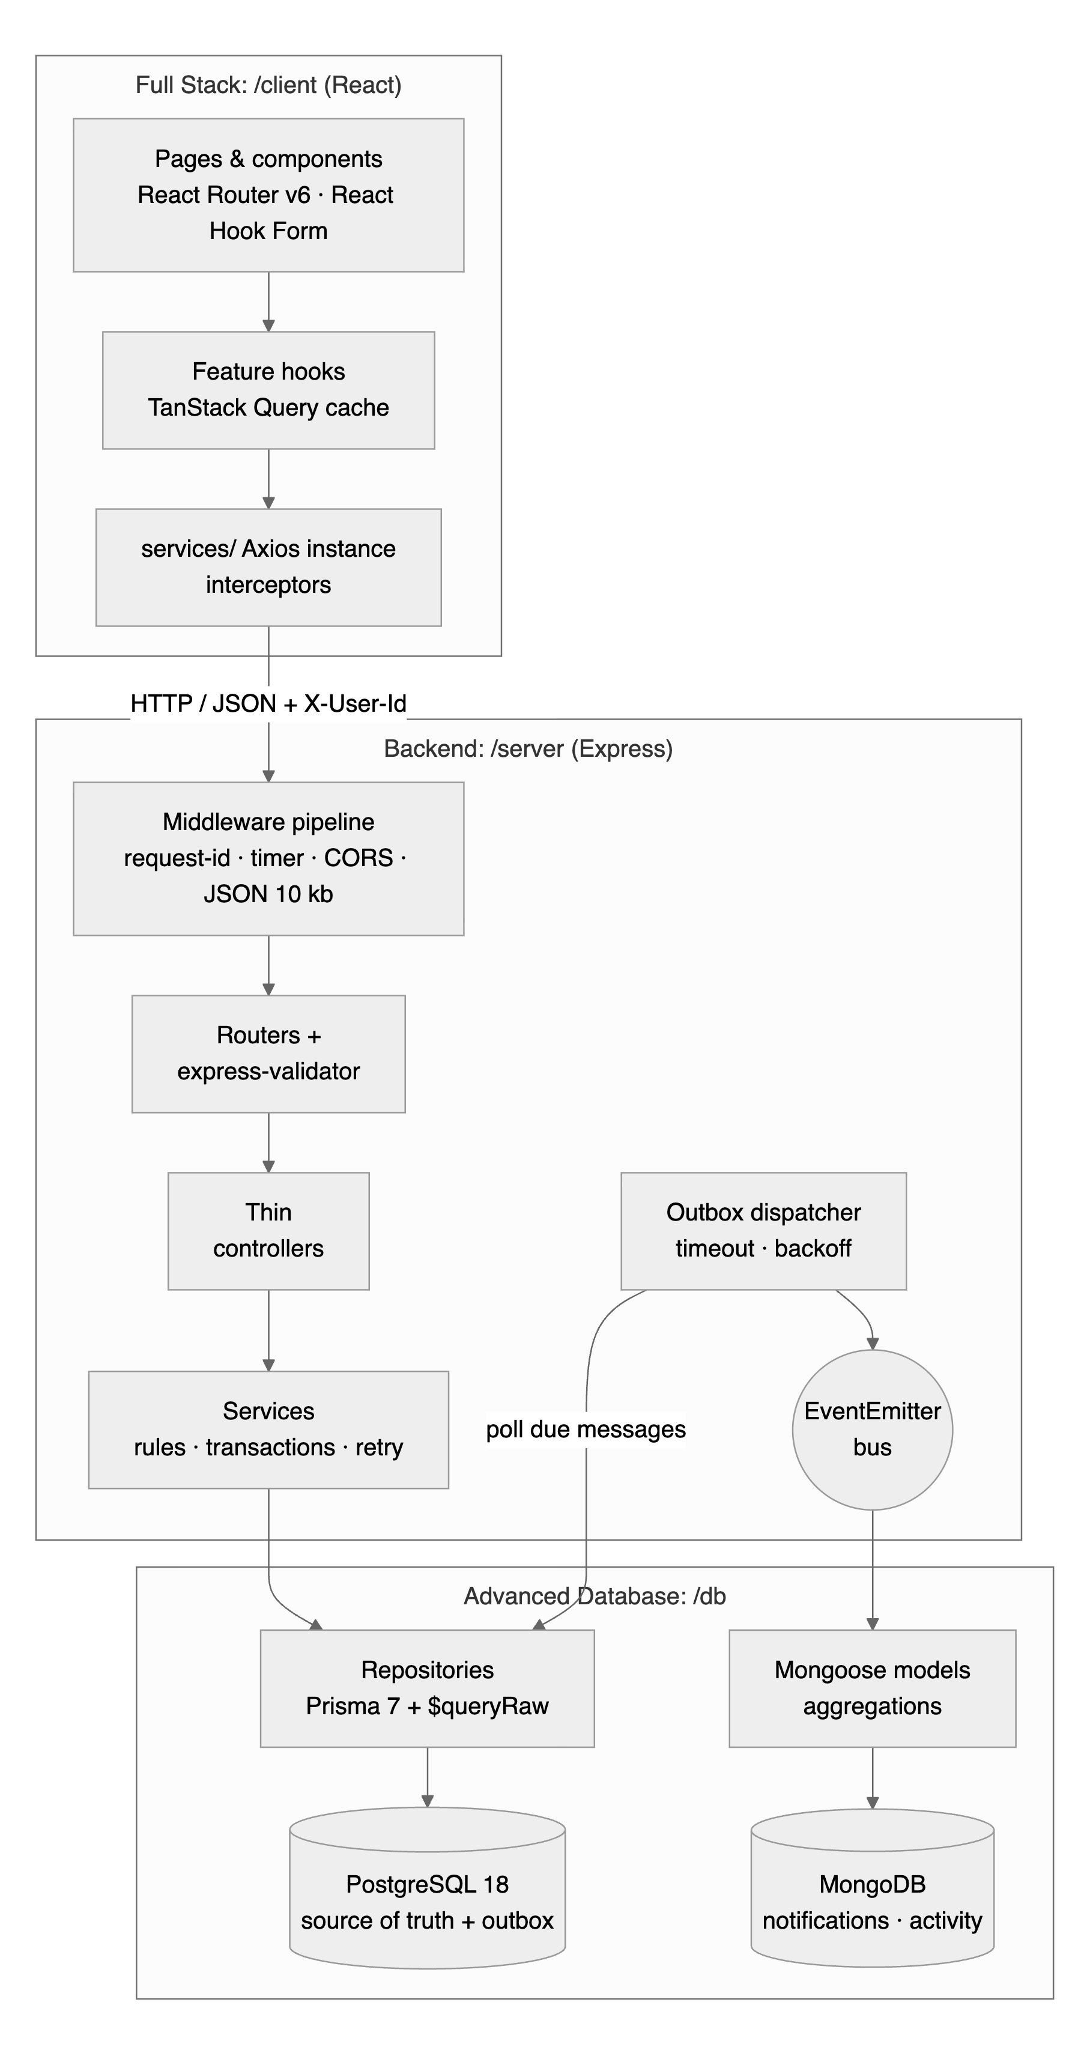
Figure 2.1: SeatSure architecture: client, API and data layers
The relational model is shown in Figure 2.2. Users, clubs and venues are independent entities. Events belong to a club, take place in a venue and are created by a user. Registrations link a user to an event with a status (CONFIRMED, WAITLISTED or CANCELLED). The many-to-many relationship “a user organises a club” is the junction table club_organisers, whose composite primary key (club_id, user_id) prevents duplicate memberships. Outbox_events stores messages for MongoDB.
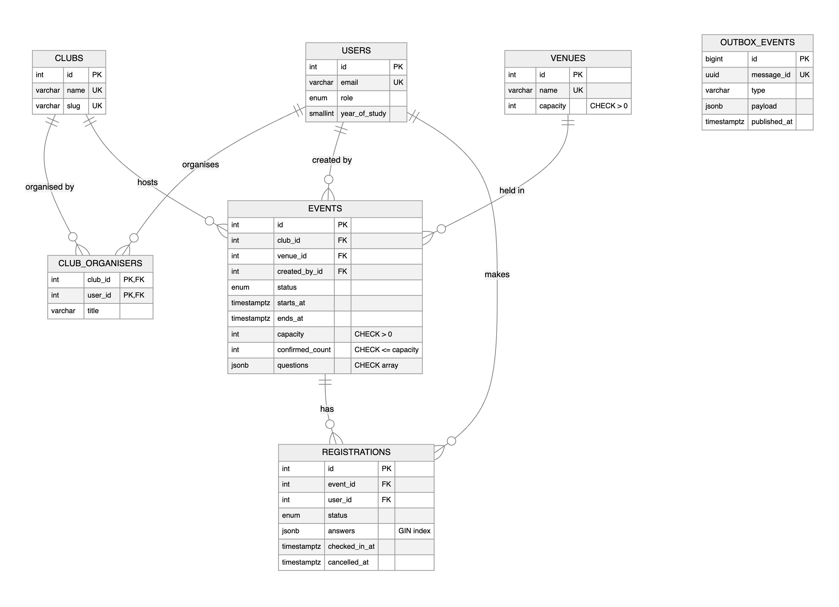
Figure 2.2: Entity–relationship diagram of the PostgreSQL schema
The schema is in third normal form. A venue’s building and capacity are facts about the room, not about any one event, so they are stored once in venues; a club’s name lives only in clubs. There is one deliberate, controlled exception: events.confirmed_count repeats the number of CONFIRMED registrations. It exists so that the seat decision reads one locked row instead of counting rows, and it is protected in three ways: it changes only inside the same transaction as the registration it counts, a CHECK constraint keeps it between 0 and the capacity, and an integrity probe (countMismatches, reported by the health endpoint) compares it with the real count.
Every index exists for a specific query. Table 2.2 lists them with the query each one serves and the evidence that it helps.
Table 2.2: Indexes and the queries they serve
Index | Type and definition | Query it serves | Evidence
events_published_starts_at_idx | Partial B-tree (starts_at, id) WHERE status = 'PUBLISHED' | Catalogue page; also the keyset for cursor pagination | Benchmark 439× (test DB-I01)
events_published_category_starts_at_idx | Partial composite (category, starts_at, id) | Catalogue filtered by category | Benchmark 3.8× (test DB-I02)
events (club_id, starts_at) | Composite B-tree | Organiser dashboard: a club’s events by date | —
registrations_one_active_per_user_key | Partial UNIQUE (event_id, user_id) WHERE status <> 'CANCELLED' | At most one active registration per student and event | DB-C07, DB-C08
registrations (event_id, status, created_at) | Composite B-tree | Waitlist order; attendee page | Benchmark 476× (test DB-I04)
registrations (user_id, created_at DESC) | Composite B-tree | “My passes”, newest first | —
registrations_answers_gin_idx | GIN jsonb_path_ops | Attendee filters such as answers @> '{"tshirt":"M"}' | Benchmark 114× (test DB-I03)
outbox_events_pending_idx | Partial (available_at, id) WHERE published_at IS NULL | Outbox dispatcher poll | —
MongoDB notifications | {outboxId} unique; {userId, createdAt: -1}; TTL {expiresAt} | Idempotent delivery; “my notifications”; expiry | DB-M04, DB-M05
MongoDB activity_logs | {event.id, at: -1}; {event.clubId, at: -1}; TTL {at} (180 days) | Event feed; club feed; expiry | DB-M09

2.2 Algorithm
The three central data algorithms are written below; the lesson that each step applies is given in brackets.

Algorithm 1: Allocating a seat safely
- BEGIN a transaction at READ COMMITTED (M1.11, M2.15).
- Lock the event row: SELECT … FROM events e JOIN clubs c … WHERE e.id = $1 FOR UPDATE OF e. Only the event row is locked, not the club. A concurrent transaction for the same event waits here (M1.14, M2.19).
- Check for an active registration of the same student; the partial unique index enforces the same rule a second time (M1.10).
- If confirmed_count < capacity: insert a CONFIRMED registration and run UPDATE events SET confirmed_count = confirmed_count + 1. The CHECK constraint rejects any update that would exceed the capacity (M1.6).
- Otherwise insert a WAITLISTED registration; its position is ROW_NUMBER() over the event’s waitlist ordered by (created_at, id) (M1.12).
- Insert an outbox row and COMMIT. The lock is released and the next waiting transaction sees the new count.
- On SQLSTATE 40001, 40P01 or 55P03, or a pool timeout, everything has been rolled back; retry with backoff (M2.19).

Algorithm 2: Proving an index with EXPLAIN ANALYZE
- Load a large synthetic data set with generate_series (50,000 events, 200,000 registrations), then run VACUUM ANALYZE so that statistics and the GIN index are up to date.
- BEGIN; DROP INDEX the index under test; run EXPLAIN (ANALYZE, BUFFERS) on the query; ROLLBACK, which brings the index back untouched (M1.15).
- Run the same EXPLAIN again with the index present.
- Compare the plan nodes (for example Seq Scan + Sort against Index Scan), the buffers read and the execution time, and report the speed-up.

Algorithm 3: Keeping MongoDB in step with PostgreSQL (transactional outbox)
- In the same PostgreSQL transaction as the registration change, insert an outbox_events row; its message_id is a UUID generated by PostgreSQL (M3.19).
- After commit, a dispatcher reads unpublished rows in (available_at, id) order through the partial index outbox_events_pending_idx.
- For each row, insert the notification or activity document into MongoDB with outboxId = message_id. A unique index on outboxId turns a repeated delivery into a duplicate-key error (code 11000), which counts as success.
- Mark the row published. On failure, increase attempts and move available_at forward (backoff).
- To rebuild an empty MongoDB, re-queue every outbox row: PostgreSQL is the source of truth.

2.3 Source Code
This section shows how and where each concept is implemented. Every listing is copied from the project, with its file path and line numbers; lines marked “omitted” were left out for brevity. Comments carry tags such as [DATABASE M1.14], so grep -rn "DATABASE M" db lists every place a concept is used, and Appendix B maps each concept to its files and tests.

2.3.1 Schema, keys, enums and indexes (M1.4–M1.10, M2.3, M2.5)
The schema is declared in schema.prisma. The event model shows foreign keys with explicit delete rules (a club or venue with events cannot be deleted), the controlled counter, the JSONB questions column and the two partial catalogue indexes (Listing 2.1).
Listing 2.1: Event model with relations and partial indexes (db/prisma/schema.prisma, lines 103–138)
103 model Event {
104 id Int @id @default(autoincrement())
105 clubId Int @map("club_id")
106 venueId Int @map("venue_id")
107 createdById Int @map("created_by_id")
// … 7 lines omitted …
115 capacity Int
116 // Controlled denormalisation: kept equal to COUNT(confirmed registrations)
inside the same
117 // transaction that changes a registration, and guarded by CHECK
(confirmed_count <= capacity).
118 confirmedCount Int @default(0) @map("confirmed_count")
119 // [DATABASE M1.9: JSONB] Per-event custom questions; the shape differs per
event.
120 questions Json @default("[]")
// … 3 lines omitted …
124
125 club Club @relation(fields: [clubId], references: [id],
onDelete: Restrict)
126 venue Venue @relation(fields: [venueId], references: [id],
onDelete: Restrict)
127 createdBy User @relation("EventCreatedBy", fields:
[createdById], references: [id], onDelete: Restrict)
128 registrations Registration[]
129
130 // [DATABASE M1.10: Composite index] Organiser dashboard: a club's events in
date order.
131 @@index([clubId, startsAt])
132 // [DATABASE M1.10: Partial + composite indexes] The public catalogue only
ever reads PUBLISHED
133 // events ordered by (starts_at, id) (also the keyset used for cursor
pagination), so the
134 // index skips drafts/cancelled rows entirely. Before/after plans:
docs/test-results/explain-analyze-*.txt.
135 @@index([startsAt, id], where: raw("status = 'PUBLISHED'"), map:
"events_published_starts_at_idx")
136 @@index([category, startsAt, id], where: raw("status = 'PUBLISHED'"), map:
"events_published_category_starts_at_idx")
137 @@map("events")
138 }

The registration model adds the partial UNIQUE index, which allows a student to cancel and register again (cancelled rows are kept as history) while forbidding two active registrations, and the GIN index on the JSONB answers (Listing 2.2).
Listing 2.2: Registration model: composite, partial unique and GIN indexes (db/prisma/schema.prisma, lines 140–165)
140 model Registration {
141 id Int @id @default(autoincrement())
142 eventId Int @map("event_id")
143 userId Int @map("user_id")
144 status RegistrationStatus
145 // [DATABASE M1.9: JSONB] Answers to the event's custom questions, e.g.
{"tshirt":"M","laptop":true}.
146 answers Json @default("{}")
// … 5 lines omitted …
152
153 event Event @relation(fields: [eventId], references: [id], onDelete: Cascade)
154 user User @relation(fields: [userId], references: [id], onDelete: Cascade)
155
156 // [DATABASE M1.10: Composite indexes] Waitlist order / attendee lists, and
"my passes".
157 @@index([eventId, status, createdAt])
158 @@index([userId, createdAt(sort: Desc)])
159 // [DATABASE M1.10 + M1.6: Partial UNIQUE index] At most one *active*
registration per student per
160 // event, while cancelled rows are kept as history (a student may cancel and
register again).
161 @@unique([eventId, userId], where: raw("status <> 'CANCELLED'"), map:
"registrations_one_active_per_user_key")
162 // [DATABASE M1.9: GIN index on JSONB] Organisers filter attendees by an
answer: answers @> '{"tshirt":"M"}'.
163 @@index([answers(ops: JsonbPathOps)], type: Gin, map:
"registrations_answers_gin_idx")
164 @@map("registrations")
165 }

Prisma’s schema language has no CHECK constraints, so the business invariants are added in a hand-written migration. The most important one is events_confirmed_within_capacity_chk: even a buggy service or a manual UPDATE cannot store an overbooked event (DB-C03) (Listing 2.3).
Listing 2.3: CHECK constraints (hand-written migration) (db/prisma/migrations/20261026092412_integrity_checks/migration.sql, lines 15–33)
15 -- Events ----------------------------------------------------------------------
-------
16 ALTER TABLE "events"
17 ADD CONSTRAINT "events_capacity_positive_chk" CHECK (capacity > 0),
18 -- The core "can't overbook" invariant, enforced by PostgreSQL itself.
19 ADD CONSTRAINT "events_confirmed_within_capacity_chk" CHECK (confirmed_count
>= 0 AND confirmed_count <= capacity),
20 ADD CONSTRAINT "events_time_order_chk" CHECK (ends_at > starts_at),
21 ADD CONSTRAINT "events_registration_closes_before_start_chk"
22 CHECK (registration_closes_at IS NULL OR registration_closes_at <=
starts_at),
23 ADD CONSTRAINT "events_published_at_chk" CHECK (status = 'DRAFT' OR
published_at IS NOT NULL),
24 -- [DATABASE M1.9] JSONB is flexible, but the top-level shape is still
guaranteed.
25 ADD CONSTRAINT "events_questions_is_array_chk" CHECK (jsonb_typeof(questions)
= 'array');
26
27 -- Registrations
----------------------------------------------------------------------
28 ALTER TABLE "registrations"
29 ADD CONSTRAINT "registrations_answers_is_object_chk" CHECK
(jsonb_typeof(answers) = 'object'),
30 -- cancelled_at is set exactly when the row is CANCELLED.
31 ADD CONSTRAINT "registrations_cancelled_at_chk" CHECK ((status = 'CANCELLED')
= (cancelled_at IS NOT NULL)),
32 -- Only a confirmed attendee can be checked in.
33 ADD CONSTRAINT "registrations_checkin_requires_confirmed_chk" CHECK
(checked_in_at IS NULL OR status = 'CONFIRMED');

2.3.2 Prisma client and the connection pool (M2.1, M2.12)
One Prisma client per process owns a pool of at most ten connections. Requests queue for a free connection instead of opening new ones, and a 5-second acquire timeout turns overload into a fast error instead of a hang. The session time zone is pinned to UTC because a probe found that the adapter sends timestamps without an offset; on an IST machine, midnight UTC had been stored as 18:30 on the previous day (regression test DB-Q11) (Listing 2.4).
Listing 2.4: Driver adapter with a sized pool and UTC sessions (db/src/client.ts, lines 23–35)
23 const adapter = new PrismaPg({
24 connectionString,
25 // A small fixed pool: requests queue for a free connection instead of opening
a new one
26 // per request (which exhausts PostgreSQL's max_connections under load).
27 max: options.poolMax ?? Number(process.env.DB_POOL_MAX ?? 10),
28 // Fail fast (instead of hanging forever) when every pooled connection is
busy.
29 connectionTimeoutMillis: 5_000,
30 idleTimeoutMillis: 30_000,
31 // The adapter sends DateTime parameters without an offset, so PostgreSQL
reads them in the
32 // session time zone. Pinning sessions to UTC stores instants exactly (found
by a probe on an
33 // IST machine: 00:00Z was stored as 18:30Z the previous day). Display code
converts to IST.
34 options: '-c timezone=UTC',
35 });

2.3.3 Transactions and row-level locking (M2.15, M1.11, M1.14, M2.19)
withTransaction wraps Prisma’s interactive transaction. Any thrown error rolls back every write, and database errors are re-thrown as storage-neutral DbError objects (Listing 2.5).
Listing 2.5: Interactive transaction with isolation level and time limits (db/src/transaction.ts, lines 25–35)
25 export async function withTransaction<T>(work: (tx: Tx) => Promise<T>, options:
TransactionOptions = {}): Promise<T> {
26 try {
27 return await prisma.$transaction(work, {
28 isolationLevel: Prisma.TransactionIsolationLevel[options.isolationLevel ??
'ReadCommitted'],
29 timeout: options.timeoutMs ?? 5_000,
30 maxWait: options.maxWaitMs ?? 3_000,
31 });
32 } catch (err) {
33 throw toDbError(err) ?? err;
34 }
35 }

Prisma’s query builder has no FOR UPDATE, so the lock is taken with a parameterised $queryRaw. FOR UPDATE OF e locks only the event row, even though the query joins the club to read its name (Listing 2.6).
Listing 2.6: Locking the event row (db/src/repositories/eventRepository.ts, lines 131–148)
131 export async function lockForUpdate(tx: Tx, id: number): Promise<LockedEvent |
null> {
132 const rows = await tx.$queryRaw<LockedEvent[]>`
133 SELECT e.id,
134 e.club_id AS "clubId",
135 c.name AS "clubName",
136 e.title,
137 e.status::text AS status,
138 e.starts_at AS "startsAt",
139 e.registration_closes_at AS "registrationClosesAt",
140 e.capacity,
141 e.confirmed_count AS "confirmedCount",
142 e.questions
143 FROM events e
144 JOIN clubs c ON c.id = e.club_id
145 WHERE e.id = ${id}
146 FOR UPDATE OF e`;
147 return rows[0] ?? null;
148 }

The race experiment in Listing 2.7 shows why the lock is needed. Both functions read the current state, pause for 20 ms (as a slow request would) and then write; only the second one locks first. Chapter III shows the results.
Listing 2.7: Race experiment: read-then-write without and with the row lock (db/scripts/race-experiment.ts, lines 45–62)
45 async function naive(eventId: number, userId: number) {
46 await withTransaction(async (tx) => {
47 const confirmed = await tx.registration.count({ where: { eventId, status:
'CONFIRMED' } });
48 const event = await tx.event.findUniqueOrThrow({ where: { id: eventId } });
49 await tx.$executeRaw`SELECT pg_sleep(0.02)`;
50 await tx.registration.create({ data: { eventId, userId, status: confirmed <
event.capacity ? 'CONFIRMED' : 'WAITLISTED', answers: {} } });
51 });
52 }
53
54 async function locked(eventId: number, userId: number) {
55 await withTransaction(async (tx) => {
56 const event = await eventRepository.lockForUpdate(tx, eventId);
57 const hasSeat = event!.confirmedCount < event!.capacity;
58 await tx.$executeRaw`SELECT pg_sleep(0.02)`;
59 await registrationRepository.create(tx, { eventId, userId, status: hasSeat ?
'CONFIRMED' : 'WAITLISTED', answers: {} });
60 if (hasSeat) await eventRepository.changeConfirmedCount(tx, eventId, 1);
61 });
62 }

Isolation levels are demonstrated with two real connections. Under REPEATABLE READ, transaction A keeps reading its snapshot after B commits a change, and A’s own conflicting update fails with SQLSTATE 40001, which the error mapping marks as retryable (DB-T07) (Listing 2.8).
Listing 2.8: MVCC snapshot and serialisation failure under REPEATABLE READ (db/tests/transactions.test.ts, lines 124–136)
124 it('DB-T07 REPEATABLE READ: the snapshot stays stable, and a conflicting write
fails with 40001', async () => {
125 const event = await createEvent(base, { capacity: 10 });
126 await a.query('BEGIN ISOLATION LEVEL REPEATABLE READ');
127 const first = (await a.query('SELECT capacity FROM events WHERE id = $1',
[event.id])).rows[0].capacity;
128 await b.query('UPDATE events SET capacity = 25 WHERE id = $1', [event.id]);
129 const second = (await a.query('SELECT capacity FROM events WHERE id = $1',
[event.id])).rows[0].capacity;
130 expect([first, second]).toEqual([10, 10]); // MVCC: A keeps reading its
snapshot
131
132 const conflict = await a.query('UPDATE events SET capacity = capacity + 1
WHERE id = $1', [event.id]).catch((e) => e);
133 await a.query('ROLLBACK');
134 expect(conflict.code).toBe('40001'); // could not serialize access due to
concurrent update
135 expect(toDbError(conflict)?.retryable).toBe(true); // the API retries these
with backoff
136 });

2.3.4 Filtering, sorting, cursor pagination and relations (M2.8–M2.11)
The catalogue query combines a compound where (including a column-to-column comparison for “seats available”), an ordering that always ends with the unique id, and cursor pagination that fetches one extra row to learn whether another page exists (Listing 2.9).
Listing 2.9: Filtering, sorting and cursor pagination with Prisma (db/src/repositories/eventRepository.ts, lines 50–74)
50 export async function listPublished(query: EventListQuery, client: Tx = prisma)
{
51 const limit = query.limit ?? 12;
52 const where: Prisma.EventWhereInput = {
53 status: 'PUBLISHED',
54 startsAt: { gte: query.from ?? new Date(), ...(query.to ? { lte: query.to }
: {}) },
55 ...(query.clubId ? { clubId: query.clubId } : {}),
56 ...(query.category ? { category: query.category } : {}),
57 ...(query.q ? { title: { contains: query.q, mode: 'insensitive' as const } }
: {}),
58 // Column-to-column comparison through a field reference (confirmed_count <
capacity).
59 ...(query.availability === 'open' ? { confirmedCount: { lt:
prisma.event.fields.capacity } } : {}),
60 ...(query.availability === 'full' ? { confirmedCount: { gte:
prisma.event.fields.capacity } } : {}),
61 };
62
63 const rows = await client.event.findMany({
64 where,
65 select: cardSelect,
66 orderBy: ORDER_BY[query.sort ?? 'soonest'],
67 take: limit + 1,
68 ...(query.cursor ? { cursor: { id: query.cursor }, skip: 1 } : {}),
69 });
70
71 const hasMore = rows.length > limit;
72 const items = hasMore ? rows.slice(0, limit) : rows;
73 return { items, nextCursor: hasMore ? items[items.length - 1]!.id : null };
74 }

“My passes” loads each registration with its event, club and venue through a nested include. Prisma resolves it with one query per relation level rather than one per row, so the number of SQL statements stays the same for 2 or 10 registrations (DB-Q08) (Listing 2.10).
Listing 2.10: Relation loading without N+1 (db/src/repositories/registrationRepository.ts, lines 62–83)
62 export async function listForUser(userId: number, client: Tx = prisma) {
63 return client.registration.findMany({
64 where: { userId },
65 orderBy: [{ createdAt: 'desc' }, { id: 'desc' }],
66 include: {
67 event: {
68 select: {
69 id: true,
// … 7 lines omitted …
77 club: { select: { id: true, name: true } },
78 venue: { select: { id: true, name: true, building: true } },
79 },
80 },
81 },
82 });
83 }

2.3.5 JSONB containment and window functions in raw SQL (M1.9, M1.12, M2.19)
The organiser’s attendee list needs three things the query builder cannot express in one statement: JSONB containment (answers @> $filter, served by the GIN index), a waitlist position per row (ROW_NUMBER()), and the total number of matching rows returned with the page (COUNT(*) OVER ()), so one round trip gives both the page and the total (Listing 2.11). Every value is a bound parameter, never concatenated into the SQL string.
Listing 2.11: Attendee page: JSONB filter, ROW_NUMBER and COUNT(*) OVER () (db/src/repositories/registrationRepository.ts, lines 140–168)
140 const rows = await client.$queryRaw<(Omit<AttendeeRow, 'waitlistPosition'> & {
waitlistPosition: bigint | null; total: bigint })[]>`
141 WITH positioned AS (
142 SELECT r.*,
143 CASE WHEN r.status = 'WAITLISTED'
144 THEN ROW_NUMBER() OVER (PARTITION BY r.status ORDER BY
r.created_at, r.id)
145 END AS waitlist_position
146 FROM registrations r
147 WHERE r.event_id = ${eventId}
148 )
149 SELECT p.id,
150 p.status::text AS status,
151 p.answers,
// … 7 lines omitted …
159 p.waitlist_position AS "waitlistPosition",
160 COUNT(*) OVER () AS total
161 FROM positioned p
162 JOIN users u ON u.id = p.user_id
163 WHERE p.answers @> ${answersFilter}::jsonb
164 ${statusFilter}
165 ${searchFilter}
166 ORDER BY CASE p.status WHEN 'CONFIRMED' THEN 0 WHEN 'WAITLISTED' THEN 1 ELSE 2
END,
167 p.created_at, p.id
168 LIMIT ${q.pageSize} OFFSET ${offset}`;

Live waitlist positions use the same idea: ROW_NUMBER() numbers each event’s waitlist in arrival order without collapsing rows (Listing 2.12).
Listing 2.12: Waitlist positions with ROW_NUMBER() (db/src/repositories/registrationRepository.ts, lines 92–99)
92 WITH waitlist AS (
93 SELECT r.id,
94 ROW_NUMBER() OVER (PARTITION BY r.event_id ORDER BY r.created_at, r.id)
AS position
95 FROM registrations r
96 WHERE r.status = 'WAITLISTED'
97 AND r.event_id IN (SELECT event_id FROM registrations WHERE id IN
(${Prisma.join(registrationIds)}))
98 )
99 SELECT id, position FROM waitlist WHERE id IN
(${Prisma.join(registrationIds)})`;

2.3.6 Analytics with CTEs and window functions (M1.12, M1.13)
The fill-rate report builds per-event numbers in two CTEs, then ranks every event overall (RANK), within its club (PARTITION BY club_id), and compares it with its club’s average fill (AVG … OVER (PARTITION BY club_id)) (Listing 2.13).
Listing 2.13: Fill-rate ranking: CTEs and three window functions (db/src/repositories/analyticsRepository.ts, lines 36–65)
36 WITH event_stats AS (
37 SELECT e.id, e.title, e.club_id, c.name AS club_name, e.starts_at, e.capacity,
e.confirmed_count,
38 COUNT(r.id) FILTER (WHERE r.status = 'WAITLISTED') AS waitlisted,
39 COUNT(r.id) FILTER (WHERE r.checked_in_at IS NOT NULL) AS checked_in
40 FROM events e
41 JOIN clubs c ON c.id = e.club_id
42 LEFT JOIN registrations r ON r.event_id = e.id
43 WHERE e.status = 'PUBLISHED' ${clubFilter(Prisma.sql`e.club_id`, clubIds)}
44 GROUP BY e.id, c.name
45 ),
46 rated AS (
47 SELECT *, ROUND(100.0 * confirmed_count / capacity, 1) AS fill_rate
48 FROM event_stats
49 )
50 SELECT id,
51 title,
// … 7 lines omitted …
59 fill_rate::float8 AS
"fillRate",
60 RANK() OVER (ORDER BY fill_rate DESC, waitlisted DESC)::int AS
"overallRank",
61 RANK() OVER (PARTITION BY club_id ORDER BY fill_rate DESC, waitlisted
DESC)::int AS "rankInClub",
62 ROUND(fill_rate - AVG(fill_rate) OVER (PARTITION BY club_id), 1)::float8
AS "vsClubAverage"
63 FROM rated
64 ORDER BY "overallRank", id
65 LIMIT ${limit}`;

Daily sign-ups use generate_series to create one row per calendar day (so days without sign-ups appear as zero), a running total SUM() OVER (ORDER BY day) and a seven-day moving average with a ROWS BETWEEN 6 PRECEDING AND CURRENT ROW frame. Days are computed in the campus time zone (Listing 2.14). The club leaderboard uses DENSE_RANK() and NTILE(3) in the same way.
Listing 2.14: Daily sign-ups with a running total and a moving average (db/src/repositories/analyticsRepository.ts, lines 79–102)
79 WITH bounds AS (
80 SELECT ((now() AT TIME ZONE ${CAMPUS_TZ})::date - ${days - 1}::int) AS
start_day,
81 (now() AT TIME ZONE ${CAMPUS_TZ})::date AS end_day
82 ),
83 calendar AS (
84 SELECT generate_series(start_day, end_day, interval '1 day')::date AS day FROM
bounds
85 ),
86 daily AS (
87 SELECT (r.created_at AT TIME ZONE ${CAMPUS_TZ})::date AS day, COUNT(*) AS
signups
88 FROM registrations r
89 JOIN events e ON e.id = r.event_id
90 WHERE r.created_at >= (SELECT start_day FROM bounds)::timestamp AT TIME ZONE
${CAMPUS_TZ}
91 ${eventId ? Prisma.sql`AND r.event_id = ${eventId}` : Prisma.empty}
92 ${clubFilter(Prisma.sql`e.club_id`, clubIds)}
93 GROUP BY 1
94 )
95 SELECT c.day,
96 COALESCE(d.signups, 0)::int
AS signups,
97 SUM(COALESCE(d.signups, 0)) OVER (ORDER BY c.day)::int
AS cumulative,
98 ROUND(AVG(COALESCE(d.signups, 0)) OVER (ORDER BY c.day
99 ROWS BETWEEN 6 PRECEDING AND CURRENT ROW), 2)::float8
AS "movingAvg7d"
100 FROM calendar c
101 LEFT JOIN daily d ON d.day = c.day
102 ORDER BY c.day`;

2.3.7 Structured error handling (M2.19)
Database failures are translated into a few storage-neutral kinds, using the PostgreSQL SQLSTATE when the driver provides one and the Prisma error code otherwise (Listing 2.15). The API maps each kind to an HTTP status and retries only WRITE_CONFLICT and TIMEOUT; it never needs to know Prisma codes.
Listing 2.15: SQLSTATE and Prisma codes mapped to error kinds (db/src/errors.ts, lines 36–54)
36 const SQLSTATE_KIND: Record<string, DbErrorKind> = {
37 '23505': 'UNIQUE_VIOLATION',
38 '23503': 'FOREIGN_KEY_VIOLATION',
39 '23514': 'CHECK_VIOLATION',
40 '40001': 'WRITE_CONFLICT', // serialization_failure
41 '40P01': 'WRITE_CONFLICT', // deadlock_detected
42 '55P03': 'WRITE_CONFLICT', // lock_not_available (NOWAIT / lock_timeout)
43 '57014': 'TIMEOUT', // query_canceled (statement_timeout)
44 };
45
46 const PRISMA_CODE_KIND: Record<string, DbErrorKind> = {
47 P2002: 'UNIQUE_VIOLATION',
48 P2003: 'FOREIGN_KEY_VIOLATION',
49 P2025: 'NOT_FOUND',
50 P2034: 'WRITE_CONFLICT', // "Transaction failed due to a write conflict or a
deadlock"
51 P2024: 'TIMEOUT', // timed out fetching a connection from the pool
52 P2028: 'TIMEOUT', // interactive transaction expired / API error
53 P1001: 'UNAVAILABLE',
54 };

Listing 2.16: Classifying an error, including a pool timeout (db/src/errors.ts, lines 71–103)
71 export function toDbError(err: unknown): DbError | null {
72 if (err instanceof DbError) return err;
73
74 if (err instanceof Prisma.PrismaClientKnownRequestError) {
75 const cause = adapterCause(err);
76 const sqlState = cause?.originalCode ?? cause?.code;
77 const kind = (sqlState && SQLSTATE_KIND[sqlState]) ||
PRISMA_CODE_KIND[err.code] || 'UNKNOWN';
78 return new DbError(kind, err.message.split('\n').pop() ?? err.message, {
79 constraint: constraintFrom(cause),
80 sqlState,
81 prismaCode: err.code,
82 cause: err,
83 });
84 }
85
// … 12 lines omitted …
98 // node-postgres pool: every connection stayed busy for longer than
connectionTimeoutMillis.
99 if (err instanceof Error && /timeout exceeded when trying to
connect/i.test(err.message)) {
100 return new DbError('TIMEOUT', 'No database connection became free in time',
{ cause: err });
101 }
102 return null;
103 }

2.3.8 MongoDB documents, validators, hooks and TTL (M3.2–M3.4, M3.19)
A notification’s data payload differs per type, which is exactly the case where a document fits better than a row. The Mongoose schema validates every field, a unique index on outboxId makes delivery idempotent, a TTL index deletes each notification after 30 days, and a pre('validate') hook fills in the expiry date (Listing 2.17).
Listing 2.17: Notification schema: validators, indexes, TTL and a hook (db/src/mongo/models/Notification.ts, lines 10–43)
10 const notificationSchema = new Schema(
11 {
12 // Idempotency key: the outbox message that produced this document. A unique
index means a
13 // retried delivery can never create a duplicate notification.
14 outboxId: { type: String, required: true },
15 // Reference (not embedding): the user lives in PostgreSQL, the source of
truth for people.
16 userId: { type: Number, required: true, min: [1, 'userId must be a positive
integer'] },
17 type: { type: String, required: true, enum: { values:
[...NOTIFICATION_TYPES], message: '{VALUE} is not a notification type' }
},
18 title: { type: String, required: true, trim: true, maxlength: 120 },
19 message: { type: String, required: true, trim: true, maxlength: 500 },
20 data: { type: Schema.Types.Mixed, default: () => ({}) },
21 readAt: { type: Date, default: null },
22 expiresAt: { type: Date, required: true },
23 },
24 {
// … 4 lines omitted …
29 },
30 );
31
32 notificationSchema.index({ outboxId: 1 }, { unique: true });
33 // "My notifications, newest first" is the only read pattern, so index exactly
that.
34 notificationSchema.index({ userId: 1, createdAt: -1 });
35 // [DATABASE M3.19: TTL index] MongoDB's TTL monitor deletes each document once
`expiresAt` passes.
36 notificationSchema.index({ expiresAt: 1 }, { expireAfterSeconds: 0 });
37
38 // Middleware hook: default the expiry before validation runs, so `required`
passes.
39 notificationSchema.pre('validate', function () {
40 if (!this.expiresAt) {
41 this.expiresAt = new Date(Date.now() + NOTIFICATION_TTL_DAYS * 24 * 60 * 60
* 1000);
42 }
43 });

Mongoose validators protect only writes that go through Mongoose. The same rules are therefore installed in MongoDB as a $jsonSchema validator when the collections are created, so even a native-driver write with an invalid type is rejected with error 121 (DB-M03) (Listing 2.18, Listing 2.19).
Listing 2.18: Server-side $jsonSchema validator (db/src/mongo/jsonSchemas.ts, lines 23–37)
23 export const notificationJsonSchema = {
24 bsonType: 'object',
25 required: ['outboxId', 'userId', 'type', 'title', 'message', 'expiresAt',
'createdAt'],
26 properties: {
27 outboxId: { bsonType: 'string', minLength: 1 },
28 userId: { bsonType: ['int', 'long', 'double'], minimum: 1 },
29 type: { enum: [...NOTIFICATION_TYPES] },
30 title: { bsonType: 'string', minLength: 1, maxLength: 120 },
31 message: { bsonType: 'string', minLength: 1, maxLength: 500 },
32 data: { bsonType: 'object' },
33 readAt: { bsonType: ['date', 'null'] },
34 expiresAt: { bsonType: 'date' },
35 createdAt: { bsonType: 'date' },
36 },
37 } as const;

Listing 2.19: Creating collections with their validators and indexes (db/src/mongo/connection.ts, lines 57–65)
57 for (const spec of specs) {
58 const validator = { $jsonSchema: spec.schema };
59 if (existing.has(spec.name)) {
60 await db.command({ collMod: spec.name, validator, validationLevel: 'strict',
validationAction: 'error' });
61 } else {
62 await db.createCollection(spec.name, { validator, validationLevel: 'strict',
validationAction: 'error' });
63 }
64 await spec.model.syncIndexes();
65 }

2.3.9 Embedding versus referencing, and index design (M3.8, M3.20)
An activity document embeds small snapshots of the event and the actor. They are always read together with the activity and must show what was true at that moment, so a later title change does not rewrite history; one query renders a whole feed without joins. The ids inside the snapshots are references back to PostgreSQL for anything that needs current data. The compound indexes match the two feed queries exactly, and explain() confirms an index scan that examines only the 10 documents it returns (DB-M09) (Listing 2.20).
Listing 2.20: Activity log: embedded snapshots and feed indexes (db/src/mongo/models/ActivityLog.ts, lines 14–39)
14 const activitySchema = new Schema(
15 {
16 outboxId: { type: String, required: true },
17 action: { type: String, required: true, enum: [...ACTIVITY_ACTIONS] },
18 actor: new Schema({ id: { type: Number, required: true }, name: { type:
String, required: true } }, snapshotOptions),
19 event: new Schema(
20 {
21 id: { type: Number, required: true },
22 title: { type: String, required: true },
23 clubId: { type: Number, required: true },
24 clubName: { type: String },
25 },
26 snapshotOptions,
27 ),
28 meta: { type: Schema.Types.Mixed, default: () => ({}) },
29 at: { type: Date, required: true, default: () => new Date() },
30 },
31 { collection: 'activity_logs', versionKey: false, minimize: false },
32 );
33
34 activitySchema.index({ outboxId: 1 }, { unique: true });
35 // [DATABASE M3.20: Index design] Supports the two feed queries: one event's
feed and one club's feed.
36 activitySchema.index({ 'event.id': 1, at: -1 });
37 activitySchema.index({ 'event.clubId': 1, at: -1 });
38 // [DATABASE M3.19: TTL index] Activity older than 180 days is removed
automatically.
39 activitySchema.index({ at: 1 }, { expireAfterSeconds: ACTIVITY_TTL_DAYS * 24 *
60 * 60 });

2.3.10 Aggregation pipelines with $facet and $lookup (M3.7, M3.12, M3.16)
The organiser dashboard’s activity summary is computed in a single round trip: $match narrows the documents to the period and the organiser’s clubs first (so later stages process less data), then $facet runs independent sub-pipelines for totals, counts per action and the most active events (Listing 2.21).
Listing 2.21: Dashboard summary with $match and $facet (db/src/mongo/aggregations.ts, lines 18–54)
18 export function activitySummaryPipeline({ since, clubIds }: { since: Date;
clubIds?: number[] }): PipelineStage[] {
19 return [
20 { $match: { at: { $gte: since }, ...(clubIds?.length ? { 'event.clubId': {
$in: clubIds } } : {}) } },
21 {
22 $facet: {
23 totals: [
24 { $group: { _id: null, activities: { $sum: 1 }, events: { $addToSet:
'$event.id' } } },
25 { $project: { _id: 0, activities: 1, uniqueEvents: { $size: '$events'
} } },
26 ],
27 byAction: [
28 { $group: { _id: '$action', count: { $sum: 1 } } },
29 { $sort: { count: -1, _id: 1 } },
30 { $project: { _id: 0, action: '$_id', count: 1 } },
31 ],
// … 5 lines omitted …
37 topEvents: [
38 {
39 $group: {
40 _id: '$event.id',
// … 9 lines omitted …
50 ],
51 },
52 },
53 ];
54 }

A second pipeline answers “did promoted students notice?”: it groups waitlist promotions per event and uses a pipeline $lookup into the notifications collection to count how many promotion notices exist and how many are still unread (Listing 2.22).
Listing 2.22: Joining collections with a pipeline $lookup (db/src/mongo/aggregations.ts, lines 73–100)
73 export function promotionReachPipeline(clubIds?: number[]): PipelineStage[] {
74 return [
75 { $match: { action: 'PROMOTED', ...(clubIds?.length ? { 'event.clubId': {
$in: clubIds } } : {}) } },
76 { $group: { _id: '$event.id', title: { $last: '$event.title' }, promotions:
{ $sum: 1 } } },
77 {
78 $lookup: {
79 from: 'notifications',
80 let: { eventId: '$_id' },
81 pipeline: [
82 { $match: { type: 'PROMOTED_FROM_WAITLIST', $expr: { $eq:
['$data.eventId', '$$eventId'] } } },
83 { $project: { _id: 0, readAt: 1 } },
84 ],
85 as: 'notices',
86 },
87 },
88 {
89 $project: {
90 _id: 0,
91 eventId: '$_id',
92 title: 1,
93 promotions: 1,
94 notified: { $size: '$notices' },
95 unread: { $size: { $filter: { input: '$notices', as: 'n', cond: { $eq:
['$$n.readAt', null] } } } },
96 },
97 },
98 { $sort: { promotions: -1, eventId: 1 } },
99 ];
100 }

2.3.11 The transactional outbox and idempotent delivery (M3.19)
Writing to PostgreSQL and then to MongoDB from the same request is a dual write: if the second write fails, the databases disagree. SeatSure writes the message into PostgreSQL instead, inside the same transaction as the change, and a dispatcher delivers it later (Listing 2.23). On the MongoDB side, a duplicate outboxId means the message was already delivered before a crash or retry, so it counts as success (Listing 2.24).
Listing 2.23: Outbox: written in the business transaction, read by the dispatcher (db/src/repositories/outboxRepository.ts, lines 11–23)
11 export async function add(tx: Tx, type: string, payload: Prisma.InputJsonValue)
{
12 return tx.outboxEvent.create({ data: { type, payload }, select: { id: true }
});
13 }
14
15 /** Oldest pending messages that are due (uses the partial index
outbox_events_pending_idx). */
16 export async function fetchDue(limit: number, now: Date = new Date(), client: Tx
= prisma): Promise<OutboxMessage[]> {
17 return client.outboxEvent.findMany({
18 where: { publishedAt: null, availableAt: { lte: now } },
19 orderBy: [{ availableAt: 'asc' }, { id: 'asc' }],
20 take: limit,
21 select: { id: true, messageId: true, type: true, payload: true, attempts:
true },
22 });
23 }

Listing 2.24: Idempotent insert on the MongoDB side (db/src/mongo/store.ts, lines 15–23)
15 async function insertOnce<T>(create: () => Promise<T>): Promise<'inserted' |
'duplicate'> {
16 try {
17 await create();
18 return 'inserted';
19 } catch (err) {
20 if (isDuplicateKey(err)) return 'duplicate';
21 throw err;
22 }
23 }

2.3.12 Measuring an index with EXPLAIN ANALYZE (M1.15)
The benchmark measures each index fairly: the “before” plan runs inside a transaction that drops the index and is then rolled back, so the index returns untouched and both plans run on identical data (Listing 2.25).
Listing 2.25: Before/after measurement inside a rolled-back transaction (db/src/bench/explain.ts, lines 76–87)
76 export async function measureScenario(client: pg.Client, scenario: Scenario):
Promise<ScenarioResult> {
77 let before: ExplainRun;
78 await client.query('BEGIN');
79 try {
80 for (const index of scenario.indexes) await client.query(`DROP INDEX IF
EXISTS "${index}"`);
81 before = await explain(client, scenario.sql, scenario.params);
82 } finally {
83 await client.query('ROLLBACK'); // the indexes come back untouched
84 }
85 const after = await explain(client, scenario.sql, scenario.params);
86 return { scenario, before, after, speedup: before.executionMs /
Math.max(after.executionMs, 0.001) };
87 }

2.4 Connection with Full Stack Web Development and Back-End Web Development
The data layer is shaped by the queries the other two parts make. Figure 2.3 follows one registration through all three layers.
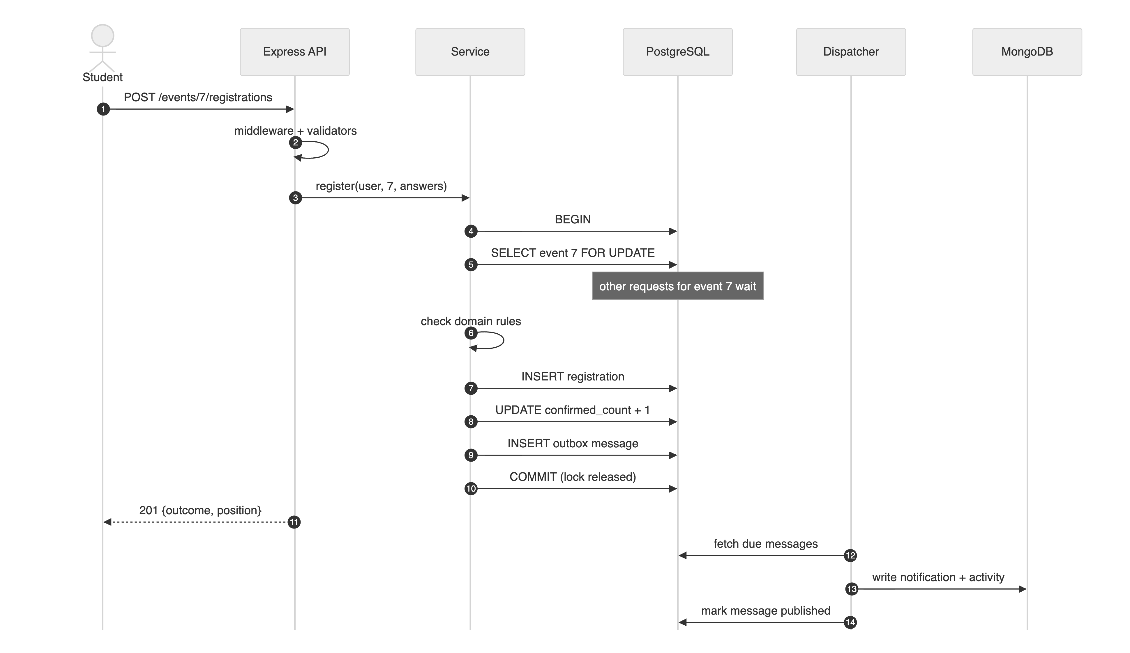
Figure 2.3: One registration across the client, the API and the two databases
- Serving the API (Back-End). The API calls repository functions such as lockForUpdate, listPublished and fillRateRanking and never writes SQL. Transactions are opened through withTransaction, and database failures arrive as DbError kinds that the API maps to HTTP status codes and uses to decide whether to retry.
- Defence in depth (Back-End). The API’s service decides seats while holding the row lock, and the database enforces the same rule again with CHECK (confirmed_count <= capacity) and the partial unique index. Constraint names such as registrations_one_active_per_user_key become stable API error codes (ALREADY_REGISTERED).
- Serving the interface (Full Stack). The catalogue’s infinite scroll uses cursor pagination over (starts_at, id), the same order as the partial catalogue index. The registration form is generated from events.questions (JSONB), the organiser’s answer filter becomes a GIN-indexed @> query, and the analytics page draws the window-function results and the MongoDB aggregations.
- Two databases, one truth. PostgreSQL holds every fact; MongoDB holds data derived from it through the outbox. If MongoDB is down, the API reports degraded: true for feeds while registration continues, and on restart an empty in-memory MongoDB is rebuilt by re-queuing the outbox.

Chapter III – Results

3.1 Testing Approach
The database tests run against a dedicated seatsure_test database, migrated with prisma migrate deploy before the run; every test starts from empty tables. MongoDB tests use an npm-distributed in-memory MongoDB 8.2 server whose TTL monitor runs every second, so expiry can be observed. The tests are grouped by concern: integrity constraints, transactions and isolation, query correctness, index impact and MongoDB. System-level evidence comes from three scripts: an EXPLAIN ANALYZE benchmark on a large synthetic data set, a connection-pool experiment and a race-condition experiment.
Every test case is recorded with an ID, the concept and lesson it proves, the scenario, the input, and the expected and actual results (Appendix A). Raw outputs are saved in docs/test-results/.

3.2 Test Results Summary
Table 3.1: Automated database tests by area (26 Oct 2026, npm run test:db)
Area (lessons) | Test IDs | Tests | Result
Integrity constraints: CHECK, FK, UNIQUE, ON DELETE, error mapping (M1.6, M1.9, M1.10, M2.19) | DB-C01 – C13 | 13 | 13 passed
Transactions, locking and isolation (M1.11, M1.14, M2.15) | DB-T01 – T08 | 8 | 8 passed
Query correctness: pagination, filters, window functions, CTEs, N+1, JSONB (M1.9, M1.12, M1.13, M2.10, M2.11) | DB-Q01 – Q11 | 11 | 11 passed
Index impact with EXPLAIN ANALYZE on 30,000 events and 100,000 registrations (M1.10, M1.15) | DB-I01 – I05 | 5 | 5 passed
MongoDB: validators, hooks, $jsonSchema, TTL, aggregation, explain (M3.2–M3.20) | DB-M01 – M10 | 10 | 10 passed
Total |  | 47 | 47 passed

3.3 Results
- All 47 automated tests passed in 15.3 s on 26 October 2026.
- Integrity (DB-C01–C12): every constraint rejected the write it guards. For example, UPDATE events SET confirmed_count = capacity + 1, run directly in SQL, was rejected with SQLSTATE 23514 by events_confirmed_within_capacity_chk, and a second active registration was rejected by the partial unique index while re-registering after a cancellation was allowed.
- Atomicity (DB-T01–T03): an error after two writes, a CHECK violation in the middle of a transaction and a nested create with one invalid child each left no partial data behind.
- Isolation and MVCC (DB-T06–T08): READ COMMITTED read [10, 25] across a concurrent commit (a non-repeatable read); REPEATABLE READ read [10, 10] from its snapshot and its conflicting write failed with 40001; a second FOR UPDATE waited at least 250 ms until the first transaction committed.
- Locking prevents overbooking (DB-T04, DB-T05): twelve parallel read-then-write transactions on a 3-seat event oversold it without a lock, and confirmed exactly 3 (9 waitlisted, counter 3) with FOR UPDATE.
- Window functions and CTEs (DB-Q04–Q07): waitlist positions renumbered from 1, 2, 3 to 1, 2 after the first person left; fill-rate ranks, in-club ranks and differences from the club average matched hand-computed values exactly.
- No N+1 (DB-Q08): “My passes” issued the same number of SQL statements (at most 4) for 2 and for 10 registrations.
- MongoDB (DB-M01–M10): invalid documents were rejected by Mongoose and, when written with the native driver, by $jsonSchema (error 121); an expired notification disappeared within about a second while a fresh one remained; the same outbox message delivered twice produced one document; the feed query used an index scan that examined only the 10 documents it returned.

Index benchmark. Figure 3.1 summarises the EXPLAIN ANALYZE benchmark on 50,000 events and 200,000 registrations, and Listing 3.1 shows the plans for the catalogue query. Without the index, PostgreSQL scanned all 50,000 events, discarded 35,000 of them and sorted the rest; with the partial index it read the first 13 matching rows in order and stopped, touching 4 buffers instead of 1,064.
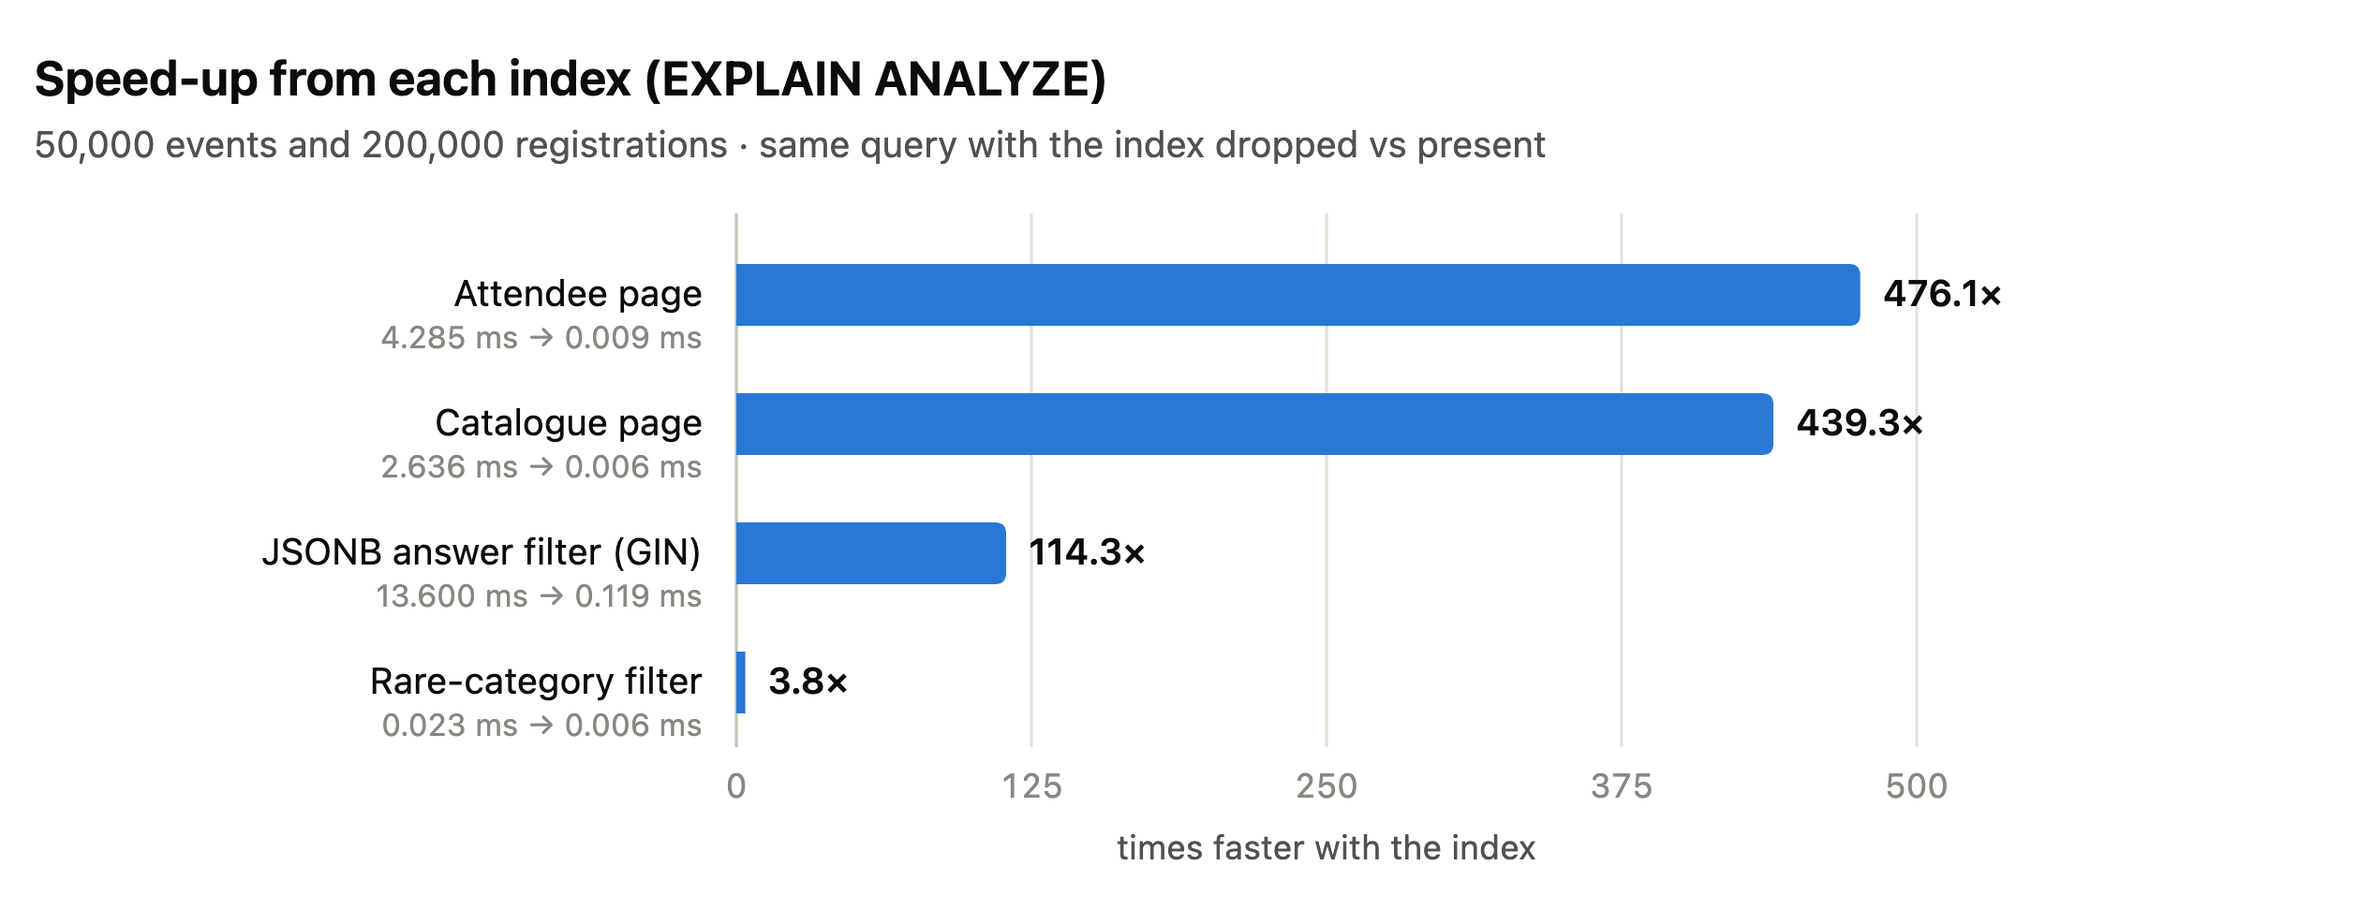
Figure 3.1: Speed-up from each index measured with EXPLAIN ANALYZE
Listing 3.1: Catalogue query plan before and after events_published_starts_at_idx (docs/test-results/explain-analyze-benchmark.txt)
BEFORE (index dropped): 2.636 ms
Limit (actual time=2.587..2.587 rows=13.00 loops=1)
Buffers: shared hit=1064
-> Sort (actual time=2.587..2.587 rows=13.00 loops=1)
Sort Key: starts_at, id
Sort Method: top-N heapsort Memory: 25kB
Buffers: shared hit=1064
-> Seq Scan on events (actual time=0.817..1.882 rows=15000.00 loops=1)
Filter: ((status = 'PUBLISHED'::"EventStatus") AND (starts_at >=
now()))
Rows Removed by Filter: 35000
Buffers: shared hit=1064
Planning Time: 0.027 ms
Execution Time: 2.590 ms
AFTER (index present): 0.006 ms
Limit (actual time=0.003..0.005 rows=13.00 loops=1)
Buffers: shared hit=4
-> Index Scan using events_published_starts_at_idx on events (actual
time=0.003..0.004 rows=13.00 loops=1)
Index Cond: (starts_at >= now())
Index Searches: 1
Buffers: shared hit=4
Planning Time: 0.017 ms
Execution Time: 0.007 ms
Speed-up: 439.3x

Table 3.2: EXPLAIN ANALYZE benchmark (npm run bench:explain)
Query | Index | Before | After | Speed-up | Plan change
Catalogue page | events_published_starts_at_idx (partial) | 2.636 ms | 0.006 ms | 439× | Seq Scan + Sort → Index Scan
Rare category | events_published_category_starts_at_idx | 0.023 ms | 0.006 ms | 3.8× | Index + filter → composite Index Scan
JSONB answers | registrations_answers_gin_idx (GIN) | 13.600 ms | 0.119 ms | 114× | Seq Scan → Bitmap Index Scan
Attendee page | registrations_event_id_status_created_at_idx | 4.285 ms | 0.009 ms | 476× | Parallel Seq Scan + Sort → Index Scan

Race experiment. With N simultaneous registrations on a 3-seat event (Figure 3.2), the unlocked version confirmed every request up to 10; it stopped at 10 only because the pool runs ten transactions at a time. The locked version confirmed exactly 3 in every run. The cost is that registrations for that one event are serialised: 40 requests took 964 ms with the lock against 124 ms without it, mostly because every transaction in the experiment includes a deliberate 20 ms pause.
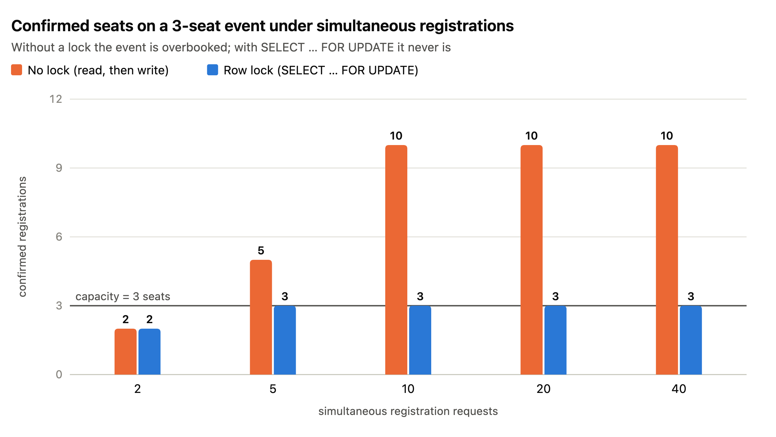
Figure 3.2: Confirmed seats on a 3-seat event under simultaneous registrations, with and without the row lock
Connection pool experiment. Forty queries that each hold a connection for 100 ms were started together with pools of different sizes (Figure 3.3). The measured times follow the queueing model ceil(40 ÷ N) × 100 ms closely: 4,106 ms with one connection, 423 ms with ten. Beyond ten connections the gain shrinks: what remains is fixed overhead, such as opening the extra connections (the experiment opens them inside the timed window) and scheduling them, and a real server would also be limited by its CPU cores and max_connections. With a pool of two, twenty one-second queries and a 5-second acquire timeout, ten queries succeeded and ten failed quickly with TIMEOUT instead of hanging (DB-C13 checks that this error is classified correctly).
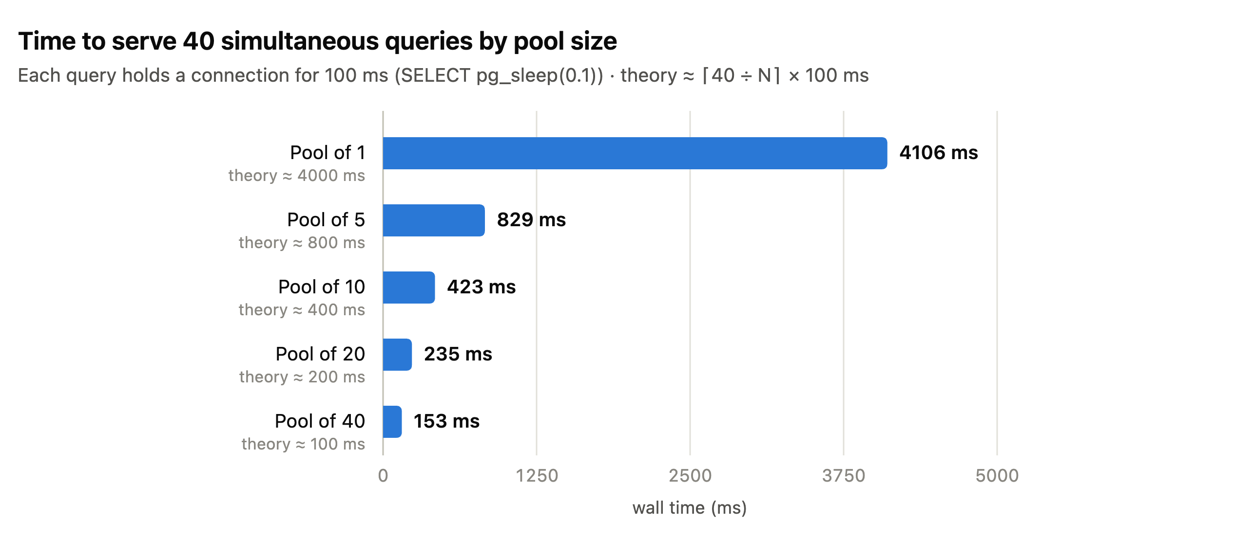
Figure 3.3: Time to serve 40 simultaneous queries by pool size
The organiser screens below show the same SQL and MongoDB results in the application.
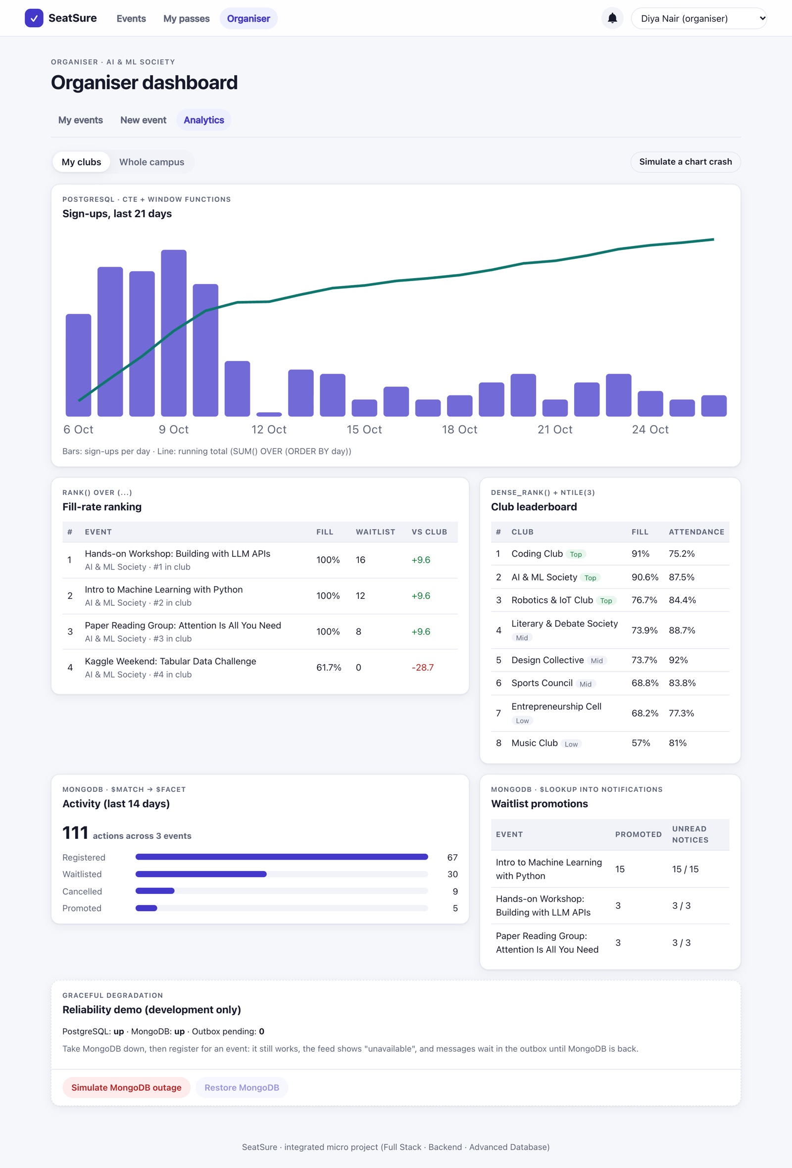
Figure 3.4: Analytics page: window-function reports from PostgreSQL and aggregation reports from MongoDB
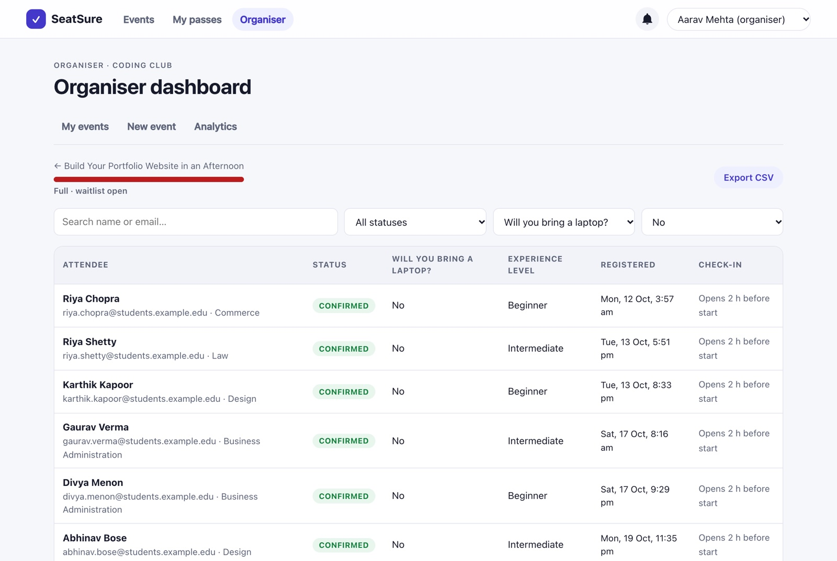
Figure 3.5: Attendee list filtered by a JSONB answer (GIN index), with waitlist positions and offset pagination

3.4 Discussion
The optimiser decides, and EXPLAIN shows its reasons. The composite category index helped only for a rare category (about 2 % of events): for common categories, the plain catalogue index plus a filter found 13 rows just as quickly, and PostgreSQL rightly ignored the composite index. The index was kept because organisers do filter by rare categories, but the report records the honest result of 3.8× rather than an inflated one (decision D-15).
Index maintenance matters. In the first benchmark run, the new GIN index was not used at all. EXPLAIN showed why: entries bulk-inserted after the index was created were still in GIN’s “pending list”, which must be scanned sequentially. After VACUUM ANALYZE merged the list, the same query read 2 index buffers instead of 493 (decision D-16).
Two real bugs were found by testing the data layer. A probe on this IST machine showed that the driver adapter sent timestamps without an offset, so PostgreSQL stored them 5½ hours off; Prisma read them back “correctly”, which hid the bug from the application, but SQL using now() was wrong. Pinning sessions to UTC fixed it, and DB-Q11 guards against regressions (D-12). Separately, an outbox id that restarted at 1 after re-seeding collided with ids remembered by a persistent MongoDB; a UUID message_id generated by PostgreSQL fixed it (D-11).
Denormalisation needs a guard. The confirmed_count column makes the seat decision cheap, but only because it is updated in the same transaction as the registrations, bounded by a CHECK constraint and verified by an integrity probe, which reported zero mismatches after the 50-request load test.

Chapter IV – Conclusion
This report presented the Advanced Database Systems part of SeatSure. From Module 1, the PostgreSQL schema is normalised to 3NF and encodes the business invariants as constraints, including a CHECK constraint that makes overbooking impossible to store; JSONB with a GIN index handles per-event questions; partial and composite indexes were matched to the real queries and proven with EXPLAIN ANALYZE; transactions with SELECT … FOR UPDATE serialise the seat decision; and CTEs with window functions produce the organiser analytics. From Module 2, Prisma ORM 7 provides migrations, typed queries without N+1, cursor pagination, interactive transactions, parameterised raw SQL and structured error handling over a measured connection pool. From Module 3, MongoDB stores notifications and an activity feed with Mongoose validators and hooks, server-side $jsonSchema validation, TTL expiry, aggregation pipelines with $facet and $lookup, and embedding decisions backed by index design, while a transactional outbox solves the dual-write problem.
All 47 database tests pass. The benchmarks show speed-ups of 114× to 476× from the main indexes, the race experiment shows the row lock turning an overbooked event into an exact one, and the pool experiment matches the queueing model. The central lesson is that the database should enforce the rules that matter most: when the database guarantees integrity and serialises the critical decision, the application above it can be simpler and safer.

4.1 Limitations
- A single PostgreSQL server with no replication or backups beyond the developer machine.
- The per-event row lock serialises registrations for one very popular event; at much larger scale this would need a queue or a different allocation strategy.
- The attendee list uses offset pagination, which slows down on very deep pages; cursor pagination would scale better there.
- Analytics are computed on demand from live tables; with much more data they would need pre-computed summaries.
- In development MongoDB runs in memory and is rebuilt from the outbox on every restart.

4.2 Future Scope
- Cache catalogue pages and analytics in Redis (Module 4), invalidated by the outbox events.
- Pre-compute daily analytics into summary tables refreshed by a scheduled job.
- Let several dispatchers share the outbox safely with SELECT … FOR UPDATE SKIP LOCKED.
- Recommend events to students with vector search over event descriptions (Module 5).
- Add read replicas and point-in-time recovery for production.

References
- Kalvium, Advanced Database Systems (Databases for Full Stack Web Development) livebook, Semester 3: Module 1 (Relational Database Engineering with PostgreSQL), Module 2 (Database Integration with Prisma ORM), Module 3 (Document Databases with MongoDB). Accessed 26 October 2026.
- PostgreSQL 18 documentation: constraints; indexes (partial, multicolumn, GIN); JSON types; concurrency control (MVCC, transaction isolation, explicit locking); window functions; WITH queries; using EXPLAIN. https://www.postgresql.org/docs/18/
- Prisma ORM documentation: driver adapters, schema reference, migrations, relation queries, pagination, transactions, raw queries, connection pool and error reference. https://www.prisma.io/docs
- MongoDB manual: schema validation ($jsonSchema), TTL indexes, aggregation ($facet, $lookup), explain results. https://www.mongodb.com/docs/manual/
- Mongoose documentation: schemas, validation and middleware. https://mongoosejs.com/docs/
- C. Richardson, “Pattern: Transactional outbox”, microservices.io.
- E. F. Codd, “Further Normalization of the Data Base Relational Model”, in Data Base Systems, Prentice-Hall, 1972.
- SeatSure project documentation: README.md (traceability matrix), DECISIONS.md, docs/er-diagram.md and docs/testing/test-cases-database.md.

Appendix A – Test Cases
Automated tests: npm run test:db (Vitest), 26 October 2026, against PostgreSQL 18.4 and an in-memory MongoDB 8.2. Result: 47 / 47 passed. Raw output: docs/test-results/database-tests.txt. The benchmark, pool and race tables at the end are system-level evidence and are not counted in the 47.
Table A.1: Integrity constraints (tests/constraints.test.ts)
ID | Concept | Scenario | Input | Expected | Actual | Pass/Fail
DB-C01 | M1.6 CHECK constraint | Venue with no seats | INSERT venues capacity = 0 | Rejected by venues_capacity_positive_chk | Rejected, SQLSTATE 23514, constraint named | Pass
DB-C02 | M1.6 CHECK constraint | Event ends before it starts | ends_at = starts_at − 1 min | Rejected by events_time_order_chk | Rejected (23514) | Pass
DB-C03 | M1.6 CHECK (core "no overbooking" rule) | Raw SQL bypassing the API | UPDATE events SET confirmed_count = capacity + 1 | Rejected by events_confirmed_within_capacity_chk | Rejected | Pass
DB-C04 | M1.9 JSONB + CHECK | Questions stored as an object, not an array | questions = {"not":"an array"} | Rejected by events_questions_is_array_chk | Rejected | Pass
DB-C05 | M1.6 CHECK | CANCELLED row without cancelled_at | status = CANCELLED, cancelled_at = NULL | Rejected by registrations_cancelled_at_chk | Rejected | Pass
DB-C06 | M1.6 CHECK | Checking in a waitlisted student | WAITLISTED + checked_in_at | Rejected by registrations_checkin_requires_confirmed_chk | Rejected | Pass
DB-C07 | M1.10 partial UNIQUE index | Same student, two active registrations | 2 inserts for the same event and user | 2nd rejected: P2002 on registrations_one_active_per_user_key | Rejected with P2002 and that constraint | Pass
DB-C08 | M1.10 partial index | Register again after cancelling | CANCELLED row, then CONFIRMED row | Allowed (cancelled rows are outside the index) | 2 rows stored | Pass
DB-C09 | M1.6 FOREIGN KEY | Registration for an event that doesn't exist | event_id = 99999 | Rejected (P2003) | Rejected (FOREIGN_KEY_VIOLATION) | Pass
DB-C10 | M1.6 UNIQUE | Duplicate email | Existing student's email | Rejected by users_email_key | Rejected | Pass
DB-C11 | M1.6 ON DELETE RESTRICT | Delete a club that still has events | DELETE club | Refused | Refused (FK) | Pass
DB-C12 | M1.6 ON DELETE CASCADE | Delete an event with registrations | DELETE event | Its registrations are removed | 0 registrations left | Pass
DB-C13 | M2.19 structured error handling | Pool could not supply a connection in time | Error('timeout exceeded when trying to connect') | Classified as TIMEOUT (API answers 503); unrelated errors are not database errors | As expected | Pass

Table A.2: Transactions, locking and isolation (tests/transactions.test.ts)
ID | Concept | Scenario | Input | Expected | Actual | Pass/Fail
DB-T01 | M2.15 $transaction, M1.14 atomicity | Error thrown after two writes | Insert registration, count +1, then throw | Nothing persists | 0 registrations, count still 0 | Pass
DB-T02 | M1.14 rollback | The database refuses a step mid-transaction | count +2 on a 1-seat event | CHECK violation, whole transaction rolled back | CHECK_VIOLATION, 0 rows | Pass
DB-T03 | M2.15 nested writes | Nested create with one invalid child | Club + 2 organiser links (1 bad FK) | Nothing created | 0 clubs created | Pass
DB-T04 | M1.14 race condition (reproduced) | No lock: read, 20 ms gap, write | 12 parallel transactions, 3 seats | More than 3 confirmed (shows the bug exists) | Oversold (> 3 confirmed) | Pass
DB-T05 | M1.14 SELECT … FOR UPDATE | Same load, same gap, with a row lock | 12 parallel transactions, 3 seats | Exactly 3 confirmed, 9 waitlisted, counter = 3 | {confirmed: 3, waitlisted: 9, stored: 3}, 0 mismatches | Pass
DB-T06 | M1.11 READ COMMITTED | Read twice while another session commits | capacity 10 → 25 | Second read sees 25 | [10, 25] (non-repeatable read) | Pass
DB-T07 | M1.11 MVCC + REPEATABLE READ | Snapshot read, then a conflicting write | Same | [10, 10], then the UPDATE fails with 40001 | [10, 10], SQLSTATE 40001, mapped as retryable | Pass
DB-T08 | M1.14 row lock waiting | Second FOR UPDATE while the first holds the lock | Lock held 300 ms | Second waits ≥ 250 ms | Waited ≥ 250 ms | Pass

Table A.3: Query correctness (tests/queries.test.ts)
ID | Concept | Scenario | Input | Expected | Actual | Pass/Fail
DB-Q01 | M2.11 cursor pagination | Walk the catalogue 3 events at a time | 7 upcoming + 1 draft + 1 past | E1…E7 once each, in order, 3 pages | E1…E7, 3 pages, no draft or past event | Pass
DB-Q02 | M2.11 filtering | Category, club, availability, title search | 3 events in 2 clubs | Correct subset for each filter | All 5 filter checks match | Pass
DB-Q03 | M2.11 sorting | "Most popular" sort with a tiebreak | counts 5 and 2 | B before A | [B, A] | Pass
DB-Q04 | M1.12 ROW_NUMBER() | Waitlist positions, then the first person leaves | 3 waitlisted, cancel #1 | 1,2,3, then 1,2 | 1,2,3 → 1,2 | Pass
DB-Q05 | M1.12 RANK() … PARTITION BY, M1.13 CTE | Fill-rate ranking across 2 clubs | Fill 100 %, 50 %, 75 % | Overall 1/3/2, in-club ranks, vs club average ±25 | Exact values match | Pass
DB-Q06 | M1.13 CTE + generate_series + SUM() OVER | Daily sign-ups with a running total | 3 sign-ups over 7 days | 7 rows, last cumulative = 3, never decreasing | As expected | Pass
DB-Q07 | M1.12 DENSE_RANK, FILTER | Club leaderboard with attendance | Past event, 1 of 2 checked in | [Other Club 100 % #1], [Test Club 50 %, attendance 50 % #2] | Exact match | Pass
DB-Q08 | M2.10 N+1 problem | "My passes" with event/club/venue include | 2 vs 10 registrations | Same SQL count both times (≤ 4) | Constant query count | Pass
DB-Q09 | M1.9 JSONB @>, COUNT(*) OVER () | Attendee filter tshirt = M, page size 2 | 5 registrations | total 3, page 1 has 2 rows, page 2 has 1 | As expected; combined filter total 3 | Pass
DB-Q10 | Integrity probe | Seat counter drifts from real rows | stored 0, actual 1 | Mismatch reported, then [] after fixing | As expected | Pass
DB-Q11 | Timestamps / session time zone | Prisma writes 2027-01-01T00:00Z | Read back via SQL in UTC | 2027-01-01 00:00, and starts_at > now() is true | Exact (regression test for a real bug, see DECISIONS.md D-12) | Pass

Table A.4: Index impact with EXPLAIN ANALYZE (tests/indexes.test.ts, 30,000 events and 100,000 registrations)
ID | Concept | Scenario | Input | Expected | Actual | Pass/Fail
DB-I01 | M1.10 partial index, M1.15 EXPLAIN | Catalogue: next 12 published events | WHERE status='PUBLISHED' AND starts_at >= now() ORDER BY starts_at, id LIMIT 13 | Seq Scan + Sort becomes Index Scan, faster | 3.393 ms → 0.011 ms (308.5×), Index Scan using events_published_starts_at_idx | Pass
DB-I02 | M1.10 composite index | Rare category (HACKATHON ≈ 2 %) | Same, plus category = 'HACKATHON' | The composite index is chosen and is faster | 0.044 → 0.010 ms (4.4×), events_published_category_starts_at_idx | Pass
DB-I03 | M1.9 GIN (jsonb_path_ops) | Who chose the Jain meal? | answers @> '{"diet":"Jain"}' over 100 k rows | Seq Scan becomes Bitmap Index Scan, faster | 16.071 → 0.172 ms (93.4×) | Pass
DB-I04 | M1.10 composite index | Attendee page in registration order | event_id = 42 AND status = 'CONFIRMED' ORDER BY created_at LIMIT 20 | Index Scan with no separate Sort | 5.260 → 0.021 ms (250.5×) | Pass
DB-I05 | M1.10 partial indexes | The definitions are really partial | pg_indexes | All 3 index definitions contain a WHERE clause | 3 / 3 | Pass

Table A.5: MongoDB (tests/mongo.test.ts)
ID | Concept | Scenario | Input | Expected | Actual | Pass/Fail
DB-M01 | M3.4 Mongoose validators | Bad notification | type: 'SPAM', empty title, userId: 0 | ValidationError on title, type, userId | Exactly those 3 paths | Pass
DB-M02 | M3.4 middleware hook (pre('validate')) | Notification without an expiry | No expiresAt | Hook sets expiry 30 days ahead | 29.9 to 30 days | Pass
DB-M03 | M3.19 $jsonSchema | Write bypassing Mongoose (native driver) | type: 'NOT_A_TYPE' | MongoDB rejects it (code 121) | Code 121 DocumentValidationFailure | Pass
DB-M04 | M3.19 TTL index | Expired vs fresh notification | expiresAt in the past | Expired one deleted automatically, fresh one kept | Deleted in about 1 s (TTL monitor), fresh kept | Pass
DB-M05 | Idempotent delivery (unique outboxId) | Same outbox message delivered twice | Same outboxId | inserted, then duplicate, 1 document | As expected | Pass
DB-M06 | M3.7/M3.12 aggregation, M3.16 $facet | Dashboard summary | 8 activities (1 outside the window) | totals 7 / 2 events, per-action counts, top event | Exact match | Pass
DB-M07 | M3.7 $match first | Scope to one club | clubIds: [7] | 1 activity, 1 event | As expected | Pass
DB-M08 | M3.16 $lookup | Promotions joined to notifications | 2 promotions, 2 notices (1 read) | {promotions: 2, notified: 2, unread: 1} | Exact match | Pass
DB-M09 | M3.20 index design + explain() | Event feed query | 300 activities across 30 events | IXSCAN on event.id_1_at_-1, docs examined = docs returned | IXSCAN, 10 / 10 | Pass
DB-M10 | M3.8 embedding | Activity keeps its event snapshot | Old title in the snapshot | Feed reads the embedded snapshot, no join | Snapshot returned unchanged | Pass

Table A.6: EXPLAIN ANALYZE benchmark on 50,000 events and 200,000 registrations (npm run bench:explain)
Query | Index | Before (dropped) | After (present) | Speed-up | Plan change
Catalogue page | events_published_starts_at_idx (partial) | 2.636 ms | 0.006 ms | 439× | Seq Scan + Sort → Index Scan
Rare category | events_published_category_starts_at_idx | 0.023 ms | 0.006 ms | 3.8× | starts_at index + filter → composite Index Scan
JSONB answers | registrations_answers_gin_idx (GIN) | 13.600 ms | 0.119 ms | 114× | Seq Scan → Bitmap Index Scan
Attendee page | registrations_event_id_status_created_at_idx | 4.285 ms | 0.009 ms | 476× | Parallel Seq Scan + Sort → Index Scan

Table A.7: Connection-pool experiment (npm run experiment:pool -w @seatsure/db)
Pool size | Wall time | Theory ≈ ⌈40/N⌉ × 100 ms
1 | 4106 ms | 4000 ms
5 | 829 ms | 800 ms
10 | 423 ms | 400 ms
20 | 235 ms | 200 ms
40 | 153 ms | 100 ms

Table A.8: Race-condition experiment (npm run experiment:race -w @seatsure/db)
Simultaneous requests | Confirmed, no lock | Confirmed, FOR UPDATE | Time, no lock | Time, FOR UPDATE
2 | 2 | 2 | 42 ms | 54 ms
5 | 5 (overbooked) | 3 | 33 ms | 119 ms
10 | 10 (overbooked) | 3 | 42 ms | 246 ms
20 | 10 (overbooked) | 3 | 69 ms | 489 ms
40 | 10 (overbooked) | 3 | 124 ms | 964 ms

Appendix B – Concept Traceability
Every concept is tagged in the code as // [DATABASE Mx.y: Concept] (or -- [DATABASE …] in SQL). This table, taken from the project README, links each concept to the files that implement it, a way to demonstrate it, and the tests that prove it.
Table B.1: Traceability matrix: concept → code → test (Advanced Database Systems)
Module | Concept | Files / functions | How to demo | Test IDs
M1.4–1.5 | ER model, normalisation (3NF) | docs/er-diagram.md; prisma/schema.prisma | Explain venue/club separation | —
M1.6 | DDL constraints (PK, FK, UNIQUE, CHECK, ON DELETE) | prisma/migrations/*_init, *_integrity_checks/migration.sql | psql: UPDATE events SET confirmed_count = capacity + 1 → rejected | DB-C01–C12
M1.9 | JSONB + GIN | events.questions, registrations.answers; registrations_answers_gin_idx; registrationRepository.listForEvent (@>) | Attendees → filter by answer | DB-C04, DB-Q09, DB-I03
M1.10 | Partial & composite indexes | schema.prisma @@index(… where: …), partial @@unique | \d events in psql | DB-C07, DB-I01, DB-I02, DB-I04, DB-I05
M1.11 | MVCC & isolation levels | src/transaction.ts (withTransaction, isolation option); tests/transactions.test.ts | Two psql sessions (as in tests DB-T06/T07) | DB-T06, DB-T07
M1.12 | Window functions | analyticsRepository.ts (RANK, DENSE_RANK, NTILE, SUM/AVG OVER); registrationRepository.waitlistPositions (ROW_NUMBER), listForEvent (COUNT(*) OVER()) | Analytics page | DB-Q04–Q07, DB-Q09
M1.13 | CTEs | analyticsRepository.ts (event_stats, rated, calendar, per_club) | — | DB-Q05–Q07
M1.14 | Transactions & concurrent writes (row locks) | eventRepository.lockForUpdate (FOR UPDATE OF e); service transaction boundaries | npm run demo:concurrency | DB-T01–T05, DB-T08
M1.15 | EXPLAIN ANALYZE | src/bench/explain.ts; scripts/explain-benchmark.ts | npm run bench:explain | DB-I01–I04
M2.1 / M2.12–2.13 | Prisma 7 setup, adapter-pg, connection pooling | src/client.ts (createPrismaClient: max, timeouts, UTC session); scripts/pool-experiment.ts | npm run experiment:pool -w @seatsure/db | DB-C13, DB-Q11
M2.3 / M2.5 / M2.20 | Schema, migrations, enums, migrate deploy | prisma/schema.prisma, prisma/migrations/, prisma7.config.ts | npm run db:migrate | (all DB tests run on migrated schema)
M2.8 / M2.10 | Prisma Client CRUD, relation queries (no N+1) | repositories/*.ts; registrationRepository.listForUser (include) | My passes | DB-Q08
M2.11 | Filtering, sorting, cursor pagination | eventRepository.listPublished | Catalogue | DB-Q01–Q03
M2.15 | Interactive $transaction, nested writes | src/transaction.ts; registrationService; nested create (DB-T03) | — | DB-T01–T03
M2.19 | $queryRaw + structured error handling | analyticsRepository.ts, lockForUpdate, listForEvent; src/errors.ts (toDbError) | Duplicate registration → 409 | DB-C07, DB-C13, BE-U28
M3.2–3.4 | Documents vs rows, BSON/_id, Mongoose schema + validators + hooks | src/mongo/models/Notification.ts, ActivityLog.ts | Notifications page | DB-M01, DB-M02
M3.7 / M3.12 / M3.16 | Aggregation pipelines, $facet, $lookup | src/mongo/aggregations.ts (activitySummaryPipeline, promotionReachPipeline) | Analytics → Activity / Waitlist promotions | DB-M06–M08
M3.8 | Embedding vs referencing | ActivityLog.ts (embedded snapshots + id references) | — | DB-M10
M3.19 | TTL indexes, $jsonSchema, dual-write problem | Notification.ts (TTL), jsonSchemas.ts, connection.ts (ensureCollections); outbox (outboxRepository.ts) | Outage demo | DB-M03–M05, BE-I25
M3.20 | Index design proven with explain() | ActivityLog.ts compound index | — | DB-M09

