MICRO PROJECT REPORT
BACK-END WEB DEVELOPMENT
SEATSURE: CONCURRENCY-SAFE CAMPUS EVENT REGISTRATION WITH AUTO-PROMOTING WAITLISTS
Submitted by:
Bhavya Sharma
2511021060291
In partial fulfilment for the award of the degree of
BACHELOR OF TECHNOLOGY
In
COMPUTER SCIENCE AND ENGINEERING (AI AND FUTURE TECHNOLOGIES)
Under the guidance of
Mr. Vaibhav Giri

Alliance School of Advanced Computing
Alliance University, Bengaluru
October-2026

COMPUTER SCIENCE AND ENGINEERING
ALLIANCE SCHOOL OF ADVANCED COMPUTING
CERTIFICATE
This is to certify that the report on Back-End Web Development for the micro project titled “SeatSure: Concurrency-Safe Campus Event Registration with Auto-Promoting Waitlists” is submitted by Bhavya Sharma (University Registration No. 2511021060291) in partial fulfilment of the requirements for the award of the degree of Bachelor of Technology (Computer Science and Engineering – AI and Future Technologies) of Alliance University. It is a bonafide record of work carried out under my supervision and guidance during the academic year 2026–27. The work presented in this report is original and has not formed the basis for the award of any other degree to the candidate or to anybody else.
……………………………
Mr. Vaibhav Giri

COMPUTER SCIENCE AND ENGINEERING
ALLIANCE SCHOOL OF ADVANCED COMPUTING
DECLARATION
I hereby declare that the report titled SeatSure: Concurrency-Safe Campus Event Registration with Auto-Promoting Waitlists (Back-End Web Development), submitted in partial fulfilment of the requirements for the award of the degree of Bachelor of Technology in Computer Science and Engineering (AI and Future Technologies) at Alliance University, is a record of project work carried out under the supervision of Mr. Vaibhav Giri.
The design, implementation and test results described in this report belong to the SeatSure project submitted with it. The course material, documentation and open-source libraries that the work builds on are acknowledged in the references.
This report has not been submitted, in part or in full, for any other degree or award.

Bhavya Sharma | 2511021060291
Name of the Student | University Registration Number | Signature

Acknowledgement
I would like to express my sincere gratitude to everyone who helped me complete this micro project, SeatSure: Concurrency-Safe Campus Event Registration with Auto-Promoting Waitlists.
First, I thank my guide, Mr. Vaibhav Giri, for the guidance, feedback and encouragement provided throughout the project. I am also grateful to the mentors at Kalvium, whose Back-End Web Development livebook sessions provided the concepts on which this work is built.
I also thank my peers in my Kalvium squad for the discussions and feedback that helped shape the project.
Working on SeatSure taught me that a feature is finished only when it has been shown to work under realistic conditions, with automated tests, measurements and failure scenarios, and not merely when it works once on my own screen.
Finally, I thank my family and friends for their support and patience during the semester.
Thank you.
Bhavya Sharma
TABLE OF CONTENTS
Acknowledgement 4
Abstract 6
Chapter I – Introduction 7
1.1 Problem Statement 7
1.2 Objectives 8
1.3 Scope of this Report 8
1.4 Theory 8
Chapter II – System Configuration 13
2.1 System Architecture 13
2.2 Algorithm 16
2.3 Source Code 17
2.4 Connection with Full Stack Web Development and Advanced Database Systems 30
2.5 Setting Up and Running the Project 31
2.6 CRUD over REST: Route Mapping and Validation 31
Chapter III – Results 33
3.1 Testing Approach 33
3.2 Test Results Summary 33
3.3 Results 33
3.4 Live API Test Cases 38
3.5 Discussion 39
Chapter IV – Conclusion 40
4.1 Limitations 40
4.2 Future Scope 40
References 42
Appendix A – Test Cases 43
Appendix B – Concept Traceability 48

Abstract
Student clubs at Alliance University run workshops, hackathons and talks in rooms with a fixed number of seats, yet registrations are still collected through Google Forms and WhatsApp, which cannot enforce a seat limit, keep a fair waitlist or report how events fill. This report describes the Back-End Web Development part of SeatSure, an integrated micro project that replaces them with a web application. Its core is an Express 5 REST API that decides every registration, so that a seat limit can never be exceeded and a cancelled seat passes automatically to the next student on the waitlist.
The API applies the concepts of Modules 1–3 of the course: REST resources with correct status codes and one JSON envelope; an ordered middleware pipeline (request id, timing, CORS and a 10 KB body limit); express-validator chains that also block mass assignment; AppError, asyncHandler and a central error handler; and a layered design of routes, thin controllers, services and repositories in which the business rules are pure functions. Registration and cancellation are multi-step workflows that run inside one database transaction which first locks the event row, so concurrent requests can neither overbook a seat nor lose a promotion; transient failures are retried with exponential backoff and jitter. The API is versioned under /api/v1, streams CSV exports, and publishes past-tense events on an EventEmitter bus through a transactional outbox, with timeouts, backoff and graceful degradation when MongoDB is unavailable.
All 64 automated tests pass: 38 unit tests that run the services with in-memory fake repositories, and 26 HTTP integration tests through Supertest against PostgreSQL and MongoDB. Fifty simultaneous registrations for a three-seat event produced exactly three confirmed seats and 47 unique waitlist positions, and a live run against the running server confirmed 10 of 50 students for a 10-seat event with no errors in 414 ms. A simplified version of the workflow without the lock confirmed up to 10 students for 3 seats. With MongoDB stopped, registrations still succeeded and the queued messages were delivered after recovery.
Keywords: Express, REST API, middleware, validation, layered architecture, race conditions, transactions, reliability, event-driven design, transactional outbox

Chapter I – Introduction
Every important decision in SeatSure is made on the server. The React client can make the experience fast, but whether a student receives the last seat or a place on the waitlist, whether a cancelled seat goes to the right person, and whether a request is allowed at all are questions that only the API can answer, because only the API sees every request and owns every transaction.
SeatSure has two kinds of user. Students browse upcoming events, register (or join a waitlist when an event is full), cancel, and follow their passes and notifications. Organisers of a club create events with their own registration questions, publish them, check attendees in, export attendee lists and read analytics about how their events fill.
The project is one application split into three folders that match the three subjects of the integrated project: /client (Full Stack Web Development: the React interface), /server (Back-End Web Development: the Express API) and /db (Advanced Database Systems: the PostgreSQL schema, the Prisma data-access layer and MongoDB). Each subject has its own report, and each report is written to be read on its own. This report covers Back-End Web Development, whose code lives mainly in /server, and explains how it connects to the other two parts.

1.1 Problem Statement
Student clubs at Alliance University run workshops, hackathons and talks in venues with a fixed number of seats, but registrations are collected through Google Forms and WhatsApp. These tools cannot enforce a seat limit, so popular events get overbooked when many students register at once; waitlists are tracked by hand; seats freed by cancellations are not offered to the next person; and organisers have no data on fill rates or attendance.
SeatSure is a web application where students browse events and register with a hard seat cap that stays correct under simultaneous sign-ups, cancellations automatically promote the next waitlisted student, and organisers manage attendees and view registration analytics.
For the server, the hard part is not storing a registration but deciding it correctly. When many requests for the last seat arrive together, a naive “read the count, then insert” sequence lets several of them see a free seat, and the event is overbooked. Cancellation is just as delicate: the freed seat must pass to exactly one waitlisted student, even when several people cancel at the same moment. The API must also reject invalid or malicious input, give clients errors they can act on, and keep its core feature working when a secondary service such as MongoDB fails.

1.2 Objectives
- Design a versioned REST API with a consistent response envelope and correct status codes.
- Structure the server in layers so that business rules can be tested without HTTP or a database.
- Validate and sanitise every input at the boundary, and block mass assignment.
- Guarantee that no event is ever overbooked and that waitlist promotion is fair and automatic, even under concurrent requests.
- Make the system reliable: retry transient failures, time out slow dependencies and degrade gracefully.
- Publish domain events so that notifications and the activity feed are decoupled from the registration code.

1.3 Scope of this Report
This report covers Modules 1–3 of the Back-End Web Development course: backend foundations (Module 1), backend application architecture (Module 2) and backend engineering design and principles (Module 3). Lesson numbers such as M3.6 refer to the lessons of the course livebook. The course keeps data in memory until Module 4; SeatSure stores it in PostgreSQL behind a separate data-access package (@seatsure/db), which is the repository layer of this design and is described in detail in the Advanced Database Systems report. Authentication (Module 4) is replaced by a placeholder middleware that reads an X-User-Id header and attaches req.user, the same contract the course’s route chains use. Rate limiting and caching are outside the scope.

1.4 Theory
Table 1.1 lists every Back-End concept applied in SeatSure. The paragraphs after it explain the theory behind each group.
Table 1.1: Back-End concepts applied in SeatSure (Modules 1–3)
Lesson | Concept | Used in SeatSure for
M1.2–1.4 | Client–server, HTTP, request–response lifecycle | React client ↔ Express API on port 4000; methods, headers and status-code families
M1.5 | REST resource design | Noun resources and sub-resources: /events, /events/:id/registrations, /registrations/:id, /me/…
M1.6, M1.15 | JSON contract, status codes, error envelope | {status, data, meta} and {status, code, message, errors?, requestId}; 201 + Location, 204, 4xx, 503
M1.7–1.9 | Node.js, npm, first Express server | npm workspaces and scripts, nodemon, dotenv, app.listen, catch-all 404 registered last
M1.11 | Routing: params vs query, Router modules | One Router per resource; /:id identifies, ?category=&cursor= filters
M2.1 | Node.js runtime and event loop | Every await is a point where another request can run, which is why races happen
M2.2 | Streams | Attendee CSV export streamed with Readable.from and pipeline (back-pressure)
M2.4 | Middleware pipeline | request id → timer → CORS → JSON (10 KB) → routes → 404 → error handler
M2.5 | Request validation | express-validator chains; one 400 response that lists every invalid field
M2.6 | API hardening | matchedData allow-list against mass assignment, payload limit, answer sanitisation, header validation
M2.7 | Error-handling architecture | AppError, asyncHandler, one four-argument error handler registered last
M2.9–2.11 | Layers, thin controllers, services, repository pattern | routes → controllers → services → @seatsure/db repositories; in-memory fakes in unit tests
M2.12 | Supporting layers and configuration | config/index.js (environment-driven, frozen), utils/, validators/
M3.1, M3.3 | Data flow and engineering principles | PostgreSQL as the single source of truth, explicit trust boundaries, defensive programming
M3.2 | Domain rules and workflows | Event state machine; register; cancel → promote; capacity increase → promote
M3.4–3.6 | Concurrency, race conditions, transactions | One transaction per workflow with a row lock; 50 concurrent requests in a test
M3.8–3.9 | API design, pagination, filtering, sorting | Cursor (nextCursor, hasMore) and offset (page, totalPages) metadata; whitelisted filters and sorts
M3.10 | API versioning | /api/v1; deprecated /api/events alias with Deprecation, Sunset and Link headers
M3.11 | Reliability engineering | Retries with exponential backoff and jitter, timeouts, graceful degradation when MongoDB fails
M3.12 | Event-driven systems | EventEmitter bus, past-tense events, an outbox dispatcher and two subscribers

1.4.1 Backend Foundations (Module 1)
HTTP and REST (M1.2–M1.5). A client sends an HTTP request (method, path, headers and an optional body) and the server answers with a status code, headers and a body. HTTP is stateless, so each request must carry everything the server needs, including who is asking. In a REST design the URL names a resource with a noun (/events/42), the method says what to do with it (GET reads, POST creates, PATCH updates, DELETE removes), and related resources are nested (/events/42/registrations).
Contracts and status codes (M1.6, M1.15). Clients can only be simple if the server is predictable. Every response therefore uses one envelope, and the status code tells the client what happened: 200 or 201 (with a Location header) for success, 204 for an empty success, 400 for malformed input, 401 or 403 for identity and permission problems, 404 for a missing resource, 409 for a conflict with the current state, 422 for input that is well-formed but breaks a rule, and 503 when a dependency is unavailable. Internal details such as stack traces or SQL must never reach the client.
Node.js and Express (M1.7–M1.11). Express builds a server from small functions. express.Router groups the routes of one resource; route parameters (/:id) identify a resource while query strings (?category=TALK) filter a collection; express.json() fills req.body; and a catch-all handler registered after all routes answers 404 for unknown paths.

1.4.2 Backend Application Architecture (Module 2)
The runtime (M2.1, M2.2). Node.js runs JavaScript on one thread and handles many requests by never blocking: whenever a handler waits (await) for the database, the event loop runs other requests. This is efficient, but it also means that two requests can interleave at every await, which is the root cause of the race conditions discussed in Module 3. Streams move large data in chunks rather than loading it all into memory, and pipeline applies back-pressure when the receiver is slower than the sender.
Middleware, validation and hardening (M2.4–M2.6). Middleware functions form an ordered pipeline; each one can modify the request, end it early or pass it on with next(), so the order matters. Validation checks that input has the right shape and type; sanitisation cleans it (for example trimming text). The boundary between the client and the server is a trust boundary: nothing that crosses it is trusted. Two common attacks are mass assignment, in which a client sends fields it should not control (such as status: "CONFIRMED"), and oversized payloads. An allow-list of accepted fields and a body-size limit stop both.
Error handling (M2.7). Expected failures (operational errors) are thrown as AppError(message, statusCode). asyncHandler forwards rejected promises to next(err), and one error handler with four arguments, registered last, turns every error into the standard envelope. Unexpected failures (programmer errors) are logged in full but shown to the client only as a generic 500.
Layers (M2.8–M2.12). As a server grows, putting everything in one file creates hidden coupling and slow, fragile tests. A layered design gives each folder one job: routes/ wire URLs to handlers, controllers/ extract input and format output, services/ apply the business rules, and repositories store data. Imports flow in one direction only. Because services receive plain values and never see req or res, and repositories hide the storage, a service can be tested with fake repositories and the database could be replaced without touching any rule. Configuration, validators and shared utilities live in their own supporting folders.

1.4.3 Backend Engineering Design and Principles (Module 3)
Data flow, rules and principles (M3.1–M3.3). A request flows through middleware, controller, service and repository to the database and back. Business rules (“registration closes when the event starts”) belong in the service layer as checks that throw AppError, and a multi-step operation is modelled as an ordered workflow. Engineering principles guide the design: a single source of truth for each fact, explicit trust boundaries, defensive programming and single responsibility.
Concurrency and transactions (M3.4–M3.6). Concurrent requests share state. A race condition occurs when the result depends on the timing of their steps: two requests read “39 of 40 seats taken”, both decide a seat is free, and both insert, which is an inventory oversell. Other forms are the lost update and duplicate processing. They are dangerous because they rarely appear in manual testing. A transaction groups several writes so that they succeed or fail together (atomicity), and with an appropriate lock or isolation level it also closes the window between “check” and “act”.
API design and versioning (M3.8–M3.10). List endpoints return pagination metadata: offset pagination for numbered pages, cursor pagination for feeds that grow while they are read. Filters and sort options are whitelisted. When an API must change in a breaking way, a version prefix (/api/v1) lets old clients keep working, and deprecated paths announce their replacement before they are removed.
Reliability and events (M3.11, M3.12). Networks and dependencies fail. A transient failure can be retried with exponential backoff (waiting longer after each attempt) and jitter (a random component, so that many clients do not retry at the same instant); a slow dependency is bounded by a timeout; and when a non-essential dependency is down, the system should degrade gracefully instead of failing completely. In an event-driven design, a producer announces a past-tense fact (“registration.confirmed”) on an event bus without knowing who listens; subscribers react independently. Node’s EventEmitter provides such a bus inside one process.

Chapter II – System Configuration
The API was developed and tested on a single laptop. Table 2.1 lists the hardware and software.
Table 2.1: Hardware and software configuration
Component | Configuration
Processor and memory | Apple M4 (10 cores), 16 GB RAM
Operating system | macOS 26.7 (arm64)
Runtime | Node.js 22.23.2, npm 10.9.8 (npm workspaces: client, server, db)
Web framework | Express 5.3.0 (JavaScript ES modules), cors 2.8.6, dotenv 17.4.2
Validation | express-validator 7.3.2
Development tools | nodemon 3.1.14 (restarts on change); tsx 4.23.15 runs the server so it can import the TypeScript data-access package
Data access (repository layer) | @seatsure/db: Prisma ORM 7.10.0 over PostgreSQL 18.4; Mongoose 9.11.4 over MongoDB 8.2 (in-memory server in development and tests)
Testing | Vitest 5.0.5, Supertest 7.3.1 (HTTP integration tests)
Manual testing | curl, the React client and the browser’s Network tab

2.1 System Architecture
Figure 2.1 shows where the API sits. It is the only component that talks to both databases: PostgreSQL holds every fact that matters (users, events, registrations, the outbox), and MongoDB holds data derived from those facts (notifications and an activity feed), which is written asynchronously by event subscribers.
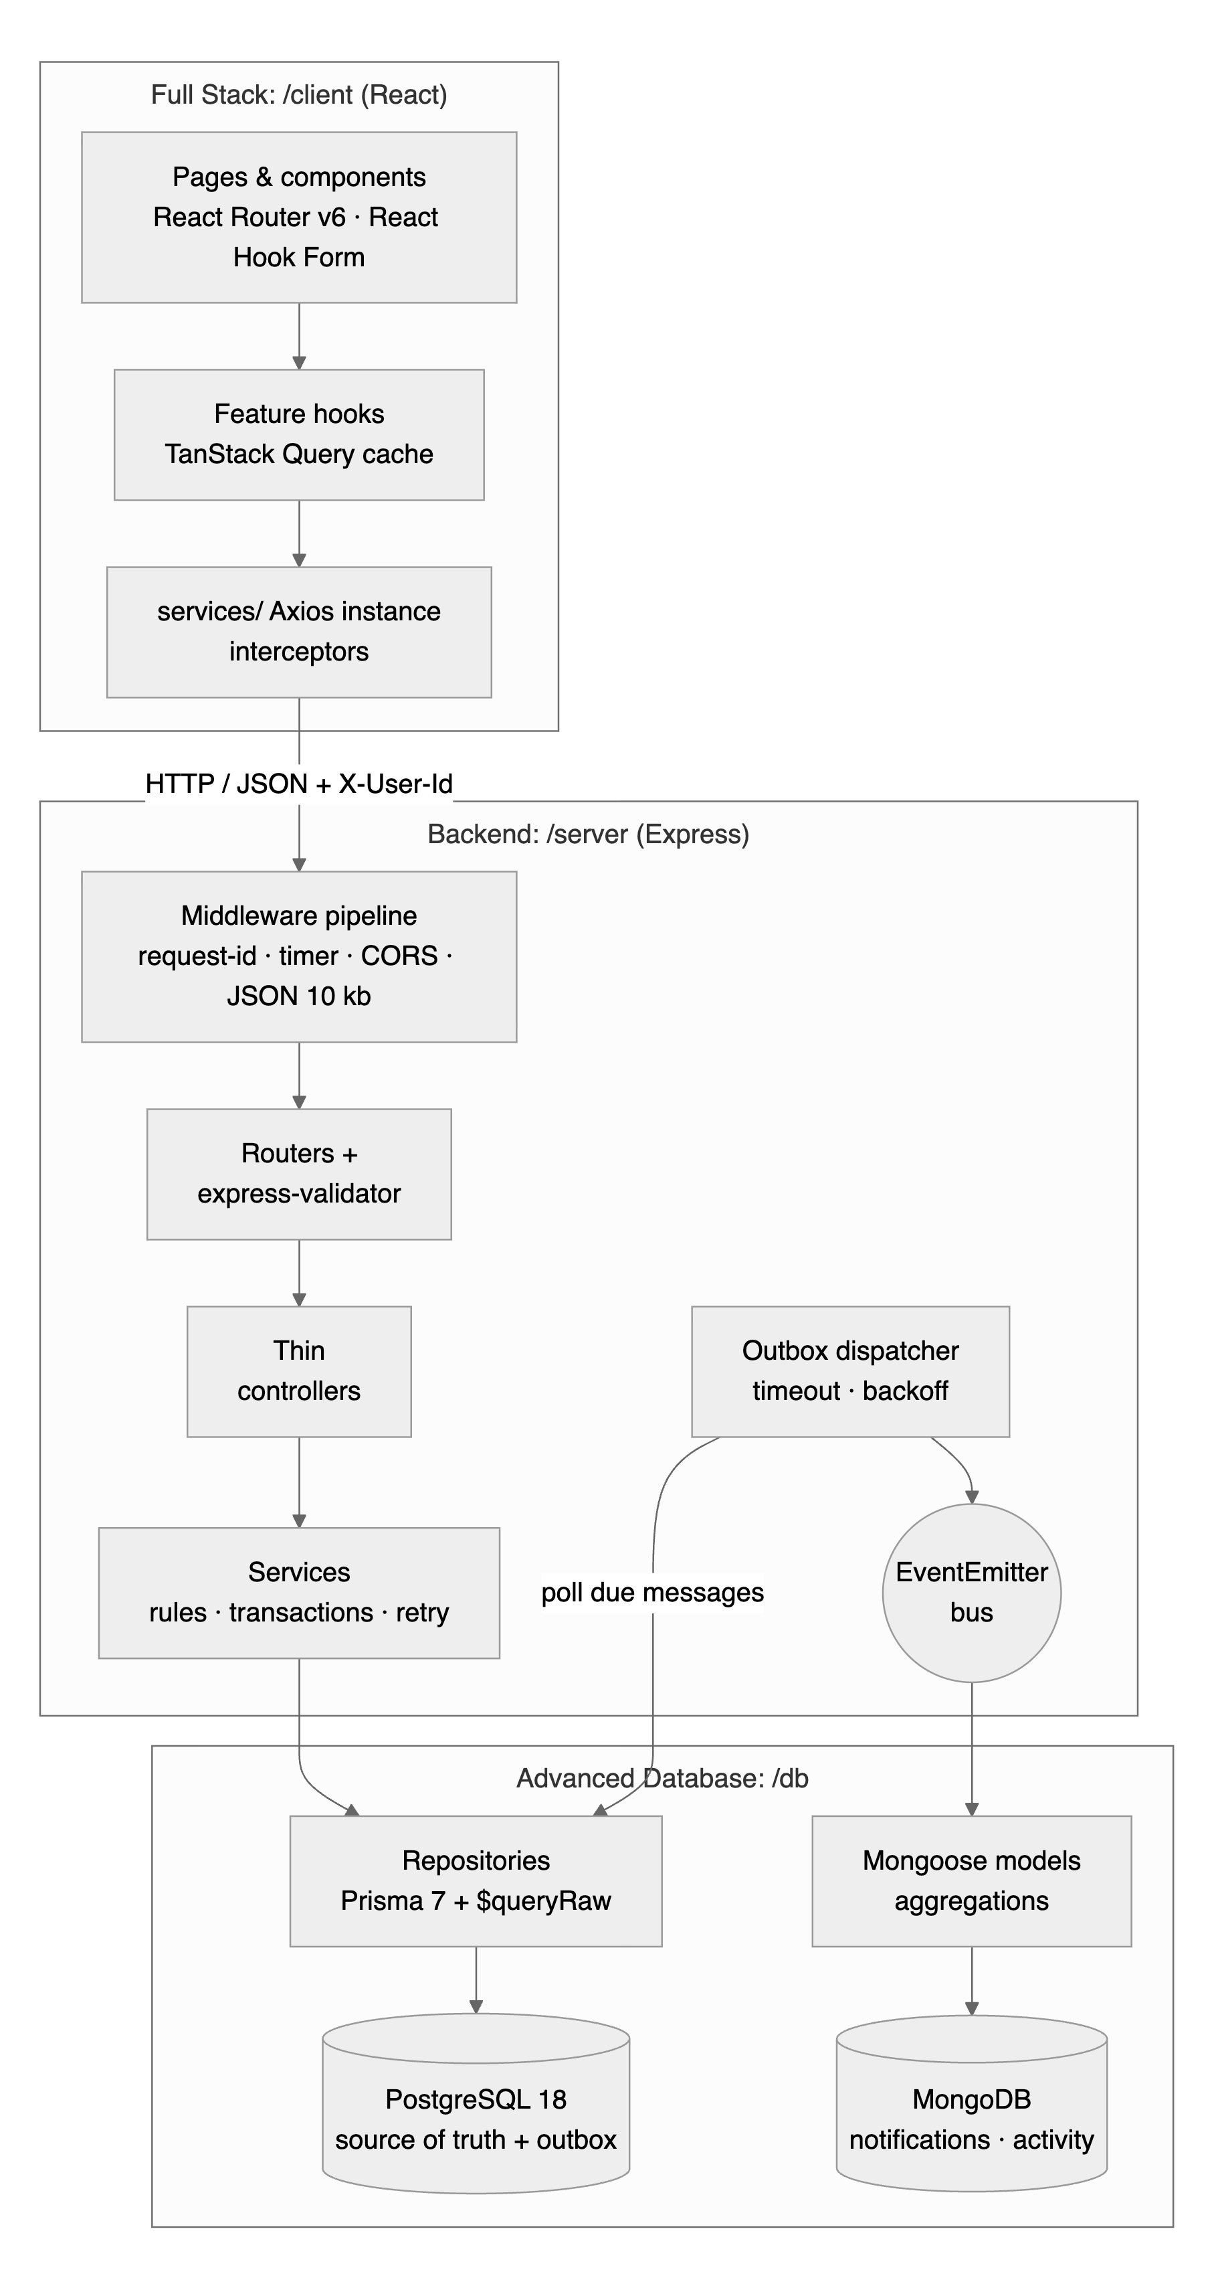
Figure 2.1: SeatSure architecture: client, API and data layers
Inside /server, each folder is one layer (Listing 2.1). Dependencies flow downwards only: routes know controllers, controllers know services, and services know repositories through the composition root container.js.
Listing 2.1: Layered folder structure of server/src
server/src/
├── app.js middleware pipeline (order matters) + routers + 404 + error
handler
├── server.js starts the HTTP server, the outbox dispatcher, graceful shutdown
├── container.js composition root: wires repositories, bus, dispatcher, services
├── config/ environment-driven, frozen configuration
├── routes/ one Router per resource; /api/v1 + deprecated /api alias
├── validators/ express-validator chains
├── controllers/ thin: extract → call one service → format the response
├── services/ business rules and workflows (rules/eventRules.js: pure
functions)
├── middleware/ requestId, requestTimer, auth (demo identity), validate,
│ notFound, errorHandler, deprecation
├── events/ EventEmitter bus, outbox dispatcher, MongoDB subscribers
└── utils/ AppError, asyncHandler, retry/withTimeout/backoff, respond,
logger

The API exposes the resources in Table 2.2. Requests that need a user send the X-User-Id header.
Table 2.2: REST API (all JSON, under /api/v1)
Method | Path | Who | Purpose
GET | /health | anyone | PostgreSQL/MongoDB status, outbox backlog, seat-counter integrity
GET | /users | anyone | Demo identities
GET | /me · /me/registrations · /me/notifications | user | Profile, passes (with waitlist positions), notifications
PATCH | /me/notifications {read:true} | user | Mark all notifications read
GET | /clubs · /venues | anyone | Reference data
GET | /events?q&clubId&category&availability&sort&cursor&limit | anyone | Catalogue (cursor pagination)
GET | /events/:id | anyone | Event detail (+ my registration)
GET | /events/mine?page&pageSize&status | organiser | Organiser dashboard (offset pagination)
POST · PATCH · DELETE | /events · /events/:id | organiser of the club | Create draft · edit/publish/cancel/capacity · delete draft
POST | /events/:id/registrations {answers} | user | Register: 201 {outcome: CONFIRMED | WAITLISTED, position}
GET | /events/:id/registrations?page&pageSize&status&search&answers[key]=value | organiser | Attendees (offset pagination + JSONB filter)
GET | /events/:id/registrations/export | organiser | Streamed CSV
GET | /events/:id/activity | anyone | MongoDB activity feed (meta.degraded if MongoDB is down)
DELETE | /registrations/:id | owner or organiser | Cancel (+ automatic promotion)
PATCH | /registrations/:id {checkedIn:true} | organiser | Check in (idempotent)
GET | /analytics/overview?scope=mine|all · /analytics/activity | organiser | Window-function reports · MongoDB aggregations
POST | /dev/mongo/outage · /dev/mongo/restore | organiser, dev only | Graceful-degradation demo
GET | /api/events | anyone | Deprecated alias (sends Deprecation, Sunset and Link headers)

2.2 Algorithm
The three central workflows of the API are written below as algorithms; the lesson that each step applies is given in brackets.

Algorithm 1: Registering for an event (POST /api/v1/events/:id/registrations)
- Middleware assigns a request id, starts a timer, checks CORS and parses JSON up to 10 KB (M2.4, M2.6).
- requireUser validates the X-User-Id header and loads the user (400 if malformed, 401 if missing or unknown) (M3.3).
- registerRules and validate check that the id is a positive integer and answers is a plain object with at most 10 keys; every other body field is dropped (M2.5, M2.6).
- The controller calls registrationService.register(user, eventId, answers) (M2.10).
- BEGIN a transaction and lock the event row with SELECT … FOR UPDATE; concurrent requests for the same event wait here (M3.6).
- Check the rules: the event is published and registration is still open; the student has no active registration; the answers match the event’s questions (M3.2).
- If confirmed_count < capacity, insert a CONFIRMED registration and add one to the counter; otherwise insert a WAITLISTED registration and compute its position.
- Insert an outbox message (registration.confirmed or registration.waitlisted) and COMMIT, which releases the lock (M3.12).
- If the transaction failed because of a deadlock, a serialisation failure or a pool timeout, repeat from step 5 after an exponential backoff, at most three times (M3.11).
- Respond 201 with {outcome, position, seatsLeft} and a Location header, then wake the outbox dispatcher (M1.15).

Algorithm 2: Cancelling with automatic promotion (DELETE /api/v1/registrations/:id)
- Load the registration (404 if it does not exist) and note whether the caller owns it.
- BEGIN and lock the event row; a caller who is not the owner must organise the event’s club (403 otherwise).
- Refuse if the event has started (409) or, re-reading under the lock, if the registration is already cancelled (409).
- Mark the registration CANCELLED and write a registration.cancelled message.
- If it was CONFIRMED, take the oldest WAITLISTED registration. If there is one, promote it to CONFIRMED (the counter does not change, because the seat passes straight on) and write registration.promoted; otherwise subtract one from the counter.
- COMMIT and respond 200 with the cancelled registration and the promoted student, if any.

Algorithm 3: Delivering outbox messages (dispatcher)
- Every 2 seconds, or immediately after a commit, fetch up to 100 unpublished messages whose available_at time has passed, oldest first.
- Publish each message on the EventEmitter bus with its UUID outboxId, bounded by a 5-second timeout (M3.11, M3.12).
- Subscribers write a notification and an activity document to MongoDB; a duplicate outboxId means the message was already delivered and counts as success.
- On success, mark the message published. On failure, increase attempts, postpone available_at by 2 s, 4 s, 8 s … (at most 60 s) and stop the round.
- Rounds never overlap: they run one after another on a promise chain, so no message is delivered twice in parallel.

2.3 Source Code
This section shows how and where each concept is implemented. Every listing is copied from the project, with its file path and line numbers; lines marked “omitted” were left out for brevity. Comments carry tags such as [BACKEND M3.6], so grep -rn "BACKEND M" server/src lists every place a concept is used, and Appendix B maps each concept to its files and tests.

2.3.1 The middleware pipeline (M2.4, M2.6, M1.9)
createApp builds the Express application without opening a port, so tests can create it with any dependencies. The order of the pipeline is deliberate: the request id comes first so that every later log line carries it, the body limit is enforced before any route runs, the 404 handler follows all routes, and the error handler is last (Listing 2.2).
Listing 2.2: Ordered middleware pipeline (server/src/app.js, lines 31–47)
31 // [BACKEND M2.4: Ordered middleware pipeline]
32 app.use(requestId); // 1. tag the request (must be first so every later log line
has the id)
33 app.use(requestTimer); // 2. time + log it
34 app.use(
35 // 3. [FULLSTACK M2.1: CORS] only the React dev/prod origins may call the API
from a browser
36 cors({
37 origin: config.corsOrigins,
38 exposedHeaders: ['X-Request-Id', 'X-Response-Time', 'Deprecation', 'Sunset',
'Link', 'Location'],
39 }),
40 );
41 app.use(express.json({ limit: config.bodyLimit })); // 4. parse JSON, reject
bodies over 10 kb (413)
42
43 app.get('/', (req, res) => ok(res, { name: 'SeatSure API', version: 'v1',
health: '/api/v1/health' }));
44 app.use('/api', createApiRouter({ controllers, auth, config, mongoControl:
container.mongoControl })); // 5. routes
45
46 app.use(notFound); // 6. nothing matched -> 404
47 app.use(errorHandler); // 7. LAST: every error becomes one consistent envelope

The request-id middleware reuses an id sent by the caller only if it looks like an id; anything else (for example an injected <script>) is replaced. The id is echoed in the X-Request-Id header and in every error body, so a failing request can be traced from the browser’s Network tab to the server log (Listing 2.3).
Listing 2.3: Request id with a trust-boundary check (server/src/middleware/requestId.js, lines 6–14)
6 const SAFE_ID = /^[A-Za-z0-9._-]{8,64}$/;
7
8 export function requestId(req, res, next) {
9 // Trust boundary ([BACKEND M3.3]): reuse a caller-supplied id only if it
looks like an id.
10 const incoming = req.get('X-Request-Id');
11 req.id = incoming && SAFE_ID.test(incoming) ? incoming : randomUUID();
12 res.setHeader('X-Request-Id', req.id);
13 next();
14 }

Identity is a placeholder for Module 4, but it is still treated as untrusted input: the header must be a positive integer and must name an existing user (Listing 2.4).
Listing 2.4: Demo identity middleware (placeholder for real authentication) (server/src/middleware/auth.js, lines 7–15)
7 async function loadUser(req) {
8 const raw = req.get('X-User-Id');
9 if (!raw) return null;
10 // Trust boundary: the header is client input, so validate it like any other
input.
11 if (!/^\d{1,9}$/.test(raw)) throw new AppError('X-User-Id must be a positive
integer', 400, 'BAD_USER_HEADER');
12 const user = await users.findWithClubs(Number(raw));
13 if (!user) throw new AppError('Unknown user. Choose a demo user again.', 401,
'UNKNOWN_USER');
14 return user;
15 }

2.3.2 REST routing and versioning (M1.5, M1.11, M3.10)
Each resource has its own router, mounted under /api/v1. The old unversioned catalogue path /api/events still works, but it is marked as deprecated with standard headers that name its successor and the date on which it will be removed (Listing 2.5, Listing 2.6).
Listing 2.5: Versioned API router with a deprecated alias (server/src/routes/index.js, lines 15–35)
15 const v1 = express.Router();
16 v1.get('/health', controllers.misc.health);
17 v1.get('/users', controllers.misc.demoUsers);
18 v1.get('/clubs', controllers.misc.clubs);
19 v1.get('/venues', controllers.misc.venues);
20 v1.use('/events', createEventsRouter({ events: controllers.events,
registrations: controllers.registrations, auth }));
21 v1.use('/registrations', createRegistrationsRouter({ registrations:
controllers.registrations, auth }));
22 v1.use('/me', createMeRouter({ misc: controllers.misc, registrations:
controllers.registrations, auth }));
23 v1.use('/analytics', createAnalyticsRouter({ misc: controllers.misc, auth }));
24 if (config.enableDevRoutes) v1.use('/dev', createDevRouter({ auth, mongoControl
}));
25
26 const api = express.Router();
27 api.use('/v1', v1);
28 api.get(
29 '/events',
30 deprecated({ successor: '/api/v1/events', sunset: 'Tue, 30 Jun 2027 00:00:00
GMT' }),
31 listEventsRules,
32 validate,
33 controllers.events.list,
34 );
35 return api;

Listing 2.6: Deprecation headers (server/src/middleware/deprecation.js, lines 4–9)
4 export const deprecated = ({ successor, sunset }) => (req, res, next) => {
5 res.setHeader('Deprecation', 'true');
6 res.setHeader('Sunset', sunset);
7 res.setHeader('Link', `<${successor}>; rel="successor-version"`);
8 next();
9 };

A route is a chain of small functions: identity, role, validation and finally the controller. Cancelling uses DELETE and returns 200 with a body (not 204), because the client needs to know who was promoted (Listing 2.7).
Listing 2.7: Registration routes as middleware chains (server/src/routes/registrations.routes.js, lines 7–12)
7 const router = express.Router();
8 // DELETE = cancel. 200 with a body (not 204) because the client needs to know
who got promoted.
9 router.delete('/:id', auth.requireUser, registrationIdRules, validate,
registrations.cancel);
10 // PATCH { checkedIn: true }: the only field an organiser may change on a
registration.
11 router.patch('/:id', auth.requireUser, requireRole('ORGANISER'), checkInRules,
validate, registrations.checkIn);
12 return router;

2.3.3 Validation and mass-assignment protection (M2.5, M2.6)
After an express-validator chain, validate either stops the request with one 400 response that lists every invalid field, or exposes only the declared fields as req.valid. A client that sends status: "CONFIRMED" or confirmedCount: 999 is ignored, because no validator declares those fields (BE-I08, BE-I13) (Listing 2.8).
Listing 2.8: Validation result and allow-list (matchedData) (server/src/middleware/validate.js, lines 9–25)
9 export function validate(req, res, next) {
10 const result = validationResult(req);
11 if (!result.isEmpty()) {
12 const errors = result.array({ onlyFirstError: true }).map((e) => ({
13 field: e.type === 'field' ? e.path : e.type,
14 message: e.msg,
15 location: e.type === 'field' ? e.location : undefined,
16 }));
17 return next(new AppError('Some fields are invalid', 400, 'VALIDATION_ERROR',
errors));
18 }
19 req.valid = {
20 params: matchedData(req, { locations: ['params'] }),
21 query: matchedData(req, { locations: ['query'] }),
22 body: matchedData(req, { locations: ['body'], includeOptionals: false }),
23 };
24 next();
25 }

Listing 2.9: The register body accepts only an answers object (server/src/validators/registrations.validators.js, lines 5–13)
5 const plainObject = (value) => {
6 if (value === null || typeof value !== 'object' || Array.isArray(value)) throw
new Error('answers must be an object');
7 if (Object.keys(value).length > 10) throw new Error('Too many answers');
8 return true;
9 };
10
11 // POST /events/:id/registrations: only `answers` is accepted. A client cannot
choose its own
12 // status ("CONFIRMED") or event; those come from the URL and the server's seat
decision.
13 export const registerRules = [idParam('id', 'Event id'),
body('answers').default({}).custom(plainObject)];

2.3.4 Errors: AppError, asyncHandler and the central handler (M2.7, M1.15)
Services throw AppError with a status code and a stable machine-readable code; they never call res.status() themselves (Listing 2.10). asyncHandler sends any rejected promise to next(err), so handlers need no try/catch:
Listing 2.10: Operational error class (server/src/utils/AppError.js, lines 4–21)
4 export class AppError extends Error {
// … 6 lines omitted …
11 constructor(message, statusCode = 400, code = undefined, errors = undefined) {
12 super(message);
13 this.name = 'AppError';
14 this.statusCode = statusCode;
15 this.status = String(statusCode).startsWith('4') ? 'fail' : 'error';
16 this.code = code ?? defaultCode(statusCode);
17 this.errors = errors;
18 this.isOperational = true;
19 Error.captureStackTrace?.(this, this.constructor);
20 }
21 }

Listing 2.11: Forwarding async errors (server/src/utils/asyncHandler.js, line 5)
5 export const asyncHandler = (fn) => (req, res, next) => Promise.resolve(fn(req,
res, next)).catch(next);

The central handler normalises every error (AppError, body-parser errors, timeouts and database errors translated from Prisma) into the standard envelope. Anything it does not recognise is a programmer error: it is logged in full with the request id and answered with a generic 500, so stack traces and SQL never leak (BE-U29) (Listing 2.12).
Listing 2.12: Central error handler (server/src/middleware/errorHandler.js, lines 53–81)
53 export function errorHandler(err, req, res, next) {
54 const appError = normalise(err);
55
// … 5 lines omitted …
61
62 if (appError) {
63 if (appError.statusCode >= 500) logger.error(appError.message, { id: req.id,
code: appError.code, cause: err?.message });
64 return res.status(appError.statusCode).json({
65 status: appError.status,
66 code: appError.code,
67 message: appError.message,
68 ...(appError.errors ? { errors: appError.errors } : {}),
69 requestId: req.id,
70 });
71 }
72
73 // Programmer error: full details in the server log only.
74 logger.error('Unhandled error', { id: req.id, name: err?.name, message:
err?.message, stack: err?.stack });
75 return res.status(500).json({
76 status: 'error',
77 code: 'INTERNAL_ERROR',
78 message: 'Something went wrong. Please try again later.',
79 requestId: req.id,
80 });
81 }

2.3.5 Layers: thin controllers and the repository pattern (M2.9–M2.12)
Controllers only extract validated input, call one service method and format the response (Listing 2.13). Pagination metadata is added here, because it belongs to the HTTP contract rather than to the business rules (M3.8).
Listing 2.13: Thin controllers (server/src/controllers/events.controller.js, lines 8–44)
8 list: asyncHandler(async (req, res) => {
9 const filters = req.valid.query;
10 const limit = filters.limit ?? config.pagination.defaultLimit;
11 const { items, nextCursor } = await eventService.list({ ...filters, limit });
12 // [BACKEND M3.8: Pagination metadata] Clients follow nextCursor; null means
"last page".
13 ok(res, items, { limit, nextCursor, hasMore: nextCursor !== null });
14 }),
15
// … 25 lines omitted …
41 register: asyncHandler(async (req, res) => {
42 const result = await registrationService.register(req.user,
req.valid.params.id, req.valid.body.answers);
43 created(res, result, `/api/v1/registrations/${result.registration.id}`);
44 }),

The composition root is the only file that knows which concrete repositories the services use (Listing 2.14). Unit tests build the same services with in-memory fakes that implement the same functions, such as lockForUpdate and changeConfirmedCount (Listing 2.15). The services cannot tell the difference, which shows that the storage is swappable.
Listing 2.14: Composition root: services receive repositories (server/src/container.js, lines 42–49)
42 const shared = {
43 events: eventRepository,
44 registrations: registrationRepository,
45 catalog: catalogRepository,
46 outbox: outboxRepository,
47 runInTransaction: (work) => withTransaction(work),
48 afterCommit: () => dispatcher.kick(), // deliver new outbox messages promptly
49 };

Listing 2.15: An in-memory fake repository used by unit tests (server/tests/helpers/fakes.js, lines 18–26)
18 async lockForUpdate(_tx, id) {
19 return clone(state.events.get(id) ?? null);
20 },
21 async changeConfirmedCount(_tx, id, delta) {
22 const e = state.events.get(id);
23 e.confirmedCount += delta;
24 if (e.confirmedCount > e.capacity) throw Object.assign(new Error('check
violation'), { kind: 'CHECK_VIOLATION' });
25 return clone(e);
26 },

2.3.6 Domain rules and workflows (M3.2)
The business rules are pure functions in services/rules/eventRules.js: they take plain values and either return or throw AppError, so each rule is unit-tested in isolation (BE-U01–U08). The event lifecycle is a small state machine (Listing 2.16).
Listing 2.16: Event lifecycle as a state machine (server/src/services/rules/eventRules.js, lines 9–20)
9 export const STATUS_TRANSITIONS = Object.freeze({
10 DRAFT: ['PUBLISHED'],
11 PUBLISHED: ['CANCELLED'],
12 CANCELLED: [],
13 });
14
15 export function assertTransition(from, to) {
16 if (from === to) return;
17 if (!STATUS_TRANSITIONS[from]?.includes(to)) {
18 throw new AppError(`An event cannot go from ${from} to ${to}`, 409,
'INVALID_STATUS_TRANSITION');
19 }
20 }

Listing 2.17: Registration rules and the seat decision (server/src/services/rules/eventRules.js, lines 29–56)
29 export function assertOpenForRegistration(event, now) {
30 if (event.status !== 'PUBLISHED') {
31 throw new AppError('Registrations are not open for this event', 409,
'REGISTRATION_NOT_OPEN');
32 }
33 const closesAt = event.registrationClosesAt ?? event.startsAt;
34 if (now >= new Date(closesAt)) {
35 throw new AppError('Registration for this event has closed', 409,
'REGISTRATION_CLOSED');
36 }
37 }
38
// … 13 lines omitted …
52
53 /** The seat decision. Callers must hold the event row lock, or two requests
could both see a free seat. */
54 export function hasFreeSeat(event) {
55 return event.confirmedCount < event.capacity;
56 }

2.3.7 Concurrency: one transaction around the whole workflow (M3.4–M3.6, M3.11)
The comment at the top of registrationService.js describes the race being prevented. Request A reads “39 of 40 confirmed” and request B reads the same; both insert a CONFIRMED row, and the event ends at 41 of 40. The fix is to run the whole read–check–write sequence in one transaction that first locks the event row. B then waits at the lock until A commits, sees 40 of 40 and is waitlisted. Transient failures are retried (Listing 2.18); business-rule failures are not (BE-U13, BE-U14).
Listing 2.18: Retrying only transient transaction failures (server/src/services/registrationService.js, lines 26–36)
26 const isTransient = (err) => err?.kind === 'WRITE_CONFLICT' || err?.kind ===
'TIMEOUT';
27
28 export function createRegistrationService({ events, registrations, outbox,
runInTransaction, afterCommit = () => {}, clock = () => new Date() }) {
29 // [BACKEND M3.11: Reliability] A transaction that lost a
deadlock/serialisation race or timed out
30 // waiting for a pooled connection is re-run with exponential backoff +
jitter.
31 const transactWithRetry = (work) =>
32 retry(() => runInTransaction(work), {
33 retries: 3,
34 shouldRetry: isTransient,
35 onRetry: (err, attempt, delay) => logger.warn('Retrying registration
transaction', { attempt, delay, kind: err.kind }),
36 });

Listing 2.19: The register workflow inside one locked transaction (server/src/services/registrationService.js, lines 53–90)
53 async register(user, eventId, rawAnswers) {
54 const result = await transactWithRetry(async (tx) => {
55 const event = await events.lockForUpdate(tx, eventId);
56 if (!event) throw new AppError(`Event ${eventId} not found`, 404,
'EVENT_NOT_FOUND');
57 const now = clock();
58 assertOpenForRegistration(event, now);
59
60 if (await registrations.findActive(eventId, user.id, tx)) {
61 throw new AppError('You are already registered for this event', 409,
'ALREADY_REGISTERED');
62 }
63 const answers = normaliseAnswers(event.questions, rawAnswers);
64
65 const confirmed = hasFreeSeat(event);
66 const registration = await registrations.create(tx, {
67 eventId,
68 userId: user.id,
69 status: confirmed ? 'CONFIRMED' : 'WAITLISTED',
70 answers,
71 });
72 if (confirmed) await events.changeConfirmedCount(tx, eventId, +1);
73
74 const position = confirmed ? null : (await
registrations.waitlistPositions([registration.id],
tx)).get(registration.id) ?? null;
75 await outbox.add(
76 tx,
77 confirmed ? OUTBOX.REGISTRATION_CONFIRMED :
OUTBOX.REGISTRATION_WAITLISTED,
78 registrationMessage(eventRef(event), { id: registration.id, userId:
user.id, userName: user.name }, now, position ? { position } : {}),
79 );
80
81 return {
// … 4 lines omitted …
86 };
87 });
88 afterCommit();
89 return result;
90 },

2.3.8 Cancel and promote in the same transaction (M3.2, M3.6)
Cancellation and promotion form one workflow. Because they commit together under the same row lock, a freed seat can neither be lost (cancelled but nobody promoted) nor given twice (two cancellations promoting the same student). The registration is re-read under the lock, because a parallel request may have changed it in the meantime (BE-I23) (Listing 2.20).
Listing 2.20: Atomic cancel-and-promote workflow (server/src/services/registrationService.js, lines 100–125)
100 const result = await transactWithRetry(async (tx) => {
101 const event = await events.lockForUpdate(tx, existing.eventId);
102 if (!isOwner) assertOrganiserOf(user, event.clubId);
103 const now = clock();
104 assertCanCancel(event, now);
105
106 // Re-read under the lock: a parallel request may have changed it since we
looked.
107 const reg = await registrations.findById(registrationId, tx);
108 if (reg.status === 'CANCELLED') throw new AppError('This registration is
already cancelled', 409, 'ALREADY_CANCELLED');
109
110 await registrations.cancel(tx, reg.id, now);
111 const ref = eventRef(event);
112 await outbox.add(tx, OUTBOX.REGISTRATION_CANCELLED, registrationMessage(ref, {
id: reg.id, userId: reg.userId, userName: reg.user.name }, now, {
byOrganiser: !isOwner }));
113
114 let promoted = null;
115 if (reg.status === 'CONFIRMED') {
116 const [next] = await registrations.nextWaitlisted(tx, event.id, 1);
117 if (next) {
118 await registrations.promote(tx, [next.id], now); // seat passes straight
on: count unchanged
119 await outbox.add(tx, OUTBOX.REGISTRATION_PROMOTED,
registrationMessage(ref, next, now));
120 promoted = { registrationId: next.id, userId: next.userId, userName:
next.userName };
121 } else {
122 await events.changeConfirmedCount(tx, event.id, -1);
123 }
124 }
125 return { cancelled: { id: reg.id, previousStatus: reg.status, cancelledAt: now
}, promoted };

2.3.9 Reliability: retry, backoff, timeouts and graceful degradation (M3.11)
retry doubles the delay after every failed attempt, caps it, and randomises it (“jitter”) so that clients that failed together do not retry together. withTimeout bounds a slow dependency, and backoffMs gives the outbox schedule of 2 s, 4 s, 8 s … 60 s (Listing 2.21).
Listing 2.21: Retry with exponential backoff and jitter, timeouts (server/src/utils/retry.js, lines 10–42)
10 export async function retry(operation, { retries = 3, baseMs = 40, maxMs =
1_000, shouldRetry = () => true, onRetry } = {}) {
11 for (let attempt = 0; ; attempt++) {
12 try {
13 return await operation(attempt);
14 } catch (err) {
15 if (attempt >= retries || !shouldRetry(err)) throw err;
16 const delay = Math.round(Math.min(maxMs, baseMs * 2 ** attempt) * (0.5 +
Math.random() / 2));
17 onRetry?.(err, attempt + 1, delay);
18 await sleep(delay);
19 }
20 }
21 }
22
// … 7 lines omitted …
30 /** Rejects if `promise` has not settled within `ms`, so a slow dependency
cannot hang a request. */
31 export function withTimeout(promise, ms, label = 'operation') {
32 let timer;
33 const timeout = new Promise((_, reject) => {
34 timer = setTimeout(() => reject(new TimeoutError(label, ms)), ms);
35 });
36 return Promise.race([promise, timeout]).finally(() => clearTimeout(timer));
37 }
38
39 /** Exponential backoff used by the outbox dispatcher between delivery attempts
(2 s .. 60 s). */
40 export function backoffMs(attempt, baseMs = 2_000, maxMs = 60_000) {
41 return Math.min(maxMs, baseMs * 2 ** Math.max(0, attempt - 1));
42 }

MongoDB-backed reads (notifications and activity feeds) are wrapped by guarded: if MongoDB is down or slower than 1.5 s, the request still succeeds with an empty result and degraded: true. Registration, which depends only on PostgreSQL, is unaffected (BE-I25) (Listing 2.22).
Listing 2.22: Graceful degradation for MongoDB reads (server/src/services/feedService.js, lines 6–13)
6 async function guarded(label, work, fallback) {
7 if (mongoState() !== 'up') return { ...fallback, degraded: true };
8 try {
9 return { ...(await withTimeout(work(), mongoTimeoutMs, label)), degraded:
false };
10 } catch {
11 return { ...fallback, degraded: true };
12 }
13 }

2.3.10 Event-driven design: bus, outbox dispatcher and subscribers (M3.12)
The bus extends Node’s EventEmitter. A plain emit() is fire-and-forget, but the dispatcher must know whether delivery succeeded in order to retry, so publish waits for every listener and rejects if any of them failed (Listing 2.23).
Listing 2.23: EventEmitter-based event bus (server/src/events/eventBus.js, lines 6–21)
6 export class EventBus extends EventEmitter {
// … 5 lines omitted …
12 async publish(type, payload) {
13 const listeners = this.listeners(type);
14 const results = await Promise.allSettled(listeners.map((listener) =>
Promise.resolve().then(() => listener(payload))));
15 const failures = results.filter((r) => r.status === 'rejected').map((r) =>
r.reason);
16 if (failures.length) {
17 throw new AggregateError(failures, `${failures.length} of
${listeners.length} subscribers failed for ${type}:
${failures[0]?.message}`);
18 }
19 return listeners.length;
20 }
21 }

The dispatcher delivers each outbox message with a timeout. On success the message is marked published; on failure it is rescheduled with exponential backoff, and the round stops so that a down MongoDB is not hammered (Listing 2.24).
Listing 2.24: Delivering one outbox message (server/src/events/outboxDispatcher.js, lines 22–38)
22 async function deliver(message) {
23 try {
24 // The idempotency key travels with the message so subscribers can ignore
re-deliveries.
25 const outboxId = message.messageId ?? String(message.id);
26 await withTimeout(bus.publish(message.type, { ...message.payload, outboxId
}), deliveryTimeoutMs, `deliver ${message.type}`);
27 await outbox.markPublished(message.id);
28 stats.delivered++;
29 return true;
30 } catch (err) {
31 const attempts = message.attempts + 1;
32 await outbox.markFailed(message.id, err.message, new Date(clock().getTime()
+ backoffMs(attempts)));
33 stats.failed++;
34 stats.lastError = err.message;
35 logger.warn('Outbox delivery failed; will retry', { id: String(message.id),
type: message.type, attempts, error: err.message });
36 return false;
37 }
38 }

Subscribers register themselves at start-up and know nothing about registrations, transactions or HTTP. The notification subscriber turns each past-tense event into a message for the affected student (Listing 2.25).
Listing 2.25: A subscriber reacting to past-tense events (server/src/events/subscribers/notificationSubscriber.js, lines 34–46)
34 export function registerNotificationSubscriber(bus, { store }) {
35 for (const [type, template] of Object.entries(TEMPLATES)) {
36 bus.on(type, (msg) =>
37 store.recordNotification({
38 outboxId: msg.outboxId,
39 userId: msg.userId,
40 ...template(msg),
41 // Expire 30 days after the fact happened (TTL index on expiresAt).
42 expiresAt: new Date(new Date(msg.at).getTime() + TTL_MS),
43 }),
44 );
45 }
46 }

2.3.11 Streams: the attendee CSV export (M2.2, M3.3)
The export reads attendees in batches from the database and pushes CSV lines through a Readable stream into the response. Memory use stays flat however many attendees there are, and pipeline waits whenever the client reads slowly. The header row is pulled first, so authorisation and 404 errors still produce a normal JSON error before any CSV byte is sent (Listing 2.26). Because organisers open the file in a spreadsheet, values starting with =, +, - or @ are prefixed with a quote to prevent formula injection, a defensive-programming measure (BE-U38) (Listing 2.27).
Listing 2.26: Streaming CSV export with back-pressure (server/src/controllers/registrations.controller.js, lines 26–37)
26 exportCsv: asyncHandler(async (req, res) => {
27 const lines = registrationService.exportCsv(req.user, req.valid.params.id);
28 // Pull the header first: authorisation/404 errors surface before any byte is
sent.
29 const first = await lines.next();
30 res.setHeader('Content-Type', 'text/csv; charset=utf-8');
31 res.setHeader('Content-Disposition', `attachment;
filename="event-${req.valid.params.id}-attendees.csv"`);
32 async function* all() {
33 if (!first.done) yield first.value;
34 yield* lines;
35 }
36 await pipeline(Readable.from(all()), res);
37 }),

Listing 2.27: Safe CSV cells (RFC 4180 quoting, formula guard) (server/src/services/registrationService.js, lines 238–246)
238 function csvCell(value) {
239 let text = String(value ?? '');
240 if (/^[=+\-@]/.test(text)) text = `'${text}`;
241 return /[",\n\r]/.test(text) ? `"${text.replaceAll('"', '""')}"` : text;
242 }
243
244 export function csvLine(values) {
245 return values.map(csvCell).join(',') + '\n';
246 }

2.4 Connection with Full Stack Web Development and Advanced Database Systems
The API sits between the other two parts of SeatSure, and its design is shaped by both. Figure 2.2 follows one registration through all three layers.
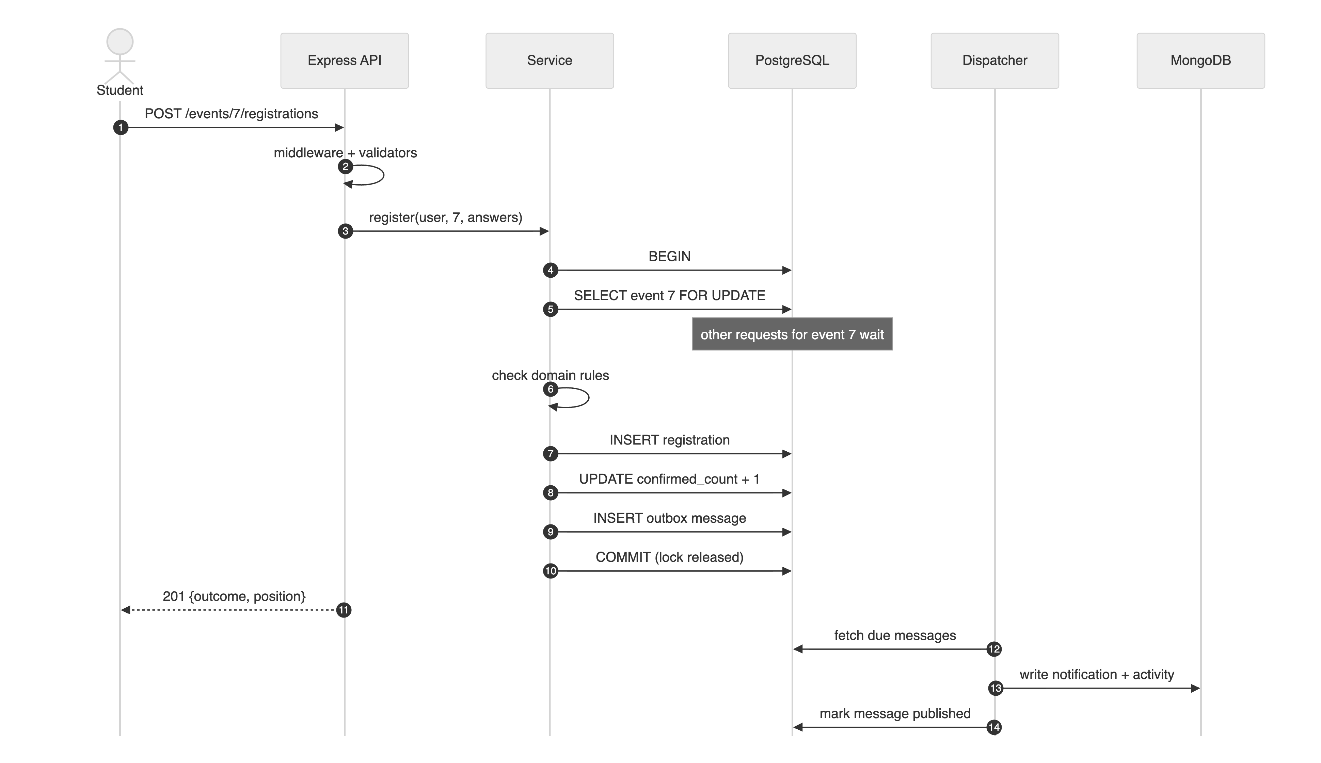
Figure 2.2: One registration across the client, the API and the two databases
- Towards the client (Full Stack). The React client relies on the response envelope and the error codes: toApiError reads code, message, errors[] and requestId, and React Hook Form shows each errors[].field (for example answers.tshirt) under the matching input. CORS allows the React origins and exposes the headers the client reads. Pagination metadata (nextCursor, hasMore, totalPages) drives infinite scroll and page controls.
- Towards the databases (Advanced Database). The services call repository functions in @seatsure/db and never see SQL. The repository behind lockForUpdate issues SELECT … FOR UPDATE, and withTransaction wraps Prisma’s interactive $transaction. Database failures arrive as storage-neutral DbError kinds (UNIQUE_VIOLATION, CHECK_VIOLATION, WRITE_CONFLICT, TIMEOUT), which the error handler maps to 409, 503 and so on, and which the retry logic uses to decide whether an attempt is worth repeating.
- Defence in depth. The service decides seats under a lock, and PostgreSQL enforces the same rule a second time with CHECK (confirmed_count <= capacity) and a partial unique index (one active registration per student). Even a bug in the service could not store an overbooked event.
- Two databases, one truth. The outbox table lives in PostgreSQL, so a registration and its “tell MongoDB” message commit together; the dispatcher and the subscribers deliver it to MongoDB afterwards. MongoDB can lag behind by about a second, but it can never miss or invent an event.

2.5 Setting Up and Running the Project
The project needs Node.js 22 and PostgreSQL 18. MongoDB is optional in development: when no MongoDB address is configured, an npm-distributed MongoDB server starts automatically. From the seatsure folder:
- Install the dependencies of all three workspaces (client, server, db): npm install.
- Copy .env.example to .env and client/.env.example to client/.env, then set DATABASE_URL and DATABASE_URL_TEST to your PostgreSQL user.
- Create, migrate and seed the databases: npm run setup (it runs db:create, db:migrate and db:seed). Alternatively, load db/schema.sql with psql and run npm run db:seed.
- Start the backend and the frontend together: npm run dev. The API listens on http://localhost:4000 and the React app on http://localhost:5173.
- Open http://localhost:5173 in a browser and choose a demo user in the header, for example Priya Singh (student) or Aarav Mehta (organiser).
- Run the automated tests with npm test, and the live API checks with npm run test:api while the API is running.

If PostgreSQL cannot be installed, the README explains how to use free hosted databases instead (Neon or Supabase for PostgreSQL, MongoDB Atlas for MongoDB).
The complete API reference is Table 2.2 in Section 2.1. Every route is under /api/v1 and answers with the same JSON envelope: {status, data, meta} on success and {status, code, message, errors?, requestId} on failure.

2.6 CRUD over REST: Route Mapping and Validation
SeatSure exposes its data as REST resources, so each create, read, update and delete operation is one HTTP method on one URL. Table 2.3 shows the mapping for the two main resources, events and registrations, together with the database operation behind each route and the status codes a client can expect.
Table 2.3: CRUD operations mapped to REST routes (under /api/v1)
Operation | Route | Database operation | Success | Typical errors
Create | POST /events  POST /events/:id/registrations | event.create (draft)  INSERT inside a transaction that locks the event row | 201 + Location | 400, 403, 409, 422
Read | GET /events, GET /events/:id  GET /me/registrations | findMany with a cursor  findUnique / include for related data | 200 | 400, 404
Update | PATCH /events/:id  PATCH /registrations/:id | event.update (edit, publish, cancel)  updateMany for an idempotent check-in | 200 | 400, 403, 409
Delete | DELETE /events/:id  DELETE /registrations/:id | event.delete (drafts only)  Status set to CANCELLED (soft delete) plus promotion | 204  200 | 404, 409

Deleting a registration is a soft delete. The row is kept with status CANCELLED, so the history stays available for analytics, and the partial unique index ignores cancelled rows, so the student may register again. The response is 200 with a body rather than 204, because the client needs to know who was promoted into the freed seat.
Why validation runs on both the client and the server. The same input is checked in three places, each for a different reason:
- In the browser: React Hook Form checks required fields, lengths and cross-field rules (the end must come after the start; the capacity must fit the venue) before any request is sent. The user gets instant feedback and no request is wasted.
- On the server: the browser is under the user’s control, and anyone can bypass the form with curl or the browser’s developer tools. The API therefore validates every request again with express-validator. It answers 400 with a list of the invalid fields (live check API-03: title and capacity), drops fields a client may not set (mass assignment), and applies the business rules (409 or 422).
- In the database: CHECK, UNIQUE and FOREIGN KEY constraints protect the rules that must never break, such as confirmed_count <= capacity, even if a bug ever slips past the code above.

In short, client-side validation makes the form pleasant to use, while server-side and database validation make the system safe.

Chapter III – Results

3.1 Testing Approach
The API was tested at three levels:
- Unit tests (38, BE-U01–BE-U38). The domain rules are tested as pure functions, and the services are built with in-memory fake repositories, so they run without HTTP or a database. Middleware and the reliability utilities are tested in isolation.
- HTTP integration tests (26, BE-I01–BE-I26). Supertest sends real HTTP requests to the complete Express application, backed by a dedicated PostgreSQL test database and an in-memory MongoDB. These include the concurrency tests, in which 50 requests are fired at the same instant with Promise.all, and an outage test that disconnects MongoDB.
- System-level checks. Fourteen live API checks (npm run test:api) exercise every CRUD route and error case on the running server (Section 3.4). A live demo script fires simultaneous registrations at it, and a race experiment compares the workflow with and without the row lock.

Every test case is recorded with an ID, the concept and lesson it proves, the scenario, the input, and the expected and actual results (Appendix A). The raw output of the run is saved in docs/test-results/backend-tests.txt.

3.2 Test Results Summary
Table 3.1: Automated API tests by area (26 Oct 2026, npm run test:server)
Area (lessons) | Test IDs | Tests | Result
Domain rules as pure functions (M3.2, M2.5, M2.6) | BE-U01 – U08 | 8 | 8 passed
Services with fake repositories: workflows, retries, authorisation (M3.2, M3.3, M3.6, M3.11, M3.12) | BE-U09 – U23 | 15 | 15 passed
Middleware, errors, reliability utilities, streams (M2.2, M2.4–M2.7, M3.11, M3.12) | BE-U24 – U38 | 15 | 15 passed
HTTP integration incl. concurrency and outage (M1.5–M3.12) | BE-I01 – I26 | 26 | 26 passed
Total |  | 64 | 64 passed

3.3 Results
- All 64 automated tests passed in 14.2 s on 26 October 2026.
- No overbooking under load (BE-I21): 50 students registering at the same instant for 3 seats all received 201; exactly 3 were confirmed, the other 47 received waitlist positions 1 to 47 with no gaps or repeats, and the stored counter was 3.
- No duplicate processing (BE-I22): one student double-clicking ten times produced one 201, nine 409 ALREADY_REGISTERED responses and a single row.
- No lost update (BE-I23): three simultaneous cancellations promoted three different students, the three oldest on the waitlist.
- Mass assignment blocked (BE-I08, BE-I13): smuggled status, confirmedCount and createdById fields were ignored; the event was created as a DRAFT with the caller as creator.
- No leaks (BE-U29): an unexpected TypeError produced a generic 500 response with no stack trace or type name.
- Graceful degradation (BE-I25): with MongoDB disconnected, registration still returned 201, feeds returned degraded: true, /health reported MongoDB as down, and the outbox kept the messages until MongoDB returned. This test found a real bug: after re-seeding, outbox ids restarted at 1 and were wrongly treated as duplicates by a persistent MongoDB. It was fixed with a UUID message id (decision D-11).

The same guarantee holds against the running server. Listing 3.1 shows the output of the live demonstration, in which 50 registrations are fired at a 10-seat event.
Listing 3.1: Live concurrency demo against the running API (npm run demo:concurrency -- --seats 10 --students 50)
SeatSure - live concurrency demo (2026-10-26 15:48 IST)
Command: npm run demo:concurrency -- --seats 10 --students 50 (API running on
localhost:4000)

Event #31: 10 seats. Firing 50 registrations at the same moment...

┌────────────────┬────────┐
│ (index) │ Values │
├────────────────┼────────┤
│ requests │ 50 │
│ HTTP 201 │ 50 │
│ confirmed │ 10 │
│ waitlisted │ 40 │
│ errors │ 0 │
│ wall time (ms) │ 414 │
└────────────────┴────────┘
Waitlist positions handed out: 1..40 (40 unique)
Database says: confirmedCount=10/10, waitlist=40
Seat counter mismatches across all events: 0

No overbooking: exactly 10 confirmed, everyone else waitlisted in order.

To show that the lock is what makes the difference, a race experiment ran a simplified version of the workflow (read the count, pause for 20 ms, insert; no duplicate check or outbox) with and without SELECT … FOR UPDATE on a 3-seat event (Figure 3.1, Table 3.2). Without the lock, the event was overbooked as soon as more than three requests arrived together; the overbooking stopped growing at 10 only because the connection pool allows ten transactions at a time. With the lock, the result was exactly 3 every time.
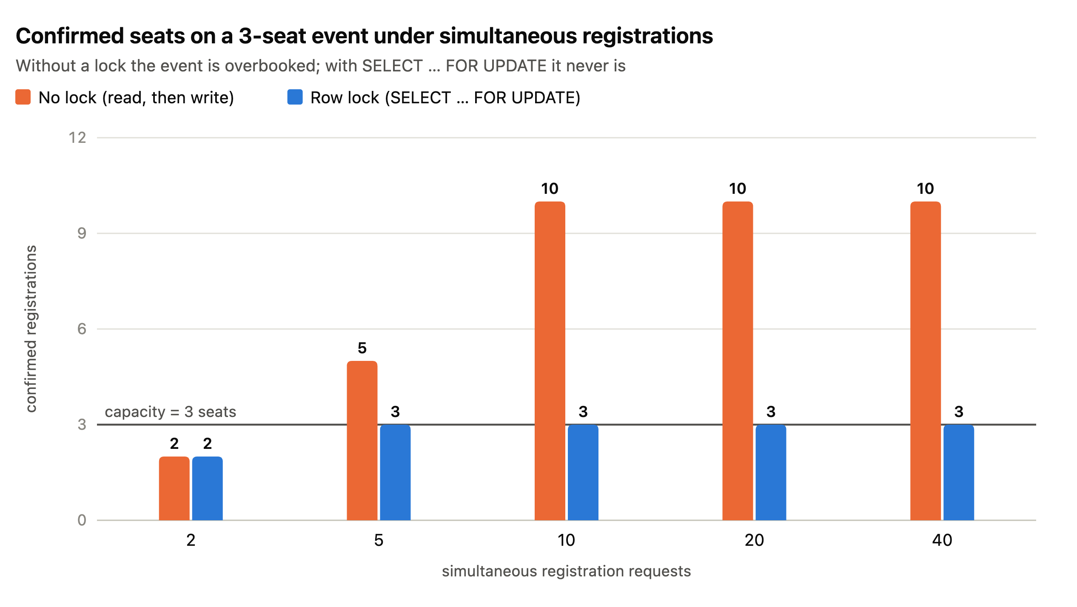
Figure 3.1: Confirmed seats on a 3-seat event under simultaneous registrations, with and without the row lock
Table 3.2: Race experiment (npm run experiment:race -w @seatsure/db)
Simultaneous requests | Confirmed, no lock | Confirmed, FOR UPDATE | Time, no lock | Time, FOR UPDATE
2 | 2 | 2 | 42 ms | 54 ms
5 | 5 (overbooked) | 3 | 33 ms | 119 ms
10 | 10 (overbooked) | 3 | 42 ms | 246 ms
20 | 10 (overbooked) | 3 | 69 ms | 489 ms
40 | 10 (overbooked) | 3 | 124 ms | 964 ms

The screenshots below show the same behaviour from the user’s side. Figure 3.2 shows one create, update and delete through the interface, each handled by one route of Table 2.3.
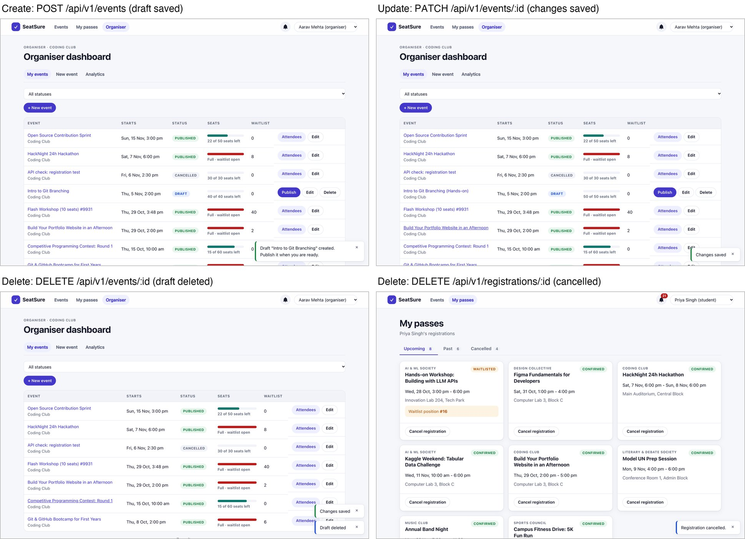
Figure 3.2: Create, update and delete through the user interface, each backed by one REST request
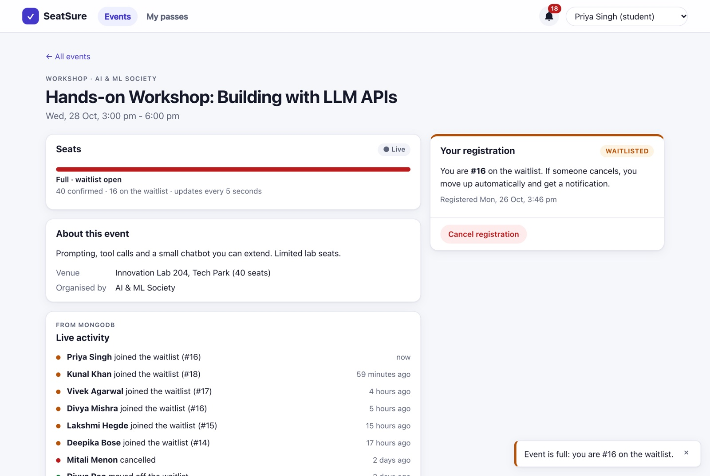
Figure 3.3: A registration for a full event: the API answers 201 with outcome WAITLISTED and the position
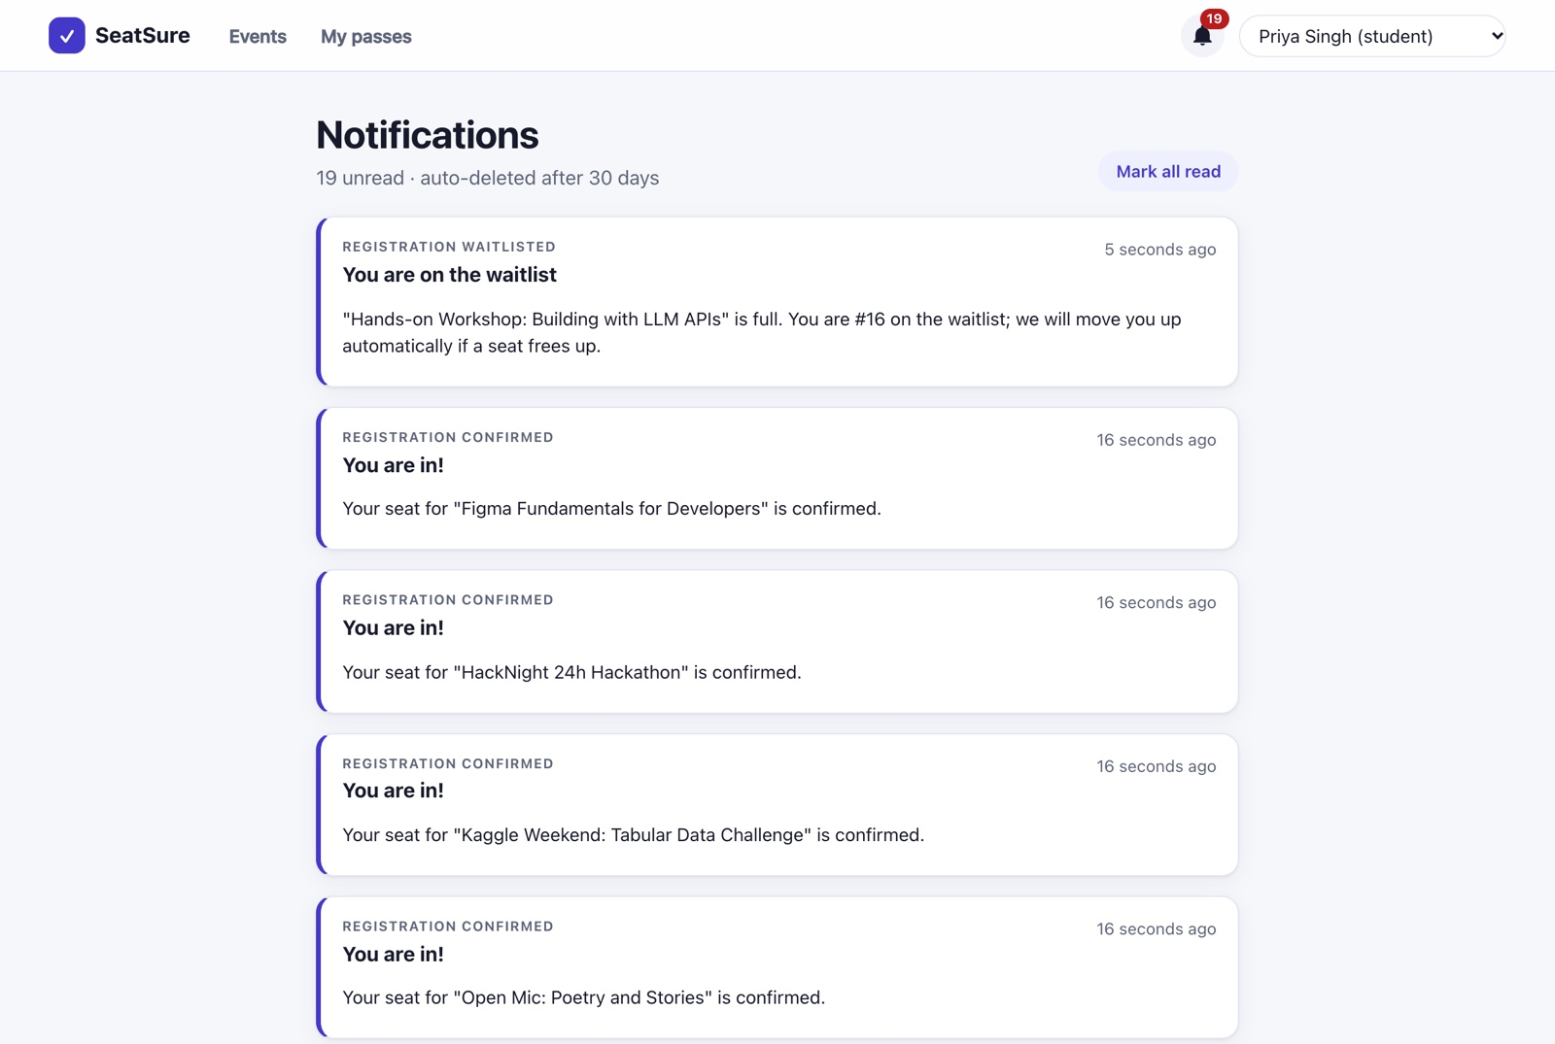
Figure 3.4: Notifications written to MongoDB by event subscribers through the outbox
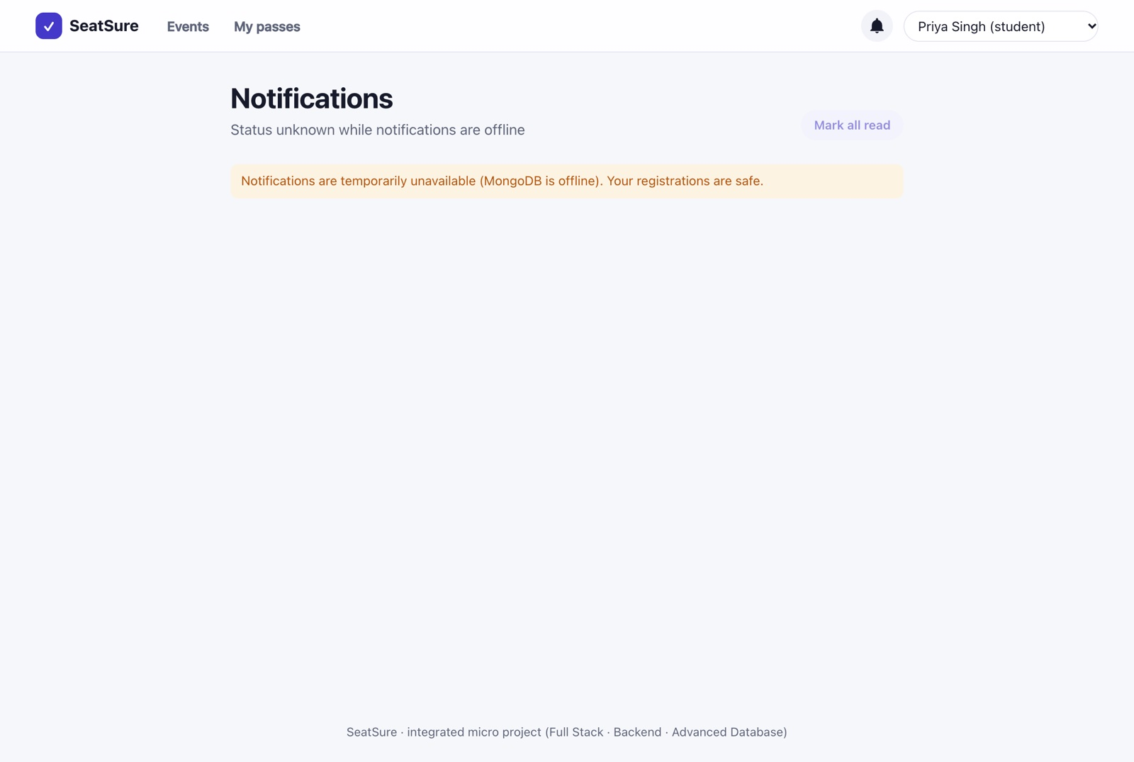
Figure 3.5: Simulated MongoDB outage: the notifications page reports that the feed is temporarily unavailable
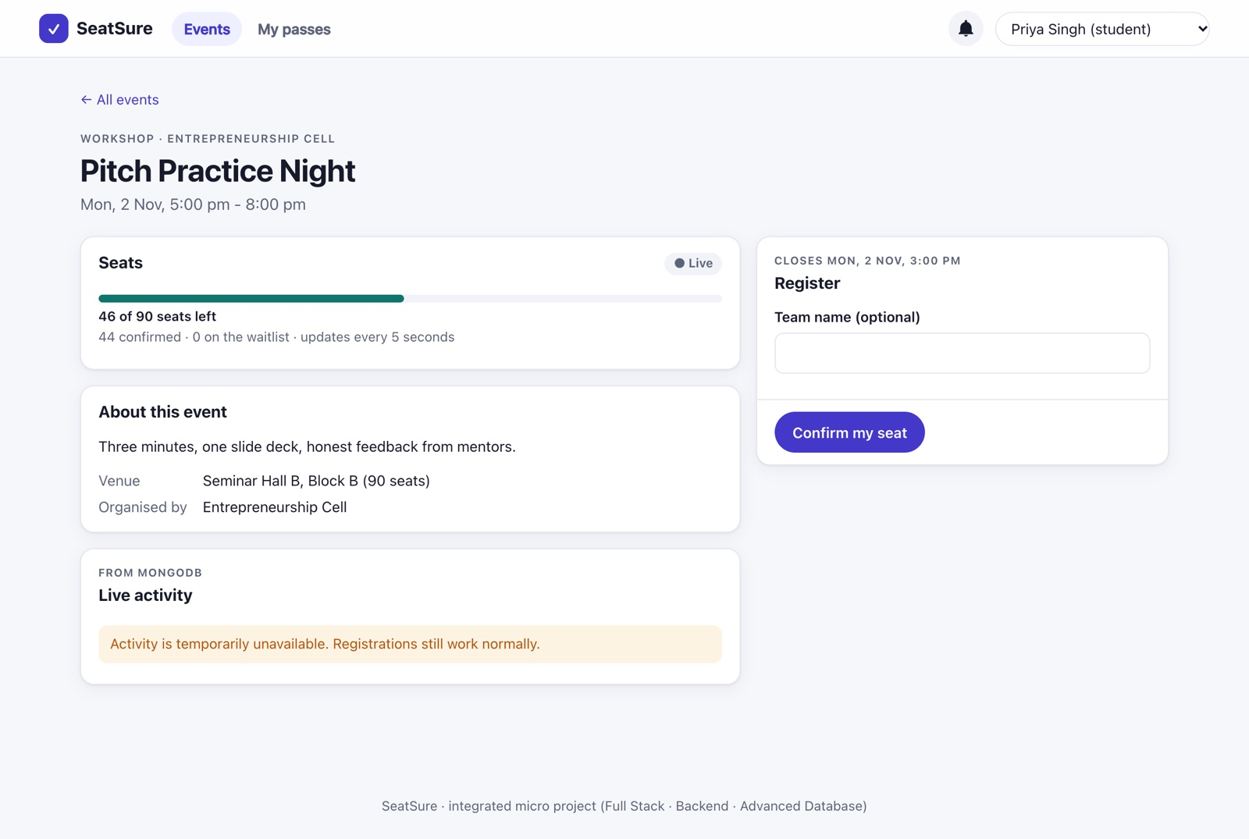
Figure 3.6: During the same outage, registration still works because it depends only on PostgreSQL

3.4 Live API Test Cases
Besides the automated suites, 14 real HTTP requests were sent to the running API on 27 October 2026 with npm run test:api, which records each expected and actual result (raw output in docs/test-results/api-checks.txt). They cover every CRUD operation and the main error cases. 14 of 14 behaved as expected (Table 3.3).
Table 3.3: Live API test cases: expected and actual results (paths relative to /api/v1)
Test | Operation | Request | Expected | Actual | Result
API-01 | Read (list) | GET /events?limit=3 | 200, 3 events + nextCursor | 200 3 events, nextCursor 31 | Pass
API-02 | Create | POST /events {title:"API check: Git workshop", …} | 201 + Location, status DRAFT | 201 DRAFT, Location /api/v1/events/32 | Pass
API-03 | Invalid input | POST /events {title:"", capacity:0, …} | 400 VALIDATION_​ERROR for title and capacity | 400 VALIDATION_​ERROR (title, capacity) | Pass
API-04 | Read (one) | GET /events/32 | 200, the new draft | 200 "API check: Git workshop" (DRAFT) | Pass
API-05 | Update | PATCH /events/32 {title:"… (updated)"} | 200, new title | 200 "API check: Git workshop (updated)" | Pass
API-06 | Delete | DELETE /events/32 | 204 No Content | 204 No Content | Pass
API-07 | Missing ID | DELETE /events/32 (again) | 404 not found | 404 EVENT_​NOT_​FOUND | Pass
API-08 | Update (workflow) | PATCH /events/33 {status:"PUBLISHED"} | 200, PUBLISHED | 200 PUBLISHED | Pass
API-09 | Create (registration) | POST /events/33/registrations {answers:{}} | 201, CONFIRMED | 201 CONFIRMED | Pass
API-10 | Duplicate | Same request again | 409 ALREADY_​REGISTERED | 409 ALREADY_​REGISTERED | Pass
API-11 | Missing user | Same request without X-User-Id | 401 | 401 UNAUTHENTICATED | Pass
API-12 | Delete (cancel) | DELETE /registrations/2567 | 200, cancelled | 200 previous status CONFIRMED | Pass
API-13 | Missing ID | DELETE /registrations/99999 | 404 not found | 404 REGISTRATION_​NOT_​FOUND | Pass
API-14 | Unknown route | GET /does-not-exist | 404 ROUTE_​NOT_​FOUND | 404 ROUTE_​NOT_​FOUND | Pass

3.5 Discussion
The lock has a cost, and it is local. With the lock, registrations for one event run one after another. In the race experiment, where every transaction deliberately pauses for 20 ms, 40 simultaneous requests took 964 ms instead of 124 ms; without that artificial pause, the real API served 50 simultaneous registrations in 414 ms. Because each event has its own row lock, registrations for different events still run in parallel. For a campus system, where even a popular event receives a few hundred registrations in its first minute, this is a good trade: correctness is guaranteed and the wait stays well under a second.
Why a row lock rather than SERIALIZABLE? SERIALIZABLE isolation would also prevent overbooking, but every conflict would surface as an error that must be retried, and under a burst most attempts would fail and retry. A row lock makes requests queue instead, so almost all of them succeed on the first attempt; retries remain only as a safety net for deadlocks and pool timeouts.
Events decouple, the outbox makes them safe. The registration code does not know that notifications exist. Writing the message in the same transaction as the registration, instead of calling MongoDB directly, means that a crash or a MongoDB outage can delay a notification but never lose one, as BE-I25 demonstrates.

Chapter IV – Conclusion
This report presented the Back-End Web Development part of SeatSure. The Express 5 API applies the concepts of all three modules of the course. Module 1 provided the REST resources, a uniform JSON contract and correct status codes. Module 2 provided the architecture: an ordered middleware pipeline, request validation with mass-assignment protection, a central error-handling pipeline, a CSV export streamed with back-pressure, and a layered design in which pure business rules are tested with fake repositories. Module 3 provided the engineering: explicit domain workflows, protection against race conditions through transactions with row locks, cursor and offset pagination, API versioning with deprecation, reliability patterns (retries with backoff and jitter, timeouts and graceful degradation) and an event-driven design built on an EventEmitter bus and a transactional outbox.
All 64 automated tests pass. Fifty simultaneous registrations for three seats produce exactly three confirmations, simultaneous cancellations promote different students, and a MongoDB outage costs only the notification feed, never a registration. The main lesson of the project is that concurrency bugs cannot be found by clicking through an application: they have to be reproduced on purpose, as the race experiment does, and then prevented by design.

4.1 Limitations
- Identity is a placeholder (X-User-Id); there is no real authentication or authorisation token yet. This is intentional, because authentication is taught in Module 4.
- There is no rate limiting, so one client could flood the API with requests.
- The event bus and the outbox dispatcher run inside the API process. Several API instances would need a shared message broker, or SELECT … FOR UPDATE SKIP LOCKED so that dispatchers do not claim the same messages.
- The per-event lock serialises registrations for one very popular event; at much larger scale, a queue in front of hot events would smooth the load.

4.2 Future Scope
- Replace the demo identity with session- or JWT-based authentication (Module 4).
- Add rate limiting per user and per IP address.
- Move event delivery to a message broker so that the API can scale to several instances.
- Publish an OpenAPI description of the API and generate the client’s service layer from it.

References
- Kalvium, Back-End Web Development livebook, Semester 3: Module 1 (Backend Development Foundations), Module 2 (Backend Application Architecture), Module 3 (Backend Engineering Design and Principles). Accessed 26 October 2026.
- Express 5 documentation: routing, writing middleware, error handling. https://expressjs.com
- express-validator documentation: validation chains, validationResult, matchedData. https://express-validator.github.io/docs
- Node.js documentation: events (EventEmitter) and stream (Readable.from, pipeline). https://nodejs.org/docs/latest-v22.x/api
- R. Fielding, M. Nottingham, J. Reschke, HTTP Semantics, RFC 9110, IETF, 2022.
- Y. Shafranovich, Common Format and MIME Type for Comma-Separated Values (CSV) Files, RFC 4180, IETF, 2005.
- E. Wilde, The Sunset HTTP Header Field, RFC 8594, IETF, 2019; and The Deprecation HTTP Response Header Field, RFC 9745, IETF, 2025.
- PostgreSQL 18 documentation: explicit locking (SELECT … FOR UPDATE) and transaction isolation. https://www.postgresql.org/docs/18/
- C. Richardson, “Pattern: Transactional outbox”, microservices.io.
- SeatSure project documentation: README.md (API reference, traceability matrix), DECISIONS.md and docs/testing/test-cases-backend.md.

Appendix A – Test Cases
Automated tests: npm run test:server (Vitest and Supertest), 26 October 2026. Result: 64 / 64 passed. Raw output: docs/test-results/backend-tests.txt. Unit tests (BE-U) use in-memory fake repositories; integration tests (BE-I) send real HTTP requests to the Express app backed by PostgreSQL and MongoDB.
Table A.1: Domain rules and workflows (unit)
ID | Concept | Scenario | Input | Expected | Actual | Pass/Fail
BE-U01 | M3.2 workflow (state machine) | Event status transitions | DRAFT→PUBLISHED, PUBLISHED→CANCELLED, DRAFT→CANCELLED, CANCELLED→PUBLISHED | First two allowed, last two 409 INVALID_STATUS_TRANSITION | As expected | Pass
BE-U02 | M3.2 domain rules | Registering for a draft or a closed event | status DRAFT; closes-at in the past | 409 REGISTRATION_NOT_OPEN / 409 REGISTRATION_CLOSED | As expected | Pass
BE-U03 | M3.2 domain rules | Check-in window | Before, during, after the window | NOT_OPEN / ok / CLOSED | As expected | Pass
BE-U04 | M3.2 seat decision | Seat or waitlist | 1/2 and 2/2 confirmed | true / false | As expected | Pass
BE-U05 | M3.2 capacity rules | Shrinking below confirmed; exceeding the venue | 30 confirmed → 20; 150 > venue 100 | 409 CAPACITY_BELOW_CONFIRMED; 422 CAPACITY_EXCEEDS_VENUE | As expected | Pass
BE-U06 | M2.6 sanitisation | Answers are cleaned | " Byte Busters ", "true" | trimmed, boolean true | As expected | Pass
BE-U07 | M2.5 validation (all errors at once) | Several bad answers | Unknown key, wrong option, missing required | 422 with 3 field paths | answers.hacker, answers.laptop, answers.tshirt | Pass
BE-U08 | M3.2 rules | Organiser's question list | Duplicate ids; choice with 1 option | 422 INVALID_QUESTIONS | As expected | Pass

Table A.2: Services with fake repositories (unit)
ID | Concept | Scenario | Input | Expected | Actual | Pass/Fail
BE-U09 | M3.2 workflow, M2.10 service | 4 students, 2 seats | Sequential registrations | CONFIRMED, CONFIRMED, WAITLISTED #1, #2 | As expected; counter = 2 | Pass
BE-U10 | M3.12 events via outbox | Outbox message per registration | 2 registrations | registration.confirmed, registration.waitlisted (position 1); delivery requested twice | As expected | Pass
BE-U11 | M3.2 rule | Same student twice | 2 registrations | 409 ALREADY_REGISTERED | As expected | Pass
BE-U12 | M3.2 + M2.5 | Answers checked against the event's own questions | Missing required select | 422 INVALID_ANSWERS, then success with a valid answer | As expected | Pass
BE-U13 | M3.11 retry | Transaction loses a write conflict once | Fake transaction throws WRITE_CONFLICT first | Retried, then succeeds (2 calls) | 2 calls, CONFIRMED | Pass
BE-U14 | M3.11 retry only when transient | Business-rule failure | DRAFT event | Not retried (1 call) | 1 call | Pass
BE-U15 | M3.2 workflow + M3.6 transaction | Cancel a confirmed seat | 1 seat, 2 waitlisted | Oldest waitlisted promoted; counter unchanged; cancelled + promoted messages | As expected | Pass
BE-U16 | M3.2 | Cancel with nobody waiting | 2 seats, 1 registered | Seat freed (counter 0), promoted: null | As expected | Pass
BE-U17 | M3.3 trust boundaries | Who may cancel | Stranger / club organiser / owner again | 403 / ok / 409 ALREADY_CANCELLED | As expected | Pass
BE-U18 | M3.2 | Cancel after the start | startsAt in the past | 409 EVENT_STARTED | As expected | Pass
BE-U19 | M3.2 idempotency | Check-in twice; check-in by a student | Organiser ×2, student ×1 | 403; alreadyCheckedIn false then true | As expected | Pass
BE-U20 | M3.3 authorisation | Create an event | Student; organiser of another club; own club | 403, 403, 201-equivalent DRAFT | As expected | Pass
BE-U21 | M3.2 | Capacity above the venue | 80 > 50 | 422 with capacity field error | As expected | Pass
BE-U22 | M3.2 + M3.6 | Raise capacity with a waitlist | 1 → 3 seats, 3 waitlisted | 2 promoted, counter 3, capacity_changed + 2 promoted messages | As expected | Pass
BE-U23 | M3.2 workflow | Publish, publish again, delete published | Same event | publishedAt set; second publish is a no-op; delete 409 NOT_A_DRAFT | As expected | Pass

Table A.3: Middleware, errors and reliability (unit)
ID | Concept | Scenario | Input | Expected | Actual | Pass/Fail
BE-U24 | M2.4 request-id + timing middleware | Any request | GET /ping | X-Request-Id (UUID) matches req.id; X-Response-Time ends in "ms" | As expected | Pass
BE-U25 | M3.3 trust boundary | Incoming request id | trace-12345678 vs <script> | Reused vs replaced | As expected | Pass
BE-U26 | M2.5 validation, M2.6 mass assignment | Bad body; extra field | {title:'x', qty:'many'}; {…, isAdmin:true} | 400 listing title, qty; handler sees only declared fields | As expected | Pass
BE-U27 | M2.7 AppError → envelope | Thrown AppError 404 | EVENT_NOT_FOUND | {status:'fail', code, message, requestId} | Exact body | Pass
BE-U28 | M2.7 + DB error mapping | DbError kinds | UNIQUE / NOT_FOUND / UNAVAILABLE | 409 ALREADY_REGISTERED / 404 / 503 | As expected | Pass
BE-U29 | M2.7 programmer errors, M1.15 no leaks | TypeError thrown | — | 500 generic message, no stack or type names | As expected | Pass
BE-U30 | M2.6 payload limit, M1.9 catch-all | Malformed JSON; 5 KB body on a 1 KB limit; unknown route | — | 400 MALFORMED_JSON; 413; 404 ROUTE_NOT_FOUND | As expected | Pass
BE-U31 | M3.11 retry with backoff | Fails twice, then succeeds | — | 3 attempts; delays grow | As expected | Pass
BE-U32 | M3.11 retry budget | Always fails; permanent error | retries 2; shouldRetry false | 3 calls then throw; 1 call | As expected | Pass
BE-U33 | M3.11 timeout, backoff cap | 200 ms task with a 20 ms timeout; backoff(1,2,3,10) | — | TimeoutError; 2 s, 4 s, 8 s, 60 s | As expected | Pass
BE-U34 | M3.12 EventEmitter bus | 2 subscribers; failing subscriber | — | Both called, returns 2; rejects "1 of 1 subscribers failed" | As expected | Pass
BE-U35 | M3.12 + outbox | Two due messages | — | Delivered in order, both marked published, outboxId attached | As expected | Pass
BE-U36 | M3.11 backoff | Subscriber failing (MongoDB down) | attempts = 2 | Rescheduled 8 s later; round stops | +8000 ms | Pass
BE-U37 | M3.11 timeout | Subscriber never settles | 30 ms timeout | Marked failed: "timed out" | As expected | Pass
BE-U38 | M2.2 streams (CSV rows) | Commas, quotes, formula injection | a,b, say "hi", =HYPERLINK(…) | RFC 4180 quoting; formula prefixed with ' | As expected | Pass

Table A.4: HTTP integration (Supertest → Express → PostgreSQL + MongoDB)
ID | Concept | Scenario | Input | Expected | Actual | Pass/Fail
BE-I01 | M1.6 contract, M3.11 health | Health check | GET /api/v1/health | 200; postgres up, mongo up, 0 counter mismatches | As expected | Pass
BE-I02 | M1.15 envelope, M2.4 request id | Unknown route | GET /api/v1/does-not-exist | 404 ROUTE_NOT_FOUND with the same request id as the header | As expected | Pass
BE-I03 | M3.10 API versioning | Legacy unversioned path | GET /api/events | 200 + Deprecation: true + Link to /api/v1/events | As expected | Pass
BE-I04 | M3.9 cursor pagination, M3.8 metadata | Catalogue page 1 and 2 | limit=2, then cursor=… | 2 + 2 events in date order; hasMore true then false | As expected | Pass
BE-I05 | M1.11 query params, M2.5 validation | Filter; invalid params | category=TALK; limit=500&category=PARTY | 1 talk; 400 listing category, limit | As expected | Pass
BE-I06 | M3.3 authorisation | Draft visibility | Student vs club organiser | 404 vs 200 canManage: true | As expected | Pass
BE-I07 | M1.5 REST, M1.15 status codes | Create an event | Student; organiser | 403; 201 + Location: /api/v1/events/:id, DRAFT | As expected | Pass
BE-I08 | M2.5 validation, M2.6 mass assignment | Invalid body; smuggled fields | title:'Hi', capacity:0; status, confirmedCount:999, createdById | 400 listing 3 fields; 201 DRAFT, count 0, creator = caller | As expected | Pass
BE-I09 | M3.2 rule over HTTP | Capacity above the venue | 100 > 40 | 422 with capacity field error | As expected | Pass
BE-I10 | M3.2 workflow | Publish; invalid target; delete published | PATCH {status}; DELETE | 200 PUBLISHED; 400; 409 NOT_A_DRAFT | As expected | Pass
BE-I11 | M3.3 authorisation | Another club's organiser edits | PATCH title | 403 NOT_CLUB_ORGANISER | As expected | Pass
BE-I12 | M2.4 auth placeholder, M3.3 trust boundary | Missing, malformed, unknown user header | none / abc / 99999 | 401 / 400 / 401 UNKNOWN_USER | As expected | Pass
BE-I13 | M3.2 workflow, M2.6 | 5 students, 3 seats; client sends status: CONFIRMED | POST …/registrations ×5 | C, C, C, W#1, W#2 (injected status ignored) | As expected | Pass
BE-I14 | M3.2 + M2.5 | Duplicate; bad answers | Same student; {tshirt:'XXXL', extra} | 409 ALREADY_REGISTERED; 422 listing answers.extra, answers.tshirt | As expected | Pass
BE-I15 | M3.2 + M3.6 | Cancel a confirmed seat with a waitlist | DELETE /registrations/:id | 200, first waitlisted promoted; #2 becomes #1; second cancel 409 | As expected | Pass
BE-I16 | M3.2 idempotency | Check-in today vs in 3 days | PATCH {checkedIn:true} | First ok, second alreadyCheckedIn, early 409 CHECK_IN_NOT_OPEN | As expected | Pass
BE-I17 | M3.9 offset pagination + JSONB filter | Attendees with answers[tshirt]=M, page size 2 | Organiser; student | 200, total 3, 2 pages, checkInOpen:false; student 403 | As expected | Pass
BE-I18 | M2.2 streams | CSV export | GET …/registrations/export | text/csv, header row + 4 rows | As expected | Pass
BE-I19 | M3.3 + analytics | Analytics as student / organiser | GET /analytics/overview | 403 / 200 with rank 1 = "Git Bootcamp", 21 daily rows | As expected | Pass
BE-I20 | M3.3 single source of truth | Counter after mixed register/cancel | 6 registrations, 2 cancels | confirmed_count = real CONFIRMED rows = 3 | As expected | Pass
BE-I21 | M3.4/M3.5 race condition, M3.6 transaction | 50 simultaneous registrations, 3 seats | Promise.all of 50 POSTs | All 201; exactly 3 confirmed; positions 1…47 unique; counter 3 | As expected | Pass
BE-I22 | M3.5 duplicate processing | One student double-clicks 10× | 10 parallel POSTs, same user | Exactly one 201, nine 409 ALREADY_REGISTERED, 1 row | As expected | Pass
BE-I23 | M3.5 lost update | 3 simultaneous cancellations | 3 parallel DELETEs | 3 different students promoted (the 3 oldest), counter 3 | As expected | Pass
BE-I24 | M3.12 event-driven + outbox | Registration reaches MongoDB | Register, drain outbox | Notification REGISTRATION_CONFIRMED + feed item REGISTERED; 0 pending | As expected | Pass
BE-I25 | M3.11 graceful degradation | MongoDB outage, then recovery | Disconnect, register, read, reconnect, drain | Register 201; reads degraded:true; health mongo down; outbox keeps messages; delivered after recovery | As expected (this test found the outbox-id bug, DECISIONS.md D-11) | Pass
BE-I26 | M3.12 | Promotion notification | Cancel a confirmed seat | Promoted student gets PROMOTED_FROM_WAITLIST | As expected | Pass

Table A.5: Live system demo, not counted in the 64 (docs/test-results/concurrency-demo.txt)
Requests | HTTP 201 | Confirmed | Waitlisted | Errors | Waitlist positions | Counter mismatches | Wall time
50 | 50 | 10 | 40 | 0 | 1..40, all unique | 0 | 414 ms

Appendix B – Concept Traceability
Every concept is tagged in the code as // [BACKEND Mx.y: Concept]. This table, taken from the project README, links each concept to the files that implement it, a way to demonstrate it, and the tests that prove it.
Table B.1: Traceability matrix: concept → code → test (Back-End Web Development)
Module | Concept | Files / functions | How to demo | Test IDs
M1.5 | REST resource design | routes/*.routes.js (nouns, sub-resources /events/:id/registrations) | API table (Table 2.2) | BE-I04, BE-I07
M1.6 / M1.15 | JSON contract, status codes, error envelope | utils/respond.js (ok, created, noContent); middleware/errorHandler.js | curl -i: 201 + Location, 204, 404, 409, 422 | BE-U27, BE-I02, BE-I07
M1.9 / M1.11 | Express server, Router modules, params vs query, catch-all 404 | server.js (app.listen), routes/index.js, middleware/notFound.js | GET /api/v1/nope | BE-U30, BE-I02
M2.2 | Streams | controllers/registrations.controller.js (exportCsv: Readable.from + pipeline); registrationRepository.iterateForExport | Attendees → Export CSV | BE-I18, BE-U38
M2.4 | Middleware pipeline (request-id, timing, logging, order) | app.js; middleware/requestId.js, middleware/requestTimer.js | Response headers X-Request-Id, X-Response-Time; server log | BE-U24, BE-U25
M2.5 | express-validator | validators/*.validators.js; middleware/validate.js | POST invalid event: 400 field list | BE-U26, BE-I05, BE-I08
M2.6 | Hardening: sanitisation, mass assignment, payload limit | validate.js (matchedData allowlist); express.json({limit:'10kb'}); eventRules.normaliseAnswers | Send status:"CONFIRMED" → ignored; 20 KB body → 413 | BE-I08, BE-I13, BE-U30
M2.7 | AppError + asyncHandler + central handler | utils/AppError.js, utils/asyncHandler.js, middleware/errorHandler.js | Any 4xx/5xx shares one shape | BE-U27–U29
M2.9–2.11 | Layered architecture, thin controllers, services, repository pattern | routes/ → controllers/ → services/ → @seatsure/db repositories; container.js (composition root) | Unit tests swap in fake repositories | BE-U09–U23
M2.12 | Supporting layers: config | config/index.js (env-driven, frozen) | — | —
M3.1 / M3.3 | Data flow, trust boundaries, single source of truth | middleware/auth.js (validates X-User-Id); PostgreSQL authoritative, MongoDB derived | /health seatCounterMismatches: 0 | BE-I12, BE-I20
M3.2 | Domain rules & workflows | services/rules/eventRules.js (state machine, windows, answers); registrationService.register/cancel/checkIn; eventService.update (capacity → promotion) | Cancel → next person promoted | BE-U01–U23, BE-I10, BE-I15
M3.4–3.6 | Concurrency, race conditions, transactions | registrationService.register (transactWithRetry → lockForUpdate → insert → counter → outbox) | npm run demo:concurrency | BE-I21–I23, DB-T04/T05
M3.8–3.9 | API design: pagination, filtering, sorting metadata | events.controller.js (meta.nextCursor/hasMore, meta.page/total/totalPages) | Catalogue / attendees | BE-I04, BE-I17
M3.10 | API versioning + deprecation | routes/index.js (/api/v1, /api/events alias); middleware/deprecation.js | curl -i /api/events | BE-I03
M3.11 | Reliability: retries, timeouts, backoff, graceful degradation | utils/retry.js; events/outboxDispatcher.js; services/feedService.js, analyticsService.activity | Analytics → "Simulate MongoDB outage" | BE-U13, BE-U31–U37, BE-I25
M3.12 | Event-driven (EventEmitter bus) | events/eventBus.js (publish); events/subscribers/*; dispatcher | Register → notification appears | BE-U34, BE-I24, BE-I26

