分布式计算：概述

参考书目

M.L.Liu. Distributed Computing: Principles and Applications. 清华大学出版社. 2004年4月

Java materials：http://java.sun.com

Definitions

Distributed Computing: Computing performed in a distributed system, such as network service or network application.

Distributed System: a collection of independent computers, interconnected via a network, that are capable of collaborating on a task. (loosely coupled: computers do not share memory or program execution space, tightly coupled share data using common memory space.)

network service: a service provided by a special kind of program known as a server on a network

network application: is an application that runs on networked computers for end users.

Different Forms of Computing

Monolithic Computing

Computing in a single computer

Single computer shared by users by timesharing

Distributed Computing
Computing performed among multiple network-connected computers.
example: WWW

parallel Computing
Typically use more than one CPU simultaneously to execute a single program.

Cooperative Computing

another branch of distributed Computing, which solves a large problem by giving small parts of the problem to many computers to solve and then combining the solutions for the parts into a solution for the problem.

History of Distributed Computing
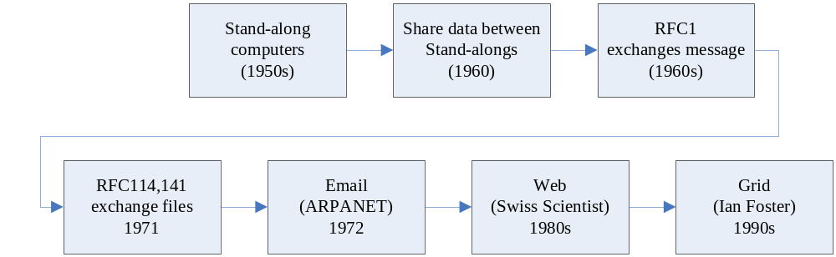

分布式计算在中国

互联网在中国的发展

上网计算机数：2005年7月，4560万台
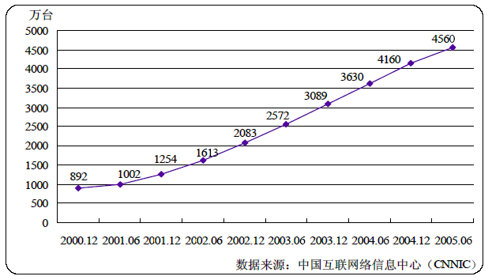

上网用户人数：2005年7月，10300万人
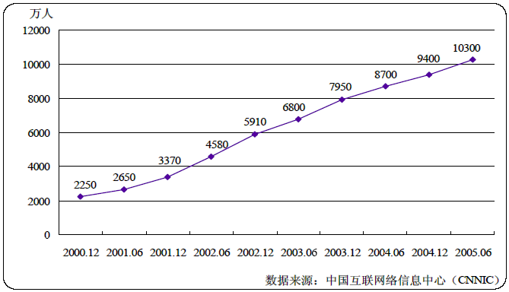

中国参与分布式计算的状况

Country | Users | Results  received | Total CPU time | Population | Participants  per capita
1) United States | 2173136 | 857721999 | 1171014.370 years | 273131194 | 0.007956
2) Germany | 494542 | 205918292 | 203927.448 years | 82561399 | 0.005990
3) United Kingdom | 396764 | 136211002 | 150014.175 years | 59355419 | 0.006685
4) Canada | 270180 | 98262891 | 132502.604 years | 30957019 | 0.008728
5) Japan | 173071 | 71399504 | 81407.308 years | 126314453 | 0.001370
6) Netherlands | 129660 | 61000572 | 65061.794 years | 15800144 | 0.008206
7) France | 183519 | 58526589 | 58844.865 years | 59100912 | 0.003105
8) Poland | 84047 | 58513875 | 52751.682 years | 38657804 | 0.002174
9) Australia | 122033 | 43275829 | 51604.570 years | 20027576 | 0.006093
10) Sweden | 68411 | 31087232 | 37594.276 years | 8870660 | 0.007712
11) Italy | 104303 | 29153376 | 29810.337 years | 57577963 | 0.001812
12) Czech Republic | 35995 | 28894986 | 28455.282 years | 10281012 | 0.003501
13) Finland | 51636 | 24010891 | 27148.391 years | 5158392 | 0.010010
14) Denmark | 51295 | 20952110 | 23300.766 years | 5319545 | 0.009643
15) Spain | 114733 | 20361424 | 23602.725 years | 39953459 | 0.002872
16) Taiwan | 37231 | 19450529 | 17908.263 years | 22009588 | 0.001692
17) Austria | 43648 | 18353591 | 19437.535 years | 8111238 | 0.005381
18) Switzerland | 37982 | 18336023 | 19799.475 years | 7242118 | 0.005245
19) China | 63344 | 13445908 | 10292.550 years | 1250463856 | 0.000051
Last updated: Thu Sep 1 18:20:24 2005 UTC http://setiathome.berkeley.edu/stats/countries.html

分布式计算的例子

SETI（The Search for Extraterrestrial Intelligence，地外文明搜索）http://www.equn.com/seticn/
SETI@home是Search for Extraterrestrial Intelligence at Home的缩写，为“在家里搜索地外文明”之意。该计划信奉的原则是，先进的外星文明只要进入无线电时代，就会像地球一样有电磁辐射从他们居住的星球泄漏出来。或者，为了试探宇宙中是否还有其他智慧生命，“外星人”很可能正在主动地发送信号。

位于加州伯克立大学的SETI@home项目组把阿雷西波(Arecibo)射电望远镜采集到的海量信息分成一个个小数据包，发送到互联网上。每台安装了SETI@home软件的电脑都可以自动下载这些数据，以运行屏幕保护或者后台程序的方式参与数据分析。目前共有226国家和地区、超过500万的个人和团体参加了这项浩大工程（在我写这句话时，是5377217个用户，详情可查看其“当前统计信息”）。使用的CPU时间超过224万年，如此多电脑联合起来，已经超过了世界上任何一台超级计算机的处理能力。

Folding@home http://www.equn.com/folding/
Folding@home是一个研究蛋白质折叠，误解，聚合及由此引起的相关疾病的分布式计算工程。它使用联网式的计算方式和大量的分布式计算能力来模拟蛋白质折叠的过程，并指引我们近期对由折叠引起的疾病的一系列研究。中国很少有人参加这个项目。

FightAIDS@home http://www.equn.com/faids/
使用您的计算机研究艾滋病的生理致病原理并寻找对抗 HIV 病毒的药物活性分子。

ClimtePrediction http://www.equn.com/cpdn/
Climateprediction.net工程是把最新的气候预测模型通过家庭、学校、办公室的计算机来进行计算。这些计算完成的结果将会组成世界最大的气象预测模型。气候改变了，而我们对此的行动已经是全球重要的话题。这将影响到人类的农业生产、水资源量、生态系统、能源需求、保险花费和很多其他与人类息息相关的方面。确凿的科学依据表明，地球在在接下来的几个实际可能会变得温暖话，但是我们无法估计到底变化会有多大。

The Advantages and Weakness of Distributed Computing

Advantages

Resource Sharing

Scalability

Fault tolerance

Weakness

Multiple points of failure

Security concerns

Knowledge to be taught in this course

Base Knowledge for Distributed Computing

Basics of Operating Systems

Computer Programs and Processes

Concurrent Programming

Concurrent process executed on multiple computers

Concurrent process executed on a single computer

Concurrent process executed in a process
- Child Process
- thread

Interprocess Communications

Event Synchronization

Connection-Oriented VS. connectionless IPC

Distributed Computing Paradigms

Client-Server Paradigm

The Peer-To-Peer Paradigm

The Socket API

Client-Server Paradigm

Event Synchronization

Software Engineering for a Network Service.

Group Communication

Multicast API

Connectionless multicast vs. Connect-Oriented multicast

Reliable Multicasting vs. Unreliable Multicasting

Distributed Object

Remote Method Invocation

The Java RMI Architecture

the API for Java RMI

CORBA ( Common Object Request Broker Architecture)

Object Servers and Object Clients

CORBA Object Reference

CORBA Naming Service

Internet Application

XML-The Extensible Markup Language

Servlet

Web Services-The Simple Object Access Protocol (SOAP)

Instant Message

JXTA

Jabber

