**Peter Dwersteg**

CSE 142 TA , CSE Major , Senior at University of Washington

Theta Xi fraternity

From Seattle ,Washington

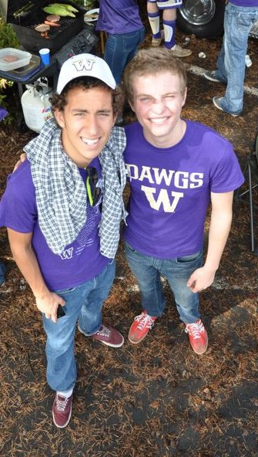

**Evan Walker**

Political Science

University of Washington- Junior

University of Sussex(England)

Class of 2013 · International Political Economy

**Favorite Quotations**

"It all began with a man and country, every plan turns another century around again, another nation, fallen. Maybe God can be on both sides of the gun, never understood why some of us never get it so good, so good."  
  
"I got no idea, but what I do have, is a GED and a 'give 'em hell' attitude." Dean Winchester

(The right) 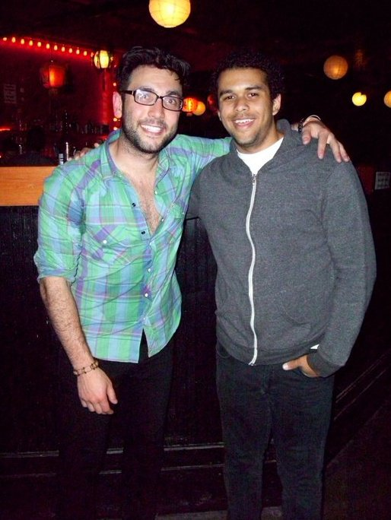

**Alex Kuehl**

From Washington, U.S.

International Study Major Junior

Like to travel very much and been volunteering in different places in the world.

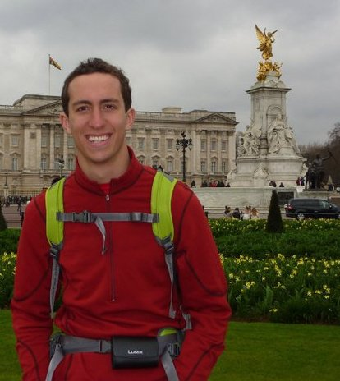

**Maialen M Etch**

**ICEP American Consultant – ICEP美国资深顾问**

Fluent in Chinese, Spanish, French, English

曾于上海，圣地亚哥**Ima he SA**工作。

华盛顿大学-商学院荣誉学士。曾获得美国全国中文business case competition 全国2等奖。



## [Nicholas Hopper](http://www.facebook.com/nadhopper)

Icep 资深顾问

德国人，精通英语，德语，汉语。曾在台湾，北京等地生活工作。

Year of 2013 : University college Dublin

Class of 2010:National Taiwan Normal University

2008:Peking Univerisyt

2011: UBC(Canada)

