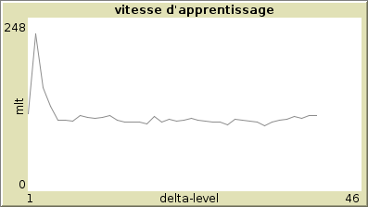
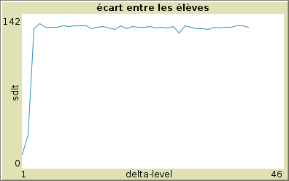
P=0,1
q=1
undotime=10
intervalle level=1
mlt=109,16
drop out=131,71
strategy 1

strategy 2
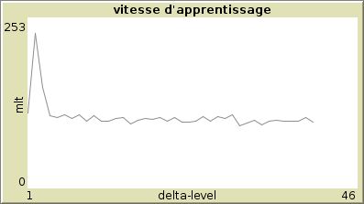
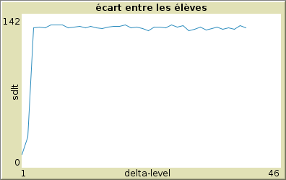

strategy 3
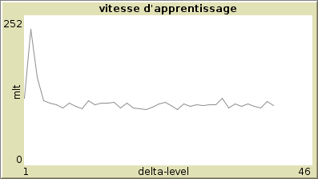

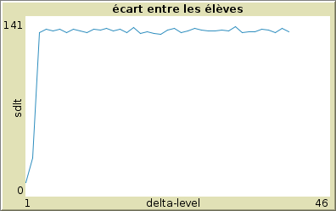

undotime=30
strat 1, 2 , 3
PAREIL

undotime = 100
strat 1

DROP OUT = 77,6
MLT=124

strat 2

drop out = 85,39
mlt =126,76

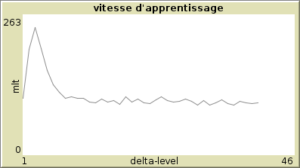
strat 3

drop out =120,42
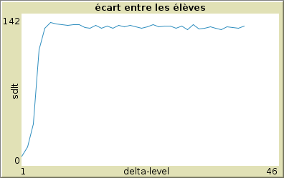
mlt=63,84

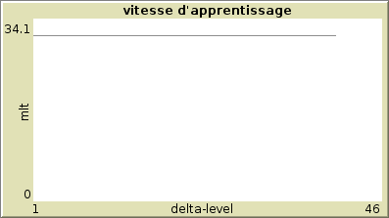

p = 1
q = 0
undotime=10
intervalle level=1
strat 1

mlt=31
drop out= 0
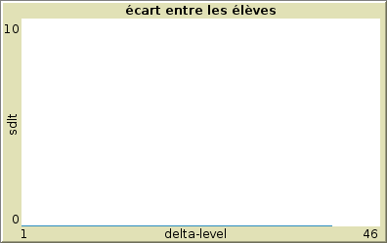

STRAT 2 same

undotime=50 same

p=0,5
q=0,5
undotime=10
intervalle level=1
strat 1
MLT=63,26
DROP OUT=8,44

strat 2

