Beyond Vision

Beniamin Bia
biabeniamin@outlook.com

Submitted for the 2019 Digilent Design Contest Europe

Advisor: Alin Grama

Technical University of Cluj-Napoca
Cluj-Napoca, Romania

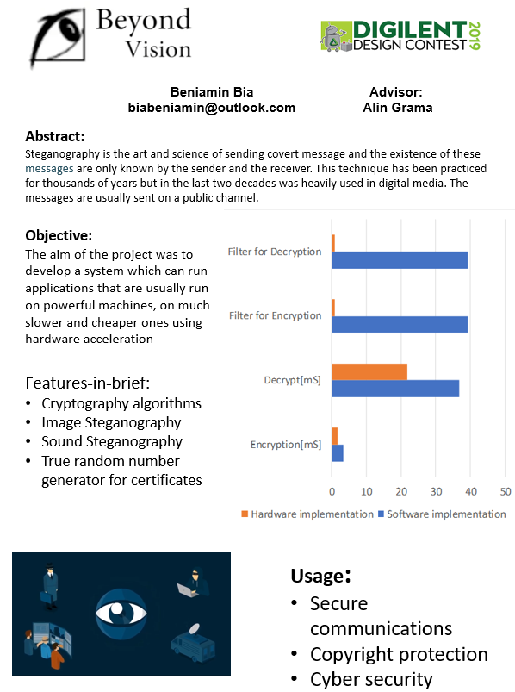

Contents
Introduction 4
Background 5
True Random Number Generators 5
Steganography 6
RSA 7
Hdmi 7
Design 9
Features and Specifications 9
Design Overview 10
Detailed Design Description 11
DMA 11
RSA encoder/decoder 11
True random number generator 13
Video processing 14
Software 16
Features and Specifications 16
Software Overview 16
Detailed Software Architecture 17
Controller: 17
HDMI driver: 17
HDMI in: 17
HDMI out: 17
Encrypter: 18
Decrypter: 18
Random number generator: 18
Web server 18
DMA Linux Kernel: 18
Functional principal 19
Encryption 19
Decryption 20
Image Steganography: 20
Sound Steganography: 21
Discussion 21
Problems Encountered 22
Transfer speed 22
Engineering Resources Used 22
Marketability 22
Community Feedback 22
References 22

Introduction

Abstract

Steganography is the art and science of sending covert message and the existence of these messages are only known by the sender and the receiver. This technique has been practiced for thousands of years but in the last two decades was heavily used in digital media. The messages are usually sent on a public channel.[3]

Objectives

The aim of the project was to develop a system which allows the user to communicate secure and run applications that are usually run on powerful machines, on much slower and cheaper ones using hardware acceleration.

Features-in-Brief

- Hardware accelerated cryptography algorithms
- Hardware accelerated Image Steganography
- Hardware accelerated Sound Steganography
- True random number generator for generating certificates

Project Summary

A hardware accelerated encryption system to accelerates RSA encryption algorithm, Image Steganography, Sound Steganography and few more video processing algorithms. It does it with the help of an external processing unit via HDMI, to extends the processing capabilities, and some FPGA components.

Digilent Products Required

- Digilent Zybo Z7-20 Board
- Digilent Nexys Video

Tools Required

- Vivado
- Linux Kernel
- Vivado HLS
- Xilinx SDK
- Digilent Analog Discovery 2 for debugging

Design Status

Fully functional

Background

True Random Number Generators
A true random number generator is very important in security primitives that can generate secret and public keys, initialization of vectors and seeds for pseudo-random number generators. Because modern cryptography algorithms require large data of keys, the entropy is reduced. Consider this, performing a brute-force attack on the seed that generated the key, could break the crypto system. Also, for secure web servers, pseudo-random numbers generator are inefficient and hardware acceleration approaches are desired instead.[1]

It is generally accepted the fact that a software approach to true random numbers generators does not exist. For a hardware implementation, a physical source of analog noise is required as primary source of randomness. [2]

The simplest circuit which generates random numbers is the ring oscillator shown in Figure 1. One or more logic gates connected in a loop which can oscillate an odd number of possible states. [2]
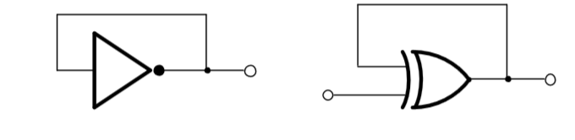
Figure 1 Simple ring oscillators by using inverters and XOR logic gates

The output of the ring oscillator is determined by propagation and route delay. It is affected by temperature and voltage variations. If we sample the output of a ring oscillator with another asynchronous clock, because clock signals would not be aligned, we could obtain a true random numbers generator.

Increasing the number of analog inputs, increases the entropy level.

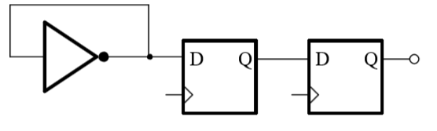
Figure 2 True random numbers generator with asynchronous clocks

Steganography
Steganography is the art and science of sending covert message and the existence of these messages are only known by the sender and the receiver. This technique has been practiced for thousands of years but in the last two decades was heavily used in digital media. The messages are usually sent on a public channel. [3]

A steganography system should meet three key requirements, imperceptibility of embedding, accurate recovery of information even if it was sent on a noise channel with lots of compressions algorithms, and large payload (amount of data hided). [3]

Types of steganography
- Text Steganography which is achieved by altering certain characteristics of textual elements like line-shift coding, word-shift and feature coding. [4]
- Audio steganography which is achieved by embedding the message into digital audio signal which result in slight altering of binary sequence of corresponding audio file. There are several methods like LSB coding, phase coding, spread spectrum. [4]
- Image steganography which is the most popular and it is achieved by altering least significant bits, masking and filtering, redundant pattern encoding, encryption. Usually, LSB method is most used by also most easily to be detected.
- Video steganography is achieved by combining audio and image steganography into a large set of data.
- Protocol steganography is achieved by slightly altering network protocols used in network transmission. [4]
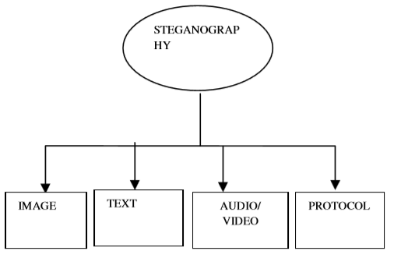
Figure 3 Types of steganography

RSA

Encryption is the standard means of rendering a communication private. The receiver receives an enciphers message from the sender usually on a public channel. The message can be deciphered only be receiver because only he has the appropriate key to decipher the message. An eavesdropper who sees the message, would see only garbage which would make no sense to him.

RSA algorithm removes the necessity of delivering keys on a secure channel before communicating safety. In RSA, the encryption keys are public, while the decryption keys are held only be the person who decrypts the message. Everyone has a public and a private key. The private keys must be generated in such a way that cannot be deduced from public key. The security of algorithm has been validated since no attempts to break the algorithm were successful, mostly due to the difficult of factoring numbers p and q, where p and q are prime numbers generated randomly.[6]
The encryption and decryption algorithms are described in following formulas:

Encoding:
C ≡ E(M) ≡ M^e (mod n)
Decoding:
M ≡ D(C) ≡ C^d (mod n)

HDMI
The High Definition Multimedia Interface (HDMI) is widely used in consumer television, Blu-ray, DVD players, set-top boxes, game consoles and digital cameras. It is a common place in the world of display equipment and professional video production. [7]
HDMI can be taught to operate when switching among multiple displays, especially if the displays have different native resolutions. [7]
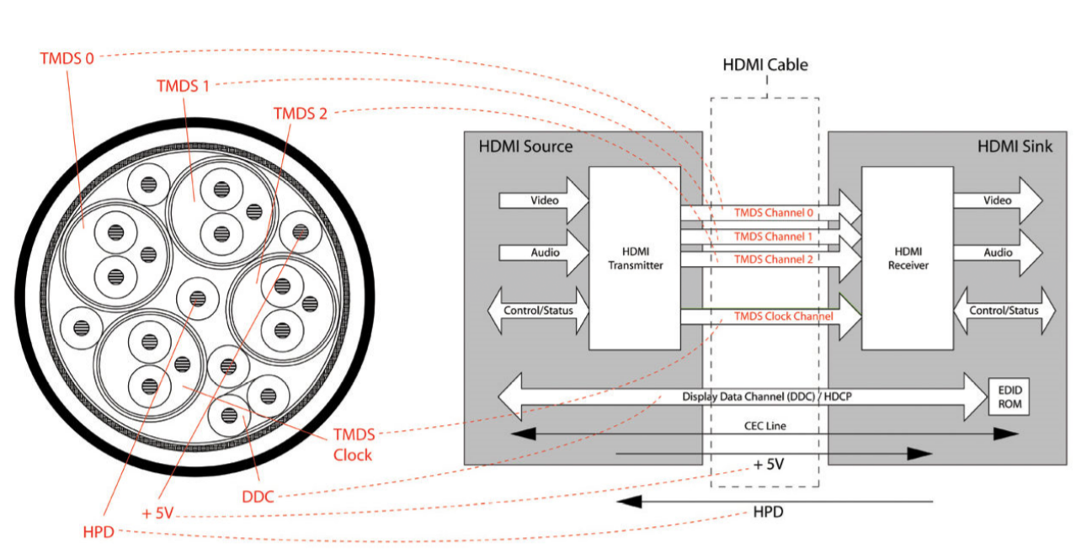
Figure 4 Components inside a HDMI cable

As presented in Figure 4, HDMI has following cable inside [8]:
- 4 TMDS (Transition Minimized Differential Signaling) signals over 4 twisted pair wires which carries 3 digital video signals and 1 clock signal. The audio signals are also multiplexed into the digital video signals.
- DDC (Display Data Channel) which carry two-way communication signals.
- CEC (Consumer Electronics Control) carry remote control signals. This signal is designed to allow the user to command the device.
- HPD (Hot Plug Detection) allows the source of the signal to detect if a display is connected in real time.
- +5 V provides the power for devices to communicate with the source even when they are not powered on.

Why This Project?

We chose this project because I wanted to create a very secure systems which cannot be broken and the technology we developed, is very secure. Also, I think that hardware acceleration is the future in machine learning and power demanding applications.

Design

Features and Specifications

- Hardware accelerated cryptography algorithms
- Hardware accelerated Image Steganography
- Hardware accelerated Sound Steganography
- True random number generator for generating certificates
- HDMI processor
- HDMI controller for external HDMI processor

Design Overview
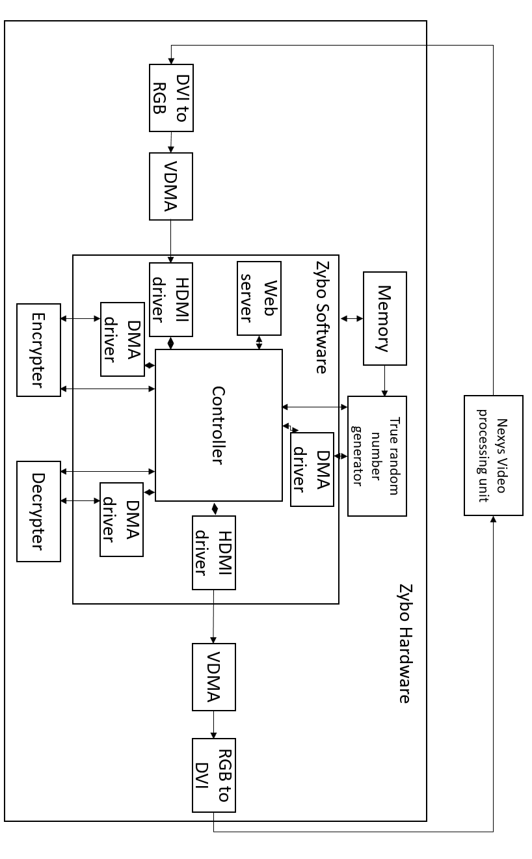

Detailed Design Description

DMA
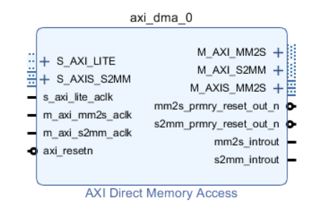
Figure 5 DMA Block

In proposed project, were used a lot of direct memory access blocks to transfer data between memory and hardware components, respectively between software and hardware.
The DMA was used because it provides a way to transfer high volume of data between software and hardware at a considerable speed, but because the system is running Linux on ARM processor, the communication is very complex and requires a lot of drivers to allocate a contiguous memory for the DMA buffer, translating the virtual address from Linux to a physical address and handle the DMA.

RSA encoder/decoder
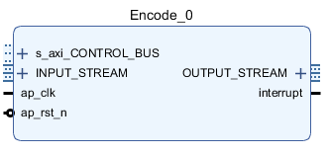
Figure 6 RSA Encoder/Decoder

This IP receives data via an AXI stream interface and an AXI lite interface and sends the result via an AXI stream interface.

Via AXI lite interface, it receives e and n values for encryption and d and n for decryption.
Then, for every value received on AXI stream interface with a lane length of 32 bits, it applies the equation 1 or equation 2 in order to calculate the value and send the result on AXI stream output interface.

Equation 1 Encoding
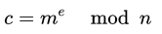
Equation 2 Decoding

The calculation of modulo takes a lot of time in a pure software implementation, that is why such a high improvement as shown in Figure 7 and Figure 8 were obtained.
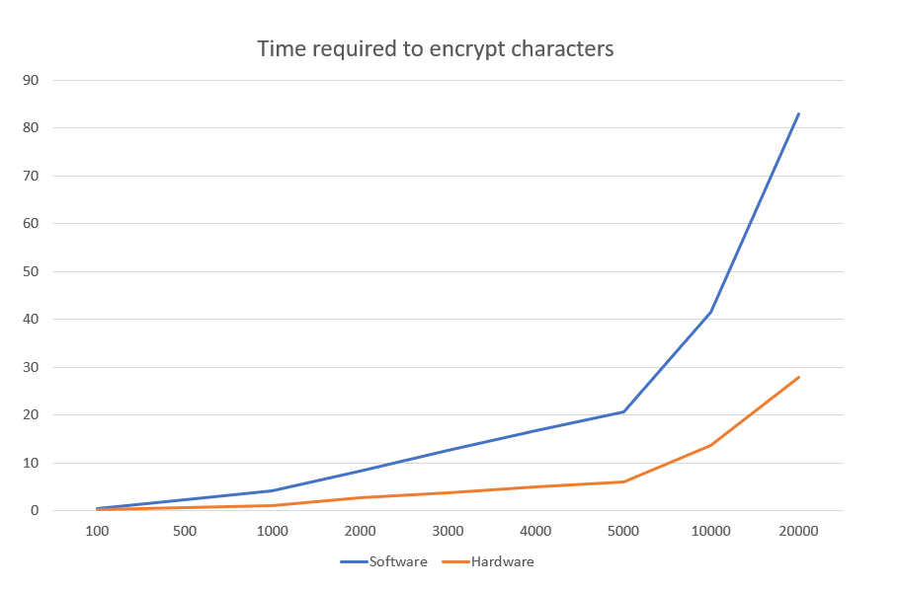
Figure 7 Achieved performances for RSA encrypt
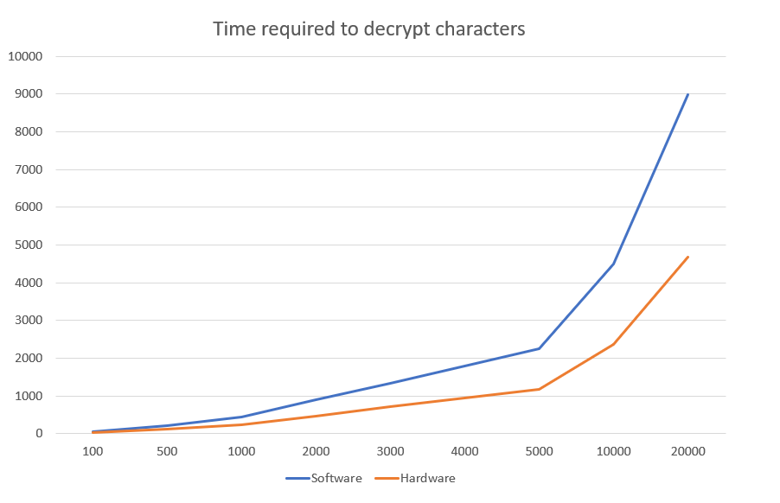
Figure 8 Achieved performances for RSA decrypt

True random number generator
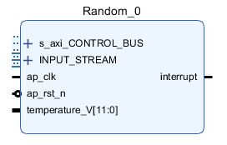
Figure 9 True random number generator IP

IP shown in Figure 9 generates a true random number by taking in consideration multiple sources of analog noise like chip temperature, random locations from Linux kernel memory and last value generated.
The AXI stream interface receives as input data from random locations of memory used by Linux kernel and do a XOR operation for every location.
Also, it takes the chip temperature measured by the 8-bit ADC, combines it with other ADC channels and do a XOR with this value. It is sampled at a very big frequency, around 120 MHz.
It has a combination loop in order to do a XOR with last value. To select the memory location from Linux Kernel and the size, it uses a pseudo-random number generator and has the time as seed.

Video processing

For video processing algorithms was used an external processing unit which consists of a Nexys Video board. The processing unit has an HDMI input, a HDMI output, and a control bus on a PMOD port. In Figure 10 is represented the block diagram of external processing unit.

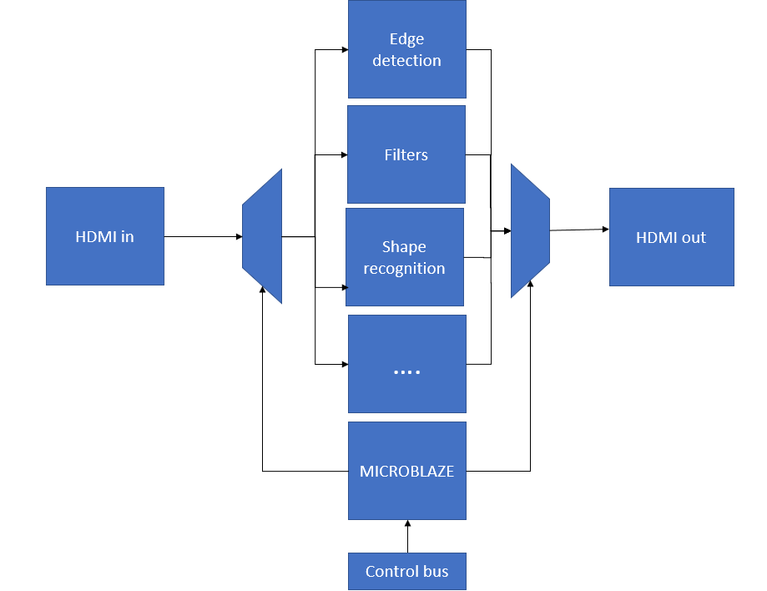
Figure 10 Processing Unit architecture

Because the chosen solution does hide the data mostly on edges of picture, it requires multiple video processing algorithms for both detection location of pixels to write and filtering modified image to detect which pixels to be read.
The control bus specifies which algorithm is being executed and the output resolution. Also, a DVI to RGB and a RGB to DVI block were used to convert the signal from HDMI to AXI stream. The IP which process the stream and applies chosen image algorithm is represented in Figure 11.
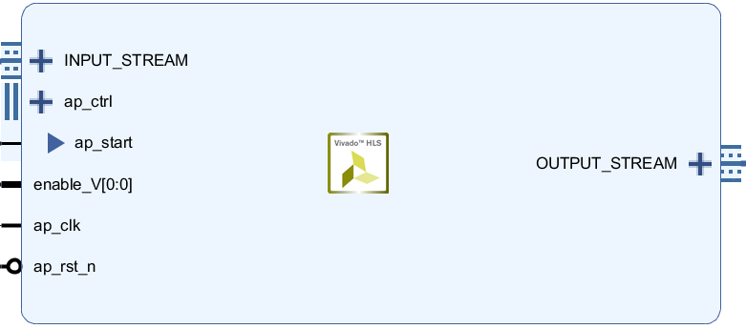
Figure 11 Image processing IP

Obtained performances software vs hardware can be seen in Figure 12.

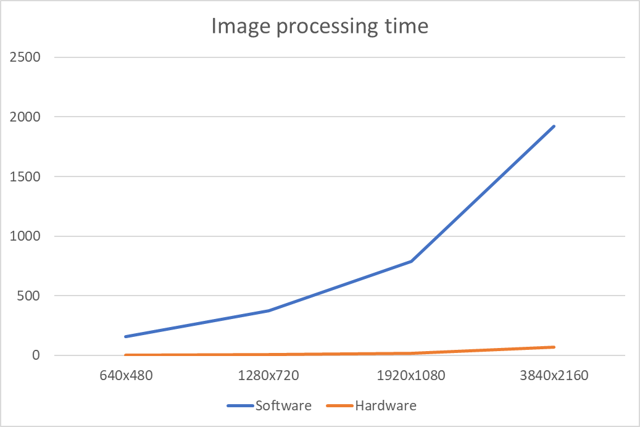
Figure 12 Achieved performances for image processing

Software

Features and Specifications

- Hardware accelerated cryptography algorithms
- Hardware accelerated Image Steganography
- Hardware accelerated Sound Steganography
- True random number generator for generating certificates
- HDMI processor
- HDMI controller for external HDMI processor
- Remote access to the system using a website
- Easily integrated with exposed API
- Chat App integrated
- Real time operating system
- Drivers for Linux Kernel developed

Software Overview

The Zybo Z20 is running a real time operating system. Running a real time operating system makes you system more scalable, optimized for multi-tasking, easier to maintain and more secure [5]. But it uses a lot of system resources, specific drivers to handle interrupts and it is power hungry. This is a problem when you don’t have many resources. Proposed system has an ARM process running at 667MHz with 1GB of ram. For simple operations it works well, but for complex algorithms coming from multiple connections at the same time, the speed is not enough, especially when you want to process a Full HD video stream.
The system runs a Linux distribution. A number of kernel drivers were developed in order to work with hardware components. The operating system requires different components beside processor in order to work, more information about hardware are specified in Hardware section.
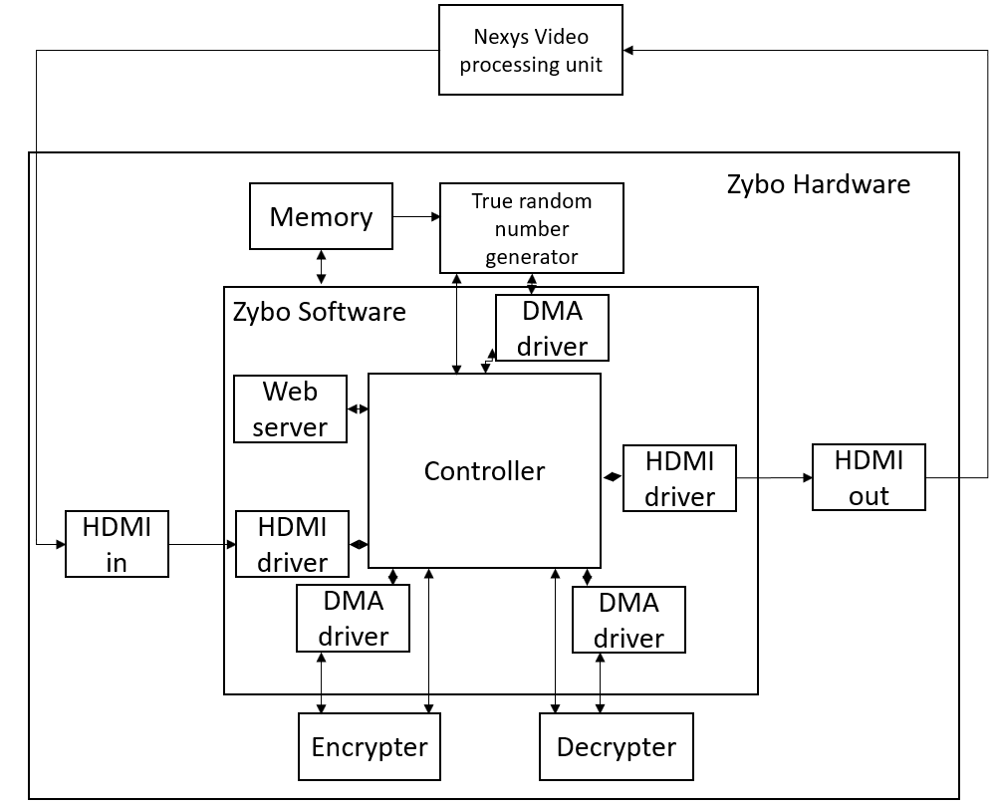
Figure 13 Software Architecture

Detailed Software Architecture

Controller:
The controller coordinates all the processes and have a queue for prioritization the tasks. When a new API POST request is received, it adds it into the queue in order to be processed. Then, it determines which tasks can be executed simultaneously and which cannot be and administrate shared resources.
See functional principal for more information.

HDMI driver:
A Linux kernel driver which interfaces a video direct memory IP. The VDMA IP requires a memory location to be allocated for it in order to work. The memory location must be contiguous and must be translated to physical memory addresses in order to be passed to VDMA. The IP is configured to work as input or output and read or write selected memory location via AXI lite interface.

HDMI in:
The input of HDMI from Zybo board is connected to a video direct memory block which is controlled by HDMI driver and is configured as input.

HDMI out:
The output of HDMI from Zybo board is connected to a video direct memory block which is controlled by HDMI driver and is configured as output.

Encrypter:
A Linux kernel driver which interfaces a custom IP in order to encrypt the data. The data is stored in memory and transfer to the device using a DMA IP via AXI stream protocol. The DMA IP requires a memory location to be allocated for it in order to work. It must be contiguous and must be translated to physical memory addresses in order to be passed to the IP. Then, it configures the memory location, size, and direction of stream in DMA IP via AXI lite interface. See hardware description for more information about the IP.

Decrypter:
A Linux kernel driver which interfaces a custom IP in order to decrypt the data. The data is stored in memory and transfer to the device using a DMA IP via AXI stream protocol. The DMA IP requires a memory location to be allocated for it in order to work. It must be contiguous and must be translated to physical memory addresses in order to be passed to the IP. Then, it configures the memory location, size, and direction of stream in DMA IP via AXI lite interface. See hardware description for more information about the IP.

Random number generator:
A Linux kernel driver which interfaces a custom IP for generating certificates. The random locations from Linux Kernel is stored in memory and transfer to the device using a DMA IP via AXI stream protocol. The address must be translated to physical memory addresses in order to be passed to the IP. Then, it configures the memory location, size, and direction of stream in DMA IP via AXI lite interface. See hardware description for more information about the IP.

Web server
The Zybo Z20 also hosts a web server using integrated 1Gbs ethernet port. The Web server is created on Linux. When a new request arrives, it adds it in a que in order to be processes. It also has an exposed API to be easily integrated. See controller section for more information.

DMA Linux Kernel:
Because we used DMA’s for true random numbers generator, encrypter, decrypter, HDMI in/out they need a contiguous space of memory to work. The DMA is configured with a physical address and the length and it starts reading X bytes from start address. In order to work properly, the memory must be allocated contiguous which means that in the physical memory, the allocated bytes would be at consecutive memory locations.

Functional principal
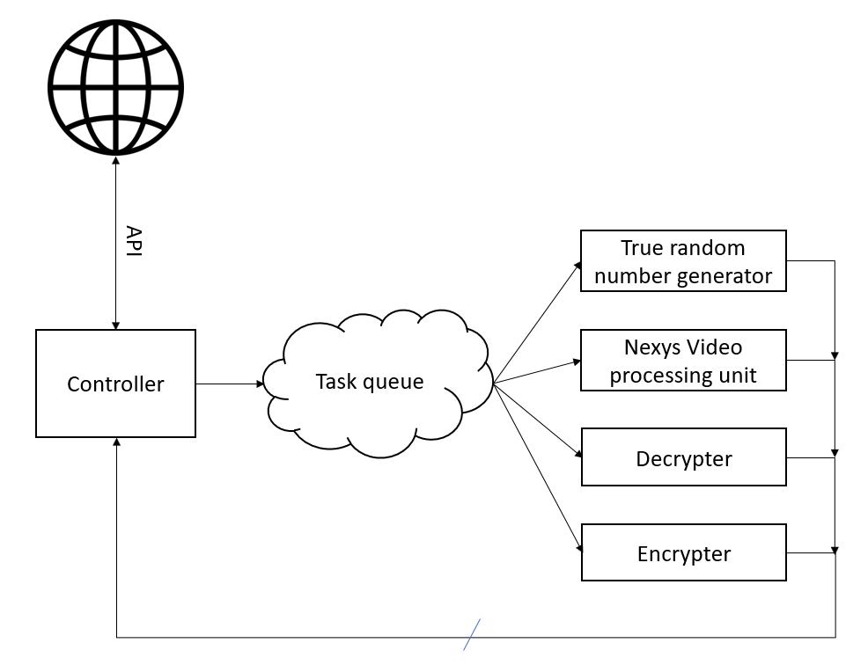
Figure 14 Functional overview

Encryption
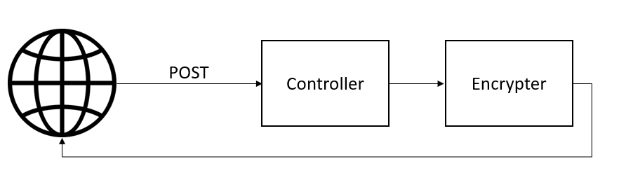
Figure 15 Encryption functional principle

As described in Figure 15, the process is very straight forward, it receives the POST request with the message and public key, it encrypts it in hardware and send it back as a response for POST request.

Decryption
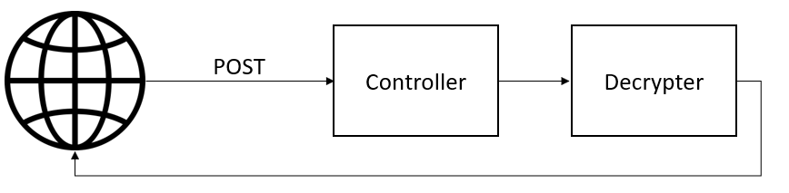
Figure 16 Decryption functional principle

As described in Figure 16, the process is very straight forward, it receives the POST request with the encrypted message and private key, it decrypts it in hardware and send back the message as a response for POST request.

Image Steganography:
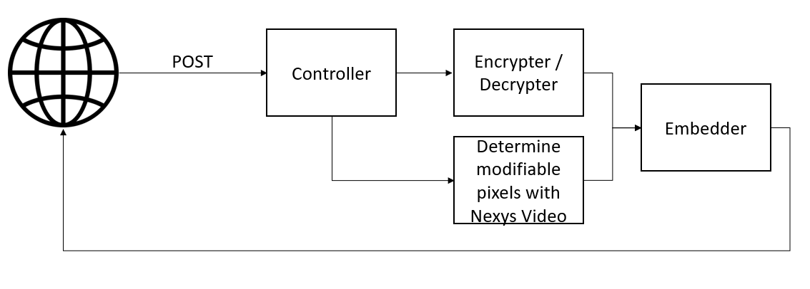
Figure 17 Image Steganography functional principal

As described in Figure 17, it receives the POST request with the message, cover image and public key. The controller encrypts it in hardware and determines which pixels are going to be modified in order to embed the encrypted data, with the help of external processing unit on Nexys Video board. Then, it sends back the image with message embedded into it as a response for POST request.
For extracting the data, the same algorithm is applied, but the external video processing unit determines which pixels were modified and then decrypts those pixels with received private key.

Sound Steganography:
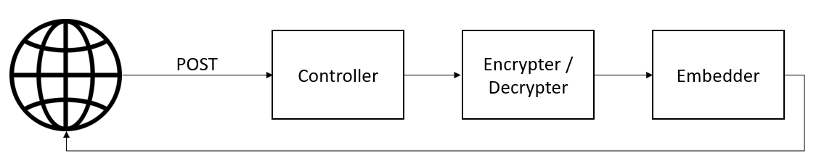
Figure 18 Sound Steganography functional principal

As described in Figure 18, it receives the POST request with the message, cover sound and public key. The controller encrypts it in hardware and determines which sections of the cover sound are going to be modified in order to embed the encrypted data. Then, it sends back the sound with received data encrypted and embedded into it as a response for POST request.

Discussion
Overall Performance

In Figure can be seen the obtained performance increase in hardware. See Hardware design for more information.
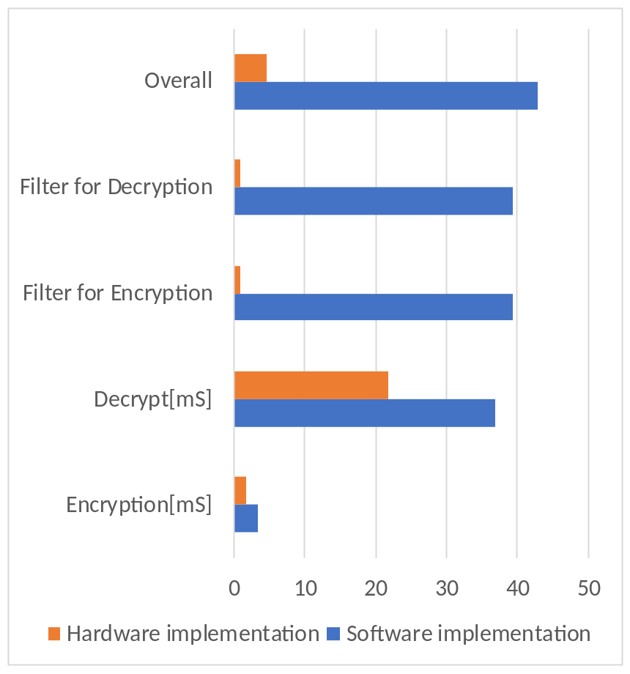

Problems Encountered

Transfer speed
Transferring a Full HD picture was not a simple task. A frame could take up to few megabits and must to be very fast. Also, the same problem applies to transferring large amount of data to encrypt/decrypt. AXI Stream interface was chosen for the task.

Engineering Resources Used

- Vivado
- Xilinx SDK
- Vivado HLS
- Linux Kernel
- C++

Marketability

Proposed product addresses mainly businesses or government agencies who want to communicate without being watched or traced and to keep their data very secured. Also, business concerned about leaked information who embed the owner of information in it. Beside B2B aspect, this product could be also sold in a B2C manner. Considering all the improvements of proposed solution brings, the market price is estimated to $600/unit, this price includes hardware and software but can handle a large amount of requests.

Community Feedback

One person from Dallas, USA thinks that this technology is very useful to communicate securely with intended person on open channels like Reddit or Facebook by posting normal photos. He mentioned about the fact that Facebook private messages are actively monitored by FBI, NSA, CIA and if he would have to send a very secured message, he would use this technique.

Another person thinks that Steganography still has its place in delivering secure message, especially chosen solution which encrypts first the message and then embed it in media content. He stated that this technique is so uncommon, and he consider it very good towards secure communications, but not in the plain form.

Someone stated that this technique drastically reduces the bandwidth, but it is very useful.

References

[1] FPGA-based True Random Number Generation using Circuit Metastability with Adaptive Feedback Control , Mehrdad Majzoobi and Farinaz Koushanfar and Srinivas Devadas
[2] High Speed True Random Number Generators in Xilinx FPGAs, Catalin Baetoniu
[3] A REVIEW OF VIDEO STEGANOGRAPHY METHODS, Richa Khare, Dr. Kuldeep Raghuwanshi
[4]Comparative Analy’sis of Steganography for Coloured Images, Shrutika Suri, Himani Joshi, Vishakha Mincoha* and Akash Tyagi
[5] A Method for Obtaining Digital Signatures and Public-Key Cryptosystems, R.L. Rivest, A. Shamir, and L. Adleman∗
[6] The RSA Algorithm, Evgeny Milanov
[7] THE CHALLENGES OF INTERFACING HDMI IN THE WORLD OF PROFESSIONAL AV, Brian Morris, Tom Kopin
[8] HDMI Demystified, Xiaozheng Lu

