The Vietnam Findex 2025 Dashboard: Connectivity and Financial Inclusion in the Digital Economy
Ngô Minh Quang (20235550), Lê Nguyễn Phước Thành (20235561), Hoàng Văn Nhân (20235542), Đinh Quốc Bảo (20235478), Nguyễn Quang Huy (20235505)

Technique Application Report
Dataset: Vietnam – The Global Findex Dataset 2025: Connectivity and Financial Inclusion in the Digital Economy

Course: Data Visualization
Instructor: PhD. Tran Viet Trung
Group: Group 6

1. Dataset overview
The Global Findex 2025 shows how mobile technology is assisting more adults worldwide to own and use financial accounts to participate in the internet and financial system. This is the world's first most comprehensive database on digital and financial inclusion and the only global source of comparable demand-side data (data collected directly from adults through surveys). The Global Findex 2025 serves as a vital resource for policymakers working on digital connectivity and financial inclusion, as well as for researchers, practitioners, and development experts.
The database was investigated by Development Research Group, Finance and Private Sector Development Unit in affliation with World Bank and was produced by Gallup, Inc.
The dashboard is based on the Global Findex 2025 microdata for Vietnam. Data was collected through face-to-face household interviews conducted between June 23 and August 31, 2024. A nationally representative sample of 1,000 individuals aged 15 years and older was obtained using a multistage probability sampling design. Survey weights were applied to correct for unequal selection probabilities and nonresponse bias, ensuring that estimates are representative of Vietnam's adult population. The survey has an approximate design effect of 1.33 and a margin of error of ±3.6 percentage points.
The primary goal of this analysis is to transform raw, high-dimensional survey observations within Findex_Microdata_2025_updateViet Nam.csv into an actionable, policy-oriented framework for monitoring financial inclusion equity, digitization bottlenecks, and household financial resilience in Vietnam. Instead of tracking flat, aggregate country-level percentages, this data is deployed to expose structural disparities by evaluating financial access through five paramount investigative questions:
- Q1. The Socioeconomic Exclusion Bottleneck: Which specific intersecting demographic cohorts (cross-referenced by income quintile, gender, education, and rurality) remain entirely excluded from the formal financial framework, and what specific institutional friction logs (e.g., cost, distance, trust, or missing documentation) drive these unbanked constraints?
- Q2. The Digital Infrastructure Leapfrogging Paradox: Is mobile money successfully expanding financial inclusion by reaching previously unbanked populations, or is it primarily serving as a secondary transaction tool for urban citizens who already have access to traditional banking?
- Q3. The Financial Inflow Digitization vs. Liquidation Vector: How effectively do formal wage channels and public transfer frameworks digitize incoming financial flows, and what structural factors cause users to immediately liquidate these digital inflows into cash?
- Q4. Consumer Protection and Digital Literacy Gaps: How does rapid smartphone and internet adoption across vulnerable, low-income or rural demographics correlate with exposure to digital scams, and does a lack of digital literacy create new security risks?
- Q5. Intersectional Financial Resilience Strategies: How do financial access levels affect a household's ability to handle sudden economic shocks, and do marginalized groups rely more on formal savings or informal, high-risk community debt networks when facing a crisis?

2. Dashboard overview
The Vietnam Financial Inclusion Dashboard 2025 is engineered as an institutional, single-page interactive policy workspace. Its structural design converts 1,000 high-dimensional, weight-adjusted individual records from Findex_Microdata_2025_updateViet Nam.csv into five interconnected thematic layers. This design enables users to isolate structural inequities, track transaction flows, and diagnose systemic barriers across the Vietnamese financial ecosystem.
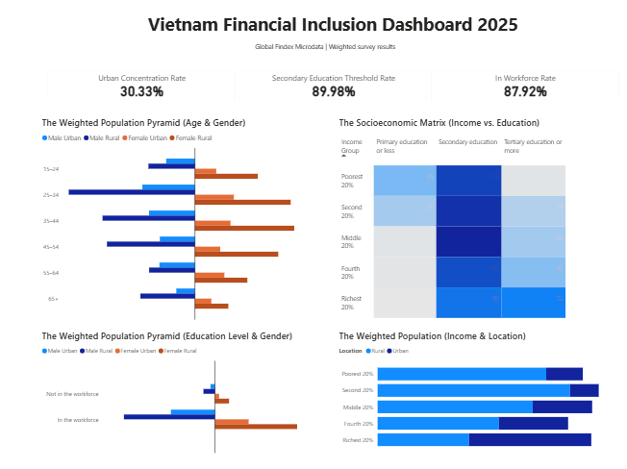
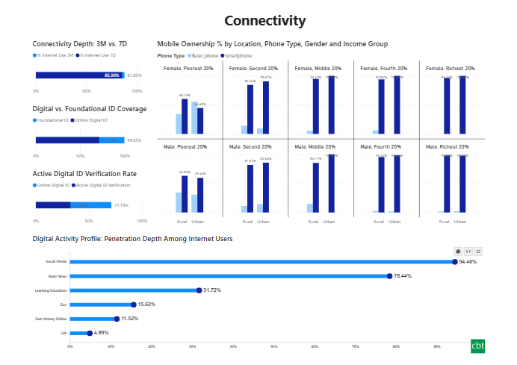
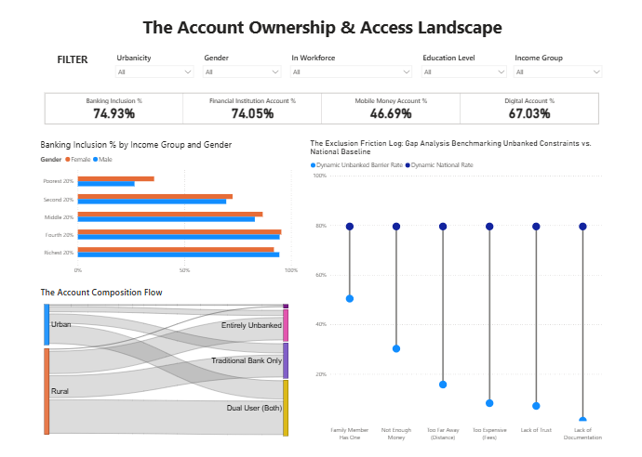
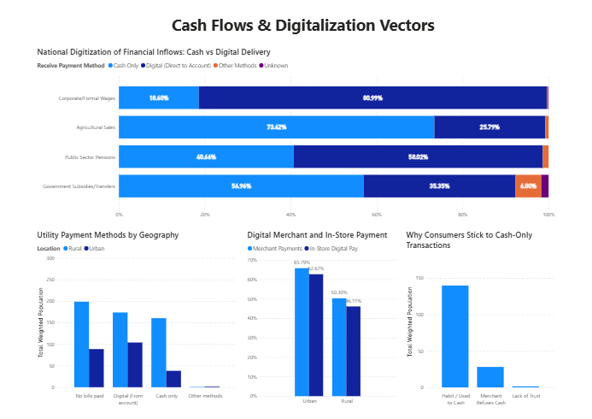
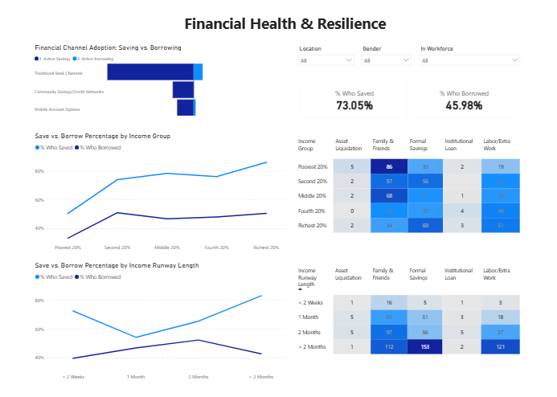
Figure 1: Overview of the Vietnam Financial Inclusion Dashboard
The application layout is structured using a top-down macro-to-micro analytical funnel. This structure minimizes cognitive load by establishing national baselines before exposing complex demographic cross-tabulations and friction logs. The narrative logic proceeds through five consecutive phases:

Demographic baseline The dashboard begins with the Macro-Socioeconomic Baseline (Page 1). This section presents core KPI cards for the country, including urban concentration, secondary education thresholds, and workforce integration rates, alongside cross-tabulated population matrices. This step is placed first because it provides the user with an essential baseline for interpretation. All subsequent financial access indicators and transaction rates are viewed in relation to these basic population properties, meaning users must digest the country's demographic balance before analyzing specific financial variables.
Connectivity & infrastructure After establishing the demographic baseline, the dashboard shifts to Connectivity (Page 2). This section tracks smartphone ownership matrices, internet usage frequency, and foundational versus online digital identity verification rates. This phase is critical because modern digital financial inclusion is impossible without technology infrastructure. By examining connectivity depth early, the user can determine whether a lack of banking access is driven by an underlying lack of hardware and digital identification options.
Account ownership & landscape Once technology readiness is verified, the narrative moves to The Account Ownership & Access Landscape (Page 3). This section details official banking and mobile money inclusion metrics across income groups and uses a Sankey diagram to trace how rural and urban populations distribute across banking tiers. It also benchmarks the explicit institutional barriers faced by the unbanked. This step transitions the user from technical infrastructure to formal institutional access, highlighting exactly where the financial ecosystem falls short.
Cash flows & digitalization vectors The dashboard moves to Cash Flows & Digitalization Vectors (Page 4) to test whether account ownership actually changes daily transactional behavior. It maps cash versus digital delivery methods across wage inflows, agricultural sales, and public transfers, while tracking utility payments and consumer motivations for avoiding point-of-sale digital tools. This step helps users move from simple inclusion metrics to tracking active financial participation, showing where account holders continue to immediately liquidate their digital inflows into cash.
Financial health & resilience The final section focuses on Financial Health & Resilience (Page 5). It connects all previous layers - demographics, technology, accounts, and transaction choices - to evaluate how long households can cover expenses if they lose their primary income source, and maps what safety nets they use in an emergency. This deep dive is placed at the very end because household financial resilience can only be fully understood after analyzing the structural, technical, and behavioral factors that shape it.
The system is a hybrid explanatory-exploratory workspace. The vertical sequence of the pages drives an authored, policy-oriented argument: true financial inclusion cannot be evaluated by high-level account access alone; it requires evaluating infrastructure readiness, daily payment habits, and long-term economic resilience. Simultaneously, integrated interactive components allow users to break down the data and explore specific demographic subsets.

3. Technique application analysis
3.1. Chapter 1: Introduction to Data Visualization
3.1.1 Techniques / Principles applied
- The Cognitive Gap in High-Dimensional Microdata: Moving past the limitations of the human brain when analyzing raw, row-by-row survey results.
- Exploratory vs. Explanatory Typology: Combining user-led data discovery with an authored, guided narrative.
- Actionable Policy Brief Framing: Designing layouts to help stakeholders identify clear public policy priorities.
3.1.2. How applied in the dashboard
The raw data in Findex_Microdata_2025_updateViet Nam.csv contains 1,000 rows and 199 columns of individual survey data. In its raw form, critical connections between demographics and financial behavior are completely hidden. For instance, looking at a spreadsheet cannot reveal how a rural woman's income level affects her choice to pay utility bills in cash or digitally.
Visualization translates these hidden connections into clear patterns. It transforms abstract survey weights (wgt) into proportional visual elements, such as the width of a path or the height of a bar. This allows researchers and policymakers to instantly spot where the financial ecosystem is lagging.
The dashboard uses a hybrid approach to match the needs of development economists and central bank planners:
- Explanatory Typology (The Anchored Narrative): The dashboard functions as a structured policy brief. It uses a strict top-down layout that guides the reader through five distinct pages, building a core argument: to evaluate true financial inclusion, we must look beyond basic account ownership and analyze actual technology readiness, daily transaction habits, and household economic resilience. The sequence is fixed, the major takeaways are highlighted with clear data labels, and reference lines provide national benchmarks to keep the user anchored in the core story.
- Exploratory Typology (User-Led Discovery): At the same time, the dashboard includes robust interactive features, such as the global drop-down filters on Page 3. These allow users to break away from the main narrative and investigate specific questions, such as: "What specific institutional barriers keep low-income rural citizens out of the banking system?" Users can manipulate the data canvas directly, using tooltips to view detailed metrics on demand.
Table 1. Typology used in the dashboard
Typology | Characteristics
Explantory layer | - Fixed 5-page vertical narrative  - Static national benchmarks  - Curated structual typography
Exploratory layer | - Dynamic multi-criteria slicers  - User-led demographic drilldowns  - Interactive details-on-demand

3.1.3. Notes / Adjustments
Traditional data visualization theory often suggests keeping exploratory discovery tools separate from explanatory presentation dashboards to avoid confusing the user. However, this dashboard deliberately breaks that rule by embedding complex multi-criteria filters directly into the presentation layout on Page 3.
This adjustment was made because financial inclusion is inherently intersectional. A static chart showing an average barrier rate is not enough for an active policymaker. To design effective regulations, an analyst must be able to instantly filter the data - such as isolating citizens who are out of the workforce - and watch the Exclusion Friction Log dynamically recalculate their specific obstacles against the national baseline. Combining both exploratory and explanatory elements into a single workspace makes the dashboard a far more effective tool for diagnosing and solving real-world policy challenges.

3.2 Chapter 2: Data Types, Marks, and Channels
3.2.1 Techniques / Principles Applied
- Taxonomic Attribute Identification: Categorizing microdata features into Nominal (N), Ordinal (O), and Quantitative (Q) taxonomic types.
- The Cleveland-McGill Perceptual Hierarchy: Prioritizing high-accuracy visual channels (Position on a common baseline, Length) over lower-accuracy channels (Area, Color Hue, Color Saturation) based on psychophysical performance rankings.
- The Expressiveness Principle: Matching visual channels to data types so that the channel expresses all, and only, the information contained in the attribute (e.g., reserving color hue for nominal variables and length or saturation for quantitative/ordinal scales).
- The Effectiveness Principle: Ensuring that the most important attributes of the dataset are encoded using the most perceptually accurate visual channels.
3.2.2 How Applied in the Dashboard
The dashboard transforms the survey microdata from Findex_Microdata_2025_updateViet Nam.csv by systematically aligning data classifications with appropriate visual primitives (marks) and retinal features (channels). The structural configuration of every chart follows these principles:
Page 1: The Socioeconomic Matrix (Income vs. Education)
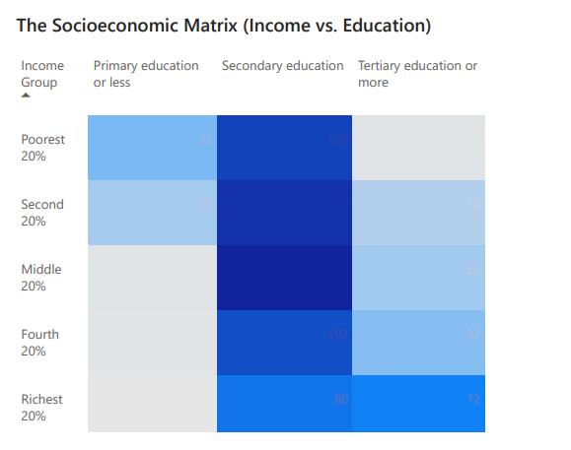
Figure 2: The scocioeconomic matrix (income vs. education)
- Data Types: inc_q (Household Income Quintile: Ordinal - 5 ordered tiers) x educ (Educational Attainment: Ordinal - 3 ordered tiers) x wgt (Survey Population Weight: Quantitative).
- Visual Marks: Geometric Areas (Grid Cells).
- Visual Channels: Vertical Position (y-axis) for Income Group, Horizontal Position ($x$-axis) for Education level, and Color Saturation / Value for the quantitative population weight.
- Rationale: According to the Expressiveness Principle, crossing two ordinal variables forms a discrete grid where cell cells hold a distinct position. Color saturation is an effective channel for quantitative attributes when ordered sequentially. It allows the viewer's eyes to easily identify high-density intersections - such as the concentration of low-income individuals in the secondary education bracket - without distorting the discrete structure of the categories.
Page 2: Mobile Ownership % by Location, Phone Type, Gender, and Income Group
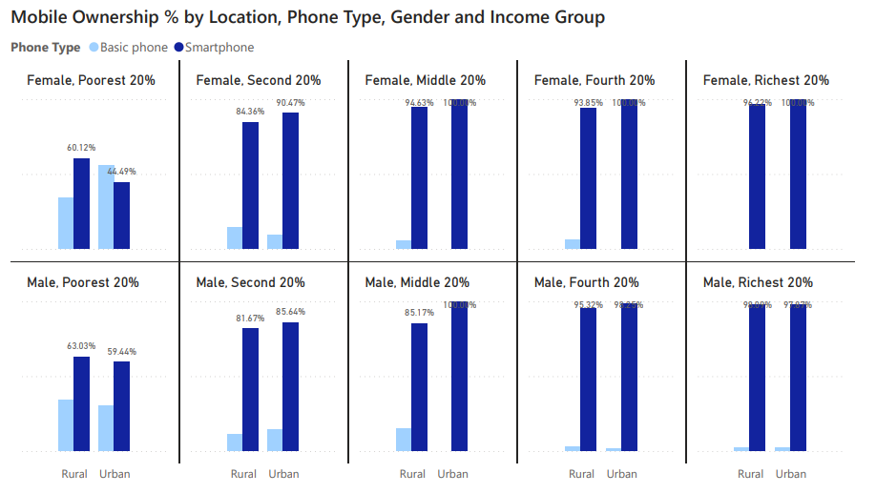
Figure 3: Mobile ownership rate by location, phone type, gender, and income group
- Data Types: urbanicity (Nominal), female (Nominal), inc_q (Ordinal), Phone Type (Derived Nominal: Smartphone vs. Basic Phone), and Access Rate (Derived Quantitative %).
- Visual Marks: Rectangular Areas (Bars).
- Visual Channels: Length of the bars for the Quantitative Access Rate; Vertical and Horizontal Position for the small-multiples grid layout (Rows = Gender, Columns = Income Group); Horizontal Position on the inner x-axis for location (Rural vs. Urban); and Color Hue for Phone Type (Dark Blue = Smartphone, Light Ice Blue = Basic Phone).
- Rationale: This configuration utilizes Length on a common baseline to represent the quantitative penetration rates. By packing the categories into an structured small-multiples grid matrix, the chart successfully visualizes a massive amount of cross-tabulated data without causing visual clutter. Policymakers can easily track shifts in access—such as how the basic phone segment shrinks and the smartphone segment expands as you move from the poorest 20% to the richest 20% quintiles.
Page 3: The Account Composition Flow (Sankey Diagram)
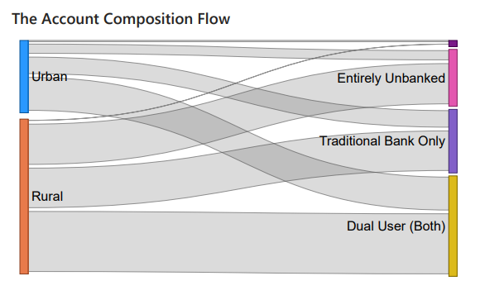
Figure 4: The account composition flow
- Data Types: urbanicity (Nominal Source Nodes) Account State (Nominal Target Nodes: Unbanked, Traditional Only, Dual User) x wgt (Quantitative Flow Volume).
- Visual Marks: Surface Ribbons (Links) connecting structural Node blocks.
- Visual Channels: Link Width (Thickness) for the Quantitative survey weight volume; Horizontal/Vertical Position for categorical node grouping; and Color Hue to differentiate source origins.
- Rationale: The Sankey graph uses width to encode flow volume. While area or volume estimation is ranked lower in the Cleveland hierarchy than linear length, the thickness of a ribbon on a localized plane provides an effective holistic view of structural shifts. It visually demonstrates how the rural nominal group splits and flows into the "Entirely Unbanked" category compared to its urban counterpart.
Page 4: National Digitization of Financial Inflows
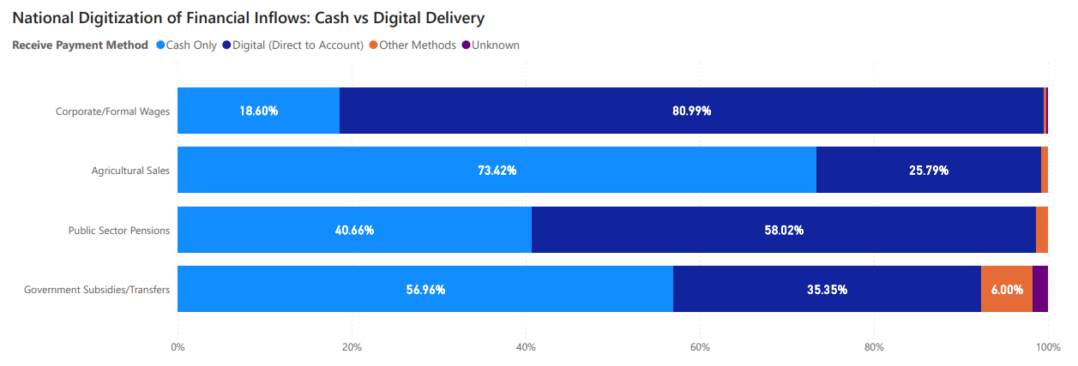
Figure 5: The national digitalization of financial inflows: cash vs. digital delivery
- Data Types: Inflow Channel Type (Nominal: Wages, Agriculture, Pensions, Subsidies) x Payment Modality (Nominal Category: Cash, Direct to Account) x Percentage Share (Quantitative).
- Visual Marks: Segmented Rectangular Areas (Stacked Bars).
- Visual Channels: Horizontal Position and Segment Length for the Quantitative percentage share; Vertical Position for Inflow Type; and Color Hue for Payment Modality.
- Rationale: A 100% stacked horizontal layout locks the total width to a uniform baseline (100%). This ensures that while inner segments lack a common reference baseline, the overall distribution of cash dominance versus digital account usage can be compared across distinct nominal inflow channels.
3.2.3. Notes / Adjustments
On Page 5, the Save vs. Borrow Percentage visualization plots rates using a line chart layout across ordered income quintiles and income runway lengths.
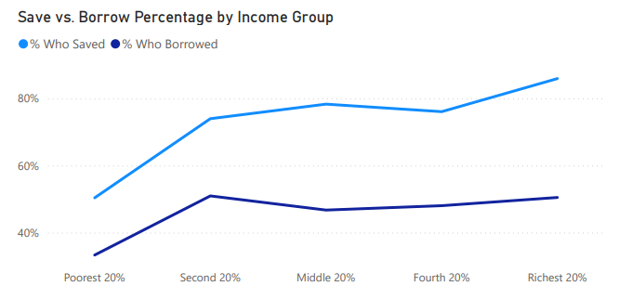  (a) | 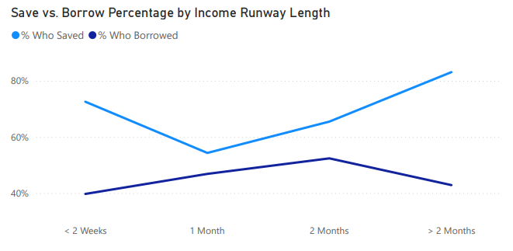  (b)
Figure 6: (a) Save vs. borrow percentage by income group; (b) Save vs. borrow percentage by income runway length
Strict visualization theory states that continuous lines should only connect truly continuous, interval, or time-series data streams (t). Connecting discrete ordinal categories (like income quintiles from the poorest 20% to the richest 20%) with a line technically violates this rule, as it can imply intermediate data values between the points.
However, we deliberately chose to use line marks here to exploit the human brain's natural ability to track trends via Spatial Continuity. The line works as a visual vector that highlights the structural trajectory of financial behavior as income increases. It shows that saving rates rise steadily while borrowing rates decline. Using discrete bars instead of a line would clutter the chart and mask the clear, contrasting crossroads between these two financial strategies.

3.3 Chapter 3: Pre-Attentive Processing, Gestalt Principles, and Magnitude Estimation
3.3.1 Techniques / Principles Applied
- Pre-Attentive Processing (Visual Pop-Out): Utilizing primary retinal properties (high-contrast color hue, saturation boundaries, and structural bounding boxes) to pass information through the human subconscious before cognitive processing begins.
- Gestalt Laws of Visual Grouping: Applying structural rules - specifically Proximity, Similarity, and Enclosure - to organize complex dashboard pages into clean, intuitive sections.
- Magnitude Estimation Consistency: Structuring comparative charts around linear lengths on a common baseline (the highest-ranked channel under Stevens' Power Law) to eliminate underestimation errors typical of areas or angles.
3.3.2 How Applied in the Dashboard
Pre-Attentive Visual Pop-Out through Saturation and Contrast
The dashboard leverages pre-attentive visual features to draw an analyst's eye directly to key socioeconomic and financial trends without requiring a manual search:
- The Socioeconomic Matrix (Page 1): This grid uses a single sequential blue saturation scale to map population weights (wgt). Low-concentration cells automatically fade into a neutral, light-grey background, while high-density intersections - such as the massive concentration of low-income citizens who have completed only secondary education - stand out immediately in a saturated deep navy blue.
- The Mobile Ownership Matrix (Page 2): High-contrast color assignments trigger an instant subconscious evaluation of technology penetration. By using a deep, saturated navy blue for smartphones next to a light ice blue for basic phones, the layout creates a sharp visual boundary. This allows users to see at a glance that smartphone adoption dominates across almost all income and gender groups, with basic phones remaining visible only in the poorest 20% segment.
Layout Organization and the Gestalt Principles
To keep the single-page application clean and reduce cognitive load, charts are arranged according to the psychological laws of visual grouping:
- The Law of Proximity: On Page 3 (The Account Ownership & Access Landscape), high-level metric scorecards (Banking Inclusion %, Financial Institution Account %, Mobile Money Account %, and Digital Account %) are clustered tightly together at the top of the viewport. This tight spacing signals that these cards belong to a single macro-summary layer, separating them from the detailed analytical charts displayed below.
Figure 7: The account ownership & access landscape KPI card
- The Law of Enclosure: The filtering tools on Page 3 are grouped inside a distinct, grey container box. This clear border isolates the interactive slicers from the data displays, indicating to the user that selecting inside this enclosed space will dynamically update the charts across the rest of the canvas.
Magnitude Estimation Accuracy
To maximize data reading accuracy across demographic segments, the dashboard prioritizes horizontal and vertical bar lengths over angular or area-based shapes.
Psychophysical research confirms that humans judge length differences along a common baseline with near-perfect linear accuracy ($β = 1.0$), whereas area, volume, and angular variations are consistently misjudged. By selecting clustered horizontal and vertical bars for complex charts like the Mobile Ownership Profile and the Exclusion Friction Log, the dashboard allows users to quickly and accurately compare exact percentages - such as contrasting 60.12% rural smartphone adoption with 44.49% urban smartphone adoption among lowest-income females - without the visual distortion caused by area-based graphics.
3.3.3 Notes / Adjustments
The Account Composition Flow on Page 3 uses a complex Sankey diagram to track inclusion pathways. Traditional visualization theory often cautions against using flowing, curved ribbons for precise estimation, as judging changes in line widths along a changing path is less accurate than reading standard bar lengths on a flat axis.
However, we deliberately chose to use this flow layout because the core policy question on Page 3 is relational, not purely numeric. The goal is to show the directional transition of rural and urban populations into distinct financial states (Unbanked, Traditional Only, Dual Users). A standard grouped bar chart can show the individual categories, but it breaks the visual link connecting those categories. The Sankey diagram uses smooth paths to create a strong sense of Visual Continuity, allowing policymakers to track how different groups move through the financial system. To compensate for the lower precision of the ribbon widths, the interface includes detailed on-hover tooltips that display the exact underlying weight-adjusted percentages on demand.

3.4 Chapter 4: Chart Types for Amounts, Distributions, Proportions, Relationships, and Trends
3.4.1 Techniques / Principles Applied
- Analytical Task-Chart Mapping: Selecting visual structures based on analytical questions - specifically isolating amounts, distributions, proportions, relationships, and trends.
- Coordinate System Dynamics: Matching data types to appropriate spatial frameworks, contrasting standard 2D Cartesian grids (x, y) with Geographic coordinates and Polar (radial) tracking spaces.
- Visualizing Uncertainty: Assessing the presence or absence of data quality indicators, statistical error bars, confidence intervals, or sampling variance indicators.
3.4.2 How Applied in the Dashboard
The dashboard handles the multi-layered survey variables from Findex_Microdata_2025_updateViet Nam.csv by matching each analytical objective with its structurally optimal chart type.
Analytical task | Dashboard chart type | Coordinate system
Amounts | Clustered & Standard Bars | 2D Cartesian
Distributions | Population Pyramids / Grid | 2D Cartesian
Proportions | 100% Stacked Bars / Sankey | Cartesian / Network
Relationships | Small-Multiples Matrix | Cartesian Grid
Trends / Profiles | Overlay Line Charts | Cartesian Coordinates

Visualizing Amounts (Magnitude Comparisons)
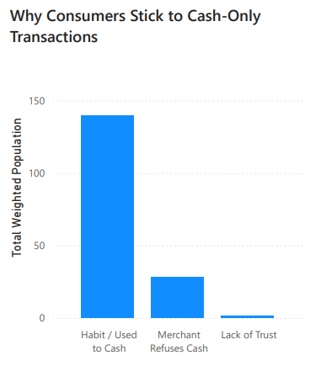
Figure 8: Why consumers stick to cash-only transactions
- Applied Charts: Why Consumers Stick to Cash-Only Transactions (Page 4) and the regional summaries.
- Execution: These charts use discrete horizontal and vertical bars to show simple categorical sums, such as the total weighted population that chooses cash out of habit versus those limited by merchant cash mandates.
- Rationale: Standard bars are highly effective for showing simple magnitudes. Because they align along a flat Cartesian baseline, users can easily rank and compare different categories without visual distortion.
Visualizing Distributions (Data Spread and Density)
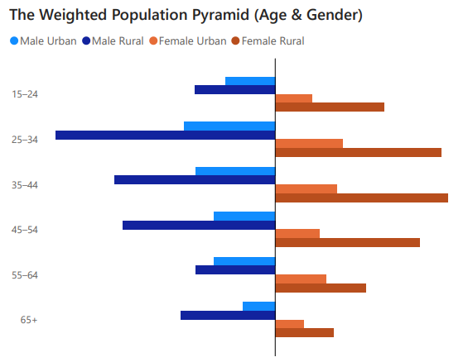
Figure 9: The weighted population pyramid by age and gender
- Applied Charts: The Weighted Population Pyramids and The Socioeconomic Matrix (Page 1).
- Execution: The population pyramids use back-to-back horizontal bars to split the sample by gender and location across ordered age and education brackets. The socioeconomic grid displays the population spread by mapping the intersection of income quintiles (inc_q) and education levels (educ).
- Rationale: This layout reveals demographic concentrations across categories. It shows whether the sample is evenly distributed or heavily skewed toward specific segments, such as the concentration of individuals with secondary education in the lower income brackets.
Visualizing Proportions (Composition Breakdown)
- Applied Charts: National Digitization of Financial Inflows (Page 4).
- Execution: This section applies a 100% stacked horizontal bar chart to illustrate the breakdown between cash and digital account delivery across channels like formal wages, agricultural sales, and public transfers.
- Rationale: The 100% stacked bar chart fixes the total width of all rows to a uniform 100% baseline. This focuses the user's attention entirely on the internal composition of each row, making it easy to see that formal wages are heavily digitized (80.99%) while agricultural transactions remain dominated by cash (73.42%).
Visualizing Relationships (Multi-Variable Interactions)
- Applied Charts: Mobile Ownership % by Location, Phone Type, Gender, and Income Group
- Execution: This chart groups data into a small-multiples grid to trace a four-variable relationship: income level, gender, urban/rural location, and type of phone owned.
- Rationale: By organizing the data into a grid layout, the chart maps complex interactions without cluttering the screen. This structure allows users to see exactly how smartphone ownership changes as income and demographic variables shift.
Visualizing Trends (Behavioral Trajectories)
- Applied Charts: Save vs. Borrow Percentage Overlays (Page 5).
- Execution: These charts use dual line graphs to map changes in savings and borrowing frequencies across ordered income quintiles and income runway lengths.
- Rationale: Plotting these variables as continuous lines highlights the behavioral trends in the data, making it easy to see how savings rates rise and borrowing rates drop as financial security increases.
3.4.3 Coordinate Systems Evaluated
The dashboard relies primarily on a 2D Cartesian coordinate system (x, y) to structure its charts. This system maps categorical labels or quantitative scales onto perpendicular axes, providing a familiar and highly legible framework for comparing metrics like percentages, age brackets, and income tiers.
3.4.4 Whether Uncertainty Was Visualized
Statistical uncertainty is not explicitly visualized anywhere in the current dashboard workspace. There are no error bars, standard deviation bands, or confidence intervals displayed on the charts.
Methodological Evaluation of this Choice
For an academic data analytics report, this omission represents a distinct compromise between visual simplicity and statistical completeness:
- The Defense: The dataset consists of official, weight-adjusted survey records from the World Bank's Global Findex database, where high-level policy analysts typically treat the finalized weighted values as fixed national baselines. Omitting complex error bars keeps the interface clean, accessible, and fast to interpret for policy planners who need to quickly spot major institutional gaps.
- The Limitation: Because the underlying data is derived from a survey sample (N = 1,000), it carries inherent sampling error and variance. Failing to show confidence intervals can create a false impression of absolute precision, mask data thinness in highly filtered demographic subsets, and hide the statistical margins of error that should inform high-stakes policy design.

3.5. Chapter 6: Visual Integrity (Ink, Overlap, Color, Layout, and Annotation)
3.5.1 Techniques / Principles Applied
- Edward Tufte's Data-Ink Ratio Maximization: Eliminating non-essential graphical elements, gridlines, and decorative borders to maximize the proportion of ink dedicated directly to the display of data information.
- The Proportional Ink Principle: Ensuring that the visual representation of every single mark is directly proportional to its mathematical value (Value ~ Area).
- Color Palette Optimization & Accessibility: Utilizing limited, highly structured palettes that differentiate nominal data without implying order, while remaining fully accessible to individuals with Color Vision Deficiencies (CVD).
- Overplotting Resolution: Deploying techniques such as transparency alpha-blending and structural separation to prevent data points from obscuring one another.
- Data–Context Balance and Annotation Grammar: Supplementing visualizations with necessary descriptive scaffolding - including clear titles, subtitles, reference lines, and details-on-demand tooltips - to provide analytical context without introducing chartjunk.
3.5.2 How Applied in the Dashboard
The dashboard enforces high standards of visual integrity across its interface to ensure that the microdata findings are communicated transparently and without distortion.
Upholding the Proportional Ink Principle
Every bar chart in the system maintains strict visual honesty by anchoring its quantitative scale at a true 0% baseline. This ensures that bar length corresponds directly to the underlying weight-adjusted data percentage. For example, in the Why Consumers Stick to Cash-Only Transactions chart on Page 4, the vertical bars for "Habit" and "Merchant Refuses Cash" reflect an accurate, undistorted visual ratio of their real values.
Similarly, the Sankey Diagram on Page 3 is proportional-ink by construction: the physical vertical width of each flowing ribbon matches the exact weighted population percentage shifting between nodes, making it impossible to visually misjudge the size of a demographic stream.
Strategic Color Management and Accessibility
The color scheme uses a highly controlled, functional palette designed to be clear and accessible to users with colorblindness (such as deuteranopia or protanopia):
- Nominal Tracking (Geography): Formulated around a sharp blue-to-indigo pairing. Rural is consistently rendered in an active sky blue, while Urban features a deep indigo/blue. This completely avoids risky red-green pairings and ensures high luminance contrast, allowing users to accurately read the data even when printed or viewed in grayscale.
- Nominal Tracking (Gender): Uses a distinct blue (Male) versus coral/orange (Female) setup on Page 3, ensuring sharp contrast when evaluating banking inclusion rates side by side.
- Microdata Intensity: Uses a single sequential blue saturation scale for the Socioeconomic Matrix on Page 1, keeping cell density easy to track without adding a distracting mix of hues.
Managing Overplotting and Graphical Overlap
To keep charts readable when handling dense demographic clusters or closely grouped bars, the layout applies three specific adjustments:
- Small-Multiples Splitting: In the Mobile Ownership Rate visualization, rather than forcing multiple overlapping bars into a single graph, the dashboard divides the mobile ownership variables into an organized grid of ten sub-panels. This structure completely eliminates overlap and keeps the complex data scannable.
- Clear Baseline Spacing: In the horizontal bar layouts (such as the Exclusion Friction Log and the National Digitization of Financial Inflows), rows are separated by generous whitespace margins, ensuring that adjacent data labels never clash or blur together.
- Sankey Layer Ordering: In the relational flow graph on Page 3, incoming paths are sorted by volume and grouped cleanly at the source nodes, preventing the criss crossing lines from creating a confusing "spaghetti effect".
Data–Context Balance and Annotation Grammar
Data points are never presented in isolation. Every chart includes contextual elements to guide the user's interpretation:
- Descriptive Annotations: Every visualization features an explicit title stating the parameters measured, alongside a clear subtitle explaining exactly how to read the chart.
- Integrated National Benchmarks: The Exclusion Friction Log on Page 3 plots a Dynamic National Rate line right alongside the specific filtered barrier bars, allowing the user to instantly benchmark a targeted cohort's challenges against the country's average baseline.
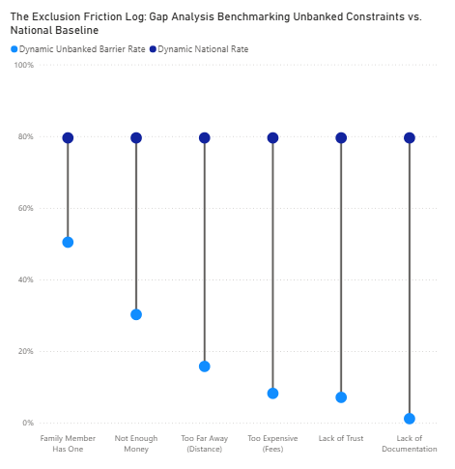
Figure 10: The exclusion friction log: gap analysis benchmarking unbanked constraints vs. national baseline
3.5.3 Notes / Adjustments (Deviations from Theory)
The National Digitization of Financial Inflows chart on Page 4 uses a 100% Stacked Horizontal Bar format. Traditional data visualization theory often cautions against stacked bars because only the first segment aligns to a reliable baseline (the left axis). As a result, users must evaluate the inner segments based on length variations without a shared starting point, which can increase reading error rates.
We deliberately accepted this compromise because the core policy question for this visualization is proportional composition, not exact comparison. The key takeaway is to instantly show the total balance between cash and digital delivery channels within each revenue stream. Converting this chart into a standard unstacked bar format would double the number of rows, scatter the segments across different lines, and destroy the immediate visual contrast between these incoming financial flows. To support accurate readings, the exact data values are explicitly labeled on screen and fully backed by interactive hover tooltips.

3.6. Chapter 8: Interaction Techniques
3.6.1 Techniques / Principles Applied
- Shneiderman’s Information-Seeking Mantra: Structuring interface mechanics to follow the prescriptive order of analytics: Overview first, zoom and filter, then details-on-demand.
- Coordinated Views and Brushing: Establishing a centralized reactive state machine where a single interactive filtering adjustment dynamically propagates updates across multiple separate visualizations.
- Dynamic Baseline Benchmarking: Re-computing and re-rendering national reference lines and group averages instantly based on user interaction to provide constant relative context.
3.6.2 How Applied in the Dashboard
The application implements a comprehensive system of interactive states to help users explore the individual survey weights and multi-variable attributes inside Findex_Microdata_2025_updateViet Nam.csv.
Implementation of the Information-Seeking Mantra
Every page in the dashboard workspace adheres to a strict, predictable interaction hierarchy designed to prevent user overwhelm:
SHNEIDERMAN'S Interaction Pipeline
Overview first | Macro KPI Snapshot Scorecards (Static Context)
Zoom & filter | Multi-Criteria Drop-down Slicers (Target Groups)
Details-on-demand | Multi-Variable Hover Tooltips (N-Size & Weights)

- Overview First: When a user lands on a page - such as The Account Ownership & Access Landscape (Page 3) or Financial Health & Resilience (Page 5) - the viewport displays a macro-level snapshot. This snapshot includes high-level metric cards and country-wide distribution trends that serve as a statistical control layer before any filtering is applied.
- Zoom and Filter: Users can then narrow their focus using the dedicated interactive filter panel. On Page 3 and Page 5, dropdown slicers allow users to filter the entire data canvas by specific demographics, including Location (urbanicity), Gender (female), In Workforce (emp_in), Education Group (educ), and Income Group (inc_q).
- Details-on-Demand: To keep the primary charts clean and readable, exact data values are tucked away into dynamic hover states. Hovering a cursor over an inner segment of a 100% stacked bar on Page 4 or over an emergency fund block on Page 5 reveals precise descriptive values, including the exact sample size (N) and the underlying survey weights.
Coordinated Views and Interactive State Management
The dashboard utilizes coordinated views to link different charts to a single, shared state machine. When a user selects a demographic subset from the dropdown menu, the system triggers a query across the dataset and updates all components on the active page simultaneously.
Figure 11: List of filters on the Account ownership & access landscape page
For instance, on Page 3, changing the selection from "All" to "Rural" + "Female" + "Poorest 20%" instructs the back-end system to filter the survey data down to those exact parameters. Instantly, the high-level KPI cards recalculate, the Account Composition Flow redrawn to display only rural female pathways, and the Exclusion Friction Log updates its bars to reflect that specific cohort's unique barriers.
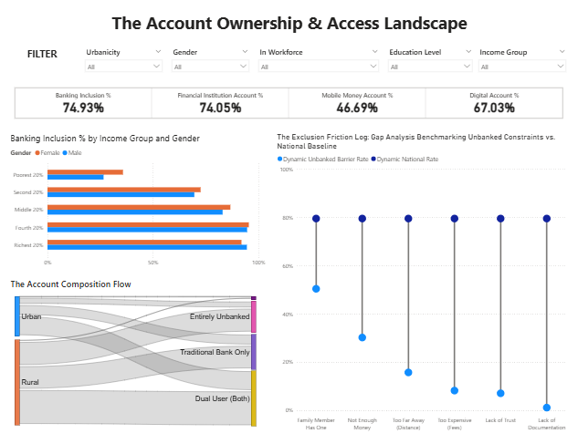  (a) | 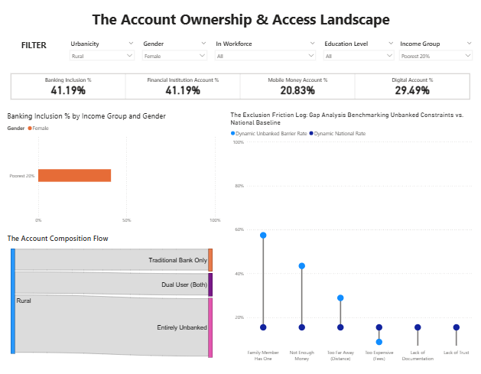  (b)
Figure 12: (a). The account ownership & access landscape page initially; (b) The account ownership & access landscape page with "Rural" + "Female" + "Poorest 20%" filters.
3.6.3 Notes / Adjustments
A core tenet of web application usability state management recommends maintaining user state across the entire interface. This means that if a user filters the data for "Rural Females" on one page, that filter should ideally stick as they click through to other tabs.
However, this dashboard deliberately breaks that rule by isolating filter controls to their individual pages. The global drop-down slicers on Page 3 do not propagate their states to the connectivity matrix on Page 2 or the financial resilience charts on Page 5.
This adjustment was made to support flexible, multi-dimensional policy analysis. Each page in the brief addresses a distinct analytical question. For example, a researcher might want to study account ownership barriers for rural women on Page 3, while simultaneously analyzing the emergency funding strategies of low-income workers on Page 5. Forcing a single global filter across all pages would create a frustrating user experience, requiring analysts to constantly clear and reset their filter settings as they navigate through different sections of the report.

3.7 Chapter 9: Storytelling and Presentation Narrative
3.7.1 Techniques / Principles Applied
- The Inverted Pyramid Structural Framework: Organizing the dashboard sections so that the presentation moves from high-level national baselines down to granular root causes and household impacts.
- The Balance of Narrative Autonomy: Balancing author-driven messaging (guiding users through a specific, structured argument) with reader-driven exploration (allowing users to explore data independently via interactive controls).
- Contextual Framing and Micro-Annotations: Using structural typography, informative headers, and clear descriptive text to turn independent charts into a unified narrative brief.
3.7.2 How Applied in the Dashboard
The dashboard organizes individual survey observations from Findex_Microdata_2025_updateViet Nam.csv into a structured, five-page presentation layout. Each section builds on the last to tell a cohesive story about financial inclusion in Vietnam.
Balancing Author-Driven and Reader-Driven Exploration
The dashboard implements a "Martini Glass" narrative structure to balance a guided author-driven flow with user-led exploration:
- The Guided Stem (Author-Driven): The overall sequence of pages is fixed and structured as an inverted pyramid. The titles, subtitles, and benchmarks are curated by the designer to guide policymakers along a clear analytical path.
- The Wide Opening (Reader-Driven): Once a user reaches the Account Ownership Landscape (Page 3) or Financial Health & Resilience (Page 5), the dashboard transitions into an open exploratory environment. By using the integrated dropdown slicers, researchers can break away from the national story and independently analyze specific cohorts, such as identifying the unique institutional barriers faced by low-income rural women.
Contextual Framing and Micro-Annotations
To ensure the data tells a clear, self-explanatory story without requiring a manual guide, the dashboard uses clear text and formatting structures:
- Section 2.1 Narrative Logic Context: Each view uses descriptive headers and summary labels to explain the direct policy impact of the data.
- On-Screen Performance Summaries: Charts are accompanied by explicit callout metrics, such as highlighting the contrast between high social media adoption (94.46%) and minimal online job seeking (4.89%) on Page 2, pointing directly to a gap in digital literacy.
- Embedded National Baselines: Reference lines are drawn onto comparative charts like the Exclusion Friction Log, ensuring that a user-selected demographic group is always evaluated in direct comparison with the country-wide average.
3.8.3 Notes / Adjustments
Traditional storytelling theory suggests using a linear, slide-by-slide presentation deck (like a scrollytelling article or step-by-step presentation slides) when delivering an explanatory policy narrative. This format controls the pacing and ensures the audience processes information in a strict, pre-determined order.
The dashboard deliberately departs from this approach by using a multi-tab, vertical dashboard canvas.
We made this adjustment because a slide-based presentation can restrict advanced policy research. Institutional users, such as development economists and financial planners, need a layout that allows them to quickly scan full sections, cross-reference multiple charts simultaneously, and instantly test variables via interactive filters. Organizing the narrative into comprehensive, thematic pages preserves a clear analytical flow while giving professional users the flexibility they need for deep, data-driven analysis.

