

Royale viewer

Technical information subject to change without notice.
This document may also be changed without notice.
November 2026
Created: 2015-07-02 By: TRo
© pmdtechnologies ag
All texts, pictures and other contents published in this instruction manual are subject to the copyright of pmd, Siegen unless otherwise noticed. No part of this publication may be reproduced or transmitted in any form or by any means, electronic or mechanical, including photocopy, recording, or any information storage and retrieval system, without permission in writing from the publisher pmd.

Table of Contents
1. Introduction 4
2. Starting the Royale viewer 4
2.1.1. Starting the Royale viewer on Windows 4
2.1.2. Starting the Royale viewer on Android 4
2.1.3. Starting the Royale viewer on Mac OS X 4
2.1.4. Starting the Royale viewer on Linux 4
2.2. Operating a camera with the Royale viewer 5
2.2.1. Settings 7
2.2.1.1. Settings > Color Range 7
2.2.1.2. Settings > Use Case (FPS) 7
2.2.1.3. Settings > Exposure Time 8
2.2.1.4. Settings > Camera Preset 8
2.2.1.5. Settings > Auto Rotation 9
2.2.1.6. Settings > Filter (Min/Max) 9
2.2.1.7. Settings > Data 9
2.2.1.8. Settings > Load File 10
2.2.1.9. Settings > Show Frustum 11
2.2.1.10. Settings > Lock View 11
2.2.1.11. Settings > Flip vertically 11
2.2.1.12. Settings > Flip horizontally 11
2.2.1.13. Settings > Show FPS 11
2.2.1.14. Settings > Show StreamID 11
2.2.1.15. Settings > Single Frame Recording 11
2.2.1.16. Settings > Check for updates on start 11
2.2.2. Help menu 12
2.2.2.1. Help menu > Log 12
2.2.2.2. Help menu > Info 12
2.2.2.3. Help menu > Help 12
2.2.2.4. Help menu > About 12
2.3. Command line parameters 13
2.4. Shortcuts 13
2.5. Mixed Modes 14

Introduction
Royale provides its own visualization tool which is based on the Royale API. It will be installed with the standard Royale installation package and it can be used to display depth data from any calibrated camera.

Starting the Royale viewer

Starting the Royale viewer on Windows
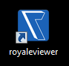
The Royale viewer can be started using the “royaleviewer”- Desktop icon or the “royaleviewer” entry in the start menu (Windows 7).
It is also accessible here: “C:\Program Files\libroyale\Version\bin\royaleviewer.exe” where “Program Files\libroyale” is the default installation folder and Version is the version number of the Royale package you installed

Starting the Royale viewer on Android
Just tap the “royaleviewer“ application. The look and feel is the same as on the x86 based OS.
Note that on Samsung Galaxy S7 devices, the point cloud visualization might look slightly different than on other platforms.

Starting the Royale viewer on Mac OS X
Click the royaleviewer-app in the /bin subfolder of your extracted package.

Starting the Royale viewer on Linux
To run the Royale viewer, please execute royaleviewer.sh in the /bin directory of the extracted Linux package. It will automatically set the right path to the necessary libraries.

Operating a camera with the Royale viewer
The application screen will open blank with the control buttons as shown below:
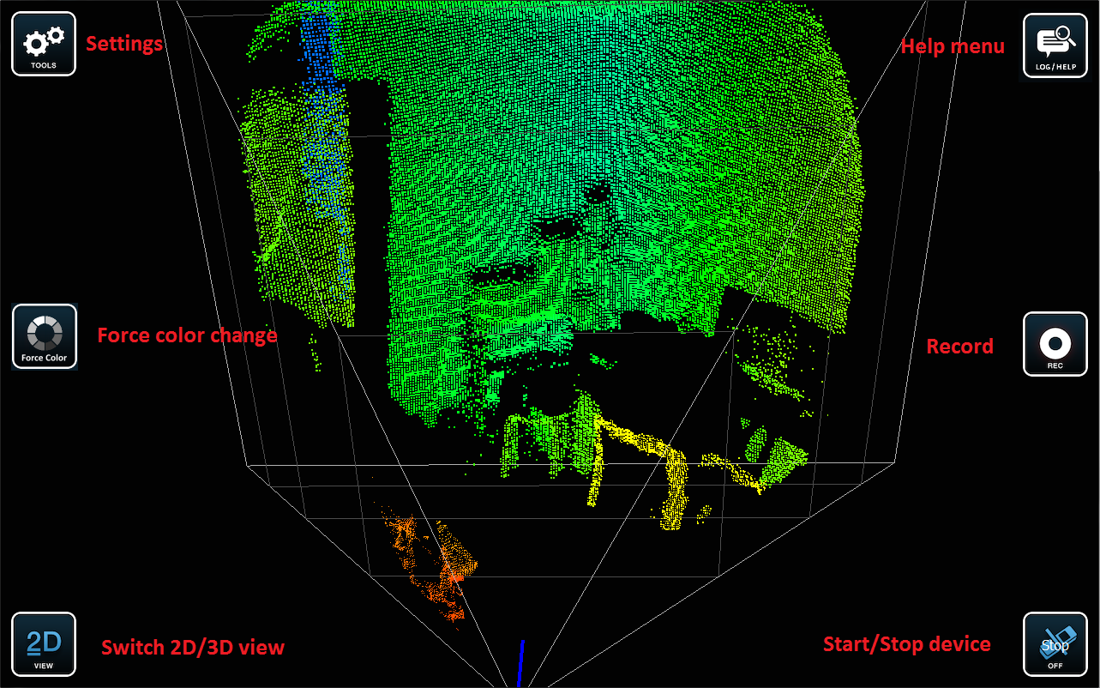

To start the data acquisition press “Start” in the lower right corner and wait for the camera to initialize.
To check if the camera was found and started click on the info button in the upper right corner. The Info-box can be closed by clicking on the Info button again.
At first you will see a color coded 2D visualization of the depth data.
You can switch to the 3D visualization by clicking on the button in the lower left corner.

Button | Function
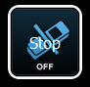 | Switch to start/stop the processing and display of 3D data from the camera
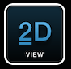 | Switch the visualization of 3D data between color coded 2D or 3D point-cloud view
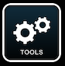 | Settings for visualization and operation modes
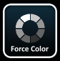 | Force an adaption of the color scheme to the current scene
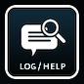 | Help menu with Log which provides status and history info, camera info, user’s guide, licenses info etc.
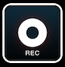 | Record (→ turns red if active)  Records Royale recording format (.rrf) as default  or single 3D point cloud (.ply) and a screenshot of the current view (.png) if selected in settings  Output folders depend on OS:  Windows : DocumentsFolder/royale  Linux : /path/to/homefolder/royale  Mac OS X : /path/to/homefolder/royale  Android : /storage/sdcard0/royale

Settings

Settings > Color Range
The color scale can be adjusted and reset (auto-scale between min and max range).
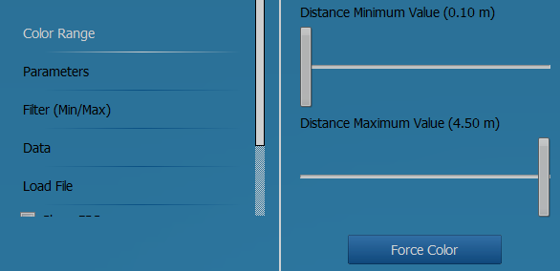

Settings > Use Case (FPS)
Selection of pre-defined operation modes. Please refer to the Royale documentation (HTML document in subfolder “doc”) for further details on operation modes.
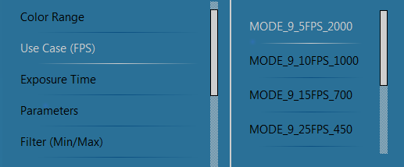

Settings > Exposure Time
Setting the exposure time between max (default) and min exposure time for the chosen operation mode.
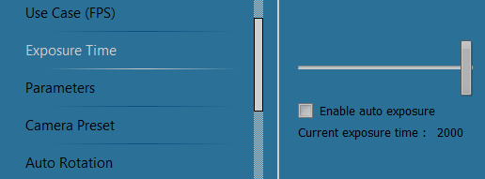

If “Enable auto exposure” is selected, the exposure time will automatically be adapted to the current scene.

Settings > Camera Preset
Affects 3D visualization only. If the 3D point cloud visualization is active (can be activated by the button in the lower left corner) the view can be switched to front view, side view or bird view here.
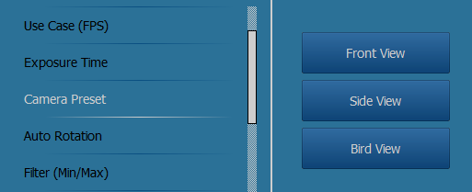

Settings > Auto Rotation
Affects 3D visualization only. If the 3D point cloud visualization is active, the view can be switched to rotate automatically. The parameters: the rotation center of the 3D point cloud and the rotation speed can be set here. The function Auto Rotation can be also activated through the mouse to directly double-click the view. During the auto rotation, the movement, zoom, and manual rotation of the view are still possible.
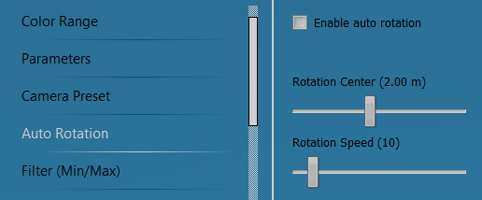

Settings > Filter (Min/Max)
The function Filter is disabled by default. The distance range can be adjusted when this function is enabled.
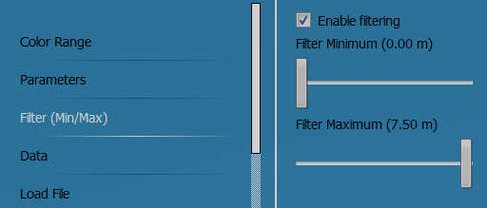

Settings > Data
Visualization can be switched between the color coded 3D data and Grayscale data formats.
Gray will show a gray scale IR image (2D) or be overlaid to the 3D point cloud)
Distance will show a color coded depth map (2D) or point cloud (3D)
Overlay shows a combination of a color coded depth and the gray image
Gray (uniform) (only available for 3D visualization) shows a uniform gray point cloud

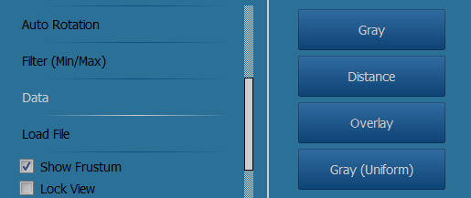

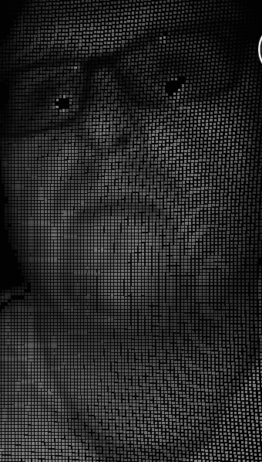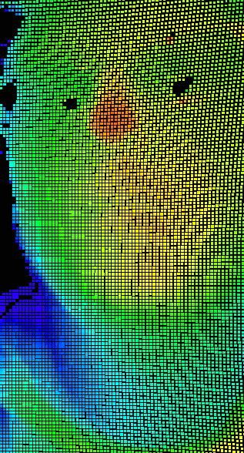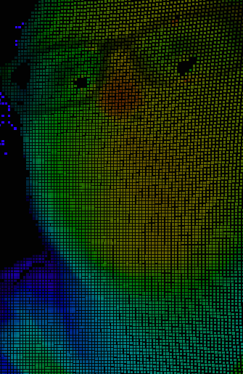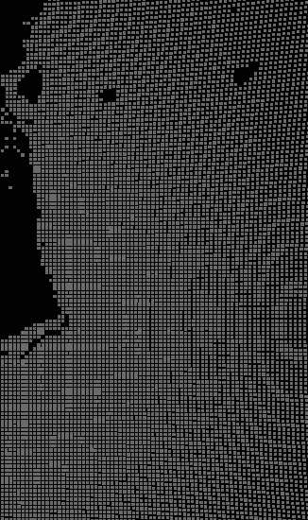

Settings > Load File
Loads .rrf (Royale recording files) files from default storage location that can be played with the viewer. Clicking the connect button during a playback will unload the current file. Afterwards you can connect to a live camera again.
To load a recording you can also drag a rrf file onto the viewer. It will then automatically open the dropped file.
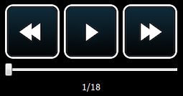

The above control buttons have the following functions:
- The left button jumps backwards (-10% during playback e.g. 90 frames for a file with a total of 900 frames and 1 frame during pause)
- The middle button stops and starts the playback
- The right button jumps forward (+10% during playback e.g. 90 frames for a file with a total of 900 frames and 1 frame during pause)
- While paused, a specific frame can be selected by the slider

Settings > Show Frustum
Enables/Disables the viewing frustum in the 3D visualization

Settings > Lock View
Enables/Disables the synchronization of the changing for different streams in the 3D visualization and the Mixed Modes

Settings > Flip vertically
Flips the displayed data vertically in the 2D visualization

Settings > Flip horizontally
Flips the displayed data horizontally in the 2D visualization

Settings > Show FPS
Shows current FPS rate if checked

Settings > Show StreamID
Shows the stream IDs of the current streams

Settings > Single Frame Recording
Toggle if a single frame and a screenshot or a rrf file is recorded

Settings > Check for updates on start
Toggle to check for updates

Help menu

Help menu > Log
The Log tab provides status and history info. When there is new log and this tab is not open, the icon of Help menu will turn red to remind.

Help menu > Info
The Info tab provides camera info, incl.: the list of connected cameras and details of the started camera. In playback mode, the used camera of playback file will also be marked here.

Help menu > Help
The Help tab provides quick links to open user’s guide (this document) and installation folder of Royale viewer directly. On Android, the quick links are not provided.

Help menu > About
The About tab provides icon and copyright notice of Royale viewer, icon and homepage of publishers and quick link to show related licenses.

Command line parameters
Some of the functionality the viewer offers can already be set before starting the viewer. Other functionality (like operating cameras as master/slave) is only available through these command line parameters:
Parameter | Function
--rrf file_to_load.rrf | Specifies a recording file which will be loaded
--cal calib_to_load.bin | Specify a different calibration file
--ac | Automatically connects to a camera
--mode “Use_Case” | Automatically sets a specified use case
--ae | Starts with auto exposure enabled
--slave | Opens the camera as a slave (please have a look at the documentation of your module to see if this is supported)
--code | Provide a Royale access code

Shortcuts
Royale viewer offers shortcuts for most of the available functions:

Shortcut | Function
S | Start/Stop camera.
L | Open Help menu (if buttons are visible)
R | Start/Stop recording
H | Hide/Show buttons
ESC | Quit Royale viewer.
F1/F2/F3/F4 | Switch data to Gray/Distance/Overlay/Uniform
2/3 | Switch view to 2D/3D
C | Force color range update
Space | Pause/Resume playback of file (only available during the playback of a file)
Left | Rewind 10% during playback e.g. 90 frames for a file with a total of 900 frames and 1 frame during pause (only available during the playback of a file)
Right | Forward 10% during playback e.g. 90 frames for a file with a total of 900 frames and 1 frame during pause (only available during the playback of a file)
Alt+Enter | Switch to fullscreen mode
Ctrl+O | Load a recording from a file

Mixed Modes
The mixed modes can be used to run two or more different modes at the same time, by capturing frames that fit into separate use cases.
In the Royale viewer application this is visualized like this:
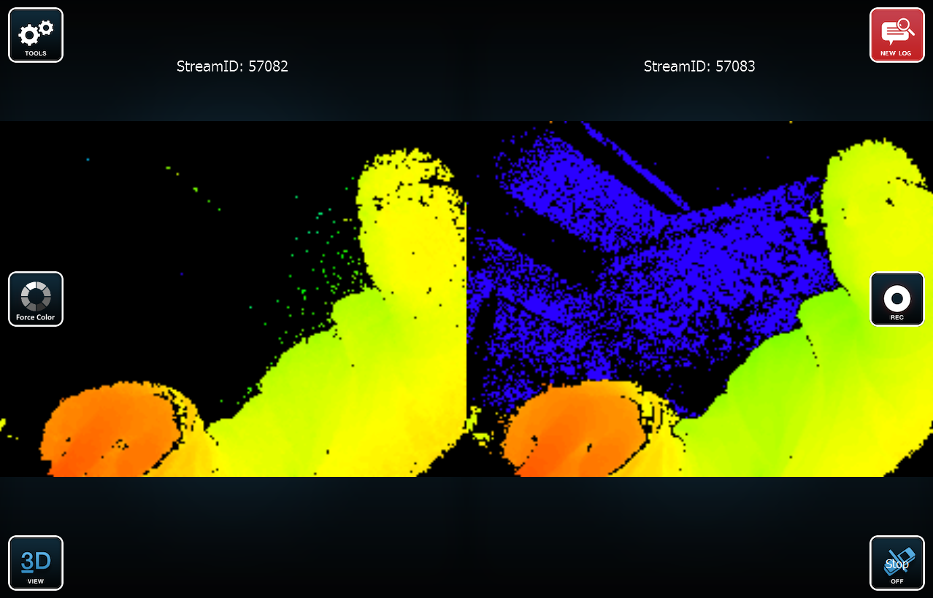

If you’re using one of the mixed modes, some of the settings will require you to select a StreamId:
