Electronic supplements: Influence of environmental and population factors on Prince William Sound spawning phenology.
AUTHORS: Dias, B.S., McGowan, D. W., Campbell, R., Branch, T. A.
E-MAIL OF CORRESPONDENCE AUTHOR: bdossantosdias@alaska..edu

Table S1. Prince William Sound model performance based on Akaike information criterion corrected for small sample size (AICc). NLL = Log-Likelihood; k = Model parameters; AIC Wt. = Model Probability; AICc wt. = weighting from AIC for each model; ER = Evidence Ratio; D²= Deviance explained.
 | Models | NLL | k | AICc | $∆$AICc | AICc wt. | ER | $$D^{2}$$
2 | ~mean age + April SST + winter downwelling+ Fall meridional winds+ Summer PNA | -121.965 | 7 | 261.429 | 0 | 0.517 | 1 | 0.521
3 | ~mean age + April SST + winter downwelling+Summer PNA | -124.741 | 6 | 264.026 | 2.597 | 0.141 | 3.66 | 0.449
1 | ~SSB + mean age + April SST + winter downwelling+ Fall meridional winds+ Summer PNA | -121.694 | 8 | 264.032 | 2.603 | 0.140 | 3.67 | 0.527
4 | ~April SST + winter downwelling + Summer PNA | -126.47 | 5 | 264.704 | 3.275 | 0.100 | 5.14 | 0.4
10 | ~mean age + March SST + winter downwelling+ Fall meridional winds+ Summer PNA | -123.649 | 7 | 264.798 | 3.369 | 0.095 | 5.38 | 0.479
9 | Summer PNA | -132.696 | 3 | 272.058 | 10.629 | 0.002 | 203.26 | 0.18
8 | winter downwelling | -133.964 | 3 | 274.594 | 13.165 | 7e-04 | 722.26 | 0.127
5 | ~SSB | -133.966 | 3 | 274.598 | 13.169 | 7e-04 | 723.62 | 0.127
6 | ~mean age | -134.415 | 3 | 275.498 | 14.068 | 5e-04 | 1134.66 | 0.107
7 | ~April SST | -134.683 | 3 | 276.034 | 14.604 | 3e-04 | 1483.29 | 0.095

Table S2. Western Prince William Sound model performance based on Akaike information criterion corrected for small sample size (AICc). NLL = Log-Likelihood; k = Model parameters; AIC Wt. = Model Probability; AICc wt. = weighting from AIC for each model; ER = Evidence Ratio; D²= Deviance explained.
 | Models | NLL | k | AICc | $∆$AICc | AICc wt. | ER | $$D^{2}$$
21 | ~mean age + modeled freshwater input + Summer PNA | -92.629 | 5 | 197.757 | 0 | 0.74 | 1 | 0.375
16 | ~mean age + modeled freshwater input+ April SST | -94.705 | 5 | 201.909 | 4.152 | 0.0928 | 7.973 | 0.283
22 | ~mean age + modeled freshwater input + Summer MEI.v2 | -95.108 | 5 | 202.716 | 4.959 | 0.062 | 11.935 | 0.263
23 | ~mean age | -98.234 | 3 | 203.391 | 5.634 | 0.0442 | 16.724 | 0.092
18 | ~mean age + Winter meridional winds + modeled freshwater input + April SST | -94.639 | 6 | 204.929 | 7.172 | 0.0205 | 36.095 | 0.286
17 | ~Mile-days of Milt + mean age + modeled freshwater input + April SST | -94.703 | 6 | 205.058 | 7.301 | 0.0192 | 38.496 | 0.283
20 | ~mean age + modeled freshwater input + April SST + winter downwelling + Fall meridional winds + Summer PNA | -91.385 | 8 | 205.627 | 7.87 | 0.0145 | 51.158 | 0.425
15 | ~SSB+ mean age + Winter meridional winds + modeled freshwater input + April SST | -94.621 | 7 | 208.333 | 10.576 | 0.0037 | 197.917 | 0.287
19 | ~mean age + Winter meridional winds + modeled freshwater input + April SST + winter downwelling + Fall meridional winds + Summer PNA | -90.901 | 9 | 208.801 | 11.044 | 0.003 | 250.134 | 0.443
13 | ~modeled freshwater input+ April SST | -120.798 | 4 | 250.887 | 53.13 | 0 | - | 0.153
24 | ~modeled freshwater input+Summer PNA | -120.939 | 4 | 251.169 | 53.412 | 0 | - | 0.146
14 | ~Mile-days of Milt + modeled freshwater input+ April SST | -120.554 | 5 | 253.108 | 55.351 | 0 | - | 0.164
5 | ~Spring offshore SST | -123.352 | 3 | 253.454 | 55.697 | 0 | - | 0.024
2 | ~Mile-days of Milt | -123.519 | 3 | 253.788 | 56.031 | 0 | - | 0.015
1 | ~SSB | -123.56 | 3 | 253.869 | 56.112 | 0 | - | 0.012
4 | ~Winter offshore SST | -123.635 | 3 | 254.021 | 56.264 | 0 | - | 0.008
8 | ~Summer NPGO | -123.702 | 3 | 254.153 | 56.396 | 0 | - | 0.004
3 | ~Fall offshore SST | -123.745 | 3 | 254.241 | 56.484 | 0 | - | 0.002
6 | ~winter downwelling | -123.778 | 3 | 254.306 | 56.549 | 0 | - | 0
7 | ~Winter NPGO | -123.779 | 3 | 254.308 | 56.551 | 0 | - | 0
12 | ~Spring offshore SST+ Winter offshore SST + April SST | -122.946 | 5 | 257.892 | 60.134 | 0 | - | 0.045
11 | ~SSB + April SST + winter downwelling + Winter NPGO | -122.943 | 6 | 260.783 | 63.026 | 0 | - | 0.046
10 | ~SSB + April SST + winter downwelling+ Summer NPGO | -122.945 | 6 | 260.786 | 63.029 | 0 | - | 0.045
9 | ~SSB + April SST + Spring offshore SST + winter downwelling + Winter NPGO | -122.703 | 7 | 263.405 | 65.648 | 0 | - | 0.058

Table S3. Eastern Prince William Sound model performance based on Akaike information criterion corrected for small sample size (AICc). NLL = Log-Likelihood; k = Model parameters; AIC Wt. = Model Probability; AICc wt. = weighting from AIC for each model; ER = Evidence Ratio; D²= Deviance explained.
 | Models | LL | K | AICc | $∆$AICc | AICc wt. | ER | $$D^{2}$$
22 | ~mile-days of milt + Winter meridional winds + Winter downwelling + Summer PNA | -124.546 | 6 | 263.638 | 0 | 0.537 | 1 | 0.495
26 | ~mile-days of milt + mean age + Winter meridional winds + Winter downwelling | -126.236 | 6 | 267.017 | 3.379 | 0.0991 | 5.417 | 0.45
28 | ~mile-days of milt + Winter meridional winds + Winter downwelling + Winter PNA | -126.293 | 6 | 267.132 | 3.494 | 0.0936 | 5.738 | 0.449
23 | ~SSB + Winter meridional winds + Winter downwelling | -128.482 | 5 | 268.728 | 5.09 | 0.0421 | 12.745 | 0.385
24 | ~mean age + Winter meridional winds + Winter downwelling | -128.519 | 5 | 268.803 | 5.166 | 0.0406 | 13.234 | 0.384
29 | ~mile-days of milt + Fall meridional winds + Winter downwelling + Summer PNA | -127.139 | 6 | 268.824 | 5.186 | 0.0402 | 13.372 | 0.425
10 | ~ Winter meridional wind | -131.39 | 3 | 269.447 | 5.81 | 0.0294 | 18.263 | 0.288
27 | ~mile-days of milt + mean age+ April SST+ Winter meridional winds + Winter downwelling + Summer PNA | -124.43 | 8 | 269.504 | 5.867 | 0.0286 | 18.792 | 0.498
21 | ~SSB + Winter meridional winds + Winter zonal wind + Winter downwelling + Summer PNA | -126.185 | 7 | 269.87 | 6.232 | 0.0238 | 22.559 | 0.452
14 | ~SSB + Winter zonal wind | -130.603 | 4 | 270.348 | 6.711 | 0.0187 | 28.656 | 0.316
16 | ~SSB + Winter meridional wind | -130.788 | 4 | 270.72 | 7.082 | 0.0156 | 34.5 | 0.31
1 | ~SSB | -132.909 | 3 | 272.485 | 8.848 | 0.0064 | 83.42 | 0.232
19 | ~SSB + April SST + Winter zonal wind | -130.45 | 5 | 272.665 | 9.027 | 0.0059 | 91.253 | 0.321
17 | ~SSB + Fall meridional wind | -132.032 | 4 | 273.207 | 9.569 | 0.0045 | 119.643 | 0.265
2 | ~Mile-days of Milt | -133.352 | 3 | 273.371 | 9.733 | 0.0041 | 129.871 | 0.215
18 | ~SSB + Spring zonal wind | -132.249 | 4 | 273.642 | 10.004 | 0.0036 | 148.716 | 0.257
15 | ~SSB + April SST | -132.289 | 4 | 273.721 | 10.083 | 0.0035 | 154.731 | 0.256
11 | ~Fall meridional wind | -134.195 | 3 | 275.056 | 11.419 | 0.0018 | 301.699 | 0.181
7 | ~Winter downwelling | -135.706 | 3 | 278.079 | 14.442 | 4e-04 | 1367.72 | 0.117
3 | ~April SST | -135.961 | 3 | 278.59 | 14.952 | 3e-04 | 1765.06 | 0.106
25 | ~mean age + FWinput.total.t + April SST + Winter downwelling + Fall meridional winds + Summer PNA | -129.069 | 8 | 278.784 | 15.146 | 3e-04 | 1945.15 | 0.366
8 | ~Summer PNA | -136.514 | 3 | 279.694 | 16.056 | 2e-04 | 3065.95 | 0.081
13 | ~Spring zonal wind | -137.363 | 3 | 281.392 | 17.755 | 1e-04 | 7167.16 | 0.041
12 | ~Winter zonal wind | -137.553 | 3 | 281.773 | 18.136 | 1e-04 | 8672.48 | 0.032
4 | ~Fall offshore SST | -137.834 | 3 | 282.334 | 18.697 | 0 | 11479.3 | 0.018
5 | ~Winter offshore SST | -138.124 | 3 | 282.915 | 19.277 | 0 | 15345.4 | 0.004
6 | ~Spring offshore SST | -138.184 | 3 | 283.034 | 19.397 | 0 | 16290.9 | 0.001
9 | ~Summer NPGO | -138.191 | 3 | 283.048 | 19.41 | 0 | 16400.6 | 0
20 | ~modeled freshwater input | -138.197 | 3 | 283.061 | 19.424 | 0 | 16510.6 | 0

Table S4. Eastern Prince William Sound model performance based on Akaike information criterion corrected for small sample size (AICc). NLL = Log-Likelihood; k = Model parameters; AIC Wt. = Model Probability; AICc wt. = weighting from AIC for each model; ER = Evidence Ratio; D²= Deviance explained.
 | Models | LL | k | AICc | $∆$AICc | AICc wt. | ER | $$D^{2}$$
4 | ~region + mile-days of milt region + mean ageRegion + Winter meridional winds + Winter downwelling + modeled freshwater input + Summer PNA | -217.137 | 11 | 460.826 | 0 | 0.4956 | 1 | 0.57
15 | ~region + mile-days of milt region + mean ageregion+ Winter meridional winds+ March SST + Winter downwelling + modeled freshwater input + Summer PNA | -216.722 | 12 | 462.917 | 2.091 | 0.1742 | 2.84 | 0.575
14 | ~region + mile-days of milt region + mean ageregion+ Winter meridional winds+ April SST + Winter downwelling + modeled freshwater input + Summer PNA | -217.072 | 12 | 463.617 | 2.791 | 0.1227 | 4.03 | 0.571
3 | ~mile-days of miltRegion + mean ageregion + Winter meridional winds + Winter downwelling + modeled freshwater input*Region+ Summer PNA | -217.116 | 12 | 463.705 | 2.879 | 0.1175 | 4.21 | 0.57
13 | ~region + mile-days of milt region + mean ageregion+ Winter meridional winds+ April SST + March SST + Winter downwelling + modeled freshwater input + Summer PNA | -216.704 | 13 | 465.908 | 5.082 | 0.0391 | 12.69 | 0.576
18 | ~region+ Surplus production 10-year regime shift + mile-days of milt * Surplus production 10-year regime shift + mean age* Surplus production 10-year regime shift + Winter meridional winds + Winter downwelling + modeled freshwater input + Summer PNA | -214.11 | 15 | 467.108 | 6.282 | 0.0214 | 23.13 | 0.606
5 | ~region + mile-days of miltregionSSB 10-year regime shift +mean age*region + Winter meridional winds + Winter downwelling + modeled freshwater input + Summer PNA | -214.406 | 15 | 467.701 | 6.874 | 0.0159 | 31.10 | 0.602
12 | ~region + mile-days of milt *region + Winter meridional winds + Winter downwelling + modeled freshwater input + Summer PNA | -222.539 | 10 | 468.807 | 7.981 | 0.0092 | 54.08 | 0.498
11 | ~region + mile-days of milt region + mean age SSB 10-year regime shift + Winter meridional winds + Winter downwelling + modeled freshwater input + Summer PNA | -220.771 | 12 | 471.017 | 10.191 | 0.003 | 163.24 | 0.523
9 | ~modeled freshwater input* SSB 10-year regime shift | -231.705 | 5 | 474.348 | 13.522 | 6e-04 | 863.48 | 0.348
17 | ~region+ SSB 5-year regime shift + mile-days of milt SSB 5-year regime shift + mean age SSB 5-year regime shift + Winter meridional winds + Winter downwelling + modeled freshwater input + Summer PNA | -211.086 | 19 | 475.373 | 14.547 | 3e-04 | 1441.41 | 0.638
19 | ~region+ Surplus production 5-year regime shift + mile-days of milt * Surplus production 5-year regime shift + mean age* Surplus production 5-year regime shift + Winter meridional winds + Winter downwelling + modeled freshwater input + Summer PNA | -211.086 | 19 | 475.373 | 14.547 | 3e-04 | 1441.40 | 0.638
6 | ~region+ SSB 10-year regime shift + mile-days of milt SSB 10-year regime shift + mean age SSB 10-year regime shift + Winter meridional winds + Winter downwelling + modeled freshwater input + Summer PNA | -226.013 | 12 | 481.5 | 20.673 | 0 | 30845.14 | 0.446
7 | ~SSB 10-year regime shift + mean age* SSB 10-year regime shift + Winter meridional winds + Winter downwelling + modeled freshwater input + Summer PNA | -230.822 | 9 | 482.645 | 21.818 | 0 | - | 0.365
8 | ~modeled freshwater input | -239.073 | 4 | 486.762 | 25.936 | 0 | - | 0.196
2 | ~mean age + modeled freshwater input + Summer PNA | -238.875 | 5 | 488.688 | 27.862 | 0 | - | 0.2
1 | ~mile-days of milt + Winter meridional wind + Winter downwelling + Summer PNA | -237.714 | 6 | 488.761 | 27.935 | 0 | - | 0.226
10 | ~mean age*SSB 10-year regime shift | -240.774 | 5 | 492.485 | 31.659 | 0 | - | 0.156
16 | ~null model | -246.694 | 2 | 497.567 | 36.741 | 0 | - | 0

Model diagnostics
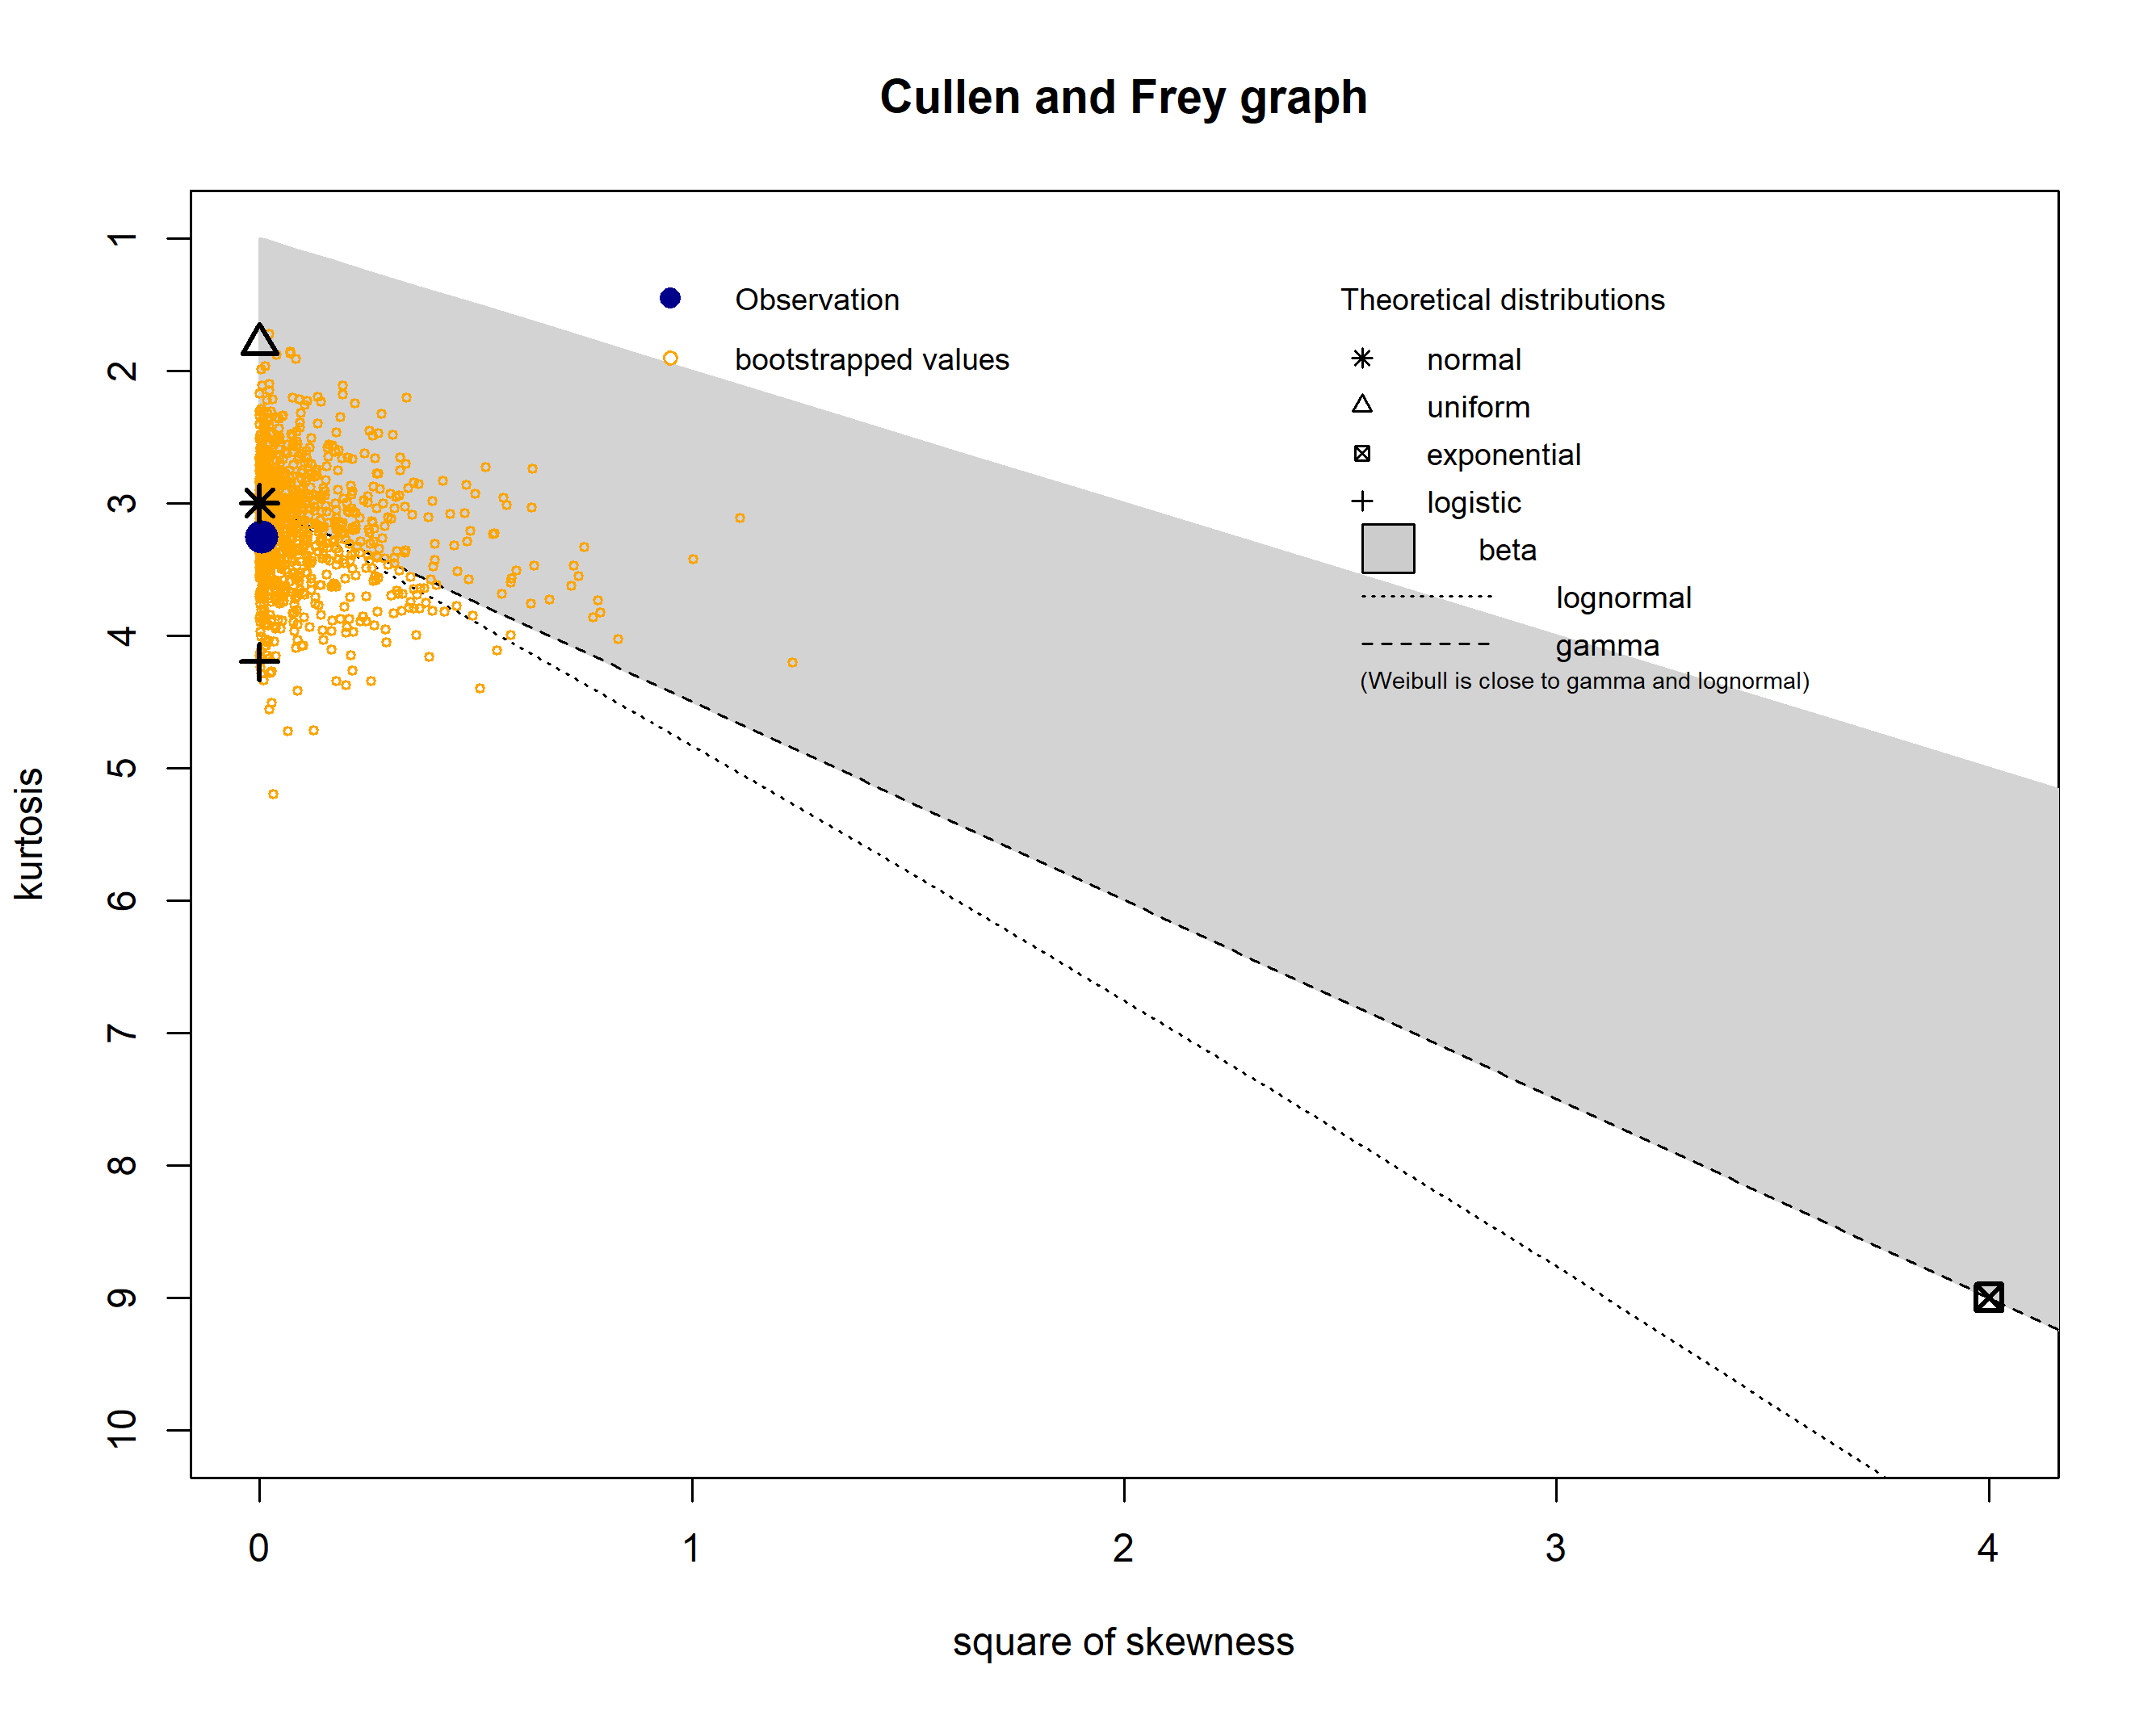
Figure S1: Cullen and Frey graph for the median spawning date.

Collinearity: measured by the variance inflation factor (VIF), which is:
$$VIF=\frac{1}{1-R^{2}}$$

Table S5. Prince William Sound model variance inflation factor (VIF).
- Variables | - Tolerance | - VIF
- Mean age | - 0.9608 | - 1.041
- April SST | - 0.9808 | - 1.02
- Upwelling index | - 0.8897 | - 1.124
- Fall meridional winds | - 0.9003 | - 1.111
- Summer PNA | - 0.9882 | - 1.012

Table S6. Western Prince William Sound model variance inflation factor (VIF).
- Variables | - Tolerance | - VIF
- Mean age | - 0.8995 | - 1.112
- Fresh water input | - 0.8811 | - 1.135
- Summer PNA | - 0.9282 | - 1.077

Table S7. Western Prince William Sound model variance inflation factor (VIF).
- Variables | - Tolerance | - VIF
- MDM | - 0.7558 | - 1.323
- Winter meridional winds | - 0.7645 | - 1.308
- Upwelling index | - 0.9814 | - 1.019
- Summer PNA | - 0.9689 | - 1.032

