**GUIDELINES FOR THE PREPARATION OF PAPERS FOR PLURIS 2021**

**R. A. R. Ramos, D. S. Rodrigues, L. C. L. Souza, A. N. R. Silva e R. C. Magagnin**

**ABSTRACT**

The guidelines for preparation of papers for the 9th Luso Brazilian Conference on Urban, Regional, Integrated, and Sustainable Planning are provided so that all manuscripts are received in a uniform format and style. Therefore, it is suggested that these guidelines should be followed as accurately as possible. To help the authors in preparing their manuscripts strictly according to these guidelines, this guide itself is printed in the format required for publication in the proceedings of PLURIS 2021.

**1 INTRODUCTION**

The 9th Luso Brazilian Conference on Urban, Regional, Integrated, and Sustainable Planning will be held at *Hotel Monte Real* *Resort*, in *Águas de Lindóia*, São Paulo, Brazil, from 7 to 9 of April 2021. This conference edition is being organized by Graduate Programs in Architecture and Urbanism and in Civil and Environmental Engineering of the Sao Paulo State University (UNESP)*, campus Bauru.* All accepted papers will be available in digital conference proceedings and a selection of the best papers may be published in a special issue of a journal (to be decided). A committee of experts will review the papers, and the final version is to be prepared by revising the paper following the peer reviewers´ comments.

**2 FORMATTING THE PAPER**

This topic shows the general instructions for formatting the paper.

**2.1 General**

The general order of the text and the other materials in the paper may follow an order as given in the list below.

Title and authors;

Abstract;

The chapters or sections of the main body of the text, tables and figures;

(The tables and figures are to appear immediately after they are referred in the text);

Acknowledgements, if any;

References;

Appendices, if required, without exceeding the limit of pages.

**2.2 Formatting and typing instructions**

The following formatting and typing instructions are to be strictly adhered to. This also indicates the way to list numbered items in the text.

1. Use A4 paper (21.0 cm x 29.7 cm);
2. Upper, lower and right margins of 2.5 cm (1 inch), left margin of 3.0 cm (1.2 inches);
3. Times (Roman or New Roman) font;
4. 12 point pitch;
5. Single spacing throughout;
6. Maximum length of 12 pages, including figures, tables, appendices and references (***papers exceeding that limit will be excluded from the selection process, given that they will not be reviewed by the Scientific Committee***);
7. Do not indent, but leave a blank line between paragraphs;
8. Do not number the pages.

After adopting the above-mentioned margins, the typing space in the page shall be 15.5 cm x 24.7 cm.

**3 STARTING TO TYPE**

This topic contains specific instructions concerning the text format, as well as regarding equations, tables, and figures.

**3.1 Text materials**

The title of the paper should be written in **CAPITALS** at the 3rd line from top and centered keeping two blank fines at top. If one line is not sufficient, use the 4th line also. In any case, each line should be centered. The name(s) of the author(s) without address should be given at the 7th line from top and centered (if one line is not enough, use the 8th line also for names of authors). The title of the paper and name(s) of author(s) should be in bold typeface.

At the 12th line the abstract should start. First, the heading as **ABSTRACT** left adjusted; then a blank line followed by the abstract of a maximum of 150 words starting from the 14th line. The abstract also should be of full width (justified to both margins) and not indented.

After the abstract, the introduction of the paper must start only on the 26th 1ine of the first page (please see section 1 of these guide1ines to understand this requirement). The body of the paper may have sections and sub-sections, which are to be numbered using maximum two digits. All headings should be in bold type face and left adjusted. All section headings should be in capital letters and all sub-section headings in upper/lower case (for example, Heading: **1 INTRODUCTION,** Subheading: **2.1 Model Validation**). Keep a blank line after each heading and subheading. All text must start at the left hand margin (that is, new paragraphs are not to be indented) and text must be justified to both left and right margins as shown in these guidelines. However, if any listing is to be given in the text, then it should be indented as shown in these guidelines. The second and subsequent pages should start from the first line of the page.

**3.2 Equations**

The equations must be written preferably using the same word processor used for the rest of the text, without hand written symbols in order to aid legibility. The letters and symbols of equation should be of same size as that of the rest of the text. The superscripts and subscripts must be of 10 point pitch. Equations must be numbered sequentially with their numbers in parenthesis. The equation should be indented from left margin as shown in these guidelines and the equation number should be right justified as shown in the Equation (1).

a2 = b2 + c2 (1)

Where:

a: hypotenuse;

b, c: catheti.

**3.3 Tables**

The tables as a whole should be centred horizontally in the page. Tables must be numbered sequentially and have a reasonably explanatory title centred above the table. The measurement units employed in the table must be indicated. Tit1e should be written in upper/lower case as shown in the example and typed boldface. One blank line is to be kept between tit1e of the table and the table boundaries. An example of a table is shown in Table 1. Sizes of all texts in the tables should be at least 10 point pitch and their fonts the same as the remaining text of the paper. The table should be referred in the text as indicated in this section of the guidelines.

**Table 1 Weights obtained for the Themes evaluated**

|  |  |  |  |
| --- | --- | --- | --- |
| **Brazil** | | | |
| **Category** | **ID** | **Theme** | **Weight** |
| E | E3 | Air quality | 0.311 |
| M | M5 | Expenditures/Investments/Economics Strategies | 0.284 |
| I | I12 | Traffic | 0.316 |
| P | P13 | Accessibility to urban facilities | 0.313 |
| S | S17 | Costs/Prices/Tariffs | 0.264 |

**3.4 Figures**

The figures should be centred horizontally in the page as shown in these guidelines. Figures must be drawn using good quality graphic software. They must be numbered sequentially and have a reasonably informative title cantered under the figure in bold typeface as shown. An example of a figure is shown in Figure 1. A blank line is to be kept between the figure boundary and the figure caption. If there is no boundary, then also the gap requirement is one blank line. Sizes of all texts in the figure should be at least 10 point pitch and their fonts the same as the remaining text of the paper. The figures should be referred in the text as indicated in this section of the guidelines.

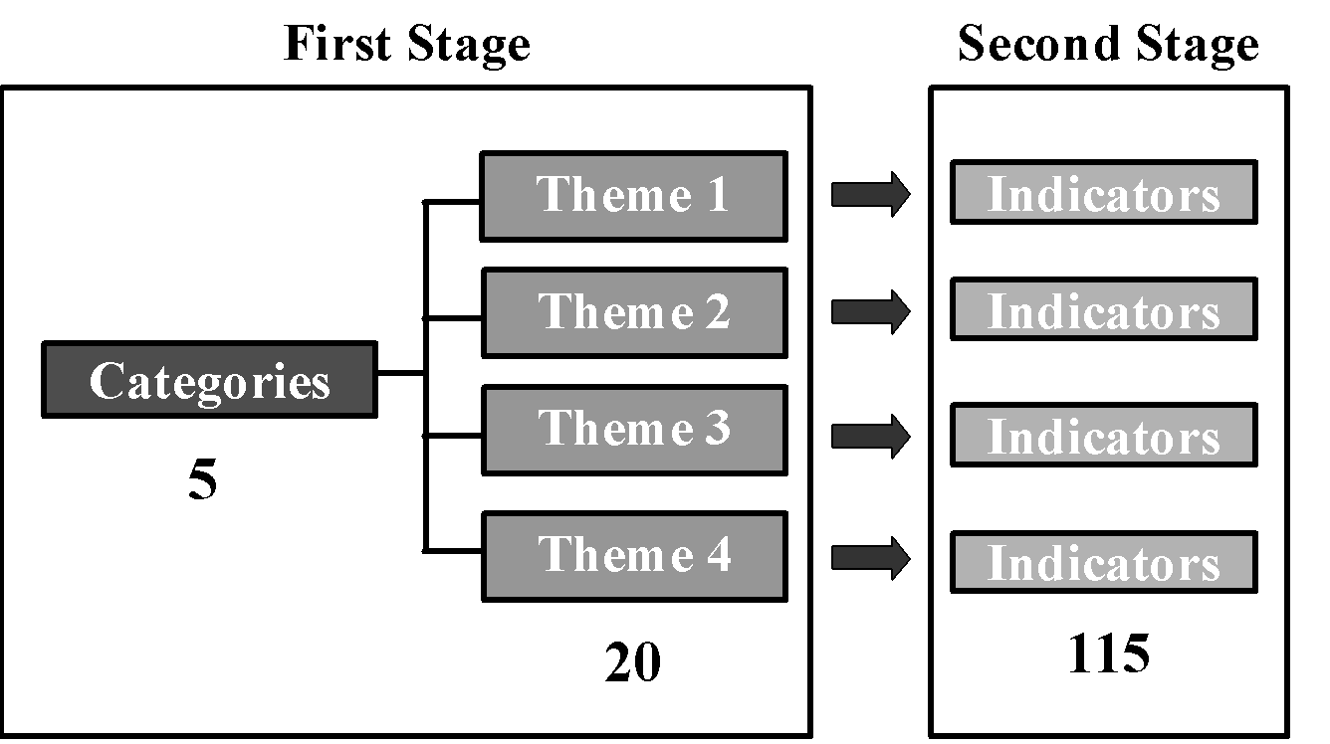

**Fig. 1 Elements of the hierarchy**

**4 GUIDELINES FOR REFERENCES**

The Harvard System of referencing must be used (see for example, *Transportation Research*). In the body of the text, papers or documents are referred by authors surname with the year of publication in parenthesis. If the quotation is itself in parenthesis, the year of publication is separated by a comma. If the reference has more than two authors, only the surname of the first author followed by “*et al.*” (in italics) should appear in the body of the text. However, in listing the reference at the end of the paper, names of all the authors of the paper must be included.

At the end of the paper, complete list of references must be given alphabetically by author's surname including: surname(s) and initials or author(s) separated by a comma, year of publication in parenthesis, title of the paper, title of the journal, volume with issue number in bracket and first and last pages. In case of books, the title of the book with the first letter capitals; the publisher and the city of publication must also be indicated. A blank line is to be kept between the references.

Examples of some typical references are listed in the section 5 of these guidelines arranged alphabetically for your guidance.

**5 REFERENCES**

Bates, J. J. and Roberts, M. (1983) Recent Experience with Models Fitted to Stated Preference Data, **Proceedings 11th PTRC Summer Annual Meeting**, University of Sussex, England, 4-7 July 1983.

Economic Software (1994) **LIMDEP (Version 6.0) User’s Manual and Reference Guide**, Econometric Software Inc., New York and Sydney.

Green, W. H. (1993) **Econometric Analysis**, McMillan, New York.

Johnson, L. W. (1990) Discrete Choice Analysis with Ordered Alternatives, in M. M. Fisher, P. Nijkamp and Y. Y. Papageorgiou (eds.), **Spatial Choices and Processes**, North Holland, Amsterdam.

Kokur, G., Adlet, T., Hyman, W. and Aunet, B. (1982) Guide to Forecast Travel Demand with Direct Utility Assessment, **Report No. UMTA-NH-11-1-82**, US Department of Transport, Washington, DC.

McKelvey, R. D. and Zavoina, W. (1995) A Statistical Model for the Analysis of Ordinal Level Dependent Variables, **Journal of Mathematical Sociology**, 4(2), 103-120.