# Estimation of risk measures applied to a portfolio of cryptocurrencies

Biagio Zaffora

Financial Econometrics – Pr. O. Scaillet (fall semester 2019/2020)

**Contents**

[Estimation of risk measures applied to a portfolio of cryptocurrencies 1](#_Toc25585437)

[1. Introduction 1](#_Toc25585438)

[2. Estimation methods 2](#_Toc25585439)

[2.1 Gaussian approximation 2](#_Toc25585440)

[2.2 Historical data 3](#_Toc25585441)

[2.3 Kernel method 3](#_Toc25585442)

[2.4 Generalized Pareto Distribution 4](#_Toc25585443)

[2.5 Empirical confidence intervals using sub-sampling 5](#_Toc25585444)

[3. Analysis of the results and discussion 6](#_Toc25585445)

[4. Conclusion and perspectives 7](#_Toc25585446)

[Bibliography 8](#_Toc25585447)

## Introduction

In the present study, we investigate two important risk measures: Value-at-Risk (VaR) and Expected Shortfall (ES) within the context of a portfolio of cryptocurrencies. In particular, we estimate each risk measure using four techniques that are used in risk management [1], namely estimation under Gaussian approximation, estimation using historical data, estimation using a kernel approach and estimation under the Generalized Pareto Distribution (GPD) assumption.

Equation 1 shows a definition of Value-at-Risk using a probability notation. In particular, the Value-at-Risk quantifies the probability that, in a given day, the loss associated with an investment (for instance, a portfolio of cryptocurrencies) is above a threshold called VaR. In Equation 1, the quantity $α$ represents the probability that the loss is above VaR and is commonly chosen to be equal to either 5% or 1%.

$$P[Loss>VaR]=α$$

Equation . Definition of Value-at-Risk [1].

The risk measure VaR is often criticised as it does not allow to quantify the extent of the losses when the VaR threshold is encompassed [2]. For this reason, a second risk measure called Expected Shortfall is calculated to estimate the expected loss, given that the loss is above VaR. Equation 2 gives a definition of ES using the probabilistic concept of conditional expectation.

$$ES=E[Loss|Loss>VaR]$$

Equation . Definition of Expected Shortfall [1].

The main goal of our study is to quantify and compare the VaR and ES using different methods. We considered a portfolio of five cryptocurrencies (see Table 1). We selected the currencies using two simple criteria: the cryptocurrency must (i) exist for at least 4 years and (ii) rank in the top ten for market capitalization (as of November 4th, 2019). We collected the data using “Coin Market Cap” [2], an online service that lists all the available and traded cryptocurrencies from the major trading platforms. The data covers the time spanning from August the 7th, 2015 to November the 4th, 2019 and consists of 1551 observations. Table 1 shows the cryptocurrencies symbols, names, market capitalizations, the so-called dominance (percentage of total market capitalization) as of the 4th November 2019, as well as the portfolio allocation. We determined the portfolio allocation for a given cryptocurrency as its capitalization fraction within the portfolio [3]. As an example, we obtain the portfolio allocation of BTC as follows: (1.7x1011/2.1x1011)x100=81.12%.

Table . List of cryptocurrencies selected for the portfolio.

|  |  |  |  |  |
| --- | --- | --- | --- | --- |
| Symbol | Currency name | Market cap. (USD $) | Dominance (%) | Portfolio allocation *a* (%) |
| BTC | Bitcoin | ~1.7x1011 | 67.37 | 81.12 |
| ETH | Ethereum | ~2.1x1010 | 8.00 | 9.90 |
| XRP | Ripple | ~1.3x1010 | 5.1 | 6.25 |
| LTC | Litecoin | ~4.0x109 | 1.51 | 1.94 |
| XLM | Stellar | ~1.6 x109 | 0.56 | 0.79 |
| Total |  | ~2.1x1011 | 82.54 | 100 |

Table 2 shows summary statistics of the daily cryptocurrency returns $R_{t}=\left(P_{t}-P_{t-1}\right)/P_{t-1}$, where $P_{t}$ is the price at time *t*.

Table . Summary statistics of the daily returns of the selected cryptocurrencies.

|  |  |  |  |  |  |
| --- | --- | --- | --- | --- | --- |
|  | BTC | ETH | XRP | LTC | XLM |
| Min | -0.1874 | -0.728 | -0.46 | -0.3264 | -0.3067 |
| Max | 0.2525 | 0.5103 | 1.7937 | 0.6659 | 1.0608 |
| Mean | 0.0031 | 0.0052 | 0.005 | 0.0033 | 0.0054 |
| Median | 0.0023 | -0.0008 | -0.0034 | -0.0001 | -0.0037 |
| 1st Quartile | -0.0107 | -0.0244 | -0.0205 | -0.0188 | -0.0302 |
| 3rd Quartile | 0.0181 | 0.029 | 0.0177 | 0.0194 | 0.0271 |
| Standard Deviation | 0.0395 | 0.0688 | 0.0831 | 0.0587 | 0.0869 |
| Skewness | 0.1963 | 0.2805 | 8.2647 | 2.3323 | 4.2123 |
| Kurtosis | 7.9092 | 17.1764 | 153.8595 | 22.6923 | 43.0497 |

In Section 2 we present the description of the different methods to estimate VaR and ES as well as the methodology to quantify empirical confidence intervals. The results obtained are presented in Section 3, where we discuss also the implications of our findings. Finally, Section 4 summarizes the conclusions of our study on risk measures applied to portfolios of cryptocurrencies.

## Estimation methods

### Gaussian approximation

The Gaussian approximation postulates that the distributions of returns are Normal. Although this assumption has far-reaching consequences in terms of risk estimation, the Normality assumption is often made (i) because it allows for a simple calculation of VaR and ES and (ii) because it is used as a reference for more advanced estimation methods. In respect to a portfolio of cryptocurrencies, it is obvious that the Normality assumption does not hold by simply looking at the values of skewness and kurtosis in Table 2.

If the Gaussian approximation for returns is used, we can estimate the VaR and the ES using Equation 3 and Equation 4 [1].

$$\hat{VaR}\left(a,α\right)=-a^{T}\hat{μ}+{\left(a^{T}\hat{Σ}a\right)}^{1/2}z_{1-α}$$

Equation . Estimation of VaR using the Gaussian hypothesis.

$$\hat{ES}\left(a,α\right)=-a^{T}\hat{μ}+{\left(a^{T}\hat{Σ}a\right)}^{1/2}{φ(z}_{1-α})/α$$

Equation . Estimation of ES using the Gaussian hypothesis.

In the previous equations *a* is the portfolio allocation vector, $\hat{μ}$ represents the estimated mean return vector, $\hat{Σ}$ is the variance-covariance matrix of the portfolio returns, $z_{1-α}$ is the quantile of the standard normal distribution at the level $1-α$ and ${φ(z}_{1-α})$ is the value that the normal density function takes at $z_{1-α}$.

### Historical data

The “Historical data” method consists of evaluating the portfolio losses over the period of interest, ranking the losses from the smallest to the largest and, finally, selecting the loss value corresponding to the empirical quantile of interest, usually taken to be either 5% or 1%. The empirical quantile corresponds to the estimated VaR. As an example, Figure 1 shows the empirical loss distribution of the portfolio of cryptocurrencies described in Section 1. The blue and red lines locate the estimated VaR at the levels 5% and 1%.

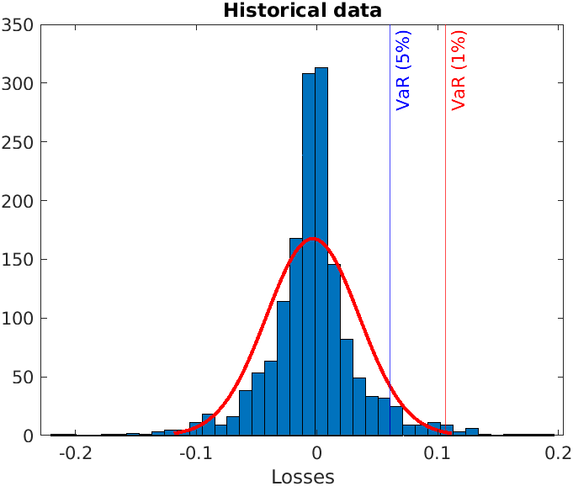

Figure . Empirical loss distribution of a cryptocurrency portfolio, with the VaR estimated as the empirical quantiles at the levels 5% and 1%.

Once the losses are ranked in ascending order and the VaR is estimated, we can estimate the ES as the arithmetic mean of the losses above the threshold VaR.

### Kernel method

The kernel method is a non-parametric technique allowing us to estimate the VaR and the ES without any assumption about the distribution of the returns (or losses) of a portfolio.

If we indicate with $f(z)$ the density of the loss distribution of our portfolio, we can rewrite Equation 1 as showed in Equation 5.

$$P\left[Loss>VaR\right]=\int_{VaR}^{+∞}{f\left(z\right)dz=α}$$

Equation . Definition of VaR using the loss density of the portfolio.

Since the true loss density is unknown, we can estimate it using its kernel counterpart. For instance, the Gaussian kernel is given by Equation 6.

$$\int_{\hat{VaR}}^{+∞}{\hat{f}\left(z\right)dz=\frac{1}{T}\sum_{t=1}^{T}{Φ\left(\frac{z_{t}-\hat{VaR}}{h}\right)}}$$

Equation . Gaussian kernel for non-parametric estimation of VaR.

In Equation 6, *T* represents the time span of the data collected (equals to the number of observations), $Φ$ indicates the normal cumulative distribution function, $z_{t}$ is the portfolio loss at time $t$, $\hat{VaR}$ is the value of the VaR to be estimated and $h$ is the so-called bandwidth of the kernel, which can be estimated by $h=\hat{σ}T^{-\frac{1}{5}}$, where $\hat{σ}$ is the estimated standard deviation of the portfolio returns.

One way to estimate VaR is to define a loss function L (not to be confused with the losses of the portfolio) representing the distance between the kernel of Equation 6 and the level $α$. The value that corresponds to the minimum of the loss function is indeed the estimated $\hat{VaR}$ (see Equation 7). Figure 2 shows an example of loss function minimization to estimate the VaR of the cryptocurrencies portfolio.

$$\hat{VaR}=argmin_{\text{VaR}}L=argmin_{\text{VaR}}{\left[\frac{1}{T}\sum_{t=1}^{T}{Φ\left(\frac{z_{t}-VaR}{h}\right)-α}\right]}^{2}$$

Equation . An algorithm to estimate VaR using the (Gaussian) kernel method.

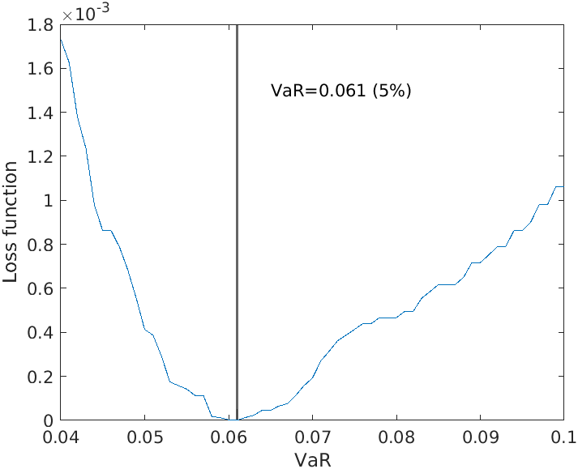

Figure . Minimization of the loss function to estimate the VaR using a kernel approach.

Once VaR is estimated we can estimate the corresponding ES using Equation 8.

$$\hat{ES}=\frac{\frac{1}{T}\sum_{t=1}^{T}{\left[z_{t}Φ\left(\frac{z_{t}-\hat{VaR}}{h}\right)\right]}}{α}$$

Equation . Estimated ES using the non-parametric Gaussian kernel.

### Generalized Pareto Distribution

A branch of statistics called Extreme Value Theory suggests that the distribution of rare events can be modelled using the so-called Generalized Pareto Distribution (GPD), having parameters $ξ$ and $σ$. In addition, the Peaks-Over-Threshold (POT) method suggests a strategy to estimate VaR and ES by fitting the GPD to the losses above a threshold *u*. Various methods exist to estimate an optimal threshold u, including the use of empirical quantiles. In the present study we decided to use a visual tool, called Mean Excess (ME) plot [4], which has allowed us to estimate an adapted threshold, before fitting the GPD to the extreme data.

The ME plot is an empirical graphical plot of the ME function of a random variable Z which is defined in Equation 9.

$$ME\left(u\right)=E[X-u|X>u]$$

Equation . Definition of the Mean Excess function.

The empirical ME function, defined in Equation 10, is an estimate of $ME\left(u\right)$, where $1_{[Z_{t}>u]}$ is the indicator function, which is equal to 1 if $Z_{t}>u$ and 0 otherwise and *u>0*.

$$\hat{ME}(u)=\frac{\sum_{t=1}^{T}{(Z_{t}}-u)1_{[Z_{t}>u]}}{\sum_{t=1}^{T}{1_{[Z_{t}>u]}}}$$

Equation . Empirical estimate of the mean excess function.

Denoted by $Z_{(k)}$ the order statistics of order *k*, the ME plot is a plot of the points $\left\{\left(Z_{(k)}, \hat{ME}\left(Z_{\left(k\right)}\right):1<k<T\right)\right\}$. For the GPD to be well defined, it is required for the empirical ME plot to be linear in the region where the threshold *u* is selected. An example of empirical ME plot and linear region of selection of the parameter *u* is presented in Figure 3.

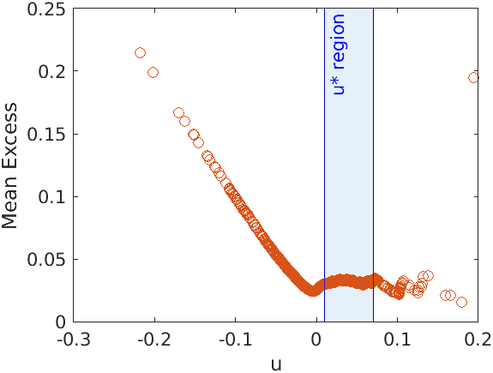

Figure . Empirical Mean Excess plot with linear region for the threshold selection.

Once the threshold *u* is selected, we can estimate the parameters of the GPD using Equation 11. In this equation, $\hat{m}$ and $S^{2}$ represent the empirical mean and variance of portfolio losses above the threshold *u*.

$\hat{ξ}=\frac{1}{2}\left(1-\frac{{(\hat{m}-u)}^{2}}{S^{2}}\right)$, $\hat{σ}=\frac{\hat{m}-u}{2}\left(\frac{{(\hat{m}-u)}^{2}}{S^{2}}+1\right)$

Equation . Formulae to estimate the parameters of the GPD.

Finally, we can calculate estimates of VaR and ES using Equation 12 and Equation 13.

$$\hat{VaR}\left(a,α\right)=\tilde{μ}+\frac{\tilde{σ}}{\hat{ξ}}\left(α^{-\hat{ξ}}-1\right)$$

Equation . Estimation of VaR using the GPD.

$$\hat{ES}\left(a,α\right)=\hat{VaR}\left(a,α\right)-\frac{\tilde{σ}}{\hat{ξ}-1}α^{-\hat{ξ}}$$

Equation . Estimation of ES using the GPD.

In the previous equations, $\tilde{σ}=\hat{σ}{(N/{T)}}^{\hat{ξ}}$, $\tilde{μ}=u-\frac{\tilde{σ}}{\hat{ξ}}\left[\left({(N/{T)}}^{-\hat{ξ}}-1\right)\right]$ and *N* is the number of observed losses above the threshold *u*.

### Empirical confidence intervals using sub-sampling

When estimating a parameter of interest, it is important to evaluate the uncertainty affecting its validity as well as its applicability. For instance, it is also interesting to test some hypothesis about the parameters that we have estimated. In this context, it is useful to evaluate confidence intervals around the quantity of interest.

There are many tools to estimate confidence intervals within statistical theory. In this study we decided to apply sub-sampling to provide confidence intervals around VaR and ES estimates. Although the theory of sub-sampling can be complex, the idea behind it is very intuitive. In fact, sub-sampling consists of taking a high number of sub-samples from the original sample, without replacement, and estimating for each sub-sample the parameter of interest $θ$. A validity condition for applying sub-sampling is that when the sub-sample size (*bT*) increases, the ratio *bT/T* goes to zero as $T→∞$. If ${\hat{ θ}}_{T}$ is the estimator of the parameter of interest (given the sample size $T$), asymptotic theory ensures that the confidence interval around the parameter of interest can be estimated using Equation 14. In Equation 14, ${\hat{q}}_{α}$ represents the empirical quantile, at the level $α$, obtained from the sub-sampling distribution. A complete treatment of sub-sampling for confidence intervals can be found in [5].

$${CI}_{T,α}=\left[{\hat{ θ}}_{T}-\frac{{\hat{q}}_{1-α/2}}{\sqrt{T}}, {\hat{ θ}}_{T}+\frac{{\hat{q}}_{α/2}}{\sqrt{T}}\right]$$

Equation . Estimation of confidence intervals using sub-sampling [5].

For the present study, we decided to apply the so-called rolling window approach to sub-sampling. The technique consists of selecting the size of the sub-sample (*b)* and calculating one estimate of the parameter of interest, considering the data from time $t_{1}$ to time $t_{b}$. The second sub-sample is the data from time $t_{2}$ up to time $t_{b+2}$ and is used to calculate a second estimate for the parameter. This procedure is repeated until a large number of estimates are calculated and the rolling window reaches *T*. Finally, an empirical distribution of the parameter of interest can be built. In particular, this technique is very useful to build confidence intervals of VaR and ES.

## Analysis of the results and discussion

Using the theoretical results of the previous section and the data described in the first section, we calculated the VaR and ES for a portfolio of cryptocurrencies, at the levels of confidence 5% and 1%. The results are summarized in Table 3. The confidence intervals between square brackets are estimated at a confidence level of 95%. Figure 4 shows the boxplots obtained for each risk measure and from sub-samples of size *b=T/2=775*.

Table . Summary of risk measure estimates for a portfolio of cryptocurrencies. Between square brackets we give the confidence intervals obtained from sub-sampling, at a confidence level of 95%.

|  |  |  |  |  |
| --- | --- | --- | --- | --- |
|  | Gaussian | Historical data | Kernel | GPD (u=0.05) |
| VaR (5%) | 0.0597 [0.0495, 0.0716] | 0.0606 [0.0489, 0.0697] | 0.061 [0.048, 0.07] | 0.0613 [0.0478, 0.072] |
| VaR (1%) | 0.0858 [0.0723, 0.1023] | 0.1064 [0.0991, 0.1174] | 0.105 [0.092, 0.108] | 0.111 [0.0961, 0.1208] |
| ES (5%) | 0.0757 [0.0635, 0.0904] | 0.919 [0.0775, 0.1021] | 0.0922 [0.0774, 0.1087] | 0.0918 [0.0777, 0.1019] |
| ES (1%) | 0.0988 [0.0836, 0.1176] | 0.1375 [0.1245, 0.1469] | 0.1698 [0.1279, 0.2099] | 0.138 [0.1253, 0.1484] |

The analysis of the data indicates that the Gaussian hypothesis underestimates the risk associated with the portfolio considered. Although for VaR at 5% this underestimation of the risk is limited (the relative percentage difference[[1]](#footnote-1) from Gaussian to the other methods in this case is below 2%), it becomes very high for VaR at 1% (about 20% underestimation of the risk) as well as for ES at 5% (about 18% underestimation of the risk) and ES at 1%. In the latter case we estimated that the highest underestimation of the risk spans from about 28% (relative difference of the Gaussian case to the use of historical data and GPD), up to above 40% when using a kernel method. Finally, for ES at 1%, the underestimation is so extreme that the upper boundary of the Gaussian estimate is below the lower boundaries obtained from the 3 other methods. Figure 4 clearly illustrates the systematic underestimation of the risk incurred by the theoretical owner of the portfolio, if using the Gaussian approximation.

With the exception of ES estimate at 1% obtained using the kernel method, the use of historical data, kernel method and GPD give strikingly coherent results, suggesting that they can be used interchangeably when estimating risks associated with a portfolio of cryptocurrencies.

The results obtained in the present study also suggest that an investor in cryptocurrencies is exposed to very high risks. For instance, the owner of the fictive portfolio discussed here would be exposed, at a given time *t*, to losses above 6% with a probability of 5%. This is equivalent to claiming that an investor has a 95% chance of losing more than 6% once every 20 days. In addition, for the days in which the losses are above the 6% threshold, the average loss will be above 9%. A similar estimation can be made also for a confidence level 1%, both in terms of VaR and ES.

|  |  |
| --- | --- |
| C:\Users\Biagio\AppData\Local\Microsoft\Windows\INetCache\Content.Word\boxplot_VaR_5.png | C:\Users\Biagio\AppData\Local\Microsoft\Windows\INetCache\Content.Word\boxplot_VaR_1.png |
| C:\Users\Biagio\AppData\Local\Microsoft\Windows\INetCache\Content.Word\boxplot_ES_5.png | C:\Users\Biagio\AppData\Local\Microsoft\Windows\INetCache\Content.Word\boxplot_ES_1.png |
|  |  |

Figure . VaR and ES sub-sampling distributions (confidence levels 5% and 1%). The sub-sample size is *b=T/2=775*.

## Conclusion and perspectives

The present study investigates the risk measures VaR and ES applied to a portfolio of cryptocurrencies. We considered and compared 4 approaches to estimate these risk measures which are the Gaussian assumption, historical data, kernel method and Generalized Pareto Distribution. We found that the Gaussian method largely underestimates both the VaR and the ES of the portfolio considered and therefore the Gaussian assumption is not appropriate to quantify (and to account for) the risk associated with a portfolio of cryptocurrencies.

We estimated that the VaR (at 5%) of a generic portfolio of cryptocurrencies is of the order of 6% while the ES corresponding to this Value-at-Risk is above 9%, which allows us to suggest that investing in cryptocurrencies is not appropriate for risk adverse investors. However, we would like to stress the fact that the portfolio considered in this study is not optimized to reduce the VaR and better allocations of the assets can be studied, potentially leading to a lower risk.

In conclusion, this study provides some tools to quantify risks that can be implemented in routine tasks of risk management. The study could be extended by considering other methods of estimation (such as copula and Monte Carlo simulations), by estimating the sensitivities of VaR and ES, and by collecting new cryptocurrency data over the following months in order to test if the predicted values of VaR and ES can be explained by the real (future) empirical loss distributions.

# Bibliography

|  |  |
| --- | --- |
| [1] | P. Jorion, Value at Risk: the new benchmark for managing financial risk, 3rd ed., McGraw-Hill Professional, 2006. |
| [2] | CoinMarketCap, Available online at : https://coinmarketcap.com/ [Accessed : 5/11/2019]. |
| [3] | J. W. Bernstein, The Four Pillars of Investing: Lessons for Building a Winning Portfolio, New York: McGraw-Hill, 2010. |
| [4] | S. Ghosh and S. Resnick, “A discussion on mean excess plots,” *Stochastic Processes and their Applications,* vol. 120, p. 1492–1517, 2010. |
| [5] | D. N. Politis and J. P. Romano, “Large sample confidence regions based on subsamples under minimal assumptions,” *The Annals of Statistics,* vol. 22, no. 4, pp. 2031-2050, 1994. |
| [6] | Basel Committee on Banking Supervision, “Minimum capital requirements for market risk,” Bank for International Settlements, Basel, 2016. |

1. For a VaR at 5%, the relative percentage difference is calculates as $\left\{\left[({VaR}_{Gauss}^{5\%}-{VaR}_{method 2}^{5\%})/{VaR}_{Gauss}^{5\%}\right]×100\right\}$, where “method 2” stands for either historical data method, kernel method or GPD. Similar relative percentage differences can be calculated for ES and other confidence levels. [↑](#footnote-ref-1)