Length x Height (pixels)

5 x 1: 3 (Z,T)

4 x 1: 6 (S, L, J, G)

3 x 1: 24 (Y, U, S, Q, P, O, H, F, E, D, C, B, A)

2 x 1: 1 (G)

3 x 3 (x shape): 1 (X)

3 x 2: 1 (W)

3 x 2: 2 (V, M)

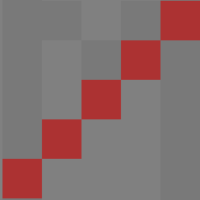5 x 5 (Diagonal up): 1 (Z)

4 x 4 (diagonal up) : 1 (K)

2 x 2 (diagonal down) : 1 (Q)

3 x 3 (diagonal down) : 2 (N, K)

1 x 7: 17 (W, R, P, N, M, L, K, I, H, F, E, D, B)

1 x 6: 6 (U, T, J, A)

1 x 5: 9 (V, Q, O, G, D, C)

1 x 3: 5 (Y, R, P)

1 x 2: 10 (X, S, R, G, B)