Bianca Anjela Rey 2ECE-B

PROBLEM 1

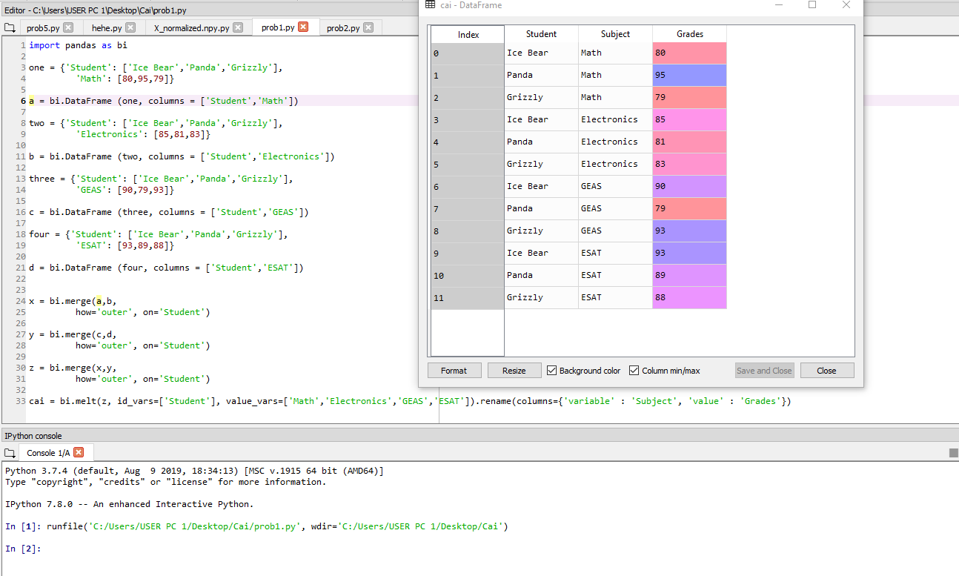

PROBLEM 2

