Rey, Bianca Anjela B

2ECE-B

Problem 1:

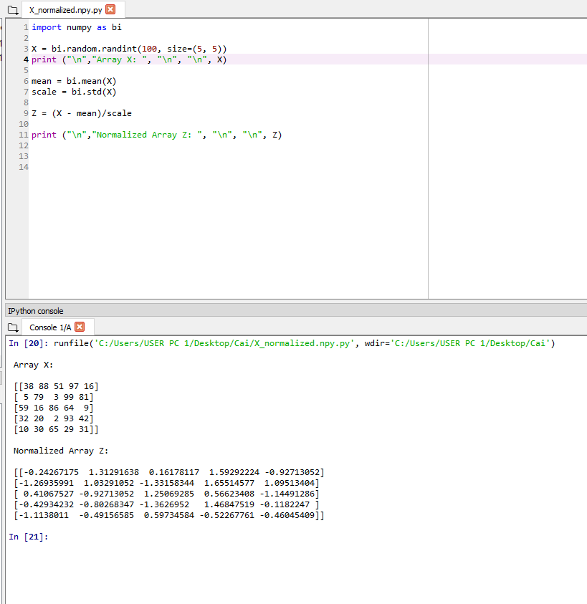

Problem 2:

