Rey, Bianca Anjela B.

2ECE-B

Problem 1

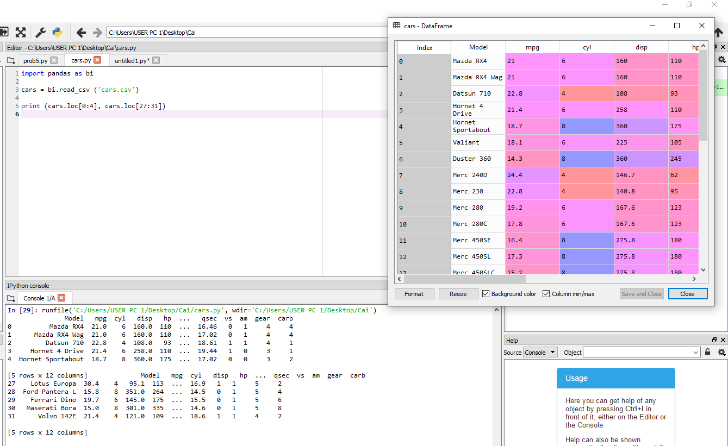

Problem 2

