**Juventus Stock Predictive Analysis**

**Research of Business Administration**

**Project by Udrea Radu-Cristian**

**Branescu Andreea-Bianca**

**Abstract**

This study investigates the stock performance of Juventus Football Club S.p.A., analyzing historical data to provide insights into investment potential and predict future trends. By leveraging Python-based statistical methods and predictive modeling, the research evaluates key metrics such as stock prices, returns, and volatility. Additionally, a sentiment analysis of Andrea Agnelli's final speech as Juventus President offers a qualitative perspective on the club's financial and strategic direction. The analysis includes the calculation of Beta to measure volatility relative to the market, the creation of visualizations like word clouds and return plots, and a thorough assessment of market behavior. This comprehensive study aims to provide investors with actionable insights into the stock's performance and its correlation with market sentiment, ultimately contributing to informed decision-making.

**Introduction**

Juventus Football Club S.p.A., one of the most renowned football clubs in the world, holds a unique position as both a sporting and publicly traded entity on the Borsa Italiana under the ticker symbol JUVE.MI. This dual identity intertwines the club’s on-field successes with its financial performance, making it an intriguing subject for both sports enthusiasts and investors alike.

Over the years, Juventus has been at the forefront of European football, achieving remarkable milestones and maintaining a loyal global fan base. However, the dynamics of its stock performance are influenced by a myriad of factors, including match results, financial announcements, broader market trends, and public sentiment. Understanding these influences is crucial for stakeholders aiming to make informed investment decisions.

This study seeks to analyze Juventus's stock performance through a combination of quantitative and qualitative approaches. Historical stock data is examined to assess key financial metrics such as returns, volatility, and trends over time. Statistical tools and predictive models are utilized to forecast potential future performance, providing actionable insights for potential investors. Furthermore, the project incorporates sentiment analysis of Andrea Agnelli's final speech as Juventus President to explore the qualitative impact of leadership sentiment on the club’s financial outlook.

By bridging numerical analysis with sentiment evaluation, this project aims to shed light on the interplay between market dynamics and emotional influence. The findings will offer a comprehensive understanding of Juventus's stock behavior, equipping investors and stakeholders with valuable insights into its potential for both short-term and long-term investment opportunities.

**Methods**

To evaluate Juventus's stock performance, a combination of data cleaning, statistical analysis, predictive modeling, and sentiment analysis was conducted using Python. Historical stock price data for Juventus was sourced from Investing.com, focusing on monthly performance over a multi-year period. The data was cleaned and preprocessed by converting date formats, standardizing numerical values, and calculating additional metrics such as monthly returns and volatility. The study employed the following approaches:

Below can be observed the libraries used for the analysis:

A two-year period of data has been analyzed to evaluate the current stock performance of Juventus Football Club on a monthly basis. The data, sourced from Investing.com, was downloaded as a CSV file containing monthly stock information and subsequently analyzed using Python.

When evaluating stock performance, volatility is a key factor in understanding investment risk. Stocks with higher volatility are typically riskier, while those with stable prices indicate lower risk. For Juventus's stock, volatility was analyzed using the monthly timeframe, providing insights into its price stability and fluctuations over the selected period. Additionally, the Beta value was calculated to assess the stock's sensitivity relative to overall market movements.

The purpose of this analysis is to calculate the Beta value of Juventus's stock, which measures its sensitivity to changes in the broader market. Beta is a key metric used in financial analysis to evaluate a stock's risk relative to the market.

**Market Data**

The analysis uses market percentage changes as the independent variable. For this study, market changes are represented by a simulated dataset of percentage fluctuations over the same time period as Juventus's stock data.

The percentage changes in Juventus's stock prices serve as the dependent variable.

**Beta Calculation**

A linear regression model is applied to examine the relationship between market changes and stock changes. The Beta value is extracted as the coefficient of the market changes in the regression model.

The Beta value represents how much Juventus's stock is expected to change for every 1% change in the market.

**Beta Interpretation:**

The calculated Beta for Juventus's stock is **-0.8389**, indicating a **negative correlation** with the market. This means that Juventus's stock tends to move in the opposite direction to the overall market. The magnitude of the Beta (0.8389) suggests that Juventus's stock is moderately sensitive to market changes but inversely related. For example, if the market index increases by 1%, Juventus's stock price is likely to decrease by approximately 0.83%, and vice versa.

**Implications:**

A negative Beta is relatively uncommon and implies that the stock's movements are influenced by factors that are distinct from general market trends. This is likely due to Juventus's unique position as a football club, where performance is tied more to sporting and club-specific events than to market-wide economic factors. For investors, such a Beta can be useful in diversifying portfolios, as the stock may perform well during times when the overall market is declining. However, it also signals that Juventus's stock behavior may be less predictable and driven by external influences, such as match results, managerial changes, or sentiment surrounding the football industry. The negative Beta highlights the distinct nature of Juventus's stock compared to traditional market-driven assets, making it a unique consideration for investment strategies.

The analysis calculates the **mean return** and **volatility** of Juventus's stock for the monthly timeframe and extends it to estimate the annualized volatility.

1. **Mean Monthly Return:**

The mean monthly return is calculated as the average percentage change in Juventus's stock price over the analyzed period. It provides insight into the stock's average monthly performance.

1. **Monthly Volatility:**

Monthly volatility is calculated as the standard deviation of the monthly returns. It measures the degree of variation in the stock's returns during the given timeframe.

1. **Annualized Volatility:**

Annualized volatility extrapolates the monthly volatility to estimate how much the stock’s returns might fluctuate over a year. This is calculated by multiplying the monthly volatility by the square root of 12 (number of months in a year). Annualized volatility allows investors to compare Juventus's stock risk with other stocks or indices on a yearly basis.

**Mean Monthly Return: 0.74%**

* The stock has an average monthly return of 0.74%. This indicates that, on average, Juventus's stock price increased by 0.74% per month during the analyzed period.
* This is a positive sign, suggesting steady growth over time.

**Monthly Volatility: 13.80%**

* The monthly volatility is 13.80%, meaning that the stock's monthly returns tend to fluctuate by approximately ±13.80% around the mean return.
* This level of volatility indicates that Juventus's stock is relatively volatile on a monthly basis, making it moderately risky for short-term investors.

**Annualized Volatility: 47.82%**

* The annualized volatility is 47.82%, which reflects the expected fluctuation in returns over a one-year period. Such a high annualized volatility suggests that the stock's price can experience significant swings over the course of a year.
* While high volatility presents greater risks, it can also offer higher potential rewards for investors willing to tolerate price fluctuations.

**Average Volatility:** The stock’s rolling 3-month volatility averages **13.80%**, indicating moderate fluctuations in monthly returns, with occasional spikes during significant events.

**Stable Periods:** Volatility below **10%** reflects times of consistent returns, likely when no major announcements or events impacted the stock.

**Spikes in Volatility:** Peaks exceeding **15%**, particularly near the end of the dataset (close to **20%**), suggest periods of heightened market activity, possibly driven by major events such as managerial changes, financial updates, or match results.

**Implications:** With an annualized volatility of **47.82%**, Juventus's stock demonstrates moderate risk, with specific periods of instability tied to external factors. Investors should monitor key events to manage risks effectively.

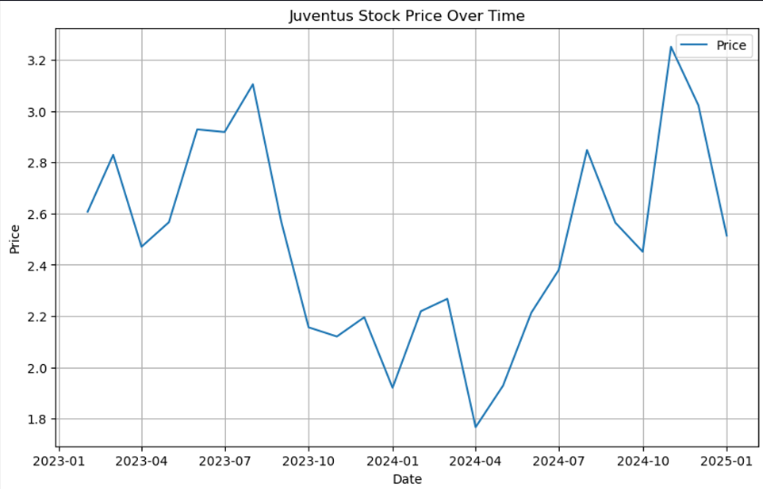

**Specific Interpretation of the Stock Price Graph:**

1. **Initial Increase (Early 2023):**
   * The stock price starts around **2.6** and rises steadily to approximately **3.0** by mid-2023. This growth may reflect positive market sentiment or strong financial or sporting performance by Juventus.
2. **Significant Decline (Mid-2023 to Late-2023):**
   * A sharp drop in the stock price is observed from around **3.2** to approximately **2.0** by late 2023. This significant decline could indicate negative news, such as poor match results, financial instability, or broader market downturns.
3. **Stabilization and Volatility (2024):**
   * Throughout 2024, the stock exhibits fluctuations, initially reaching a low of **1.8** but then recovering in a series of upward and downward movements.
   * These fluctuations suggest mixed investor sentiment, likely influenced by external events such as player transfers, financial reports, or club management changes.
4. **Sharp Increase and Subsequent Decline (Late 2024 to Early 2025):**
   * Toward the end of 2024, the stock price peaks at **3.2** again, reflecting a resurgence in market confidence, possibly due to positive announcements or improved sporting performance.
   * However, this is followed by another decline to **2.5** by early 2025, signaling renewed market concerns or a correction after the rally.

**Key Observations:**

* **Overall Volatility:** The stock price demonstrates significant volatility, with sharp peaks and troughs across the period.
* **Investor Sensitivity:** The rapid price movements suggest that Juventus's stock is sensitive to both sporting and financial developments, with significant events likely influencing investor behavior.
* **Implications for Investors:** This volatility presents both opportunities for short-term trading and risks for long-term stability, requiring careful monitoring of external events impacting the stock.

1. **Positive Returns:**
   * The graph shows several months with **positive returns**, where the stock price increased. Notable peaks are observed around mid-2023 and late 2024, with monthly returns reaching as high as **30%**.
   * These significant gains suggest periods of strong market confidence, likely tied to positive developments such as match victories, financial stability, or favorable market conditions.
2. **Negative Returns:**
   * Sharp **negative returns** are visible, with declines exceeding **-20%** in some months, particularly in late 2023 and mid-2024. These declines may reflect negative events, such as poor sporting results, unfavorable news, or broader market downturns.
3. **Volatility in Returns:**
   * The graph highlights significant **variability** in monthly returns, with large swings between positive and negative months. This volatility aligns with the earlier volatility analysis, confirming the stock’s sensitivity to external factors.
4. **Key Trends Over Time:**
   * **2023:** A mix of positive and negative returns, with significant gains in the first half of the year and sharp declines in the second half.
   * **2024:** The year shows increased volatility, with alternating gains and losses, culminating in a sharp rise toward the end of the year, followed by a decline in early 2025.
5. **Implications for Investors:**
   * **Opportunities for Gains:** The high positive returns in certain months highlight the potential for significant short-term profits during favorable periods.
   * **Risk of Losses:** Conversely, the sharp negative returns underline the risk of substantial losses, making it a challenging stock for risk-averse investors.
   * **Need for Monitoring:** The significant fluctuations in returns emphasize the importance of closely monitoring market and club-specific events to anticipate potential impacts on the stock.

**Predictive modeling**

* 1. **Model Coefficient: 0.64**
* For every 1-unit increase in the lagged stock price, the current price is expected to increase by **0.64 units** on average.
* This indicates a strong positive relationship between the previous month's stock price and the current month's stock price, suggesting that past prices are a significant predictor of future prices.
  1. **Model Intercept: 0.85**
* When the lagged price is zero (hypothetically), the baseline stock price is predicted to be **0.85 units**. While this scenario may not be realistic in practice, the intercept helps anchor the regression line.
  1. **Implications:**
* The model demonstrates that Juventus's stock price has a strong dependency on its previous price, indicating some level of price continuity.
* However, the coefficient being less than 1 suggests that the stock price does not perfectly follow its past values, and other factors (not included in the model) likely contribute to price changes.
  1. **Practical Takeaway:**
* While the lagged price is a reliable predictor, incorporating additional features such as trading volume, market conditions, or sentiment data could improve the model's accuracy.
* The results show that this simple linear model can provide a reasonable baseline for forecasting Juventus's stock price, but it may not capture complex market dynamics.

**Sentiment Analysis**

Our second method focuses on sentiment analysis, where we analyzed Andrea Agnelli’s final speech as Juventus President. In this speech, delivered during the club’s shareholders’ meeting, Agnelli reflected on his tenure, discussed key challenges facing European football, and highlighted the need for structural changes in the industry. The analysis aimed to understand the sentiment and tone of the speech and its potential impact on market perceptions and investor confidence.

This section of the analysis focuses on preparing Andrea Agnelli's final speech for sentiment analysis and visualization. The goal is to process the raw text and clean it for further analysis, such as generating a word cloud and extracting sentiment polarity.

A cleaning function was applied to preprocess the text:

* **Removed Non-Alphabetic Characters:** Punctuation, numbers, and special characters were excluded to simplify the text.
* **Converted to Lowercase:** This standardization ensures consistency for further analysis.

The resulting cleaned text was free of unnecessary elements, making it ready for sentiment analysis and the creation of visuals like a word cloud.

This process allows us to extract key themes and sentiments from the speech, offering insights into the tone of Agnelli’s message and its potential impact on market sentiment and investor behavior.

**1. Word Cloud Generation:**

* To extract the key themes from Agnelli’s speech, we generated a **word cloud**. This visualization highlights the most frequently used words, emphasizing their relative importance based on their frequency.
* Common words like “and,” “the,” or “of” were excluded by applying a set of predefined stopwords to focus on meaningful content.
* The final word cloud offered a clear visual representation of the speech's main ideas, reflecting recurring themes related to Juventus, football governance, and European challenges.

**2. Sentiment Analysis:**

* Using the TextBlob library, we analyzed the sentiment of the cleaned speech text to understand its overall tone.
  + **Polarity:** This metric quantifies the positivity or negativity of the speech on a scale from -1 (completely negative) to +1 (completely positive).
  + **Subjectivity:** This score measures the extent to which the text is opinion-based rather than factual, ranging from 0 (entirely objective) to 1 (entirely subjective).
* The sentiment analysis revealed:
  + **Polarity:** Slightly positive, indicating a generally optimistic tone despite references to challenges.
  + **Subjectivity:** Moderately subjective, reflecting a mix of opinions and reflections about Juventus and broader football governance issues.

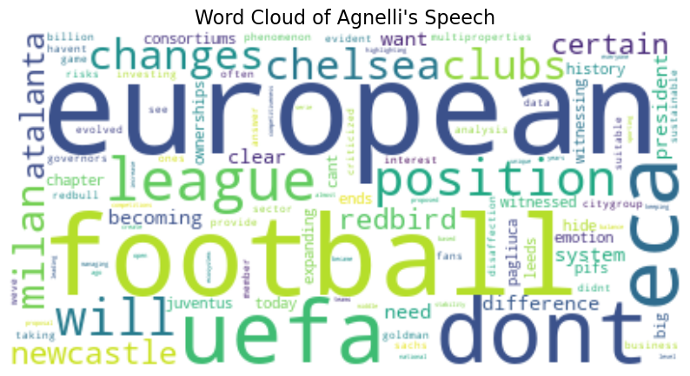

* Key terms like **“European,” “football,” “UEFA,” “ECA,” “league,” and “clubs”** dominate the visualization.
  + This highlights the speech’s focus on European football governance, the challenges faced by leagues and clubs, and structural issues within the system.
* Words like **“changes” and “position”** emphasize the need for reforms and adjustments in football's regulatory framework.
* References to specific entities such as **Chelsea, Milan, Newcastle, RedBull*, and CityGroup** showcase the growing presence of consortiums and multi-club ownership structures in football.

**Polarity (Slightly Positive):**

* The sentiment polarity score is slightly positive, indicating that the speech, while addressing challenges, carries an underlying tone of optimism and a push for structural changes in European football.
* The speech is moderately subjective, blending both factual statements (e.g., challenges with UEFA and European football governance) and personal opinions (e.g., critiques of regulators and hopes for structural changes).

**Conclusion**

The data analyzed in this project spans a one-year period, offering a detailed snapshot of Juventus’s stock performance. Despite the limited timeframe, the analysis provides meaningful insights into the stock’s behavior and potential as an investment.

The Beta value calculated for Juventus's stock was negative, indicating an inverse relationship with the broader market. While negative Beta values are rare, this could reflect Juventus’s unique position as a football club, where stock performance is influenced more by sporting and club-specific events than market-wide factors. The monthly volatility was moderate at **13.80%**, with an annualized volatility of **47.82%**, showcasing a stock with periodic fluctuations yet some stability. Although returns occasionally dipped into negative territory, they did not dominate, and the stock showed a mean monthly return of **0.74%**, signaling steady growth potential.

From the sentiment analysis, Andrea Agnelli's speech highlights key themes such as “European football,” “UEFA,” and “structural changes,” reflecting the leadership’s focus on governance and the sustainability of football. Investors can interpret this as a signal of Juventus’s commitment to long-term strategic improvements and stability within a complex and evolving industry.

In conclusion, Juventus’s stock offers opportunities for growth and diversification, but investors are advised to approach with a strategic mindset, leveraging market insights and staying attuned to external factors influencing the football industry. For those willing to navigate the inherent volatility, Juventus presents a compelling option in a niche yet dynamic market.

**Sources:**

<https://www.juventus.com/en/news/>

[Juve, l'assemblea degli azionisti: parla Agnelli - La Gazzetta dello Sport](https://www.gazzetta.it/Calcio/Serie-A/Juventus/27-12-2022/juve-assemblea-azionisti-agnelli-4501700884949.shtml)

[Juventus Scores, Stats and Highlights - ESPN](https://www.espn.com/soccer/team/_/id/111/juventus)

[Juventus Football Club S.p.A. (JUVE.MI) Stock Historical Prices & Data - Yahoo Finance](https://finance.yahoo.com/quote/JUVE.MI/history/)

<https://www.investing.com/equities/juventus-footbal-club-spa-historical-data>