ANTI-THEFT SYSTEM

Author: | Bianca CIOBANU
- Theme requirements:

Nowadays the importance of security has increased more and more due the danger of burglars or thieves. Because of this, anti-theft systems are created.
A jewelry shop contains precious and high value objects. Taking into consideration this aspect, a smart device of tracking and catching the possible thieves is needed.

- Chosen solutions:

In this manner, it will be used an ultrasonic distance sensor, that will be put next to the doors of the shop.
If the device detects movement and lights in the shop are turned off, which means that there are no employees in the shop, the device will turn on a LED with a discontinuous light and a sound-based alarm.
The motors will be activated also simultaneously with the alarm and they will act on the anti-theft protection for doors and windows.
The device detects movement at a height of approximately 300 cm and a width of about 800 cm.
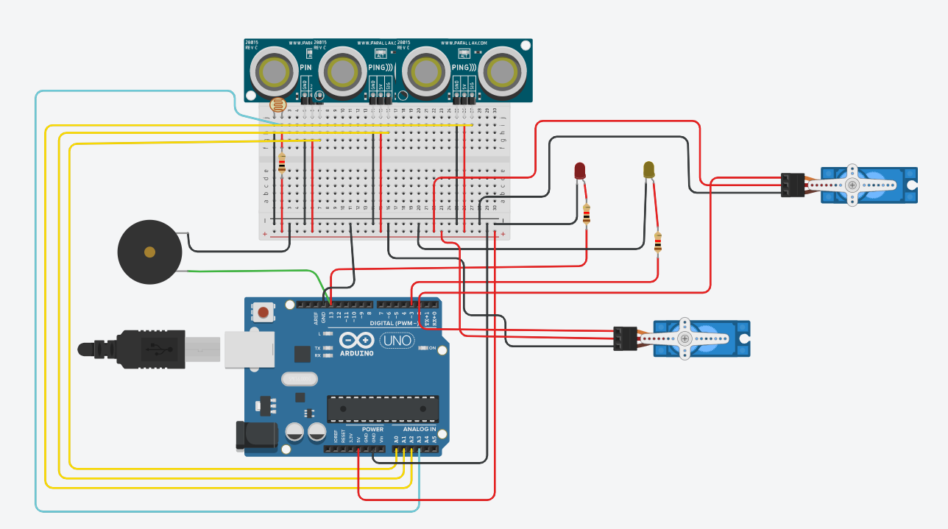
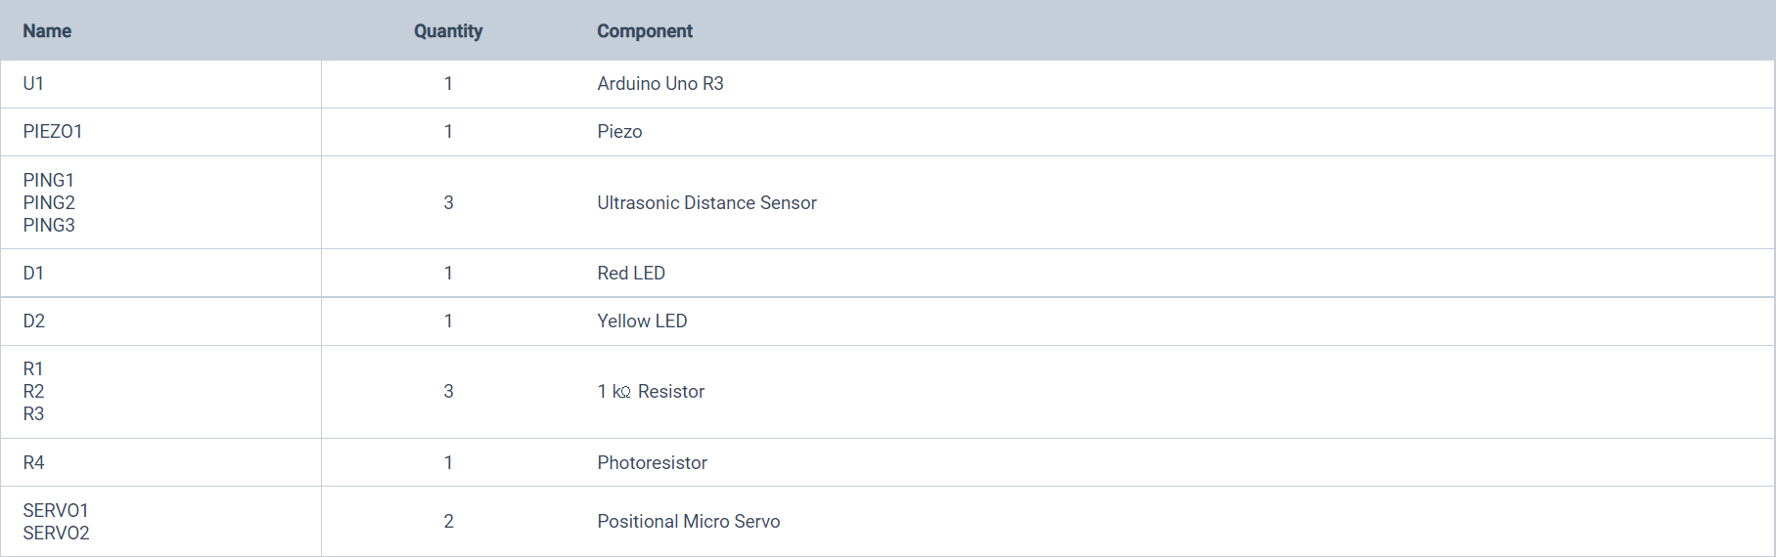

If the lights are on in the store, then the alarm does not work. Just when the lights are off the device detects motion with photoresistor support.



- Obtained results:

Firstly, we initialize and set the input/output pins for each component. Then we go in a loop with the commands, creating „switch” statement where we treat all the cases.
First command displays the available commands.
The second one sets the pin for the outside light to LOW => yellow LED on
The third one sets the pin for the outside light to HIGH => yellow LED off
The fourth tests the alarm, creating a „for” statement for the 3 sensors, displaying the values recorded by the motion sensors. If the values recorded are between the conditions and the value for the night is passed, that means there are thieves in the store, so it will activate the alarm, red LED and the motors for windows and doors. The alarm will be activated and wait for the administrator to close it.
The last command will the turn off the alarm, motors and the yellow LED is turned on.
The app contains the following components:
  - 3 motion sensors for detecting the thieves. There must be no obstacles in front of the device intrusion detection

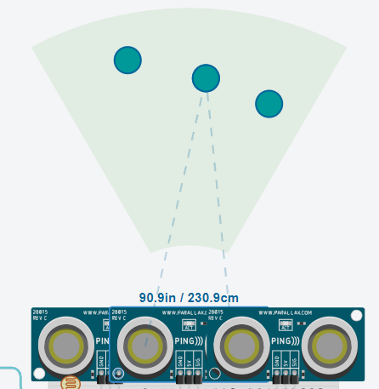

  - the photoresistor must be placed next to the lights in the store.



  - the buzzer (PIEZO alarm)

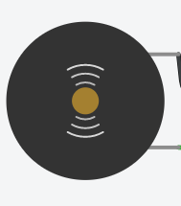

  - 2 LEDs (1. Alarm light-activated by the buzzer 2. Outside light-activated by the employees)

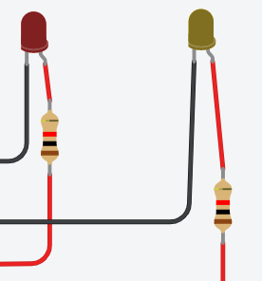
  - 2 servo-motors (one for the doors and for the windows)

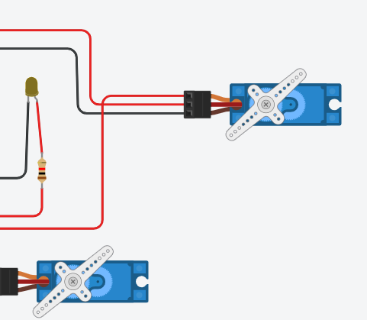

We start by running the simulation and next message will be displayed in the serial monitor and the motors will be moved with 40 units:

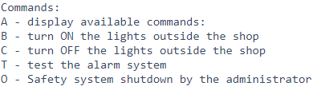
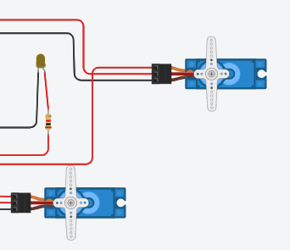
If we press “A”, it will display the commands again:

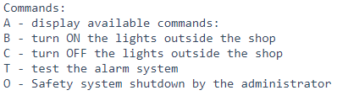

If we press “B”, it will turn on the light in the exterior of the shop, the following message being shown:
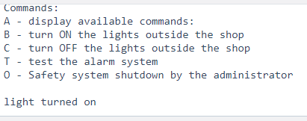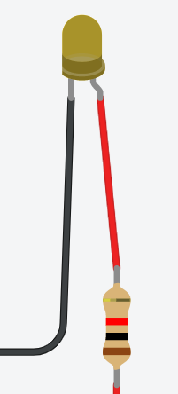

If we press “C”, it will turn off the light in the exterior of the shop, the following message being shown:

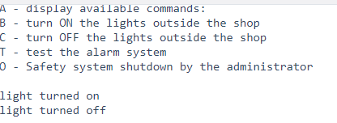

If we press “T”, it will activate the alarm and the red LED, the following message being shown:

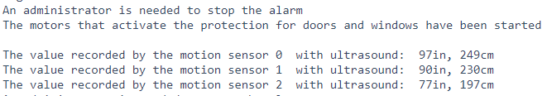

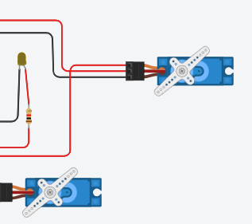

If we press “O”, it will close the alarm and turn on the yellow LED, the following message being shown:

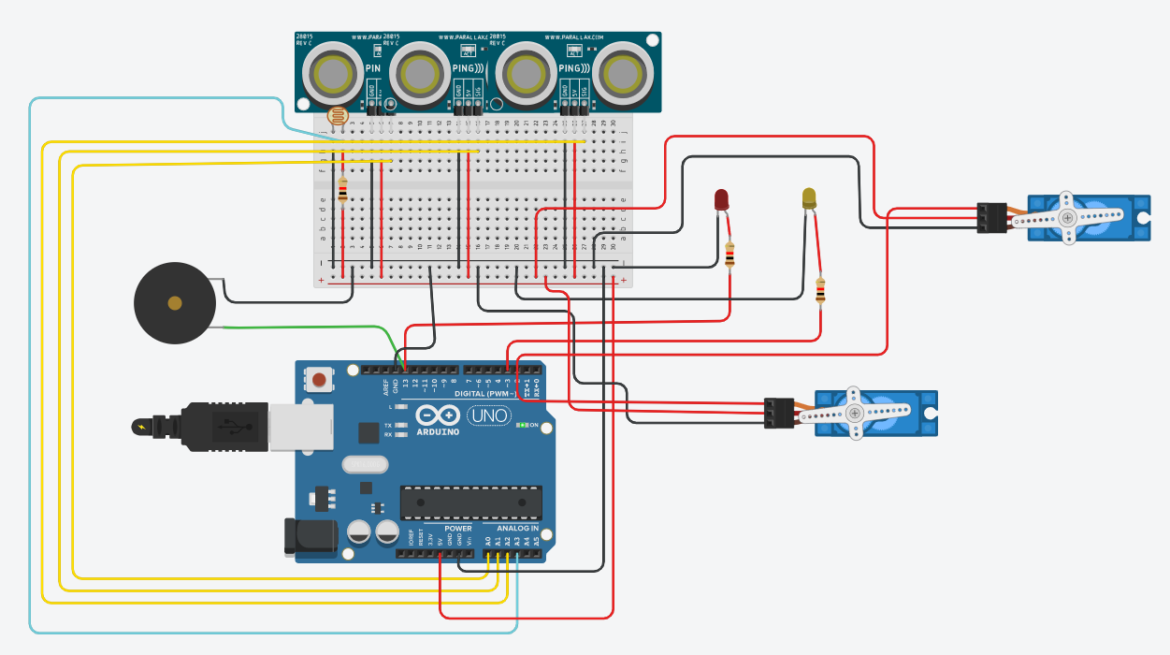

- Tests and verification:

Several commands have been tested, depending on the serial monitor:
"A" will display the command menu
"B" – will turn ON the exterior store lights (yellow LED on)
"C" - will turn OFF the exterior store lights (yellow LED off)
"T" -test alarm system (an engine will move all the doors
safety, another one will move window grille and photoresistor will operate the
alarm (piezo on the diagram) and alarm light (red LED))
"O" - Shut down the security system by the administrator (will be given back
motors for unlocking the grilles, the red LED will turn off, meaning that the alarm light and the piezo sound stops).
- during the test, each step of the motor will be displayed, both when moving forward and when moving backwards together with the values read from the 3 sensors and, following them, the actuation or not of the protection system.
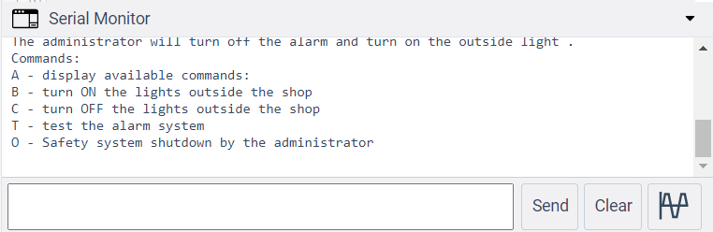

The user must connect the device to a 5V battery and place the device next to the access paths, and the buzzer and lights placed in a space where a supervisor can access them. It is recommended that the motors for activating the door protection andwindows to be installed by a specialist.

https://www.tinkercad.com/things/62bcIOHbvfB

Date:

28.05.2021

